Chapter 1
Information system(IS): Group of components that interact to produce information. (ex:Calendar or Dewey decimal system)
Computerized information system= information system
5 component framework of IS: Computer hardware, software, data, procedures and people.
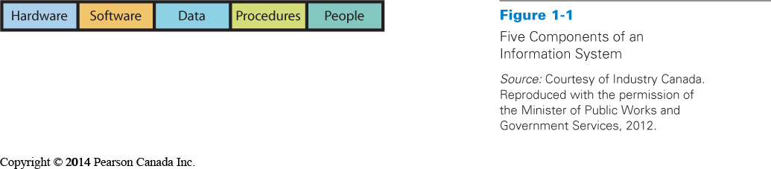
These components are linked together through networks that leverage the power of connectivity to tie software, hardware and data together to make information more accessible and powerful.
1- Hardware: Electronic components and associated gadgetry that constitute a computer system
2- Software: Programs that run or operate on computer systems
3- Data: Building blocks of information such as facts and observations (stored in servers)
4- Procedures: Instructions or processes that you follow to achieve your desired objective (formal or documented policies, or informal instructions)
5- People: Actors who want to achieve a particular outcome by interacting with the system
Basic information systems: e-mail, web pages, word processors, spreadsheets, PowerPoints, talking on a cell phone, instant messaging and location-based services on cellphones
MIS
MIS: Management and use of business processes, information systems and information to help organizations achieve their strategies.
3 key elements - Development and use
Information systems
Goals and objectives
Development and use:
- Take an active role in order to ensure that the system will meet your needs (helping choose and implement information systems)
- Understand how they are constructed
- Important role in the use of information systems (know how to employ the system)
- Responsible in protecting the security of the system and its data :Security, Backup (when system is down), Recovery
Achieving Business Goals and Objectives:
- MIS aids and assist organization or business and who: sell, buy, design, produce, finance, market, account, and manage
- MIS needs to be developed for the right reasons
IT
Information Technology (IT): methods, inventions, standards, and products – refers to raw technology and concerns only hardware, software and data components of an information system and how they are networked together
- IT alone does not help an organization achieve goals
- IT must be embedded into IS to accomplish objectives ( combined with people and procedures) – then IS makes IT useful
- Including people in the system impacts how you design and implement systems
ICT
The industry sector most closely related to the development and use of information systems is ICT
The Information and Communications Technology (ICT): includes companies involved in

- Software and computer services
- cable and other program distributors
- telecommunications services
- ICT manufacturing
- ICT wholesaling

ICT 2.0
David Ticoll suggested that within the next decade:
  - Unlimited storage will be almost free
  - Analytical software will reveal hidden treasures
  - The real and virtual world will collide as wide-area networks become cheap, reliable, and widely available
  - These technology trends will enable deep, powerful, performance-enhancing innovations that will be felt in almost every industry
Beyond the Basics
Business professionals need to expand their knowledge to include the following:
  - Use of mobile devices and applications
  - Use of project-management software – Microsoft Project, OpenProject
  - Business graphics – MS Visio, SmartDraw
  - Collaborative systems such as Google Docs

Moore’s Law
Moore’s Law: density of circuits on an intefrated chip was doubling approximately every two years or so. ( shrinking size of devices too) – one of the few predictions that stood the test of time
Ex: price of computers decreased, computer capacity increased, computer power increases for the same price as before
‘’Network effects’’ and ‘’lock-in’’: value that is received increases significantly as the number of users increases
____________________________________________________________________________________
1- What is an information system? a system of hardware, software, data, procedures, and people that produces information
2- What is MIS? Management and use of business processes, information systems and information to help organizations achieve their strategies.
3- What is IT? represents raw technology components of IS (Hardware, Software, data components)

Chapter 4
History of IT
1940s - First computing devices
1950s – First commercial computers
1980s – First personal computers
1990s – Cellphones and Internet
2000s – Mobile computing, texting and smartphones
Early computers: 1939 – 1952
- Early computers financed by the US military
- First reprogrammable general-purpose computer ENIAC (Electronic Numerical Integrator and Computer) designed in 1946, calculates firing tables for ballistic missiles
- Early computers were large, complex and expensive, ran one program at a time
- ‘’Computer bug’’: actual moth caught in the mechanical relays of the Mark II Aiken Relay Calculator
- First digital computer in Canada in 1952 at the University of Toronto
- Current mobile phone is 1000 times smaller and 1 000 000 times faster than these early computers
Mainframes: 1952-Present
1st generation
- First commercial digital computers: large, room-sized devices based on now-obsolete vacuum tube technology were called mainframes
- Mainly used by government and businesses
- Cost between 200 000$ and 400 000$
- Could add and subtract about 16 000 numbers per second
2nd generation
- Late 1950s: used transistors, smaller, easier to maintain and more reliable
- Manulife Financial first insurance company to adopt this technology
3rd generation
- Introduced in mid 1960s
- Included operating systems and multiprocessing capability (many users could share processor at the same time)
- Cost: Millions of dollars
Mainframes: Still used in large organizations, fast processing and massive storage
Microcomputers: 1975 – Present
Typical mainframe includes: 1. CPU: Central processing unit
2. Short-term memory
3. Long-term memory
- Microprocessors developed by Texas Instruments and Intel : incorporated a CPU and some short-term memory into a single silicon ‘’chip’’ using integrated circuits (ICs) such as calculators
- First microcomputers: MITS Altair 8800 and Data-point 2200 ( developed in 1975), didn’t have display screen or monitor and required users to develop their own program
- Small microprocessors
- Companies such as Microsoft created gramming languages (BASIC) and operating systems (DOS)
- 1981: Launch of personal computer with keyboards, portable floppy disks, word processors, spreadsheets, and other software
Networking Personal Computers: 1985 - Present
- LAN: Local Area Networks technology (Robert Metcalfe at the Palo Alto Research Center and later patented by Xerox
- LAN serves small groups of people within small areas, links personal computers together, shared access to data, printers and other peripheral devices
- Ethernet: set of rules, protocols that allowed connected device to communicate and share information, printers, and other peripheral devices (connect PCs together with unique adresses)
- 1990s – WAN : Wide Area Networks technology, internet, building on email, web browser, access to worldwide network of computers
Mobile and Tablet Computing : Late 1990s – Present
- High cost of early computer technology encouraged computer programmers to save resources by coding only the last two digits of the year
- Dramatic lowering of costs for cellular technology and mobile telephones – adopted by large groups of people
- Arrival of cellphones such as Blackberry (two way messaging device) with internet and MP3 with applications such as banking and scheduling
- Apple – Launch of Ipod (2007) and launch of Ipad (2010)

Information Technology Principles
1) Price and performance advances: Moore’s Law : In 18 months, price of given Integrated Circuit (IC) will be cut down in half or same amount with twice as many transistors
Price of processing power decreases and improvement of high-bandwidth resources
2) Small is powerful: IT will become smaller and powerful (advancement of nano-technology)
Main componenents of a computer : Processor, Memory and Storage
3) Network is the thing: Rate of communication in computers has increased
Computer Hardware
HARDWARE: Physical electronic components and related gadgetry that input, process, output and store data according to instructions encoded in computer programs or software.
Four basic components (that all computers have):
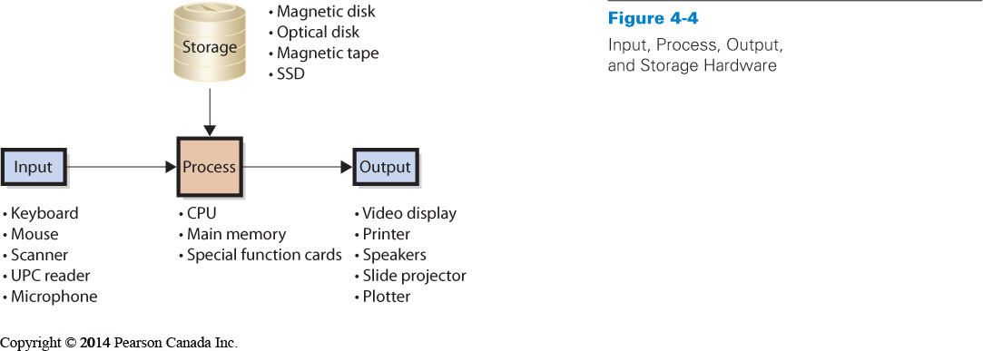
1- Input devices: Keyboard, Mouse, scanner, UPC reader, microphone, Barcode scanner to cash register, scanners to read exams
2- Processing devices: CPU (Central Processing Unit aka brain of computer), Main memory, special function cards
CPU: Selects instructions, processes them, performs arithmetic and logical comparisons and stores results operations in memory. Its performance is measured in Hertz (Hr) or cycles and counted in Kilohertz (kHz), Megahertz (mHz) or Gigahertz (GHz). Varies in terms of speed, function and cost.
It works in conjunction with the computer’s main memory, often referred to as random access memory (RAM). CPU reads data and instructions from the RAM and then stores the results of its computations in the storage (hard drive)
3- Output devices: Video display, printer, speakers, slide projector, plotter
Producing, displaying the desired results of a computational task or request. They can be described in terms of resolution quality (dots per inch, or DPI) or how many pages are printed per minute.
4- Storage: Magnetic disk (hard disk), Optical disk (CDs and DVDs), magnetic tape, SSD
Storage saves data and programs. Requires less power, no moving parts, less susceptible to mechanical failures
Special function cards can be added to augment each of its component, like video cards, extra storage
Computer Data
Binary Digits (bits): represent data
- Computers represent data using binary digits, called bits
- A bit is either 1 or 0
- Bits are used for computer data because they are easy to represent physically
Sizing Computer Data
- Computer Data are represented by bits. Data can be numbers, characters, currency amounts, photos - Strings of bits
- Bits are grouped into 8-bit chunks called bytes (one character = one byte)
- Bytes are used to measure sizes of non-character data as well (8 bits per byte)
Kilobyte (K) = 1024 bytes
Megabyte (MB) = 1024 K = 1 048 576 bytes
Gigabyte (GB) = 1024 MB = 1 073 741 824 bytes
Terabyte (TB)= 1024 GB = 1 099 511 627 776 bytes
Petabyte (PB) = 1024 TB = 1 X 10¹⁵ bytes

How does a computer work?
CPU (Central Processing Unit)
- transfers program or data from disk to main memory
- moves instruction from main memory into the CPU via data channel or bus.
- CPU keeps frequently used instructions in the cache. Cache: small amount of very fast memory

Memory

Main Memory contains…
- Program instructions
- Operating system (OS) instructions

Memory swapping:
- Main memory is too small to hold all data
- CPU loads programs into memory in chunks
- Places new program into unused memory
- If none available, the operating system will remove chunk being used and replace with requested data

Why Should a Manager Care How a Computer Works?
- Main memory size - if too little = constant memory swapping, slow processing
- CPU- Expressed in hertz, needs more CPU if handling complex tasks
- Cache and main memory are volatile: content is lost when power is off
Non-volatile: Usb sticks, magnetic and optimal disks

Computer components

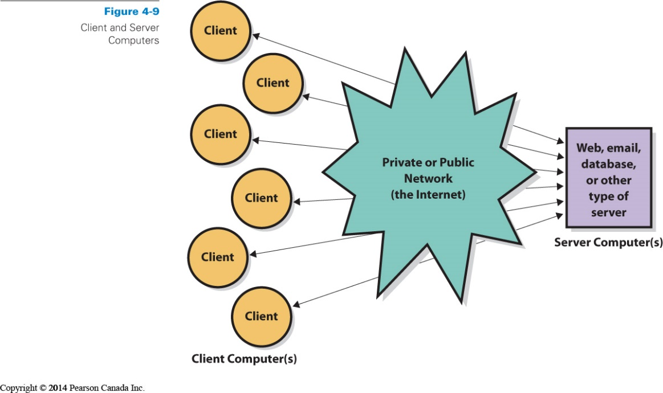

Types of computers: Apple or PC Models: Laptop or Desktop

Difference between a client and a server & what is cloud computing?

Client computers: Word processing, spreadsheets, data-base access etc (could enable them to connect to a network such as school or at work) – connect to servers for Web, e-mail, database

Servers: Provide service, used to publish websites, sell goods, host databases, support printing and provide other functions (may or may not have video display) ex: Facebook, Google – they need to be faster and larger than client computers

Server farm: Large collection of computers that coordinate all activities

Cloud computing: Concept of servers that supply applications and data.
- Users don’t own the computer.
- Hardware, software and applications are provided as a service, through a web browser – cloud = Internet, Ex: Hotmail, Google Docs
- Available at any location and time
- Cloud computing popular because of the reduction in the costs per megabyte of storage and b/c they pay for the storage they use
- Very common amongst CRM ( Customer Relationship Management)
- Build upon the concept of grid computing
- Grid computing: several computers are used to address a single problem at the same time – uses software to divide and apportion pieces of a program among several computers (up to thousands)

Instruction set: commands that a CPU can process

4 Major operating systems

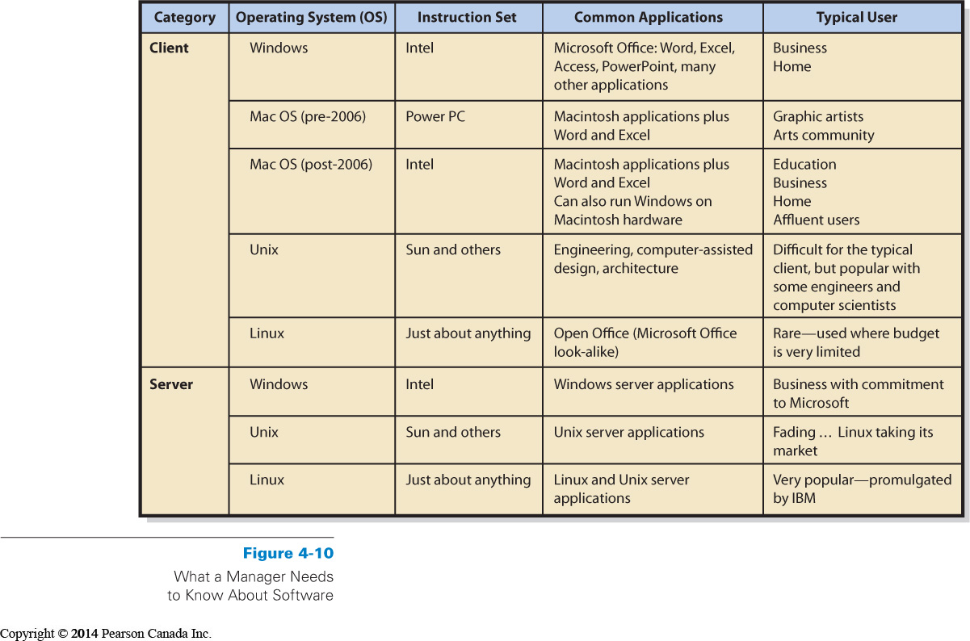
- Windows: 85% of worlds desktop. 95% of business users.
Windows runs the Intel instruction set.

- Mac OS: Apple Computer, Inc. Easy-to-use interfaces. 1 of 10 computer purchases, selling price higher than window based computers. Used primarily by graphic artists and art community

- Unix: developed at Bell Labs in the 1970s, more difficult than Windows or Macintosh. Workhorse of scientific and engineering community. Sun Microsystems and other vendors of computers for scientific and engineering applications are the major proponents of Unix.

- Linux: version of Unix developed by open-source community (loose group of programmers who volunteer their time to contribute code to develop and maintain Linux with no license fee – companies make money by offering support). Most used for servers, particularly web servers. IBM primary proponent of Linux

Two types of computer software:

1- Operating System (OS): Program that controls computer’s resources

2- Application programs: perform a business function and/or specific user tasks. Ex: Quickbooks (program that provides general ledger and other accounting functions), Excel, Word

Its constraints…
- a particular version of an operating system is written for a particular type of hardware
- application programs are written to use a particular operating system

Owning versus Licensing

- Users buy license to use program
- Ownership remains with development company

Categories of Application Programs

1- Horizontal market application: software that provides capabilities common across all organizations and industries. They are purchased on the self with little customization.
Ex: word processors, graphics program, Excel, Powerpoint, Word, Photoshop.

2- Vertical market application: Software that serve the need of a specific industry. Usually altered or customized. Ex: dental offices to schedule appointments and to bill patients, tracking system for mechanics

3- One-of-a-kind application: software developed for specific unique need ex: Canada Revenue Agency

4- Other (dual-category) application software: ex: CRM software

5- Acquiring application software

Software type (Software source) see p.115*
- Off the shelf ( Horizontal and vertical applications)
- Off the shelf with alterations (Vertical application)
- Tailor made (Custom-developed)
- Difficult and risky
- Staffing and managing teams is challenging
- Developed in-house or by outside developer
What is Firmware?

Firmware: Computer software that is installed into devices such as printers, print servers and various types of communication devices. Coding of software is similar to that of other software but it is installed into the special, read-only memory of the printer or other device. Program becomes part of the device’s memory. Can be changed and upgraded.
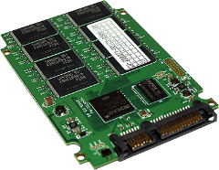
Utility software/Driver: Software that supports communication between the computer and the printer. Type of software that does not fit into either operating software or application software. Ex: disk image, security software, file and data recovery.
Basic Input/Output System (BIOS): Important piece of firmware. BIOS used when computer is initially started or ‘’booted’’ up. BIOS is required because all volatile memory is lost when computer is shut down.
Système élémentaire d’entrée et de sortie
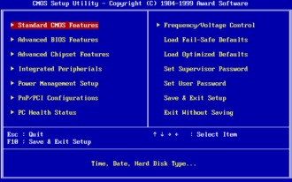

Only way to get the computer running again is to provide a set of instructions in non-volatile read-only memory (ROM)***

1st thing computer does when starting up is to load BIOS from ROM and run through the commands provided by the firmware.

Thin vs. Thick – amount of code that must run on the client computer

Thin Client: Application requiring only browser. Unable to run without network access (internet).

Thick Client: Applications that requires programs other than a browser on the user’s computer. Provide features and functions that more than compensate for the expense and administration of its installation and doesn’t need access to network to run. ex: Microsoft Outlook (emails)
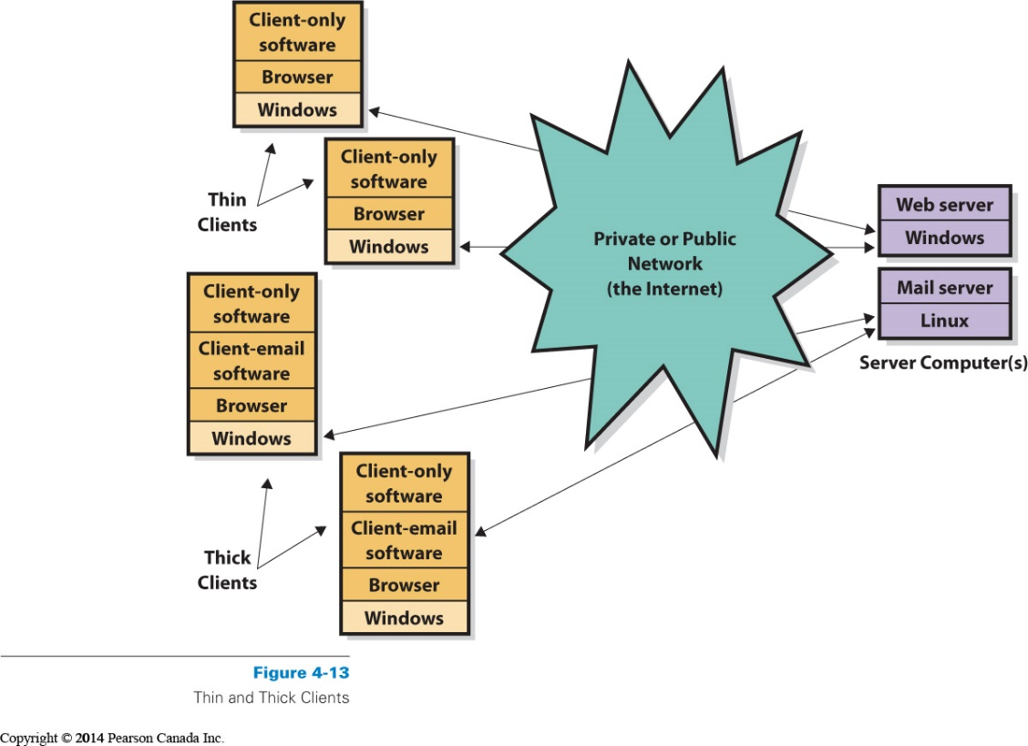

Buying Decisions that a Manager Needs to Make

1- Manager’s role depends on organization’s policies
- Large organizations usually have IS department that sets specifications
- Medium to small organizations are less formal
  - Managers take more active role
  - Standardized to single client operating systems

2- Managers and employees may have role in specifying application software
3- Has no role in server specifications

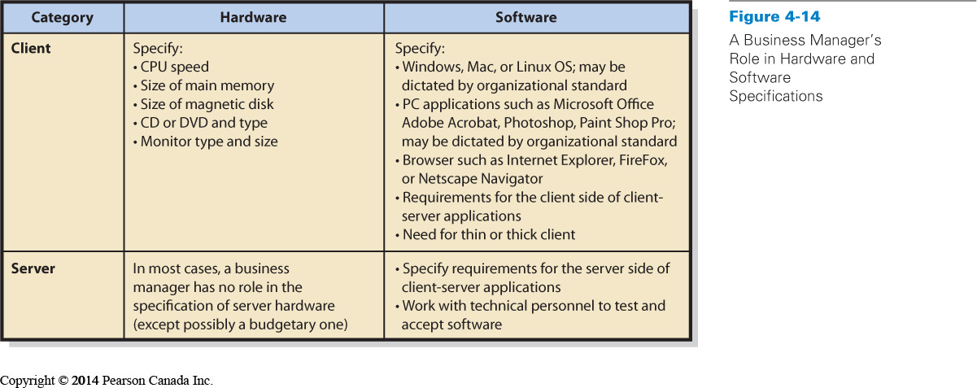

Malwares

Virus: Computer program that replicates itself. Consumes computer’s resources and take unwanted and harmful actions.
- Payload: Program code causing unwanted activity. Can delete programs or data, or modify data in undetectable ways

Macro-viruses: They attach themselves to Word, Excel and other types of documents. When infected document is opened, virus places itself in the start-up files of the application and infects every file that application creates or processes.

Worm: virus that propagates using internet or other computer network. Worms spread faster (programmed to spread)

Non-worm viruses: Must wait user to share a file with a second computer.

Zombie computers: Computers infected by viruses and worms.

Botnet: Set of computers and applications that are coordinated through network and used to perform malicious tasks.

Measures to prevent viruses

-Use Antivirus program and patches

Patches: Program modifications of security holes in computer programs. Keep from getting viruses. Sued to fix problems

Source code is is computer code as written by humans and that is understandable by humans.
Which of the following is true of a 32-bit CPU? It cannot effectively utilize more than 4GB of main memory.

Chapter 3
Why should I care about Productivity and Innovation?
Productivity or labour productivity: ratio of Canada’s gross domestic product (GDP) over total paid hours worked by Canadians – measures value Canadian workers generate per hour
GDP/total paid hours worked by Canadians
- Primary indicator of our per capita income
- Around 35$/hour
- Increase of productivity = Country’s growth
- Increasing productivity = working smarter, culture of innovation, open industries to more competition, increase amount of machinery and equipment, particularly in the Information and Communications Technology (ICT)
Productivity Paradox
- In 1989, economist Stephen Roach found no evidence of an increase in worker productivity associated with the massive increase in investment in information technology.
- This result led the Nobel Prize winning economist, Robert Solow, to make the now famous quote "We see computers everywhere except in the productivity statistics"

Information and Communications Technology (ICT):
- Raising ICT capital intensity means increasing amount of technology that supports people working
- Important industry for productivity and innovation * because it includes technologies that can enhance individual and organizational productivity across many industries
- ‘’Invisible’’ industry because does not produce as much ‘’direct’’ output
How IT adds to productivity = How IT can be used to create business value
How can IT create business value?
- Productivity – make more output from the same inputs, and/or to make better output and/or to make the output faster than before the technology
- Structure of competition – IT can alter the way corporations compete
- Benefits to the end customer – prices reduce or more services are accessible as a result of IT
Business Technology Management (BTM)
- Create programs that combine technology and business training.
How do Information Systems improve Productivity?
a) Increasing efficiency
- Means that business processes can be accomplished either quickly or with fewer resources and facilities
- ‘’Doing things right’’= right amount of resources, facilities, information to complete the job satisfactorily
b) Increasing effectiveness
- ‘’Doing the right things’’ = Deliver something new and improved
- Offering with new or improved goods or services that the customer values
Business Processes and Value Chains
- Business processes use resources, facilities, and information
Value chain: Network of value-creating activities (with primary and support activities)
- Improve the effectiveness (or value) of a good or service, made up of at least one or many business processes
- Enable the development of more efficient or more effective supporting activities
- Increase the margin enjoyed by company
- Information systems increase productivity by offering new and improved services, primary activities
Ex: Trees-Vietnam-Canada-Factory-Shipping-Tire Store
Margin: Difference between the price the customer is willing to pay and the cost the company incurs in moving the goods or services through the value chain - Greater the margin, the greater the profit
Two types of activities with value chain
a) Primary activities: activities in which value are added directly to the product
ex: Shipping raw materials, designing tires, manufacturing the tires, shipping finished tires and installing tires
Primary activities include the following (five):

- Inbound logistics: Receiving, storing and disseminating inputs to the product
- Operations: Transforming inputs into the final product
- Outbound logistics: Collecting, storing, and physically distributing the product to buyers
- Marketing and sales: Inducing buyers to purchase the product and providing a means for them to do so
- Service: Assisting customer’s use of the product and thus maintaining and enhancing the product’s value
Stages accumulate costs and add value to product (Net result = Total margin of chain)
b) Support activities: Support the primary activities – add value indirectly and critical to success of organization such as production, sale and service
- Firm infrastructure: includes general management, finance, accounting, legal, and government affairs.
- Human resources
- Technological development
- Procurement

Add value and costs (Produce margin hard to calculate)
ex: Workers in the factory, who bought machines to make tires, who maintain machines inside the factory and keep lights on and heat working, payroll, production, financial, HR systems
Information systems increases productivity by offering new and improved services, primary activities that wouldn’t be available without IT. Ex: Online shopping, 24h customer support

Porter’s Value Chain Model
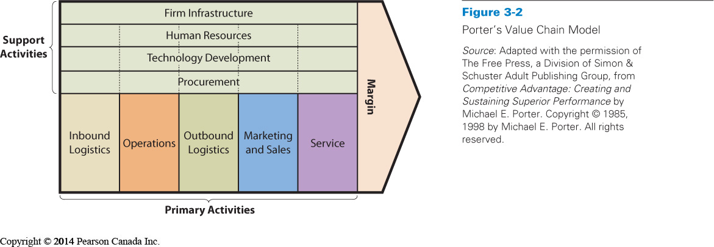
Companys’s strategy: Goals and objectives – influenced by the competitive structure of the company’s industry
Model to assess an industry structure – Porter’s Five Forces Model
Five competitive forces determine industry profitability

1. Bargaining power of customers
2. Threat of substitution
3. Bargaining power of suppliers
4. Threat of new entrants
5. Rivalry among existing firms

Determines the characteristics of the industry, how profitable it is, and how sustainable that profitability is
Ex: Soft drink industry – competing other soft drinks, threat to substitutes such as water, juice
- Customers taste and preference are important forces
- Need to respond constantly to threats – by expanding their product offerings
- New entrants have a hard time, disadvantages in terms of cost because of Coke and Pepsi being around for so long, hard time to enter market with well established brands
- Pepsi and Coke don’t compete in price, but marketing
Organization examine the structure of its industry by choosing a competitive strategy
Model of four competitive strategies
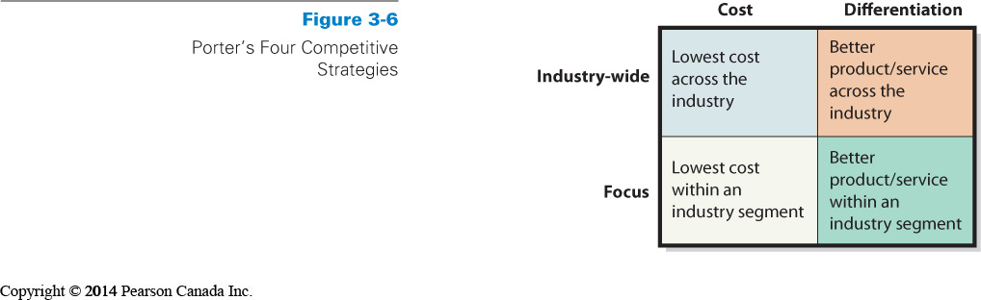
- Cost leadership – across an industry
ex: low cost - car rental company
- Cost leadership – focusing its strategy on a particular industry segment
ex: low cost - car rental company for domestic business travellers only

- Focus on differentiating its products from those of the competitors – across an industry
ex: car rental company by providing luxurious cars
- Focus on differentiating its products from those of the competitors –– focusing its strategy on a particular industry segment
ex: car rental company that brings cars to its customers’ homes – who rents luxurious cars only
Porter says ‘’Goals, objectives, culture and activities must be consistent with strategy’’
Relationship between Innovation and Information Technology
- Industry structure occurs through innovation
Two types of technology innovations:
- Sustaining technologies: changes in technology that maintain the rate of improvement in customer value
- Help make processes more efficient and thus create value for organizations

Ex: vulcanization of rubber allowed tire manufacturers to produce tires that facilitated faster and more comfortable rides- sustained the original innovation

IT in sustaining technology– improved size and speed of electronic memory, store and retrieve data more quickly

- Disruptive technologies: Introduce very new package of attributes to accepted mainstream products
Ex: Music industry – MP3, because offered ability to store and play music through digital devices

IT in disruptive technology – Royal Bank offering national automated banking machine network in Canada, presented customers with new choices – other banks quickly responded with machines of their own
Competitive advantage can lead to new industries such as the internet with Amazon and Facebook
Theory of diffusion of innovation by Everett Rogers
- Process by which an innovation is communicated through certain channels over time among the members of a social system – process of adoption of new technology
Five stages of diffusion
- Knowledge: occurs when you hear first about an innovation but lack specific information about it
- Persuasion: become interested in the innovation and find out more about it
- Decision: Consider pros and cons of adopting the innovation and make a decision as to adopt or reject it
- Implementation: Use innovation and figure out whether to continue using it or look for an even better way
- Confirmation: when you are happy about the decision, and use the innovation to its full potential

Principles of Competitive Advantage
- Retain customers by making it difficult or expensive for them to switch to another product. This business strategy is sometimes referred to as adding ‘’switching costs’’.
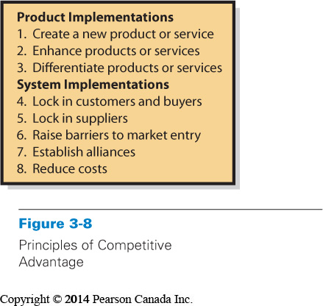
Locking in customers: High switching costs
Locking in suppliers: Making it easy to connect to and work with organization
Create entry barriers: Making it expensive for new competition to enter market
Establish alliances: Establish standards, promote product awareness
Reducing costs: Increased profitability
Information systems can achieve these objectives
A business process is a network of activities, roles, resources, repositories, and data flows that interact to accomplish a business function.
An organization responds to the structure of its industry by choosing a competitive strategy.
Each stage of the value chain not only adds value to the product but also accumulates costs.
In which of the following cases is the strength of competitive forces low? when switching costs are high
In which of the following situations would the suppliers have the strongest bargaining power? coffee planters during a season of frost that decreases production (because it raises the cost)
Manufacturing systems that use linkages also use sale’s forecast to plan production.
Porter defined value as the amount of money that a customer is willing to pay for a resource, product, or service.
Porter originally developed the five forces model to determine the potential profitability of an industry
Porter's five competitive forces can be grouped into two types: forces related to competition and forces related to supply chain bargaining power.
The competitive strategy of an organization determines its value chain
The strength of bargaining power forces depends on the availability of substitutes and relative size of the firm compared to the size of suppliers or customers.
Two strength factors that relate to all three competitive forces are switching costs and customer loyalty.

Chapter 2

Kaizen: Japanese for ‘’good change’’

What is a Business process?

- Sequence of activities for accomplishing a function. They involve resources, such as people, computers, and data and document collections.
Ex: University – business process to record final grades, drop a class section.

Activity: Task within a business process
Ex: University – Compute final grades, fill out grade reporting form

Documenting business processes using BPMN
Create abstraction of business processes (Reich’s term): Documenting each process and activity.
Technique for documenting business processes
- Business Process Model and Notation (BPMN) standard: Global standard widely used in industry

Roles: Subset of activities in a business process that is performed by a particular actor (people, computers)
- Cashier (actor) : Greets customer and ask for order
- Order Tracker (actor): Computer system
- Presenter : Giving his or her order
- Food Runner: Directed by presenter to bag food items
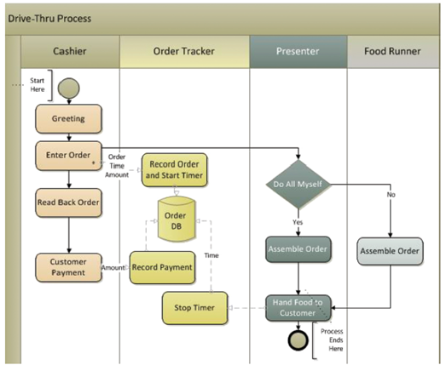
BPMN standards - Starts with circle with narrow border and ends with at a circle with heavy border
Swimlanes (The long columns): Contains all activities for a particular role. Easy to determine which roles do what.
Symbols of BPMN
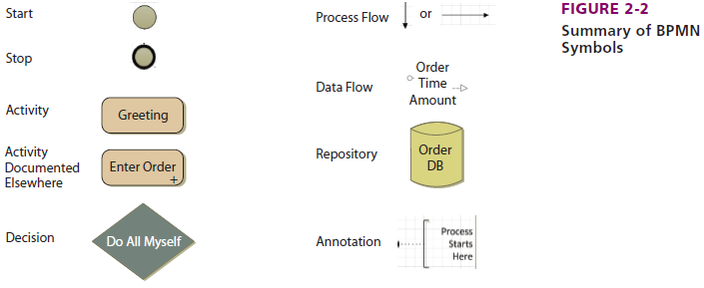
Repository: Collection of something, usually a collection of records. Often a database (DB). Ex: box full of records, inventories, collection of things other than data.
Enter Order + , the + means that the details of the activity are documented elsewhere, to simplify diagram or when details of subprocesses are unknown or unimportant to the process.
Benefits to standardize business processes
- Enforce policies ex: restaurants must record all transactions electronically
- Results are more consistent ex: by following same steps, the results will be the same
- Processes can be copied and reused; they are scalable
- Risks from errors and mistakes are reduced ex: following same processes reduces errors
What is an Information system?
Information System: Group of components that interact to produce information
System: Group of components that interact to achieve some purpose
Five-component framework of Information System: Model of components of a functioning information system and common to all information systems, smallest to largest
- Computer hardware ( Computer, storage disk, keyboard, and monitor)
- Software (Word, WordPerfect, other word processing software)
- Data (words, sentences, paragraphs in your report)
- Procedures (Steps to start program, enter your report, print it)
-Set of instructions for a person to follow when operating an IS ex: form to fill in when creating a facebook account, uploading a picture, searching friends.
- There are different procedure for every process
- People
Hardware and people – do things
Programs and procedures – are instructions
Programs - tell hardware what to do
Procedures – tell people what to do
Data – bridge between machine side and human side

Computer-based information system and non-computer based information systems (calendar)
*Not all computers are information systems ex: robotic computers

How to use the five component model?
- Recognize that you are the key
- Make each component work
- Estimate the scope of new information systems
- Order components by difficulty and disruption
An Information System can support several processes
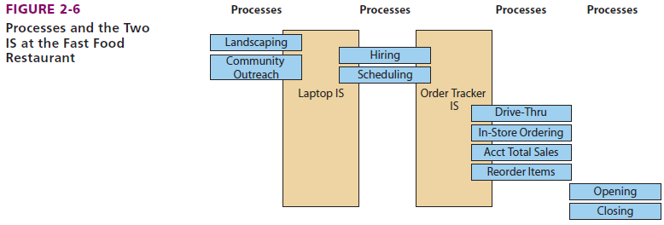
Roles of procedures
- Set of instructions for a person to follow when operating an IS
- Different procedure for different processes
Processes- two broad categories
- Structured processes: Formally defined, standardized processes- they are prescriptive, delimit what the users of the system can do and under what conditions they can do it. ex: scheduling work shifts, calculating daily sales tax totals
- Dynamic processes: Less specific, more adaptive, even intuitive ex: open a new store location and how best to solve a problem of poor employee training, collaborate with students for a group project
- Tend to be informal
- Does not mean that they are unstructured, rather it means that the process cannot be reduced to fixed activities done the same way every time
- Change rapidly as requirements and situations change
- They are supportive – instructions for using an information system are less rigid
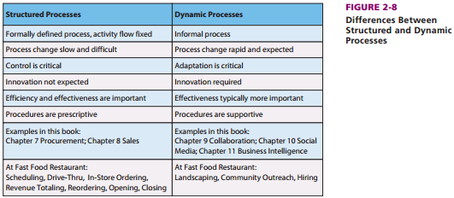
Efficiency: Accomplishing the process with minimum resources
Effectiveness: Process contributes directly to the organization’s strategy

What is Information?
- Knowledge derived from data(defined as recorded facts or figures)
Other definitions…
- Information is data represented in a meaningful context
- Information is processed data or processed through sorting, filtering, grouping, comparing and other similar operations
- Information is any difference that makes a difference

Ex: Information – wage of *all* hourly employee is 10.37$/hour
Data - Jake earns 11.50$/hour

Information is more than data…is meaningful from person to person…located inside you
Ex: someone’s wage, driving speed

Necessary data characteristics
- Accurate
- Timely (in time)
- Relevant

-To context
-To subject

- Just sufficient
- Worth its cost
How can I use these ideas about information?
- Assume it is hard to communicate
- Recognize that all new information systems are frustrating at first
- Understand how to be effective on a team
- Stay curious

Chapter 5
Important characteristics of Processes in Organizations
Business Process: Sequence of activities for accomplishing a function
Activities: Tasks within a business process
Resources: Items necessary to accomplish an activity
Actors: Resources that are either human or computers
Role: Subset of activities in a business process performed by a particular actor

Examples of processes

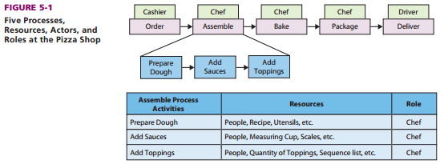
Characteristics of processes
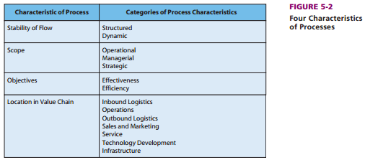

Structured: Predefined sequence
Dynamic: Informal
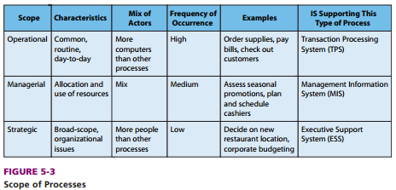

SCOPE OF PROCESSES

1. Operational processes: commonplace, routine, everyday business processes
- Procedures or instructions for these processes are changed very infrequently
- Typically computerized actors
- Because many actors contribute to this process, changing operational is more difficult than changing other types of processes
- Sometimes called transaction processing systems (TPS)
Ex: paying bills, ordering supplies

2. Managerial processes: concern resource use
- Include planning, assessing and analyzing the resources used by the company in pursuit of its objectives
- Occur less frequently and with many fewer computerized actors than operational processes
- Referred as Management information systems (MIS)
Ex: assessing seasonal promotions, planning and scheduling cashiers

3. Strategic processes: resolve issues that have long-range impact on the organization
- Broad scope and affect most of the firm
- Judgment and a tolerance for ambiguity are important
- More human actors
- Called executive support systems (ESS)
Ex: deciding where to locate a new restaurant, corporate budgeting, and new product introduction.

OBJECTIVES OF PROCESSES

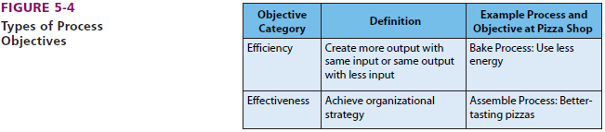

Objective: Desired goal an organization has decided to pursue

a) Efficiency: aims to conserve resources – doing things right
- process creates more output with the same inputs or the same output with fewer inputs
- Ratio of process outputs to inputs
Ex: Go green, or use less energy

b) Effectiveness: Effective objective helps achieve an organization strategy – doing right things
Ex: sell better tasting pizzas

Both of these objectives are
- Not mutually exclusive
- Can occur at any level of processes

What Are Examples of Common Business Processes?
- Location in Value Chain
- Inbound Logistics Processes
- Operations Processes
- Outbound Logistics Processes
- Sales and Marketing
- Customer Service

The Value Chain: value-adding activities
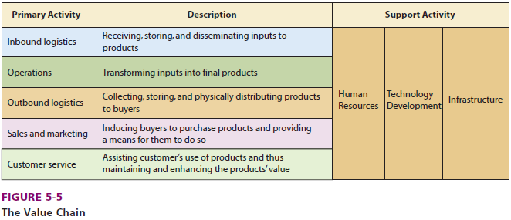

Primary activities

1. Inbound Logistics Processes: receive, store and disseminate product input
a) Procurement: operational process that acquires goods and services
Ex: ordering ingredients and boxes

b) Inventory management: Managerial process that uses past data to compute stocking levels, reorder levels and reorder quantities with inventory policy

c) Evaluate Potential Suppliers

2. Operations Processes: transform inputs into outputs- schedule the equipment, people and facilities to build or assemble a product or provide a service
Ex: scheduling maintenance of ovens

3. Outbound logistics processes: Collect, store and distribute products to buyers. Concern the management of finished-goods inventory and the movement of goods from that inventory to the customer.

Operational outbound process = Sales process= records the sales order, ships the product, and bills the customer

4. Sales and marketing processes: Provide means and incentives for customers to purchase a product or service.

5. Service processes: Track orders, customer support, customer support training

Support activities

1. Human Resources Processes: Assess the motivation and skills of employees, create job positions, investigate employee complaints and staff, train and evaluate staff

2. Technology Development Processes: Designing, developing and testing technology in support of the primary activities
Operation technology development= tests whether newly developed software can handle tens of thousands of possible keystroke entries

3. Infrastructure processes: Essential supporting processes in the organization that enable day-to-day operations. Processes in accounting, administration, quality assurance and legal and financial areas.

Applying Process Characteristics
  - Ask good questions about objectives
  - Standardize structured processes; keep dynamic processes fluid
  - Don’t confuse process and IS
  - Ensure processes work together

How management improves processes?

Process improvement: process better achieves its objectives based on its measures

-Process Objectives: Either efficient or effective
Ex: Sales in pizza shop – 2 objectives: efficiency: reduce time to place order / effectiveness: sell to freshman

-Process Measures: Measures (also called metrics) are quantities assigned to attributes. Also called key performance indicators (KPIs) by process improvement experts.
Ex: Measure of delivery=elapsed time in minutes and seconds from leaving the store until arrival at customer’s location

Best measures are reasonable, accurate and consistent

How Information Systems be used to Improve Processes?
- Improve an Activity
- Improve Data Flow Among Activities
- Improve Control of Activities (limit behavior)
- Use Automation
- Improve Procedures
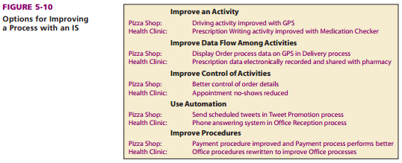

How can Process Management Principles improve Processes?

Process Management Principles

- Systems engineering
- Workflow/WfMc
- Business Process Modeling
- Six Sigma: Removing causes of defects, minimizing variability in the process (99,99966% of output free from defects)
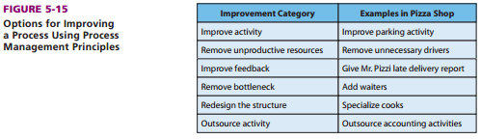
Bottleneck: when one activity reduces the performance of the overall process

How Do Process Teams Diagram Process Improvement?

Diagrams in Process Improvement
    - BPMN Diagramming: standard
    - As-is diagrams: Diagrams of the current process
    - Ought-to-be diagrams: Diagrams of suggested improvements
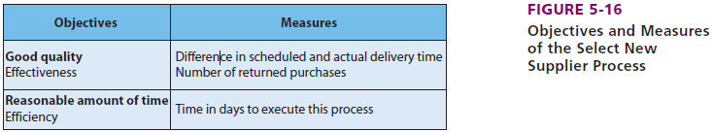

How Can an IS Hinder a Process?
- Information Silos: Data exists in isolated functional IS

Why Information Silos Exist? Data stored in separate databases because it’s cheaper to do so by department
The most significant technology for improving business processes is ERP (Enterprise Resource Planning)

What are the characteristics of good process measures? reasonability; accuracy; consistency

What are the three terms represented in the philosophy of SOA? (Service oriented architecture) service; encapsulation; standards

Which of the following is true about managerial processes? They rely on fewer computerized actors compared to operational processes.

Which of the following is true about strategic processes? They are broad in scope and impact most of the firm.

Chapter 6 (PSI)
What Problem does an ERP system solve?
- Information Silo Problem: Data isolated in separate information systems
Solution? Referred as enterprise systems
1. Enterprise Application Integration (EAI): Common data model and middleware
- Connects information silos via a new layer of software
- Enables existing applications to communicate and share data
- Integration of data across departmental boundaries
- Leverages existing sytems, leaving departmental information systems as is, but providing an integration layer over the top
  - Organizations to continue taking advantage of their current IT investments
  - Causes less disruption than an ERP implementation
- Enables gradual move to ERP
- Has no centralized database

EAI keeps files of metadata that describe where all the organization’s data are located*
Greates benefits: Enables organizations to use existing applications while alleviating many of the problems of information silos
Layer on top: ex: Accounting information system sends data to the HR information systems, EAI program intercepts the data and converts it to work in the format required by HR, and send the converted data on to HR system
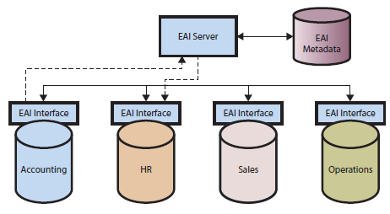

2. Enterprise Resource Planning (ERP): Centralized data repository (or single information system)
- ERP centralizes all processes previously supported by separate information systems
- Integrates data and supports processes across departmental areas
- Uses a single database ( avoids having multiple versions of one thing)
ERP predecessors
1. Material requirements planning (MRP): Efficiently manage inventory, production and labor (strong in manufacturing and supply processes
2. Manufacturing resource planning (MRPII): Added financial tracking capabilities and opportunity to schedule equipment and facilities
3. Just in time (JIT) delivery: Integrates manufacturing and supply- manufacturing occurs as raw materials arrive. Tight suppliers are needed
Sarbanes Oxley Act (SOX): federal law that exercised greater control over financial processes
Elements of an ERP system?
ERP includes applications that integrate the processes for the following functions:
  - Supply Chain Management (SCM): Procurement, sales order processing, inventory management, supplier management, and related activities
  - Manufacturing Resource Planning: Manufacturing scheduling, capacity planning, quality control, bill of materials, etc.
  - Customer Relationship Management (CRM): Sales prospecting, customer management, marketing, customer support, call center support
  - Human Resources Management: Payroll, time and attendance, HR management, commission calculations, benefits administration, etc.
  - Accounting/Finance: General ledger, accounts receivable, accounts payable, cash management, fixed-asset accounting
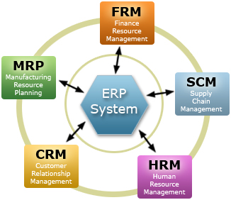

Key Performance indicators(KPIs):
Five components of an ERP System
- Software
- Hardware
- Data
- Procedures
- People

- Company installs the ERP’s software and databases on hardware
- Writes procedures
- Trains people to follow the procedures

ERP Software and Hardware
- Can be customized = configuration
- Configuration is very long, thousands of procedures, and data tables
- Writing new codes = customization
Types of data
1. Transactional data: Related to the activities conducted by the organization.
Ex: Customer orders, payment records, goods movements, etc.
2. Master data ( a.k.a reference data): data used in the organization that don’t change with every transaction. Often shared between different functional areas, processes, and system modules.
Ex: supplier names and addresses, item names, units of measure, employee data
3. Organizational Data: Data elements which model the organizational structure units in an enterprise.
Examples: plants, warehouses, storage locations, divisions, distribution channels, sales organizations, etc.
ERP - People
Executives and managers
Users: employees of the firm implementing the system
IT analysts (system analysts): employees with specialized training or education, that supports, maintains and adapt the system, they have background in MIS or IT.
Consultant: works for the ERP vendor, called a third party, helps budget, plan, train, configure, and implement the system.
Vendors
ERP Business Processes
1. Inherent processes (or process blueprints)
- System specified business processes
- Process blueprints
2. Customized processes
Gap analysis: Study that highlights the differences between the business requirements that emerge from strategic planning and the capabilities of the ERP system
Benefits of ERP System
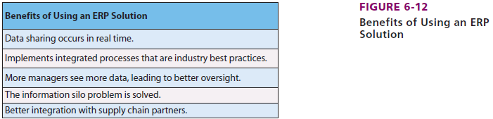
Dashboards: Up-to-the minute displays of process KPIs (key performance indicators)
Challenges of Implementing an ERP System
1. Decision making challenges
- Selecting the right ERP vendor
- Gap analysis: Deciding what you want ERP to do for your company
- Configuration decisions ex: decisions on wages, holidays
- Item identifier: does company want to identify or track every item in an incoming and outgoing shipment, bundle of items or just shipment?
- Order size: specify number of items in a standard order
- Bill of material (BOM): specifies raw materials, quantities, and subassemblies needed to create a final product
- Data issues: Format of data, duplications, who can enter and edit data
- Cutover pressure: During transition, adapting to new ways
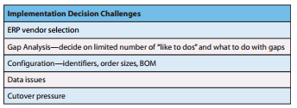
2. People Challenges
- Management moves on prematurely: when top management believes the hardest part of the implementation process is the decision to implement
- Management oversells: Overselling vision of what the system will do
- Management fails to anticipate cultural resistance: Can change culture (day-to-day work habits and practices) of an organization. Threatens worker’s self-efficacy
- Collaboration breaks down: no collaboration = implementation suffers
- Employees see little benefit: No gain for employees only organization
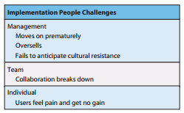

3. ERP Upgrades
- Version lock-up: Problems with upgrades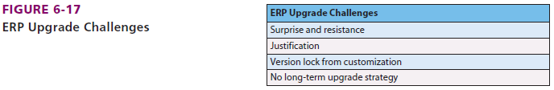
Main reasons for ERP failures
- Lack of purpose for implementing ERP
- Not having “eyes wide open” (unrealistic expectations)
- Lack of executive and management buy-in
- Not choosing software that is aligned with the business
- Misalignment between software configuration and business processes
- Lack of effective organizational change and training
- Weak internal and external project management

Types of organizations that use ERP?
Indutry type:
  - Manufacturing
  - Distribution & transportation
  - Mining, material extraction, petroleum
  - Medical care
  - Government and public service
  - Education
  - Retail
  - Utilities

Organization size:
  - Large
  - Recently also medium- and small-size

International ERP
- Global enterprises: Many languages and currencies

Major ERP vendors
- Microsoft Dynamics (10%)
- Four ERP products: AX, Nav, GP and SL
- Oracle (15%)
- SAP (22%): System, Application, Product
- Industry specific platforms: preconfiguration platform that is appropriate for a particular industry
- Module: distinct and logical grouping of processes
- Outside of Tier 1 (53%)

All SAP implementations start with an SAP industry-specific platform
A architect is a high-level planner of IS who ensures compatibility of technology and directs technology toward strategic goals.
A systems analyst understands the technical aspects of ERP and helps plan, configure, and implement an ERP system for company use.
Just-in-time delivery synchronizes manufacturing and supply-manufacturing occurs just as raw materials arrive.
The customization of ERP software to meet different customer requirements without changing the program code is called configuration
Which of the following documents does a firm receive from its suppliers and contains details such as the amount due to the supplier? itemized bill
Which of the following statements is true about an EAI system?
Select one:
a. It prohibits information silos from communicating with each other and sharing data.
b. It provides users with access to metadata files that describe the location of an organization's data.
c. It utilizes a centralized database.
d. It appears as an integrated database to the user.

Which of the following statements is true about Oracle and its ERP products?
It is known to produce fully featured products with superior performance.
Which of the following supply chain processes is strategic in nature? evaluation of suppliers

Chapter 6 (EMIS)
Networks and Collaboration
- Networks allow you to send and receive email, browse web pages stored across the globe, download audio and video files, and even talk to friends using the telephone
- When connected to the Internet, you are part of a functioning network of networks containing millions of computers
Collaboration: When two or more people work together to achieve a common goal, result or product
- involves communication and coordination, and often makes us use computer networks
- produces results greater than those produced by individuals alone
Effectiveness of collaborative effort driven by 4 factors
- Communication skills and culture
- Key to effective collaborative effort: ability to be in group, give and receive critical feedback important for employers
- Criticize each other without bad feelings
- Communication systems
- Availability of email, virtual private networks, instant messaging, and sophisticated communications systems is crucial
- Content management
- Multiple users are contributing and changing documents, schedules, task lists, assignments
- Workflow control
- Process or procedure by which content is created, edited, used and disposed of
- Delivering a g/s internally to other employees
Not all equally important
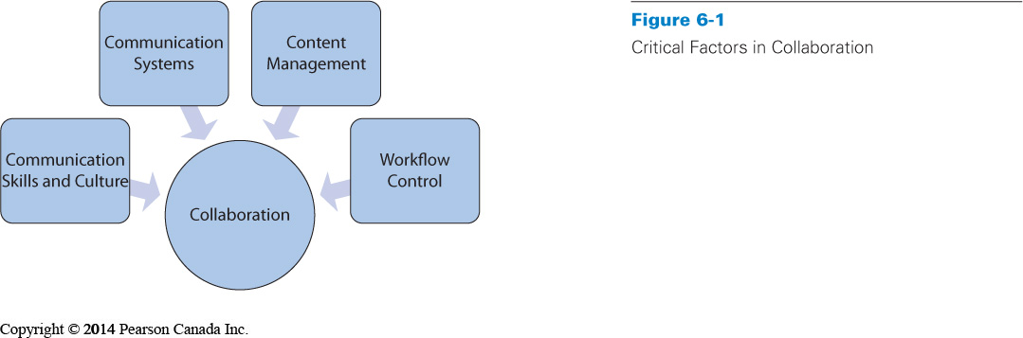
Network Externalities
Network externality (or network effect): the larger the number of people using a network, the more valuable that network becomes
- When networks are first started, people often look for the critical mass
Critical mass: value of being part of the network is larger than the cost of being on it
- When networks hit critical mass, they usually grow at a faster rate
- Network growth leads to congestion problems or the market may become saturated

What is a Computer Network?
Computer network: collection of computers that communicate with one another over transmission media
Transmission media: might be physical media, such as copper cable and optical fibre or wireless media transmitting light or radio frequencies
Three basic types:
- Local Area Network (LAN): connects computer within a small, single geographical location (1)
  - Communication lines can be placed where the organization wants
- Wide Area Network (WAN): connect computers at different geographical locations (two or more separate sites)
  - Uses communication networks from vendors, licensed by government
- Internet: Networks of networks
  - Connects LANs, WANs and other internets
  - The Internet (the famous internet) : collection of networks that you use to send email or access a website
  - Internets: Private networks of networks
  - Use a variety of communication methods and conventions
    - Seamless flow of data provided by layered protocol
Layered protocol: Set of rules that two communicating devices follow (they use same protocol)
Components of LAN
Local Area Network
- Computers connected on a single company site
- Usually located within half mile area
- Property controlled by company operating network
  - company can run cabling as necessary
Components
- Switch: special purpose computer that receives and transmits messages on the LAN
- Network Interface Card (NIC): hardware that connects each device’s circuitry to the cable
  - onboard NIC or card that fits into an expansion slot
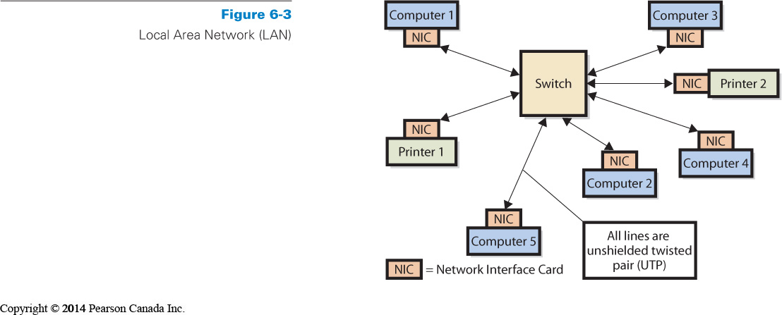
Network Interface Card (NIC)
- Each device on a LAN has a hardware component called network interface card
- NIC connects the device’s circuitry to network cable
- MAC (Media Access control) address - Unique identifier
- Media connections
- Unshielded twisted pair (UTP) cable
  - RJ-45 connector: connects UTP cable into NIC devices on the LAN
- Optical fibre cables: Light rays reflected inside glass core surrounded by cladding
    - Uses ST and SC connectors
Network Interface Card
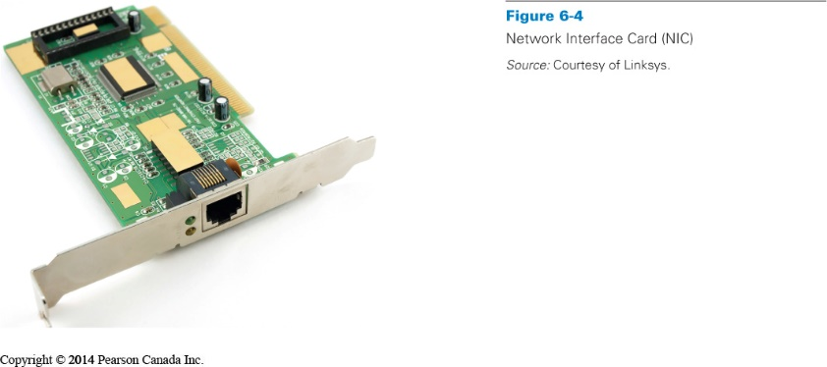
IEEE 802.3 (Ethernet), Protocol

IEEE 802 Committee: Electrical and Electronics Engineers that addresses LAN standards
- IEEE LAN protocol always starts with 802

Ethernet protocol standard
- Specifies hardware characteristics (which wire carries which signals)
- Describes how messages are packaged
- Determines how messages are processed
- Operates at Layers 1 and 2 of TCP/IP-OSI architecture
- Personal computers usually support 10/100/1000 Ethernet
  - transmission rate of 10, 100, or 1000 Mbps (megabits per second)
  - k=1000
  - M=1 000 000
  - G= 1 000 000 000
  - 100 Mbps = 100 000 000 bits per second
  - Communication speed is bits, Memory sizes is bytes
Wireless LANs

Wireless LANs: Computer network that allows users to connect without using a network cable
- Popular names: 802.11 or Wi-Fi

Wireless NIC (WNIC) in a smartphone: lets users move around and stay connected to his network

LAN operation
  - NICs operate on 802.3 protocol
  - WNICs operate on 802.11 protocol (Wi-Fi)
  - WNICS connect to Access Point (AP) (Point d’accès sans fil)
    - AP processes both standards

Coverage of wireless access points range from 40 to 100 meters

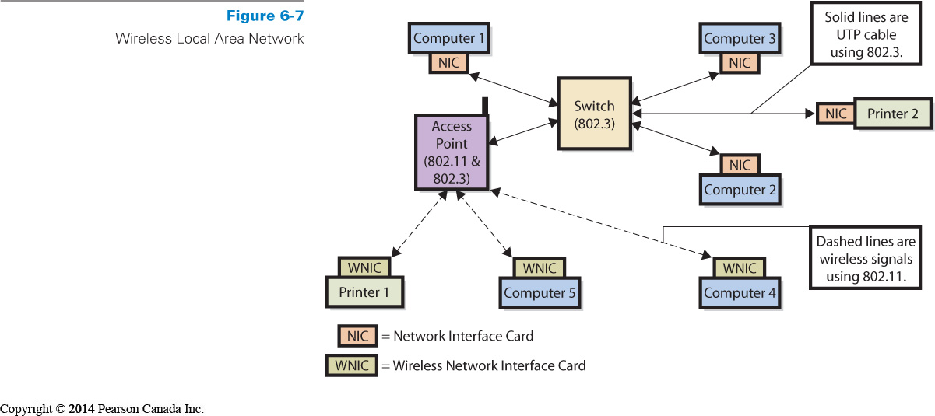

Why is Mobile Computing Important?
Two trends for accessing the Internet:
- Your computer is likely to be a portable laptop than desktop
  - Your new smartphone or other highly portable device such as a tablet
- Cellular phones are no longer just phones
- Mobile devices provide a wide variety of services
- Mobile devices are built for communication and collaboration
Mobile devices
- Combines a powerful processor with sophisticated operating systems and cellular network technology
- Provide a host of applications such as voice, text, email, web browsing, etc
- User of mobile devices can access email, instant message, respond via voice or text messaging, browse the Internet anywhere
- These devices change the way that people work, and more changes are still being expected

Smartphones
- M-commerce: Mobile commerce, conduct new kinds of transactions (banking, ticket purchases), mobile coupons are replacing paper coupons
Smartphone Basics
- Design to be easy to use and most smart phones operate on a 3G (3rd Generation) network
- 3G: group of standards for wireless communications
- The difference between 2G and 3G is that 3G provides higher data transfer rates and allows for simultaneous use of voice and data transfer
- Before buying a cell phone you need to understand the operating system at the foundation of each phone
- Users do not need to know intricacies of mobile device networks
- Before purchasing a smartphone, you need to think about how and where you will use it
- Telecommunication companies may not have the same types of technology outside Canada
- Systems compatibility is a factor that must be considered
- Understanding operation system (OS) is a factor that a user must also consider
- Examples of OS: Blackberry OS, iPhone OS, Windows Mobile, Android and Linux

Tablets and eReaders
- hybrid-type devices that fill a gap between small handheld smartphones and notebook computers
- eReaders, such as the Amazon Kindle or Barnes and Noble Nook, were originally designed mainly for reading books and magazines
- Tablets, such as the Apple iPad, were designed for more general use, for example, email and Internet browsing
- Issues in these devices include support, security, synchronization complexity and ownership
- Bring Your Own Device (BYOD): encourage workers to work with their own devices for work rather than additional company-issued devices
What to know about connecting to the Internet
- The Internet is a Wide Area Network (WAN)
- WANs connect computers at separate sites
  - No cabling between sites
  - Cable connections made through licensed communications companies
  - Routers implement the protocol for WANs
- Internet Service Provider (ISP):
  - Provides legitimate Internet address
  - Serves as gateway to the Internet
  - Pay for the Internet

Web: subset of the internet, consists of sites and users that process the hypertext transfer protocol (HTTP).
Browsers: Programs that implement the HTTP protocol, Mozilla Firefox and Internet Explorer
Hypertext transfer protocol (HTTP):

Names and addresses
- Rules for naming sites on the Internet
- Top-Level Domain (TLD)
  - .ca, .com, .org, .biz
- Uniform Resource Locator (URL)
  - easy to remember address on the Internet
- IP address is a numbered address for each machine connected to the network (logical address)
  - Public IP addresses are used on the Internet
  - IP addresses are used within private networks and internets
  - ex: 194.532.7532.45
Two types of IP addresses
  - Public IP addresses are used on the Internet
  - Private IP addresses are used within private networks and internet – they are controlled only by the private company that operates them
DHCP Server
  - Dynamic Host Configuration Protocol server is a computer or router that host a program called DHCP
  - DHCP assigns a temporary IP address to your computer
  - Whey you disconnect, the IP address is available again
  - The DHCP server re-assigns it when it is needed

Domain Names
- Domain Name System (DNS): converts human-friendly URLs into computer-friendly IP addresses
  - Domain name resolution: Conversion of domain name into a public IP address. Done by domain name resolvers
- Three ways of connecting Home and small-business computers to an ISP (internet service provider)
  - through a regular telephone line
  - through a special telephone line called a DSL line
  - through a cable TV line

Analog versus Digital Signals
- Those three connections require that the digital data in the computer be converted to an analog, or wavy, signal before being sent
- When receiving data, the analog signal must be converted to a digital signal before the computer can read it
- A device called a modulator/demodulator, or modem, performs these conversions
- Different modems use different protocols and speeds

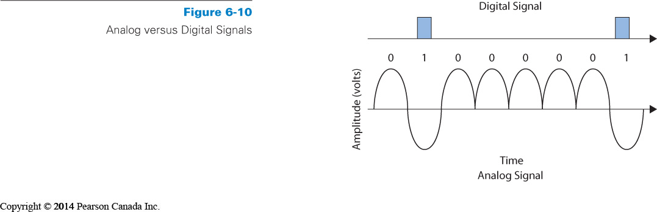
Types of modem
- Dial-up modems
  - Operate over regular telephone lines
  - Interfere with voice telephone service
  - Perform conversion between analog and digital
  - Connection made by dialing ISP’s phone number
  - Maximum transmission speed of 56 kbps
- Digital Subscriber lines (DSLs)
  - operates on the same lines as voice telephones, but the signal does not interfere with voice telephone service
  - Faster data transmission than dial-up
  - Connection always maintained
  - Download and upload speeds vary
    - Asymmetric Digital Subscriber Lines (ADSL): DSL lines that have different upload and download speeds
    - Symmetrical Digital Subscriber Lines (SDSL): provide fast speed, with same receiving and transmitting speed in both directions
- Cable modems
  - Provide high-speed data transmission
  - Connection always maintained
  - Use cable television lines
    - High-capacity optical fibre cable run to neighborhood distribution centre
    - Television cables connect at distribution centre and run to subscribers (up to 500 per one center)
    - Do not interfere with television transmission
  - Transmission speeds
    - Narrowband – less then 56 kbps
    - Broadband – in excess of 256 kbps
All require digital data in the computer to be converted to analog
  - Modem (modulator/demodulator) device performs conversion
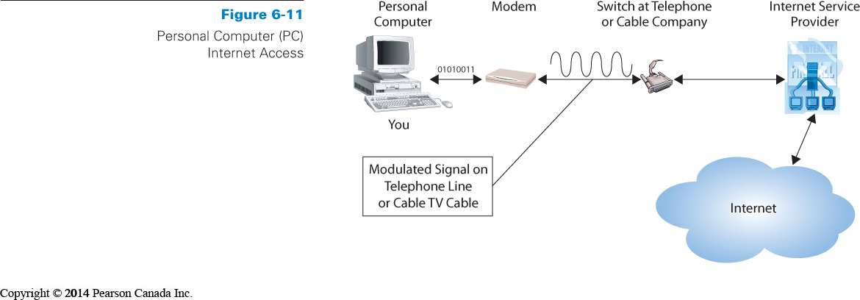
Wireless WAN
Wireless WAN (WWAN)
  - Covers a larger area
  - Use cellular networks to transfer data
- Portable computer with a wireless WAN modem connects to a base station on the wireless networks via radio waves
- Radio tower carries the signal to a mobile switching centre, where the data are passed on to the appropriate network
- Wireless service provider then provides the connection to the Internet

IETF Network Levels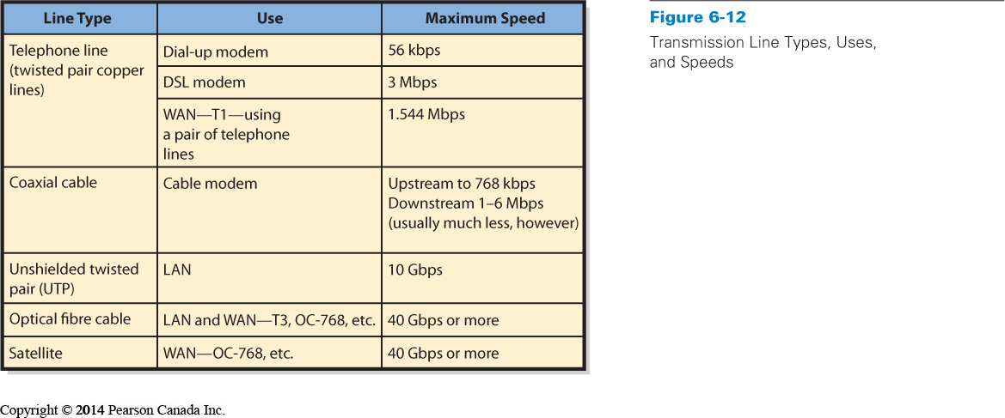
How email actually work?

Network Layers
- Transmission Control Program/Internet Protocol (TCP/IP)- four-layer scheme
    - Layer 1 is used to transmit data within a single network
    - Layers 2 & 3 are used for data transmission across an internet
    - Layer 4 provides protocols that help different applications interact with each other and the person using the computer
Emailing Steps
- Getting Internet Access and Pressing “Send/Receive”
  - Layer 4, Simple Mail Transfer Protocol (SMTP)
- Break Apart Message and Get Ready for Transport
  - Layer 3, Transmission Control Program (TCP)
- Send and Receive Packets
  - Layer 2, Internet Protocol (IP)
- Reassemble Packets and Display Message

Packet: unit of data unit of data that is routed between an origin and a destination on the Internet or any other packet-switched network.

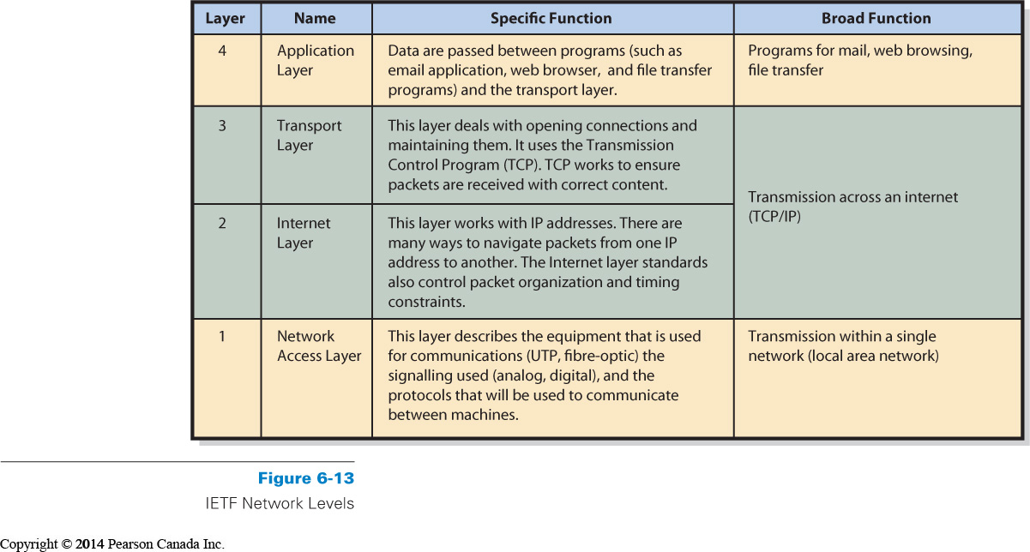
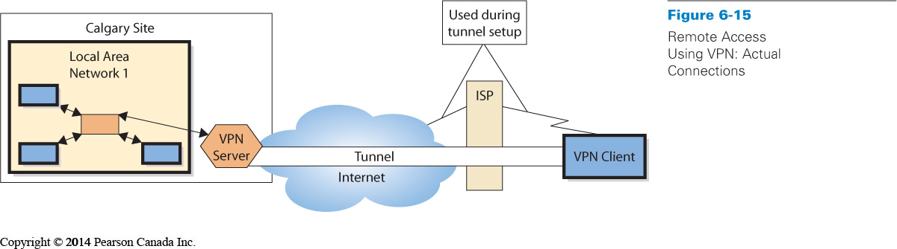
What are Firewalls, Encryption and VPNs?
Firewall: Computing device that prevents unauthorized network access
- May be special-purpose computer or program
- Access Control List (ACL) encodes rules stating what packets are allowed or prohibited ex: blocking certain sites from employees
- Organizations may have multiple firewalls
  - Perimeter firewalls sit outside organizational network
  - Internal firewalls are inside network
  - Packet-filtering firewalls examine source address, destination address, and other data before allowing message to pass ex: hacker addresses
- May filter both incoming and outgoing messages
Encryption
- Process of transforming clear text into coded, unintelligible text for secure storage or communication
- A key is a number used to encrypt data
- Coding and decoding messages are done using encryption algorithm
- Types of Encryption
  - Symmetric: the same key is used to encode and to decode
  - Asymmetric: different keys are used; one encodes the message, and the other decodes the message
- Symmetric encryption is simpler and much faster than asymmetric encryption

Flow of Symmetric Encryption
- Your computer obtains the public key of the website to which it will connect
- Your computer generates a key for symmetric encryption
- Your computer encodes that key using the website’s public key. It sends the encrypted symmetric key to the website
- The website then decodes the symmetric key using its private key
- From that point forward, your computer and the website communicate using symmetric encryption

The Virtual Private Network (VPN)
- Virtual Private Network (VPN): additional WAN alternative
  - Uses the Internet or private internet to create appearance of private point-to-point connections
  - Uses public Internet to create appearance of private connection
  - Client and server have point-to-point connection called a tunnel
    - Tunnel: private pathway over shared network
  - Secure, encrypted communications
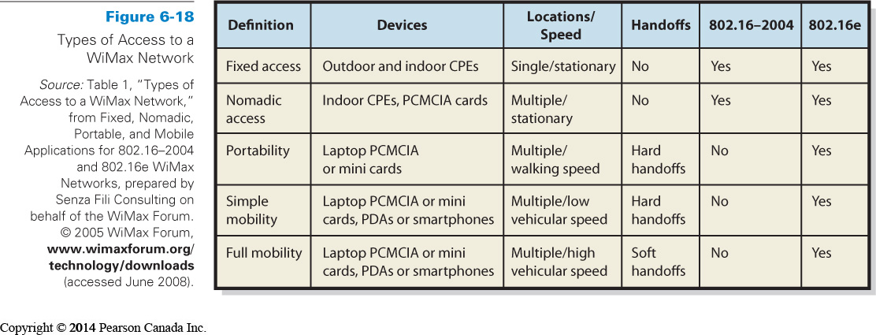
How Search Engines Work?
- Search engines are a tool used to search for information on the Internet
- Web search engines require two things:
  - a way to collect URLs
  - a method for storing/accessing the URLs so that they can be searched
- Web crawlers browse the web to find URLs
- Search engine indexing
  - creates indexes for the results from the web crawling
- Search engine needs understanding of breadth of coverage and the ordering of the results from a search

A layered protocol is used to provide seamless flow of data across networks

A commerce server receives requests from users via the Web server, takes some action, and returns a response to the users via the Web server.

The Web is the Internet-based network of browsers and servers that process HTTP or HTTPS.

What is the protocol commonly used for wireless LAN? IEEE 802.11n
Which of the following protocols is commonly used by LAN? IEEE 802.3
Which of the following statements about LAN protocols is true? The access point uses both the 802.3 and 802.11 standards.

Chapter 7

Fundamentals of a procurement process?

Procurement: Process of obtaining goods and services such as raw materials, machine spare parts and cafeteria services. Operational process executed many times a day in a large organization.
- Order
- Receive
- Pay
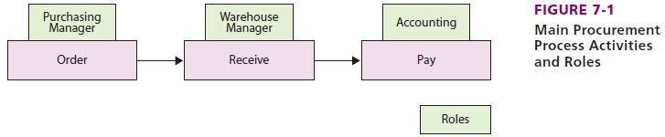
Procurement objectives: Saving money and time, finding reliable, high-quality suppliers, seek less errors

Supporting the Inbound Logistics Process within the Value Chain
  - Procurement of raw materials needed for production
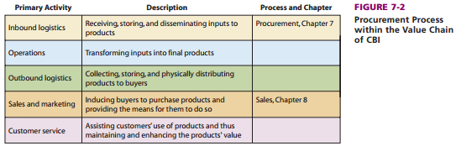

Linking the Fundamentals of the Procurement Process with Inbound Logistics in the Value Chain
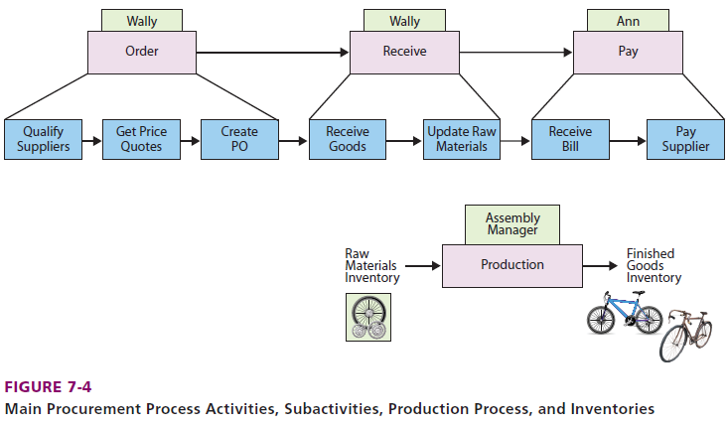

Each computer role has an information silo

Lead time: Time required for a supplier to deliver an order
How Did the Procurement Process at CBI Work before SAP?

Six Roles
  - Two roles performed by people
    - Warehouse Manager and Accountant
  - Four roles performed by separate computer applications with separate databases (DB)
    - Sales DB; Purchase Order DB; Warehouse DB; and Accounting DB

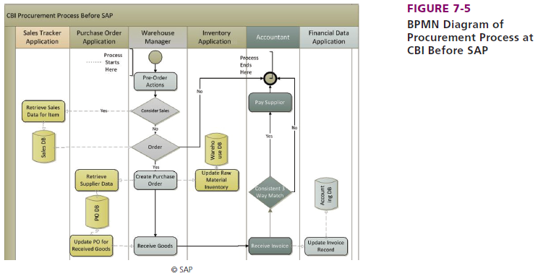
Three-way match: invoice, purchase order, receipt for goods

Information Systems Silos
  - Sales DB: Monitor demand for materials
  - Purchase Order DB: Manage purchase order information
  - Warehouse Database: Manage inventory levels
  - Accounting DB: Manage payables

CBI’s Procurement Process
  - Involved several roles
  - Resulted in information silos
  - Inefficiencies

Procurement problems before SAP
- Warehouse problems
- Manager lacked sales data
- Accounting problems
- Three-way match for payment was a challenge
- Correcting discrepancies were labor intensive
- Time delays in updating accounting data
- Purchasing problems
- Purchasing wasn’t centralized
- Inexperienced users
- Errors in data entry
- Pressure for greater financial controls (Sarbanes Law)

CBI implements SAP to provide ERP solutions

How does CBI implement SAP?
- Reexamine and refocus their strategy (gap analysis too)

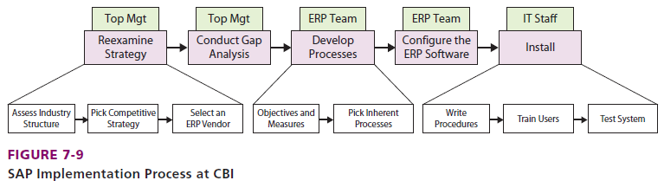
Purchase requisition (PR): internal company document that issues a request for a purchase

How does CBI implement SAP?

1. Determine industry structure
  - Porter’s Five Forces
    - Strong rivalry with low switching costs
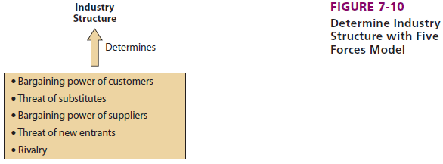

2. Commit to a specific competitive strategy
  - Differentiation strategy of responsiveness
  - Focus on high end bikes
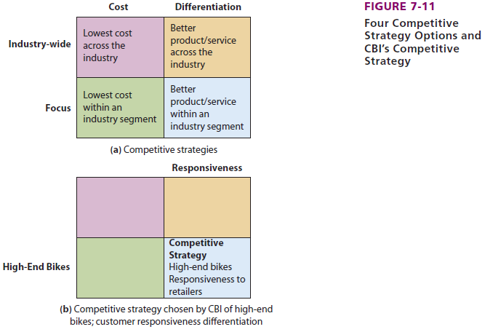

3. Develop objectives and measures for processes
  - ERP Team
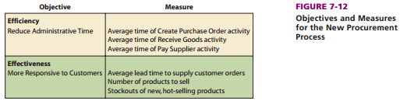

Clear approach to implementing SAP
  - Found their position in their industry
  - Defined a competitive strategy
  - Created objectives and measures for their processes

How Does the Procurement Process Work at CBI after SAP?

- Maintained same three major activities
  - Order; Receive; and Pay
- Solutions to prior problems
  - Purchasing
  - Warehouse
  - Accounting
- Benefits of SAP

New Purchase Process
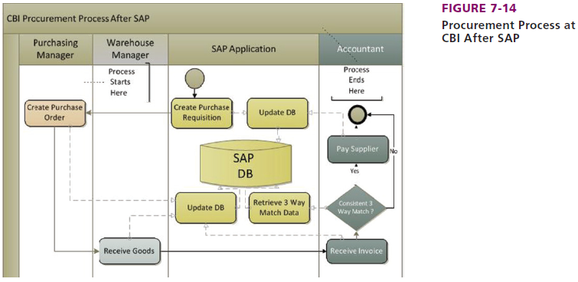

Warehouse
  - Goods receipts entered into same database as PO’s
  - SAP verifies the goods received against the PO
  - Immediate update to inventory
  - SAP documents this in the database

Accounting
  - Three-way check completed by SAP
    - Less labor intensive
    - Incoming invoices are compared to PO and Goods Receipt for verification
  - Payment simplified
  - Accounting updated automatically in SAP
  - SAP documents these steps in the database
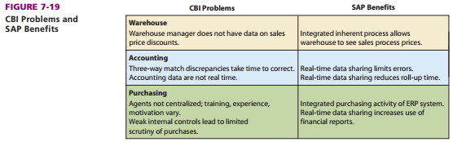
How Can SAP Improve Supply Chain Processes at CBI?

1. Supply Chain Processes
  - Supplier Relationship Management (SRM): automates, simplifies, and accelerates variety of supply chain processes. Management process that helps companies reduce procurement costs, build collaborative supplier relationships, etc.
  - Returns Management: manages returns of faulty products for businesses
  - Supplier Evaluation: Criteria for supplier selection and adds and removes suppliers from the list of approved suppliers
  - Supply Chain Management (SCM): design, planning, execution and integration of all supply chain processes
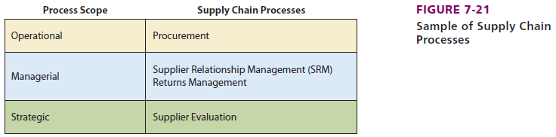

2. Improving Supply Chain Processes by Sharing Data
- Process integration improves with sharing data
Bullwhip effect: companies order more supplies than are needed due to a sudden change in demand
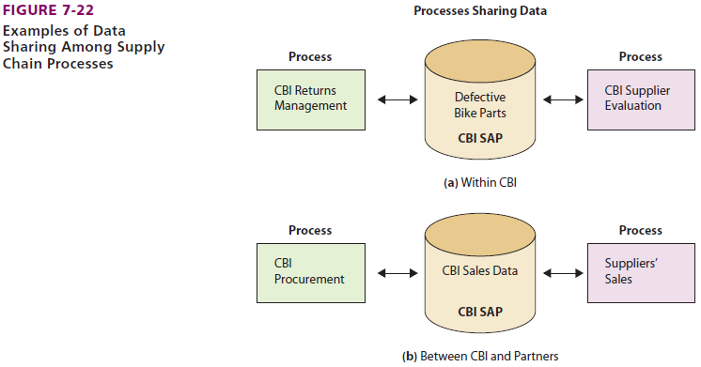

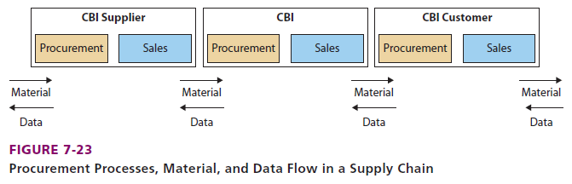
3. Improving Supply Chain Processes with Integration
Bottleneck: limited resource greatly reduces the output of an integrated series of activity or processes
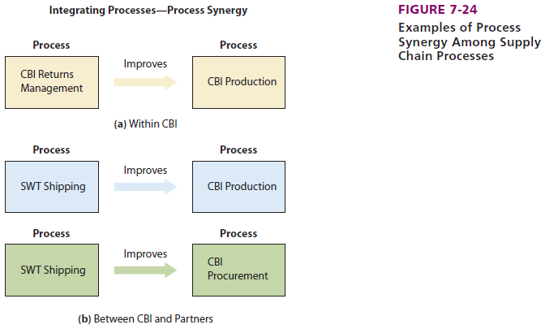

4. Improving CBI Processes beyond the Supply Chain
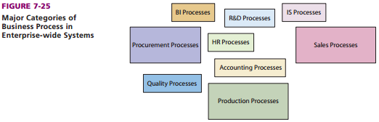

How Does the Use of SAP Change CBI?
- New skills are needed
- Process focus
- More data sharing
- Outsourcing

What New IS Will Affect the Procurement Process in 2024?
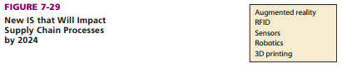

Augmented reality (AR): Computer data or graphics are overlaid onto physical environment
Radio-frequency identification (RFID): identity and track items in the supply chain
3D Printing (additive manufacturing): objects manufactured through the deposition of successive layers of material

Web 2.0 : User generated content ex: Youtube, Facebook

Chapter 5a
Who will volunteer?
Fundraising manager needs database to:
  - Find volunteers
  - Track volunteers
    - how many years
    - effectiveness
    - personal information

How are Database Application Systems Developed?
Database application system consists of:
  - Database
  - DBMS (Database Management System): Collection of programs that enables you to store, modify, and extract information from a database.
  - One or more database applications
Database Application:
- Forms
- Reports
- Queries
- Application programs
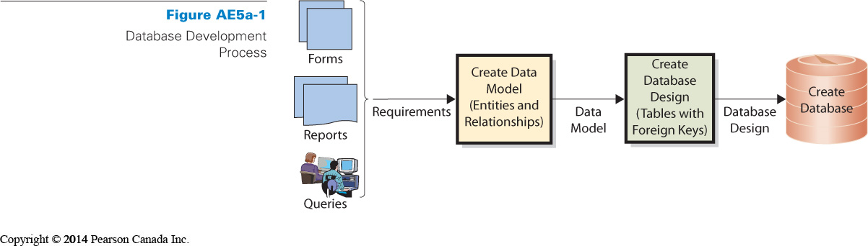
Database application system development
- Developers interview users
- Develop requirements for new system
- Analyze existing reports, forms, and user activities
- Requirements summarized in data model
- Data model: Logical representation of structure of data. Contains description of data and relationships
- Users validate and approve the data model
- Design implemented in a database / Transformed into a database
- Database filled with user data
Database should include the following:
- Must include all data necessary for users to perform jobs
- Contains only that amount of data, and no more
- Developers rely on users to:
  - Tell them what to include
  - Check data model
  - Verify correctness and completeness

What Are the Components of the Entity-Relationship Data Model?
Techniques to create a data model
1. Entity-relationship (E-R) data model: describe content of a database by defining the things (entities) that will be stored in the database and the relationship among those entities
2. Unified Modeling Language (UML)
Entity
- Something that users want to track
- e.g., Order, Customer, Salesperson, and Item
- May be:
- Physical object (e.g., Item or Salesperson)
- Logical construct or transaction (e.g., Order or Contract)
- Entity names are always singular
- Entities have:
    - Attributes: describe characteristics of the entity
    - Identifier : attribute (or group of attributes) whose value is associated with one and only one entity instance
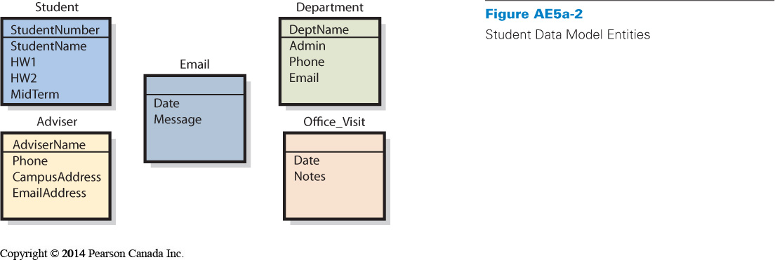
Relationships
Entities have relationships to eachother
- 1:1 relationship: Single entity to single entity
- 1:N relationship
  - One-to-many
  - Single entity to many entities
- N:M: Many-to-many

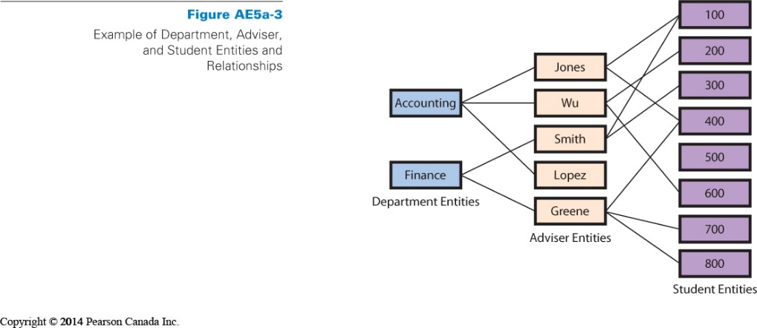

E-R Diagrams
- Rectangles represent entities
- Relationships shown by lines
- Crow’s foot
  - Forks at end of lines
  - Indicate more than one relationship
  - Read “many”
- Vertical line means at least one entity of that type
- Small oval means entity is optional
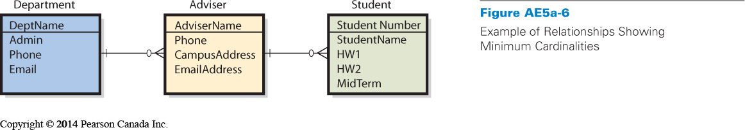
Cardinality
Number of entities that can be involved in relationship
- Maximum cardinality
-Maximum number involved
-ex: 1: N, N: M, 1:1
- Minimum cardinality
-constraints on minimum requirements

How Is a Data Model Transformed into a Database Design?

Database design: Process of converting a data model into tables, relationships, and data constraints

  - Transforms entities into tables
  - Expresses relationships
    - defines foreign keys
  - Shows data constraints

Normalization: Process of converting poorly structured tables into two or more well-structured tables

Data Integrity Problems:
  - Different names for the same entity
  - Produces incorrect and inconsistent information
  - Resolve by eliminating duplicated data
Normalizing for Data Integrity
- Eliminate data duplication
- Slower to process
- Construct tables such that every table has single topic
How is a data model transformed into a database design?
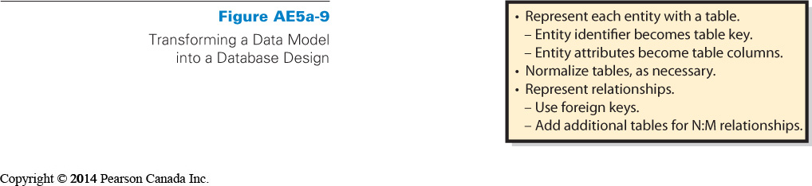
Normal form: Remove duplicated data and other problems is called normalizing the table

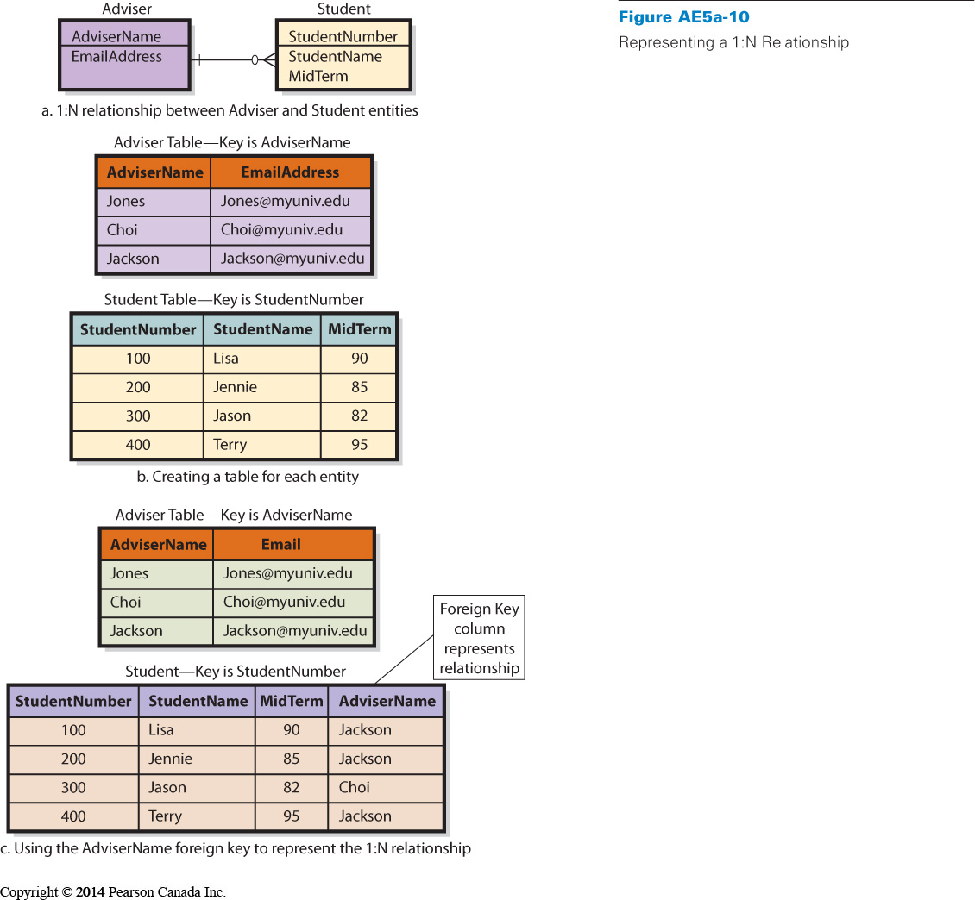

Relational Database Design
- Designer creates table for every entity
- Entity identifier becomes primary key of table
- Attributes of entity become columns
- Tables normalized to single theme
- Represent relationships between tables
- Add foreign key to one or more tables

User’s role
- Final judges as to what data should contain
- Determine how records are related to each other
- Need to review data model
- Must insure that model reflects an accurate view of business

Who will volunteer?
- Consultant creates data model
  - Based on interviews with users
- Data model reviewed and approved
- Database tables constructed
  - Primary and foreign keys selected
    - based on interviews
- Microsoft Access database created
  - Relationships indicated
  - Forms and reports constructed
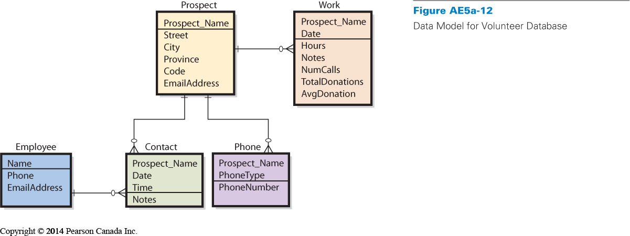

A key is a column or group of columns that identifies a unique row in a table.
Bytes are grouped into columns, which are also called fields

In a database, a byte refers to a character of data.
In a database, rows are also known as records

Chapter 9
What is E-commerce, and how is it used?
E-commerce: Buying and selling of goods and services over public and private computer networks
- This definition restricts e-commerce to buying and selling transactions
- Checking the weather at yahoo.ca is not e-commerce, but buying a weather service subscription that is paid for and delivered over the Internet is

E-commerce has a number of implications
  - Technology perspective: Defines the need for additional infrastructure
  - Management and governments perspective
    - Coordination for smooth business operations
    - Security must be enabled

1. Merchant companies: that take title to the goods they sell, buy goods and resell them, sell services that they provide

- Business-to-consumer (B2C) :Sales between a supplier and a retail customer (the consumer)
- Business-to-business (B2B) : Sales between companies
- Business-to-government (B2G): Sales between companies and governmental organizations

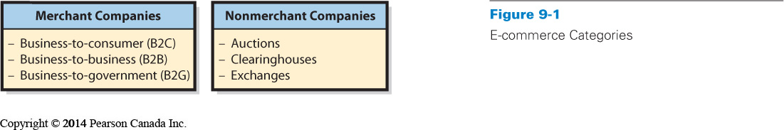
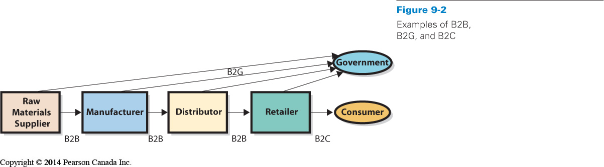

2. Nonmerchant companies: arrange for the purchase and sale of goods without ever owning or taking title to those goods, sell services provided by others, ex: auctions and clearinghouses
- E-commerce auctions match buyers and sellers by using an e-commerce version of a standard auction
- Clearinghouses provide goods and services at a stated price and arrange for the delivery of the goods, but they never take title (sits in the middle of a transaction) ex: section of Amazon.ca, sells books owned by others
- Electronic exchanges match buyers and sellers; the business process is similar to that of a stock exchange

Benefits of E-commerce
- Disintermediation: removal of intermediaries between parties
- Higher revenues for manufacturers and lower consumer prices

Market consequences of E-commerce
- Greater market efficiency
  - Disintermediation
  - Increased information on price and terms
- Knowledge of price elasticity
  - Losing-bidder auction prices
  - Price experimentation
  - More accurate information obtained directly from customer

Price elasticity: measures how much demand rises or falls with changes in price

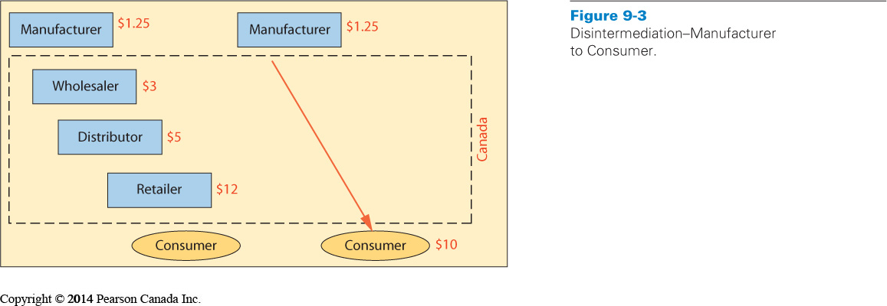
Issues with e-commerce
- Channel conflict
- B2G, B2B
- Price conflict
- Because of disintermediation
- Logistics expense
- Processing and entering orders
- Customer service expense
- Increases b/c they sell directly to customers
- Showrooming
- customer tries a product in store but buys online
- Taxation
- Different taxation in the provinces and countries

What is Social Networking, and How is it Enabled and Affected by IS/IT?

Social network: Structure of individuals and organizations that are related to each other in some way
- Social networking is the process by which individuals use relationships to communicate with others in a social network

Business literature defines three types of capital:
  - Physical: the investment of resources for future profit
Ex: machines, manufacturing equipment
  - Human: the investment in human knowledge and skills for future profit
Ex:school
  - Social: investment in social relations with the expectation of returns in the marketplace
Ex: attending a business function to network

Social Capital adds value in four ways:
  - Information : opportunities, alternatives, problems, etc to business professionals
  - Influence: influence decision makers in one’s employer or organizations
  - Social credentials:
  - Personal reinforcement

The Importance of Weak Relationships
- Strong relationships create the most social capital in a social network
- Weak relationships contribute the most to the growth of social networks
- Weak tie: the people you know the least but they contribute the most to your network
- Weak links add the greatest number of new connections to your social network
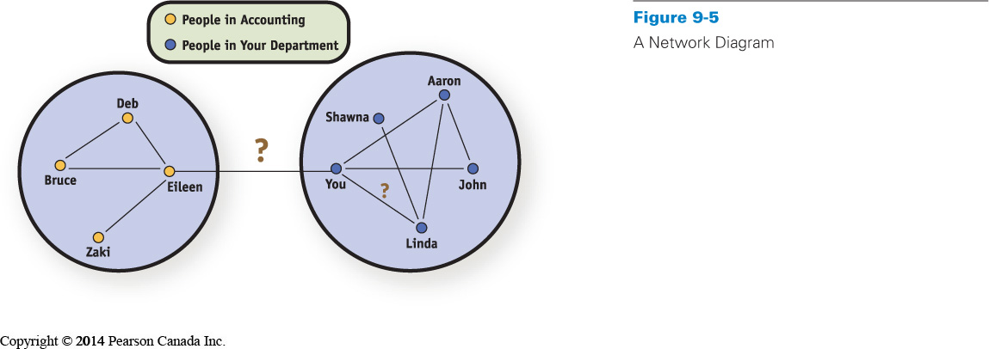
How Do Social Networks Add Value to Business?

- Organizations have social capital just as humans do
- Social capital is measured using: number of relationships, strength of relationships, and resources controlled by “friends”
- Endorsements by high profile people are a traditional way of increasing social capital
- Progressive organizations maintain a presence on Facebook, LinkedIn, Twitter, and possibly other sites

How is Social Networking Enabled by IS/IT?

Besides the ubiquity of computers and the relative low cost, three other considerations and benefits of technology are:
  - improved search capabilities
  - reduction in the trade-off of richness and reach
  - network effects

What is Web 2.0?
Web 2.0: Describe applications and platforms on the web
  - Tim Reilly is noted for helping to establish the concept of Web 2.0
  - Examples include smartphones, user created content, social networking, location and context-based services and dynamic marketplaces
  - Google, Amazon.com, and eBay exemplify Web 2.0

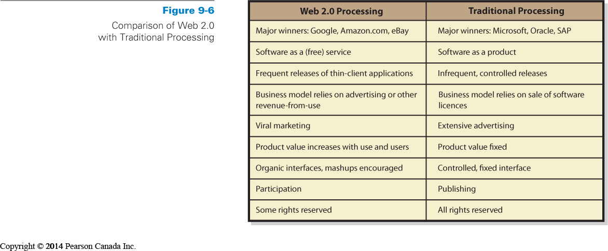
Software as a service (SAAS)
- Web 2.0 companies do not sell software licenses because software is not their product
- Instead, they provide software as a service (SAAS)
- Several software items are obtained from a thin-client browser, with the bulk of the processing occurring in the cloud, somewhere on the Internet
- The Web 2.0 business model relies on advertising or other revenue that results as users employ the SAAS
- Traditional software vendors depend on software license fees

Use Increases Revenue
- Another characteristic of Web 2.0 is the extent of network effects
- The value of the site increases with users and use
- Example: Amazon.com gains more value as more users write more reviews
- User-generated content (UGC) refers to website content that is contributed by users
ex: livejournal
- On some sites, users provide customer support to one another in the creation of product specifications, designs, and complete products in a process called crowdsourcing ex: kickstarter

How can Businesses Benefit from Web 2.0?
- Amazon.com, Google, eBay, and other Web 2.0 companies pioneered Web 2.0 technology and techniques to their benefit
- Businesses use Web 2.0 as follows:
  - Advertising
  - Mashups
- Not for all applications
  - Note that not all business information systems benefit from flexibility and organic growth
  - There is need for some level of control

Is there a Web 3.0?
- Web 2.0 is thought to be preceded by Web 1.0, and that it will be followed by Web 3.0
- It is hard to predict the future as some changes are discontinuous and the invention and use of technology are hard to predict as well
- Web 2.0 is a broad overarching term
- We cannot predict what Web 3.0 will look like (or even if it will be called “Web 3.0”)
- Nobody knows what the next generation of inventors and entrepreneur will invent

A folksonomy is a content structure that has emerged from the processing of many user tags

Content data is data and responses to data that are contributed by users and SM sponsors.
Social media sponsors are companies and other organizations that choose to support a presence on one or more SM sites.
Which of the following is true about Web 2.0 applications? They are subject to frequent interface changes.
Which of the following is true of social networking problems? Responses are best reserved for when the problematic content has caused the organization to do something positive as a result.

Chapter 10
Project Management Body of Knowledge (PMBOK)
  - A project consists of a temporary endeavor undertaken to create a unique product, service or result
- Projects often begin with a set of goals or objectives
- A scope is developed for the project
- Projects usually have a start and an end date

Information technology project Management (ITPM) is the collection of techniques and methods that project managers use to plan, coordinate, and complete IT projects, including:
  - Planning tools
  - Budgeting methods
  - Graphical scheduling methods
  - Risk management techniques
  - Communication planning
  - High-tech team development

IT Operations: The delivery of service, maintenance, protection, and management of IT infrastructure
IT projects: The renewal and adaptation of IT infrastructure is normally accomplished through projects

Operational work and project work tend to attract two different types of IT professionals

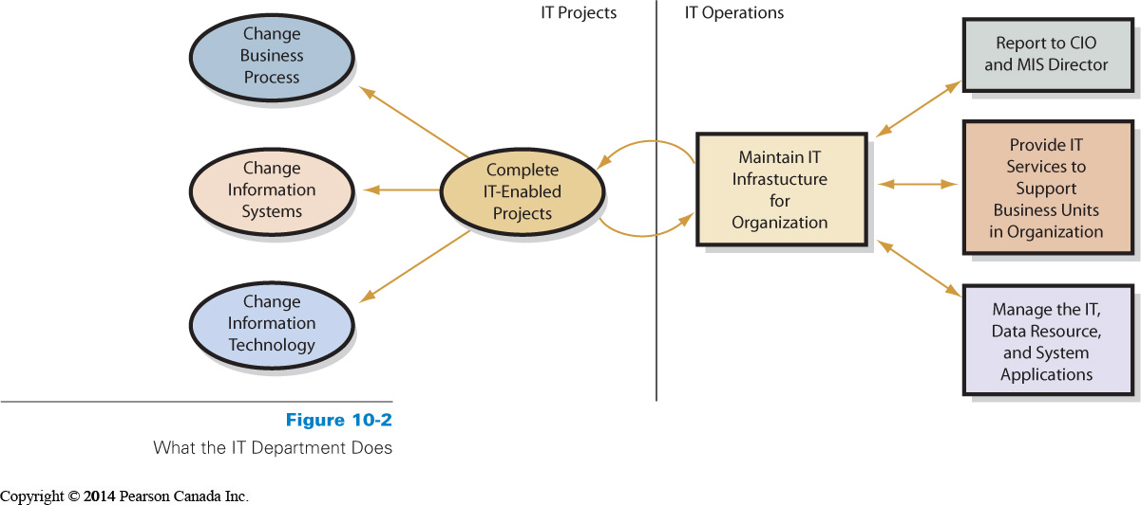
Information Technology Infrastructure Library (ITIL):
- ITIL is a well-recognized collection of books that provide a framework of best-practice approaches to IT operations
- ITIL offers a large set of management procedures that are designed to help businesses achieve value from IT operations
- ITIL has gone through several revisions; core books from the latest refresh (ITIL V3)
- It basically refers to a well-developed set of best practices that can support IT operations

Why Are IT Projects So Risky?
- Most IT project definitions are not easy to graphically represent
- Lack of a good model is an important risk to recognize in IT projects
- Good estimates are difficult to develop because the technology is continually changing
- Being able to monitor progress is another challenge for IT projects

Its risks
- Lack of experience in the team
- Lack of support from top management
- Lack of participation from system users
- Unclear and uncertain project requirements
- A high level of technical complexity, and changes in the project environments

What Is the SDLC?
The systems development life cycle (SDLC) is the classic process used to acquire information systems
- To successfully acquire and maintain information systems, there are basic tasks that need to be performed

These basic tasks are combined into phases of systems development
1. Systems definition
    - Management’s statement defines new system

Define goals and purpose for new system
  - Must facilitate organization’s competitive strategy
  - Supports business processes
  - Improves decision making
Defining project’s scope
  - Simplifies requirements determination and other subsequent development work
Assess feasibility of project
  - Cost
  - Schedule
  - Technical
  - Organizational

2. Requirements analysis
    - Identify features and functions
- Management of scope in an IT project
- Determine and document specific features and functions of the new system
- Approve requirements
- Less expensive to change system in this phase

3. Component design
    - Based on approved user requirements

- Develop and evaluate alternatives
  - Accurate requirements critical
- Hardware design determined by project team
- Software design depends on source
  - Off-the-shelf
  - Off-the-shelf with alterations
  - Custom-developed programs
- Data model converted to database design
- Procedures designed for BI system
- Job descriptions created for users and operations personnel

4. Implementation
    - Implement, test, and install new system

- System must be built
  - Components constructed independently
  - Document and review
- System testing
  - Individual components tested
  - System integrated and tested
- Users must be converted to new system
Test plan
- Test plan
  - Sequences of actions that users take when employing system
  - Both normal and incorrect actions should be considered
  - Labour intensive
- Product quality assurance (PQA)
  - Testing specialists
- Beta testing
  - Future system users try out system on their own
System Conversion
- Converting business activity from the old system to the new
  - Pilot
    - Organization implements entire system on single, limited unit
    - If systems fails, it only affects limited boundary
    - Reduces exposure
  - Phased
    - New system installed in phases
    - Tested after each phase
    - Continues until installed at entire organization
    - Can’t be used in tightly integrated systems
  - Parallel
    - New system runs in parallel with old system during testing
    - Expensive and time consuming
    - Data must be entered twice
    - Provides easy fallback position
  - Plunge
    - Direct installation
    - Install new system and discontinue old
    - There is no backup position

5. System maintenance
    - Repair, add new features, maintain

- Fixing the system so that it works correctly or adapting system to changes in requirements
  - Need method to track system failures and enhancements
  - Corrections usually prioritized based on severity
    - creation and installation of patches & service packs
  - Enhancements usually prioritized based on business decision
    - must generate reasonable rate of return
    - decision to restart systems development process

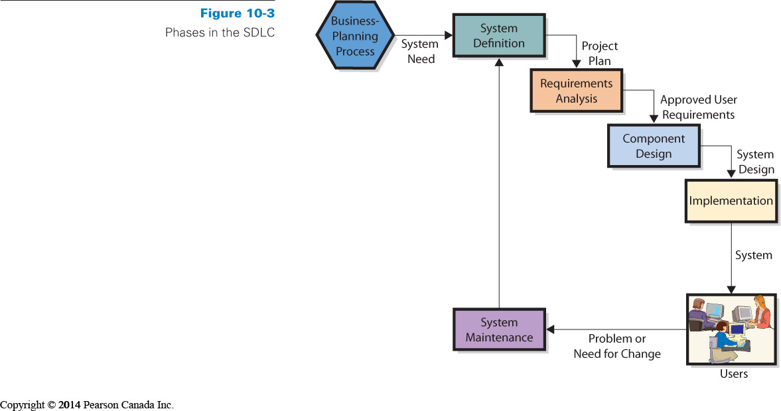
How are IS Designed, Implemented, and Maintained?
Four ways to acquire information systems:
  - Buy
  - Buy and customize
  - Rent
  - Build it yourself
  - Outsource
For options 1-3, organization must match its requirements with the capabilities of the available software application
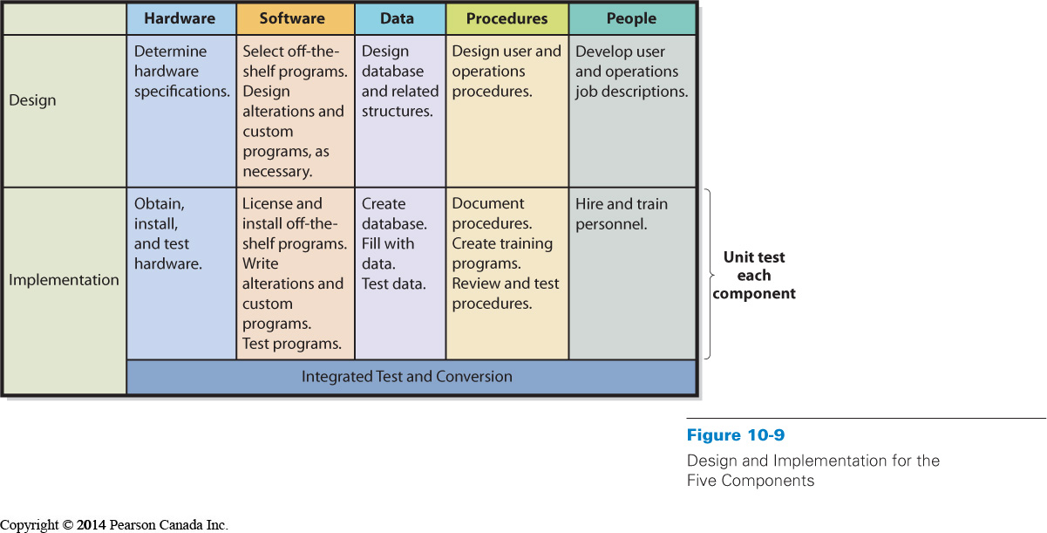
Problems with SDLC
SDLC waterfall: Series of waterfalls, process described as a sequence of nonrepetitive phases
Difficulty in documenting requirements
  - Analysis paralysis or uncertain requirements
Scheduling and budget difficulties
  - Multiyear projects difficult to properly schedule
  - Estimations on labour often produce insufficient budgets

What is outsourcing and what are Application Service Providers?
- Outsourcing is the process of hiring another organization to perform a service
- The outsourced vendor can be domestic or international
  - Offshoring is when vendor is overseas
(e.g., China, India, and Russia)
- Application service providers (ASPs) are a special form of outsourcing

Reasons to outsource
- An easy way to gain expertise
- Concern cost reductions
- To reduce development risk

Outsourcing Risks
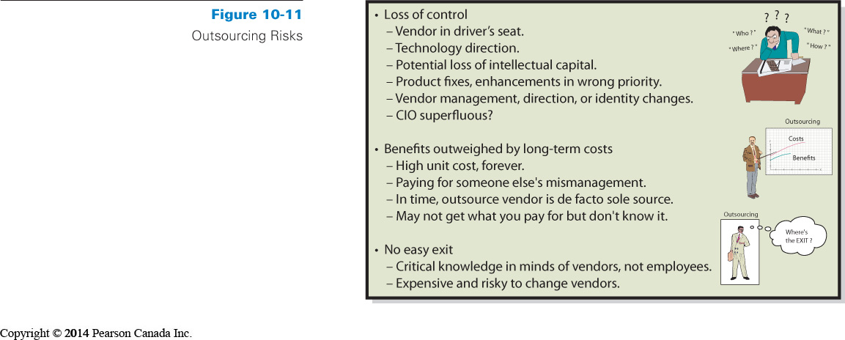
Application Service Providers

ASP agreement
  - Organization contracts with a vendor to “rent” applications from the vendor company on a fee-for-service basis
- Vendor maintains the system at its own web location and the client organization accesses the application on the vendor’s website
- Payments
  - Monthly or yearly
  - Based on number of employees or “users”

An organization purchases SAP's ERP system. After customizing the system and training employees, the organization shuts down the old system and implements the new one across all business processes. This is an example of plunge installation.
During the integrated testing and conversion phase of the SDLC process, the project team will be heavy with business users
Which of the following is a disadvantage of building information systems before business processes? Some aspects of business processes are unlikely to be considered when the system is constructed first.

Which of the following is true of systems analysts? They integrate the work of programmers, testers, and users
Which of the following is true of systems development? It requires coordinated teamwork of both specialists and nonspecialists with business knowledge

Chapter 11
IT architecture is the basic framework for all the computers, systems, and information management that support organizational services

Enterprise architect creates a blueprint of an organization’s information systems and the management of these systems
    - organizational objectives, business processes, databases, information flows, operating systems, applications and software, and supporting technology
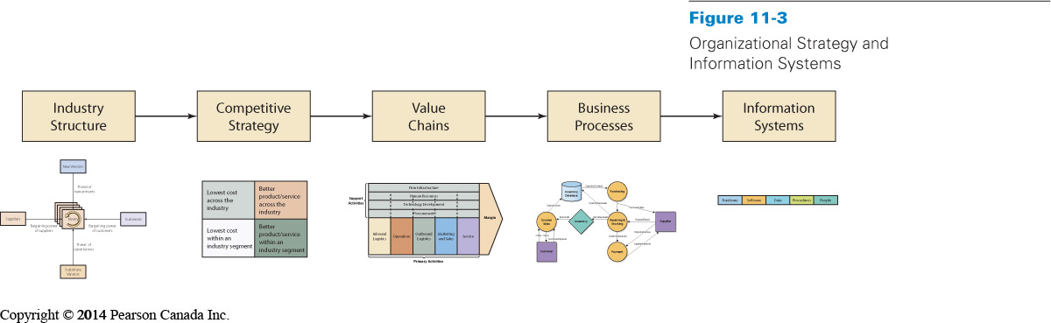
What is Alignment, Why is it Important, and Why is it Difficult?
Alignment: Process of matching organizational objectives with IT architecture
- Ongoing -- fitting IT architecture to business objectives is continuous challenge
- Measured as the degree to which the IT department’s missions, objectives, and plans overlapped with the overall business missions, objectives, and plans
- Communication between business and IT executives is the most important indicator of alignment

What is Information systems governance?
Goal of IS governance is to improve the benefits of an organization’s IT investment over time
  - Reporting structures
  - Review processes
  - Improve quality
  - Reduce service costs and delivery time
  - Reduce IT risks
  - Better support business processes

Governance: development of consistent, cohesive management policies and verifiable internal processes for information technology

What is an Information Systems Audit?
- Examination and verification of a company’s information resources that are used to collect, store, process, and retrieve information – including organization’s IS policies and procedures
Control Objectives for Information and Related Technology (COBIT) is a framework of best practices designed for IT management

Why Should You Care about IS Governance?
Increased need to report and disclose IS operational information will require employees at all levels of an organization to become more familiar with the issues facing information technology management
- Senior business managers are required to make assertions about the controls on IS that will expose them to both financial and criminal penalties
Information Systems Ethics
- Information systems ethics is about people involved with the system, not hardware or software
- about understanding our own behaviour—the way we think and act in situations where our choices affect others

Ethical principles
    - United Nations Declaration of Human Rights
    - Canada’s Charter of Rights and Freedoms
    - Association of Computing Machinery’s code of ethics

What Is Green IT and Why Should I care?
- Green IT, or green computing - using IT resources to better support the triple bottom line for organizations

The triple bottom line: includes measures of traditional profit along with ecological and social performance

- Primary goals to improve energy efficiency, promote recyclability, and reduce the use of materials that are hazardous to the environment
- Green IT considers the effects of choices on people and the environment
ENERGY STAR program - is an international government/industry partnership to produce equipment that meets high-energy efficiency specifications or promotes the use of such equipment
E-cycling or the recycling of electronic computing devices
According to Reich and Benbasat (1996), effective alignment occurred in organizations that developed a climate of supporting the sharing of domain knowledge and common business practices.
Alignment is not only about planning and building frameworks, but also about effectiveness in communication.
Bill 198 affects mainly accounting information systems.
E-cycling should be considered in a company's IS auditing procedures.

EPEAT is a tool based on 28 criteria that measure a product's efficiency and sustainability attributes.

Graduating business students can be successful in the ICT industry, if they are familiar with issues facing information technology and can communicate.
In Canada, CICA has an agreement with ISACA to recognize a designated specialist in information systems auditing.
ISACA has become a leader in IT audits and IT governance.
Moving downward in the Zachman framework provides a higher levels of detail.
Successful companies find ways to share knowledge and frustrations between the IT department and the business functions.
The Canadian legislation that is similar to the Sarbanes-Oxley Act in the US is the Budget Measures Act.
The Certified Information Systems Auditor (CISA) certification is recognized globally and has been earned by more than 90,000 professionals. Members have job titles like is auditor, consultant, IS security professional, regulator, chief information officer, and internal auditor.

Chapter 12
What is PIPEDA?
PIPEDA: Personal Information Protection and Electronic Documents Act
- The Act is intended to balance an individual’s right to the privacy of his or her personal information, which organizations need to collect, use, or share for business purposes
- The Privacy Commissioner of Canada oversees this Act
- PIPEDA governs how data are collected and used

Types of Security Threats That Organizations Face

Three sources of security threats are:
- Human errors and mistakes
  - Accidental problems
  - Poorly written programs
  - Poorly designed procedures
  - Physical accidents
- Malicious human activity
  - Intentional destruction of data
  - Destroying system components
  - Hackers
  - Virus and worm writers
  - Criminals
  - Terrorists
- Natural events and disasters
  - Fires, floods, hurricanes, earthquakes, tsunamis, avalanches, tornados, and other acts of nature
  - Initial losses of capability and service
  - Plus losses from recovery actions

Five types of security problems are:
  - Unauthorized data disclosure
  - Incorrect data modification
  - Faulty service
  - Denial of service
  - Loss of infrastructure

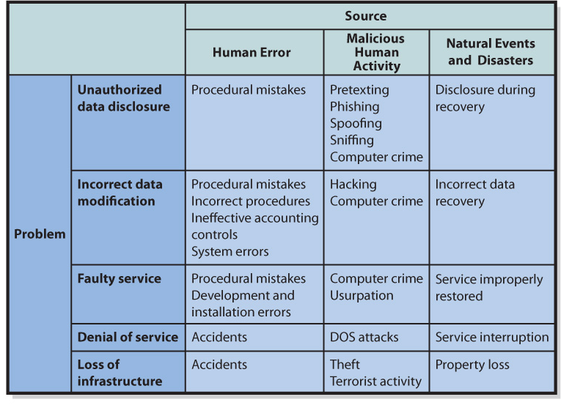

A HOT SITE is a utility company that takes over another company's processing with no forewarning.

