Lecture 8 & 9: Viruses + Lecture 10: Nosocomial Infections
- grow only in living cells:
- embryonated eggs
- living animal/plants
*it is impossible to grow / culture viruses using artificial media (viruses only grow in living cells)
- possess either DNA OR RNA; NEVER BOTH
- pretty small; smallest of the organisms : viruses < prokaryotes <eukaryotes
- Nucleic acid carries the genetic code, and protein coat protects the core
- viruses do not divide/ do not have own metabolism
- always require a host cell ; can infect BOTH ANIMALS & HUMANS
- viruses are extremely small (10 nm to 300 nm) –
but bigger than proteins and small molecules

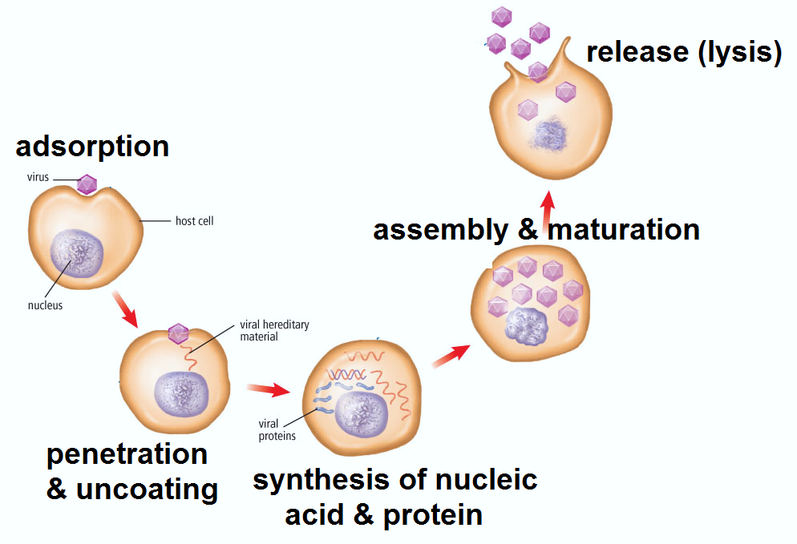
Know steps!! (short answer Q)
FIVE : 5 Steps of replication
Remember to include MATURATION!!!
- Adsorption
(“adsorb”: adhesion to surface)
- Penetration and Uncoating
- Synthesis of nucleic acid and protein (viruses: made of nucleic acid + protein)
- Assembly and Maturation
- Release
Detection of Viruses
- detect the VIRUS ITSELF direct
- Direct ELISA to directly detect viral antigens
- EM : electron microscopy
- cell culture inoculation (inoculating virus into cell culture):
cytopathic effects for cytopathic viruses
immunofluorescence for non-cytopathic viruses
hemagglutination

- detect the IMMUNE RESPONSE (antibodies against the virus) indirect
Immunity Test: detection for presence/absence of antibody against a specific virus
Diagnostic Test: detect if high antibody titre = virus has recently caused the viral illness

What types of viruses are there?

RESPIRATORY VIRUSES (breathing/broncho/pneumonia infections) *
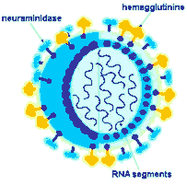
INFLUENZA
2 surface antigens: H (hemaglutinin), N (neurominidase)
antigenic variability (many different types of influenza viruses)
2 main types of influenza viruses:
*MAJOR EPIDEMICS: Influenza virus type A
*minor/ milder infections: -Influenza virus type B
Prevention: annual VACCINATION or antiviral DRUGS
*need new vaccines each yr cuz existing ones don’t work as well
PARAINFLUENZA- croup (seaal voice; high pitch)   |   RSV (resp. syncytial virus)  very YOUNG (<2 yrs)  * treat with antiviral drug: Ribavizine | ADENOVIRUS:  Pharyngitis/  conjunctivitis/  pneumonia/    gastroenteritis | RHINOVIRUS-  common cold;  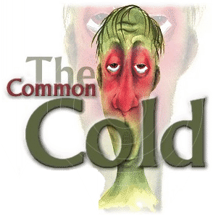  vaccination doesn’t exit  -too many serotypes  - immunity against one doesn’t prevent others
ENTEROVIRUS enteroviruses are blood bourne
travel to target organs through blood = viremia (presence of virus in blood)
Entry: via aerosols or ingestion (in respiratory tract or gastro-intestinal tract)
  SALK: has a “K” so for “Killed vaccine”  Poliovirus  global WHO vaccination launch in 1988  SALK (KILLED vaccine): can give to immunocompromised  SABIN (LIVE ATTENUATED) – cannot. | Coxsachi  aseptic meningitis  Echovirus

DIARRHEA: gastroenteritis
  ROTAvirus : diarrhea associated with daycares/ children hospital |   NOROvirus: food-bourne  ** Majority of non-bacterial (virus) related gastroenteritis

RASH
Measles:  BLOTCHY patches | 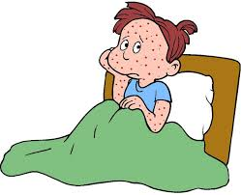  VARICELLA: * Zoster*  Varicella Zoster Virus= chicken pox  Herpes Zoster= shingles
Rubella:
‘German measles’
PAPILLOMA VIRUS : HPV  warts and cervical cancer | 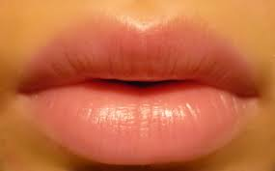HERPES SIMPLEX (HSV)-  Herpes Simplex type 1: LIPS  Herpes Simplex type 2: genital herpes

HIV:Cytocidal for T4 helper cells (kills them); NO VACCINE SO FAR
all sexual diseases are DANGEROUS TO FOETUS= serious congenital infections
GLANDS
MUMPS  Swelling of parotid glands  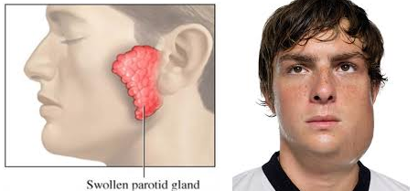 | Epstein-Barr  Infectious mononucleosis  (kissing disease) | Cytomegalovirus (CMV): 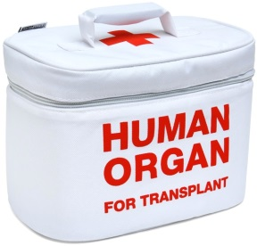  life-threatening for organ transplant pts.

HEPATITIS VIRUSES: inflammation of the liver *****
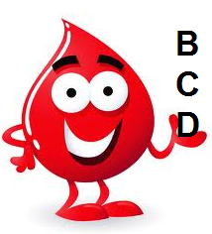
Hep.A +E: food bourne ** enters body through mouth and gastrointestinal tract
Hep. B+C+D: blood bourne
B for BLOOD bourne
no vaccine
delta agent can be controlled by vaccinating against Hep. B

Yellow Fever Virus: transmitted by mosquito
Central Nervous System:
West Nile virus: transmitted by mosquito
Rabies virus: have animal reservoir and human as accidental or dead-end host
- found in wild animals
- humans are dead-end host
- solution: vaccination of WILD ANIMALS
Vegetative cells – cells of body – more sensitive (less resistant) to sanitizers/detergents
Spores – sex cells– are more resistant (so less sensitive) to sanitizers/detergents
MOST RESISTANT LEAST RESISTANT:
Spores/cysts Mycobacteria Fungi Vegetative bacteria Enveloped virus
Resistance level;
spores are the most resistant
viruses are the least resistant

Pre-cleaning is NEEDED before decontamination of endoscopes.
(before you use any agent of steralization/decontamination, make sure your instruments –like endoscopes- are cleand from any soil/dirt… since soil and dirt can attract pathogens possibly present in the cleaning agents)
***Sterilization: KILLS ALL organisms + spores on an object
Decontamination: destroy harmful chemicals/radioactivity
Sanitizers: reduce microbes by washing/wiping with cleaning agents
Disinfect: germicides (doesn’t detroy spores though)
Antisepsis: germicide used on skin (les antiseptiques sur la peau)
The most important procedure in preventing hospital-acquired infections is: handwashing.
Hospitalized patients may have weakened defense mechanisms caused by:
disease, surgery, radiation and invasive medical procedures
Infections caused by a patient's normal flora are called: endogenous
ENDOGENOUS: patients own flora EXOGENOUS: outside pt.
Cleaning, Steralization, & Disinfection; heat treatment, radiation, filtration
1) HEAT TREATMENT  Pasteurization: destroys vegetative form of pathogens BUT DOES NOT STERILIZE  (think milk; they want to preserve food so want to kill vegetative forms that can cause infection… but no sterilization; sterilization would eliminate nutritious substances & change taste of the product)  Autoclaving: Steam under pressure  ** BEST method to sterilize small contaminated instruments  Boiling water: time& temperature not enough to kill spores.  NOT always guaranteed as a method of sterilization. | 2) RADIATION  Gamma radiation: oxidation and damage to DNA.  U.V. radiation: damages nucleic acids | 3) FILTRATION
Dry heat: Destruction through oxidation; requires higher temp. and longer times.
Moist heat: Irreversible denaturation of proteins by coagulation
MOIST HEAT is more effective for sterilization than dry heat (moist always better; think cookie)
Ionizing radiation: microbicidal treatment – sterilizes food packages & med supplies
(‘ionizing’ since food have high energy particles; lotsa ions)
Non-ionizing radiation: microbicial treatment – sterilizes operating room tables/ floors
Incineration: getting rid of HAZARDOUS materials (used needles, ebola virus)
Route of infection:
- direct or indirect …
- contaminated objects (fomites) e.g., a wound dressing, blood soiled needles, etc.
- vectors (e.g., insects)
- air, food, water
Rank in size: smallest to largest
Measles virus chlamydia trachomatis [ S.aureus ] yeast HISTOPLASMA CAPSULATUM
Hospital infection programs include:
protecting against infection of NURSES, PHYSICIANS, and LABORATORIES
3 factors hospital infection control programs must focus on:
SOURCE of infection , ROUTE of transmission, HOST

Fun Facts:
Nosocomial infections can sometimes be unpreventable
Handwashing is the most effective means of reducing the transmission of a pathogen from source to host;
Infection control programs are mandatory in most Canadian hospitals;
Alcohol-based hand rubs remove transient flora. (‘temporary flora’ ; ones on surface)
A patient CAN be considered a source for nosocomial infection

Filtration : to treat small liquids which can be damaged by heat
MIDTERM 1+2 MATERIAL:

humoral immunity: "antibody-mediated" primary & secondary immune response.
- for bacteria on host cell's surface (antibodies)
- antibodies are made by B-cells (B lymphocytes)
non-specific innate immunity
includes skin, mucous membranes (lysozymes), iron-binding proteins, and phagocytosis

complement (plasma proteins in blood): a host defence
(for opsonisation: coats bacteria w/antibodies ; because some bacteria are sneaky... they protect themselves with a polysaccharide capsule. SO opsonization must occur.)

exotoxins are more powerful/potent than endotoxins (only released when bacteria dies)

PROTOZOA: Gardiasis, trichomoniasis, cryptosporidiosis, cyclosporidiosis
flagellates : gardia lamblia, trichomanis vaginalis
amoeba : entamoeba hystolytica
sporozoans : toxoplasma gondii, plasmodium, cryptosporidium, cyclosporidium

METAZOA (intestinal worms): trichinosis
nematodes: enterobius vermicularis (pinworm), trichinella spp. (pork), ascaris lumbricoides, anisakiasis simplex
cestodes: diphyllobothrium spp., taenia spp.
termatode: schistosoma (blood fluke)

BACTERIA
gram + cocci:
- staphylococcus- resistant to abx-.....S. aureus: (toxic shock syndrome in women)
- STREPTOcoccus - abx are used against them >:) -......
S. pyogenes (strep throat, scarlet fever)
S.agalactiae (vagina, birth)
gram - diplococci:
- Neisseria meningiditis
- Neisseria gonorrhea (STD)

gram + bacilli:
- spore forming....
- bacillus [aerobic]:
B.anthracis (capsulated ~has protein capsule)
B.cereus (food-poisoning/ gastroenteritis; resistant to abx)
clostridium [anaerobic]:
C.tetani (tetanus; lockjaw & severe muscle spasms)
C.difficile (overuse of abx; enterocolitis)
- non-spore forming....
corynebacterium diphtheria (diphtheria)
gram - bacilli:
- shigalla sonnei
- pseudomonas aeruginosa (cystic fibrosis)
- legionella (transmitted thru aerosols)
- e.coli (not so resistant to disinfectants); LEAST resistant are viruses.
- fungi are a bit more resistant than e.coli
Cannot be gram-stained: myobacteria, spirochetes, chlamydiae, mycoplasma
treponema pallidum (syphilis STD; serious congenital infection)
chlamydia psitacci (from birds)
borrelia burgdorferi (lyme disease; tick bite)
myobacterium tuberculosis: MANTOUX TEST (tb test I did for cheo)
myobacterium leprae (leprosy; transmitted thru armadillos- an animal not insect)

PROTOZOA:
giarda lamblia (have trophozoites w/bilateral symmetry, distributed worldwide)
trichomonas vaginalis (STD)
toxoplasma gondii (cats; serious congenital infection)
plasmodium spp. (malaria)
entamoeba histolytica (diarrhea/constipation)
METAZOA:
enterobius vermicularis ( diagnosis= "scotchtape" test of perianal area)
trichinella spp. (trichinosis)

HISTOPLASMA IS LARGEST ORGANISM
(humans become infected w/ histoplasmosis after inhaling condia from soil dust)

Put full names!!!
Common cold: rhinovirus
Inflammation of the liver: hepatitis virus
Mantoux test: Mycobacterium tuberculosis
Cat faeces as common vector of transmission: Toxoplasma gondii
Warts and cervical cancer: Papilloma virus
Cytocidal for T4 helper cells: HIV
Vaccination of wild animals: Rabies virus
Swelling of parotid glands: Mumps virus
“Scotch-tape” test of perianal area: Enterobius vermicularis
Annual vaccination for high risk groups: Influenza virus
Majority of non-bacterial related gastroenteritis: Norovirus
Diarrhea associated with daycares: Rotavirus
Toxic shock syndrome in women: Stapylococcus aureus
Lockjaw and severe muscle spasms: Clostridium tetani
Chickenpox: Varicella zoster virus
Global WHO vaccination launched in 1988: Polio virus

