Midterm Review

Chapter 1

In the business environment there are two components: 1) Market component (Industry Analysis/ Market Analysis) and 2) Nonmarket component (Issues Analysis)

Market component: includes those interactions between firms, suppliers, and customers that are governed by markets and contracts. These interactions typically involve voluntary economic transactions and the exchange of property

Nonmarket Component: is composed of the social, political, and legal arrangements that structure interactions outside of, but in conjunction with, markets and contracts.

Market Environment determines significance of non-issues to the firm.
Nonmarket Environment shapes business opportunities in the marketplace.

Role of Management:
- Managers operate in both the market and nonmarket environments.
- Managers are in the best position to assess the impact of their firm’s market activities on its nonmarket environment and the impact of developments in the nonmarket environment on market opportunities and performance.
- Management thus is responsible for formulating and implementing nonmarket as well as market strategies.

Four I’s of NM
- Issues:
- Environmental protection, health and safety, product liability, human rights, corporate social responsibility, ethics, competition policies, regulations, trade policies.
- Can originate from External forces AND/OR a Internal from the firms own actions
- Interests:
- Those affected or concerned about an issue. Can be Organized OR Unorganized.
- Institutions:
- Where concerned interest seek to influence outcome on an issue (Arena where issues are addressed)
- Information:
- Information refers to what interests and institutional officeholders know about an issue, the consequences of alternative courses of action, and the preferences of those concerned with the issue. (Interests may have different info on an issue)

Sources of NM Issues:
- Scientific discovery and technological advancement
- New understandings
- Institutional change
- Interest group activity
- Moral concerns

Approaches to Anticipating Change in NM
- Reactive:
  - Respond to nonmarket issues only when they are strong enough to force the firm to act.
  - Limit the extent of the damage once the firm has been challenged by an issue.
- Proactive:
  - Anticipate and prepare firm to take advantage of opportunities as they arise and address issues before they become problems
  - Be proactive – act to affect which issues arise and how they will be framed

NM Issue Stages (impact on firm increases with progression i.e. Life cycle)
- Issue identification
- Interest group formation
- Legislation
- Administration
- Enforcement

Chapter 2

Market Strategy: concerted pattern of actions taken in the market environment to create value by improving the economic performance of the firm
Non-Market Strategy: concerted pattern of actions taken in the nonmarket environment to create value by improving overall performance.

Effective Management in NM
- Analyzing nonmarket issues and the broader environment
- Formulating effective strategies for addressing those issues, and
- Positioning the firm in its nonmarket environment.

A synergy is present if a nonmarket action increases the return from a market action or, conversely, a market action increases the return from a nonmarket action. More synergy between markets= more efficiency.

NM Positioning: affects the set of nonmarket issues and challenges a firm faces, including challenges from activists and interest groups, governments, and competitors.

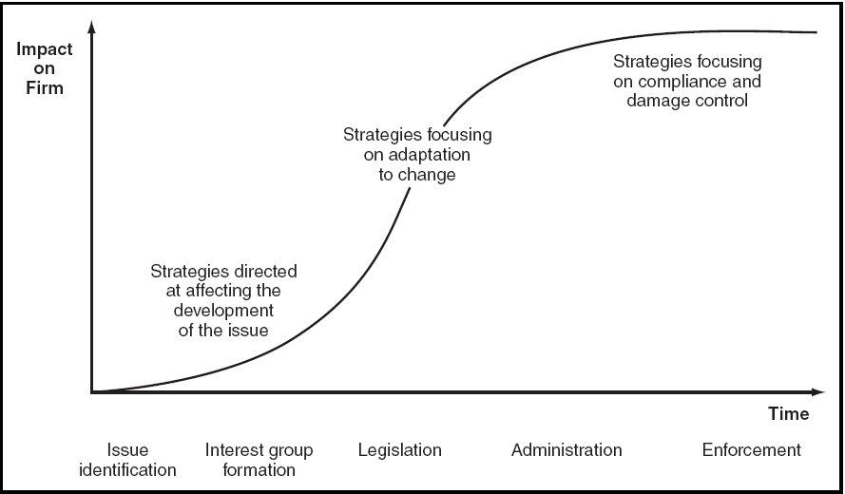

Positioning in NM Environment:
- Public sentiment
- Political space
- Legal space
- Align interests with those of: lawmakers, regulators, public, and politicians

Forms of NM Capabilities:
- Expertise in dealing with government, the news media, interest and activist groups, and the public.
- Knowledge of the procedures and functioning of the institutions in whose arenas nonmarket issues are resolved.
- A reputation for responsible actions earned with government, stakeholders, and the public.

Chapter 3

News Media Role: an arena in which nonmarket issues are addressed, the news media plays an important role in identifying nonmarket issues and placing issues on the agendas of firms.

News Media Affect on NM Issues:
- Alert the public, activists, interest groups, and govt. officeholders to nonmarket issues
- Raise concerns about the policies and practices of firms
- Provide information about the likely effects of alternative courses of action
- Reduce the costs of collective nonmarket action
- Enhance a nonmarket strategy by conveying information generated by an interest group
- Represent certain interests and principles consistent with the news media’s perception of its role in society

Treatment Can Take Several Forms:
- A straightforward presentation of facts and description of events.
- An interpretation of the facts and events.
- An exploration of their potential significance and ramifications.
- Advocacy of a course of action.

Intrinsic audience interest in the issue; coverage increases audience interest and treatment will be chosen to appeal and retain the audience.
An issue’s societal significance as perceived by the news media; serving democracy by providing info citizens need.

Treatment depends more on societal significance than on audience interest, whereas
Coverage depends more on audience interest.

Bias, Accuracy, and Fairness: inaccurate stories due to pressure from deadlines, space constraints, etc.

Business Concerns:
- Few companies like their activities to be publicly scrutinized.
- The desire for balance and the incentive to develop controversy to make stories appealing often give critics of the company an opportunity to deliver their message to the public.
- Some executives agree that the media caters to antibusiness sentiments.
- Media has control over the editing process
- Media treatment almost always results in oversimplification

Chapter 4

Public Politics: competition between firms and other interests over the resolution of nonmarket issues in the context of the institutions of government.
Private Politics: competition between firms and individuals, interest groups, activists, and NGOs over the resolution of issues outside of government institutions. Motivated by self-interest, and broader concerns.

Affects of Private Politics on NM Environement:
- The groups initiating private politics can identify issues about which management either is unaware or has not understood as important to others.
- These groups can affect the organizations of interests by forming watchdog and advocacy groups and by mobilizing people to work for causes.
- The pressure these groups exert can affect the institutional configuration of the nonmarket environment.
- Individuals, interest groups, and activists provide information that influences public and private politics.

Activist Strategies:
Putting direct pressure on firms through private politics.
Working through public institutions using public politics

Advocacy Science: frequently used strategy of activists to conduct a policy study or scientific investigation to call attention to an issue.

Benefits of Advocacy Science:
- A study can attract the media, and hence the public, which gives a degree of credibility to the claims of the activists.
- A study can also attract sympathetic legislators, who can provide support, introduce bills, and hold hearings at which activists can testify.

Interacting with Activist Groups:
- Assessment: what is demanded from the firm by the activists and public, assess vulnerability, if vulnerable make public commitment to new policies.
- Strategy and negotiations: determine if the claims have merit and its strengths. Gain support of employees. Negotiation is voluntary but may resolve the issue
- Challenging the activists: if demands are too costly or unreasonable the firm but fight back.

Addressing the Activist Environment:
- Identify the relevant interest groups and activists organizations in your market and nonmarket environments
- Understand their agenda, preferences, and capabilities
- Understand the broader public support for their agenda
- Consult with them on important issues; a number of companies have established regular forums for exchanging information and views
- Cooperate when that is beneficial
- Fight when you are right and can win – but be careful

Must Understand:
- The nature and strength of the activists
- The concerns that motivate them
- The likelihood of media coverage
- How much damage they might cause
- How central is the issue is to their agenda
- Determining if they are led by professionals or amateurs

Chapter 5

Crisis: a situation in which harm to people or property either has occurred or is imminent. They are often unpredictable, can escalate quickly, can damage a firm (reputation, performance, and credibility),high potential to gain media attention.

Stages of Crisis Management
- Identification: may result from a single event or series of events over time.
- Escalation: as a result of media coverage, government, and company action.
- Intervention: actions from company or government to deal with crisis.
- Resolution: eliminate any future potential for harm, assure public, compensation for those harmed.

Components of Crisis Management:
- Avoidance: reduce the likelihood of a crisis developing. Conduct audits.
- Preparedness: need a crisis management team, plan, and resources.
- Response: must act quick/ communication is key
- Root cause analysis: objective of identify the cause of crisis
- Resolution: action to resolve crisis, deal with root cause, and communicate with stakeholders, public, and government.

Communication must be truthful, sincere, and express concern for those affected.

Chapter 6

Interests: individuals, firms, and organizations with a stake in an issue AND the magnitudes of their stakes.

Predicting NM Action On Issue:
- Define the Issue: alternative being considered
- Identify Interests: what position they take (support/ oppose)
- Asses Demand and Supply of NM Action for each Interest
- Are Coalitions likely?

Demand for NM Action can be:
- Are the aggregate benefits to the interests on a side of an issue? (Relative measure of total benefit gained or lost by interest group)
- Are the per capita benefits for an individual interest? (Benefit to each member of the group)
- Is there are any other means, such as substitutes, for achieving the benefits? (If YES= decrease incentive to take action)

The benefits from nonmarket action are lower when there are other means of generating them, and the closer these substitutes come to replicating the benefits, the smaller are the incentives.

Supply for NM Action can be:
- Numbers: number of affected interests
- Coverage: number of political jurisdictions covered by interests. Greater number of legislators with constituents that are interest group members, the more effective the group will be
  - Determine Effectiveness
- Resources

Effectiveness of NM Action: Effectiveness refers to the impact of a given level of nonmarket action on the outcome of an issue. Depends on number of members in interest group AND their geographic distribution.

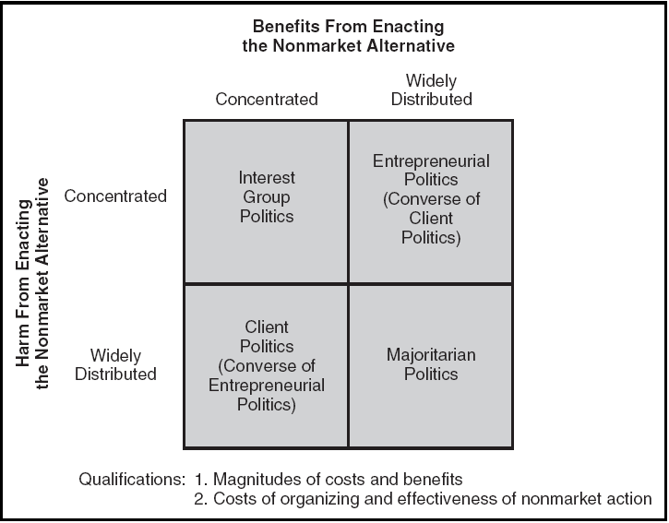

Status quo is normally favoured UNLES: interests in favour of change are of moderate or high impact and those apposed are low impact.

