BIO1140 LAB EXAM REVIEW
Lab1:
Parts of the Compound Microscope:
Revolving Nose piece: supports the objectives
Stage: Supports the specimen- can slide x and y direction
Coarse Focus Knob: Allows for large distance between objective and specimen for rough focusing. Don’t use on 40
Fine Focus: Small changes in distance between specimen and objective
Ocular (Eye Piece): 10x magnifying element in microscope. Para focal- won’t completely loses focus
Objectives: Magnifying element closet to stage
Resolving power: ability for a microscope to produce separate images for things close together
Condenser: lenses that concentrate light from illuminator
Aperture Iris Diaphragm: reduces glare from light by adjusting cone of light from condenser

Parts of the Stereoscopic (Dissecting) Microscope:
- For shit that’s too large
- Two oculars produce 3-D image that not inverted
- Magnification 6.5-45X
- Reflected light directed on opaque things from above, transmitted is used with translucent specimens shines through from bottom
- Reflected = darker image

Measuring object:
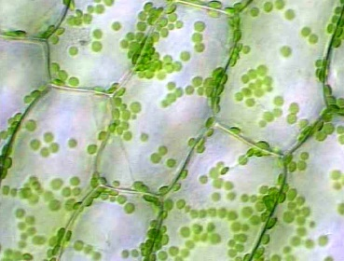
Actual size of object= actual size of FOV (table)/ on screen size of FOV (width) x onscreen size of object
In the Lab:
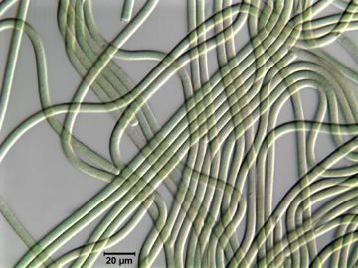
- Looked at similarities and differences between prokaryotic and eukaryotic cells
Eukaryotic- Prepared wet mount of Elodea and induced plasmolysis with NaCl 5%- causes wter to diffuse out so you can see cell membrane
- Chloroplast moved up called cytoplasmic streaming or cyclosis- used for transporting nutrients and shit in the cell
Prokaryotic- Wet mount of Cyanobacteria Ocillatoria
- Little green filaments

Lab 2: Permeability of Red Blood Cells
Osmosis: movement of water across membrane from low solute concentration to high
Hypotonic: Environment where water rushes into the cell to which membrane can’t handle causing it to burst. Called hemolysis in cells. Also achieved by putting it in a solution of a penetrating substance (ex. Ethylene glycol)
Part 1 Permeability:
- Given various solutions which were added to a drop of sheep blood
- When testube was inverted it was t=0
- 2 for instantaneous hemolysis and 1200 for longer than 20 minutes
- When 75% or blood cells hemolysed the become transparent
Solution (M) | Mean average (s) | Standard deviation | Standard error
Distilled Waterª | 2 | 0 | 0
Ethanol (0.3) | 3 | 1.732051 | 1
Triton X | 5 | 3.605551 | 2.081666
D- Glucose (0.3)^{b} | 1200 | 0 | 0
Thiourea (0.3) | 1100 | 173.2051 | 100

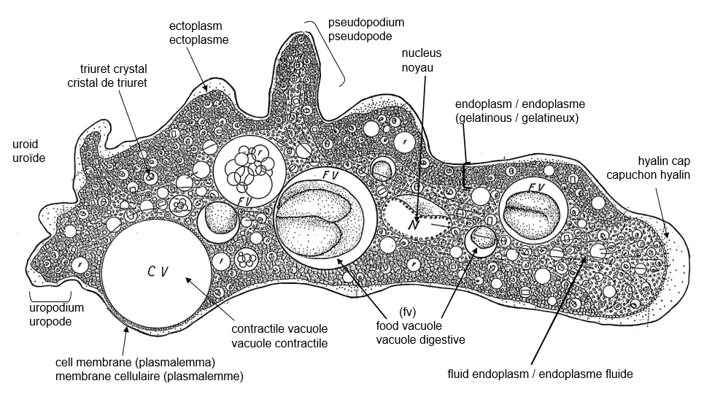
Lab 3: Cellular Processes in Amoeba Proteus
Amoeboid Movement:
- Use pseudopodia – extensions of long polymers of actin ( free actin G-actin bind forming F-actin)
- Uroid “back” contracts helping cell contents to be pushed toward the font- adhesive molecule detach
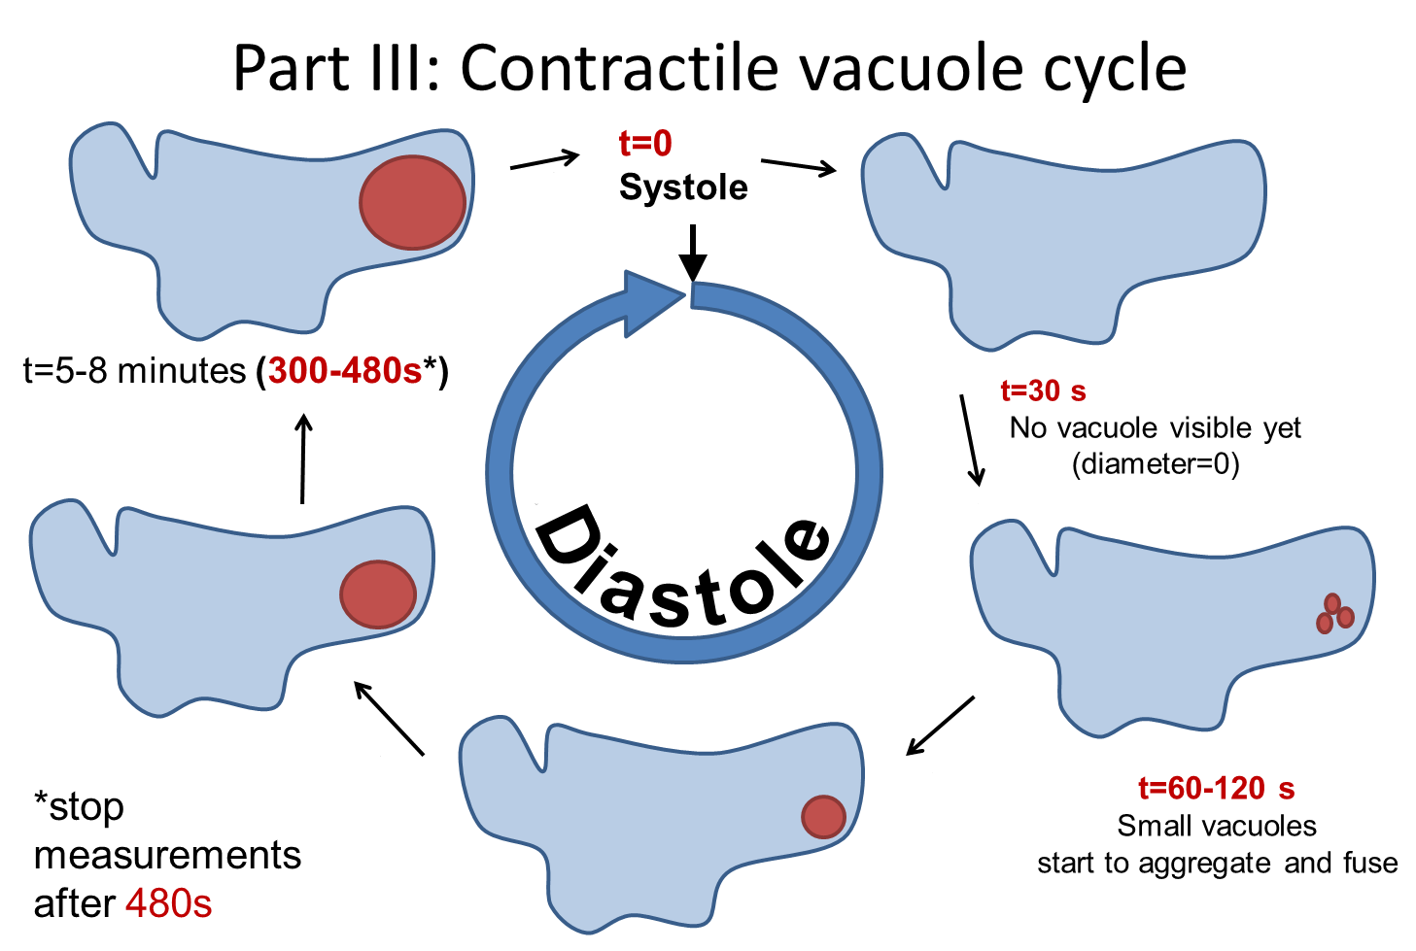
- Adhesive molecules attach legs to substratum
Contractile Vacuole:
- Contractile vacuole regulates osmosis by releasing excess water
- Amoeba Proteus only have one
- 2 phases in cycle- Diastole ( coalescence and growth), Systole ( release of CV contents to exterior)
Endocytosis:
- Inducing agent causes cell to get rounder
- Endoplasm flow stops and it becomes restricted to the central region in the cell
Small protrusions will form

Lab 4: Mitosis

The Cell Cycle:
- M phase: Cell division mitosis ( nuclear division) and cytokinesis (cell division)
- Interphase: period of growth, preparation for m phase
- G1 ( Gap 1) – growth synthesis of macromolecules and duplication of organelles
- S(synthesis) Phase- replication of dna and synthesis of dna associated proteins
- G2- protein synthesis and structure associated with mitosis
Mitosis:
- Nuclear division
- Prophase: chromosomes shorten and thicken and consists of 2 chromatid
- Metaphase: centromeres split
- Anaphase: chromatids located at different poles- shortening of microtubules
- Telophase: phragmoplast in plant cells and cleavage furrow in animal cells

In the lab:
- Apical meristems: growth tip were mitotic cells are abundant
- Looked at root tips and white fish Coregonus clupeaformis
Feulgen Stain: softens hard tissue, squash for a layer of cells-
- Dna colored magenta red
- To react with staid, dna is hydrolyzed with 1M HCL to remove purines and free aldehyde groups- forms aprunic acid

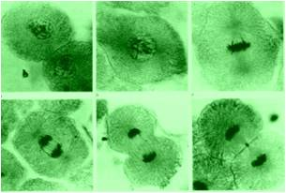
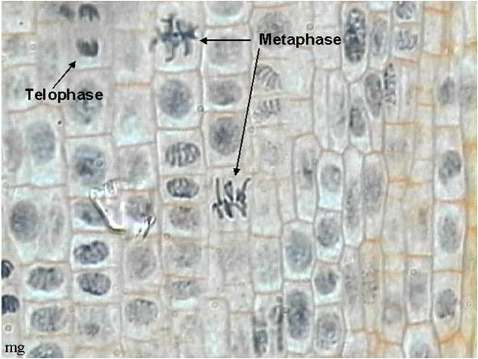
Allium cepa (root tip)

Whitefish (Coregonus clupeaformis) blastula



