Definitions
Human Resource Management is:
- The strategic approach to the management of an organization’s employees.
- Its objective is to recruit, motivate, develop and retain employees whose performance is necessary for the attainment of the organization’s goals.
Performance Management is:
- The process of establishing performance expectations with employees.
- The design of interventions and programs to improve performance.
- Monitoring the success of the interventions and programs.
Training is:
- The acquisition of knowledge, skills and abilities to improve performance on one’s current job.
- A planned effort undertaken by a company to facilitate their employees’ learning of job-related competencies.
Development is:
- The acquisition of knowledge, skills and abilities required to perform future job responsibilities and the long-term achievement of individual career goals and organizational objectives.
Organizational Learning:
- The process of creating, sharing, diffusing, and applying knowledge in organizations.
- It is not simply a focus on current needs or deficiencies, but also on continuous learning.
- It is a main characteristic of an adaptive or agile organization; one that is able to identify the need to alter its practices based on shifts in its environment.
Intellectual Capital:
- An organization’s knowledge, experience, relationships, process discoveries, innovations, market presence, and community influence.
- The source of innovation and wealth production.
- Has to be formalized, captured, and leveraged to produce a more highly valued asset.
- Not like other assets – it grows with use.
- It is increasingly viewed as the organization’s most valuable asset.

Training is not education.
Education: | whereas | Training:
- focuses on the development of one’s intellect (knowledge acquisition). | whereas | - deals with learning how to perform specific skills (skill acquisition).
- is an individual activity which involves the use of one’s mind | whereas | - is a way to develop skills that are used for social and economic benefit.

The Benefits of Training and Development
- When an organization invests in training and development, not only can it result in a positive effect on its bottom line, but it can also benefit its employees, as well as the society in which it operates.
- When an organization invests in the training and development of its employees, either by implementing it themselves and/or by providing an environment that fosters it, the benefits reverberate at numerous levels directly and indirectly.

A) Employee Benefits
- Intrinsic
- Greater knowledge and skills
- Higher self-efficacy
- Feel more useful
- More positive attitudes towards their job and organization
- Extrinsic
- Higher earnings
- More marketable
- Greater job security
- Enhanced promotion prospects

B) Organizational Benefits
- Organizational strategy
- Help organizations achieve their short- and long-term goals.
- Increase organizational effectiveness
- Better productivity, fewer errors, fewer accidents, less supervision needed.
- Return on investment.
- Employee recruitment and selection
- A company’s training and development program can help recruit new employees, and retain the ones they have.
C) Societal Benefits
- Educated population
- Helps to create an educated and skilled workforce.
- Provides skills that also serve employees outside of the work environment.
- Better standard of living
- A better-trained workforce is more productive, thereby improving the economy and the standard of living.

Employer Reluctance to Training Investment
- Employers lack confidence in their specific training needs and how best to organize and provide for it when it is identified.
- Employers are concerned about employees who take advantage of their training opportunities, and then offer their services elsewhere. Some companies have countered this with “firm-specific” training.
- Small and medium-sized enterprises lack the economies of scale that make training more feasible for larger firms.

High Performance Work System
An interrelated system of HR practices and policies which typically includes:
- rigorous recruitment and selection procedures
- performance-contingent incentive compensation
- performance management
- a commitment to employee involvement
- extensive training and development programs
- Workplace training is not an independent activity.
Context of Training and Development
- It is influenced by a broader organizational and environmental context, and a human resource system

Context of Training and Development
A) Environmental Factors
- Laws
- Quebec's 1% Law is an example of legislation that has a direct effect on a company's attitude towards training its employees.
- Global competition (and globalization)
- International competitors, customers, suppliers and employees require increased cross-cultural awareness training.
- Technology
- Employees must be trained in using new technologies if they are to be adopted.
- Demographics
- An ageing workforce means that there will be a significant "brain drain" as experienced workers retire. Transferring the know-how to new employees will be a challenge.
- Labour market
- Changes in demographics of the Canadian workforce will require adaptations in the amount and type of training required.
- Economy
- The economic downturn of 2009-10 caused higher unemployment and a return to school for many to upgrade their skills in an attempt to find a new job.
- Change
- Trends, new laws, economic changes and other events (external to the company) that affect the organization.
- Social Climate
- Specialized training programs that deal with diversity, security, and stress management are examples of the effects of the social climate on training needs.
B) Organizational Factors
- Strategy
- One of the most influential factors of training and development.
- The alignment of human resources practices with an organization’s business strategy is called: Strategic Human Resources Management (SHRM).
- Training becomes strategic when it is related to the business strategy.
- Structure
- Changes in employee tasks and responsibilities due to structural change within the organization.
- Emphasis on teamwork may require additional training in communication, supervision and cross-training (skills needed to complete all tasks that work team is responsible for).
- Culture
- The shared beliefs, values and assumptions that exist in an organization are referred to as the organizational culture.
- Human Resources Management System
- All functional areas of HR work together to create an HR system
- Driven by organizational strategy and SHRM
- Is what constitutes a High Performance Work System (HPWS)
- Leads to a Strategic Model of training and Development

Strategic Model of Training and Development
Chain Reaction:
- An organization’s business strategy has a direct impact on its human resource management (HRM) strategy.
- The HRM strategy has an impact on the organization’s strategy for the learning and training of its employees.
- Once a strategy for the learning and training of employees has been identified, this will determine the nature of the training and development programs to design and deliver.

Instructional Systems Design (ISD) Model
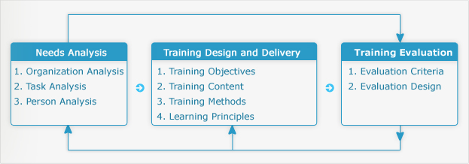
Popular Instructional Design Models
- Training that is aligned with the business strategy is created using an instructional design process. Benchmarks against other companies are known as high-leverage training.
- There are several prescriptive design models. There is no consensus as to which is preferred.
Some design model examples are:
- ARCS
- Component
- Display Theory
- Dick and Carey
- (see below)
- Elaboration
- Theory
- Etc.
The Dick and Carey Instructional System Design Model
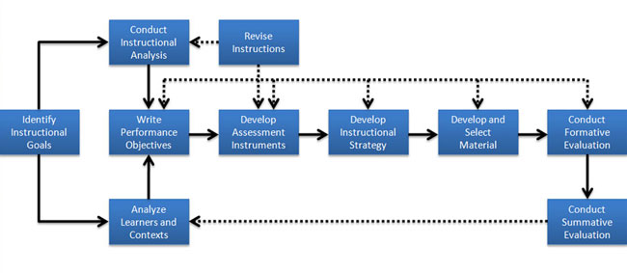

Instructional design is sometimes referred to as the ADDIE process :
- Analyze the situation (learners, content, resources, environment).
- Design the instruction (objectives, method).
- Develop the learning material (content, multimedia, resources).
- Implement the training (face-to-face, online, blended delivery).
- Evaluate the outcome (make changes if necessary).

Key Points for Lesson 1
To fully understand the concepts covered in this lesson it is important to have acquired a solid background on a number of key points such as:
- Training Seminar
- Training and development has benefits for the employee, the organization, as well as society as a whole.
- Overall, Canadian businesses have not fared well in the training of their employees.
- Demographic shifts in the Canadian workforce, in addition to other environmental and organizational factors, will increase reliance on training.
- The government of Quebec introduced special legislation to penalize companies that did not invest in the training and development of its employees (the “1% Law”).
- Training and development works in the context of a larger system (HPWS).
- The instructional systems design (ISD) model is a systemic approach to the creation of training and development practices.

The Learning Organization
An organization that acquires, organizes, and shares information and knowledge, and uses new information and knowledge to change its behaviour in order to achieve its objectives and improve its effectiveness.
- Able to transform itself by acquiring and disseminating new knowledge and skills throughout the organization.
- Has enhanced capacity to learn, adapt, and change its culture.
- Has the ability to make sense of, and respond to, surrounding environment.

The Five Disciplines
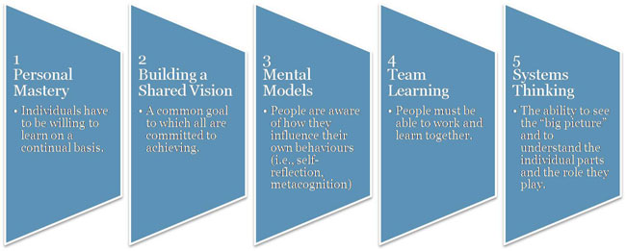

Principles of a Learning Organization

- Classroom training
- Everybody is considered a learner.
- People learn from each other.
- Learning is part of a change process.
- Continuous formal and informal learning.
- Learning is an investment.
- Experimentation is valued.
- Failure is tolerated if it leads to learning.
Four Key Dimensions of a Learning Organization
- Vision
- Requires clear vision of organization’s strategy and goals.
- Culture
- Fosters information sharing and continuous learning.
- Learning Systems/Dynamics
- Seek solutions to problems through a systemic view of the organization and its environment.
- Knowledge Management/Infrastructure
- Technology, systems and processes to support the capture, dissemination and evaluation of knowledge.
- Ensure that the “right person has the right knowledge at the right time.”

Types of Knowledge

Knowledge can be grouped in two ways:
  - Explicit Knowledge:
- Things that you can buy or trade, such as patents or copyrights and other forms of intellectual property.
- Knowledge that has been codified and documented.
- Can be written into procedures or stored in databases.
- Is transferred fairly accurately.
- Small proportion of corporate knowledge is explicit.

  - Tacit Knowledge:
- Known only by the individual and is not necessarily known by the organization.
- Valuable wisdom learned from experience and insight that has been defined as intuition, know-how, little tricks, and judgment.
- Difficult to transfer.
- People are often not aware of the tacit knowledge they possess and how valuable it is to others.
- Difficult to articulate.
- Accounts for greater proportion of corporate knowledge.
- Often this knowledge is critical to competitive advantage.
Example: One can learn a new language through their experience with others without the need of learning the grammar and formal sentence structure. On the other hand, one cannot open a book and memorize the grammar and expect to be fluent without practicing it with a native speaker.

The Types of Intellectual Capital
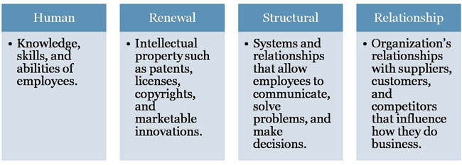

The Life Cycle
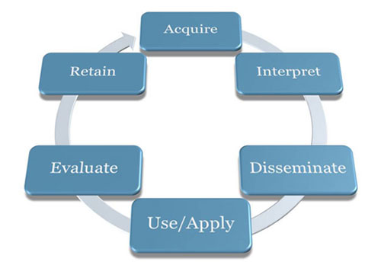

- Aquire
  - Knowledge Acquisition
- Interpret
  - Knowledge Interpretation
- Disseminate
  - Knowledge Dissemination
- Use/Apply
  - Use/Application
- Evaluate
  - Evaluation
- Retain
  - Knowledge Retention
A. Knowledge Acquisition
1 | Environment scanning: | - Internal; includes individuals, teams, departments, etc.  - External; includes sources of information from other organizations, customers, industry watchers, etc.
2 | Formal learning  (training & development): | - Key part of the knowledge-acquisition process  - Represents a small, but critical proportion of how employees learn
3 | Informal learning: | - Represents the largest proportion of employee learning  - Often spontaneous, immediate and task-specific  - Can be based on trial and error, search or social network
 | (Learn more about informal learning on the following slide)

There are different nuances in the definitions found in the literature:
- Learning that occurs naturally as part of work and is not planned or designed by the organization. (Saks & Haccoun)
- “Learning which takes place in the work context, relates to an individual’s performance of their job and/or their employability, and which is not formally organized into a programme or curriculum by the employer. It may be recognized by the different parties involved, and may or may not be specifically encouraged.” (Dale & Bell, 1999)
- Learning that takes place outside a dedicated learning environment and which arises from the activities and interests of individuals and groups, but which may not be recognised as learning.” (McGiveney, 1999)

Comparing Formal and Informal Learning
Factor | Formal Learning | Informal Learning
Control | Controlled by organization | Controlled by learner
Relevance | Variable | High
Timing | Delay between learning and use of knowledge acquired | Learning used immediately on the job
Structure | Highly structured | Unstructured
Outcomes | Specific | Not specific

B. Knowledge Interpretation
- Mental models are deeply engrained assumptions, generalizations, or images that influence how we understand the world and how we take action.
- An effective way to develop shared mental models is to establish teams to stimulate work-related learning, solving real problems.
- Communities of Practice are networks of people who work together and regularly share information and knowledge.

Communities of Practice (CoPs) comprise individuals who share common values, goals, problems or challenges, and a shared language for framing and exploring issues.
- Often, members share a disciplinary background, though a CoP could be interdisciplinary.
Unlike a project team, a CoP has no formal mandate, no formal designation of roles and responsibilities, no predefined deliverables or preset lifespan and no specific defined objective.
CoPs are the mechanism through which individuals gradually come to participate fully in a profession or discipline.
- The learning that occurs is largely informal, and based on exposure to the practices and norms of the community. This form of learning is sometimes referred to as “enculturation” or “apprenticeship.”
There is an upper limit on the number of individuals who can form a CoP. This limit is sometimes pegged at the “Dunbar Number” after the sociologist Robin Dunbar, who studied the relationship between the cognitive ability of different species and their sociability.
CoPs are naturally occurring phenomena. However, in modern organizational settings, there is a great deal of focus on facilitating CoPs through information and communications technology, and even on creating CoPs. It is an open question to what extent CoPs can be implemented artificially.

C. Knowledge Dissemination
- Moving ideas requires a different set of skills.
- Systems for sharing knowledge.
  - Shared mental models and language.
- Information and Communication Technology (ICT):
  - Increased codification of knowledge; that is, its transformation into information that can be easily transmitted.
  - Intranet and portals are critical components for managing knowledge.
    - Employee questions can be answered in hours instead of weeks.
- CoPs are a mechanism for disseminating knowledge (particularly tacit knowledge).
D. Use/Application
In the sphere of KM, it is important to monitor:
How knowledge is being used. | Where it is being used. | Who is using it.

E. Evaluation
- A consideration of the value and potential of the knowledge.
- Could be rated by employees and managers.
- Could be gauged through measurable outcomes (e.g., the return-on-investment of a best practice or an innovation).
- Could be based on usage (e.g., number of searches in a repository in a given subject area).
F. Knowledge Retention
- The way in which useful knowledge is stored and organized in such a way that it can be easily be retrieved.
- Knowledge repositories are inventories of knowledge that organizations compile and store, which can be easily retrieved.
  - Some repositories are more informal lists of lessons learned, white papers, presentations, and so on.
  - Most have links to the originator of the documents.
  - Includes content and document management systems, public file structures, and libraries.

Connection Between Organizational Learning and Training:
- Training is an important element of learning.
- Learning organizations exceed other organizations in terms of both training practices and expenditures.
- Increased spending on training alone does not entail a learning organization.
- Individuals learn through training and development.

Key Points
- Organizational learning is the process of creating, sharing, diffusing, and applying knowledge within an organization.
- A learning organization is one that establishes and maintains conditions for organizational learning to occur.
- Senge (1990) identified five disciplines that are widely regarded as guiding principles for creating learning organizations.
- Learning organizations are characterized by four important principles.
- Although explicit knowledge is the easiest to quantify and record, tacit knowledge is the most valuable and the most difficult to maintain.
- Knowledge management practices and intellectual capital have become increasingly important in a competitive, knowledge-based economy.
- Once knowledge is acquired, it is then interpreted, disseminated, applied, evaluated, and retained/stored.

Learning Outcomes
Learning outcomes can be classified according to five general categories (Gagne, 1984):
1) Verbal information
- Facts, knowledge, principles, information (declarative knowledge).
- Verbs: state, recite, tell, declare, define.
- Example: “Define the term learning.”

2) Intellectual skills
- Concepts, rules, and procedures (procedural knowledge).
- Categories: discrimination, concrete concept, defined concept, rule, higher-order rule.
- Verbs: distinguish, identify, classify, solve, label, specify.
- Example: “Identify each instance as an example of procedural or declarative knowledge.”
3) Cognitive strategies
- Application of information and techniques.
- Understanding how and when to use the information.
- Verbs: adopt, create, originate, invent.
- Example: “Create and explain your own strategy to solve the following problem.”
4) Motor skills
- Coordination and execution of physical movements.
- Verbs: execute, perform, demonstrate.
- Example: “Hit a ball with a baseball bat.”
5) Attitudes
- Preferences and internal states associated with beliefs and feelings.
- Verbs: elect, favour, prefer, choose.
- Example: “Which learning theory do you prefer and why?”

Stages of Learning a Skill
Stages | Example in Reading
Declarative knowledge:  Learning knowledge, facts, and information. | Learn the alphabet, learn conventions about direction of reading (in North America: left-right, top-down) separation of words, purpose of punctuation, rote learning of some words, learn some phonemes.  - Attempts at reading involve the conscious application of this knowledge to text.
Knowledge compilation:Integrating tasks into sequences to simplify and streamline the task. | Word recognition becomes automatic, however over time, a proficient reader is able to grasp whole sentences and even passages at a glance.  - This is because the comment sub skills involved in reading have been completely automated and merged together, overcoming limitations of working memory.
Procedural knowledge: Learner has mastered the task & performance is automatic & habitual. | Learner no longer has to think deliberately and consciously about the sounds associated with letter combinations or the meaning of individual words.  - Comprehension increases as working memory no longer has to perform the conscious tasks mentioned above.

Learning Styles
Definition: The way an individual gathers , processes and evaluates information during the learning process.
According to Kolb (1984), there are four ways in which individuals gain experience (and learn):
    - Concrete experience (CE)
    - Abstract conceptualization (AC)
    - Reflective observation (RO)
    - Active experimentation (AE)
An individual’s preferred learning style is a combination of two of the modes of learning:
- Converger (AC + AE) = thinking and doing
- Diverger (CE + RO) = feeling and watching
- Assimilator (AC + RO) = thinking and watching
- Accomodator (CE + AE) = feeling and doing

Learning Theories
A. Conditioning Theory
- Learning is a result of reward and punishment contingencies that follow a response to a stimulus.
- A stimulus or cue would be followed by a response, which is then reinforced.
- Strengthens the likelihood that response will occur again and that learning will result.
Positive Reinforcement: | Negative Reinforcement: | Punishment:
- application of a positive stimulus after an act. | - removal of a negative stimulus after an act. | - receiving a negative consequence for an undesirable act.
Note that both forms of reinforcement (postitive and negative) will increase or maintain behaviour.

Shaping: | Chaining: | Generalization:
- Reinforcement of each step in a process until it is mastered. | - Reinforcement of entire sequence of a task. | - Conditioned response occurs in circumstances different from those during learning.

B. Situated Cognition
Theory that builds on cognitive approaches to understanding learning. Cognitivism focuses on the structures that are created in the mind, through experience, and that further mediate our interpretation of experience.
- These structures are called mental models or schema.
- Schema evolve through different processes in which they are tweaked or extended to deal with new experiences, or undergo radical restructuring, if required (“accretion”, “tuning”, “restructuring”).
- Schema serve as filters that focus our attention in different ways
Learning is seen as a process in which schema are further elaborated to contend with new experiences.
  - Key processes are “generalization” and “discrimination” (in the former, a very concrete concept becomes more abstract, and more inclusive; in the latter, a schema that reflects a broad categorization is narrowed or restricted, to allow more contrast or discrimination).
Cognitive theories are also based on an information processing model of the mind.
- Key elements in the basic model (there are variants) are short-term, working and long-term memory stores or registers.
- Sensory channels provide input to short-term and working memory. These are not permanent storage units, and there are well-established limits on how much information can be held in working memory and manipulated (7 plus or minus 2).
- The object is to move information from working memory into long-term memory, which is a stable repository, for future retrieval and use.
Situated Cognition builds on the cognitive paradigm.
  - The insight captured in situated cognition is that at the time of learning we also encode aspects of the situation in which we are learning. These become part of our memory structures and affect our ability to successfully apply what we have learned – both facilitating and obstructing performance depending on circumstances. The aspects of the situation that are encoded are, if you like, conditions of applicability.
- If we learn and practice a new concept or skill over and over in the same or very similar situations or contexts we will find that we are very well able to apply this learning when we are confronted with a similar context.
  - Our ability to do this will likely exceed that of someone who has learned the principle or concept in a more abstract (less situated, less applied) fashion.
- However, it is also true that if we are placed in a novel context where the same learning could be useful, we may be unable to recognize this, and fail to retrieve and apply the relevant schema.
- To enable learners to access and apply schema across a wide variety of relevant situations, learning and practice must involve a variety of contexts.
- Decontextualized or abstracted presentations of a topic may also lead to greater “wide transfer” of what is learned.
C. Social Learning Theory
Three Key Components
1. Observation | - Learning by observing the actions of others and the consequences.  - Four key critical elements: Attention, Retention, Reproduction, Reinforcement
2. Self-efficacy | - Judgments people have about their ability to successfully perform a specific task.  - Influenced by four sources of information in order of importance:  - Task performance outcomes  - Observation  - Verbal persuasion & social influence  - Physiological/emotional state  “People who hold a low view of themselves will credit their achievements to external factors rather than to their own capabilities.” (Albert Bandura)
3. Self-management | Managing one’s own behaviour through a series of internal processes.  - Observe personal behaviour, as well as the behaviour of others  - Setting performance goals  - Assessing personal progress  - Rewarding oneself for goal achievement  - Concepts: self-regulation, metacognition

Behavioural, Cognitive and Socio-Cultural Theories
o-cultural learning theories differ in the emphasis they place on the environment, the individual, and behaviour.
- Behaviourists will argue that an influence in the environment will have a change on one’s behaviour. Individual differences are not as important.
- Cognitivists believe that the individual is key since individuals can perceive the environment differently and their behaviour will differ accordingly.
- Socio-cultural theorists focus on the effect of the environment on behaviour, but particularly on the role of the community in shaping one’s behaviour.

Need Theories
- Needs refer to physiological and psychological desires.
- Needs are motivational because people are motivated to obtain the things that will satisfy their needs.
1) Maslow’s hierarchy of needs

2) Clayton Alderfer’s ERG theory
Three needs:
- Existence needs
- Relatedness needs
- Growth needs

Process Theories
1) Expectancy Theory
- Process theory of motivation.
- Energy or force that a person directs toward an activity is a direct result of three factors:
A) Expectancy:  individual’s subjective probability that they can achieve a particular level of performance on a task. | B) Instrumentality:  subjective likelihood that attainment of a first-level outcome such as an “A” or “B” in this course will lead to attractive consequences that are known as second-level outcomes. | C) Valence:  refers to the attractiveness of first- and second-level outcomes.
D) Effort = Expectancy x (Instrumentality x Valence)
2. Goal Setting Theory
- People’s intentions are a good predictor of their behaviour.
- Goals are motivational because they direct people’s efforts and energies and lead to development of strategies to help them reach their goals.
Characteristics for goals to be motivational are: | - Specific in terms of their level and time frame  - Challenging  - Must be accompanied by feedback  - People must accept them and be committed to them

Goal orientation
Mastery/Learning goals:  Process-oriented goals that focus on learning process. | Performance goals:  Outcome-oriented goals that focus attention on achievement of specific performance outcomes.

Model of Training Effectiveness
- Training motivation is also a strong predictor of learning and training outcomes.
- Self-efficacy, cognitive ability, and personality characteristics also have an effect on learning.
- Attitudes (i.e., job involvement, job satisfaction, and organizational commitment).
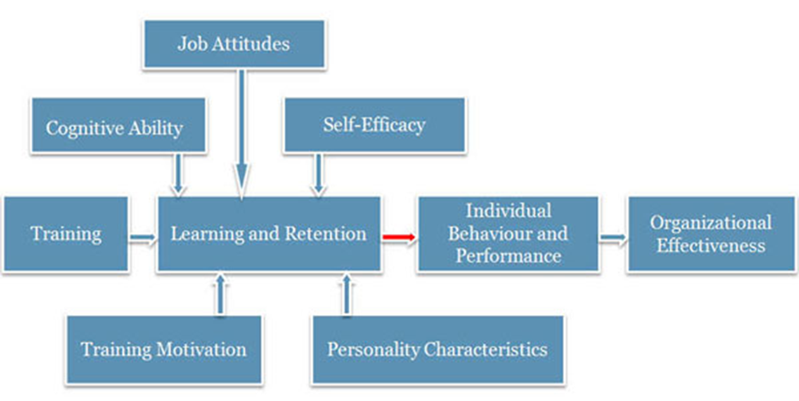
- Key issue for training is ensuring that what is learned is applied in the workplace (in the operational context).
- Degree of transfer attained in training is often limited.

Key Points
- The major goal of all training and development is learning.
- Learning involves a change in behaviour by an individual based on their interaction with the environment.
- Different learning theories explain this relationship in various ways.
  - Behaviourist vs. cognitivist vs. social learning
- Adult learning theory and theories of motivation have implications for the design of training and development.
- Organizational effectiveness is the end product of a model that involves training, employee characteristics, attitudes, learning and retention, and performance.

What is Transfer of Training?
Definition: Transfer of training refers to generalization of knowledge and skills learned in training on the job and maintenance of acquired knowledge and skills over time.
Two conditions:
Generalization | - Use or application of learned material on the job.
Maintenance | - Use or application of learned material on the job over a period of time (repeated behaviour).

The Extent of Transfer of Training
Positive | Zero | Negative
- Trainees effectively applynew learning on the job. | - Trainees do not apply new learning on the job. | - Trainees perform worse on the job after training.

Types of transfer of training:
- Near: Applying new learning to situations that are very similar to those in which training occurred.
- Far: Applying new learning to situations that are different from those in which training occurred.
- Horizontal: Transfer across different setting at the same level.
- Vertical: Transfer from trainee level to organizational level.

The Transfer of Training Process

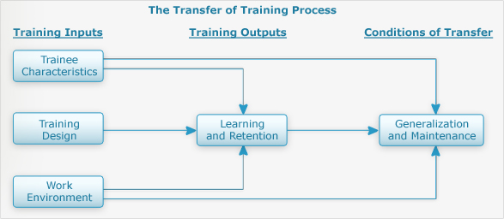

Training Inputs
1 | Trainee Characteristics | Cognitive ability, training motivation, self-efficacy, personality characteristics.  Most likely to transfer:  - High cognitive abilities, motivation to learn, self-efficacy.  - Internal locus of control and high need for achievement.  - High job involvement, job satisfaction, and organizational commitment.
2 | Training Design | Active practice and conditions of practice.  Learning principles:  - Identical elements (authenticity)  - General principles (theory)  - Stimulus variability (practice)
  These topics are covered in more detail in the next lesson - Training Design.
3 | Work Environment | Pre-training  - Management actions send messages/signals regarding importance and organizational support of training.  - Organizational constraints: lack of time, equipment, and/or resources.  Post-training  - Support provided by trainees’ supervisor.  - Training transfer climate: Characteristics in the work environment that can foster or inhibit applying the training to the job.  - Learning culture: Transfer of training is greater in an organization that values the acquisition of knowledge and skill (a learning organization).

Facilitating and Improving Transfer of Training
Transfer of Training Activities Before Training
1. Management | 2. Trainer | 3. Trainees
Decide who should attend  - Readiness to learn/trainability  (Ability x Motivation x Perceptions of the Work Environment) = Readiness to Learn and Trainability.  - Trainability tests  Increase motivation to learn  - Meet with employees to discuss training needs.  - “WIIFM” (“what’s in it for me?”)  Provide employees with support for learning and training. | - Ensure application of ISD model.  - Ensure both trainees’ supervisor and trainees are prepared in terms of knowing objectives and benefits.  - Find out supervisor and trainee needs and expectations.  - Ensure that trainees are prepared for training in terms of prerequisite courses/readings, etc. | - Find out about training objectives prior to attendance.  - Meet with supervisor to discuss training program and develop action plan for learning and transfer.  - Prepare for training program.

Transfer of Training Activities During Training
1. Management | 2. Trainer | 3. Trainees
- Participate in training programs.  - Speak about importance of training programs.  - Attend training programs before trainees.  - Reassign employees' work while they are attending training. | - Incorporate conditions of practice, adult learning principles, and other learning principles in design.  - Include content and examples that are relevant and meaningful.  - Include instruction on transfer of training.  - Have trainees prepare a performance contract. | - Enter training program with positive attitude and motivation to learn.  - Engage themselves by actively participating.  - Develop an action plan for application of training on the job.

Transfer of Training Activities After Training
1. Management | 2. Trainer | 3. Trainees
- Ensure trainees have immediate and frequent opportunities to practice and apply what they learned.  - Encourage and reinforce trainees’ application of new skills.  - Develop action plan with trainees, reduce job pressures and workload, arrange practice sessions, give promotional preference to employees who have received training and, transfer and evaluate employees’ use of trained skills on the job. | Conduct field visits  - Observe trainees, provide feedback and support.  Offer booster sessions  - Definition: Extensions of training programs that involve periodic face-to-face contact between the trainer and trainees. | - Begin using new knowledge and skills on the job ASAP.  - Meet with supervisor to discuss opportunities for transfer.  - Form a “buddy system”.  - Consider high-risk situations that might cause a relapse and develop strategies for overcoming them and avoiding a relapse.

Transfer of Training Interventions
Relapse prevention
- Anticipate transfer obstacles and develop coping skills.
Self-management and self-coaching
- Perform a series of steps to manage transfer behaviour and establish performance maintenance and improvement goals.
Goal setting
- Set specific, challenging goals to enhance transfer.
Goal setting interventions
- Teach trainees about the goal setting process.
Booster sessions
- Extensions of training programs that involve a review of the training material.

Model of Training Effectiveness
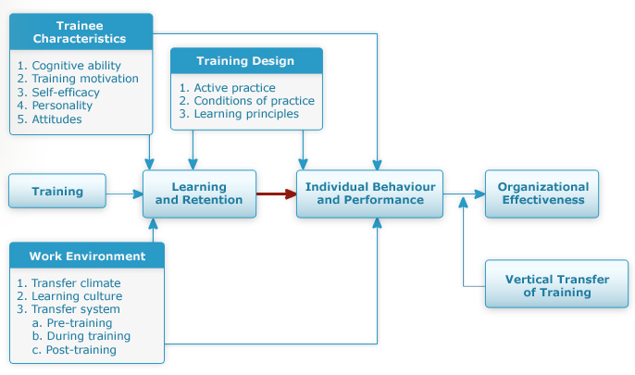

Key Points
- The transfer of training to the workplace is a serious problem because it is difficult to measure and there are many potential barriers.
  - Personal characteristics of the trainee, the design of the training, and the environment in which it is delivered and applied.
- Transfer can be affected by all stakeholders (management, trainer, trainee) before, during, and after the training.
- The transfer system combines human and organizational factors to model the effectiveness of training.
  - The Learning System Transfer Inventory (LTSI) can be used to assess this system.

What is Needs Analysis?
A process to identify gaps or deficiencies in employee and organizational performance.
- Goal: Identify differences between what is and what is desired or required in terms of results, and compare the magnitude of gaps against the cost of reducing them or ignoring them.
- Also known as: needs assessment, training needs analysis (TNA).
Needs Analysis Process

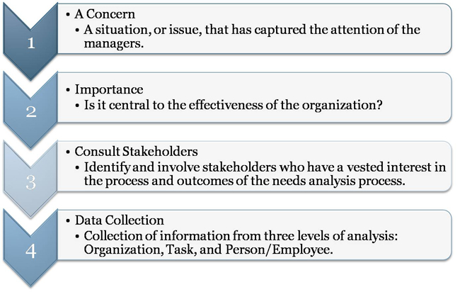
The Steps
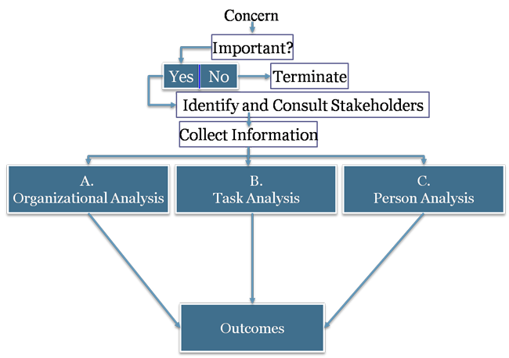

Needs Analysis Outcome
- Identifies performance gaps.
- Clarifies nature of performance gaps.
- Determines if training and development is necessary.
- Identifies where (what/for who) training and development is necessary.
- Write training objectives and design training programs.
- Develop measures for training evaluation.

Organizational Analysis
The study of the entire organization. This includes the following:
Strategy | - Consists of an organization’s mission, goals, & objectives such as a dedication to quality or innovation.  - Strategic training: Alignment of an organization’s training needs & programs with the organization’s strategy & objectives.
Environment | - New technologies, competitors, recessions, regulations, mergers, acquisitions, and trade agreements can profoundly affect:  - The need for training.  - The content of training.  - Employees’ receptivity to being trained.
Resources | Resource Analysis: Identification of the resources (money, time, expertise) available in an organization that might be required to design and implement training and development programs.  - This will be covered in more detail in Lesson 12 – The Costs and Benefits of Training.
Context | Organizational Context  - Climate: The collective attitudes of employees toward work, supervision and company goals, policies, and procedures.  - Training transfer climate: Characteristics in the work environment that can either facilitate or inhibit the application of training on the job.  - Learning culture: Culture in which members of an organization believe that knowledge and skill acquisition are part of their job responsibilities and that learning is an important part of work life in the organization.  - The training transfer climate and learning culture were investigated in the previous lesson – Transfer of Training.
The key is to not only determine if training is needed, but also to gauge the chances of success by identifying potential barriers.

Task Analysis
The process of obtaining information about a job by determining the duties, tasks, and activities involved and the knowledge, skills, and abilities required to perform the tasks.

Job | Task
Consists of a number of related activities, duties, and tasks. | Smallest unit of behaviour studied by the analyst and describes specific sequence of events necessary to complete a unit of work.

Six Steps of a Task Analysis
1 | Identify the target jobs.
2 | Obtain a job description.  - Job description: A statement of tasks, duties, and responsibilities of a job. It lists the specific duties carried out through the completion of several tasks.
3 | Develop rating.  - Rate the importance of each task and the frequency that it is performed.
4 | Survey a sample of job incumbents.
5 | Analyze and interpret the information.
6 | Provide feedback on the results.

Alternative Approach: Cognitive Task Analysis
A set of procedures that focuses on understanding the mental processes and requirements for performing a job.
- Differs from traditional task analysis in that it describes mental and cognitive activities that are not directly observable, such as decision making and pattern recognition.
Some will argue that task analyses are limited since they (1) emphasize the observable behaviours of individuals rather than their cognitive processes and (2) they assume that the tasks are performed by individuals rather than by groups.

Alternative Approach: Team Task Analysis
Analysis of tasks of the job, as well as the team-based competencies (knowledge, skills, and attitudes) associated with the tasks.
- Differs from traditional task analysis in that interdependencies of the job, skills required for task coordination, and cognitive skills required for interacting in a team must be identified.

Person Analysis
Process of studying employee behaviour to determine whether performance meets standards.
- Define the desired performance.
- Determine the gap between desired and actual performance.
- Identify the obstacles to effective performance.

Barriers to Effective Performance
Human | Technical | Information | Structural
Lack of knowledge* | Poor job design | Ill-defined goals/ objectives | Overlapping roles & responsibilities
Lack of skills* | Lack of tools/equipment | Lack of performance measurements | Lack of flexibility
Lack of motivation | Lack of standardized procedures | Raw data, not normative or comparative data | Lack of control systems
Counterproductive reward systems | Rapid change in technology | Resources sub-optimized | Organizational political climate
Group norms | Ineffective feedback | Informal leaders
*Only barriers that can be addressed with a training solution.

Needs Analysis Methods
Nine Methods
1. Observation | 2. Questionnaires | 3. Key consultation
4. Print media | 5. Interviews | 6. Group discussion
7. Tests | 8. Records and reports | 9. Work samples

Needs Analysis Sources
- Employees and managers
  - Self-assessments
- Subject matter experts
- Customers
  - Satisfaction ratings and perceptions.
- Computer-based analysis
  - Analysis of business data (e.g. CRM, manufacturing quality systems, call centre management software).

Obstacles to Needs Analysis
- Budgetary constraints to conduct a needs analysis.
- Feel that they can accurately identify training needs and that more analysis is a waste of time and money.
- Managers may even have their own agendas.
- Time is a constraint.
- Lack of expertise to conduct a needs analysis.

Key Points

- Needs analysis is a crucial step in the design and development of training.
- The needs analysis process consists of a series of interrelated steps.
  - The identification of a concern, measuring its importance, consulting the stakeholders, and the collection of information.
- The outcome of a needs analysis may reveal that the solution is non-instructional.
- Given that the proposed solution is instructional, the results of the needs assessment drive the rest of the instructional design process.
  - A poorly conducted needs analysis will impede the chances of a successful training program.
- Information must be collected from various sources in order to properly understand the problem:
  - Organizational analysis, task analysis, person analysis.
- There are many different methods to collect information.
  - Each have specific advantages and disadvantages.

What is Design?
Definition of Design:
A disciplined inquiry engaged in for the purpose of creating some new thing of practical utility. It involves exploring an ill-defined situation, finding as well as solving a problem(s), and specifying ways to effect change.
Design is carried out in numerous fields and will vary depending on the designer and on the type of thing that is designed. Designing requires a balance of reason and intuition, an impetus to act, and an ability to reflect on actions taken. (Rowland, 1993, p.80)
The word “design” can be defined in many ways and has different connotations based on the context in which it is used.
- To conceive or fashion in the mind; invent
- To formulate a plan for; devise
- To plan out in systematic, usually graphic form
- To create or contrive for a particular purpose or effect
- To have as a goal or purpose; intend
- To create or execute in an artistic or highly skilled manner
Basic Beliefs of Design
1. Design is a problem-solving discipline.
-A problem must first be defined and a concentrated effort is then carried out to design a solution to solve the problem.
2. No two problems are the same.
-Although the situation could be similar (same learners, same company, same budget), the timing could differ, as could the expectations, the technology used, etc...
3. One of the main reasons for defining a problem is to identify any constraints associated to it.
-The constraints help identify the solution that will be used to solve the problem.
4. There is no perfect solution
-A designer must choose from a list of many possible solutions. To do so, they will consider the constraints, as well as the nuances regarding the situation at hand. What could work in one situation may or may not work in another.
Reaching a solution for a design problem is part science, part instinct, and part art.

What is Instructional Design?
Instructional design is a comprehensive system of procedures informed by research and practice that is employed to develop effective and efficient educational and training programs in a consistent and reliable way (Gustafson & Branch, 2002).
The complex process, often called Instructional Systems Design (ISD), is active (it is constantly being monitored and altered), iterative (the process is repeated and refined), and creative (allows for many different solutions).
A system consists of a set of elements that interact with each other in such a way that it is:
- interdependent: No individual element can be separated from the system. They rely on each other to accomplish a common goal.
- synergistic: The sum of the parts of the system is greater than the individual contributions of each.
- dynamic: The system is constantly monitoring its environment and is flexible enough to be altered to changing conditions.
- cybernetic: The individual elements are able to effectively communicate with each other.

The ISD Model - Design
Recall that the ISD Model of Training and Development is composed of three main phases:
- The Needs Analysis: used to analyze the situation and determine if training is a viable solution to the problem
- Training Design and Delivery: to develop the training and deliver it to the trainees
- Training Evaluation: to assess the results of the training and determine if adjustments are required

Training Objectives
According to the ISD Model, the end result of the Needs Analysis is the identification of a problem. The more information we are able to gather about that problem, the more likely we are to find a solution that will address it.
If a training solution is chosen (recall that not all problems can be solved with training), the first step of the design and delivery phase of the ISD model is the establishment of the training objectives.
A Training Objective is a statement of what trainees are expected to be able to do after a training program. Objectives are more than simple statements of goals or general outcomes.
- They are written following a specific format.
- They dictate the design of the training.
- They serve as the basis for evaluation (if it can be measured).
- They provide the learner with the means to self-select their instruction (using metacognitive strategies).
Training objectives are also known as learning or performance objectives.

Purposes of Training Objectives
Training objectives are important for all the stakeholders involved in the training intervention: the trainees (the individuals being trained), the trainers (the individuals who are designing and/or presenting the training), and the managers (the individuals who have sponsored the training intervention and/or are supervising employees who are being trained).

Writing Training Objectives
Training objectives should include five key elements of the desired outcomes:
- Who is to perform the desired behaviour?
- What is the actual behaviour?
- Where is the behaviour to be demonstrated?
- When is the behaviour to be demonstrated?
- What is the standard by which the behaviour will be judged?

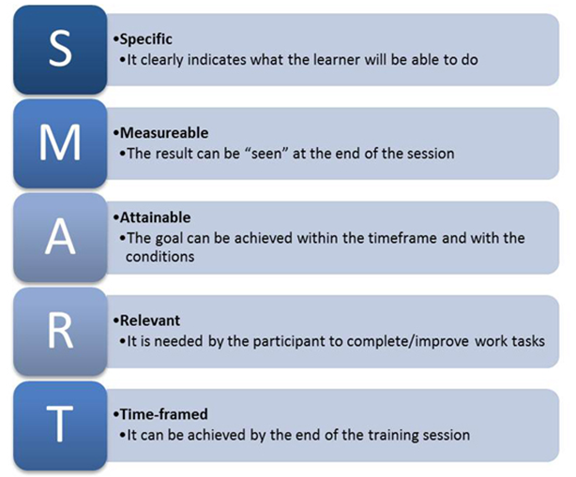

Training Content
Once we have established what the training objectives will be, we now turn our attention to the content that needs to be delivered to the trainees.
In scenarios where a company has their own training department (perhaps with their own subject matter experts and trainers), they may opt to design and develop the training solution internally. In other situations, particularly when resources for training and development are scarce, the solution might involve buying a ready-made product (off-the-shelf) or hiring/outsourcing the training to a third party. For larger projects, this may require that the company ask for suppliers to bid on their project (a request for proposal or RFP).
We will explore the advantages and disadvantages of each scenario.
The content presented to the trainees must be designed to fulfill the needs of the company. Once a needs analysis has been conducted, the results are used to help identify the nature of the content that needs to be included in the training program.
- Follow the training objectives
  - Once a proper needs analysis has been conducted, let the training objectives help dictate the content required for the training.
- Compare actual performance to performance goals
  - The content should address the identified performance gap of the employees.
- Refer to legislation
  - If training is required because of new or updated legislation, the content would reflect it.
- Consult with subject matter expert (SME)
  - In other cases, one might need to consult a subject-matter expert (internally or externally) to create the content for the training, or validate training that was created in-house in order to make sure that it is authentic.

Off-the-Job Training Methods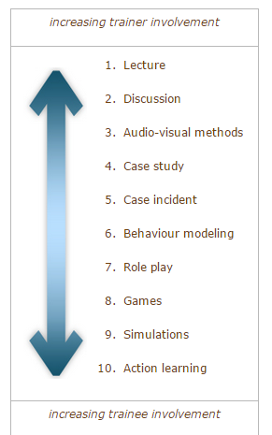

Method: Lecture
Trainer organizes content and presents orally; little listener involvement.
Advantages | Disadvantages
- Transfer large amounts in short time. Minimal costs to produce.  - Listeners all get same message (consistency in content). | - Not effective for development of skills/change of attitudes.  - Forced passive learning.  - Does not accommodate differences among participants (experience, ability, role, interests, motivation, etc.).  - Scheduling (inflexible).
See the following for tips on improving your presentation technique.
Method: Audio-Visual
Advantages | Disadvantages
- Can be used to illustrate behaviour.  - Highlight key points (slides).  - Control pace of training. | - Might be a tendency to emphasize style over substance.  - Cost increases with use.

Method: Discussion
Leader facilitates analysis of a problem or case.
Discussions have five purposes:
- Helps members recognize what they do not know but should.
- Opportunity for members to get answers to questions.
- Allows members to get advice on concerns.
- Allows sharing ideas and deriving a common wisdom.
- Way to learn about one another.

Method: Case Study
Students discuss, analyze, and solve problems based on real situations.
Objectives | - Introduce realism into learning.  - Deal with variety of problems, goals, facts, conditions, and conflicts.  - Teach how to make decisions.  - Teach creativity, think independently.
Requirements | - Students/teachers must have qualifications to analyze material.  - Appropriate time must be provided.  - Atmosphere must be supportive.
Styles/Methods | - Single problem vs. multiple situations.  - Written, audio-visual, live case/operational consulting.

Method: Case Incident
This method presents one part of an organization’s problem for analysis.
Advantages | Disadvantages
- Useful to stress one topic or concept.  - Short, so can be read during training session.  - Reduces effect of differences in reading times.  - Trainees can draw on their own experiences. | - Lack of background material.  - Problematic for people with limited work experience.

Method: Behaviour Modeling
This method demonstrates key behaviours that trainees observe and attempt to replicate.
- Good for learning skills and behaviours, not for factual information.
- Used often for teaching interpersonal skills.

Based on four learning principles:
1. Observation | 2. Rehearsal | 3. Reinforcement | 4. Transfer

Method: Role Play
- Trainees practice newly learned skills in a safe environment.
- Various forms of role play exist.
- Three phases: (1) development, (2) enactment and (3) debriefing.
- Debriefing should take 2-3 times longer than enactment.
Advantages | Disadvantages
- Useful for acquiring skills in human relations and changing attitudes.  - Requires active participation. | - There may be resistance to participating.

Method: Games
- Activities characterized by structured competition that allow trainees to learn specific skills.
- Tend to focus on development of problem-solving, interpersonal skills, and decision-making skills.
- Incorporate learning from experience, active practice and direct application to real problems.
- Disadvantage: possibility of learning wrong things, weak relation to training objectives, and emphasis on winning.

Method: Simulations
Use of operating models of physical/social events designed to represent reality.
- Used to recreate situations by simplifying them.
- Used when training in real world might involve danger or extreme costs.
- Equipment simulators: mechanical devices similar to those on the job (e.g. flight simulators).

Advantages | Disadvantage
- Realistic and sometimes cost effective.  - Opportunity to experience many situations and get performance feedback. | - Expensive to develop and stage.

A soldier tests out a heavy-wheeled-vehicle driver simulator (Source: Wikipedia.org)
Fidelity of the simulation is a key concept that affects transfer of learning to the work environment:
  - Physical fidelity: similarity of physical aspects of the simulation to actual job.
  - Psychological fidelity: similarity of psychological conditions of the simulation to actual work environment.

Method: Action Learning
I hear, I know. I see, I remember. I do, I understand. (Confucius)
Action learning consists of a process in which the learner performs a given activity, then analyzes their actions in order to improve on their performance. The learner repeatedly performns the task and typically obtains feedback from a small group (or set) of individuals.
Accept challenge of studying and solving real problems, accept responsibility for solutions.
- Advantage: test theories in the real world.
- Involves identifying real problems, developing solutions, testing them and evaluating consequences.
- Changes trainees from passive information receivers to problem solvers.

So Which Is Best?
- The more highly involved the trainee in the learning process and the more the training situation resembles the job, the more likely it is that transfer will occur.
- Effectiveness of a training method depends on its achievement of training objectives.
- Most effective training programs utilize more than one method. This is also known asblended learning.
  - In blended learning programs, a mix of delivery methods are used to suit the objectives, learner needs, and organizational resources.
  - This allows for more learner flexibility with the style/method that they prefer and more trainer flexibility in the method to use to achive a particular learning outcome (case study may work well for one objective, but action learning may be more effective with another.
Factors to consider:
- Training objectives.
- Cost and resource availability.
- On-the-job application.
- Trainer skills and preferences.
- Trainee characteristics and preferences.
  - Aptitude-treatment interaction: when a training method has differential effects on trainees with different aptitudes.

Key Points
- There are several ways that off-the-job training can be accomplished.
  - Each one has advantages and disadvantages.
  - Selecting the appropriate off-the-job training method will depend on several factors.
- Simulations are considered effective if they involve concepts of physical and psychological fidelity.
- Different trainees will benefit from a particular method of instruction.
  - An aptitude-treatment interaction occurs when a particular training method is more effective on certain trainees because of their different aptitudes.
- A blended delivery approach to training is favourable because it combines the strengths of different delivery methods.

On-the-Job Training Methods
Trainees receive instruction and training in their work environment from a supervisor or experienced coworker.
- Especially useful for small businesses.
- Most common approach to training.
- Most misused:
  - Often not well planned or structured.
  - People assigned to train have no training to be trainers.
  - Potential transfer of undesirable habits/attitudes.
- Structured approach most effective.

This lesson presents the advantages and disadvantages of the most common on-the-job training delivery methods.

- Job instruction training
- Performance Aid
- Job rotation
- Apprenticeship
- Coaching
- Mentoring

Method: Job Instruction Training
Formalized, structured, and systematic approach to on-the-job training (OJT).
The four steps are:
Step 1: Preparation  - Develop communication strategy that fits trainee.  - Determine what trainee already knows and nature of the tasks to be performed.  - Stages:  - Put trainee at ease.  - Guarantee the learning.  - Build interest and show personal advantage. | Step 2: Instruction  - Telling, showing, explaining, and demonstrating the tasks.  - Show trainee how to perform the tasks.  - Repeat and explain key points in detail.  - Allow trainee to see whole job again.
Step 3: Performance  - Trainee performs tasks under guidance from instructor who provides feedback and reinforcement.  - Ask trainee to perform less difficult parts of job.  - Allow trainee to perform entire job. | Step 4: Follow-Up  - Trainer monitors performance and provides feedback.  - Gradually tapers off instruction as employee gains confidence and skill.

- To succeed:
  - OJT should not be managed differently from other types of training.
  - OJT should be integrated with other training.
  - Ownership must be maintained.
  - Trainers must be properly chosen and trained.
  - Used as an incentive for recruitment and employee retention.

Method: Performance Aids
- Devices that help an employee perform his/her job. Examples include:
  - Signs/prompts.
  - Troubleshooting aids.
  - Special tool or gauge.
  - Flash cards.
  - Posters or checklists.
- Also known as job aids or job performance aids.
- Good training design identifies key information that must be retained in the individual’s mind versus information that is seldom used (e.g. rare exceptions) or that can be accessed on the job. The latter is a candidate for performance aids.

Method: Job Rotation
- Trainees are exposed to many jobs, functions, and areas within an organization.
- Often used as an ongoing career-development program.
- Objective: to learn a variety of skills required for current and future jobs (or colleagues’ jobs: cross-training).
- Benefits:
  - Improved knowledge and skills.
  - Higher job satisfaction and salary.
  - More opportunities for career advancement.
- Role: job rotation should be only one component of a training program and learning process and supplemented with classroom instruction and coaching and mentoring.

Method: Apprenticeship Programs
- Training for skilled trades that combines OJT and classroom instruction.
  - On-the-job component teaches requisite skills (hand-on).
  - Classroom component teaches theory and design.
- In Canada, apprenticeship system covers over 65 regulated occupations in four occupational sectors: construction, motive power, industrial, and service.
- Differs from other methods in that it is regulated through partnership between government (federal and provincial), labour, and industry.
  - Federal government: facilitates interprovincial mobility, pays tuition for in-school training, provides income support during in-school period, provides tax credits to employers and apprentices.
  - Provincial government: regulates and administers programs, pays for school programs, promotes programs and develops curriculum, provides tax credits to employers and apprentices.
  - Industry: Sponsors apprentices, pays for on-the-job training period, provides and pays costs of on-the-job training.
  - Labour: promotes programs and develops currculum.
- Much of Canada’s apprenticeship system remains out of date.
- Program enhancement/expansion are key elements in meeting needs of current/future industries.
- Must address special needs of new labour groups.

Method: Coaching
- Method in which a seasoned employee works closely with another employee to develop insight, motivate, build skills, and to provide support through feedback and reinforcement.  - Effective in training interpersonal skills, communication skills, leadership skills, and self-management skills.  - Individual: Improves working relationships, job attitudes, increases rate of advancement and salary increases.  - Organization: Increases in productivity, quality, customer service, retention; decreases in customer complaints, costs.
  Key Elements:
  - Agreed-upon plan or set of objectives
  - Work environment is training laboratory
  Steps:
  - Initial discussion, setting objectives
  - Opportunities identified, long-term plan set
  - Employee performs tasks, reports to coach
  - Process fitted into employee’s goals and organization’s long-term strategies

Techniques: | Issues with coaching include:
- Special project assignment  - Job rotation  - Design method or schedule of representation  - Job redesign/restructuring  - Job enlargement  - Conference attendance, professional memberships, teaching/publishing, professional societies | - Coach must be selected based on ability, motivation, and availability and matched with the employee.  - Coaching should be part of broader process.  - Performance of the coach should be integrated into performance management for that individual.

Method: Mentoring
- Method in which senior member of an organization takes a personal interest in the career of a junior member.
- Mentor: experienced individual who provides coaching and counseling to a junior employee.
- Two roles:
  - Career support
  - Psychosocial support
- More focused than coaching - career development
Benefits: | Issues with mentoring:
- Accelerate career progress of underrepresented groups.  - Transmit culture and values to newer managers.  - Pass on accumulated wisdom of seasoned leaders. | - Ensure clarity of roles and expectations  - Choose mentors carefully  - Match mentors and protégé(s) with care  - Train both mentors and protégé(s)  - Structure the mentoring relationship  - Ensure support from management  - Include benefits for mentors

Off-the-Job versus On-the-Job Training
Off-the Job Training Methods | On-the-Job Training Methods
Advantages:  - Can use wide variety of training methods.  - Can control training environment.  - Large numbers of trainees can be trained at once. | Advantages:  - Lower cost.  - Greater likelihood of application of training on the job.
Disadvantages:  - Can be much more costly than on-the-job training.  - Because training environment differs from workplace, there are challenges regarding transfer of training. | Disadvantages:  - Distractions in work environment during training.  - Potential for damage when training on actual equipment.  - Disruption of service or slowdown of production during training.  - Potential safety issues.

Key Points
- There are several ways that on-the-job training can be accomplished.
- Each have their advantages and disadvantages.
- Selecting the appropriate on-the-job training method will depend on several factors.
- There are four steps to the design and delivery of on-the-job training:
- Preparation
- Instruction
- Performance
- Follow-up
- Coaching and mentoring programs figure prominently among the methods used in workplace training, and apprenticeship training is more popular for certain trades training.
- On-the-job and off-the-job training have their advantages and disadvantages.
- Combining and mixing different methods to best suit a particular need (tailor-made training) is the most effective.

Technology-Based Training
Technology-based training involves the use of technology to develop, deliver and manage courses or learning content.
  - This differs from traditional-based training methods that do not involve technology, such as instructor-led classroom training, self-study (textbook-based or workbook), and seminars.
Technology-based training makes use of different mechanisms to deliver learning content:
- Online courses delivered via network (Internet, Intranet, Extranet) or local media (CD-ROM, DVD)  - Teleconference  - Videoconference  - Television (cable, satellite) | - Virtual classroom/meetings  - Mobile devices (phones, PDAs)  - Social computing platforms  - Digital Collaboration

Computer-Based Training and e-Learning
Training Delivery Methods
Computer-Based Training (CBT):  Training that is delivered via the computer for the purpose of teaching job-relevant knowledge and skills.  - Interactive training experience in which the computer provides the stimulus, the trainee responds, and the computer provides feedback based on the response (Noe & Peacock, 2008)  - Older term that designated delivery of training via stand-alone computers.  - In academic circles, this term is synonymous with computer-assisted instruction (CAI).  - Includes: stand-alone applications, CD-ROM-based software. | e-Learning (Electronic Learning):  The use of computer network technology such as the intranet or Internet to deliver information or instruction to individuals.  - More recent, broader term designating the use of digital media for training, usually via networks.  - No consensus on its definition, nor its spelling (eLearning, e-learning). The authors of the textbook describe e-learning as a subset of computer-based training, whereas others see CBT as one way of delivering e-learning, and others consider them synonymous.  - Includes: web-based courses, desktop conferencing.
Electronic Performance Support System (EPSS):  A computer-based system that provides information, advice, and learning experience on the job to improve performance.  - Accessed by employee when needed (just-in-time) to get the information to complete a given task.  - e.g. job-aids. | Videoconferencing:  Linking an expert or trainer to employees via two-way video using satellite or network technology.  - One-to-many (one expert communicating to many learners).  - Many-to-many (several sites can initiate communications).  - Videoconferencing over the Internet is often referred to as desktop or web conferencing.  - Common applications: Skype, MSN Messenger

e-Learning in Canada
e-Learning was mainly used for:
- Software training, technical skills training, and management skills development.
- Professional/technical employees, clerical/service/support staff, managers, senior executives.
- The past decade has seen a significant growth in e-Learning in Canadian schools and businesses. This has been the result of:
  - Evolution of digital technologies that can foster interactive environments and the use of media on the web,
  - Globalization and the knowledge-based economy/society,
  - Increased accessibility and affordability of high-speed networks,
  - Increased availability of quality e-Learning services, platforms, content, and products,
  - More tech-savvy and demanding Internet consumers.
  - In addition to the learners, the stakeholders involved in e-Learning include: instructors, institutions, content providers, technology providers, accreditors, and employers.

Modes of e-Learning
Instructor-Led Training | Self-Directed Learning
- Instructor-Led Training (ILT) involves an instructor or facilitator who, in the case of technology-based training, might lead, facilitate, or teach online.  - This type of training requires that students log in and participate at a specific time.  - Instruction is offered in real-time (live). Also known as synchronoustraining.  - Examples: videoconference, chat session, virtual classrooms. | - Self-Directed Learning (SDL) is a process in which the individual identifies the resources necessary to learn, and then manages their own learning experiences.  - This type of training is typically available to learners at any time, from wherever they may be.  - Instruction is not in real-time. Learners can set their own pace through the materials. Also known as asynchronous training.  - Examples: web-based courses (such as this one!), computer-based simulations, interactive exercises.

e-Learning: Redefining the Role of the Instructor
Instructor-Led Training | Self-Directed Training
- Teacher-controlled pace.  - Instruction occurs frequently and systematically with whole class, less often in groups or individuals.  - Use of class time determined by teacher.  - Predominant source of content is from teacher in the form of a lecture.  - Instruction mostly synchronous (in real time).  - Instructor acts as a “Sage on the stage”. | - Student can pursue content at own pace (shift in control of learning).  - Personalization of learning experience.  - Student determines how learning is done (autonomous).  - Content comes from a variety of sources.  - Instruction mostly asynchronous (at any time).  - Instructor acts as a “Guide on the side”.

e-Learning: Some Terminology
Bandwidth | A measure for the amount of digital information that can travel between computers. It is usually measured in bits per second.  - e.g. streaming video requires more bandwidth than images and text.
Blog | Short for “web log”, is a web page that contains periodic posts (usually in the form of comments or information).
Computer-Mediated Communication (CMC) | Exchanges that are carried out between two or more individuals via computer-based technology (e.g. e-mail, discussion board, chat, etc.)
Digital Collaboration | The use of CMC to enhance and extend the employees’ ability to work together regardless of their geographical proximity.
Distance Education | Learning method in which formal course content is communicated from an accredited source (i.e. an educational institution) to individuals who are not in the same geographical area.  - e.g. online courses, correspondence (book-based) courses, videoconference-based courses, television courses, and radio courses.
Learning Management System (LMS) | Software that allows for the administration of e-learning by providing an access point as well as a means to track learner progress.
Open-Source | Software which has public and freely-available source code (the programming language).
Podcast | Audio or video recording that can be downloaded onto a mobile device.  - Although it is associated with the iPod, the word podcast existed before Apple released its mp3 player. Also known as an audiocast (if audio only).
Wiki | A web application which allows its users to create and edit web pages very quickly from any web browser. The word comes from the Hawaiian term “wiki wiki”, which means quick.
Web 2.0 | Web applications that foster the of sharing of user-generated content.

Five Myths about e-Learning
1 | e-Learning requires less study time than more traditional delivery methods.
2 | Due to its flexibility and convenience, e-Learning activities do not need to be scheduled in advance.
3 | All online learners have the characteristics and motivation to study and practice in a self-directed, independent learning environment.
4 | All learners have the pre-requisite skills to succeed in an e-Learning environment.
5 | All e-Learning programs are legitimate and are from reputable organizations.

Technology-Based Training: Advantages
Advantages for trainee: | Advantages for organization:
- Trainees can learn outside the workplace (increased access facilitates more time for learning).  - Trainees can learn at their desktop (minimize productivity loss due to training away from the workplace).  - Progress at own pace.  - Flexibility and convenience.  - Has a built-in guidance system (allows learners to monitor their progress through the content).  - Available all the time (just-in-time training).  - Provides privacy.  - Greater control over their own learning experience.  - Reduced travel time (or none) and cost for learners.  - Opportunity for repeated practice and review. | - All trainees receive the same training (consistency).  - Large numbers can be trained in a short period.  - Train across the globe (international business).  - Track trainees’ performance (useful for regulatory compliance and to monitor progress).  - Increase efficiencies and cost savings.  - Flexibility and convenience (employees can access it according their own schedules and when they need it).  - Can be strategic.  - An investment to support business strategies such as time-based competition, increase customer loyalty.

Technology-Based Training: Disadvantages
Disadvantages to trainees: | - Less interpersonal contact (contributes to feelings of social isolation).  - Potential computer illiteracy  - Increases anxiety  - Online degrees not yet seen as equivalent to those attained via more traditional means (if completed outside the organization).  - Loss of “hand-raising” ability (immediate feedback is compromised in asynchronous courses).
Disadvantages to the organization: | - Resistance to technology-based training.  - Cost and complexity of development.  - Obsolescence due to evolution of technology, authoring tools, etc.  - Lack of ownership or control of the content.  - Content is often developed by external vendors.  - Ineffective for certain training content.  - Who got the message?  - Loss of non-verbal cues, no idea who received announcements and important messages.

How Effective is Technology-Based Training?
Drop-Out Rates
Drop-out rates are higher in online courses than in classroom-based instruction (Devey, 2009).
- Some enrol in online courses for the wrong reasons (assume that it will be easier, that they will have more time for it).
- Students who opt for online because of work, family, or health-related issues are at a higher risk of dropping out for the same reasons.
- Learners who have dropped out of a course in the past are more likely to do so again.

- Comparative studies between e-learning and classroom instruction have yielded conflicting results.
  - Majority conclude that there is no significant difference between the two mediums with regards to student learning.
  - However, comparative studies are fraught with confounding variables.
- Technology-based training seems effective for cognitive learning of less complex material.
- Not as effective for learning complex material, soft skills, psychomotor skills, or team skills.
- Trainee motivation plays a significant role.

Strategies for Making Technology-Based Training Effective
Strategies
1. Develop job-focused curriculum | 6. Support learners
2. Make learning interactive | 7. Monitor and report results
3. Offer support material | 8. Evaluate
4. Prepare learners | 9. Enhance the course
5. Prepare managers | 10. Identify future training needs

The Design of Technology-Based Training
However, a choice will have to be made as to which technology to adopt as the main medium. This decision will be based on:
- The results of the needs analysis (What technology is available? What are the computer literacy skills of the target audience? Can using technology help solve the problem?)
- The budget and resources available
- The existing training and development platform (does the organization have an LMS, an LCMS?)
- Lessons learned from past experiences
Technology is not to be used to merely attempt to recreate a classroom environment.
Learning and retention (and transfer) is fostered by incorporating the principles of sound instructional design in the design of technology-based training.
  - Incorporate principles of adult learning
  - Active practice
  - Conditions of practice
  - Make training experiential and interactive
    - Games
    - Computer simulations
    - Role play
    - Stories
    - Scenarios
Customization: tailoring instructional elements to meet trainee preferences and needs.
Personalization: structuring the program so that trainees feel that they are engaged in a conversation with the program.

The Future of Technology-Based Training
- How to blend effectively with traditional methods?
  - Training objectives
  - Content of training
  - Design factors
- The evolution of technology
  - Hardware, bandwidth, accessibility, connectivity, computer literacy skills, portability, etc.

Key Points
- Technology-based training encompasses a wide range of ever-changing mechanisms to deliver content.
- Computer-based training (CBT) has evolved over time and has been absorbed into a broader category called e-learning.
- Instructor-led instruction is predominantly a synchronous (live) mode of delivery that is most common in face-to-face training, whereas self-directed learning (asynchronous) has become increasingly popular due to web-based courses.
  - Each modality has its pros and cons, especially in its design and communication among stakeholders.
- There are several advantages and disadvantages to technology-based training.
  - The effectiveness of technology-based training programs is still being questioned and researched.
- There are several myths that exist about e-learning
  - They need to be addressed if it is ever to be regarded at the same level as more traditional instructional approaches.

What is Training Evaluation?
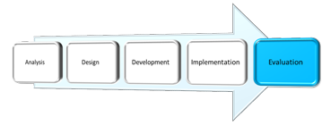
- The process to assess the value (the worthiness, the effectiveness) of training programs to employees and to organizations.
  - Involves the analysis of data collected from trainees, supervisors, and through other stakeholders or forms of measurement.
  - Objective and subjective information is gathered at different points: before, during, and after training.
Why Conduct Training Evaluations?
- Assist managers in identifying what, and who, should be trained.
- Determine cost-benefits of a program.
  - This will be explored in more detail in the next lesson: Lesson 12: The Costs and Benefits of Training.
- Determine if training program has achieved expected results.
- Diagnose strengths and weaknesses of a program and pinpoint needed improvements.
  - Go back to the design phase of ADDIE and re-evaluate to see if the improvements worked.
- Justify and reinforce the value of training.

Barriers to Training Evaluation
Barriers fall into two categories:
- Pragmatic
Requires time (loss of production) to organize the collection of the data and specialized knowledge to properly analyze and interpret it.
- Political
Pressure from administration to justify the costs, potential to reveal ineffectiveness of training, conflict of interest (may require added resources to get external audit).

Types of Training Evaluations
Evaluations may be distinguished from each other in two fundamental ways:
- The data gathered and analyzed:
- Trainee perceptions, learning and behaviour at the conclusion of training.
- Assessing psychological forces that operate during training.
- Information about the work environment.
    - Transfer climate and learning culture
- The purpose of the evaluation:
Types of Training Evaluations
Formative evaluations:  Provide data about various aspects of a training program.  - Tend to focus on the content and how it is presented with the goal of improving it.  - Based on feedback received during the design and development of the learning experience.  - Can be carried out on a regular basis (i.e. a progress report) or at the time of a given incident or problem.  - Of greater interest to instructors and instructional designers. | Summative evaluations:  Provide data about the worthiness or effectiveness of a training program.  - Based on evidence (data) gathered at the conclusion of the training intervention (can also be carried out at mid-point).  - Tend to focus on financial benefits to organization (return on investment).  - Of greater interest to managers and administrators.
Descriptive evaluations:  Provide information that describes the trainee once he or she has completed a training program. | Casual evaluations:  Provide information to determine if training caused the post-training behaviours.

Four Models of Training Evaluation
A. Kirkpatrick’s Hierarchical Model:
- Donald Kirkpatrick first published his ideas about the evaluation of learning in 1959 in a series of articles he wrote for Training and Development. He later published them in a 1975 book titled Evaluating Training Programs.
- "The Four Levels of Training Evaluation" remains to this day the seminal model used in the training industry.
The Four Levels of Training Evaluation:
Level 1: Reactions | - Trainee perceptions of the training program and/or specific aspects of the course/experience.  - Methods: the “smiley” sheets, post-training surveys.
Level 2:  Learning | - Trainee acquisition of the program material (procedural and declarative knowledge).  - Methods: before and after assessments.
Level 3: Behaviours | - Extent to which the new knowledge and skills are applied to the job (the transfer to the workplace).  - Methods: observation and interviews (over time), self-reports, supervisor reports, production records.
Level 4:  Results | - The effect on the business or the work environment by the trainee.  - Methods: Expenses, revenues, sales, and other existing business measures.
A. Kirkpatrick’s Hierarchical Model
- Each increase in the level of evaluation also increases the complexity of the measurements and the costs associated with it.
  - Very few of the organizations surveyed carried out high-level evaluations. Most use Kirkpatrick level one, but only to improve the overall efforts, not necessarily to improve performance (Bloom, 2003).
- In a study by the Conference Board of Canada (Hughes & Grant, 2007) about 75% of businesses evaluate at Level 1 (trainee reactions), 33% evaluate learning (Level 2), 15% assess changes in behaviour (Level 3), and very few look at results (Level 4).
  - Overall evaluation has been declining, likely due to barriers to evaluation.
Kirkpatrick’s guidelines are not without critics.
- Doubt about the validity.
  - No evidence of correlation between the levels.
- Insufficiently diagnostic.
- Reliance on the same variables and outcome measures.
- Lack of clarity.
  - What is meant by learning?
- Not a “one-size-fits-all” model.
B. COMA Model
A training evaluation model that involves the measurement of four types of variables
- Cognitive
- Organizational Environment
- Motivation
- Attitudes

The COMA model improves on Kirkpatrick’s model in three ways:
- Integrates a greater number of measures
- Measures are causally related to training success
- Defines variables with greater precision
C. Decision-Based Evaluation Model
A training evaluation model that specifies the target, focus, and methods of evaluation
- Decision-based evaluation goes further than either of the two preceding models:
  - Identifying the target of the evaluation
  - General to any evaluation goals
  - Flexibility: guided by target of evaluation

D. The Learning Transfer System Inventory (LTSI)
Recall Holton’s LTSI from Lesson 5 –Transfer of Training.
This inventory contains all of the variables from COMA, plus additional ones such as: learner readiness, resistance/openness to change, and opportunity to use learning.

Training Evaluation Variables
Reactions | - Affective reactions: measures that assess trainees’ likes and dislikes of a training program  - Utility reactions: measures that assess the perceived usefulness of a training program
Learning | - Learning outcomes can be measured by:  - Declarative learning: refers to the acquisition of facts and information, and is by far the most frequently assessed learning measure  - Procedural learning: refers to the organization of facts and information into a smooth behavioural sequence
Behaviour | - Behaviours can be measured using three approaches:  - Self-reports  - Observations  - Production indicators
Motivation | - Two types of motivation in the training context:  - Motivation to learn  - Motivation to apply the skill on the job (transfer)

Self-efficacy | - Refers to the beliefs that trainees have about their ability to perform the behaviours that were taught in a training program.
Perceived/anticipated support | - Two important measures of support are:  - Perceived support: The degree to which the trainee reports receiving support in attempts to transfer the learned skills  - Anticipated support: The degree to which the trainee expects to be supported in attempts to transfer the learned skills
Organizational perceptions | - Two scales designed to measure perceptions:  - Transfer climate: can be assessed via a questionnaire that identifies eight sets of “cues”  - Continuous learning culture: can be assessed via questionnaire presented in Trainer’s Notebook in chapter 10 of your text.  - Transfer climate cues include:
  - Goal cues  - Social cues  - Task and structural cues  - Positive feedback | - Negative feedback  - Punishment  - No feedback  - Self-control
Organizational results | - Hard data: Results that can be measured objectively (i.e., number of items sold)  - Soft data: Results that are assessed through perceptions and judgments (i.e. attitudes)  - Return on expectations: Measurement of a training program’s ability to meet managerial expectations

Data Collection Designs in Training Evaluation
- The manner in which the data collection is organized and how the data will be analyzed.
- All data collection designs compare the trained person to something.
  - Non-experimental designs: Comparison is made to a standard and not to another group of (untrained) people.
  - Experimental designs: Trained group is compared to another group that does not receive the training and when the assignment of people to the training group and the non-training group is random.
  - Quasi-experimental designs: Trained group is compared to another group that does not receive the training, but when the assignment of people to the training group and the non-training group is not random.
Non-Experimental Designs
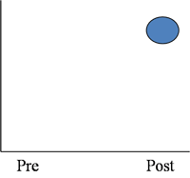 | 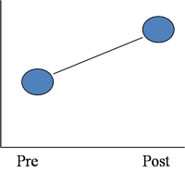 | 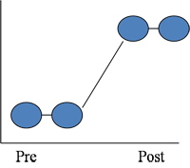
A: Single Group Post-Only Design | B: Single Group Pre-Post Design | C: Time Series Design

Experimental and Quasi-Experimental Designs
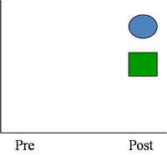 |  | 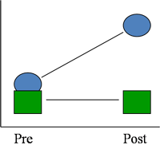
D: Single Group Design with Control Group |  | E: Pre-Post Design with Control Group

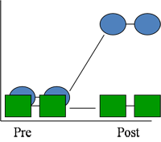 |  | 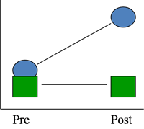
F: Time Series Design with Comparison Group  Causal Models: experimental or quasi-experimental |  | G: Internal Referencing Strategy Hybrid Design that permits some conclusions drawn from causal designs

Key Points
- Evaluating training interventions helps justify their costs and improve their effectiveness.
- Despite their obvious benefits, evaluations are not carried out for various reasons.
- In fact, they tend to be one of the least popular steps in the ADDIE model.
- Formative evaluations tend to focus on the content that is being developed whereas summative evaluations look at the results of the training experience.
- Kirkpatrick’s "Four Levels of Training Evaluation" is considered the standard in the field.
- It is not without its critics and other models have been suggested (COMA, DBE).

Costing Training Programs
Costing: The process of identifying all the expenditures used in training.
Costing Approaches
- According to stages of the design process needs analysis, program development, delivery and evaluation.
- According to nature or kind of costs:
Five Cost Categories
1. Direct costs | Costs that are directly linked to the training program.  - e.g. trainer salary and benefits, equipment rental, room rental, course materials, food/refreshments, travel.
2. Indirect costs | Costs that are incurred to support training activities, but are not directly linked to a particular training program. These are costs that would still exist even if the training was cancelled.  - e.g. administrative support, trainer preparation and planning, marketing.
3. Development costs | Costs that are related to the design of a training program.  - e.g. conducting the needs analysis, development of materials (audiovisual, graphics, manuals), evaluation.
4. Overhead costs | Costs incurred by the training department that are not associated with a particular training program.  - e.g. maintenance of training facility (heat and lighting), equipment, salaries of clerical and administrative staff.
5. Trainee compensation | Cost associated with the salaries and benefits paid to trainees while they are attending a training program (and subsequently, not working).  - e.g. cost of replacing the employee.

Comparing the Costs of Training Programs
- Cost Analysis Worksheets (Costing Sheets) are helpful tools that not only help to identify the costs of the training program, but also allow for the comparison of training program alternatives.
  - They can be modified to meet an organization’s needs.
  - The level of detail varies according to needs.
  - There is choice regarding what to include.
  - Helps to identify the cheapest option.

Calculating the Benefits
of Training Programs
Cost-effectiveness evaluation | A comparison of the monetary costs of training to the benefits of training in monetary terms.
Cost-benefit evaluation | A comparison of the costs of training in monetary terms to the benefits of training in non-monetary terms.
Net benefit | The estimated value of the performance improvement over the costs of improving performance.
Benefit-cost ratio (BCR) | The benefits divided by the costs of the training program.
Return on Investment (ROI) | A comparison of the costs of a training program relative to its benefits.

Return on Investment (ROI)
- Return on Investment is one of many different methods that are used to attempt to quantify the value of an investment (in our case, training). ROI compares the cost of a training program relative to its perceived benefits to the company. To calculate ROI for training, two values need to be identified:
  - The costs of the development and implementation of the training program (in $)
      - cost to develop the training, lost production of employees attending the training, materials, etc...
  - The benefits of the training program (in $)
  - additional sales, decreased insurance costs related to on-the-job accidents, more efficient workflow, etc...
Return on Investment | = | Net Program Benefit  Cost of the Program

Training Program Costs
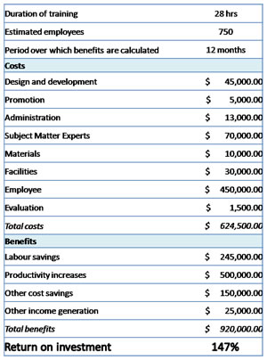

The Credibility of Estimates
Five steps involved in converting measures to monetary values:
Step 1 | Focus on a single unit.  - Determine a particular unit of output to target for improvement (e.g. output, quality, time, employee behaviour).
Step 2 | Determine a value for each unit.  - Based on single unit in step one. Easier for hard measures (e.g. units sold) than soft ones (e.g. cost of one employee absence).
Step 3 | Calculate the change in performance.  - Eliminate all confounding variables so that the measure reflects a change in units that is attributable to the training.
Step 4 | Obtain an annual amount.  - Industry standard: Total change in the performance data during one year.
Step 5 | Determine the annual value.  - The annual performance change multiplied by the unit value.

Utility Analysis
A method to forecast the net financial benefits that result from human resource programs such as training and development.
- Important factors to consider in calculating the utility of training program:
  - Effectiveness (effect size).
  - Standard deviation of job performance in dollars of untrained employees.
  - Number of employees trained.
  - Duration training benefits will last.
- Break-even analysis: Finding the value at which benefits equal costs and utility is equal to zero.
Utility of a training program:
ΔU = (T)(N)(d_{t})(SDy) – (N)(C)
ΔU | Utility, or dollar value of the program
T | Number of years the training has a continued effect on performance
N | Number of people trained
d_{t} | Effect size
SDy | Standard deviation of job performance in dollars of the untrained group
C | Cost of training each employee

The Credibility of Estimates
- Increasing credibility of benefit estimates:
1. | Take a conservative approach.
2. | Use credible and reliable sources.
3. | Explain approaches and assumptions.
4. | Results must appear realistic.
5. | Use hard data.

Supporting the Costing Function
- Cost-Benefit Tracking Systems
- Accounting Treatment of Training Cost
  - Three ways to administer training accounts:
    - Allocation of costs.
    - Selling the service/cost recovery.
    - Policy costs.
- Record Keeping

Key Points
- Costing is an exercise that involves the identification of all the expenses related to a training program.
  - It can be done either by matching the costs to individual levels of the design process, or by placing the cost into one of five cost categories.
- Using costing worksheets allows for the identification and the comparison of costs between different possible interventions.
- The benefits of training programs can be calculated in different ways.
  - There is no consensus on how this is done.
- Return on Investment (ROI) involves the comparative cost of a training program relative to its benefits.
  - Difficult to estimate the monetary value of the benefits of training.
- Utility analysis is a method to forecast the financial benefits as a result of human resource programs, such as training and development.
- The credibility of the benefits estimation is enhanced by following certain guidelines.

Types of Training Programs
- Formal learning content as a % of TLD expenditures, 2008 (%, n = 218)
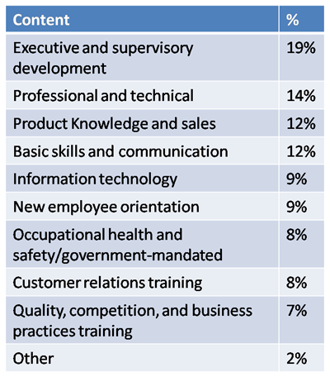
Source: Conference Board of Canada, 2008 (Learning and Development Outlook)

Program: New Employee Orientation Training
Programs designed to introduce new employees to their job, the people they will be working with, and the organization.
- Usually conducted in-house by human resource practitioners.
- Effective orientation programs have a positive effect on new employee attitudes and adjustment, can shape corporate culture, increase speed-to-proficiency, and lower turnover.

Program: Basic (Essential) Skills Training
Provide employees with critical literacy skills such as reading and arithmetic that are required to perform their job.  Literacy: The ability to understand and employ printed information in daily activities. Different types of literacy include:  - Prose literacy  - Document literacy  - Quantitative literacy (basic math)
  Literacy Levels of Canadians
  - Level 1 (16.6%): Very poor literacy skills
  - Level 2 (25.6%): Weak skills
  - Level 3 (35.1%): College entry skill level
  - Levels 4 & 5 (22.7%): Higher-order information processing skills

Program: Technical Skills Training
Training in specific job skills that all employees need to perform their jobs.
Information Technology Training:
Training programs that focus on the use of computers and computer systems.
- Computer software training: Training programs that focus on how to use a specific computer software application.

Program: Health and Safety Training

- An effective health and safety training program should include:
  - The organization’s safety rules, practices, accident, and injury reporting procedures.
  - Duties of employer, supervisor, and worker as specified in the Occupational Health & Safety (OHS) legislation.
  - Importance of strict compliance with warning and emergency signs and signals.
  - Types and use of emergency equipment.
  - Use, care, and acquisition of personal protective equipment.
  - Organization benefits.
  - Known hazards and safeguards against them.
  - Importance of reporting other hazards and the mechanism for doing so.
  - Emergency and evacuation procedures for dealing with things such as fires, spills, and so on.
  - Need for good housekeeping.
  - Courses in first aid, CPR, and defensive driving where applicable.

Workplace Hazardous Materials Information Systems (WHMIS):  Legislation to ensure workers across Canada are aware of potential hazards of chemicals in the workplace, and are familiar with emergency procedures for the clean-up and disposal of a spill.
  Healty and Safety Statistics
  - Approximately 423,000 Canadian workers are injured at work each year.
  - Workplace injuries result in 15 million lost workdays a year.
  - Costs between $8 and $10 billion dollars if indirect costs are included.

Program: Quality Training
Total quality management (TQM): Systematic process of continual improvement of the quality of an organization’s products and services.
Harper & Rifkind’s Outline for TQM Training:
- Overview of the state of the organization
- Statement from the head of the organization
- Overview of TQM
- Team training
- Training in the use of tools

Program: Non-Technical Skills Training
Skills that are required to work and interact effectively with people, such as communication and interpersonal skills.
- These skills have become important in areas where traditionally they were not understood to be as relevant as technical skills.
Team Training
Programs that are designed to improve the functioning and effectiveness of teams in areas such as communication and coordination.
Team training focuses on three types of skills:
  - Task work skills
  - Teamwork skills
  - Management/supervisory team skills

Program: Sales Training
- Today, sales professionals need to develop:  - Relationships with customers.  - Understanding of customers’ needs and problems.  - Solutions to customers’ problems.  - A business partner mentality.  - Knowledge about their own products and business.  - Knowledge about their customers’ business needs.
  Characteristics of Successful
  Sales Training Programs
  - Identification of a real business need that must be addressed before any training is developed.
  - Use of a team approach to design and implement new training.
  - Communication is a central component of the development and implementation process.
  - Comprehensive blended learning curriculum.
  - Performance assessment support tools.

Program: Customer Service Training
Employees must be motivated and able to meet the following customer expectations:
- Reliability  - Responsiveness  - Competence  - Access  - Courtesy | - Communication  - Credibility  - Security  - Understanding the customer  - Tangibles

Program: Compliance Training
Compliance training involves programs that have been designed to educate an organization's employees about laws, rules, and regulations that affect their work environment. Different levels of government will establish regulations in a variety of fields, some of which change frequently and require employees to stay up-to-date as quickly as possible.
Recall that within a high performance work system, changes in the environment is one of the many factors that could elicit a need for an organization to develop a training program. Compliance training would subsequently be issued as a result of changes in legislation (laws). For organizations that operate in highly regulated industries it is not uncommon to have a need for a full-time position that oversees and manage compliance issues within that organization (e.g., a Chief Compliance Officer).
Topics covered in compliance (also known as regulatory) training could include workplace discrimination and harassment, record management, environmental health and safety, the handling of hazardous materials, emergency response protocols, financial and human resource services, and code of conduct or ethics. In organizations where there is a need to oversee and manage compliance issues, there has been precedence

Program: Sexual Harassment Training
- Sexual Harassment: Unwelcome sexual advances, requests for sexual favours, and verbal or physical conduct of a sexual nature that is a condition of employment, interferes with work performance, or creates a hostile work environment.
- Consequences:
  - Decreased morale and job satisfaction.
  - Negative effects on psychological well-being and physical well-being.
- Two kinds of sexual harassment:
  - Quid pro quo: Explicit requests for sexual favours as a condition of employment.
  - Hostile environment: Work environment in which language/actions or both create an uncomfortable and offensive work environment that interferes with job performance.

Program: Ethics Training
- 32% increase in organizations offering ethics training since 1994.  - In Canada, most organizations have ethics policies, but less than 30% have training programs to support them.  - Ethics training programs involve teaching employees about the organization’s values and ethical policies.
  Components of an effective ethics training program:
  - Mandatory
  - Include copy of organization’s code of ethics
  - Discussion of relevant compliance laws
  - An ethical decision making model
  - Resources for help
  - Role playing scenarios

Program: Diversity Training
- Training that focuses on differences in values, attitudes, and behaviours of individuals with different backgrounds.
- Noe & Ford (1992): “the goal of diversity training programs is to estimate barriers such as values, stereotypes, and managerial practices which constrain employee contribution to organizational goals and personal development.”
Diversity Training Objectives | Diversity training should focus on:
- Increase awareness about diversity issues.  - Reduce biases and stereotypes.  - Change behaviours to those required to work effectively in a diverse workforce. | - Increasing awareness of diversity.  - Providing skills required.  - Application strategies.

Program: Cross-cultural Training
- Training that prepares employees for working and living in different cultures and for interactions with persons from different backgrounds.
- Expatriates: Employees who work outside their home countries .
  - 20% of U.S. expatriates fail in their global assignments.
- A critical factor in the success of cross-cultural training is training rigour.
  - Training Rigour: The degree of mental involvement and effort that must be expended by the trainer and the trainee in order for the trainee to learn the required concepts.
  - Also refers to the length of time spent on training.
  - The degree of rigour required depends on three dimensions:
    - Cultural toughness
    - Communication toughness
    - Job toughness
Examples of Different Levels of Training Rigour:
Low Rigour  - Lectures  - Films | Medium Rigour  - Role plays  - Cases | High Rigour  - Field trips  - Interactive language training

Recommendations for an effective cross-cultural training program
  - Should be considered mandatory.
  - Location should be chosen based on needs of the family.
  - Depth of training is of utmost importance.
  - Families must be incorporated into training.
  - Language training should be incorporated.
  - Education and expectations of training should be clear.

Key Points
- The goal of specialized training programs is to sensitize and inform employees about a variety of subjects that relate to their working environment.
  - But are not necessarily required to perform their individual tasks.
  - Team, sales and customer service training have more direct impact on job performance.
- There is a debate about the responsibility of basic (essential) skills training.
  - Some believe that the government should be responsible for the design and development of this training, and not the organization.
- The massive amount of costs associated with workplace injuries are addressed by organizations that promote health and safety training.
- The ultimate goal of training programs is to set the foundation for a productive and distraction-free workplace environment in which employees can perform at their optimal levels.

What is Management?
The process of getting things done, efficiently and effectively, through and with other people.
- Roles
  - interpersonal, informational, decisional
- Functions
  - controlling, planning, organizing, leading work organizations.
- Skills
- Programs

What is Management Development?
Complex process by which individuals learn to perform effectively in managerial roles.
- Is management development important?
  - Per capita training expenditures are greater for managers than any other category of employee.
  - Corporate expenditures on management development are estimated at $45 billion annually.
    - $12B on executive education.
    - Average cost of executive education for an organization is reported to be $2M annually.

Leadership Development
Leadership:
  - The qualities and behaviours required to shape the direction of the organization and that inspire others to pursue that direction in the face of obstacles and constraints.

Management Development versus Employee Training
Differences:
- Managers work mainly through other people.
  - Need to focus on interpersonal skills and the development of the individual.
- Training design techniques tend to be different.
  - Manager training tends to be more experiential and informational.
- Managerial personalities must be taken into account.
- Management development is a longitudinal process.
  - Complex skills and competencies are developed over time with training and experience.
- Incompetent managers can severely affect an organization’s success.
  - Has a unique strategic significance.

Major Functions of Management
- Organizing
  - Establishing systems that ensure that the efforts of individuals working on major tasks are efficiently and effectively coordinated and organized.
- Planning
  - Defining the direction towards which the efforts of individuals are to be directed.
- Leading
  - Influencing the actions of others such that these actions are coordinated to produce the desired outcomes.
    - Acting as a role model
    - Inspiring a shared vision
    - Challenging the status quo and encouraging others to do so
    - Recognizing contributions

Management Skills
Skills: A set of actions that individuals perform and that lead to certain outcomes.
  - For example:
    - Managing time and stress
    - Verbal communication
    - Delegating
    - Managing conflict
    - Self-awareness
    - Motivating and influencing others
    - Problem-solving

Emotional Intelligence
Ability to manage your own and others’ emotions and your relationships with others.
Five sets of skills
1. Self-awareness
- Being aware of and understanding oneself and one’s emotions when dealing with others.
2. Self-control
- Managing and regulating emotions that arise from encounters with others.
3. Motivation or drive
- Channelling one’s emotions and energies in the pursuit of a goal.
4. Empathy
- Reading the emotions of others and responding/adjusting accordingly.
5. Interpersonal skills
- Ability to manage one’s interactions with others through the management of emotions.

Models of Management Skills Development
- All management development programs should include:
Skills Assessment | - Identifies strengths and weaknesses of managers relative to the specific skills to be trained.  - Builds self-awareness.  - Contributes to training motivation.  - Identifies managers’ learning and behavioural styles.
Skill Acquisition (Learning) | - Instead of being taught specific procedures or steps, managers learn how to recognize the need for the skill in a diverse number of circumstances.  - Usually involves group discussion of opportunities, obstacles, and strategies pertaining to skill use.  - Focus on learning principles, not specific approaches.  - Objective is to promote procedural learning.
Skill Practice | - Practice serves three fundamental purposes:  - Reinforces learning and shifts learning from the declarative to the procedural learning stage.  - Enhances self-efficacy.  - Maintains trainees’ interest, attention and motivation.
Skill Application on the Job (Transfer) | - During training managers establish specific plans for the application of learning.  - Follow-ups, coaching and reinforcement are frequently required to ensure transfer

Content of Management Development Programs
Management skills can be
organized in three categories:
Conceptual skills
- e.g. problem solving and decision making, planning, performance management and goal-setting.
Technical skills
- e.g. using Excel, PowerPoint, knowing tax laws.
Interpersonal skills
- e.g. communication, managing conflict and stress.

Methods of Management Development
Experiential learning | Learning experiences that include skill practice exercises that actively engage and involve the learner  - Builds procedural knowledge & boosts self-efficacy  - e.g. role-play, simulations
Management education | The acquisition of a broad range of managerial knowledge and general conceptual abilities  - Typically conducted by colleges and universities  - e.g. MBA programs
Management training | Programs and activities designed to develop specific managerial skills  - e.g. outdoor wilderness training develops teamwork and leadership skills
On-the-job management development | Programs designed to provide individuals with managerial learning experiences on the job  - e.g. job rotation, coaching

Coaching
- Effective coaching characteristics include:
  - Goal orientation
  - Challengers
  - Person focused
- Coaches are most helpful when they structure their efforts to help managers develop:
    - Insight
    - Motivation
    - Capabilities
    - Real-world practices
    - Accountability

Key Points
- Managers, regardless of the domain, have common roles, functions, and critical skills.
- Managers engage in a number of interpersonal, informational, and decisional activities.
- The organizational goals of a manager include controlling, organizing, planning, and leading the work of others.
- Manager development programs revolve around the improvement of conceptual, technical, and interpersonal skills.
  - They involve informational and experiential learning.
  - They include management education, management training, and on-the-job development.
- Emotional intelligence refers to one’s ability to manage their emotions, as well as the emotions of others, through interactions.
- Management development is most helpful when it focuses on developing a manager’s insight, motivation, capabilities, real-world practices, and accountability.

