Introduction
The problem of this laboratory is to create a program in C that takes in an integer value, say N, and outputs:
- the total number of possible Pythagorean triples such that c < N
- The actual Pythagorean triples (a, b, c)
- The triple that has the highest c value
Gathering of Information and Input / Output Description.
C Program that Computes the Area of a Triangle given Three Coordinate Points

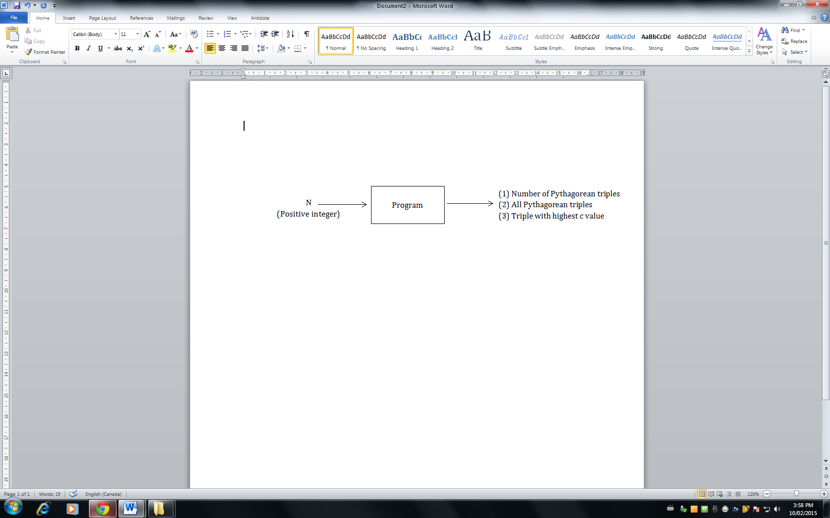

Design of Algorithm and Test Cases 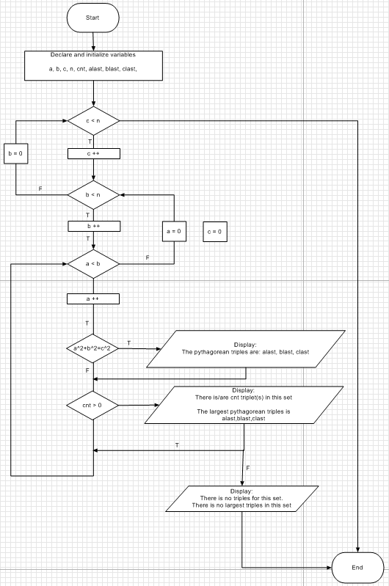

Implementation

#include<stdio.h>
#include<math.h>

int main()
{

int a = 0, b = 0, c =0, n, cnt=0;
int alast=0, blast=0, clast=0;

printf("Please enter an interger value: ");
//read and store in that integer as n
scanf("%d", &n);

for(c=0; c<n; c++)
for(b=0; b<c; b++)
for(a=0; a<b; a++)
if((a*a+b*b)==c*c)
{
printf("\n\nThe pythagorean triples are: %d, %d, %d \n\n", a,b,c);
cnt++;
alast = a;
blast = b;
clast = c;
}
if (cnt>0)
{
printf("There is/are %d triple(s) in this set \n\n", cnt);
printf("The largest pythagorean triples is %d, %d, %d \n\n", alast,blast,clast);
}
else
{
printf("There is no triples for this set. \n\n");
printf("There is no largest triples in this set \n\n");
}
system("PAUSE");

return 0;
}

Proofs of Test Cases by Print Screen of Console Windows
Case 1  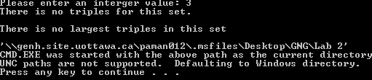 | No Pythagorean Triple
Case 2  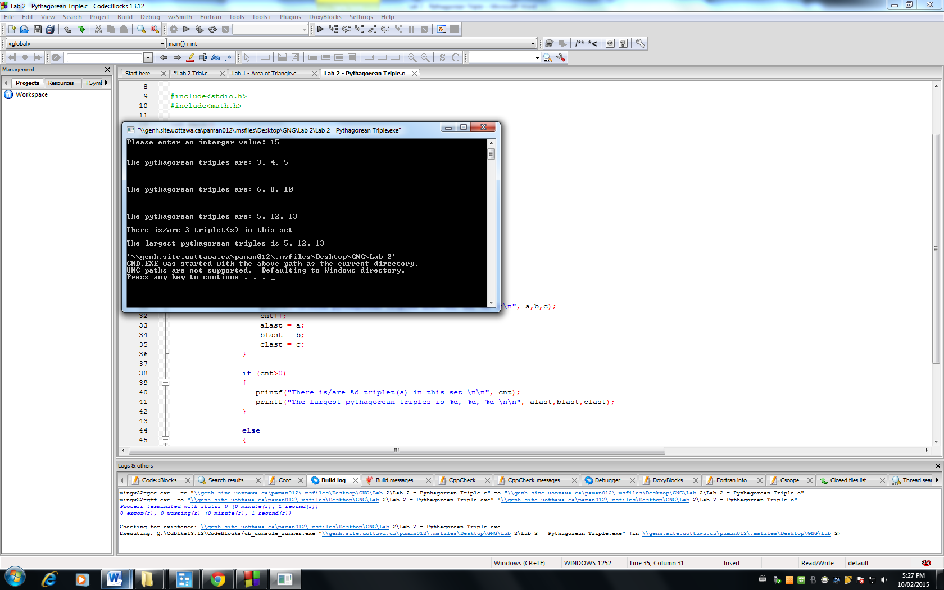 | More than one Pythagorean Triple
Case 3  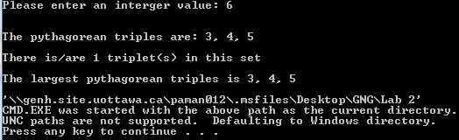 | Only one Pythagorean Triple

