Lesson 1: Introduction to Real Estate
The Real Estate Investment
- Advantages
  - Risk in REI is Low. Compared to other types of investment, REI is stable and secure.
  - Appreciation of real estate increases annually. The Canadian Real Estate Association found that residential real estate is increasing in value an average of 5% per year.
  - Down payment is accessible. REIs are low of risk because the property is used as security; therefore, financing can cover up to 90% of the amount needed to buy a property.
  - Net return will most likely be high. Real estate value increases with time. Thus, by the time you sell a property you will be receiving more than what you spent.
  - Tax rates are beneficial to REI. Canadian laws allow contributors several advantages that go from tax-free to tax saving on capital gains.
  - REI builds up on equity. Payments on mortgage mean acquiring equity, the part of the property that becomes yours, and that is clear of debts.
- Disadvantages
  - Basic knowledge is essential to make sound decisions. Although some REIs do not require that you be an expert on real estate, you will need to allocate time to research and planning to reduce investment risks and ensure expected outcomes.
  - Cash is not available immediately. Despite having a big real estate investment, you will need to find a buyer or borrower to turn your investment into cash and this process might take some time.
  - REI is a long-term investment. You might have to wait 5 to 10 years before selling the property to see the expected return.
  - Advice from expert is necessary. Suggestions from legal, accounting, insurance, and real estate experts will help you plan to reach your REI objectives and avoid any potential problem that any investment might involve.
Major Participants in REI
- Equity Investors
  - Equity investors or landlord is the person or entity that acquires the real estate investment. The equity investor assesses how the REI will be taken, as an individual or as an organization. To make a decision, the equity investor will analyze questions such as how the organization will be created and how marketable it is, who the partners will be, how each partner will share liabilities, and how the taxation opportunities and constraints for the specific organization are.

The most common forms of equity investors are:
  - Individual
  - Corporation
  - Partnership
  - Real Estate Investment Trust (REIT)
- Mortgage Lenders
  - The mortgage lenders is the entity that lends the money that the equity investor need to start a real estate investment.

Among the most common mortgage lenders are:
  - Another individual
  - Insurance companies
  - Banks
  - Real Estate Investment Trust (REIT)
- Tenant
  - The tenant is the one who buys right of possession and use of a property from the equity investor.

The object of possession could be used for different purposes:
  - Residential
  - Commercial
  - Industrial
  - Special purposes (theatre, sports, reception halls, etc.)
- Government
  - The government regulates the relationship between participants, and restricts participants with the imposition of taxes.

Government participation in the process takes place on different level
  - Federal
  - Provincial
  - Municipal
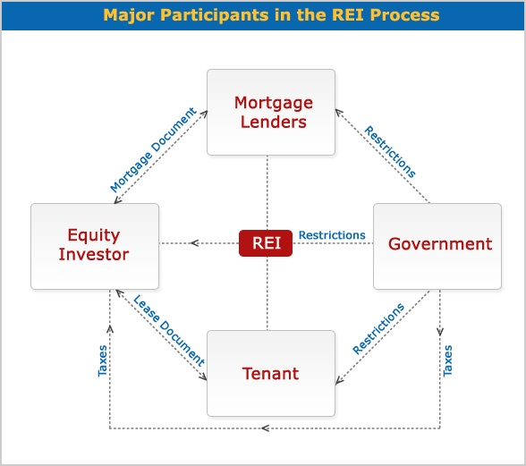
Relationship Between REI Participants
- Equity Investor and the Mortgage Lender
  - The equity investor borrows money from the mortgage lender.
  - As a provider of debt service, the mortgage lender expects mortgage payments that will include the principal plus the interest generated through time.
  - The mortgage lender gets a mortgage document as collateral; this document specifies the method of payment, which could consist of the repayment of interest first and principal at the end, or the repayment of both principal and interest in each amortization.
- Equity Investor and Tenant
  - The equity investor leases the right to use a property to the tenant.
  - The tenant pays rent to the equity investor to use the property.
  - The lease document establishes the attributions and restrictions involved in using the property.
- Equity Investor and Government
  - The equity investor pays taxes to the government.
  - The government sets restrictions on owners, such as police power, taxation and eminent domain.
  - Police may enter a property without requiring the owner’s permission
  - Most taxes are on income and capital gains. The taxes on income are for money made on rents received from tenants. The taxes on capital gains (wealth) are for gains for selling a property. The government also requests a “welcome tax” from the buyer of a property and a “goodbye tax” from the seller of a property.
  - Appealing to eminent domain, the government may expropriate private property at its fair market value in order to create something that favours society in general.
- Mortgage Lender and Government
  - The mortgage lender's relationship to other participants in the REI is regulated by the government.
  - The government imposes restrictions on mortgage lenders which will depend on the nature of the mortgage lender; for example, restrictions on banks will be different from restrictions on corporations.
  - The government also sets mortgage laws on debt service or mortgage payments for equity investors.
- Government and Tenant
  - The government regulates the use that the tenant can make of the property on lease.
  - Landlord–tenant law has evolved to detail not only legal aspects between a landlord and tenant but also the actions that tenants should take to protect the property, such as the installment of fire alarms, smoke detectors, and so on.
The Real Estate Investment Process
- Step 1: Identify investor’s objectives, goals and constraint
  - Is it important to start the REI process by understanding that major participants bring their own expectations and limitations to the REI.
- Step 2: Analyze investment climate and market conditions
  - The second step in the REI process is learning about the market, legal, financial and tax environment. The result of this analysis will have a great impact on your decision making throughout the process.
    - The market environment: the analysis identifies supply and demand in the real estate market at local, provincial, and state levels and how they affect the REI.
    - The legal environment: a complex legal system regulates REI and the relationships between its participants. Analysing the legal opportunities and limitations that a REI may entail will play an important role in the acquisition decision and also in the rest of the REI process.
    - The financial environment: the analysis of the cost of debt or interest rate, and the cost of equity or rate of return, shows how feasible the REI is and how profitable it might be.
    - The tax environment: taxes decrease the REI’s income; therefore, knowing the taxation system and the impact that it will have on the expected income will help making the right investment decision to save money or to increase gains.
- Step 3: Develop financial analysis
  - The financial analysis deals with financial calculations that will allow you to anticipate the cash flow of the REI. At the end of the analysis you will be able to answer questions such as:
    - How much profit per year?
    - How much is the mortgage payment?
    - How much is the capital gain when I sell?
    - How much will taxes diminish my profit?
    - How much will taxes decrease my capital gains?
    - What strategies should I use to reduce taxes on profits and capital gains?
- Step 4: Apply decision-making criteria
  - In this step, you apply decision-making criteria to decide how much you are able or willing to pay for a property to obtain the desired rate of return. To do so, you may use three criteria:
    - Rules of Thumb Techniques, which measure the payback period necessary to regain what was invested to acquire a property, and the methods needed to achieve the highest rate of return. Techniques are: payback method, return on investment (ROI), return on equity (ROE), return on asset (ROA), gross income multiplier (GIM), net operating multiplier (NIM) and overall capitalization method (OCR).
    - Discounted Cash Flow Techniques, which calculate the value today of the REI future cash flow. These techniques take time value of money into consideration and include discounted payback period method, net present value method, internal rate of return and profitability index method.
    - Traditional Valuation Techniques, which estimate the value of the property that will be used in the REI. These techniques are: cost approach, net income approach and market (sales) comparable approach.

- Step 5: Investment decision
  - The previous steps will give you the necessary information to decide whether to acquire REI or not. If the result of the analysis is not what you expect, you will repeat the process assessing another REI until you find what meets your financial goals.
  - In the following lessons we will discuss each step of the process in greater detail. You will also have exercises and self-assessments to practice what you learned and to help build your confidence in order to start your real estate investment.
Lesson 2: The Time Value of Money
Time Value of Money
- The Time Value of Money techniques enable us to compare dollars received or paid out in different time periods. This is important in making smart decisions in budgeting, investments, debt management, tax and retirement planning. Sound financial decisions are made with considerations of not only the size, but also the timing of cash flows. As it is often said, “a dollar today is not the same as a dollar tomorrow.” The reason, of course, is that, everything else being equal, today’s dollar can be invested to earn interest and grow to a larger sum in the future.
- In this lesson, we will discuss nominal and effective rates and we will solve the problems using formulas and the financial calculator to find Present Value (PV), Future Value (FV), Present Value of an Annuity (PVA), and Future Value of an Annuity (FVA).
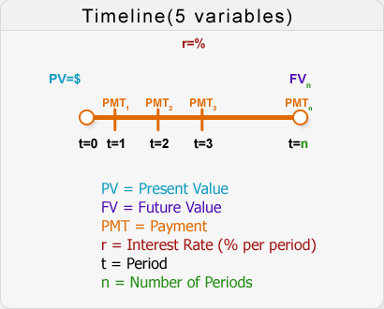
Nominal Rate
- Definition: the nominal rate is also known as “in name only” because it has not been adjusted for inflation. Other sources might also call it Quoted Rate, Stated Rate, Observed Rate, or Annual Percentage Rate (APR). In a given problem, when we talk about the interest rate we are talking about the nominal rate, always written on a per annum basis.
- Example: imagine that you borrow $500 today and you are told that at the end of the year you will have to pay back $550. This means that you are being charged an interest rate of 10% per annum.
Effective Annual Rate
- Definition: the effective annual rate (EAR) is the interest rate compounded once per year.
- Example: If you borrow $500 at an interest rate of 10% but compounded semi-annually, it means that the lender is charging you 5% every six months. However, 5% every six months does not mean 10% per annum; it is 10.25% per annum (EAR). Therefore, the nominal rate of the loan is 10%, but the effective rate is 10.25%.
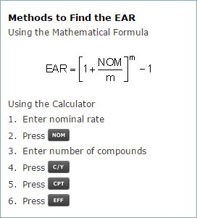
- Example 2: Finding EAR
Assume that you have $1,000 in your bank account at an interest rate of 10% per annum. Find the effective rate compounded annually and semi-annually.
  - Solution Part 1: Effective Rate Compounded Annually
    - Using the Mathematical Formula:
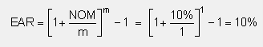
    - Or use the Calculator
  - Solution Part 2: Effective Rate Compounded Semi-Annually
    - Using the Mathematical Formula:
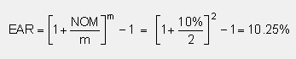
    - Or use the Calculator
    - Either methods provides the same results:
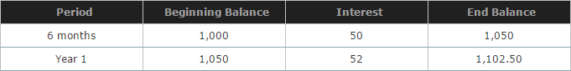
The Five Variables and the Timeline
Present Value
- Definition: the present value is the current value that a future amount of money is worth. This value is calculated using four variables: interest rate, number of periods or compounds, future value, and payment.
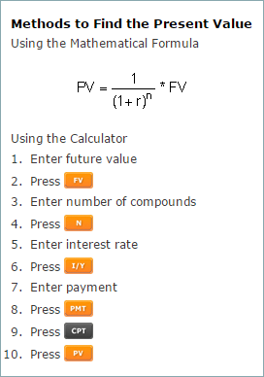
- Example: Finding Present Value
You will receive $1,000 one year from today at an interest rate of 10% per annum (compounded annually). What is the present value of this amount?
  - Solution: Using the Mathematical Formula:
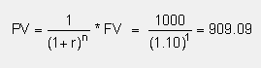
- Example 2: Finding Present Value of an Ordinary Annuity
You will receive $1,000 at the end of each year for 5 years. Interest rate is 10% per annum, compounded annually. What is the present value of these cash flows?
  - Solution: Using the Mathematical Formula:
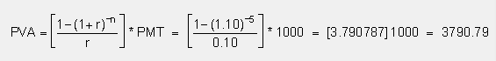
  - Solution: Using the Calculator
- Example 3: Finding Present Value of an Annuity – Due
You expect $1,000 per annum at the beginning of each year for 5 years. Interest rate is 8% per annum. What is the present value of this annuity (annuity-due)?
  - Solution: Using the Mathematical Formula:
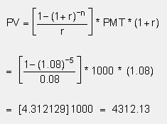
  - Solution: Using the Calculator (1 + r)
- Example 4: Finding Present Value of a Lump Sum Amount
You will receive $5,000 10 years from today. Interest rate is 8% per annum, compounded semi-annually. What is the present value of this future amount?
  - Solution: Using the Mathematical Formula:
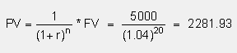
  - Solution: Using the Calculator
Future Value
- Definition: the future value is the value that a current amount of money will have at a specified date in the future. This value is calculated using four variables: interest rate, number of periods or compounds, present value and payment.
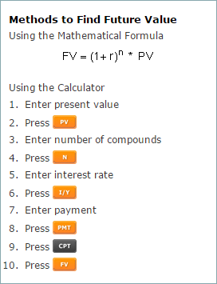
- Example: Finding Future Value
You deposited $1,000 today in an account earning 10% per annum, compounded semi-annually. How much is your bank balance at the end of the first year?
  - Solution: Using the Mathematical Formula:
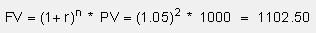
  - Solution: Using the Calculator:
1000 – (PV) – 2 – (N) – 5 – (I/Y) – 0 – (PMT) – (CPT) – (FV) = 1102.50
- Example: Finding Future Value of an Ordinary Annuity
You plan to deposit $1,000 in the bank at the end of each year for 5 years. The interest rate is 10% per annum (compounded annually). What will the future value of these deposits be at the end of the fifth year?
  - Solution: Using the Mathematical Formula:
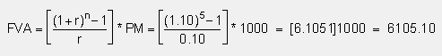
  - Solution: Using the Calculator
- Example: Finding Future Value of an Annuity – Due
You plan to deposit $1,000 at the beginning of each year for 5 years (5 deposits). The interest rate is 8% per annum. What is the future value of these deposits at the end of the 5th year?
  - Solution: Using Mathematical Formula:
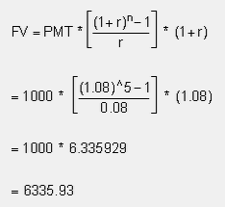
  - Solution: Using the Calculator
- Example: Finding Future Value of a Lump Sum Amount
You deposit $5,000 today, earning 8% per annum, compounded semi-annually. How much will you have at the end of the tenth year?
  - Solution: Using the Mathematical Formula:
  - Solution: Using the Calculator

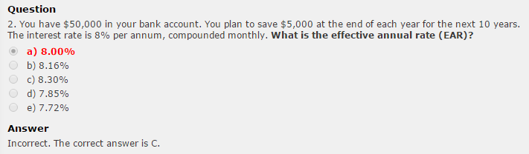

Lesson 3: The Market Environment
Companies and Real Estate
Companies own real estates for the following reasons:
Stock and Bonds:
- There are limited number of stocks and bonds
- Studies shows that real estate outperforms stocks and bonds
- Studies shows that real estate offers higher returns with no increase in risk compared with other investments
- Real estate provides higher overall returns with lower variance if one does require a higher level of liquidity

The Morgan Index of the Toronto Stock Exchange:

- The Morguard Index of the Toronto Stock Exchange (TSX) indicates high returns and low risk
- The Morguard Index uses proxy data (appraisal values) which can cause inaccuracies because it fluctuates with market conditions
- The Morguard Index uses quarterly appraisal values to determine returns
- Studies on the Morguard Index show annual data, making it difficult to analyze the data
Appraisal Values and Actual Values:
- Studies do not determine the relationship between appraisal values and actual values
- If appraisal values are understated or overstated, they will cause errors in returns
Appraisers
- If, for example, an appraiser deliberately understates the value of a house, he or she indirectly increases the rate of return for the client. If he or she overstates the value of the house, it decreases the rate of return. The following illustrates this.
- Example:

Cash flow = $10,000
True Market Value = $100,000

If you hire an honest appraiser, he or she will inform you that your rate of return is 10.00% (simply divide cash flow by the market value: $10,000/$100,000).

A dishonest appraiser will downplay the market value and inform you that your property is only worth $90,000 and by doing so he or she has increased your rate of return to 11.11% ($10,000/$90,000).

A bad appraiser who overvalues the property decreases your rate of return. If he or she states that the value is $105,000, your rate of return is only 9.52% ($10,000/$105,000).
Information Costs
- The real estate market is segmente3d (residential, commercial (retail and office), industrial, special purpose and others) which increases information costs
- The real estate market is also segmented based on local market conditions
- Information costs increases the cost of operating real estate portfolios
- Information is difficult to find (commercial, industrial, special purpose) because of low turnover or low number of transactions given in a special period, compared to residential
- Information on real estate (if low turnover) is available through proxy (the use of appraisal values) which increases information costs

Capital Gains
- Capital gains make up a large portion of estimated returns (capital gains equal selling prie minus original costs)
- Miles and McCue’s study for a regional real estate portfolio indicates that only 14% is market related (not diversified), whereas 86% is diversifiable

Advantages and Disadvantages of Owning Real Estate
- Advantages:
  - Real estate segmented geographically: different cities, municipalities, priced/reacts differently to market conditions. It increases information costs (different markets and tenants). This characteristic of real estate permits the investor to diversify his portfolio in two possible ways:
    - Invest in one type of real estate in different cities, e.g. invest only in residential in Anjou, Cote-Saint-Luc, NDG, DDO, etc.
    - Invest in different types of real estate such as residential, commercial and industrial in only one city.
  - By diversifying, the investor can reduce his information costs significantly.
  - Real estate is segmented by asset type: residential, commercial, industrial, special purpose (e.g. old people’s home), and others (land).
  - Segmented market implies disequilibrium, i.e. costs (price) not equal to value.
  - Market segmentation suggest the possibility of lowering risk through diversification.

- Disadvantages:
  - Diversification benefits and information costs.
  - Barrier to entry (large amount of money required). Real estate segmented by wealth (approximately 25% down payment).
  - Different types of expertise required
  - Imperfection competition (barrier to entry) and information costs (paid prior to investing) i.e. inefficient market which creates opportunities.
  - Higher information costs if investing in different segments.

The Real Estate Pricing Puzzle
Why Is Real Estate a Puzzle?
- The present model (capital Asset Pricing Model – CAPM) being used to value real estate is doing a poor job because it does not consider cash payments.

Performance Justifies the Development of New Models
- The market should develop new models because:
  - The performance of real estate compared to other investments in the market justifies this
  - Studies show that companies are including large amounts of money in real estate in their portfolios
  - The performance of real estate investments outperform other investments in the market as many studies have indicated
  - There is enough order in the financial market to justify this
  - Companies hire specialists in real estate for consulting services and to write reports on how good the market is for real estate investments. The companies know that the report will favour investing in real estate prior to acquiring the professional services; they simply need a professional’s name on the report. This is what “studies are done only in good times” implies; it is very rare to find any study conducted when markets are down. Furthermore, inefficiency also exists due to appraisers manipulating the numbers to their advantage and thus increasing rates of return as the above-mentioned example illustrates. Finally, current models do not capture the qualitative aspects that are taken into consideration during a real estate transaction. As mentioned earlier, they only consider risk and return, which is not sufficient.

Problem with data
- Appraisal values estimated by the appraiser are not the same as the actual values (actual selling price). True market value can only be found when the property is sold; we hire an appraiser to determine a property’s value prior to selling. The value they return is known as a proxy. Appraisers have the habit of downplaying numbers so that when a buyer offers a bid near the true market value one will be pleased with this work.
- Short-run evaluation when real estate investments are long-term investments.
- Sample size will cause sampling errors; i.e., 1/100 compared to 1/99 does not contain much estimation error; however in real estate the sample size is smaller and therefore the difference between ¼ and ½ is quite significant.
- Un-levered basis (assumed no leverage or debt, 100% down payment). Un-leveled property is that which is purchased with cash only (no loan used).
- Data problems, in addition to the conclusion that real estate gives higher returns and has lower risk compared with other investments, are questionable.
Reason for Lower Variance
- Three possible reasons for lower risk (or variance)
  - Rent income is less risky than other income because of contractual agreements or leases
  - Stocks and bonds are affected by other factors such as human resources, lumpy investments, immobility and market segmentation
  - Management costs are not accounted for in the analysis

So less risk or variance would be expected. However, less risk or variance does not mean excess return.
Portfolio Implications
- Real estate is negatively correlated compared to the stock market.
- Data problems versus high percentage of portfolio: problems with appraisal values should not stop you from investing in real estate.
- Diversification benefits possible within same market (to reduce information costs), i.e. do not have to evaluate different classes of real estate such as residential, commercial and office.
- Price should reflect mean evaluations of investors.
- Prices should reflect highest and best use, but not true in real estate because a) there is no short selling; b) price adjustment is slower; and c) optimistic opinion (pessimistic will not buy).
- Prices are biased upwards because of the sequential bidding process.
- Real estate prices vary between the average value of potential buyers and the best use of the property.
- Some price inefficiency exists: markets are segmented and not everyone has the capital required to conduct a feasibility study; therefore, inefficiency arises.
Conclusion
- Historical models used in the stock market such as the Capital Asset Pricing Model (CAPM) and the Arbitrage Pricing Model (APM) have proved to be unsuccessful in real estate.
- The Summation approach still works best.
- A gap exist (market price versus mean expected).
- Optimists buy and no short selling, i.e., price estimate less than market price
- The studies provide a balanced view of current issues
- There is a need for refined models
- Future studies should show or explain how a qualitative variable (i.e., a house is on a corner, pay is in cash, etc.) affects the property value.
Lesson 4: The Legal Environment
The Law of Agency
The legal environment in real estate transactions includes two parties: principal and agents. They are governed by the law of agency.

Definition: The law of agency entails rules set forth when another individual is doing something on one’s behalf. In real estate, a principal hires an agent to sell his house, or a principal can hire an agent to purchase a house on his behalf.

Agency is created when one person is given the right to act on behalf, or under the control of, another. The law of agency concerns the legal rights, duties, and liabilities of the principle (P), the agent (A) and a third party (TP), based on contracts and/or the relationship between them.

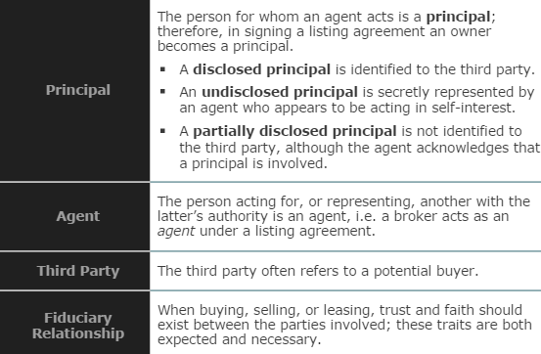

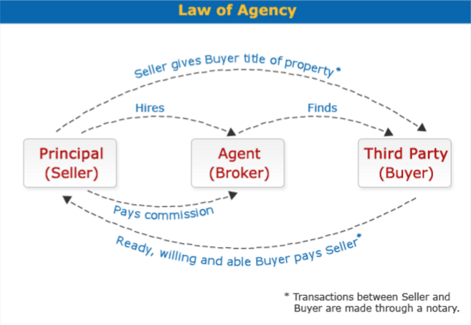

Duties, Liabilities and Rights of Principals and Agents

- Principal
  - Compensation. A Principal’s main duty is to compensate the agent in accordance with the contract of employment.
  - Accuracy. A principal must also give the broker/agent complete and accurate information when listing a property.
  - Liability. A principal is liable on all agreements or contracts made by an agent within the authority given the agent. Agents are personally liable for their own acts.
- Agent
  - Care. An agent must be diligent and responsible and act in good faith in any representation. Agents are personally liable for their own acts.
  - Obedience. An agent should obey instructions that pertain to the purpose of the principal-agent relationship. This includes keeping within the authority granted; any agent who exceed his or her authority will incur personal liability, unless such acts are affirmed by the principal.
  - Accountability. An agent should keep adequate records concerning funds or property. It is illegal for a broker to communicate or mix personal funds with the funds of a principal.
  - Loyalty. An agent must not benefit from the relationship except through compensation from the principal unless otherwise agreed. This is known as faithful performance.
  - Communication. Any information given to the agent must be communicated immediately to the principal. Any agent who exceeds his or her authority will incur personal liability, unless such acts are affirmed by the principal. An agent has the right to enforce a contract between a principal and a third party if an interest is held in this contract, such as the collection of an anticipated commission. Most listing agreements provide that a broker may engage salespersons as agents. In this instance the broker/agent acts as the principal.

Listing Agreements
Definition: a listing agreement is an oral or written contract of employment between a principal and a broker/ agent to buy, sell or lease real estate. The broker/ agent needs this agreement in order to enforce his or her right to a commission. This agreement also creates the traditional principal-agent relationship discussed earlier.

- This is the foundation of a broker’s business as it provides the basis of a broker’s trust and confidence in the principal and addresses the right to compensation.
- A typical “listing” is not a contract. Rather, it is a unilateral contract that becomes bilateral upon performance by the broker and is therefore revocable by either party at any time prior to performance.
- Listing agreements may be reached orally, but written agreements are needed in order to collect a commission. Therefore, most brokers refuse to handle a property without a written agreement.
- Most listing agreements provide that a broker may engage salespersons as agents. In this instance the broker/agent acts as the principal.

Types of Listing
- Open: An owner offers several brokers an equal chance to sell realty; the broker who arranges the sale receives compensation. The owner may receive the right to personally sell the property terminates an open listing.
- Exclusive agency: engaging one broker to sell realty with a right retained by the owner to sell the property without the obligation of a commission. Usually contains words “exclusive agency”. The purpose is to give the broker holding the listing the opportunity to apply their “best effort” without interference or competition from other brokers.
- Exclusive Right-to-Selling: engaging a broker to sell realty with commission to be paid to the broker regardless of who sells the property, owner included.
- Multiple: a special version of exclusive right-to-sell agreement, it involves multiple listing service groups wherein all members agree to share listing with others in the group. This is advantageous to the owner as the property gets wider exposure, a higher price and a likely shorter selling time.
- Net: engaging a broker to sell realty at a fixed or minimum price, with any excess to be considered as the broker’s commission
Critical Issues in the Listing Agreement
Asking Price
- In his or her own self-interest, an owner wants the highest possible price and therefore prefers a high asking price.
- A broker prefers a low listing price for a quicker sale.
- A fiduciary relationship requires that the broker provide the owner with the market value of the property and document that any suggested listing price is not too low.
Reservation of Right-to-Sell
- An owner may retain right-to-sell without a commission being required, even in an exclusive right-to-sell agreement
Broker Compensation
- Commission rates are largely set by local area customs.
- Brokers are prohibited from collusion in setting commission rates
- The amount of commission or method of determining commission should be included in a listing agreement. Many commission methods are possible:
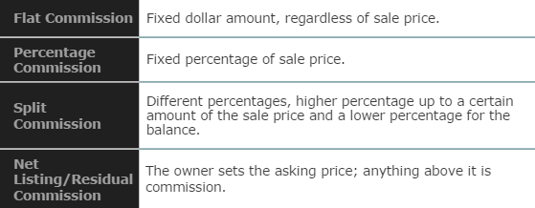

The Termination and Duration of an Agreement
- Termination by actions of the parties:
  - Mutual consent of the parties
  - Completion of the contract by sale
  - Time expiration or running-out
  - Revocation by the principal revocation or abandonment by the agent
- Termination by law:
  - Destruction of the property, as by fire
  - Death of the principle or agent
  - Insanity of principal or agent
  - Bankruptcy of the principal or agent
- Broker Proof of Performance
  - A broker’s obligation is to find a buyer who is “ready, willing, and able” (RWA).
  - Failure to complete a sale through fault of the owner (due to title defect, refusal of spouse to sign deed, fraud, the owner charging their mind or requiring terms not included in the listing agreement) does not cancel commission. If a qualified RWA buyer is found, the broker is entitled to commission.
  - The owner may include a “no-closing, no commission” clause, which means unless the transaction results in a conveyance of title, no commission need be paid.
Commissions
General Rules on Earning Commissions
- To get commission, the broker must:
  - Show an agreement or contract of employment
  - Be the procuring cause in the sale
  - Bring about the deal on the terms of the employer
  - Act in good faith
  - Produce a purchaser who is “ready, willing and able”
  - Arrive at a completed transaction
* The employer is liable and must pay commission in every case where performance has occurred.
Commission on Installment Sales
- Owners use installment sales to spread property payments over time in order to keep tax payments low.
- A broker may agree to accept commission in proportion to principal cash payments received by the seller

Commission on Exchanges, Loans, and Leases
- All parties in an exchange pay a commission based on the value or price their respective properties. In some instances the broker may receive double commission.
- A broker is entitled to commission for producing a mortgage loan only if the loan is approved.
- A lease broker is not entitled to compensation unless a lease or a complete agreement on their terms is obtained.

Selecting a Broker
Important considerations in selecting a broker are:
- Office and agent specialization
- Office location and procedures
- The firm’s attitude and reputation
- A positive track record evidenced by satisfied clients.
Lesson 5: The Financing Environment

Definition: The financing environment exist when a buyer does not have sufficient cash to purchase the property in question; he/she resorts to his/her bank to obtain a mortgage to cover the portion that is missing.
Mortgage
Definition: Mortgage is the term used for a loan on a real estate transaction. It may also go under the name Loan-To-Value ratio.

Mortgage Payments: Usually refers to monthly instalments made to your bank in order to reduce your outstanding loan and eventually pay it off entirely.

Mortgage Payment = Interest portion + Principle portion

Principle portion = Mortgage Payment – Interest portion

Mortgage Loan Balance: the portion of the loan that is still outstanding at any point in time.

Mortgage Loan Balance = Mortgage Loan – Principle portion

Loan-To-Value (LVR) Ratio: the loan expressed as a percentage. In other words, it is the mortgage value that the bank is willing to give you.

Outstanding Loan Balance: refers to mortgage loan balance
Slide 6-10
Effective Cost of Borrowing (ECB)
Effective Cost of Borrowing (EBC) is a rate expressed in percentage form which takes into consideration the effects of processing fees, cancellation penalties, and so on. Processing costs are fees many banks charge in order to process your mortgage, due to the extensive paperwork and effort on their behalf.

Exercise 7: No processing fees
Given the following information:
- You have CASH ON HAND to complete the transaction
- You stay for the entire term
- Value of Property = $300,000
- LVR = 70%
- Term = 10 years
- Payable = Annually
- Interest rate = 5% per annum (compounded annually)
- Processing fees = 0
- Cancellation penalty = 0
Q1: What is the maximum loan?
Answer: $210,000
Q2: How much are the processing costs?
Answer: $0
Q3: What is the net amount you receive?
Answer: $210,000
Q4: What is the term?
Answer: 10 years
Q5: What is the Effective Annual Rate (EAR)?
Answer: 5%
Q6: What is the Mortgage payment per annum?
Answer:
Q7: What is the Effective Cost of Borrowing (ECB)?

Lesson 6 – The Tax Environment
The Tax Environment
Definition:
- Governments on all levels (municipal, provincial and federal) tax the equity owner on income and capital gains.
- The taxes on income are for money made on rents received from tenants.
- The taxes on capital gains (wealth) are for gains for selling a property.
- In addition, certain municipal government oblige equity owners to pay taxes. The buyer pays a “welcome tax” and the seller pays a “goodbye tax”.
Canadian Taxation: Old and New Rules
Few industries will be severely affected by tax reform as the real estate development industry. The rationale behind the proposed changes is spelled out very clearly in the government’s Tax Reform papers in the following comment:
“The nature of real estate is such that it can be largely debt-financed. In addition, vacant land is often held for several years before it is sold, and real estate property may take long to construct. As a result, the carrying cost of unused land and soft cost attributes to building construction often represent a significant portion of the cost of the property while the related income is not earned for several years. The effect of this mismatching of revenues and cost of to permit these costs to shelter other income from tax.”
The new rules apply to vacant land carrying charges and construction period soft costs incurred after December 31, 1987. In this lesson, we will look at some of the changes on and before December 31, 1987 and after December 31, 1987.
We will refer to the rules on or before 31, 1987 as the old rule and after December 31, 1987 as the new rules.
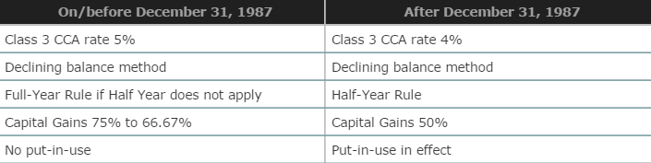

Capital Cost Allowance (CCA)
Definition: The Capital Cost Allowance (CCA) is a depreciation method under Canadian tax law which allows for the accelerated write-off of property under various classifications.

- The Capital Cost Allowance (CCA) rate is applicable to buildings in Class 3 will be reduced from the current 5% to 4% declining balance basis, effective for acquisitions after 1987.
- These rules will not apply to buildings acquired after December 31, 1987 and before 1990 pursuant to an obligation in writing from Revenue Canada where the property was under construction on June 18, 1987.
- Special transitional rules will also apply to the cost of post – 1987 additions and altercations to a 5% rate buildings.
Put-In-Use
Put-in-use means that all costs are capitalized to year 0 when the building is constructed and ready to be occupied.

The new “put-in-use” rule applies in order for the capital cost allowance on buildings not to be available until the first year the building is put in use (this is the year that the building is completed and thus ready for use). This proposal, coupled with the existing “half-year” of the normal CCA rate, will result in a significant slowing down in claims for capital cost allowance on buildings.

The increase in the proportion of capital gains (the difference between the selling price of the property and the initial cost of the property) to be included in the income will impose an additional tax burden on companies disposing of investment properties.

The following are important terms that you will find when calculating the CCA:
- The Full-Year Rule (FYR) applies when 100% of the CCA rate is taken in year 1.
- The Half-Year Rule (HYR) applies when 50% of the CCA rate is taken in year 1.
- The Beginning Undepreciated Capital Cost (BUCC) is the amount prior to CCA being taken.
- The Ending Undepreciated Capital Cost (EUCC) is the amount after CCA is taken.
EXAMPLES

Lesson 7 – The Investment Decision: Criteria

Definition: the purpose of investment decision criteria in real estate is to quantify certain measures in order to compare them to a predetermined benchmark or to rank properties according to the decision criteria of choice (i.e. payback).

Ultimately, using these tools will facilitate decision-making process.

- There are several formulas we use to evaluate real estate investment.
- Some are some (rules of thumb approach) and can be calculated quite easily using a basic calculator; others are more complex and require a financial calculation or a scientific calculator.
- In this course, we will use the Rules of Thumb Techniques.
Rules of Thumb Techniques
The Rules of Thumb Techniques are based on the real estate income statement, which is similar to the traditional income statement that companies use in their annual financial statements. However, the terms used the statement differ. For example, instead of the “sales” which usually appear on the traditional accounting statements, “potential gross income” is used in real estate.

A Typical Real Estate Income Statement:
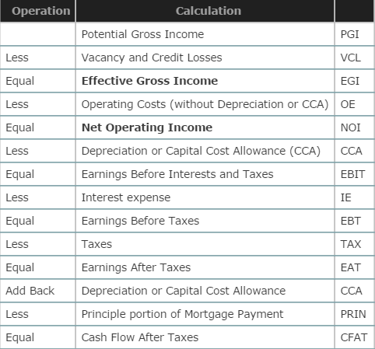

* The real estate income statement is a tool that will assist you in calculating Net Income Multipliers (NIM), Gross Income Multipliers (GIM), and Overall Capitalization Rates. It is also very helpful in determining the cash flow after taxes (CFAT) on assets.

Payback Period (PB)
- The number of years or period to recover your investment costs.
- If the investment cost (cash outflow) is $60’000 and the cash inflow in $20’000 per year for 5 years, the PB is 3 years.
Return on Asset (ROA)
- This is the rate of return on the asset, often denominated on a per annum basis.
- If the return of profit is $20’000 for the year and the investment costs $100’000 (total costs of the investment, i.e. loan plus the down payment, the ROA is 20%.
Return on Investment (ROI) or Return on Equity (ROE)
- This is the rate of return on the down payment (the equity) on the asset, often denominated on a per annum basis.
- If the return or profit is $10’000 for the year and the down payment or equity is $40’000 (i.e. cost of investment is $100’000) less loan ($60’000), the ROI or ROE is 25% (i.e. 10’000 divided by 40’000).
Gross Income Multiplier (GIM) – this is a multiplier or number of times. The GIM is calculated as follows:
GIM = Value of Property / Effective Gross Income
- Value of Property equals to Asking Price (if the property has not been sold) or Selling Price if property has been sold.
- Effective Gross Income is the Potential Gross Income (100% occupancy) less vacancy and Credit Losses.

Note:
Both Seller and Buyer knows the Effective Gross Income and Seller wants a high price (high GIM) and Buyer wants a low price (low GIM). Remember: buy low, sell high.

Example 1: Finding the GIM
Given:
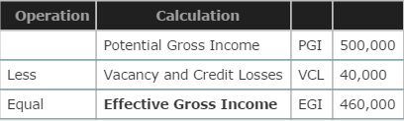

- Suppose the asking price is $2’000’000 and the effective gross income is calculated above, the GIM = 4.347826 times, rounded 4.35 times. Suppose the property was sold at a 10% discount (i.e. 90% of 2’000’000 = 1’800’000), the GIM = 3.913043 times, rounded to 3.91 times.

Note: Buyer wants low GIM (3.91), Selling want high GIM (4.35).

Net Operating Income Multiplier (NIM) – this is a multipler or number of times. The NIM is calculated as follows:
NIM = Value of Property / Net Operating Income
- Value of property equals to Asking Price (if property has not been sold) or Selling Price if the property has been sold.
- Net Operating Income is the Effective Gross Income less Operating Expenses (without depreciation also called capital cost allowance).

Note: Both Seller and Buyer knows the Net Operating Income and Seller wants a high price (high NIM) and Buyer wants a low price (low NIM)

Example 2: Finding the NIM
Given:
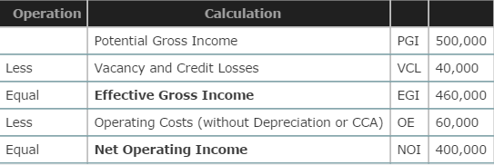

- Suppose the asking price is 2’000’000 and the net operating income is calculated above, the NIM = 5.00 times. Suppose the property was sold at a 10% discount (i.e. 90% of 2’000’000 = 1’800’000), the NIM = 4.5 times.

Note: Buyer wants low NIM (4.5), Seller wants high NIM (5.00).

Overall Capitalization Rate (OCR) – this is a rate of return and not a multiplier, as the name suggests. It is calculated as follows:

OCR = Net Operating Income / Value of Property
- Value of property equals the Asking Price (if the property has not been sold) or Selling Price if the property has been sold.
- Net Operating Income in the Effective Gross Income and the Seller wants a high price (low OCR) and the Buyer wants a low price (high OCR). Note that this is the opposite of what was said about NIM.
Example 3: Finding the OCR
Given:
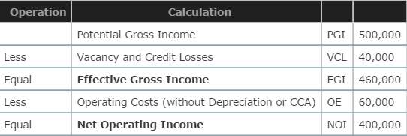

- Suppose the asking price is 2’000’000 and the net operating income is calculated above, the OCR = 20%. Suppose to property was sold at a 10% discount (i.e. 90% of 2’000’000 = 1’800’000) the OCR = 22.22%.

Note:
Buyer wants low price and Seller wants high price; this happens when buyer gets high OCR (22.22%_ and Seller get low OCR (20%).

Note:
OCR = 1 / NIM
Lesson 8 – The Investment Decision: Techniques

Definition: Traditional Valuation Techniques are used to calculate the valuation of a property.

They consist of three approaches:
- Cost approach
- Net Income Approach (NOI)
- Sales Comparable Approach
When to Use the Cost Approach
The Cost Approach is used:
- To value unique real estate investments.
- To value real estate projects with little or no depreciation.
- When real estate investments do not have any comparables, i.e. when the Sales or Market Comparable Approach cannot be applied.
- By municipalities or local governments to calculate property tax.
Advantage and Disadvantage of the Cost Approach
Advantage:
- Easy to apply the procedures if the information is available.
Disadvantage
- Difficult to evaluate depreciation.
- Depreciation calculations are very subjective.
- Different variables used to calculate value of new buildings, i.e. generates different answers.
How to apply the Cost Approach:
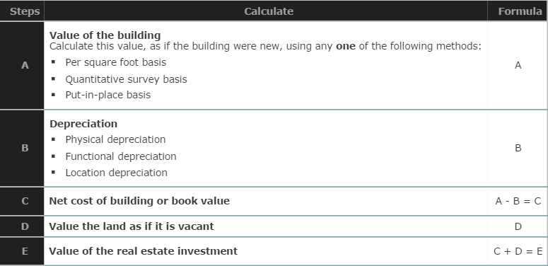
Example 1:
You are given the assignment of appraising a property. This property has 28,000 square feet (sqft) of usable space. Analysis of construction costs indicate a per square-foot cost of $27 for the first 18,000 square feet of space and $5more per square foot for the remaining space. The property is twenty years old with an estimated economic life of eighty years. Changing neighbourhood (location depreciation) characteristics have had a negative influence on the property of approximately 14% of building (construction) costs. An examination of similar lots indicates a land value of $17.50 per square foot and this property is on 55,000 square feet of land.
Answer:
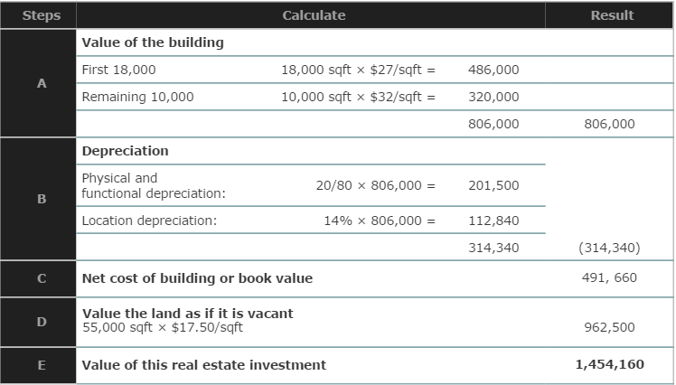

When to Use the Net Income Approach
The Net Income Approach is used:
- To value real estate investments that generate income.
- To value real estate investments when the Cost Approach is difficult to apply.
- To value real estate investments when there are few or no comparables on the market, i.e. when Sales Comparable cannot be applied.
Advantages and Disadvantages of the Net Income Approach
Advantage:
- Do not have to calculate depreciation which is very subjective (see cost approach).
- Take into account changes in the fiscal policy (such as supply and demand, etc.) and monetary policies (such as interest rates, inflation, etc.) of the economy.
Disadvantages:
- Difficult to estimate expected vacancy and credit losses.
- Difficult to estimate expected operations expenses.
- Difficult to estimate Net Operating Income if vacancy and credit losses and operating expenses are difficult to estimate or sometimes subjective.
How to Apply the Net Income Approach:
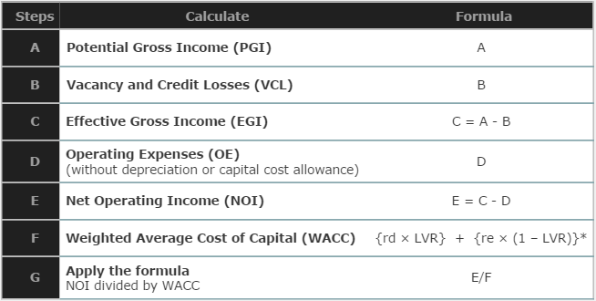
Weighted Average Cost of Capital (WACC)
[rd x LVR] + [re x (1 – LVR)]
rd = cost of debt: this is the interest rate the bank charges you on the mortgage
LVR = Percentage of Real Estate Investment as Debt: This is the loan amount, therefore making 1-LVR the down payment.
re = Cost of Equity: this is the opportunity cost that your equity could have earned if you did not invest in property (for example: if markets are currently yielding returns of 10%, then 10% is your cost of equity (in economics this is referred to as an opportunity cost)).
Example 2:
A property has 21,000 square feet of rentable space at $25 per square foot. You expect a vacancy and credit loss of 7% and operating expenses (without CCA) amount to $128,000. Financing for this property is as follows: down payment is 35%; loan is $360,000 at 8.75% per annum compounded monthly; processing fees are 1.10% of the loan and the term is 18 years. The opportunity costs of your down payment are 6.50% above the effective annual rate (EAR) of the loan. Tax rate is 40% and 50% of capital gains is taxed. You have cash on hand.
Answer:
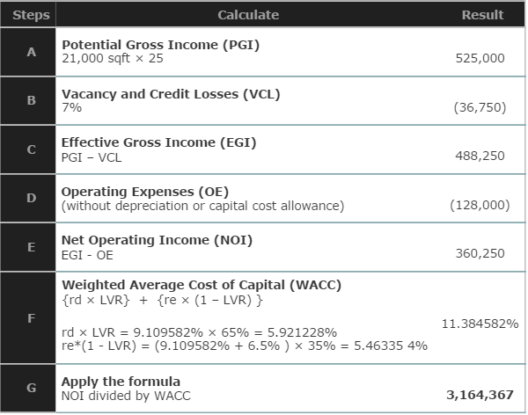

When to Use the Sales Comparable Approach
The Sales Comparable Approach is used:
- To value real estate investments that have many comparables, such as resident properties.
  - Residential properties are bought and sold every day.
  - Comparable properties (used for comparison have few differences for adjustments.
  - Adjustments are usually required with reference to Time (inflation); Location (location or middle or across); Size (square feet); Age (number of years); Garage (number of garages); type of Financing used; and Others (such as swimming pool, etc.).
- When the Cost Approach and Net Income Approach are not applicable.
Advantages and Disadvantages of the Sales Comparable Approach
Advantages:
- Easy to find comparables.
- Comparable are bought and sold every day.
- Takes into account changes in the fiscal policy (such as supply and demand, etc.) and monetary policies (such as interest rates, inflation, etc.) of the economy.
Disadvantages:
- Difficult to find comparables with no adjustments; no two properties are exactly the same
- Difficult to estimate the required adjustments, very subjective depending on buyer or seller’s point of view, very biased.
- Standard estimates (biased downwards) suggested by appraisers to make adjustments.
- Difficult to quantify or put a dollar amount on all the differences between subject property and comparables.
How to Apply the Sales Comparable Approach
Using the selling price of the comparables, the subject property is used to incorporate the difference between the subject property and the comparable, with positive or negative or no adjustments, depending on what is necessary.
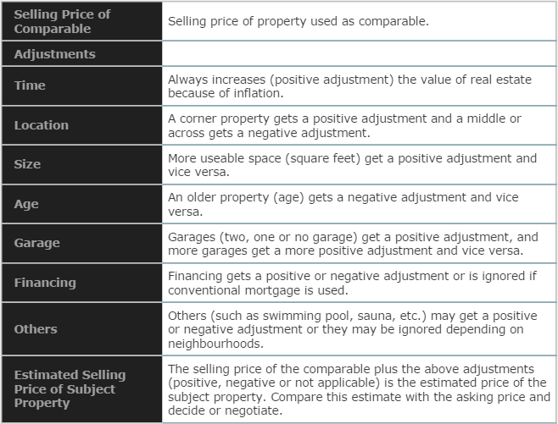
Example 3:
A potential buyer offers you $450,000 for your property today and you have the following information to evaluate the offer.
- Housing prices are increasing at 2.60% per annum
- $56 per square foot
- $22,000 per year reduction for age
- Two-car garage valued at $42,000 compared to $25,000 for a one-car garage
- Corner property warrants a 15 percent premium
- Swimming pool worth approximately $30,000 considered a good selling point in your neighbourhood
What is the estimated value of the subject property based on the comparable approach?
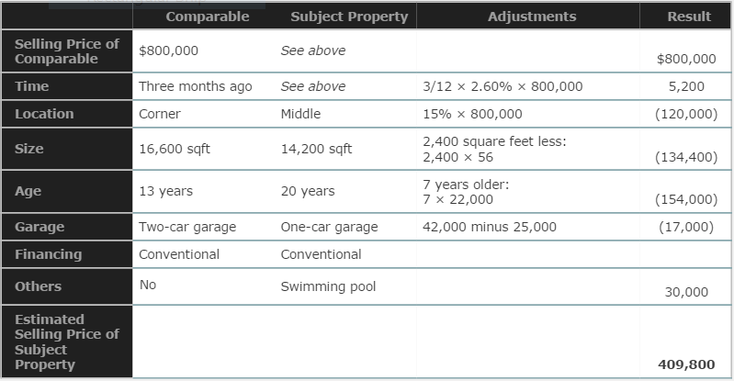
Should you accept the offer? Yes, because the offer ($450,000) is greater than the estimated value ($409,800).

