FINAL STARTS HERE
Chapter 9: The learning sciences & constructivism
THE LEARNING SCIENCES & CONSTRUCTIVISM
“mini lecture”

Selected Topics
- Intro. To The Learning Sciences
- Basic Assumptions of the Learning Sciences
- 2 Types of Constructivism (Links to Piaget & Vygotsky) (building knowledge)
- Cognitive Apprenticeships
- Reciprocal Teaching
- Co-operative Learning
- Service Learning

What are the Learning Sciences?
Learning Science’s an, “… interdisciplinary science of learning based on many diff fields that study or address learning.” (p. 304). Ex: Psychology, anthropology, sociology, neuroanatomical, and philosophy

Basic Assumptions of the Learning Sciences (pp. 304-305)
- Experts have deep conceptual knowledge (know info inside + out, can pick out patterns in problem solving, their knowledge is organized + they can easily access it)
- Learning comes from the learner (I’m constructing my knowledge, it’s an active, not passive process)
- Schools must create effective learning environments (school should help you apply the info, not just repeat it verbatim)
- Prior knowledge is key (learning builds on prior knowledge, can learn by building on/adding to prior knowledge)
- Reflection (look at what I learned, what I did well on + how I can improve)

CONSTRUCTIVIST THEORY
2 Central Ideas ( p. 308)
- Central Idea #1: “Learners are active in constructing their own knowledge”(actively trying to understand + learn the info + make it part of ur repertoire)
- Central Idea #2: “Social interactions are important in this knowledge construction process”

Piaget: Constructivism (Idea #1)
Piaget: Psychological, Individual & Cognitive Constructivism (these are 3 names for his, know all 3)
- Learning is “inside the head”
- Learning in a social environment creates Disequilibrium (Cognitive Conflict) which Piaget thought was vital to learning. Examples?

He’s agree that social interaction can influence disequilibrium thus lead an indiv to learn something but its cuz the indiv is changing their own thoughts. Plus, they can do this w/out social interactions.

-we’re drawn by curiosity to try + figure out our world!

Vygotsky: Social Constructivism (Idea #2)
Learners, “… appropriate/internalize the outcomes produced by working together” (p. 310)
- NEED SOCIAL INTERACTIONS to learn!!

Social Constructivism requires
  - Social interactions
  - Cultural tools (ex: language, books, pencils, forks etc. these help us learn what’s valued in our culture, some of our tools are culturally specific)
  - Active involvement in learning through social exchanges (all parties must be actively engaged in the learning process, i.e., just listening to a lecture or watching a movie wouldn’t be considered an active process of learning, so your not really learning from the situation, you didn’t construct knowledge!)
Examples? Group work

More on Vygotsky
Due to co-constructed knowledge, learners reach levels of knowledge (or skills) far beyond what they would have learned on their own. Why? Link to ZPD? Scaffolding?
- We learn more and better with someone (scaffolding) than if we did it on our own. The scaffold individual needs to be actively involved in the process.
- Each peer impacts the other, but the more competent one is scaffolding the less advanced person so that they can reach a higher level.
- ZPD: give them info that’s a bit harder than their current knowledge, scaffold them, so that they can reach a higher level + then do that again + again.

Explain, “… culture & cognition create each other” (p. 310) (see next slide)
How do culture + cognition create/impact + change or modify each other?
- Can’t have 1 w/out the other!
Trying to learn what’s valued w/in our culture. Can use cultural tools (ex: methods or things like computers and language) to learn what’s valued in our culture.
Our learning methods can be influenced by culture.

Adult use cultural tools (Examples?) to steer children in the direction of culturally valued goals
Ex: teaching kids to read, providing books (western societies), teaching pps to hunt (other cultures) etc.
- together they may come up w/ ideas that can influence their culture.
- adult & child work together to enhance/enlarge the cultural group’s tools, strategies, etc.
- *Thus we’re both “products” & “producers” of our culture/society* especially as we get older
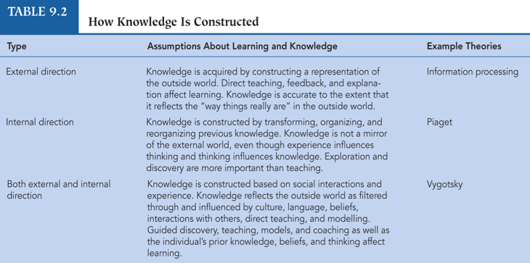
- Giving you back the info the same way they learned it spitting it back in the same form (didn’t make the info my own! Not actively using it + applying it to my life)

- Internalize info + then transform our knowledge if the info doesn’t fit our current knowledge/ past experiences, then we transform our knowledge to reduce the cognitive conflict. We don’t need an interaction for this but it can happen due to one (accommodate ur ideas to new info, it’s an active process!) can do it ourselves in out heads, we manipulate the info there.

- Our knowledge is incoming + outgoing (we internalize info + need others input) Don’t just use direct teaching, use teaching that actively involves the students.
Model what you want them to learn rather than just giving them the info and telling them to learn it. (SOCIAL + INTERNALIZATION).
- Mentally manipulate the info you received, then can discuss it w/ others and co-construct more knowledge.

Cognitive Apprenticeships (p. 319-320) (can be an academic task or training program) in these learners..
Learners:
  - Observe an expert
  - Receive coaching, hints, encouragement, scaffolding
  - Articulate their knowledge
(if you can’t verbalize what you learned, then you didn’t learn it well enough according to the cog apprenticeship.
And need to outline the steps you need to take)
  - Reflect on progress
  - Explore new ways to apply learning
(if u can only use what u learned in 1 sense, then ull have low road transfer, better to apply ur lessons to many situations) Sometimes, Its not the content but the process you used that id transferred to new situations.

Learn from an expert, you are there w/ them, they’re modeling for you + helping you out. You are active. They scaffold + hint.
- Watch them do it to learn. Also they need to break down the steps for you to learn it.

Reciprocal Teaching (pp. 320-321) November 6th, 2014
- Used to deepen students’ knowledge/understanding of what they read
- Teacher models then gradually helps the students to:
  - Summarize (students summarize it) – or teacher can model by summarizing.
  - Ask Questions that matter to our learning about the topic.
  - Clarify (ask Qs that ur not sure about)
  - Make Predictions (ex: if have damage to Frontal lobe, they may have trouble noticing what doesn’t make sense or w/ impulse control).

First the teacher models all of these
Then the kids are divided into groups on another occasion. (small groups, approx. 4)
Now the chosen “teacher” in each groups has to summarize a topic to their group, others ask them questions about the topic that will help them understand it and this “teacher/child” will answer or the other students will come up with answers w/in the group, they’ll ask for clarification of things they don’t get, can also ask the teacher if none of them get it. And based on the info, they can make predictions.
“Educator’s” the facilitator, asks if the kids can answer to Question
If they can’t then this “educator” can fill in the blanks.

Start w/ summery but the rest may not be in order.

Co-operative Learning (very brief) 23 mins
Essentials of Co-op Learning: (small group approx. 4)
    - Face-to-face interactions: need to be nice to others in group so they don’t kick you out
    - Positive interdependence: both need each other to gain + co-construct knowledge. If one slacks off than the group will fail, so there’s some peer pressure (you don’t want to let the group down)
    - Individual accountability: YOU CANT HIDE, you have your own tasks + goals ex: maybe you have an assigned part of the project to do, so you have to do your part. You have both indiv + group goals (want to do ur part + get ur grade & want the rest of your group to do well too cuz it effects your grade)
    - Collaborative skills: being a team player, helping others in ur group, know that you can’t be bossy etc. maybe helping others in your group if they have trouble with their part of the process.
    - Group processing: Analyze how their group is functioning to see if any changes should be made. You may rate yourself + the other members. This is a metacognitive task. You are evaluating how you guys work as a group.
Examples?

Service Learning 38:40 / community service
- Coordinates our needs w/ the community’s needs/goals. How?
- meeting needs of ppl who are out there in the community, ex: volunteer work.
- Found smthing that needs to be done in the community + coordinate our needs/interests w/ it, ex: volunteer for “friendship circle” to see if you’d like working w/ disabled children.

- Integrates into student curriculum Examples?
- ex: ppl in psych volunteering in areas that interest them so that they can learn about fields that will interest them.
- Time for reflection + writing
- write about your experience, report back to see how things are going.

- Applies academic skills/knowledge
- use/apply some of what I learn in my pych courses to my volunteer experience (good cuz this can help us solidify the knowledge that we learned in class).

- Enhances academics + sense of Care (Remember: Gilligan)
- learn more about the material + start caring about helping others more

there should be more involvement of the teacher so kids don’t take advantage + “fake doing the community service”. Also they should do things that relate to their interests so the kids can benefit + stick w/ it.

Possible links to lowering H.S. drop out rates?
Ex: big bro big sis/ parmetheus program. Maybe the kid will start to admire their mentor and want to stay in school in order to be like them. (positive role model).

BREAKKK
Comments & Questions
- In your own words, define constructivism

Constructivism: building your own knowledge (actively working on something to understand/learn about something. It’s very personalized).
But according to Vygotsky, you can co-construct knowledge

- Describe the Jigsaw Approach (a type of co-operative learning). Why is this approach helpful in classrooms with students from diverse backgrounds?

Jigsaw Approach: diff ppl may understand diff things, so integrating their varied info will increase their knowledge. (maybe grade 3 or 4)

Ex: have a topic to learn about, diff ppl in the group need to explain diff parts of this topic to their group. Each person has to become an expert in their part + teach it to their group. But in the end, all the students have to learn every part. We all learn from each other’s info that they provide to the group.
- this helps their communication + listening skills, increases their confidence (cuz u teach others)

- How/Why “two heads are worse than one” when any type of group learning is misused (p. 323)
- 2 ppl who want to lead + have very diff ideas argue a lot
- Social loafing – maybe ppl wont try as hard cuz they think others will pick up the slack.
- Ex: maybe a person in ur group plagiarised, so then you both get fucked.
- Maybe do worse if you understood the topic but ur partner didn’t and then they confused you.

Chapter 10: Social Cognitive Views of Learning + Motivation
Selected Topics: 11:10
- Bandura: Social Cognitive Theory (came out of his social learning theory, cuz he realized that we need to consider ppls believfs + past behaviors)
- Bandura: Triarchic Reciprocal Causality
- Self-Efficacy
- Observational Learning in Teaching
- Self-Regulated Learning
- Cognitive Behavior Modification
- Promoting Self-Efficacy & Self-Regulation
- Some Comparisons/Contrasts (4 views of Learning – Table 10.4)

Albert Bandura
- Bandura built on his Social Learning Theory (modeling, vicarious reinforcement/punishment) to emphasize cognitive factors such as expectations, beliefs & self-perceptions (self esteem, self efficacy, past successs) in learning.
- New Theory: Social Cognitive Theory
- This dynamic theory (always changes) describes Triarchic Reciprocal Causality
- Helps us explain the reciprocal interactions of these 3 VIP elements

Regarding Triarchic Reciprocal Causality (previous slide)
- Clarify how the cycles are, “progressive & self-perpetuating” (p. 350)
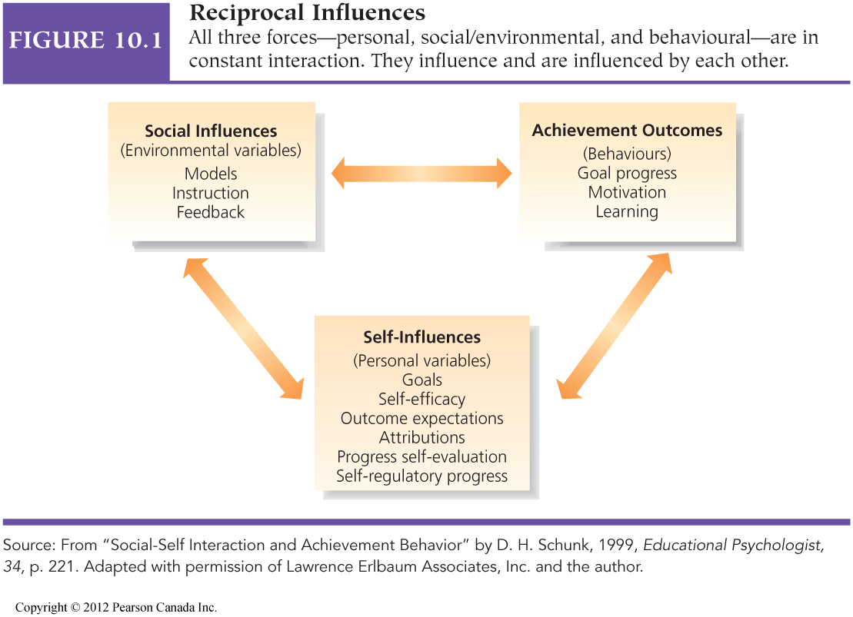

Models – you observe others behaviour + learn from it
Instructions
Feedback – do I like the outcome of these actions

Achievement/Behavior outcomes (behaviour, not so cognitive)
Goal prog – am I reaching my goal
Motivation – is it intrinsic or extrinsic (ex: do I care about really learning or just the grade)
Learning – did I learn anything, why am I learning, am I motivate to learn this

Most VIP the personal variables (these are more cognitive)
Goal – to learn, show off etc. what are my goals do I have any, who established these for me
Self-efficacy – do I feel that I have the skills to do X. (ex: based on past experiences, motivations, goals etc. do I feel that I can handle this task?)
Outcome expectations – based on task difficulty + past experience
Attributions – what do I attribute my success + failure to ex: amount of effort or difficulty of task. How we attribute these can influence how we will feel, ex; if can control the situation than we will feel better about it for future situations that are similar.
Progress self-evaluation – eval how your progress is going, if it good continue, if not change something.
Self-regulatory processes- control your own behaviour so that u can reach your goal

- 1 change anywhere in the cycle leads to changes all over

- Give a clear, specific example of the interactions of your environment, behavior, & beliefs/cognitions (self-influences) re: preparing for & going to a job interview
- enviro: ask ppl for advice
- behavior: motivated to get the job, doing what u can to get it ex: take their advice into practice
- Cog: goal (to get the job), self-efficacy (if believe u can get the job, ull be more confident + more likely to go to the interview) [self efficacy will also influ ur motivation, not motivated as much if u think ull fail]
Ex: 1) prepare Cv, get feedback for interview 2) see if I did everything I needed to do, a check list. 3) if I did it all than Ill feel more confident that I will reach my goal

- Use TRC to explain Learned Helplessness
(Learned helplessness: no control of the outcomes no matter how much you try)
If failed in the past + told by others that you can’t do it, than maybe you will start to feel like you can’t do it no matter how much you try.

STOPPED HERE!! NOW DOING REVIEW FOR THE TEST

Self-Concept, Self Esteem & Self-Efficacy
- As noted in Chapter 3 plus pp. 350-351, Self-Concept is a cognitive structure which includes Self-Efficacy, while Self-Esteem is based on affect and is a judgment of self-worth (“Do I like what I see?”)
- Self-Efficacy is a future-oriented, context specific belief which focuses on whether a person thinks he/she can cope with the demands of the situation. Example?
- Examine the next slide carefully (Table 10.1)

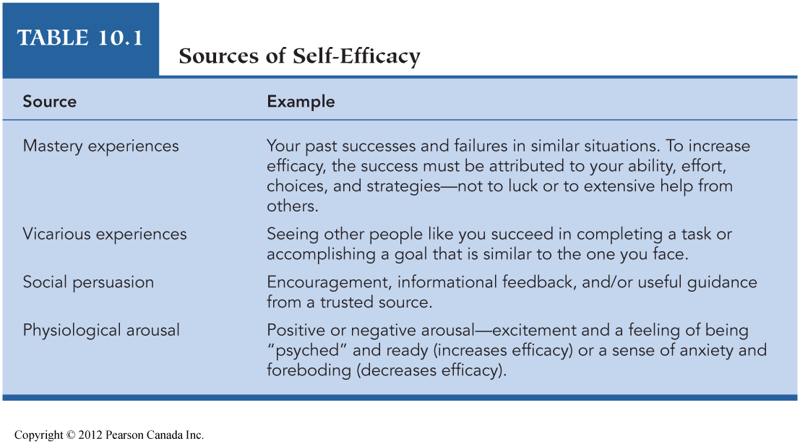
High Self-Efficacy
(Teachers’ & Students’ S.-E.)
- General Guidelines Re: Self-Efficacy
- Help students set realistic short term goals
- Teach strategies – outlining/note-taking
- Reward achievement not just engagement
- Emphasize/record progress in a particular area
- Make suggestions for improvement; allow for a revision of grade (1st attempt, 2nd attempt)
- Stress connections between past efforts and past accomplishments

OBSERVATIONAL LEARNING (Selected from Table 10.2)
- When does Observational Learning have the most impact? (Examples):
  - The model has high prestige and competence
  - Also: if the model is similar to the learner in age, race, same sex
  - Vicarious consequences (pos. or neg.?)
  - The best model is someone who initially struggled with a task and persisted until he/she was successful
  - Self-efficacy (If he/she can do it, so can I!)

Observational learning in teaching
- Directing attention
- Fine-tuning already-learned behaviours
- Strengthening or weakening inhibitions (Ripple effect?)
- Teaching new behaviours
- Arousing emotion (pp. 352-354)
Give Examples of the above

SELF-REGULATED LEARNING
- Self-Regulated Learning: The “process of activating and sustaining thoughts, behaviours, and emotions in order to reach goals” (p. 358)
- Influences on self-regulation: (skill & will)
  - Knowledge
  - Motivation (commitment)
  - Volition (follow-through)
Examine the next slide carefully & Give examples. (Figure 10.2: The work of Winne & Hadwin. Is there an omission? I think so!)

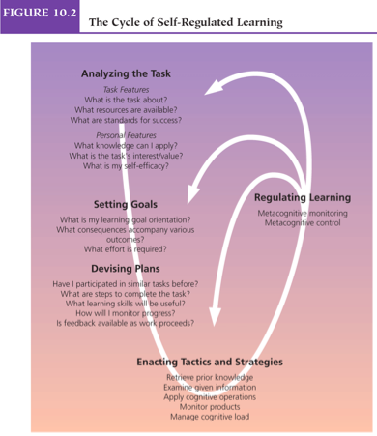

Cognitive Behaviour Modification (CBM)
- Cognitive Behaviour Modification is a form of self-regulation via self-talk
    - Cognitive modeling (adult says instructions while performing the task)
    - Overt external guidance (adult says instructions while the child performs the task)
    - Overt self-guidance (child says instructions aloud while performing the task)
    - Faded overt self-guidance (child whispers instructions while performing the task)
    - Covert self-instruction (child says the instructions to him/herself while performing the task)
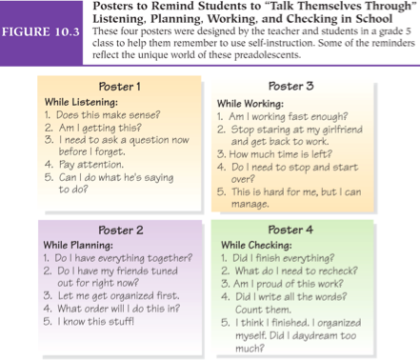

Teaching to Promote
Self-Efficacy & Self-Regulation
- Self-efficacy and Self-regulation can be achieved through: (examples)
  - Complex tasks (multiple goals & deep meaning; work is spread over time)
  - Shared control with students (choices)
  - Self-Evaluation (“cost of participation is low” – impact?)
  - Collaboration with peers (co-regulation of learning – Link to Vygotsky?)
(Examples from pp. 367-369)

Examples from Table 10.4:
Views of Learning (p. 371)
- Compare/Contrast the process of Learning:
  - Behavioural: Learning is due to rein. & pun; drill & practice
  - Cognitive: Learning stems from the use of appropriate strategies (When do I use strategy X?)
  - Constructivist (Individual): Active construction and reconstruction of knowledge; must have many opportunities to form more complex schemes (Piaget)
  - Constructivist (Social): Collaboration & Co-Construction (socially defined values) (Vygotsky)
  - Social Cognitive: Observations & interactions; active construction of knowledge (self-regulation) (Bandura)

More Examples from Table 10.4:
Views of Learning (p. 371)
- Compare/Contrast the role of peers in the learning process:
- Behavioural: Peers can be sources of rein. & pun.
- Cognitive: Not necessary but can influence how we process info. How?
- Constructivist (Individual): Not necessary but Cognitive Conflict is beneficial
- Constructivist (Social): “…ordinary in and necessary to…” co- construction of knowledge
- Social Cognitive: “…ordinary in and necessary to…” acquiring/building knowledge

Questions & Comments
- Table 10.4: Which one of the approaches best describes your processes of learning in Educ 210? Other courses?
- Table 10.4: Which approaches do you identify with regarding the roles of peers in your learning? Why?

Chapter 11: motivation in learning and teaching
(Readings: 13 & 18)

Selected topics

- Definition of Motivation
- -Types of Motivation
- -5 Approaches to Motivation
- -Impacts of Goal Setting
- -Types of Goals
- -Attributions
- -TARGET Model (To enhance Motivation)

What is motivation?

- Motivation is “… an internal state that arouses, directs, and maintains behaviour” (p. 377). Examples?
- When examining motivation, we usually look at peoples’ choices, time it takes to “jump in”, intensity of involvement, what causes persistence (or not), plus thinking and feeling (p. 377). Examples?

What is motivation to learn?
- “The tendency to find academic activities meaningful and worthwhile and to try to benefit from them” (p. 417)
- Give an example from your academic career.

Intrinsic and extrinsic motivation
- Extrinsic:
  - You are motivated to do the activity because you are trying to earn or avoid something located externally (external locus of causality). Example?
- Intrinsic:
  - You are motivated to do the activity because you find the activity or the end goal rewarding (internal locus of causality). Example?

5 approaches to motivation

- Behavioural
- Humanistic
- Cognitive
- Social cognitive
- Sociocultural

Behavioural approach
- A system of external reinforcements & punishments (consequences) used to encourage or discourage student behaviours
- Give specific examples
- Disadvantages of this approach?

Humanistic approach

- Educators must encourage the learner to tap into natural inner resources such as:
Needs/Drives for Self-Actualization (next slide) and Self-Determination
Self-Determination arises from our needs for
  - Competency (achievement)
  - Autonomy & Control (Power)
  - Relatedness (Affiliation) (pp. 382-383)

Maslows Hierarchy of needs
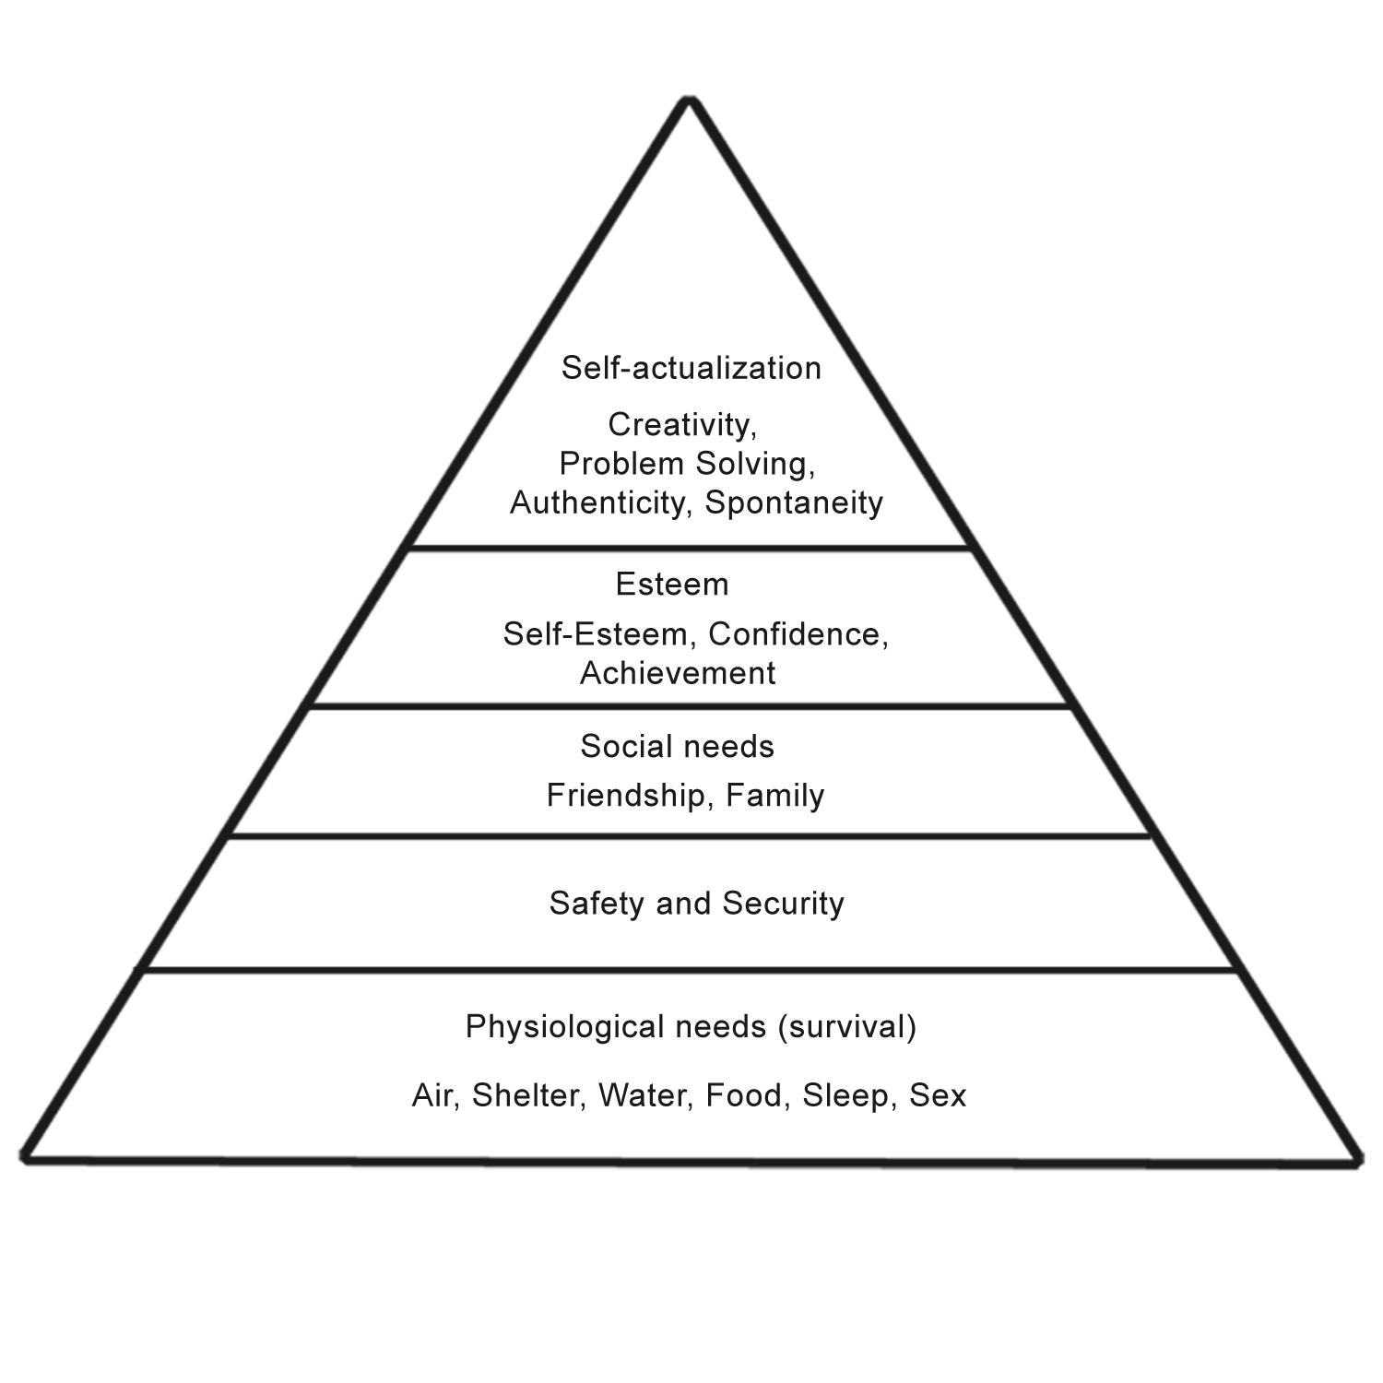

Maslow
Self-actualization:
Deficiency needs: things that we need to survive.

- According to Maslow, when Deficiency Needs are met, motivation decreases; however, when Being Needs are met, motivation increases. Do you agree? Why/Why not?
- We are born by these innate needs or drives and desires.
- Deficiency needs: extrinsic
- Being needs: intrinsic
Cognitive Approach
- People are active and curious about learning
- People are intrinsically motivated to solve personally relevant problems
- Behaviour is determined by cog. processes (not rewards/punishments)
- Real life examples?
- Mental why we make certain decisions and strategies is all based on our minds.
- Based on prior knowledge, memories, metacognition
- Does NOT look on overt behaviour.

Social cognitive approach (remember Bandura)
- These approaches acknowledge the importance of consequences along with beliefs, expectations, etc.
- ** Motivation = Expectancy (of success) x Value (is the goal important to me?)
- What is the potential Cost to me?
- What if Expectancy or Value = Zero?

Sociocultural Approach
- Emphasizes social participation in valued activities in one’s community or culture
- Legitimate Peripheral Participation (LPP) leads to full recognition & inclusion. Examples of LPP?
- Note: in the beginning, the contribution of novices is quite small
- Authentic tasks carry high values (and enhance motivation). Why? Examples?
- Vygotsky sociocultural theory (intrinsic + extrinsic motivation): authentic tasks depend on what is valued by the culture.
- LEGITIMATE PERIPHERAL PARTICIPATION (LPP)-> INVOLVEMENT OF SOMEONE WHO IS NOT AN EXPERT BUT IS STILL INVOLVED IN THE ACTIVITIES (authentic tasks; real life)
- Participation in social activities is valued.
- Novices (young child) may start off small and then as they get older get more involved in social activities; they are still participating they feel a sense of belonging (important in our needs)
- Authentic tasks-> has a high value

Teacher finds problems with this in the table ****

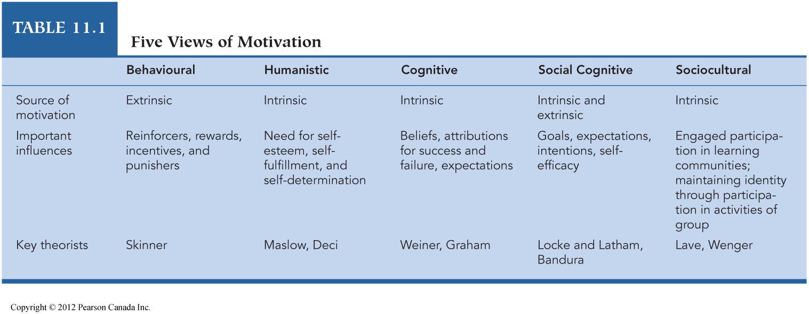

Skinner: behavioural
Humanistic: maslow + deci
Cognitive: weiner + graham
Social cog: bandura
Sociocultural: vygotsky

Impacts of Goal Setting
(Why is it Important to Set Goals?)
- Directing our attention (focusing attention on it)
- Energizing effort (putting in effort to reach the goal)
- Increasing persistence (If you see you are getting closer to the goal, you will persist. If you are failing at the goal, then you may not persist on the goal)
- Promoting the development of new knowledge and strategies (look at strategies im using to reach my strategy)

4 types of goals
Note: Goals should be specific, moderately difficult and likely to be reached in the near future (p. 385).
- Mastery Goals (Learning Goals): To learn and to improve one’s abilities (“I like learning”)
- Performance Goals: To show one’s abilities (“Look what I did!!”). Impact?- often people set really high performance goals that they cannot reach.
- Work Avoidant Goals: Success = Not having to work hard. Impact? They did not even have to put in the effort.
- Social Goals: To increase social network, to “fit in”. Impact? – I want the prestige of joining in on the group. (increase my social network)
Attributions regarding success of failure
Attributions: your reasoning or beliefs for why you succeed or fail on a task
Why did I succeed or fail on a task?”
  - Locus: internal/external
  - Stability: stable/unstable (Is the cause the same across time & situations?)
  - Controllability: controllable/uncontrollable (Can I control the cause?)
  - Note: Lots of Overlap…
(Comment from Lisa: The textbook overcomplicates these ideas)

Brief comments on self-worth
- High/Low Self-Worth outcomes:
  - Mastery-oriented students: they attribute their failures to not working hard enough or putting in the effort, they attribute their successes to their effort (incremental view) – they know that they can do better/ improve more confident view (BEST THING TO BE)
  - Failure-avoiding students: they have a strong fear of failure- they may cheat, take on easy goal- they attribute their failures to themselves being not capable; (entity view)
  - Failure-accepting students: (learned helplessness) they expect to fail; they set very low goals, learn that their efforts never pay off. (Entity view)

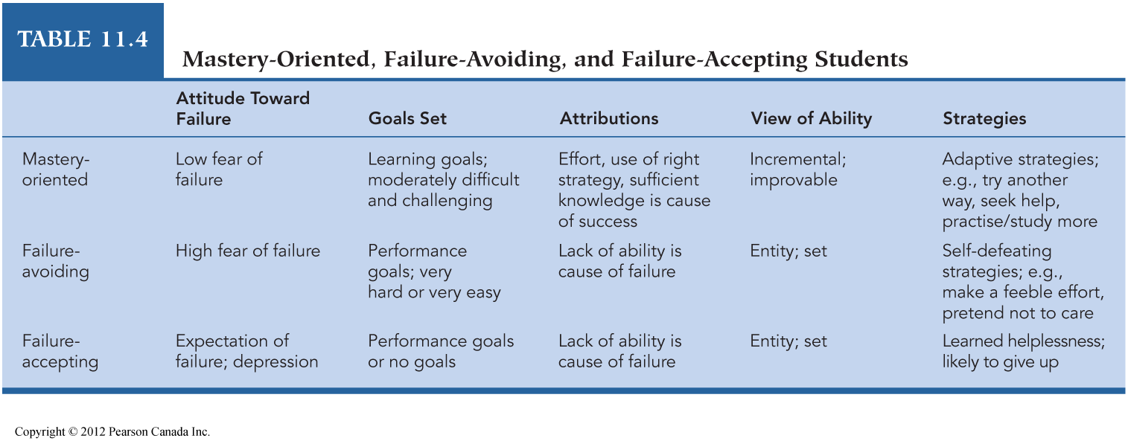

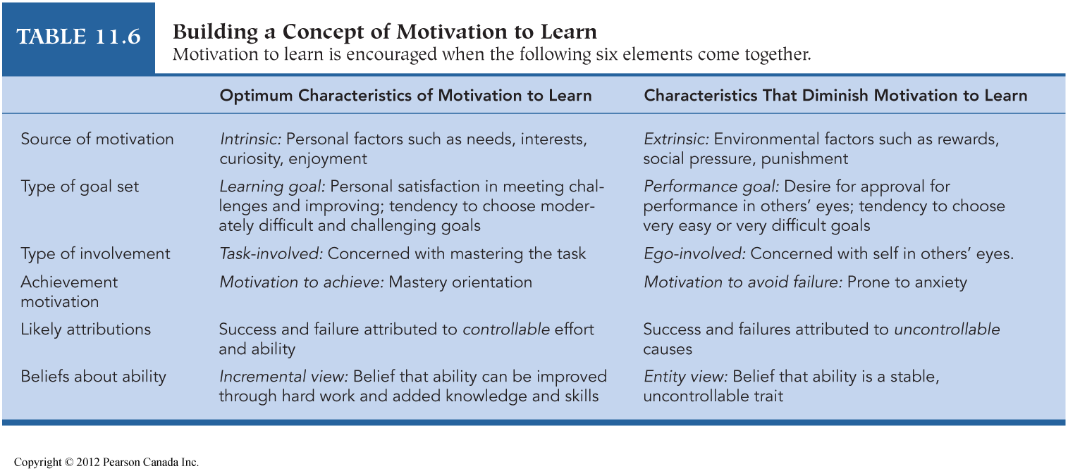

TARGET MODEL to increase motivation in school

T
  - Tasks for learning (academic)
  - Task value:
    - Importance/attainment value
    - Interest/intrinsic value
    - Utility value
- As noted previously, Authentic tasks enhance motivation
- Problem-based learning: Examples?- looking at bigger picture or problem
A & R
- Autonomy:
  - Bounded choices: Example?
  - Other ways to enhance autonomy?- gives them a sense of independence
  - Problems when there is too much autonomy?-needs to be a limit, too much autonomy leads kids to become very confused + stressed)
- Recognition:
  - Recognizing accomplishments but do not go overboard with praise.
  - Remember: The “Perils” of Praise
G
- Grouping
  - Try to group by individual needs
  - Try to group by similar interests
  - Goal structures:
    - Cooperative
    - Competitive (not that good)
    - Individualistic

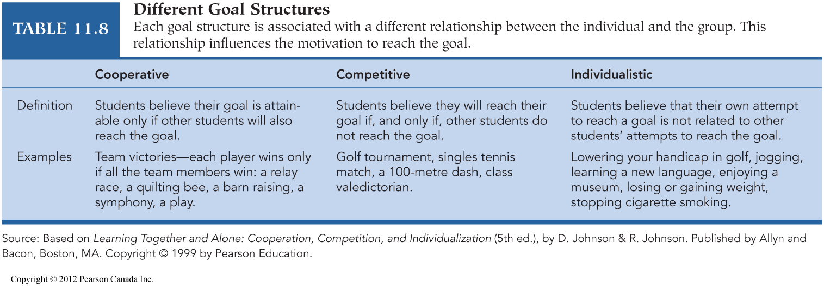

E & T

- Evaluation
  - Emphasize understanding over finishing
  - Have students self-evaluate (next slide)
- Time
  - Help students to self-regulate
  - Be organized, but flexible
  - Allow ample time for challenging activities (large blocks of time, if possible)



Readings 13 & 18
- -Some students need a few attempts to reach initial (basic) mastery of material. Impact on goal setting?
- -How do flexibility (examples?) and multiple opportunities to succeed (initial mastery and beyond) help students to feel respected and to have a positive attitude about school work?
- -Explain: Student Driven Curriculum (Reading 18, p. 127)
- -Explain why academic challenge plus academic support lead to high engagement and motivation- have input; curriculum can be based on their interests as well; autonomy in learning.

Comments & Questions

1 -Explain the impact of anxiety on (1) focused attention, (2) learning and (3) behavior prior to/during testing (pp. 399-400)
2 -Give examples of how educators can promote curiosity, increase interest levels and promote positive emotions in class

3 -With reference to tasks that require complex learning & problem solving skills, why does co-operative learning (instead of competitiveness) lead to higher achievement, especially for lower ability students? (p. 406)

More comments & Questions

4-Young children equate effort with intelligence; older kids (ages 11 or 12) (Piaget formal operations stage) realize that no matter how much effort you expend, the outcome will at least partially depend on intelligence. Impact on motivation? (p. 389)

5-What is Self-Handicapping and when is it most likely to occur? (p. 393)- sabotaging yourself- you can do better but you chose not to. May be due to a self-full filling prophecy.

Educ Notes Chapters 13-14
TEACHING EVERY STUDENT
Selected Topics
- 3 Characteristics of Effective Teachers
- Expert teachers know…
- Mager & Gronlound explination for how to plan a lesson + present material (Briefly)
- Bloom’s Taxonomy
- Bloom - Revised (Anderson & Krathwohl)
- Ausubel (Briefly) – read in text too KNOW THESE NAMES!!!
- Direct Instruction (its pros + cons)
- Seatwork, homework, etc.
- Differentiated Instruction
- Teachers’ Expectations

3 Characteristics of Effective Teachers
- Knowledgeable
- Present material in a Clear + Organized way (organized also relates to sticking to the syllabus)
- Warmth & Enthusiasm (no amount of this can compensate for a lack of teachers knowledge or clarity of explanation and organization)
need all 3!

Expert Teachers Know (p. 459):
- The academic subjects they teach at a deep & interconnected level, can link it to other subjects + help students link it to other topics.
- General teaching strategies (know about hw, what type of work should be assigning etc…)
- Curriculum materials & programs appropriate to age & grade level
- Subject-specific knowledge for teaching (ex: know how to teach spec topics like math rather than history)
- Characteristics + cultural backgrounds of diverse learners (have a general knowledge about the needs of learners with special needs + those of different cultural backgrounds that will be entering ur classroom so that u can be prepared to help them)
- Settings & groupings to enhance learning (ex: field trips)
- Goals & purposes of teaching (know why ur teaching something & ur goal for the lesson)

Planning: Mager & Gronlund (13mins) how we should plan & present material?
Mager: Behavioural Objectives (Instructional objectives as stated & measured by observations of behaviour, p. 461):
- Clearly describe the intended student behavior (ex: put boots by the door, color these red circles; BASIC SKILLS)
- Clearly state conditions where/when the behavior will occur
- Clearly state criteria for acceptable behavior (for example, 75 or 80% correct)

Mager claims, “… that students can teach themselves if they are given well-stated objectives” (p. 461).

Examples? Short comings of Mager’s plans? - not necessarily true. They need scaffolding as well. It is not only behavior (observations) that matter, BUT if it would be for kids with special needs than it would make sense because they need help for the behavioral task.
Gronlund (pp. 461-462)
Gronlund: Cognitive Objectives (Instructional objectives stated in terms of higher order thinking skills, p. 461):
- State the objective using general cognitive terms (understand, apply, analyze, etc.)
- Clarify #1 by stating specific examples (Compare & Contrast the political views of ________ and ________)
Note: Progress from general to specific

Planning in the Cognitive Domain (21:00min)
- Bloom’s Taxonomy (1956) – Cognitive Domain (from “low” to “high”):
  - Knowledge (recite, list, define, locate)
  - Comprehension (give examples, explain, translate)
  - Application (use maps or charts, cook, build)
  - Analysis (classify, contrast, compare)
  - Synthesis (hypothesize, compose, design, combine theories to make a new theory)
  - Evaluation (critique, judge)

Bloom’s Taxonomy as Revised by Anderson & Krathwohl (2001)
- Remembering
- Understanding
- Applying
- Analyzing
- Evaluating
- Creating
A & K used verbs (to indicate activity). Your opinion re: the change in order (5 & 6)?

Affective Domain (p. 463)
- Receiving (take it in)
- Responding (maybe its moving me emotionally)
- Valuing (valuble experience)
- Organization
- Characterization by value
Examples? When/where do we most focus on the Affective Domain?

Psychomotor Domain (briefly)
In the Psychomotor Domain, our actions shift from basic perceptions & reflexes to “skilled, creative movements” (p. 464).
Examples? ? Physical skills, dance steps

Expository Teaching (Ausubel) teacher presents a complete package of material gradually.
- *****Meaningful verbal learning (not rote learning or memorization; more connections)
- Deductive reasoning (general to specific, like Gronlund)
- Advance organizer: A general statement of the concepts to be studied; a summary of the topic). Example regarding the work of Piaget?
- Expository Organizer: New Knowledge
- Comparative Organizer: Activate pre-existing schemes (bring old info into working memory)
The educator guides the students to more and more specific information. Example re: Piaget?

Direct Instruction: Explicit Verbal Instruction for the Teaching of Basic Skills
    - Review & check previous work
    - Present new material
    - Provide guided practice (ex: start hw in class)
    - Give feedback & correctives
    - Provide independent practice
    - Review weekly & monthly
    - Review, feedback & re-teaching should occur as often as needed
    - Note: Direct Teaching is more useful for remembering, understanding & applying than for higher order thinking

Seatwork & Homework
Seatwork: Supervised practice that follows the lesson (in class work):
- Clear objectives, support available, aim for high success rates, it should be a challenge but not so difficult cause then the children may give up.

Homework Promotes:
- Continued involvement in lesson (Ideally: start the h.w. in class)
- Accountability (check the h.w.; count it as part of the overall grade)
- Involve the family (or not)?

Questioning to Enhance Learning
Explain: Convergent & Divergent Questions
Convergent (leads to one answer)
Divergent Questions (leads to many answers; divergent thinking)

IRE: questioning to helps students enhance their learning
- Teacher initiated questions
- Student responses
- Evaluation by teacher (probing, praising, work in groups, etc.)

Value of Questions: (Examples from pp. 471-472): rehearsal, cognitive engagement, identify gaps in knowledge, provoke curiosity, cognitive conflict, etc.)

Group Discussions: Advantages
- Students:
  - Readily express themselves
  - Clarify & Examine their own thinking
  - Justify opinions
  - Develop tolerance for varying views
  - Learn leadership skills
- Teachers are not necessarily dominant (Remember: Socratic Seminars)

Group Discussions: Disadvantages
- Unpredictable (ex: can go on tangents, may digress or sore)
- May digress into “exchanges of ignorance” (p. 476)
- Uneven participation (some students take over the discussion)
Solutions? Ask those who aren’t contributing to do so cuz every body needs a chance to speak
- A lot of preparation is necessary to ensure that students have the knowledge/skills to allow for meaningful participation in discussions. How to prepare? (LAST 3 or so minutes??)

Differentiated Instruction: Briefly
- Within Class Ability Grouping: students are assigned to groups (within the class) based on ability levels. Also: Between Class Ability Grouping (Review)

- Flexible Grouping: grouping & regrouping, continuous assessment with all students taught in their ZPDs. Problems? Note: High expectations for all. (may move up and down levels throughout the year)
  - Issues w/ this? sad if see others move up and ur unable to, Hard to move up (but less so than when tracking).

- Non-Graded Elementary Schools: (also flexible grouping): not placed based on grades or levels! Grouped based on “… achievement, motivation or interest in different subjects” (p. 482).
Ex: today we will talk about sports, who ever is interested in soccer go to that corner, b-ball, that corner, tennis that one etc.
  - 1 limitation: if a child focuses 1 one area of interest, they may never learn about other areas.
15:33

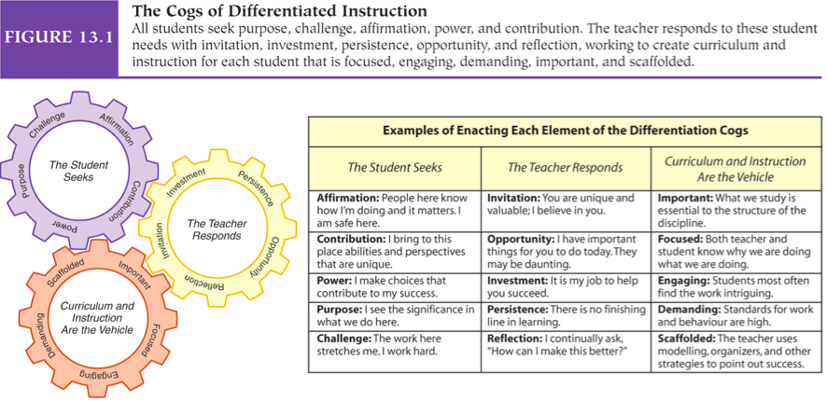
when 1 cog moves they all do. [just know that all the cogs move + interact]
- Just know what the student is seeking don’t need to know all the little words
- dont need all the little topics, just know the general idea cuz the little words can be in diff sections. (ex: teacher is scaffolding, not really the curriculum as much)

- this is an ever changing process of differentiated instruction
Teachers’ Expectations 22:20
(Some examples from pp. 484-488)
- Sources of expectations: IQ scores, gender, appearance, SES, feedback from other teachers, experiences w/ older siblings, other?
- Re: I.Q.: Rosenthal & Jacobson (1968), p. 484 – Impact of Self-Fulfilling Prophecy?
- In general, the Self-Fulfilling Prophecy has a stronger impact in the early grades

MISSED SOME, FILL IN
Experiment 1968: (25min) at the beginning of the year, at random, about 5 students per class (in grades 1-5) had great potential to improve (didn’t tell them or their parents). Tested them 3 times (beginning of the year, 4 months later, & the following spring), these students IQs increased! Especially if they were young!!

used Flanagan IQ tests (very basic test of abilities)
– mainly looked at picture vocabulary
ex: which picture illustrates something to drink? Pic the right one out of 5.
Also had some logical reasoning
ex: which picture doesn’t fit w/ the rest.

Self-fulfilling prophecy: if believe that a student is smart, the teacher may engage them more, smile at them more, treat them diff etc.
Findings teachers expectations can make them smarter
But it was poorly researched + there were ethical issues.
(but still see that teachers expectations can influ how well kids do)

- Sustaining Expectation Effect: Although the student’s abilities increase, the teacher maintains the same expectations. Stronger impact in later grades. Example? (ex: may stop trying if ppl don’t expect u to accomplish anything)

More on Teachers’ Expectations
(Examples from pp.486-488)
- Teachers with high expectations for certain students:
    - Ask more & harder questions
    - Give more time to answer
    - Give cues, hints
    - Show they believe in the students’ abilities (ex: encourage the child, let them know they can do it)
    - Smile, show warmth
Impacts of high/low expectations?
High but realistic expectations – kid may rise to the challenge
Low – won’t bother trying

Accommodations for Students with Special Needs (Briefly) 36:37
- Accommodations are strategies that enhance a student’s functioning & minimize his/her learning differences. (ur butting them on an equal playing field)
Exs: Extra time, typing class tests etc.

- As noted, Expert Teachers are familiar with the needs of diverse learners. They plan in advance regarding the inclusion of students with special needs.
Exs: Higher tolerance for error, make sure all have access to what’s in the classroom etc

- In addition to learning academic material, students with special needs must be, “… full participants in the day-to-day life of the classroom” (p. 484). Examples?
(don’t have to do it in the class, can do it in a separate room for a bit but they are fully involved in the class to the best of their abilities. But this doesn’t always work – it may not be what’s best for the student.)
Comments & Questions 42: 27
Re: Teachers’ knowledge: “… knowledge is necessary but not sufficient for effective teaching…” (p. 458). Clarify.
- knowledge is VIP, but also need warmth + enthusiasm, & clarity + organization

Explain, “For experienced teachers, unit planning seems to be the most important level, followed by weekly and then daily planning” (p. 460).
- Unit planning – decide how much time u should devote to each unit. Ex: learning fractions (for 2 weeks) and thing of sub topics per day/week. Ex: on Monday ill teach about this area, then on Tuesday about that one etc.

Teachers usually allow a second or less for responses. Impact?
- Leads to more involvement from the students who need a bit longer to think about the answer!

From a Constructivist Approach, “… planning is shared & negotiated” (p. 465). Explain.
- Vygotsky: planning what we will do should be shared + negotiated bw teacher + students. Its co-constructed!
- Good cuz the students are coming up with ideas + this leads to ownership + power for the students.

Explain the “double threat” of low expectations & inadequate teaching (p. 487)
- Low expectations wont engage the student as much, give them clues, etc.
- Also if have little knowledge on the matter wont be able to teach it adequately
- (also low expectations can influ + inhance inadequate teaching).

Chapter 14: Classroom Assessment & grading
Readings 20 & 21

Selected Topics
- Norm-Referenced Tests
- Criterion-Referenced Tests
- Standardized Tests
- Formative Evaluations
- Summative Evaluations
- Reliability, Validity & Absence of Bias

Norm-referenced tests “ Grading on a curve”
In general, in norm-referenced testing, we examine where a score, “…falls in relation to the scores of the norm group” (p. 497)
ex: where does ur score as a 10 yr old fall in relation to others, is it average, above average etc.
- Give exs of norm groups (ex: 10 year olds, ur cegep classroom)
- Norm-Referenced: I.Q. tests, GRE, SAT, etc. (how u do as an indiv doesn’t matter too much, its more how u do in relation to others that matters)
- In a university course, it may have been pre-determined that only 3% of students will receive a grade of A+; to clarify, a grade of 97% may equate to a B (or whatever) if there are many high scores. Opposite scenario? Pros & Cons?
- ex: if the whole class failed but you got 60% and thus got an A
- does this really tell you how much ppl learned cuz tells u how well u did in comparison to others. So maybe non of you learned a thing but cuz u did better than the others, than it may seem like u know a lot even if ur grade wasn’t so great.
- high score may be more of a reflection of others doing poorly than of u
doing well.

Criterion referenced Tests 13:15
Student’s score is compared to a pre-established standard of performance; for example to earn an A+, his/her test score must be 95%+
- At the extreme, every student may earn an A+ (or every student may earn an F).
Problems? – maybe the class is too easy or too hard, so doesn’t reflect their lesrning, just reflects the teachers course at that point.
- mine* - maybe if too strict, u loose a letter grade for 1 stupid point.

- Examples: Driver’s test, Citizenship test, Licensing for professionals (a pre-established “cut off” determines if the student passes or fails)

“In criterion-referenced grading, the grade represents the quality of accomplishments” (p. 522); contrast this point with Norm-Referenced testing/grading
- NR: may not reflect how much you learned! Where as CR does! (ex: don’t want a doctor who only did well cuz of NR but wouldn’t have done so through CR).

There are problems w/ both system & both are appropriate for diff situations!!

Standardized Testing (around 20:25)
Standardized tests are given w/ same conditions, same instructions, same time allocations, same materials & methods of scoring
- These tests can be norm or criterion-referenced
- I.Q. tests are standardized tests meant to determine how well a student will do in school (an aptitude test); as noted, I.Q. tests are norm-referenced (p. 499) (ur score is formed by comparing how do to how others do on the test)

Formative Evaluations 30 mins
…”formative assessments [evaluations] help shape or form instruction” (p. 500).
How? - ex: after seeing how kids did on a test, the teacher may realize that the kids had trouble on the essay portion so then the teacher will go back + teach kids about essay writing

- it tells teacher + students where the students strengths + weaknesses are & then forms/guides future instruction!!

Also, formative assessments help a student form + guide his/her future learning (setting goals, examining strengths & weaknesses, changing study strategies, seeking help, etc.)

Formative assessments are given prior to or during instruction.
Examples? – ex: prior – given a pretest (if didn’t do well on a spec area, learn that u should focus on that area while studying). Or during – to see how much students are grasping during the class, ex: ask students questions during the lesson, or in class work.

No grade is given!!! Just given feedback on where improvement is needed!

- Also see Reading 20

In a kinder world – you would always have a second chance to improve your work
BUT if know this than ur motivation won’t be as high, cuz if u fail then its not a big deal, cuz you can always do it again (less pressure).

Summative Evaluations
A summative evaluation (assessment) occurs when instruction is finished; it “sums” up a student’s accomplishments
- A grade is assigned

Give examples of when Formative or Summative evaluations are best used
Formative – use more for young (ex: satisfactory, succeeds expectations etc)
Summative – usually for older kids

Reliability
Reliability = the consistency/stability of scores (small fluctuations are normal but if an indivs scores vary very differently bw testings than the test is not reliable. Their scores should be fairly consistent)
- When examining test results, researchers know that there could be “error” due to fatigue, anxiety, illness, etc.; that is, a small difference in scores is likely due to error, not a lack of reliability of the test
- Examples of Reliability: test-retest (when u retake a particular test, ur scores should be consistent) split-half (ex: take all odd #ed Qs from 1 test & even ones from another, and then compare how students did on those – should be consistent), inter-rater reliability (different graders should give the same student similar results) (maybe around 45) maybe look these 3 up

- As noted previously: A diagnosis or an academic placement should never be based on one score. Why? 48min – should look at a variety of tests, and things to get a full picture. Not just on 1 test! Talk to parents, observe the child, see how they do on diff tests etc. NEED LOTS OF SOURCES OF INFO BEFORE YOU DIAGNOSE THEM!!!

ENDED HEREE!!

Validity
In General: Can I interpret the test results as truly reflecting what the test is supposed to measure? Are my conclusions about the meanings of the scores accurate/appropriate?
- For example, if a math test contains a lot of reading, a low score may indicate problems with reading, not problems with math
- Validity can be determined when the person’s scores on Test A are highly correlated with his/her scores on Test B, given that Test B truly measures what it is intended to measure

Absence of Bias
- Is the test in favour of or biased against people of different cultures, races, genders?
- Will people of certain groups be offended by the language or content of the test? Example?
- As noted, some of the earlier (also current?) items on the WISC were biased against low SES kids and non-North American kids. Examples?

Objective & Essay Tests
- Multiple Choice, True or False, Fill in the Blanks and Matching are objective test items (“not subjective”) (p. 507)
- Essays or “longish” short answers are generative test items; that is, the student must generate an answer. These evaluations usually involve some subjective aspects Examples?
- Pros & Cons of each?

Comments & Questions
- Clarify how/why norm-referenced grading may harm relationships: student-teacher and student-student? (p. 522)
- Clarify how/why a well-constructed grading rubric can increase reliability and validity when grading essay answers (Note: The grading rubric should be available to students as they work)
- Clarify how/why criterion-referenced tests can be used as assessment tools in the affective and psychomotor domains
- Give examples of Authentic, Portfolio and Exhibition assessments. Pros & Cons?

Reading 20
- Explain the importance of Learning how to Learn (LtL), especially in today’s society (p. 147)
- Self-assessment depends on “…monitoring learning and managing learning” (p. 148)
- Give an example of a formative self-assessment; what is your opinion regarding summative self-assessments? Examples?
- Clarify: Students should, “…use formative self-assessment as a navigational chart and compass – to know where they are going…” (p. 151)

Reading 21
- In this study, the teachers would not allow the students to fail; if the work was not completed at an acceptable level, the students had to re-do it (at lunch, after school, even in summer school). Pros & Cons?
- The teachers took responsibility for the students’ learning. Pros & Cons?
- Why did the teachers have, “… to re-assess the quality and quantity of their graded assignments”? (p. 155). Examples?
- Would you like to work at a school with this policy? Why or why not?

