Educ 240- Lessons 6-7-8-9-10

What is Needs Analysis? A process to identify gaps or deficiencies in employee and organizational performance.
- Goal: Identify differences between what is and what is desired or required and compare the magnitude of gaps against the cost of reducing them or ignoring them.
- Also known as: needs assessment, training needs analysis (TNA).
- Instructional solutions can only have instructional solutions
- What is the problem or the need deficiency?

Dr. Saul Carliner discusses the role of needs assessment in instructional design:
- Needs analysis is an important part.
- Needs assessment: planning to identify the need, going to collect data and evaluate the data.
- Needs analysis: refers to the whole process.
- Purpose: what is the problem or gap? Who is it addressed to? What tasks would they do?
- What is good enough? Perfect?
- What do people need to perform this task? ( for example: if people need a cellphone to perform their job, you need to make it available and they need training)
- What is it that people need to learn? (talk to people, get opinions)

The Needs Analysis Process
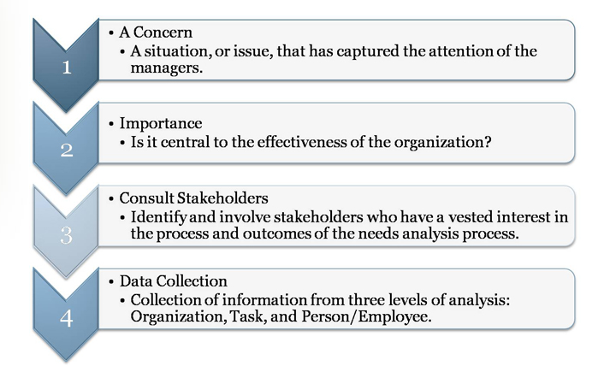
Is their a problem?
Is it important? If yes consult stakeholders. If no, terminate.
Then collect data from three levels of analysis.
  - Organization analysis, 2) task analysis & 3) person analysis
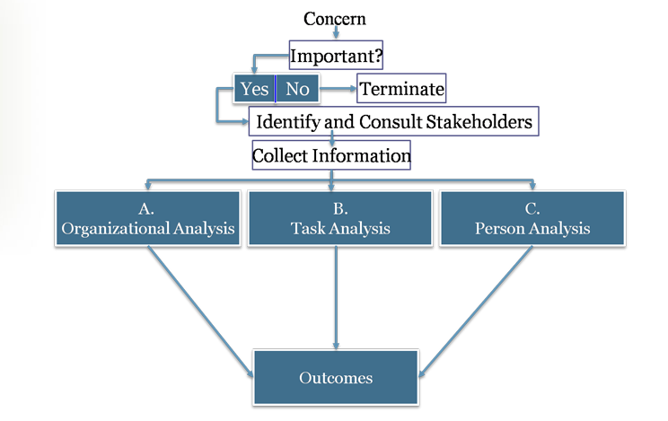

Needs Analysis Outcome
- Identifies performance gaps (problems or “itch”).
- Clarifies nature of performance gaps.
- Determines if training and development is necessary.
- Identifies (where, what/for whom) training and development is necessary.
- Write training objectives and design training programs. (write out goals)
- Develop measures for training evaluation.

- Organizational Analysis: the study of the entire organization as a whole including the strategy, environment, resources and context.
This includes the following:
Strategy  (congruency) | - Consists of an organization’s mission, goals, & objectives such as a dedication to quality or innovation.  - Strategic training: Alignment of an organization’s training needs with the organization’s strategy & objectives (goals).
Environment  (external) | - New technologies, competitors, recessions, regulations, mergers, acquisitions, and trade agreements can profoundly affect:  - The need for training.  - The content of training.  - Employees’ receptivity to being trained.
Resources | Resource Analysis: Identification of the resources (money, time, expertise) available in an organization that might be required to design and implement training and development programs.
Context | Organizational Context  - Climate: The collective attitudes of employees toward work, supervision and company goals, policies, and procedures.  - Training transfer climate: Characteristics in the work environment that can either facilitate or inhibit the application of training on the job.  - Learning culture: Culture in which members of an organization believe that knowledge and skill acquisition are part of their job responsibilities and that learning is an important part of work life in the organization.
****The key is to not only determine if training is needed, but also to gauge the chances of success by identifying potential barriers.

Task Analysis: The process of obtaining information about a job by determining the duties, tasks, and activities involved and the knowledge, skills, and abilities required to perform the tasks of that job.

Job | Task
Consists of a number of related activities, duties, and tasks. | Smallest unit of behaviour studied by the analyst and describes specific sequence of events necessary to complete a unit of work.
Job analysis template  (from Service Canada) | Sample task analysis  (from U.S. Department of Labor- Mine Safety & Health Administration)

Six Steps of a Task Analysis
1 | Identify the target jobs.
2 | Obtain a job description.  - Job description: A statement of tasks, duties, and responsibilities of a job. It lists the specific duties carried out through the completion of several tasks.
3 | Develop rating.  - Rate the importance of each task and the frequency that it is performed.
4 | Survey a sample of job incumbents.
5 | Analyze and interpret the information.
6 | Provide feedback on the results.

Alternative Approach: Cognitive Task Analysis
A set of procedures that focuses on understanding the mental processes and requirements for performing a job.
- Differs from traditional task analysis in that it describes mental and cognitive activities that are not directly observable, such as decision making and pattern recognition.
Some will argue that task analyses are limited since they (1) emphasize the observable behaviours of individuals rather than their cognitive processes and (2) they assume that the tasks are performed by individuals rather than by groups.

Alternative Approach: Team Task Analysis
Analysis of tasks of the job, as well as the team-based competencies (knowledge, skills, and attitudes) associated with the tasks.
- Differs from traditional task analysis in that interdependencies of the job, skills required for task coordination, and cognitive skills required for interacting in a team must be identified.

Person Analysis

Process of studying employee behaviour to determine whether performance meets standards.

1. Define the desired performance.

2. Determine the gap between desired and actual performance.

3. Identify the obstacles to effective performance.

Barriers to Effective Performance
Human | Technical | Information | Structural
Lack of knowledge* | Poor job design | Ill-defined goals/ objectives | Overlapping roles & responsibilities
Lack of skills* | Lack of tools/equipment | Lack of performance measurements | Lack of flexibility
Lack of motivation | Lack of standardized procedures | Raw data, not normative or comparative data | Lack of control systems
Counterproductive reward systems | Rapid change in technology | Resources sub-optimized | Organizational political climate
Group norms | Ineffective feedback | Informal leaders
*Only barriers that can be addressed with a training solution.

Needs Analysis Methods
Nine Methods
1. Observation | 2. Questionnaires | 3. Key consultation
4. Print media | 5. Interviews | 6. Group discussion
7. Tests | 8. Records and reports | 9. Work samples

Needs Analysis Sources
- 1) Employees and managers
  - Self-assessments
- Subject matter experts
- 2) Customers
  - Satisfaction ratings and perceptions.
- 3) Computer-based analysis
  - Analysis of business data (e.g. CRM, manufacturing quality systems, call centre management software).
More on needs analysis sources:
- Check out: Concordia University’s Job Evaluation Questionnaire.

Saul Carliner: suggests different ways that information can be gathered for a needs assessment.
- How do we gather information?
- 1) Read up and get background info
- 2) Interview (
- 3) focus group, have a list of questions, surveys,
- 4) observation (get out and observe)
- Look at wat employees don’t know or are misinformed
- Background reading, talk to people involved, observe

Obstacles to Needs Analysis
- Budgetary constraints to conduct a needs analysis. Need Money $$$
- Feel that they can accurately identify training needs and that more analysis is a waste of time and money.
- Managers may even have their own agendas.
- Time is a constraint.
- Lack of expertise to conduct a needs analysis.

Key Points

- Needs analysis is a crucial step in the design and development of training.
- The needs analysis process consists of a series of interrelated steps.
  - The identification of a concern, measuring its importance, consulting the stakeholders, and the collection of information.
- The outcome of a needs analysis may reveal that the solution is non-instructional (evaluation of outcomes).
- Given that the proposed solution is instructional, the results of the needs assessment drive the rest of the instructional design process.
  - A poorly conducted needs analysis will impede the chances of a successful training program.
- Information must be collected from various sources in order to properly understand the problem:
  - Organizational analysis, task analysis, person analysis.
- There are many different methods to collect information.
  - Each have specific advantages and disadvantages.

Lesson 7: The training design
Equal access: Universal design of instruction:
To find out more about this concept:
Watch this video (Length: 13:09)
http://www.youtube.com/watch?v=AY6PhtCLrTg
- Allows a professor or teacher to look at the different ways of teaching and learning in individuals
- One method does not fit ALL student
- The goal is to maximize the learning for everyone. (good for EVERYONE) plan for diverse characteristics, diverse instruction, determine level of preparation of students, cultural backgrounds, flexibility,
- Use a variety of methods to teach
- Class climate: adopt practices and principles for inclusiveness and diversity
- Physical access, utility and disability: make classrooms, labs and field work accessible and safe for students with a range of abilities
- Delivery methods: use multiple methods, lectures, discussions, field work, web-based methods, audio-visual

What is Design?
Definition of Design: A disciplined inquiry engaged in for the purpose of creating some new thing of practical utility.
It involves exploring an ill-defined situation, finding as well as solving a problem(s), and specifying ways to effect change.
Design is carried out in numerous fields and will vary depending on the designer and on the type of thing that is designed. Designing requires a balance of reason and intuition, an impetus to act, and an ability to reflect on actions taken. (Rowland, 1993, p.80)
The word “design” can be defined in many ways and has different connotations based on the context in which it is used.
For instance, www.thefreedictionary.com defines “design” as:
- To conceive or fashion in the mind; invent
- To formulate a plan for; devise
- To plan out in systematic, usually graphic form
- To create or contrive for a particular purpose or effect
- To have as a goal or purpose; intend
- To create or execute in an artistic or highly skilled manner

Basic Beliefs of Design
1. Design is a problem-solving discipline.
-A problem must first be defined and a concentrated effort is then carried out to design a solution to solve the problem.
2. No two problems are the same.
-Although the situation could be similar (same learners, same company, same budget), the timing could differ, as could the expectations, the technology used, etc...
3. One of the main reasons for defining a problem is to identify any constraints associated to it.
-The constraints help identify the solution that will be used to solve the problem.
4. There is no perfect solution
-A designer must choose from a list of many possible solutions. To do so, they will consider the constraints, as well as the nuances regarding the situation at hand. What could work in one situation may or may not work in another.

Reaching a solution for a design problem is part science, part instinct, and part art.

What is Instructional Design?
Instructional design is a comprehensive system of procedures, informed by research and practice, that develops effective and efficient educational and training programs in a consistent and reliable way (Gustafson & Branch, 2002).
- The complex process, often called Instructional Systems Design (ISD), is active (it is constantly being monitored and altered), iterative (the process is repeated and refined), and creative (allows for many different solutions).
A system consists of a set of elements that interact with each other in such a way that it is:
- interdependent: No individual element can be separated from the system. They rely on each other to accomplish a common goal.
- synergistic: The sum of the parts of the system is greater than the individual contributions of each.
- dynamic: The system is constantly monitoring its environment and is flexible enough to be altered to changing conditions.
- cybernetic: The individual elements are able to effectively communicate with each other.
Dr. Saul Carliner: shares some of his strategies for the design of instruction and the importance of having a full bag of tricks (design practices)

- Most imp: engages learner in an emotional and intellectual level
  - Emotional: its really important that info s made relevant (story telling)
  - Relevance: learner will be able to recognize in their own experience
  - Material needs to be communicated clearly
  - Prerequisite knowledge:
  - Simulation: model of the real world.
  - Case study analysis: let’s look at other examples

The ISD Model - Design
Recall that the ISD Model of Training and Development is composed of three main phases:
- The Needs Analysis: used to analyze the situation and determine if training is a viable solution to the problem
- Training Design and Delivery: to develop the training and deliver it to the trainees
- Training Evaluation: to assess the results of the training and determine if adjustments are required
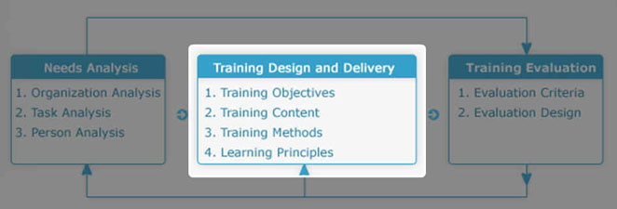
Training Objectives
According to the ISD Model, the end result of the Needs Analysis is the identification of a problem. The more information we are able to gather about that problem, the more likely we are to find a solution that will address it.
If a training solution is chosen (recall that not all problems can be solved with training), the first step of the design and delivery phase of the ISD model is the establishment of the training objectives.

A Training Objective is a statement of what trainees are expected to be able to do after a training program. Objectives are more than simple statements of goals or general outcomes. (esther does this during the trsining at lancome)
- They are written.
- They dictate the design of the training.
- They serve as the basis for evaluation (if it can be measured).
- They provide the learner with the means to self-select their instruction (using metacognitive strategies).
Training objectives are also known as learning or performance objectives.

Purposes of Training Objectives
Training objectives are important for all the stakeholders involved in the training intervention:
- the trainees (the individuals being trained) ex: me
- the trainers (the individuals who are designing and/or presenting the training ex: esther
- managers (the individuals who have sponsored the training intervention and/or are supervising employees who are being trained). Ex: simon
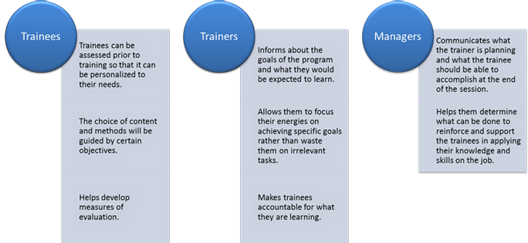

Writing Training Objectives
Training objectives should include five key elements of the desired
outcomes:
- Who is to perform the desired behaviour?
- What is the actual behaviour?
- Where is the behaviour to be demonstrated?
- When is the behaviour to be demonstrated?
- What is the standard by which the behaviour will be judged?

- Ex: The sales representative (who) will be able to make ten calls a day to new customers (what) in the territory assigned (where and when) and will be able to generate 3 (30% sales) worth at least 500 $ (how or the criterion).

Learning objectives should describe the intended outcome of the performance of the participant. When writing learning objectives, a good rule of thumb is to design them to be SMART GOALS:
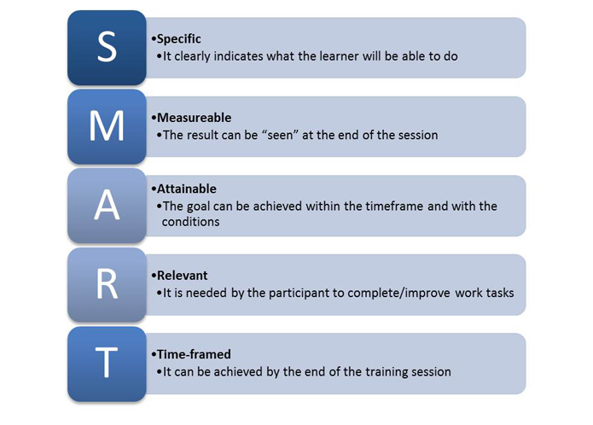

Writing Training Objectives (cont'd)
Each learning objective should contain three key components:
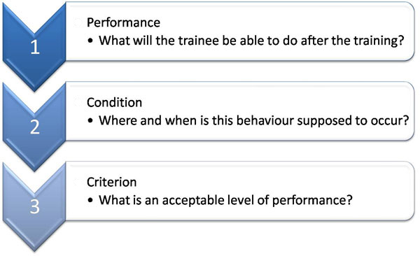

In order to write SMART learning objectives, it is recommended that you make use of action verbs that help to describe and measure the desired performance.

Training Content
After we have established what the training objectives will be, we now turn our attention to the content that needs to be delivered to the trainees.
In scenarios where a company has their own training (education) department (perhaps with their own subject matter experts and trainers), they may opt to design and develop the training solution internally.
In other situations, particularly when resources for training and development are scarce, the solution might involve buying a ready-made product (off-the-shelf) or hiring/outsourcing the training to a third party. For larger projects, this may require that the company ask for suppliers to bid on their project (a request for proposal or RFP).
We will explore the advantages and disadvantages of each scenario.
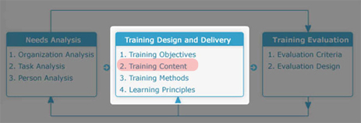
The content presented to the trainees must be designed to fulfill the needs of the company. Once a needs analysis has been conducted, the results are used to help identify the nature of the content that needs to be included in the training program.
- Follow the training objectives
  - Once a proper needs analysis has been conducted, let the training objectives help dictate the content required for the training.
- Compare actual performance to performance goals
  - The content should address the identified performance gap of the employees.
- Refer to legislation
  - If training is required because of new or updated legislation, the content would reflect it.
- Consult with subject matter expert (SME)
  - In other cases, one might need to consult a subject-matter expert (internally or externally) to create the content for the training, or validate training that was created in-house in order to make sure that it is authentic.

Purchase or Design Decision: Packaged Programs (pg. 140, lesson 7)
1) Advantages of Packaged Programs (aka: Commercial Off-The-Shelf Products)
- High quality
- Immediate delivery
- Ancillary services (tests, videos)
- Potential to customize the package to the org.
- Benefits from others’ experience
- Extensive testing
- Often less expensive (less money)

**** when resources are scarce for training and dev. Companies may use packaged programs.

Purchase or Design Decision: Internal Programs
2) Advantages of Internal Programs
- Security and confidentiality
- Use organization’s terminology
- Incorporate organization’s values
- Fully branded
- Use internal content expertise
- Understand audience
- Pride and credibility
- Content is linked with organization-specific processes

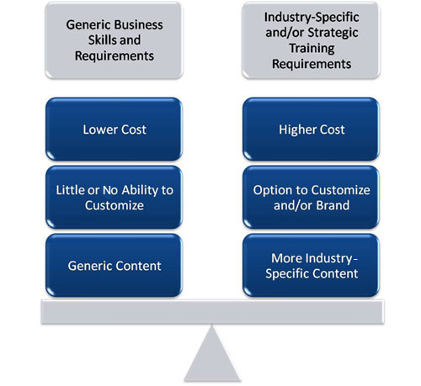

Purchase Decision Considerations

Important factors to consider when deciding between
purchasing a ready-made training solution and designing it in-house:
- Cost $$$
- Human resources
  - Access to a subject-matter expert (Do they have the time to devote to the program design? What would be the production lost if they have to take time off their job to work on this project?)
- Time (How long will it take to have the training program ready? How soon can it be delivered to the employees?)
- Who needs the training?
- What is the expected return or benefit?

Request for Proposal (pg 142, lesson 7)
Definition: A Request for Proposal (RFP) is a document that outlines to potential vendors and consultants an organization’s training and project needs (aka: a tender).
In the corporate world, RFPs are generally targeted to identified service providers (by invitation).
In the public sector, RFPs may be available more widely as part of a public tender process.
- MERX is the Canadian federal site for electronic tenders (www.merx.ca).
- SEAO (le système électronique d’appel d’offres) offers the same service on behalf of the government of Quebec (www.seao.ca).
- Could be related to any subset of the training development processes.

RFPs include sections such as:
- Description of company and opportunity.
- Scope of project and statement of work.
- Instructions on how to respond.
- Level of service required.
To learn more: Read: Chapman, B. (2004). How to create the ideal RFP . Training, 41(1), 40-43.

Training Methods
Once the training content has been identified and the development phase has begun, a step to consider concurrently is the way in which that content will be delivered to the trainees. The training can be active or passive for the trainee, communication can be one-way or two-way, and it can employ techniques that are informational or experiential.
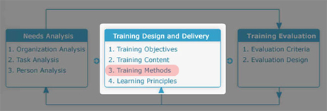
The next three lessons are devoted to exploring the different ways that training can be delivered.
Off-the-Job: | On-the-Job: | Blended Training:
- Examples: classroom, simulations  - This topic will be investigated in greater detail in Lesson 8: Off-the-Job Training Methods. | - Examples: coaching, performance aids  - This topic will be investigated in greater detail in Lesson 9: On-the-Job Training Methods. | - Example: use of a combination of approaches to training (i.e. on-the-job training, off-the job training and computer technology )(e.g. classroom training coupled with course website with online resources)  - This topic will be revisited in Lessons 10 Technology-Based Training and 15 Training Trends and Best Practices.

Learning Principles
The training objectives (as identified by the needs analysis), the content to be delivered (whether it is created in-house, off-the-shelf, or outsourced) and the method by which the training will be delivered (based on the context of the situation) will provide the instructional designer with the ingredients for the training intervention.
However, these elements of the training design and delivery phase still require a proper recipe to create a useful training activity. There still needs to be a plan of how to combine these elements in such a way as to yield a plausible result.
This is where the instructional designer must consider learning theories, design techniques, their experience, and other tricks of the trade to create a learning experience that strives to fill the gap identified by the objectives. There is where the science and practice of instruction combine with the art and creativity of design.
For the purposes of this course, the techniques used to maximize the effectiveness of the instruction will be called "learning principles".
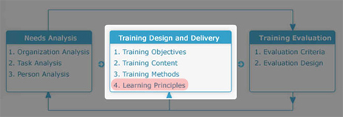

Active Practice: Active practice provides practice to learners during the training.
Practice:
- Physical or mental rehearsal of a task, skill, or knowledge in order to achieve a certain level of proficiency at performing that task or skill or demonstrating that knowledge.
  - Active practice, on the other hand, is planned and integrated in the course design.
Active Practice:
- Providing trainees with opportunities to practice performing a training task or using knowledge during training.

Pre-practice Conditions (pg .146) (before training)
There are 6 Strategies or interventions that can be implemented prior to a training program
(1)  Attentional Advice | Providing trainees with information about the task process and general task strategies that can help them learn and perform a task. (focus on specific aspects of the task)
(2)  Metacognitive Strategies | Metacognition: A self-regulatory process that helps people guide their own learning and performance through self-monitoring and self-control. (awareness of your thoughts and mind)  - Strategies include: thinking out loud, asking yourself questions during the activity
(3)  Advance Organizers | Activities that provide trainees with a structure or framework to help them assimilate and integrate information acquired during practice.
(4)  Goal Orientation | Refers to the type of goal that is set during training (mastery or performance).
(5)  Preparatory Information | Providing trainees with information about what they can expect to occur during practice sessions so that they can develop strategies to overcome performance obstacles.
(6)  Pre-practice Briefs | Sessions in which team members establish their roles and responsibilities and performance expectations prior to a team practice session.

Conditions of Practice during Training (pg 150)
(1) | Massed versus distributed practice (single session vs distributed)  - Training is offered in a single session or spread out.
(2) | Whole versus part learning (material presented all at once or one at a time)  - Training materials are presented all at once or one part at a time.
(3) | Overlearning (over learn something so it comes naturally or happens automatically)  - Repeated practice so that the behaviour becomes automatic.  - Automaticity: the performance of a skill to the point at which little attention from the brain is required to respond correctly (e.g. typing, driving).
(4) | Task sequencing (divided into sections)  - Training material is divided, organized, and presented in a logical sequence of subtasks.  - Robert gagne – a trainee will learn each successive sub-task before the total task is performed.  - According to Gagne, the most important in training is the identification of tasks and subtasks and their arrangement into a meaningful sequence.
(5) | Feedback or knowledge of results (to trainees)  - Providing trainees with information and knowledge about their performance on a training task.

Active Learning and Adaptive Expertise
Training individuals to reproduce specific behaviours in similar settings and situations is known as routine expertise, and is the traditional approach to learning.
- But this approach is not always effective (or sufficient) with more complex jobs that require more creativity and/or are situated in dynamic environments.
- expertise involves the ability to use knowledge and skills across a broad range of tasks, settings, and situations.
- Active learning is a training approach where the onus is put on the trainees to control (i.e. become active participants) their own learning experience.
  - Active learning: promotes inductive learning process in which the learner is provided with unstructured opportunities to discover rules, principles, and strategies for performing a task on their own through exploration and experimentation.
  - Traditional approaches to learning are deductive because they transmit knowledge to learner and provide more guidance and structure on how and what to learn.

- Involves exploratory/discovery learning where trainees are given the opportunity to explore and experiment with the training tasks to infer and learn the rules, principles, and strategies for effective task performance.
- This differs from proceduralized instruction where trainees are provided with step-by-step instructions.

Integrating Errors into Learning and Training
Error  training: | Error  avoidant training: | ****Error  management instructions:
- Training that explicitly allows trainees to make errors while learning to perform a task. (its ok to make mistakes) | - Training that explicitly avoids or minimizes trainee errors while learning to perform a task. (how to perform a task so that they make the least amount of errors. | - Statements that errors are a necessary and natural part of learning & emphasize the positive function of errors.

Advantages of error training: | - Forces people to develop thoughtful strategies  - Deeper processing of information  - Greater practice  - Learn “error recovery strategies”  - Greater exploration

The Lesson Plan
Definition: A lesson plan is a blueprint that outlines the training program in terms of sequence of activities and events that will take place.
Lesson plans are important because they: | Lesson plan cover pages should include:
- Ensure training is directed toward solving real problems.  - Organize the sequencing and complexity of the content.  - Enhance the credibility of the training.  - Foster smooth operation of training activities.  - Help control costs of training design and delivery.  - Facilitate competition for funding. | - Training objectives.  - Trainees and instructor.  - Time allocation and location (if applicable).  - Classroom requirements and seating (if applicable).  - Training materials and equipment.  - Trainee supplies and handouts (if applicable).

Gagné’s Events of Instruction
- Gagné (1962) proposed nine events of instruction that should be contained in every training program in order to ensure its effectiveness.
1. Gain attention | - Get the trainees interested and motivated to initiate training.
2. Describe the objectives | - Set the expectations of the trainees and establish how this relates to their needs.
3. Simulate recall of prior knowledge | - Queue prior knowledge and how it relates to new training material. (review of previously learned things)
4. Present material to be learned | - Organization and presentation of material should be done in a logical and consistent manner.
5. Provide guidance for learning | - Reflects use of metacognitive strategies, attentional advice, and advance organizers.
6. Elicit performance practice | - Reflects the importance of active practice.
7. Provide informative feedback | - Provides trainees with an idea of what they understand well and what they need to work on.
8. Assess performance | - Links training objectives to trainee learning and performance on the job.(evaluation)
9. Enhance retention and transfer | - Ensures that trainees know how the training material can be used and applied on the job.

To learn more:
- Check out: Gagne's Nine Events of Instruction (R. Gagné).
- Read: Gagné, R. M. (1962). Military training and principles of learning . American Psychologist, 17, 83-91.

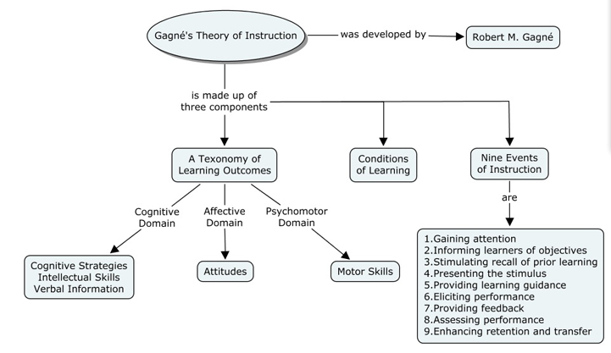
Gagné’s Events of Instruction (cont'd)

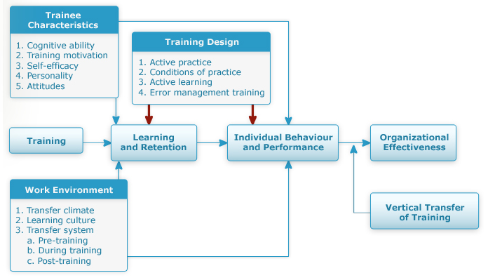

Universal Design (learning for all!)
Universal Design is a conceptual framework for designing and developing inclusive environments. It stems from an attitude, not a prescriptive set of procedures. Its tenets challenge us to think beyond mere legal compliance by promoting new ways of viewing disability and access. Universal design reframes the concept of accessibility from “special features for a few” to good design throughout the lifespan.
Universal Design involves the design of products and environments to be usable by all people, without need for adaptation or specialized design.
Universal Design for Education (UDE):
- ensures accessibility
- incorporates flexibility (one size does not fit all- especially in learning)
- instruction and design are straightforward and intuitive
- instructional methods are effective and clear
- fosters a supportive learning environment
- minimizes unnecessary tasks and requirements
- ensures adequate and appropriate space

Dr. Leo Bisonnette suggests that applying universal design principles to instruction can be beneficial for everyone enrolled in the course or program. He also suggests ways that UD can be applied to the design of instruction and the role that technology has played in this process.
- Universal Design : designing products and environments with flexibility, and incorporate with features that accommodate all populations.
- You have to accommodate for an individual UD is the way to do that. Designing learning environments that are flexible for many of the needs that learners present with.
- Ex: Curb-cut in the sidewalk: designed to accommodate those in wheel chairs. Other people who use them as well (people with baby carriages etc…) this opens up how we can serve a range of people, not just a limited number of people.
- Always taught the average population, outliers were forgotten. This had to change. We need to individualize learning.
- What is the syllabus ? (lecture, textbook, web resources, film clips, additional references)
- Use of technology: powerpoint technology, webinar technology, cerotec, jaws
- Instructers need to learn about their learners, demographics of the population
- UD not only for disabled individuals.

Universal Design - What Does It Look Like?
EQUITABLE USE  The design is useful and marketable to people with diverse abilities | Guidelines: Provide the same means of use for and appeal to all users; avoid segregating; provide for privacy, security and safety for all.  Examples:  - Physical: Curb cuts benefit users of wheelchairs, baby strollers, delivery carts, walkers, and bicycles  - Curricular: Take-home tests, copies of notes posted on a Website  - Technological: Websites that incorporate alt tags on all graphic images
FLEXIBILITY IN USE  The design accommodates a wide range of individual preferences and abilities. | Guidelines: Provide choice in methods of use and facilitate the user’s accuracy and precision; assure compatibility with accommodations and adaptability to the user’s pace.  Examples:  - Physical: Water fountains that can be approached from all sides and offer options for turning on the water  - Curricular: Options for preparing a project individually or working in a group  - Technological: Electronic files that can be read on-line (with or without screen reading technology) or printed out in text, Braille or large-print
SIMPLE AND INTUITIVE USE  The design is easy to understand regardless of the user's experience, knowledge, language skills or concentration level. | Guidelines: Eliminate unnecessary complexity, be consistent with user expectations and intuition, and accommodate a wide range of language skills; arrange information in order of importance; incorporate prompts and feedback.  Examples:  - Physical: Campus maps that incorporate colors, graphics and simple, clear text  - Curricular: Simple course syllabus that uses a clear layout and font and minimizes jargon  - Technological: Electronic bank tellers that provide the opportunity to select a language preference
PERCEPTIBLE INFORMATION  The design communicates necessary information effectively, regardless of ambient conditions or the user's sensory abilities. | Guidelines: Incorporate a variety of modes for redundant presentation of essential information; provide contrast between essential information and its surroundings; assure compatibility with techniques and devices used by people with sensory limitations.  Examples:  - Physical: Elevators that indicate floors with both lights and sound  - Curricular: Class presentations that supplement the lecture with Power Point slides to deliver information bi-modally  - Technological: Computer operating systems that allow for customization based on preference for look, feel and use

TOLERANCE FOR ERROR  The design minimizes hazards and the adverse consequences of accidental or unintended actions. | Guidelines: Minimize errors through the arrangement of elements by placing the most used elements in the most accessible location and eliminating or shielding hazardous elements; include warnings and fail-safe features; discourage unconscious actions in tasks that require vigilance.  Examples:  - Physical: Irons that turn themselves off when left unattended for an extended period of time  - Curricular: The opportunity to turn in a draft for feedback prior to completing the final paper  - Technological: The “undo” or “back” keys in computer applications
LOW PHYSICAL EFFORT  The design can be used efficiently and comfortably and with a minimum of fatigue | Guidelines: Allow users to maintain a neutral body position; use reasonable operating force; minimize repetitive actions and sustained physical effort.  Examples:  - Physical: Power doors or door levers in replacement of door knobs  - Curricular: Course materials in 3-ring binders so that sections of text, rather than the complete, heavy book, can be brought to class  - Technological: Split keyboards, track balls, copy/paste computer application functions
SIZE AND SPACE FOR APPROACH AND USE  The design provides appropriate size and space for approach, reach, manipulation, and use regardless of user's body size, posture or mobility. | Guidelines: Provide a clear line of sight to important elements and assure comfortable reach for any seated or standing user; accommodate variations in hand and grip size; provide adequate space for assistive devices and personal assistance.  Examples:  - Physical: Height adjustable lecterns; planned space and lighting in auditoriums for Sign Language Interpreters  - Curricular: Use of an overhead projector or Power Point slides to avoid talking to the blackboard  - Technological: Height adjustable computer work stations

Lesson # 8: Off-the-job training
- Simulate forest fires- training for forest fires.
Off-the Job training methods
This lesson presents the advantages and disadvantages of the most common off-the-job training delivery methods. They are presented in increasing order of trainee involvement.
increasing trainer involvement
 | - Lecture  - Discussion  - Audio-visual methods  - Case study  - Case incident  - Behaviour modeling  - Role play  - Games  - Simulations  - Action learning
increasing trainee involvement

Method 1: Lecture
Lecture: Trainer organizes content and presents orally; little listener involvement.
Advantages | Disadvantages
- Transfer large amounts in short time. Minimal costs to produce.  - Listeners all get same message (consistency in content). | - Not effective for development of skills/change of attitudes.  - Forced passive learning.  - Does not accommodate differences among participants (experience, ability, role, interests, motivation, etc.).  - Scheduling (inflexible).
See the following for tips on improving your presentation technique. (clickers, smart boards, interactive classrooms).

Method 2: Audio Visual
Lectures can be supplemented/enhanced with audio-visual methods (i.e., video, slides, short video clips, powerpoint etc…).
Advantages | Disadvantages
- Can be used to illustrate behaviour.  - Highlight key points (slides).  - Control pace of training. | - Might be a tendency to emphasize style over substance.  - Cost increases with use.
More on audio-visual methods:
Watch this Video Clip
 | Polish up your presentation skills by viewing: "How to Deliver an Oscar-Winning Presentation" (Length: 03:47) at: http://www.videojug.com/film/how-to-deliver-an-oscar-winning-presentation.

Method 3: Discussion

Leader facilitates analysis of a problem or case.

Discussions have five purposes:
  - Helps members recognize what they do not know but should.
  - Opportunity for members to get answers to questions.
  - Allows members to get advice on concerns.
  - Allows sharing ideas and deriving a common wisdom.
  - Way to learn about one another.

Method 4: Case Study
Students discuss, analyze, and solve problems based on real situations.
Objectives | - Introduce realism into learning.  - Deal with variety of problems, goals, facts, conditions, and conflicts.  - Teach how to make decisions.  - Teach creativity, think independently.
Requirements | - Students/teachers must have qualifications to analyze material.  - Appropriate time must be provided.  - Atmosphere must be supportive.
Styles/Methods | - Single problem vs. multiple situations.  - Written, audio-visual, live case/operational consulting.

Method 5: Case incident
This method presents one part of an organization’s problem for analysis.
Advantages | Disadvantages
- Useful to stress one topic or concept.  - Short, so can be read during training session.  - Reduces effect of differences in reading times.  - Trainees can draw on their own experiences. | - Lack of background material.  - Problematic for people with limited work experience.
Method 6: Behaviour Modelling
This method demonstrates key behaviours that trainees observe and attempt to replicate.
- Good for learning skills and behaviours, not for factual information.
- Used often for teaching interpersonal skills.
Based on four learning principles:
1. Observation | 2. Rehearsal | 3. Reinforcement | 4. Transfer

More on behaviour modeling:
- Read: Latham, G. P., & Saari, L. M. (1979). Application of social-learning theory to training supervisors through behavioral modeling . Journal of Applied Psychology, 64(3), 239-246.

Method 7: Role Play (done in lancome)
- Trainees practice newly learned skills in a safe environment.
- Various forms of role play exist.
  - Three phases: (1) development, (2) enactment and (3) debriefing.
- Debriefing should take 2-3 times longer than enactment.
Advantages | Disadvantages
- Useful for acquiring skills in human relations and changing attitudes.  - Requires active participation. | - There may be resistance to participating.

More on role play:
- Read: French, J. R. P. (1945). Role-playing as a method of training foremen . Sociometry, 8(3/4), 172-187.
- Read: Swink, D. F. (1993). Role-play your way to learning . Training and Development, 47(5), 91-97.

Method 8: Games
- Activities characterized by structured competition that allow trainees to learn specific skills.
- Tend to focus on development of problem-solving, interpersonal skills, and decision-making skills.
- Incorporate learning from experience, active practice and direct application to real problems.
- Disadvantage: possibility of learning wrong things, weak relation to training objectives, and emphasis on winning.

Example of Games:
- Ready-to-use training games and activities from Thiagi: http://www.thiagi.com/games.html
- Eductional games based on Nobel Prize-awarded achievements: http://nobelprize.org/educational_games

Method 9: Simulations
Use of operating models of physical/social events designed to represent reality.
- Used to recreate situations by simplifying them.
- Used when training in real world might involve danger or extreme costs.
- Equipment simulators: mechanical devices similar to those on the job (e.g. flight simulators).

Advantages | Disadvantage
- Realistic and sometimes cost effective.  - Opportunity to experience many situations and get performance feedback. | - Expensive to develop and stage.
Fidelity of the simulation is a key concept that affects transfer of learning to the work environment:
- Physical fidelity: similarity of physical aspects of the simulation to actual job.
- Psychological fidelity: similarity of psychological conditions of the simulation to actual work environment.
Method 10: Action Learning
Action learning consists of a process in which the learner performs a given activity, then analyzes their actions in order to improve on their performance.
- The learner repeatedly performs the task and typically obtains feedback from a small group (or set) of individuals.
  (Source: Wikipedia.org) | Accept challenge of studying and solving real problems, accept responsibility for solutions.  - Advantage: test theories in the real world.  - Involves identifying real problems, developing solutions, testing them and evaluating consequences.  - Changes trainees from passive information receivers to problem solvers.  So which is the best approach?  - The more highly involved the trainee is in the learning process and the more the training situation resembles the job, the more likely it is that transfer will occur. (high involvement, high resemblance of job in training= HIGH training transfer)  - Effectiveness of a training method depends on its achievement of training objectives.  - Most effective training programs utilize more than one method. This is also known as blended learning.  - In blended learning programs, a mix of delivery methods are used to suit the objectives, learner needs, and organizational resources.  - This allows for more learner flexibility with the style/method that they prefer and more trainer flexibility in the method to use to achieve a particular learning outcome (case study may work well for one objective, but action learning may be more effective with another.  S
  Factors to consider:
  - Training objectives.
  - Cost and resource availability.
  - On-the-job application.
  - Trainer skills and preferences.
  - Trainee characteristics and preferences.
    - Aptitude-treatment interaction: when a training method has differential effects on trainees with different aptitudes.
Lesson # 9: On-the-job training
On-the-job training methods
Trainees receive instruction and training in their work environment from a supervisor or experienced coworker.
- Especially useful for small businesses.
- Most common approach to training. (more popular)
- Most misused:
  - Often not well planned or structured.
  - People assigned to train have no training to be trainers.
  - Potential transfer of undesirable habits/attitudes.
- Structured approach most effective.
Dr. Robert Haccoun examines the pros and cons of on the job training
- Very imp for learning
- Done very informally: i.e. a colleague helping out another
- Difficulty: in environments where helping out another colleague is not helpful for to the individual
- Apprenticeship programs: most effective way for the development of peoples skills, also very inefficient because it takes a longer time
- Coaching is not for everyone, one needs special skills !
- Issue of job rotation: give them experience in a wide variety of jobs.
On-the job training methods
This lesson presents the advantages and disadvantages of the most common on-the-job training delivery methods.

- Job instruction training

- Performance Aid

- Job rotation

- Apprenticeship

- Coaching

- Mentoring

Method 1: Job-instruction training
Ex: macdonalds supervisor trains new employee, employee earns while they learn
Formalized, structured, and systematic approach to on-the-job training (OJT).
The four steps are:
Step 1: Preparation  - Develop communication strategy that fits trainee.  - Determine what trainee already knows and nature of the tasks to be performed.  - Stages:  - Put trainee at ease.  - Guarantee the learning.  - Build interest and show personal advantage. | Step 2: Instruction  - Telling, showing, explaining, and demonstrating the tasks.  - Show trainee how to perform the tasks.  - Repeat and explain key points in detail.  - Allow trainee to see whole job again.
Step 3: Performance  - Trainee performs tasks under guidance from instructor who provides feedback and reinforcement.  - Ask trainee to perform less difficult parts of job.  - Allow trainee to perform entire job. | Step 4: Follow-Up  - Trainer monitors performance and provides feedback.  - Gradually tapers off instruction as employee gains confidence and skill.
- To succeed:
  - OJT should not be managed differently from other types of training.
  - OJT should be integrated with other training.
  - Ownership must be maintained.
  - Trainers must be properly chosen and trained.
  - Used as an incentive for recruitment and employee retention.

Method 2: Performance Aids
- Devices that help an employee perform his/her job.
- Examples include:
  - Signs/prompts.
  - Troubleshooting aids.
  - Special tool or gauge.
  - Flash cards.
  - Posters or checklists.
- Also known as job aids or job performance aids.
- Good training design identifies key information that must be retained in the individual’s mind versus information that is seldom used (e.g. rare exceptions) or that can be accessed on the job. The latter is a candidate for performance aids.
Dr. Allison Rossett discusses 2 types of performance support: planners and sidekicks
- Performance support and job aids: is there just in case you need it, results of training are internal, organizational resource where individuals go if they need it
- Planners: advice delivered to help one person, reflect on what you did i.e., audio planner support to help real estate people as they were in their car driving, to make presentations and make negotiations. Planners help folks get ready.
- Sidekick: is there when you need it- information available for one.
Method 3: Job Rotation
- Trainees are exposed to many jobs, functions, and areas within an organization.
- Often used as an ongoing career-development program.
- Objective: to learn a variety of skills required for current and future jobs (or colleagues’ jobs: cross-training).
- Benefits:
  - Improved knowledge and skills.
  - Higher job satisfaction and salary.
  - More opportunities for career advancement.
- Role: job rotation should be only one component of a training program and learning process and supplemented with classroom instruction and coaching and mentoring.
Method 4: Apprenticeship Programs
- Training for skilled trades that combine OJT and classroom instruction.
  - On-the-job component teaches requisite skills (hand-on).
  - Classroom component teaches theory and design.
- In Canada, apprenticeship system covers over 65 regulated occupations in four occupational sectors: construction, motive power, industrial, and service.
- Differs from other methods in that it is regulated through partnership between government (federal and provincial), labour, and industry.
  - Federal government: facilitates interprovincial mobility, pays tuition for in-school training, provides income support during in-school period, provides tax credits to employers and apprentices.
  - Provincial government: regulates and administers programs, pays for school programs, promotes programs and develops curriculum, provides tax credits to employers and apprentices.
  - Industry: Sponsors apprentices, pays for on-the-job training period, provides and pays costs of on-the-job training.
  - Labour: promotes programs and develops currculum.
- Much of Canada’s apprenticeship system remains out of date.
- Program enhancement/expansion are key elements in meeting needs of current/future industries.
- Must address special needs of new labour groups.

Method 5: Coaching
- Method in which a seasoned employee works closely with another employee to develop insight, motivate, build skills, and to provide support through feedback and reinforcement.
- Effective in training interpersonal skills, communication skills, leadership skills, and self-management skills.
- Individual: Improves working relationships, job attitudes, increases rate of advancement and salary increases.
- Organization: Increases in productivity, quality, customer service, retention; decreases in customer complaints, costs.
Key Elements:
- Agreed-upon plan or set of objectives
- Work environment is training laboratory
Steps:
- Initial discussion, setting objectives
- Opportunities identified, long-term plan set
- Employee performs tasks, reports to coach
- Process fitted into employee’s goals and organization’s long-term strategies

Techniques: | Issues with coaching include:
- Special project assignment  - Job rotation  - Design method or schedule of representation  - Job redesign/restructuring  - Job enlargement  - Conference attendance, professional memberships, teaching/publishing, professional societies | - Coach must be selected based on ability, motivation, and availability and matched with the employee.  - Coaching should be part of broader process.  - Performance of the coach should be integrated into performance management for that individual.

Method 6: Mentoring
- Method in which senior member of an organization takes a personal interest in the career of a junior member.
- Mentor: experienced individual who provides coaching and counseling to a junior employee.
- Two roles:
  - Career support
  - Psychosocial support
- More focused than coaching - career development
Benefits: | Issues with mentoring:
- Accelerate career progress of underrepresented groups.  - Transmit culture and values to newer managers.  - Pass on accumulated wisdom of seasoned leaders. | - Ensure clarity of roles and expectations  - Choose mentors carefully  - Match mentors and protégé(s) with care  - Train both mentors and protégé(s)  - Structure the mentoring relationship  - Ensure support from management  - Include benefits for mentors

Off-the-Job versus On-the-Job Training
Off-the Job Training Methods | On-the-Job Training Methods
Advantages:  - Can use wide variety of training methods.  - Can control training environment.  - Large numbers of trainees can be trained at once. | Advantages:  - Lower cost.  - Greater likelihood of application of training on the job. (high transfer of training)
Disadvantages:  - Can be much more costly than on-the-job training.  - Because training environment differs from workplace, there are challenges regarding transfer of training. | Disadvantages:  - Distractions in work environment during training.  - Potential for damage when training on actual equipment.  - Disruption of service or slowdown of production during training.  - Potential safety issues.
There are four steps to the design and delivery of on-the-job training:
- Preparation
- Instruction
- Performance
- Follow-up

Lesson 10: Technology based Training delivery
Technology-based training involves the use of technology to develop, deliver and manage courses or learning content.
  - This differs from traditional-based training methods that do not involve technology, such as instructor-led classroom training, self-study (textbook-based or workbook), and seminars.
Technology-based training makes use of different mechanisms to deliver learning content:
- Online courses delivered via network (Internet, Intranet, Extranet) or local media (CD-ROM, DVD) econcordia  - Teleconference  - Videoconference  - Television (cable, satellite) | - Virtual classroom/meetings  - Mobile devices (phones, PDAs)  - Social computing platforms  - Digital Collaboration

Watch this Video Clip | Dr. Richard Schmid  discusses the trend of using technology as a medium to deliver workplace training.  Watch the video (Length 09:14)  - Recently, there is a trend of e-learning, learning theories not applied  - Send out information in a passive form, individual needs to take in information and then they are evaluated on what they know.  - Effective use of technology in trainers  - Provide urls, links, web pages, opportunity of a richer context

Computer-Based Training and e-Learning
Training Delivery Methods
Computer-Based Training (CBT):  Training that is delivered via the computer for the purpose of teaching job-relevant knowledge and skills.  - Interactive training experience in which the computer provides the stimulus, the trainee responds, and the computer provides feedback based on the response (Noe & Peacock, 2008)  - Older term that designated delivery of training via stand-alone computers.  - In academic circles, this term is synonymous with computer-assisted instruction (CAI).  - Includes: stand-alone applications, CD-ROM-based software. | e-Learning (Electronic Learning):  The use of computer network technology such as the intranet or Internet to deliver information or instruction to individuals.  - More recent, broader term designating the use of digital media for training, usually via networks.  - No consensus on its definition, nor its spelling (eLearning, e-learning). The authors of the textbook describe e-learning as a subset of computer-based training, whereas others see CBT as one way of delivering e-learning, and others consider them synonymous.  - Includes: web-based courses, desktop conferencing.
Electronic Performance Support System (EPSS):  A computer-based system that provides information, advice, and learning experience on the job to improve performance.  - Accessed by employee when needed (just-in-time) to get the information to complete a given task.  - e.g. job-aids. | Videoconferencing:  Linking an expert or trainer to employees via two-way video using satellite or network technology.  - One-to-many (one expert communicating to many learners).  - Many-to-many (several sites can initiate communications).  - Videoconferencing over the Internet is often referred to as desktop or web conferencing.  - Common applications: Skype, MSN Messenger

e-Learning: More Definitions
- Instruction and delivery of training by computer online through the Internet or Web (Noe & Peacock, 2008).
- Refers to the use of a computer and Internet technology to deliver and access a broad array of solutions to enhance knowledge and performance (Rosenberg, 2000).
- Any form of learning that utilizes a network (Internet or intranet) for delivery, interaction, or facilitation (Long, 2004).
- A wide set of applications and processes, such as web-based learning, computer-based learning, virtual classrooms, and digital collaboration. It includes the delivery of content via the Internet, audio-videotape, satellite broadcast, interactive TV, and CD-ROM (ASTD, 2009).

e-Learning in Canada
e-Learning was mainly used for:
- Software training, technical skills training, and management skills development.
- Professional/technical employees, clerical/service/support staff, managers, senior executives.
- The past decade has seen a significant growth in e-Learning in Canadian schools and businesses.
- This has been the result of:
  - Evolution of digital technologies that can foster interactive environments and the use of media on the web,
  - Globalization and the knowledge-based economy/society,
  - Increased accessibility and affordability of high-speed networks,
  - Increased availability of quality e-Learning services, platforms, content, and products,
  - More tech-savvy and demanding Internet consumers.
  - In addition to the learners, the stakeholders involved in e-Learning include: instructors, institutions, content providers, technology providers, accreditors, and employers.

Modes of e-Learning
Instructor-Led Training | Self-Directed Learning
- Instructor-Led Training (ILT) involves an instructor or facilitator who, in the case of technology-based training, might lead, facilitate, or teach online.  - This type of training requires that students log in and participate at a specific time.  - Instruction is offered in real-time (live). Also known as synchronous training.  - Examples: videoconference, chat session, virtual classrooms. | - Self-Directed Learning (SDL) is a process in which the individual identifies the resources necessary to learn, and then manages their own learning experiences.  - This type of training is typically available to learners at any time, from wherever they may be (e-concordia)  - Instruction is not in real-time. Learners can set their own pace through the materials. Also known as asynchronous training.  - Examples: web-based courses (such as this one!), computer-based simulations, interactive exercises.

e-Learning: Redefining the Role of the Instructor
Instructor-Led Training | Self-Directed Training (auto-learning)
- Teacher-controlled pace.  - Instruction occurs frequently and systematically with whole class, less often in groups or individuals.  - Use of class time determined by teacher.  - Predominant source of content is from teacher in the form of a lecture.  - Instruction mostly synchronous (in real time).  - Instructor acts as a “Sage on the stage”. | - Student can pursue content at their own pace (shift in control of learning).  - Personalization of learning experience.  - Student determines how learning is done (autonomous).  - Content comes from a variety of sources.  - Instruction mostly asynchronous (at any time).  - Instructor acts as a “Guide on the side”.

e-Learning: Some Terminology
Bandwidth | A measure for the amount of digital information that can travel between computers. It is usually measured in bits per second (bps).  - e.g. streaming video requires more bandwidth than images and text.
Blog | Short for “web log”, is a web page that contains periodic posts (usually in the form of comments or information).
Computer-Mediated Communication (CMC) | Exchanges that are carried out between two or more individuals via computer-based technology (e.g. e-mail, discussion board, chat, etc.)
Digital Collaboration | The use of CMC to enhance and extend the employees’ ability to work together regardless of their geographical proximity.
Distance Education | Learning method in which formal course content is communicated from an accredited source (i.e. an educational institution) to individuals who are not in the same geographical area.  - e.g. online courses, correspondence (book-based) courses, videoconference-based courses, television courses, and radio courses.
Learning Management System (LMS) | Software that allows for the administration of e-learning by providing an access point as well as a means to track learner progress.
Open-Source | Software which has public and freely-available source code (the programming language).
Podcast | Audio or video recording that can be downloaded onto a mobile device.  - Although it is associated with the iPod, the word podcast existed before Apple released its mp3 player. Also known as an audiocast (if audio only).
Wiki | A web application which allows its users to create and edit web pages very quickly from any web browser. The word comes from the Hawaiian term “wiki wiki”, which means quick.
Web 2.0 | Web applications that foster the of sharing of user-generated content.

Five Myths about e-Learning
1 | e-Learning requires “less study time” than more traditional delivery methods.
2 | Due to its flexibility and convenience, e-Learning activities do not need to be scheduled in advance. It needs to be scheduled.
3 | All online learners have the characteristics and motivation to study and practice in a self-directed, independent learning environment. Not true. Not everyone can use this method.
4 | All learners have the pre-requisite skills to succeed in an e-Learning environment.
5 | All e-Learning programs are legitimate and are from reputable organizations.

Technology-Based Training: Advantages
Advantages for trainee: | Advantages for organization:
- Trainees can learn outside the workplace (increased access facilitates more time for learning).  - Trainees can learn at their desktop (minimize productivity loss due to training away from the workplace).  - Progress at own pace.  - Flexibility and convenience.  - Has a built-in guidance system (allows learners to monitor their progress through the content).  - Available all the time (just-in-time training).  - Provides privacy.  - Greater control over their own learning experience.  - Reduced travel time (or none) and cost for learners.  - Opportunity for repeated practice and review. | - All trainees receive the same training (consistency).  - Large numbers can be trained in a short period.  - Train across the globe (international business).  - Track trainees’ performance (useful for regulatory compliance and to monitor progress).  - Increase efficiencies and cost savings.  - Flexibility and convenience (employees can access it according their own schedules and when they need it).  - Can be strategic.  - An investment to support business strategies such as time-based competition, increase customer loyalty.

Technology-Based Training: Disadvantages
Disadvantages to trainees: | - Less interpersonal contact (contributes to feelings of social isolation).  - Potential computer illiteracy some people have absoloutely no knowledge of working with computers  - Increases anxiety  - Online degrees not yet seen as equivalent to those attained via more traditional means (if completed outside the organization).  - Loss of “hand-raising” ability (immediate feedback is compromised in asynchronous courses).
Disadvantages to the organization: | - Resistance to technology-based training.  - Cost and complexity of development.  - Obsolescence due to evolution of technology, authoring tools, etc.  - Lack of ownership or control of the content.  - Content is often developed by external vendors.  - Ineffective for certain training content.  - Who got the message?  - Loss of non-verbal cues, no idea who received announcements and important messages.

How Effective is Technology-Based Training?
Drop-Out Rates
Drop-out rates are higher in online courses than in classroom-based instruction (Devey, 2009).
- Some enrol in online courses for the wrong reasons (assume that it will be easier, that they will have more time for it).
- Students who opt for online because of work, family, or health-related issues are at a higher risk of dropping out for the same reasons.
- Learners who have dropped out of a course in the past are more likely to do so again.
Source: Devey, P. L. (2009). Survivor - Online courses: A study of voluntary student attrition in asynchronous undergraduate online courses using a multi-analytic approach. (Doctoral dissertation, Concordia University).
- Comparative studies between e-learning and classroom instruction have yielded conflicting results.
  - Majority conclude that there is no significant difference between the two mediums with regards to student learning.
  - However, comparative studies are fraught with confounding variables.
- Technology-based training seems effective for cognitive learning of less complex material.
- Not as effective for learning complex material, soft skills, psychomotor skills, or team skills.
- Trainee motivation plays a significant role.

Strategies for Making Technology-Based Training Effective
Strategies
1. Develop job-focused curriculum | 6. Support learners
2. Make learning interactive | 7. Monitor and report results
3. Offer support material | 8. Evaluate
4. Prepare learners | 9. Enhance the course
5. Prepare managers | 10. Identify future training needs

The Design of Technology-Based Training
However, a choice will have to be made as to which technology to adopt as the main medium. This decision will be based on:
- The results of the needs analysis (What technology is available? What are the computer literacy skills of the target audience? Can using technology help solve the problem?)
- The budget and resources available
- The existing training and development platform (does the organization have an LMS, an LCMS?)
- Lessons learned from past experiences
Technology is not to be used to merely attempt to recreate a classroom environment.
Learning and retention (and transfer) is fostered by incorporating the principles of sound instructional design in the design of technology-based training.
  - Incorporate principles of adult learning
  - Active practice
  - Conditions of practice
  - Make training experiential and interactive
    - Games
    - Computer simulations
    - Role play
    - Stories
    - Scenarios
Customization: tailoring instructional elements to meet trainee preferences and needs.
Personalization: structuring the program so that trainees feel that they are engaged in a conversation with the program.

The Future of Technology-Based Training
How to blend effectively with traditional methods?
  - Training objectives
  - Content of training
  - Design factors

- The evolution of technology
  - Hardware, bandwidth, accessibility, connectivity, computer literacy skills, portability, etc.

