EDUC 240- Training and Development
NOTES

LESSON #2: (Chapter 1) The training and Development process
- Canada is behind when it comes to training compared to other countries
- Companies will cut training budgets in times of financial hardship
Opening Case: CIA TRAINING
- Lindsey Moran, an EX CIA officer
  - How would you design training in CIA, target audience, how it is measured, how are you going to deliver training etc…?
- What types of physical training do CIA officers receive?
  - Army Fitness Physical Test before paramilitary training (VERY HARD)
  - Paramilitary training
  - Defensive driving test
  - Boating (speed boats and zodiac)
  - Hand to hand combats
  - Jump school (air borne)
- Does the physical training help CIA officers in the field?
  - Not Really. There is not a lot of physical aspect to the job. A lot of the time is driving around, spying on foreigners, going around. Make sure that your not being watched or followed.
  - Sedentary job. Not a lot of physical fitness. Unless you are involved in paramilitary trainings.
- Do CIA officers continue to be physically fit after training?
  - No. They are not really physical fit after.
- How difficult is the physical training for the CIA?
  - VERY DIFFICULT. It’s hard at the beginning. You need to be in TOP physical conditions.
- What types of trainees fail during physical training at the CIA farm?
  - Those who did not pass the Army fitness physical test could not pass and go on to other trainings or they had stigma around them.
- How does the physical training from the CIA help you in the field?
  - Helped in being physically fit
  - Builds your confidence and gives you a sense of accomplishment
  - Capability (self-efficacy)

Human Resource Management (HRM) is:
- The strategic approach to the management of an organization’s employees.
- Its objective is to recruit, motivate, develop and retain employees whose performance is necessary for the attainment of the organization’s goals.

Performance Management is:
- The process of establishing performance expectations with employees (goals of employees)
- The design of interventions and programs to improve performance.
- Monitoring the success of the interventions and programs.
Training is:
- The acquisition of knowledge, skills and abilities to improve performance on one’s current job.
- A planned effort undertaken by a company to facilitate their employees’ learning of job-related competencies. (short-term)
Development is:
- The acquisition of knowledge, skills and abilities required to perform future job responsibilities and the long-term achievement of individual career goals and organizational objectives. (long term)
- Training is a means to acquire skills that can have an immediate impact in the company (SHORT TERM) whereas….
Development focuses on preparing the employee for future situations. (LONG-TERM)

*****READ THIS: If you have not already done so, read the Garavan article, "Training, Development, Education and Learning: Different or the Same?"
Notes:

Training:
Development:
Education:
Learning:

Importance of training: The Ocean Ranger Disaster
The Ocean Ranger Disaster On February 15, 1982, the largest oil rig in the world, Mobil’s Ocean Ranger, was lost at sea along with its 84 employees, off the coast of Newfoundland. Poor training and sub-par safety gear were blamed for the disaster.
- “Chain of events resulted from a coincidence of severe thunder storm conditions, design inadequacy and lack of knowledgeable human intervention.”
- Poor training and faulty design and inadequenate equipment.

Training is not education !
Education: | whereas | Training:
- focuses on the development of one’s intellect (knowledge acquisition). | whereas | - deals with learning how to perform specific skills (skill acquisition).
- is an individual activity which involves the use of one’s mind | whereas | - is a way to develop skills that are used for social and economic benefit.

Dr. Haccoun defines the terms “training”, “development”, and “education” Dr. Devey:
Dr. Haccoun, I would like to discuss a bit more on the basic side with terminology the difference between “training and development” and “training and education”.
Dr. Haccoun:
- Education is a lifelong process. It is delivered in a variety of ways. Education is a broad term that really subsumes everything that involves us learning. (knowledge acquisition)

- Development has to do with the sequences activities, specific activities. We developed for example, computer skills. That is, we first learn how to open up a computer and then we learn a number of other things which steps which chain to form a general competency that we have with computers. Development enters a longitudinal process and a sequential process. (long term)

- Training refers more specifically to things. Training tends to be much more specific, (short term) acquiring knowledge, skills and abilities for the immediate social and economic benefit.

- development is a longitudinal process, and the sum of all of that is education.

Dr. Schmid compares education, training, and development
Dr. Schmid talks about it the difference between training, education, development and knowledge.
Dr. Schmid: Okay, that is tough. I can easily distinguish between education and training:
- Education is much broader. We identify a whole series of core competencies that we feel will be of value to an individual over time: some acquisition basic skills like reading and writing, understanding and so forth, how to gain access to information; all the things that we cover in primary and secondary school. To a large extent also what from a formal learning standpoint is offered in CEGEPs, universities and so forth.
- Training is much more focused, by definition. There are specific objectives that need to be achieved. Training basically scales back that larger educational environment and identifies the competencies that need to be applied in a particular environment. So I don't see them as being different in kind but rather different in focus. Training is much more focused.
- Development from a cognitive standpoint is something that occurs naturally. I was talking before about nature and nurture and so forth, that we are pre-wired. We know a lot now from a learning theory standpoint, about how people develop, how people come to understand things over time. Adults can do things very differently from kids. Kids, for example young kids, can't engage in formal logic, for example, they just plain can't. We develop over time, based on our cognitive growth and so forth.
- From a training standpoint, if you're dealing with adults we make assumptions about what they are now capable of doing in terms of induction, deductions, synthesis analysis, and so on. If you are talking about professional development that opens up a huge issue. I guess what I'd like to do with is make the distinction between professional development that we were talking about before in the terms of training and professional development in context. I made reference to the ineffectiveness of workshops, for example. The ability of an individual in a fixed setting to acquire and apply information is extraordinarily limited. We can dump the information out and so forth but again going back to this whole idea transfer, very little of that actually occurs. In terms of informal learning the learning that we acquire over time occurs not by design but rather by virtue of our interaction with the environment. Our selfassessment (I spoke early on about self-efficacy), when we understand ourselves to be able to do something, we are motivated to engage in that activity more often and so forth, in a sense that is self-reinforcing and so forth. That, in turn, encourages informal learning. We are interested in something, we pursue it on our own, and that could be in the workplace too. In other words, doing our job better, doing it more efficiently, even to the extent that if I do this really well I can start my coffee break earlier, and so forth. In a sense we self-reinforce our Friday in different ways. The idea that informal learning encourages development I think is critical from a training standpoint. I've spoken before about increased access to information. It is engagement that results in learning, having a person do it on their own or cooperatively as I already talked about is what really leads to a rich and deep learning. Learning that they retain over a long period of time and indeed can transfer.
Dr.Haccoun on the importance of training
- Whether or not involved in this, as workers, people will invariably have to go through some sort of training and in a repeated way throughout most of their career. Especially those people who will be taking on areas of responsibilities within organizations. Training is very important for someones career. Especially if people will be changing jobs over the course of their lives compared to others before them. In order to maintain employability, one must maintain their skills level and in order to do that one must know about the principles of training.
Dr. Schmid on the importance of training and development
- It is important because it is at the core of modern society.
- Knowledge based economy
- The development of knowledge and skills is critical for anyone to live in society
- In an organization: managers need to understand what provides opportunity for the worker to undertake his or her tasks to the best of their ability (SELF-EFFICACY)
- Understanding learning styles, what motivates people, what kind of incentives to provide, and support
- We need to recognize that performance of an individual is part of a larger group, a system. (wider setting)
- Dr Schmid was involved in developing the evaluation system for Air force Pilots. Focused on behaviourist model-skinner (stimulus-response) type of learning. Something happens, we react to it, we get feedback and we continue. This, however, doesn’t work in military. Its more complicated than simple micro-unit measures of learning. The environment is more complex and fast-paced. There are a lot of variables to take into consideration.
- Satisficing: we seldom get right or wrong answers in most cases. What we do is, satisfice. Which means we find a solution that within a particular context we find to be satisfactory.
The Benefits of Training and Development on the employee, organization and society
When an organization invests in training and development, not only can it result in a positive effect to the organization, but it can also benefit its employees, as well as the society in which it operates.

- Employee Benefits
- Employee
- Organization
- society
Intrinsic
- Greater knowledge and skills
- Higher self-efficacy
- Feel more useful
- More positive attitudes towards their job and organization

Extrinsic
- Higher earnings $$$$
- More marketable
- Greater job security
- Enhanced promotion prospects

- Organizational benefits
Organizational strategy
- Help organizations achieve their short- and long-term goals.
Increase organizational effectiveness
- Better productivity, fewer errors, fewer accidents, less supervision needed.
- Return on investment.
Employee recruitment and selection
- A company’s training and development program can help recruit new employees, and retain the ones they have.

- Societal benefits
Educated population
- Helps to create an educated and skilled workforce
- Provides skills that also serve employees outside of the work environment.
Better standard of living
- a better trained workforce is more productive, thereby improving the standard of living.
Training in Canada

Demographics
- Aging workforce as baby boomers retire (employee turnover).
  - Rate with which workers are leaving the workforce is greater than the ability of new employees to fill that void.
  - Will likely have to rely on immigration.
  - Causing a loss of expertise and knowledge.
  - Greater need for knowledge management initiatives.
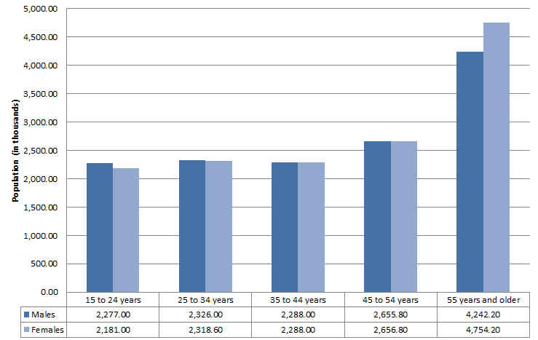
"Labour force characteristics by age and sex." 2012 estimates from Statistics Canada.

2008* increase in unemployment rate
Unemployment rate: Ratio of people actively seeking work / labour force
How is training and development linked to the unemployment rate?
- In cases where there is a shortage in work (or unemployment), training and education are needed to provide opportunities to the unemployed to alter or enhance their skills in order to take on jobs that they otherwise would have not been able to do.
- Another reason for higher demand in training and development is linked to the labour force. If the amount of people available to work decreases, let’s say due to a high rate of retirement, this could suggest a workforce gap that has been created by the departure of very experienced workers. It is likely that this gap would then be filled by less experienced workers who will need more training and professional development.
- workers losing their jobs, young workers entering the work force, older workers deciding to come back, or an influx of immigrants and other new Canadians who have become eligible to work in Canada. NEED TRAINING!
- Skills training and specialized development plans are therefore needed to prepare these workers to take their place in the labour force and in doing so, contribute to the national economy.
Evolution of information technologies
- New products
- New ways of gathering info
- New ways of communicating
- New ways to efficiently carrying out the tasks of one’s job
***This requires the constant updating of skills in order to remain competitive!!!!

Dr.Haccoun lists the additional driving forces for training and development in Canada and Quebec
- Globalization. We need to compete with all other countries. We need to have well trained people who are able to handle the demands of goods and services efficiently.
- Economy is shifting. From agricultural-based to service.
- Developing skills.
Dr. Haccoun: How does Canada compare (in terms of training & dev) compared to the rest of the world?
- We are NOT doing that well compared to other jurisdictions.
- There is NO national policy on training.
- We do NOT spend $$ as much on training compared to Americans and Europeans
- The reason: we are too focused on agricultural society (industrialization) as opposed to strictly service.
- Free entreprise country. We don’t intervene directly but this is thankfully changing. Quebec and New Brunswick have been the leaders in this area.

Quebec’s 1 % Law (Bill 90)
Legislation (Bill 90) was introduced in 1995 to catalyze the stagnant workplace training sector.
- “La Loi favorisant le développement de la formation de la main-d’oeuvre.”
*****Law requires the investment of a minimum of 1% of a company’s total payroll on the training of its employees. *****
- In cases where the payroll exceeds $1 million CAD.
- Failure to spend that money would result in a tax equivalent to the unspent amount.
- Collected monies are pooled into a common fund used to finance workplace training initiatives throughout the province. Use it or lose it.

Results of Quebec’s “1% Law”
Over a 6-year span starting in 1997, workplace training in Quebec enjoyed the fastest growth rate in Canada in workplace training.
- Increased by 57%.
- Despite significantly narrowing the gap, the province was still below the national average.
- Training participation among companies was not evenly distributed.

Results of 1% Law study between Quebec and Ontario
- Quebec spends at least 1% of their payroll on training. Not so much for Ontario.
- If an organization spends more on training is it actually more productive and – as defined by profit – is it more profitable place? Well here, unfortunately the result is not all that clear. In fact, we show that there was very little difference between those organizations that spend a great deal and those that spend very little. Mixed findings.
- One interpretation is that one must be careful that throwing money at training may not actually be the simple solution that we thought it might have been at some point. So in Quebec we encourage organizations to spend more than they do elsewhere.

Employers reluctant to training Investment
- Employers lack confidence in their specific training needs and how best to organize and provide for it when it is identified.
- Employers are concerned about employees who take advantage of their training opportunities, and then offer their services elsewhere. Some companies have countered this with “firm-specific” training.
- Small and medium-sized enterprises lack the economies that make training more feasible for larger firms

High Performance Work System (HPWS)
An interrelated system of HR practices and policies which typically includes:  - rigorous recruitment and selection procedures  - performance-contingent incentive compensation  - performance management  - a commitment to employee involvement  - extensive training and development programs | Workplace training is not an independent activity.  - It is influenced by a broader organizational and environmental context, and a human resource system.
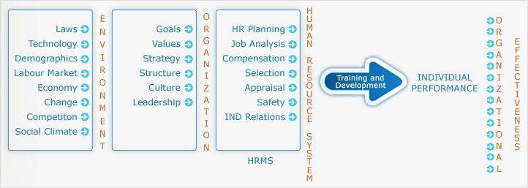

Context of training & Dev
Environmental Factors
- Laws
  - Quebec's 1% Law is an example of legislation that has a direct effect on a company's attitude towards training its employees
- Global competition
  - International competitors, customers, suppliers and employees require increased cross-cultural awareness training.
- Technology
  - Employees must be trained in using new technologies if they are to be adopted.
- Demographics
  - An ageing workforce means that there will be a significant "brain drain" as experienced workers retire. Transferring the know-how to new employees will be a challenge.
- Labour Market
  - Changes in demographics of the Canadian workforce will require adaptations in the amount and type of training required.
- Economy
  - The economic downturn of 2009-10 caused higher unemployment and a return to school for many to upgrade their skills in an attempt to find a new job.
- Change
  - Trends, new laws, economic changes and other events (external to the company) that affect the organization
- Social Climate
  - Specialized training programs that deal with diversity, security, and stress management are examples of the effects of the social climate on training needs.
B) Organizational Factors
1) Strategy
- One of the most influential factors of training and dev
- The alignment of human resources practices with an organizations business is called: Strategic Human Resources Management (SHRM)
- Training become strategic when is it related to business strategy.
2) Structure
- Changes in employee tasks and responsibilities due to structural change within the organization.
- Emphasis on teamwork may require additional training in communication, supervision and cross-training (skills needed to complete all tasks that work team is responsible for).
3) Culture
- The shared beliefs, values and assumptions that exist in an organization are referred to as the organizational culture.
4) Human Resource Management System
  - All functional areas of HR work together to create an HR system
  - Driven by organizational strategy and SHRM
  - Is what constitutes a High Performance Work System (HPWS)
  - Leads to a Strategic Model of training and Development

Strategic Model of Training & Dev

Chain Reaction:
- An organization’s business strategy has a direct impact on its human resource management (HRM) strategy.
- The HRM strategy has an impact on the organization’s strategy for the learning and training of its employees.
- Once a strategy for the learning and training of employees has been identified, this will determine the nature of the training and development programs to design and deliver.
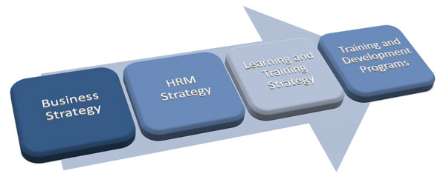

Instructional Systems Model (ISD)
- Needs Analysis
  - Analyze the needs of the learners
  - Individual needs of the learners
  - Look at current skills
- Design of Training
  - Content
  - Methods
  - Delivery of content
  - Use assessment strategies
- Evaluate performance
  - Establish criteria
  - Evaluating the assessments (if they were successful or not)
  - Redesign. Readjust and perfect the training experience.
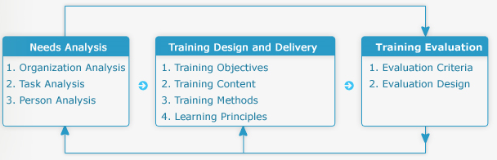

Popular Instructional Design Models
Training that is aligned with the business strategy is created using an instructional design process. Benchmarks against other companies are known as high-leverage training.
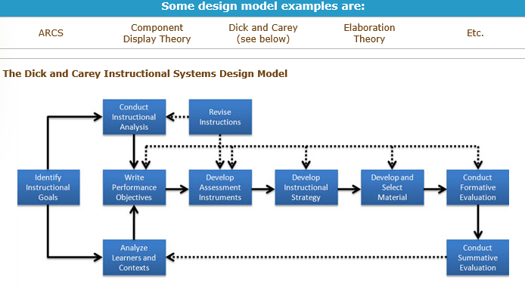

The ADDIE PROCESS
  - Analyze the situation (learners, content, resources, environment).
  - Design the instruction (objectives, method).
  - Develop the learning material (content, multimedia, resources).
  - Implement the training (face-to-face, online, blended delivery).
  - Evaluate the outcome (make changes if necessary).

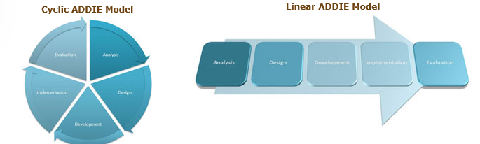

2008 Canadian Listeriotic outbreak
Maple Leaf Foods- closure of plant due to bacteria found in food
- Listeria contamination (bacteria) that caused deaths
- New training for staff and a stamdard operating procedure was implemented to address the issues.
Identify the external influences that lead to maple leafs food situation?
- The Laws governing food products were NOT strict enough and were sometimes followed by employees
- Enforcement of rules from inspectors was NOT great- they spent not enough time
- Social climate: consumer reaction to deaths and illness created fear and loss of confidence to the company
Discuss the impact the product recall had on the organization?
- Major IMPACT.
- They need to change and move very quickly!!!
- MLF leadership, the CEO, issued a public apology. The plant was shut down in order to clean.
- Lack of sales, loss of jobs, loss of revenue, uncertainty
How is the new training for staff part of the solution to the food recall problem?
- Need for stricter iperating procedures
- New cleaning techniques
- Do a NEEDS ANALYSIS: Identify who needs to learn what, need to develop and deliver the training. And evaluating the training method. We cannot wait for another disaster.
Lesson #3: Organizational Hiring
How information is acquired and shared.
What is a learning organization? | What are the three building blocks to building a learning organization? | What can managers do to promote an organizational learning culture? | What concrete practices can be put into place to become a learning organization? | How can a manager promote learning despite the organizational culture?
What is a learning organization?
- Learning organization is a skill at 2 things:
  - 1) creating, acquiring, transferring and retaining knowledge
  - 2) Acting on that knowledge (modifying behaviour).
- The rate at which people learn is the only competitive advantage in a world that is constantly evolving.
What are the three building blocks to building a learning organization?
- Learning processes and the learning environment.
- If rate of learning is not as fast as the rate of change, people will fall behind.
- Many of early discussions were abstract
- Concept was only aimed at CEOs rather than local leaders in the organizations
- Lack of standards and or tools
Three building blocks
- A supportive learning environment
- Concrete learning processes and practices
- Leadership that reinforces learning
What can managers do to promote an organizational learning culture?
- Help their teams have a supportive learning environment!

  - Psychological Safety: people perceive that the local and social environment is one that is comfortable for asking questions, making mistakes, sharing ideas etc…
  - Blame-free reporting: all people at all levels of the organizations to speak up about any issues they feel or mistakes being made and be free from penalty or blame. (Being TOLERANT)
What are some concrete practices that can be put into place to become learning organization?
- You have to have a supportive learning climate
- Concrete processes and procedures, experimenting, sharing knowledge, reflecting, generate ideas, evaluating.
  - What did we set out to do
  - What actually happened (actual details)
  - Why was their a difference (gap)
  - What do we do next time- what activities we keep or discontinue

How can a manager promote learning despite the organizational culture?
- As a manager, start simply modelling the behaviours!! Show curiosity, admit mistakes, and acknowledge uncertainty and welcome input.

Definition: Organizational learning
Organizational Learning: The process of creating, sharing, diffusing, and applying knowledge in organizations.
- It focuses on continuous learning.
- It is a main characteristic of an adaptive or agile organization; one that is able to identify the need to alter its practices based on shifts in its environment.

The Learning Organization
An organization that acquires, organizes, and shares information and knowledge, and uses new information and knowledge to change its behaviour in order to achieve its objectives and improve its effectiveness.
- Able to transform itself by acquiring and disseminating new knowledge and skills throughout the organization.
- Has enhanced capacity to learn, adapt, and change its culture.
- Has the ability to make sense of, and respond to, surrounding environment.

Organizational learning results in continual improvements in:
Work systems | Products services | Teamwork | Management practices

The goal: A more successful organization
The five disciplines (senge 1990)
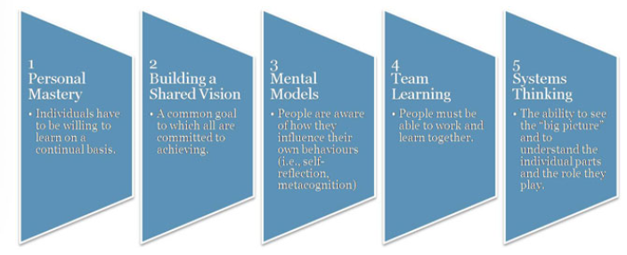

Principles of a Learning Organization
- Everybody is considered a learner.

- People learn from each other.

- Learning is part of a change process.

- Continuous formal and informal learning.

- Learning is an investment.

- Experimentation is valued.

- Failure is tolerated if it leads to learning.

Four Key Dimensions of a Learning Organization
1 | Vision (companys goals)  - Requires clear vision of organization’s strategy and goals.
2 | Culture  - An environment that fosters information sharing and continuous learning.
3 | Learning Systems/Dynamics  - Seek solutions to problems through a systemic view of the organization and its environment.
4 | Knowledge Management/Infrastructure  - Technology, systems and processes to support the capture, dissemination and evaluation of knowledge.  - Ensure that the “right person has the right knowledge at the right time.”

Definition: Knowledge
Knowledge: Sum of what is known; a body of truths, information, and principles.  - Found in the minds of employees.  - Transferred and stored in information systems in the organization.  - Embedded in tools and standard operating procedures and processes. | More than just information!  It is information that has:  - been edited and put into context.  - analyzed and interpreted in a way that makes it meaningful, and therefore valuable to the organization.

Two types of knowledge
Explicit Knowledge: Things that you can buy or trade, such as patents or copyrights and other forms of intellectual property.
For more information, see Smith, E. A. (2001). "The Role of Tacit and Explicit Knowledge in the Workplace." Journal of Knowledge Management. 5(4), 311-321.
- Knowledge that HAS BEEN codified and documented.
- Can be written into procedures or stored in databases.
- Is transferred fairly accurately.
- Small proportion of corporate knowledge is explicit.

Tactic Knowledge: Known only by the individual and is not necessarily known by the organization.
- Valuable wisdom learned from experience and insight that has been defined as intuition, know-how, little tricks, and judgment.
- Difficult to transfer. (obvs)
  - People are often not aware of the tacit knowledge they possess and how valuable it is to others.
- Difficult to articulate.
  - Accounts for greater proportion of corporate knowledge.
  - Often this knowledge is critical to competitive advantage.
Example: One can learn a new language through their experience with others without the need of learning the grammar and formal sentence structure. On the other hand, one cannot open a book and memorize the grammar and expect to be fluent without practicing it with a native speaker.

Definition: Intellectual Capital
Intellectual Capital: An organization’s knowledge, experience, relationships, process discoveries, innovations, market presence, and community influence.
- The source of innovation and wealth production.
- Has to be formalized, captured, and leveraged to produce a more highly valued asset.
- Not like other assets – it grows with use.
- It is increasingly viewed as the organization’s most valuable asset.

The Types of Intellectual Capital
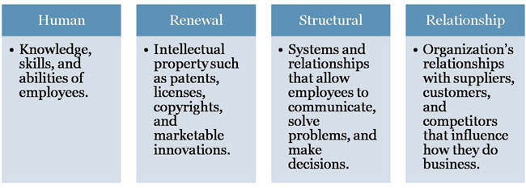

Knowledge Management
Knowledge Management: Involves the creation, collection, storage, distribution, and application of compiled ‘know-what’ and ‘know-how’ or, seeks to identify and connect individuals based on their expertise and areas of activity.

Knowledge Management/Infrastructure
- Refers to systems and structures that integrate people, processes, and technology.
For more information, read: "If Only HP Knew what HP Knows..." by T. Davenport .

Why is KM important?
- In a knowledge-based economy, knowledge (or know-how) rather than access to labour, capital, technology, or raw materials, is the basis of competitive advantage.
- Knowledge in the form of intellectual capital has assumed a greater value.
Learn more about the importance of knowledge management in a knowledge-based economy:
Outstart Whitepaper. "Why an LCMS is Essential to Your Learning Strategy" .

The Life Cycle of Knowledge
Aquire  A. Knowledge Acquisition  Interpret  B. Knowledge Interpretation  Disseminate  C. Knowledge Dissemination  Use/Apply  D. Use/Application  Evaluate  E. Evaluation  Retain  F. Knowledge Retention | 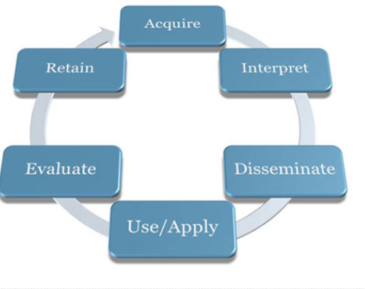
Knowledge Acquisition:
 | Environment scanning: | - Internal; includes individuals, teams, departments, etc.  - External; includes sources of information from other organizations, customers, industry watchers, etc.
2 | Formal learning  (training & development): | - Key part of the knowledge-acquisition process  - Represents a small, but critical proportion of how employees learn
3 | Informal learning: | - Represents the largest proportion of employee learning  - Often spontaneous, immediate and task-specific  - Can be based on trial and error, search or social network

More about Informal Learning
There are different nuances in the definitions found in the literature:
- Learning that occurs naturally as part of work and is not planned or designed by the organization. (Saks & Haccoun)—acquire it as we work.=, on –the-go etc...
- “Learning which takes place in the work context, relates to an individual’s performance of their job and/or their employability, and which is not formally organized into a programme or curriculum by the employer. It may be recognized by the different parties involved, and may or may not be specifically encouraged.” (Dale & Bell, 1999)
- Learning that takes place outside a dedicated learning environment and which arises from the activities and interests of individuals and groups, but which may not be recognised as learning.” (McGiveney, 1999)

Jay Cross
- Informal learning is everything that is not formal learning (curriculum, same time and smae pace with others, and some sort of recognition or goals), Informal learning happens all the time, it never is over!
- 80% of learning about a job is informal learning
- Social networks are vital! Most powerful instructional technology ever invented is human conversation.
- How can an organization invest in informal learning?
  - Small companies: disadvantage, training not strong.
  - Learning is internalized,

Comparing Formal and Informal Learning
Factor | Formal Learning | Informal Learning
Control | Controlled by organization | Controlled by learner
Relevance | Variable | High
Timing | Delay between learning and use of knowledge acquired | Learning used immediately on the job
Structure | Highly structured | Unstructured
Outcomes | Specific | Not specific

- B. Knowledge Interpretation: Mental models are deeply engrained assumptions, generalizations, or images that influence how we understand the world and how we take action.
- An effective way to develop shared mental models is to establish teams to stimulate work-related learning, solving real problems.
- Communities of Practice are networks of people who work together and regularly share information and knowledge.
What is a Community of Practice? (social way of learning)
Communities of Practice (CoPs) comprise individuals who share common values, goals, problems or challenges, and a shared language for framing and exploring issues.
- Often, members share a disciplinary background, though a CoP could be interdisciplinary.
Unlike a project team, a CoP has no formal mandate, no formal designation of roles and responsibilities, no predefined deliverables or preset lifespan and no specific defined objective.
CoPs are the mechanism through which individuals gradually come to participate fully in a profession or discipline.
- The learning that occurs is largely informal, and based on exposure to the practices and norms of the community. This form of learning is sometimes referred to as “enculturation” or “apprenticeship.”
There is an upper limit on the number of individuals who can form a CoP. This limit is sometimes pegged at the “Dunbar Number” after the sociologist Robin Dunbar, who studied the relationship between the cognitive ability of different species and their sociability.
CoPs are naturally occurring phenomena. However, in modern organizational settings, there is a great deal of focus on facilitating CoPs through information and communications technology, and even on creating CoPs. It is an open question to what extent CoPs can be implemented artificially.

C. Knowledge Dissemination:
- Moving ideas requires a different set of skills.
- Systems for sharing knowledge (transmission).
  - Shared mental models and language.
- Information and Communication Technology (ICT):
  - Increased codification of knowledge; that is, its transformation into information that can be easily transmitted.
  - Intranet and portals are critical components for managing knowledge.
    - Employee questions can be answered in hours instead of weeks.
- CoPs are a mechanism for disseminating knowledge (particularly tacit knowledge).

D. Use/Application
In the sphere of KM, it is important to monitor:
How knowledge is being used. | Where it is being used. | Who is using it.

E. Evaluation
- A consideration of the value and potential of the knowledge.
- Could be rated by employees and managers.
- Could be gauged through measurable outcomes (e.g., the return-on-investment of a best practice or an innovation).
- Could be based on usage (e.g., number of searches in a repository in a given subject area).

F. Knowledge Retention
- The way in which useful knowledge is stored and organized in such a way that it can be easily retrieved.
- Knowledge repositories are inventories of knowledge that organizations compile and store, which can be easily retrieved.
  - Some repositories are more informal lists of lessons learned, white papers, presentations, and so on.
  - Most have links to the originator of the documents.
  - Includes content and document management systems, public file structures, and libraries.

Organizational Learning and Training
Connection Between Organizational Learning and Training:
- Training is an important element of learning.
- Learning organizations exceed other organizations in terms of both training practices and expenditures.
  - Increased spending on training alone does not entail a learning organization.
- Individuals learn through training and development.

Dr. Robert Haccoun and the importance of aligning training to the goals, strategy, and culture of the organization.
(lesson 3, slide 19)
Case study: Frozen Rock Solid
GM: Nick Vanderstoop: in charge of implementing a system that he created to prevent erosion of knowledge. He recounts a story about a retired employee who used to send messages to inform others that certain freezable chemicals like upholstery cleaners must be shipped in heated trucks during the winter. After this employee retired, many people complained (angry sutomers) because some products use to arrive frozen!
It costed the company, 1.5 $ million dollars. This suggests that the retired employee left with informal and tactic knowledge that turned out to have a huge impact on the organization.

Lesson #4: Learning & Motivation
- Learning in any case requires MOTIVATION on the part of the individual in the initial part and the continual process. Its easier to learn when we are interested interested in something.
Tangential Learning: tangential learning is the process by which people will self-educate if a topic is exposed to them in a context that they already enjoy.
For example: after playing a music-based video game, some people may be motivated to learn how to play a real instrument, or after watching a TV show that references Faust and Lovecraft, some people may be inspired to read the original work.[
What is Learning???
Definition: “The process of acquiring knowledge and skills, and a change in individual behaviour as a result of some experience.” (Saks and Haccoun).
- “Learning is an interaction between the individual and the environment that results in a relatively permanent change in behaviour.” (O’Donnell et al., 2009).
- Learning is a persisting change in human performance or performance potential as a result of experience. (Driscoll, 2000).

The basics of learning – Dr.Louis Pugliese
- Our brain perieves with the 5 senses. Once we recognize something as familiar we organize the info in some way as well as for new experiences.
- A stimulus is any information that comes to us with the 5 senses. Brain processes it in order to organiza them, based on on what we know or novel information.
- Practice: rehearsal or repetition of information in order to commit to memory.
  - Procedural knowledge: the way to do something
  - Associative knowledge: learning with associations
  - Declaritve knowledge: things that we just know
- Memory: storage of information in brain that their for retrivel for later on.
- All learning will involve LONG TERM MEMORY. Store useful information in ltm
- Boredeom: why someone is not interested in particular task or stimuli. It was either not challenging enough or too challenging! Too easy or too hard for us.
- Motivation: internal drive or motivation we have towards something
  - Extrinsic motivation: motivation comes from an external source
  - Intrinsic motivation: comes from within
- Self-efficacy: the value or feeling one has of their abilities to complete a task.
- Attention span: focus on a stimulus or activity

Learning outcomes are classified into 5 general categories
1) Verbal information | - Facts, knowledge, principles, information (declarative knowledge).  - Verbs: state, recite, tell, declare, define.  - Example: “Define the term learning.”
2) Intellectual skills | - Concepts, rules, and procedures (procedural knowledge).  - Categories: discrimination, concrete concept, defined concept, rule, higher-order rule.  - Verbs: distinguish, identify, classify, solve, label, specify.  - Example: “Identify each instance as an example of procedural or declarative knowledge.”
3) Cognitive strategies | - Application of information and techniques.  - Understanding how and when to use the information.  - Verbs: adopt, create, originate, invent.  - Example: “Create and explain your own strategy to solve the following problem.”
4) Motor skills | - Coordination and execution of physical movements.  - Verbs: execute, perform, demonstrate.  - Example: “Hit a ball with a baseball bat.”
5) Attitudes | - Preferences and internal states associated with beliefs and feelings.  - Verbs: elect, favour, prefer, choose.  - Example: “Which learning theory do you prefer and why?”

Stages of Learning a skill
Stages | Example in Reading
Declarative knowledge:  Learning knowledge, facts, and information. | Learn the alphabet, learn conventions about direction of reading (in North America: left-right, top-down) separation of words, purpose of punctuation, rote learning of some words, learn some phonemes.  - Attempts at reading involve the conscious application of this knowledge to text.
Knowledge compilation: Integrating tasks into sequences to simplify and streamline the task. | Word recognition becomes automatic, however over time, a proficient reader is able to grasp whole sentences and even passages at a glance.  - This is because the comment sub skills involved in reading have been completely automated and merged together, overcoming limitations of working memory.
Procedural knowledge: Learner has mastered the task & performance is automatic & habitual. | Learner no longer has to think deliberately and consciously about the sounds associated with letter combinations or the meaning of individual words.  - Comprehension increases as working memory no longer has to perform the conscious tasks mentioned above.

Learning Styles
Definition: the way an individual gathers, processes and evaluates information during the learning process.
According to Kolb (1984), there are four ways in which individuals gain experience (and learn):
- Concrete experience (CE) feeling
- Abstract conceptualization (AC) thinking
- Reflective observation (RO) watching
- Active experimentation (AE)doing
An individual’s preferred learning style is a combination of two of the modes of learning:
- Converger (AC + AE) = thinking and doing
- Diverger (CE + RO) = feeling and watching
- Assimilator (AC + RO) = thinking and watching
- Accomodator (CE + AE) = feeling and doing

- Not all agree that their is “learning style” for different people.
- 2 articles suggesting that their isnt enough evidence to support the notion of learning styles. (slide 6)
What is a learning theory?
A learning theory consists of a set of propositions and constructs that attempt to explain how change in behaviour (learning) is achieved.
We will investigate three learning theories:
- Conditioning Theory (from Behaviourism)
- Situated Cognition (from Cognitivism)
- Social Learning Theory

Dr. Richard Schmid explains what is meant by a leaning theory.

  - What is the definition of a learning theory?
    - A learning theory is a permanent or semi-permanent change in behaviour due to experience. There are 3 components to the definition:
      - Permanent or semi-permanent means that it is not something that occurs briefly and we forget about it. It is something that we retain over a relatively long period of time.
  - Behaviour comes in 2 forms: external and internal (inside out) form of learning. Comes from within the mind and is transmitted foward.
  - Experience: humans are prewired to be able to do certain things. We start out with certain capabilities but learning differentiates between what we are prewired to be able to do as a predisposition or capacity and what the environment offers us which changes and manipulates that capacity. (nature vs nurture issue)

- Conditioning theory
- Learning is a result of reward and punishment contingencies that follow a response to a stimulus. (S-R)
- A stimulus or cue is followed by a response, which is then reinforced.
- Strengthens the likelihood that response will occur again and that learning will result.
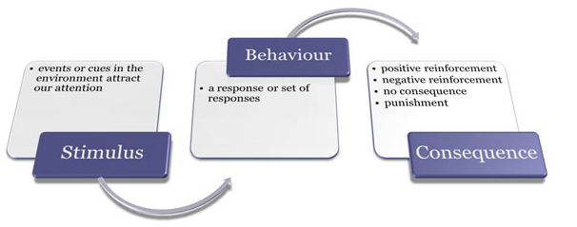
Positive Reinforcement: | Negative Reinforcement: | Punishment:
- Application of a positive stimulus after an act. | - Removal of a negative stimulus after an act. | - Receiving a negative consequence for an undesirable act.
Note that both forms of reinforcement (postitive and negative) will INCREASE or maintain behaviour.

Shaping: | Chaining: | Generalization:
- Reinforcement of each step in a process until it is mastered. (step-by-step learning and reinforcement) | - Reinforcement of entire sequence of a task. | - Conditioned response occurs in similar circumstances different from those during learning. (generalize learning)

- Situated Cognition (mind)
- Theory that builds on cognitive approaches to understanding learning.
- Cognitivism focuses on the structures that are created in the mind, through experience, and that further mediate our interpretation of experience.
- These structures are called mental models or schema.
- Schema evolve through different processes in which they are tweaked or extended to deal with new experiences, or undergo radical restructuring, if required (“accretion”, “tuning”, “restructuring”).
- Schema serve as filters that focus our attention in different ways
What is Schema?
- Teach Patrick the concept of a DOG. Points to a “dog” and Patrick forms a mental representation or schema of a dog. Patrick schema is limited and concrete. Patrick schema for a dog is: “brown, 4 legged, sharp teeth, long ears, friendly and a tail”. Patrick sees another dog and learns that not all dogs look a lot. Patrick schema is elaborated to include this new information. Over time, Patrick encounters many types of dogs, the properties of his schemas and can discriminate them. His schemas include many different variables. Then Patrick sees a cat. “IT’S A DOG”. Patrick has overgeneralized his schema. This begins the process of discrimination

Learning is seen as a process in which schema are further elaborated to contend with new experiences.
  - Key processes are “generalization” and “discrimination” (in the former, a very concrete concept becomes more abstract, and more inclusive (add in other types of information into the schema); in the latter, a schema that reflects a broad categorization (i.e. “all cats are dogs too”) is narrowed or restricted, to allow more contrast or discrimination).
Cognitive theories are also based on an information processing model of the mind.
  - Key elements in the basic model (there are variants) are short-term, working and long-term memory stores.
  - Sensory channels provide input to short-term and working memory. These are not permanent storage units, and there are well-established limits on how much information can be held in working memory and manipulated (7 plus or minus 2). Miller article.
  - The object is to move information from working memory into long-term memory, which is a stable repository, for future retrieval and use.

- Situated Cognition builds on the cognitive paradigm.
  - The insight captured in situated cognition is that at the time of learning we also encode aspects of the situation in which we are learning. These become part of our memory structures and affect our ability to successfully apply what we have learned – both facilitating and obstructing performance depending on circumstances. The aspects of the situation that are encoded are, if you like, conditions of applicability.
- If we learn and practice a new concept or skill over and over again in the same or very similar situations or contexts, we will find that we are very well able to apply this learning when we are confronted with a similar context. (more applied)
  - Our ability to do this will likely exceed that of someone who has learned the principle or concept in a more abstract (less situated, less applied) fashion. Learning needs to be more applied and less abstract and situated.
- However, it is also true that if we are placed in a novel context where the same learning could be useful, we may be unable to recognize this, and fail to retrieve and apply the relevant schema.
- To enable learners to access and apply schema across a wide variety of relevant situations, learning and practice must involve a variety of contexts.
- Decontextualized or abstracted presentations of a topic may also lead to greater “wide transfer” of what is learned.

- Social Learning theory
Three Key Components
1. Observational learnin | - Learning by observing the actions of others and the consequences.  - Four key critical elements: Attention, Retention, Reproduction, Reinforcement (motivation)
2. Self-efficacy | - Self-efficacy: Self-Judgments that people have about their ability to successfully perform a task.  - Influenced by four sources of information in order of importance:  - Task performance outcomes  - Observation  - Verbal persuasion & social influence  - Physiological/emotional state  “People who hold a low view of themselves will credit their achievements to external factors rather than to their own capabilities.” (Albert Bandura) people who have low S-E will attribute their failures to themselves and attribute their successes to externa factors.
   | Watch the video:  "Bandura's Social Cognitive Theory"  - Dr. Albert Bandura explains his social cognitive theory: Watch Clip (6:17)  - Biography of Dr. Albert Bandura: Watch Clip (9:58)
  To learn more about self-efficacy:
  - Review: Information on Self-Efficacy: A Community of Scholars
  - Read: Bandura, A. (2002). Social Cognitive Theory in Cultural Context. Applied Psychology: An International Review , 151, 269-290.
3. Self-management | Managing one’s own behaviour through a series of internal processes.  - Observe personal behaviour  - Setting performance goals  - Assessing personal progress  - Rewarding oneself for goal achievement  - Concepts: self-regulation, metacognitive awareness

Behavioural, Cognitive and Socio-Cultural Theories
- Behavioural, cognitive, and socio-cultural learning theories differ in the emphasis they place on the environment, the individual, and behaviour.
- Behaviourists will argue that an influence in the environment will have a change on one’s behaviour. Individual differences are not as important.
- Cognitivists believe that the individual is key since individuals can perceive the environment differently and their behaviour will differ accordingly.
- Socio-cultural theorists focus on the effect of the environment on behaviour, but particularly on the role of the community in shaping one’s behaviour. (vygotsky)


Dr. Richard Schmid: provides an overview of the evolution of learning theories and its impact on the design of training.
What is a learning theory?
- Learning theories has gone through an evolution. Psychologists wanted to be more scientific. Behaviourism (skinner) Stimulus-Response theory... According to behaviorists, learning is the connection of S-R. Problem with behaviourism was that it was too simplistic. It only accounted for animals and human behaviour is much more complex and variable. Its different from the animals.
- The theories held for animals but when it came to humans it was a different story.
- Out of that work was the development of the concept of developing behavioral objectives. In other words, when we develop a training program we have certain objectives in mind. We need to identify what the individual needs to do, under what circumstances they need to do it, and the criteria or the standards by which they do it
- Influence of behaviour learning theory is incentives (motivation). If one is motivated, they will attend to a task and learn.
- The more important form of motivation is intrinsic motivation (one that comes from within). Extrinsic motivators are like money and so forth. Extrinsic motivators are what drive the workplace. An individual ultimately will perform their job well only when they are intrinsically motivated to do so.
- Social Learning theory: we watch things happen and we learn. Looked at cognitive and behaviourist.
- (Slide 13… didn’t finish it )
Adult Learning Theory
- Andragogy: An adult-oriented approach to learning that takes into account the differences between adult and child learners.
- Pedagogy: the traditional approach to learning used to educate children and youth.
Dr. Saul Carliner: Discusses adult education and the differences in educating adults in the workplace as opposed to younger learners in a formal education setting.
- Learning for adults (andragogy) make material relevant and adults have other things are going on in their lives. In contrast, youth students, going to the school are their full-time job. That is all they focus on. Neuroscience and brain processes change as we get older, different to learn. Different incentives to learn.
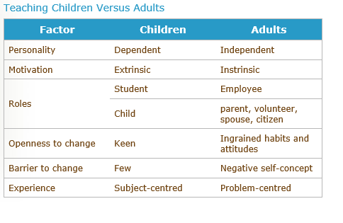
Theories of Motivation
Motivation: degree of persistent effort that one directs toward a goal
There are 2 forms of motivation:
  - Extrinsic Motivation: stems from factors in the external environment
  - Intrinsic motivation: stems from a direct relationship between worker and task (internal motivation)
- Need theories
  - Needs refer to physiological and psychological desires.
  - Needs are motivational because people are motivated to obtain the things that will satisfy their needs.

Maslow’s Hierarchy of Needs
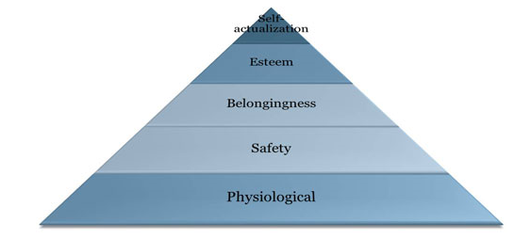
The only way to reach self-actualization is by satisfy ing the lower level needs. You cannot go to the next stage without reaching the ones prior to it.
- Clayton Alderfer’s ERG theory
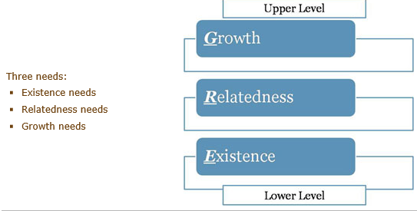
ERG theory differs from Maslow’s in the following ways
- Not a rigid hierarchy of needs
- If unable to satisfy a higher need, then the desire to satisfy a lower level will increase.

- Process Theories
1) Expectancy Theory
- Process theory of motivation.
- Motivation: Energy or force that a person directs toward an activity is a direct result of three factors:
A) Expectancy:  Individual’s subjective probability that they can achieve a particular level of performance on a task. | B) Instrumentality:  Subjective likelihood that attainment of a first-level outcome such as an “A” or “B” in this course will lead to attractive consequences that are known as second-level outcomes. | C) Valence:  Refers to the attractiveness of first- and second-level outcomes.
D) Effort = Expectancy x (Instrumentality x Valence)
2. Goal Setting Theory
- People’s intentions are a good predictor of their behaviour.
- Goals are motivational because they direct people’s efforts and energies and lead to development of strategies to help them reach their goals.
Characteristics for goals to be motivational are: | - Specific in terms of their level and time frame  - Challenging  - Must be accompanied by feedback  - People must accept them and be committed to them

Goal orientation
Mastery/Learning goals:  Process-oriented goals that focus on learning process. | Performance goals:  Outcome-oriented goals that focus attention on achievement of specific performance outcomes.

Training Motivation
Definition: The direction, intensity, and persistence of learning-directed behaviour in training contexts.
Personality variables that predict training motivation: | - Locus of control (source of motivation)  - Achievement motivation  - Anxiety  - Conscientiousness  - Self-efficacy

Dr. Richard Schmid: compares different learning theories and their effects on motivation, learning and performance. Slide 19.

What is the right learning theory?
- Unified learning theory
Model of training Effectiveness
- Training motivation is also a strong predictor of learning and training outcomes.
- Self-efficacy, cognitive ability, and personality characteristics also have an effect on learning.
- Attitudes (i.e., job involvement, job satisfaction, and organizational commitment).

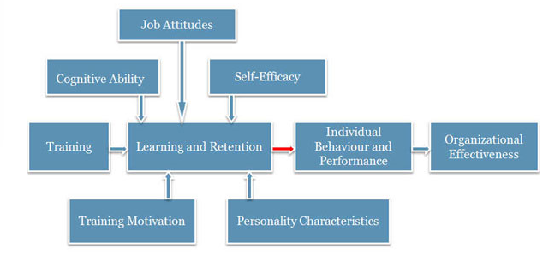

- Key issue for training is ensuring that what is learned is applied in the workplace (in the operational context).
- Degree of transfer attained in training is often limited.

Case study: The case of the underperforming sales team
Sarah low productivity of employees, poor past training, new intervention strategies
Manager: senior sales people have retired and new recruits are having trouble with the elevated expectations.

Lesson #5: The transfer of Training (chapter 10)
Transfer of training: is prior knowledge and applying to contexts. Will an employee benefit from the training and use the skills learned and apply it to their work environment? This is tough to measure. Transfer is a problem.
Dr. Ed Holton: Why training transfer is critical?
- “The transfer of training problem” 15-30% of training actually transfers to on-the-job work.
- Large organizations spend 60 billion dollars spent on training (in the U.S.) 42 billion dollars is wasted!
- Human capital is driving competitive advantage
What is the transfer of Training?
Definition: Transfer of training refers to generalization of knowledge and skills learned in training on the job and maintenance of acquired knowledge and skills over time.
Two conditions:
Generalization | - Use or application of learned material on the job.
Maintenance | - Use or application of learned material on the job over a period of time (repeated behaviour).

Dr. Schmid on the transfer of training
- Transfer: modifying our understanding in the new context. Anticipate what is to come (all variability). We still need a fundamental background. The learning has to be relevant to the individual. Difference between training and education?
- Blended learning approaches: multimedia environments, getting people together to work on complex problems and applying those problems.
- Performance evaluation: see whats happening with employee
- Learning occurs on-the-job!
The extents of Transfer of Training
Positive | Zero | Negative
- Trainees effectively apply new learning on the job. | - Trainees do not apply new learning on the job. | - Trainees perform worse on the job after training.

Types of transfer of training:
- Near: Applying new learning to situations that are very similar to those in which training occurred.
- Far: Applying new learning to situations that are different from those in which training occurred.
- Horizontal: Transfer across different setting at the same level.
- Vertical: Transfer from trainee level to organizational level.

Dr. Robert Haccoun discusses the transfer of training to the workplace and how it is mesaured?
- Most importanr asppect of organizational training
  - 1) behaviours: do people behave in ways which are consistent in what they have learnt.
  - 2) has this had an impact in the quality of work ?
  - 3) obervations

The transfer of training process
Baldwin & Ford (1988)

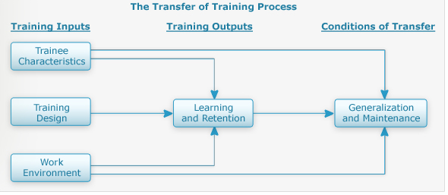
Training Inputs
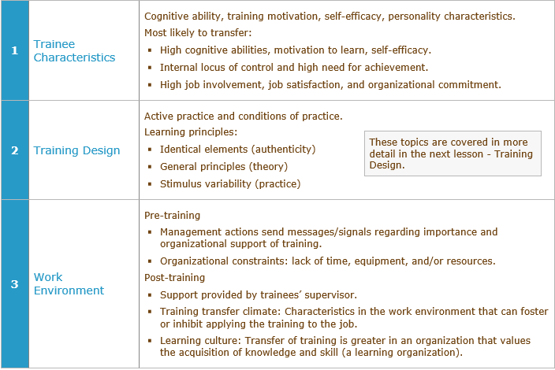

Facilitating and Improving Transfer of Training

Transfer of Training Activities Before Training

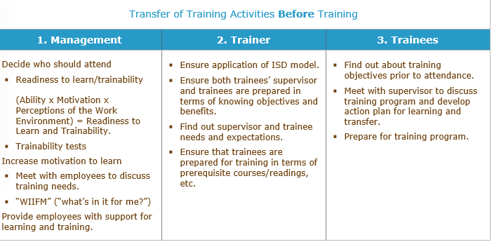
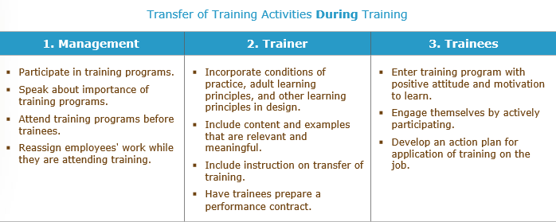

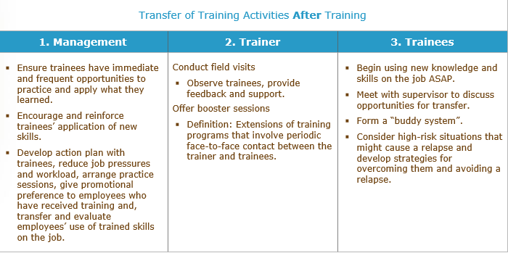

Transfer of training internventions
Relapse prevention
- Anticipate transfer obstacles and develop coping skills.
Self-management and self-coaching
- Perform a series of steps to manage transfer behaviour and establish performance maintenance and improvement goals.
Goal setting
- Set specific, challenging goals to enhance transfer.
Goal setting interventions
- Teach trainees about the goal setting process.
Booster sessions
- Extensions of training programs that involve a review of the training material.

The transfer System: All factors in the person, training and organization that influence transfer of learning to job performance.
Dr. Holton explains the Learning Transfer System Inventory
- In order for someone to perform on the job, we need to give them the ability to do it, be motivated and a work environment that is supportive and encouraging for them. Take what they have learned and go in their jobs and do it (transfer if training)
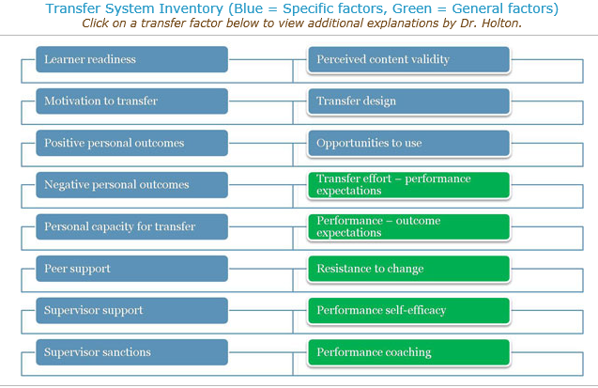
Training Effectiveness
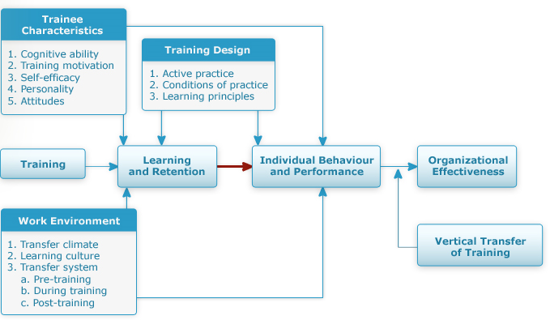

Case study: The school board
- Parents, teachers, and students complaining that no one listened, that decisions were made without participation, and good ideas were not acknowledged.
- Carlos tackled communication issue in the school board. He implemented the 3-day communication program. (active listening, upward communication, brainstorming, and other areas)-used different mechanisms to teach.
- Didn’t really work long term- problems of transfer with this training method.

- What are some of the reasons why Carlos’s training program did not transfer?
  - No post-training visits or follow up training was conducted.
  - Training wasn't contextual or easily related to everyday processes / not meaningful.
  - No managerial endorsement, participation or support for the training process either pre, during or post.
  - Poor organizational learning culture in general ('training was great but this is how it is')
  - Lack of defined expectations or outcomes.
- Discuss some of the barriers to transfer that might be operating at the school board. Who is responsible for these barriers
The general barrier in this situation was a poor culture of learning throughout the organization, which stifled any kind of transfer. All parties involved were culpable in this respect - 1) Supervisors who were not present or part of the training process; 2) Employee apathy in accepting 'the way things are'; 3) No executive presence aside from what we assume was a general order to fix a problem. Carlos' initiative may have been better served had he recognized this situation and employed strategies to address these barriers in addition to focusing his train on the real-life problems it was meant for. It's interesting to note that the labor union element was missing from this case, which surely would have added to the complexity of effectively carrying out this process.

- Describe some of the things that Carlos might have done before, during, and after the training program to improve the transfer of training.

Before
  - Get management on board for the preparation of training and selection of participants.
  - Define desired outcomes and expectations preferably with the input of participants and management alike.
  - Aligned instruction design more closely to the types of needs the training is addressing.
During
  - Recruit managers to participate or at least be visible at training and ensure that participants' workloads are being compensated for during training.
  - Incorporate conditions of learning that are meaningful to the learner.
  - Include activities that engage participants in developing some sort of action or learning plan that applies new skills and knowledge into their daily work.
After
  - Communicate with management to make sure that:
-Employees have opportunities to practice.
-New skills are being applied in appropriate situations
-That participants are getting feedback on this application
  - Follow up visits and/or booster training.

Discussion Board

