Childhood and Education
Traditional Roman Names
- Gaius (first name) Julius (family name) Caesar (additional name)
- His daughter is named Julia (feminine form of father’s family name).
- If there were two, they would be Julia Maior and Julia Minor.
- If there were three, they would be Julia Prima, Julia Secunda, and Julia Tertia.
Roman Women’s Names, after 1st Century BCE
- Julia is the daughter of Gaius Julius Caesar Octavianus Augustus
- Julia marries Marcus Vipsanius Agrippa
- Their daughters are Julia and Agrippina, not Vipsania Maior and Vipsania Minor, as they would traditionally have been.
Roman Slaves and Freedwomen’s names
- A slave named Cytheris
- Her master’s family name is Volumnius
- Her name once she became a freedwoman: Volumnia Cytheris
Married Women’s Names
- A married woman does not take her husband’s family name
- A married woman may be known as the wife “of someone”, e.g. Clodia Metelli (of Metellus)
Girls in Trades
- In memory of Viccentia, a very sweet girl, a worker in gold. She lived nine years
- In memory of Pieris, a hairdresser. She lived nine years. Her mother Hilara put up this tombstone

Questions to consider
Q: What sort of education did girls receive? Why? How did it differ depending on class?
A: Girls were taught how to do household tasks, even if they were part of the upper class the girls must be able to oversee that the slaves are doing the work correctly.
Q: Why did the Spartans focus on physical fitness for girls and boys?
A: Because they believed strong females bore strong males.
Q: Did ancient Greeks and Romans love their daughters?
A: Epitaphs of Young Girls Rome is evidence that girls were loved in Rome. Turia’s Eulogy. Girls would play dice games, dolls and balls.

Marriage, Sex, Motherhood, and Death
Guardianship: Women
- All children have legal guardians.
- Boys no longer have guardians once they are adults.
- Women remain in guardianship throughout their lives: women are never legally adults.
- Adult women need their guardians’ permission to make financial transactions larger than day to day household needs and to make wills.
- Women had lower legal status than men of the same class.
- Couldn’t vote, and couldn’t take part in politics.
- Could hold some priesthoods -> sometimes involved in some politics.
- Couldn’t join army/navy -> UNLESS there’s a crisis
- Very few commanded -> Cleopatra, for instance.
- Women could own property.
- Control and day-to-day use was not in their own hands.
- Boys no longer had guardians once they were adults = conduct own affairs.
- Women remain under the guardianship of someone -> NEVER legally adults.
- In many cases, it would pass to their husband and then their son.
- Needed guardian’s permission to make financial transactions larger than day to day household needs.
- Needed approval to make wills.
Guardianship: Slaves
- Slaves were property.
- Slave could be anyone who was not from their town/city
- If you could afford one, you’d have one.
- Doctors, architects, and teachers were usually slaves.
- Many women enslaved in war.
- Included elite women.
- Slave women heavily involved in raising freeborn children.
General Points about Marriage
- Women married young, usually early to mid-teens.
- Their husbands were often significantly older, mid-twenties to early thirties.
- Chastity was vitally important and women were expected to be virgins at first marriage.
- Young girls were secluded and kept away from non-family men to ensure this.
- Men not expected to be sexually faithful, but were expected to be respectful of their wives.
- Unfaithful wives called into question the legitimacy of their kids.
- Men couldn’t put other women in control of household over wife.
- They were not supposed to bring mistresses into the house.
- A wife could expect to be honoured as the mother of her husband’s legitimate children and to be placed in charge of the running of the household.
Purposes of Marriage:
- Legitimate children.
- Property in the form of dowry.
- Forming or strengthening bonds between families.
- Political alliance.
- Business connections.
Importance of Children:
- Needed to have them to take care of them in their old age
- To worship their household gods
- To mourn their death & give a proper burial
Women
- Dowry included money and property like jewelry (not farmland, which would stay in the family).
- It went with the women if they divorced.
- As long as they were married, the husband could use the dowry.
- Girls had little to no say in who they married.
- They would not usually disagree with their father’s choice.
- There were some love matches, but probably in the lower classes.
- If your family didn’t approve, it wasn’t going to happen.
- Love or at least respect was something desired in a marriage… over time, but not necessary.
- Passionate affection was inappropriate.
- You should not love your wife like you’d love a mistress -> no public displays of affection.
- Wives need to be respected.

Marriages were NOT religious
- Romans had a temple for this: Temple of Marital Concordia
- The most important point was the contract, though not legally necessary.
- In lower levels of society -> not necessary -> not formal
- Divorce was not a moral problem, unless it was due to adultery.
- Could get remarried.
- Man had no legal requirement to care for concubines.
- Married men not supposed to have a concubine.
- Some marriage contracts stated that he couldn’t have one.
Marriage Contracts
- Let Philiscus supply all necessities and clothing that are befitting for a wedded wife to Apollonia.
- Let Philiscus not be allowed to bring in another wife.
- Let Philiscus not beget children from another woman while Apollonia is alive.
- Let Apollonia not dwell in another house of which she is not mistress.
Terms for Athenian Marriage
- Engue: betrothal.
- Ekdosis “giving out”: the physical transfer of the bride from her father to the groom.
- Gamos: wedding feast.
- Loutrophoros: jar for carrying water for the bridal bath.
- Sunoikein: to live together/ be married.
Epikleros
- In Athenian law, the only daughter of a deceased man, must marry a near relative and produce a child who can inherit her father’s estate.
- Cannot inherit the estate herself, nor can her husband take it over.
Athenian Tradition:
- Contract between the father of the bride and the father of the groom or groom if his father was dead.
- It was a serious affair, the father had to arrange a marriage and offer a dowry for her.
- Girls orphaned in war had marriages contracted by the state.
- Father formally handed over his daughter (ENGUE)
- There would be witnesses and sometimes it was written down.
- Did not usually go live with husband yet -> underage
- When she does go to her husband’s house, it was a procession.
- The girl would be welcomed into the house by his mother/relative.
- Then there would be a feast by the husband’s family.
- Done very publically so that everyone knew that they were married.
- Legal requirement, Verbal agreement.
- Physical transfer of the girl.
- Before wedding day, the bride’s family makes a sacrifice.
- She dedicates items from her childhood (toys) to a group of nymphs = end of childhood.
- Sometimes girls cut hair and dedicated that too.
- Night before, she was given a bath with water from a sacred spring.
- On day of the wedding, there would be a feast at her house.
- One of only times when Athenian women ate with men who weren’t related to them.
- After the feast, bride, groom, his friend participate in a mule-drawn chariot to the groom’s house as part of the procession.
- Accompanied by other people holding torches and singing songs.
- Groom would put on a mock abduction -> lift her into the cart.
- Mother would take her to the hearth while people threw nuts at her.
- At the hearth, the groom holds her wrist and walks her around -> mock abduction theme.
- Also a ritualization of the bride’s grief and reluctance to leave her family.
- During feast at the groom’s, a boy would walk around giving bread to guests = had to have both parents still living and symbolized the hope of children.
- Then they’d go consummate the marriage.
- Next day she would get gifts that were usually stuff for the house.
Citizenship
- 451 BC – Pericles required that to be an Athenian citizen you needed an Athenian parents.
- Prior, rich families from other polis would marry their daughters off to Athenians to gain influence.
- This now meant they couldn’t do that.
- This also made it easier for poor Athenian women to get married.
- Metics = resident aliens. Lived in Athens for generations -> not Athenians
- They would marry into Athenian families -> can’t do that anymore.
- Made women more important in Athens b/c they were necessary for producing Athenian citizens.
Terms for Roman Marriage
- Sponsalia: betrothal ceremony.
- Lares: household gods.
- Fillets: wool ribbons worn by brides.
- Talassio: marriage cry.
- Hymen Hymenaeus: marriage cry.
Types of Roman Marriage
USUS = “by use”
- No formal contract, couple live together, act like they are married, and others agree.
- Everyone in family & community knows that they’re married and kids are legit.
- Pass into husband’s guardianship after 1 year.
- If they didn’t want this to happen, she would have to sleep outside her husband’s house for 3 consecutive nights a year.
- Most people would have used this type.
- No real dowry = no real need of contract.
- They might still have a ceremony.
CONFARREATIO = least common
- Seen as an archaic form.
- Probably a small group of Pats.
- Almost completely out of use by 2nd BC.
- Involved sacrificing a cake made of grain to Jupiter.
- Came under guardianship of groom.
- COULD NOT GET DIVORCED.
- By 1st c BC, the only ones using it were a few hereditary priest positions because it required it.
CUM MANU = “with power”
- Wife under the power of groom.
- Once he died, she would inherit like she was his daughter.
- Popular in the 2nd c.
Coemptio = basically buying the bride.
- Presented problems for upper class.
- Less popular starting in 2nd c BC.
- Fathers didn’t want groom to have control of daughter’s wealth.
SINE MANU = “without power”
- Wife remains under the guardianship of her father.
- Gives her more freedom.
- Wife can’t inherit from the husband unless he leaves her something.
- Father’s land stayed in family.

Univira
- A Roman woman who only married once in her lifetime. “one made woman”
- Although there was no stigma attached to being married more than once, the Univira was thought of as especially virtuous and honourable.
Rome Tradition:
- Very similar to Athenian marriage.
- Sponsalia = formal betrothal = consent to the marriage by the bride’s dad, groom’s father.
- Night before wedding, dedicate toys to father’s household gods (LARES)
- Family would take omens to assure that it was a lucky day.
- Bride dressed by mom, girdle that the husband would later have to untie and an orange-yellow veil.
- She had a special hairstyle where the hair was divided into 6 sections with an iron spear -> drive away evil spirits or to allude to the mock abduction. Tied in buns on her head and held with wool ribbons.
- After ceremony, there was a feast at her house.
- Then marriage contract was signed with witnesses.
- After that there would be a procession to groom’s house.
- Mock abduction: She would walk accompanied by 3 boys who had to have both parents alive. 2 held her hand and one held a torch.
- Talassio & Hymen Hymenaeus = marriage cries.
- Afraid of evil spirits – tell dirty jokes to cover over the happiness and drive off spirits.
- During procession, she would carry wool working tool = mistress of the household.
- Groom got to the house before her, she is lifted through the doorway.
- When she gets there, she tied wool around door and anoints it with oil.
- After this, groom would offer fire and water to her = basics of life
- She would light the hearth with her torch.
- Pray to gods of new house.
- Then consummate marriage.
Augustan Marriage laws
- Lex Julia de maritandis ordinibus (Julian law concerning cross-class marriage).
- Lex Julia de adulteriis coercendis (Julian law concerning restraining adultery).
- Lex Papia Poppaea (Papian-Poppaean law encouraging marriage and puts taxes on celibacy).
Provisions of the Marriage Laws
- Senators and their family were not allowed to marry freed people, actors, prostitutes, or adulteresses.
- Unmarried men under 60 and women under 50 could not receive inheritances.
- Candidates for political office who had children were preferred to those who did not.
- People who were married but childless could only receive half of any inheritance that was left to them.
- Women who bore a certain number of children were released from guardianship: 3 for free women (more if living outside of Rome) and 4 for freedwomen.
- Adultery became public and a crime, rather than a private matter to be resolved in the household.
Hellenistic Egypt
- They had documents.
- Earliest are receipts for the dowry.
- Later it included dowry and what would happen to it in case of divorce.
- If wife violated contract = may lose dowry
- If husband violated it = pay the amount of dowry + a fine
- Contract outlined what was expected of a marriage.
- Marriage contract -92BC ->> SLIDE
- Contract tells us, Fidelity of women
- Not act like she may have been w/ someone else
- Can’t sleep away from the house
- Can’t waste household resources -> spend money on lovers
- Groom, Marital fidelity = not allowed to bring someone home.
Divorce Agreement, Egypt
- Zois and Antipater agree that they have separated from one another and no longer live together.
- Zois agrees that Antipater has returned to her, handed over from his household, the items he received as her dowry, namely clothing valued at 120 silver drachmas and a pair of gold earrings.
- Both parties agree that henceforth the marriage contract will be null and void.
- From this day it will be lawful for Zois to marry another man and for Antipater to marry another woman, with neither party being liable to prosecution.
Questions to consider:
Q: What were the important symbolic meanings of the various parts of the Athenian or Roman wedding?
A:
Q: Why did people get married?
A:
Q: What protections from mistreatment did married women have?
A:
Women and Domesticity/ Domestic Space
Legislation about Women’s Mourning
- Athenian:
  - Only blood relatives (at least a second cousin)
  - No excessive displays like lacerating the flesh and lamenting at the grave side
- Roman:
  - Children under three: no formal mourning.
  - Children between 3 and 10: 3-10 months of mourning.
  - No one could be formally mourned for more than 10 months.
  - Widows had to remain unmarried and in mourning for ten months.

Oikos: Greek term for household; includes the people who live there and the physical buildings
Familia: Latin term for household; includes the people who live there and the physical buildings
- Rooms often multi-functional
- Very little privacy
- More people/square meter of space than is usual in modern Canada
- Activities such as production of household goods, craft-production and health care performed at home
- Household may include extended family, slaves, and other dependents

Gendered Space
Little house divided in two, the upper part being equal in space to the lower. The women's quarters above and the men's below. When the child was born to us, its mother suckled it; and in order that, each time that it had to be washed, she might avoid the risk of descending by means of the stairs, I used to live above, and the women below.

Houses in Pompeii
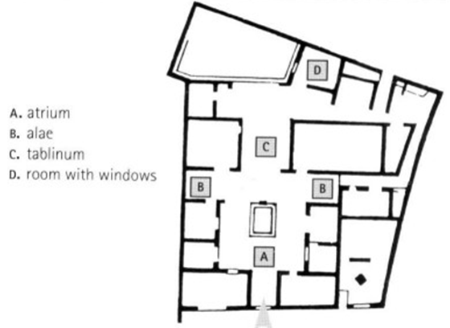

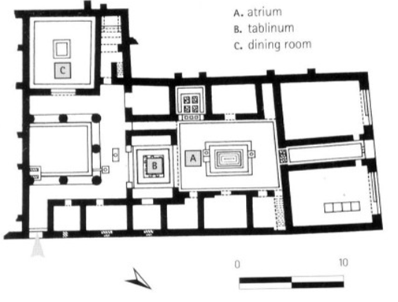

Classical Athens

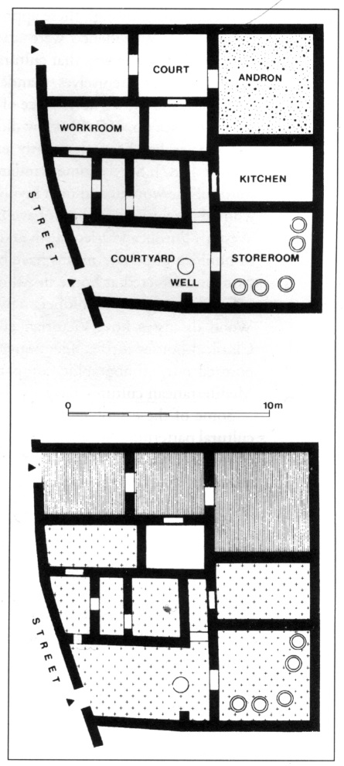

- Think about the connection between ideal and what actually happened. Sometimes they are the same, but not always.
- Most houses were designed for flexible use, depending on the season, what activities were currently happening, and who was there.
- Actual experience of domestic space and the work in it varied across time, place, and social class.

Questions to consider
Q: How did women in antiquity use domestic space?
A:
Q: What are the differences and similarities between Athenian and Roman homes?
A:
Q: What do the grave monuments of women emphasize? Why?
A:

Women and Religion
General Points:
- Greeks and Romans were polytheistic.
- BUT not every person worships every deity.
- Focus on gods that related to their occupations, stage of life, or one they had a civic connection.
- The supernatural and the gods were part of every aspect of their lives.
- Women are usually priestesses of goddesses, not male gods
- Oracles are a major exception to this rule, though.
- Women tend to be most heavily involved in worship revolving around fertility or the female life cycle.

Types of Worship:
- Household and ancestor cults
- State religion
- Fertility rituals
- Magic
- “Mystery Cults” offering personal salvation.
Arkteia Festival
- Celebrating Artemis.
- For pre-pubescent girls.
- Sanctuary at Brauron, in Attica.
- Involved a race, possibly pretending to be bears.
Thesmophoria
- Honours Demeter, goddess of agriculture.
- Takes place in late October/early November, just before the fall planting season.
- Only women could attend; associates fertility of women with fertility of the land.
- Part of state religion of Athens, held on Pnyx hill.
- Lasted 3 days long.
- Anodos: “the way up”; first day.
- Nesteia: “the fast”; second day.
- Kalligeneia: “bearer of beautiful offspring”; third day.
- Fertility festival

Eleusinian Mysteries
- Celebrating Demeter and Persephone.
- Took place at Eleusis, just outside of Athens. Hall of the Mysteries, Eleusis
- Celebrated in September.
- Not a state religion, participation was voluntary.
- Anyone could participate.
- Hierophantides: priestesses who assisted in the ritual
- Dates in Eleusis were recorded by the name and year of office of the chief priestess ofEleusis
- Mystery cult
Panathenaia
- Major state festival at Athens
- Celebrated by everyone
- Arrhephoros: girls who help weave the sacred robe for the statue of Athena
- Kanephoroi: women who carry baskets of incense in the procession
Priestesses
- Did not have to be virgins or celibate (except in certain specific cases)
- No priestess had to maintain lifelong virginity/celibacy
- One of the only prominent public positions open to women
- Usually aristocrats, often hereditary.
Oracles
- Apollo at Delphi
- Zeus at Dodona
- Both had female priestesses serving as conduits of the gods’ will.
Vestal Virgins
- 6 at a time, started at age 6-10, served for 30 years.
- Could marry when they were done their service.
- Important role in state religion.
- Resided in the temple of the goddess Vesta in Rome, the goddess of the hearth and household.
- Tasked with keeping a constant fire to burn. If it went out it meant a tragedy would strike.

Rights and Duties
- Tend to the sacred flame
- Perform certain sacrifices
- Can make their own wills
- Do not have guardians
- Treated like honorary males, in some ways
- Harming one is a criminal and religious offense
Bona Dea
- “the Good Goddess”
- Part of state religion
- Native Italian goddess with no Greek equivalent
Bona Dea scandal: the cast
- Pompeia: Julius Caesar’s wife, the woman in charge of the ritual.
- Aurelia: Julius Caesar’s mother.
- Publius Clodius Pulcher: a Roman nobleman and politician, known for scandalous behaviour.
- Julius Caesar: chief priest (pontifex maximus) of Rome.
Cybele
- Imported from Anatolia during a time of crisis
- Her priests came from her homeland
- Her priests were self-castrated
- Megalesia: a major festival to her celebrated by all Romans
- “The ten men in charge of sacred things”: a group of priests who oversaw her religion.
Oracles
- The Sybil, located at Cumae and devoted to Apollo
- Sybilline books: books of prophecy consulted by the Roman state in times of crisis.
Lares and Penates
- Household gods
- Lares connected to ancestor worship
- Penates related to the household’s security and prosperity
- Women participated in the worship

Bacchus
- Very popular among women
- Not part of state religions
- Roman authorities frequently felt threatened by it
- Bacchanalian scandal

Alternative Reasons for the Crackdown
Women occupied leadership positions in the cult.
Slaves and the poor were the cult's members to display of the Senate's supreme power to the Italian allies as well as competitors within the Roman political system, like successful generals.

Summary
Women participated in many of the important public rites of Greek and Roman religion, especially those involving fertility. Women also had important roles in private rituals, especially those involving the household or fertility. Non-state sanctioned religions could be seen as threatening, especially if they transgressed boundaries or provided ecstatic emotional release.

Questions to consider
Q: What types of religious practices were considered threats by the authorities? Why?
A:
Q: What were the duties and privileges of the Vestal Virgins? Why?
A:
Q: How do women’s public roles in religion interact with their private roles in the home?
A:

