PSY1102 –Chapter 12: Emotions, Stress and Health

Emotion: Arousal, Behavior and Cognition

Someone cuts you off on the road. You may feel the emotion of anger.

Emotions are a mix of:

- Expressive behavior –quickened pace (yelling, accelerating)
- Bodily arousal –heart pounding, sweating
- Conscious experience –thoughts and feelings (What a bad driver! I’m angry and scared, better calm down.)

An emotion is a full body/mind/behavior response to a situation.
*Most psychological phenomena (vision, sleep, memory, sex, etc) can be approached –physiologically, behaviorally and cognitively.

Theories of Emotion: Arousal and Cognition “Chicken and Egg” Debates

Which happens first? Your bodily arousal or your emotional feelings?
Do you notice your heart racing, then start getting scared about a midterm or because you realize you’re scared about the midterm, does your heart then start racing?

How do thinking (cognition) and feeling interact? Which one comes first?
James-Lange Theory: Body responses become recognized, thus causing the experience of emotion (thoughts/feelings).
Cannon-Bard Theory: Emotion-arousing stimulus simultaneously triggers body responses and experience of emotion (thoughts/feelings)
Singer-Schachter/Two-factor theory: To experience emotion, one must be physically aroused and can cognitively label the arousal.
Robert Zajonc, Joseph LeDoux and Richard Lazarus: Emotions are experienced without awareness or cognition.

James-Lange Theory

“We feel afraid because we tremble, we feel sorry because we cry.”

This theory states that emotion is our conscious awareness of our body responses to stimuli.
Body arousal happens first, then the cognitive awareness and label for the feeling: “I’m angry”
Then, according to this theory, if something makes us smile we may then feel happy.

Cannon-Bard Theory

This theory states that we have a conscious/cognitive experience of an emotion at the same time as our body is responding.
*A.k.a human body responses run parallel to the cognitive responses rather than causing them.

Adjusting this theory:

Emotions are not just a separate mental experience. When our body responses are blocked, our emotions do not feel as intense.

Cognition influences emotion –our interpretation of stimuli: “Is that a threat? Then I’m scared.”

Schachter-Singer “Two-factor” Theory

This theory states that emotions don’t exist until we add a label to the body sensations we’re feeling.

Ex: I face a stranger and my heart is pounding. We have to recognize why: if it’s fear, excitement, anger, lust? Or was it because we had too much caffeine. The label completes the emotion.

Schachter and Singer did a study where the subjects experienced a spill-over effect. This effect is when arousal was caused by injections of adrenaline.
The subjects interpreted their agitation to whatever emotion the others were feeling; hence the reason for their emotion “spilled over” from others.

Robert Zajonc, Joseph LeDoux and Richard Lazarus’ Theory

This theory states that some emotional reactions: fears, likes, dislikes develop in a part of the brain that skips conscious thought.

In one study, people showed an amygdala response to certain images (fearful eyes vs relaxed eyes) without being aware of the image or their reaction.

When Appraisal Affects Emotion

Lazarus –Appraisal (is it dangerous or not?) sometimes without our awareness defines emotion.
He noted that even in emotional responses that operate conscious thought, “top-down” cognitive functions, (i.e. appraisal of stimuli –threat vs enjoyment) could be involved.

Schachter and Singer highlighted the role of appraisal in _______ consciously experienced emotions: “This agitation is fear.”

Summary of Different Emotion Theories:
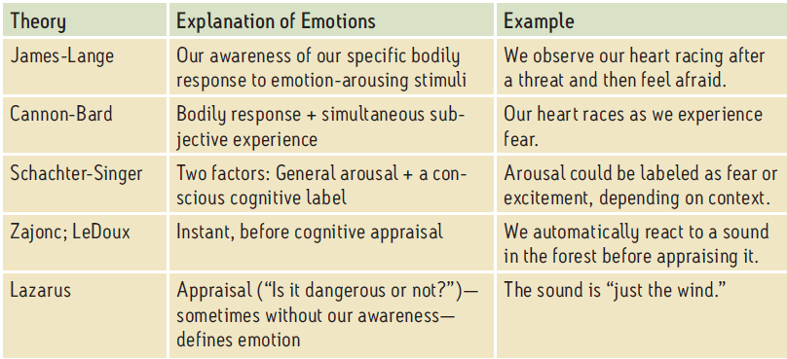

Theories of Emotion

Emotion can include the appraisal of the stimulus such as, is it a threat or not?

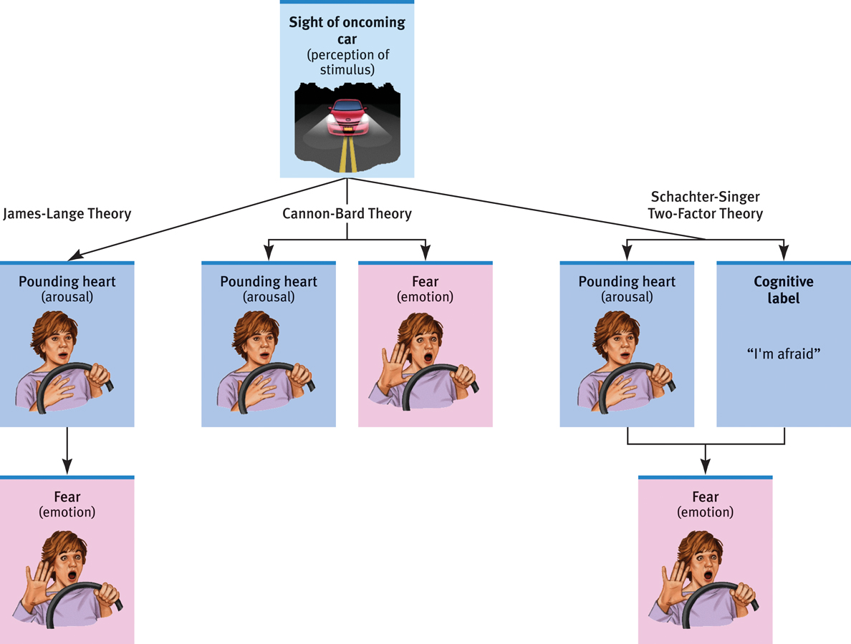
Avoiding the highway today without identifying or explaining any fear is an example of the “Zajonc and LeDoux theory” of emotion.

Embodied Emotion: The Role of the Autonomic Nervous System

The physiological arousal felt during various emotions is controlled by the sympathetic nervous system, which triggers activity/changes in our organs.

In time, the parasympathetic nervous system calms down the body.
Sympathetic division symptoms –dilated pupils, salivation decreases, sweating, increase in heart rate, lack of digestion, stress hormones are secreted, immune system decreases.

Parasympathetic division symptoms –contracted pupils, salivation increases, skin dries, decrease in heart rate, digestion activated, decreased stress hormone release, immune system increases.

How do Emotions Differ in Body Signs?

It is difficult to see differences in emotions from tracking: heart rate, breathing and sweating.
There is a large overlap in brain activity patterns across different emotions.
However, there are small differences.
Ex: fear triggers more amygdala activity than anger.

The left hemisphere is good for analyzing details (up close, approaching).
The right hemisphere is good for understanding the big picture.

Emotional Expression

Are there universal forms of emotional expression across all cultures?
Are there differences of emotional expression by individuals, cultures or genders?

What is the relationship between emotional expression and inner experience of emotion?
If emotions are hard to read is it because of culture difference or a difference in performance?

Detecting Emotion in Others

A lot of emotions are visible in the eyes (“the windows to the soul”) and the face.
Introverts are better at detecting emotions, while extroverts have emotions that are easier to read.

We typically notice and detect negative emotions first.

Those who have been abused are biased toward seeing fearful faces as angry.

Detecting Lies and Fakes

Polygraphs detect physiological arousal can sometimes fail at correctly identifying if someone is lying.
Visible traits that someone is lying: eye blinks decrease, other facial movements change.

A real smile uses involuntary muscles around the eyes.

Gender and Emotional Expression/Detection

Women have a greater/ more complex emotional expression.
Women are also more skilled at detecting emotions in others. (Nurturing instinct)
*This is an overgeneralization: women’s emotions disposition; men’s emotions circumstances.

Some emotions appear more “male” or “female”, changing our perception of a gender-neutral face.

Culture and Emotional Expression

There seem to be some universally understood facial expressions.
However, in other studies, people had more accuracy detecting emotions from their own culture.

Evolutionary Theory of the Origins of Emotional Facial Expressions

People blind from birth show the same facial expressions as sighted people.
This suggests that facial expressions are not learned from experience, they must be genetic/innate.

Survival of ancestors due to the genetic coding for facial expressions? Wolf’s snarl warns competitors to back off. We have aggressive “snarl-like” facial expressions when we are mad.

Our “surprised” facial expression improves our ability to take in information.
Smiling builds protective social bonds; this could explain why people smile more when facing someone.

The expression of “disgust” might be to help us close our nostrils to avoid breathing in toxic fumes.

Emotion Detection and __ ?_____Cues

If the faces are exactly the same in multiple photos, our detection of emotion will be based on the context: the situation, gestures and tears.
Ex: Man holding underwear –situation makes the emotion appear as disgust.
Man holding his own hands with added tears on his face –tears make the emotion appear as sadness.
Man with his fist in the air –gesture makes the emotion appear as angry/aggressive.
However, through each photo the man had the same facial expression.

Linking Emotions and Expressive Behavior: Facial Feedback

Facial feedback effect –the facial position and muscle changes can alter which emotion we feel.

In a study, people hose faces were moved to smiling or frowning positions experienced a change in mood. (Mood matched the facial expression that was positioned)
*Not just faces: middle finger felt hostility; thumbs up positive attitude

Carroll Izzard suggested that there are ten basic emotions evident at birth:

- Joy –mouth forming smile, twinkle in eye, cheeks lifted.
- Anger –browns together and downward, mouth squarish, eyes fixed.
- Interest –brows raised, mouth rounded, lips puckered
- Disgust –nose wrinkled, upper lip raised, tongue pushed out
- Surprise –brows raised, eyes widened, mouth oval-shaped.
- Sadness –inner corners of brows raised, mouth corners drawn down.
- Fear –brows level, eyelids lifted, mouth corners pulled back.
- Contempt
- Shame
- Guilt

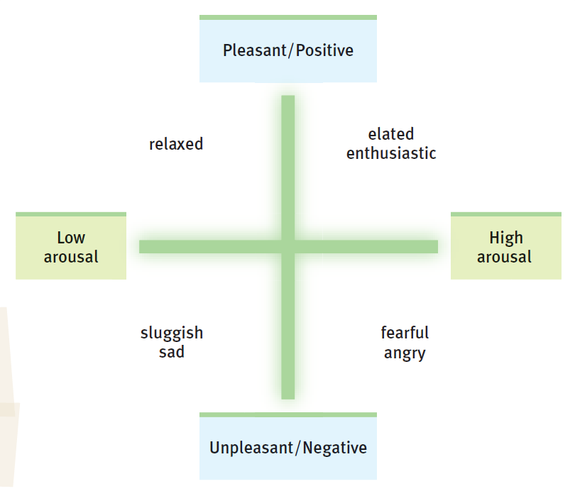
Two Dimensions of Emotion

Russell sees our emotional experience in two dimensions:
- Pleasant to unpleasant
- Low to high arousal

Anger
A ______ of anger gives us energy and initiative to fight or otherwise take action when necessary.

Expressing anger can cause more harm than whatever we’re angry about.

Ways to decrease anger: distraction, constructive action, problem-solving, exercise, verbal expression and allowing others to be wrong.

The catharsis myth refers to the idea that we can reduce anger by “releasing” it, and we do this by acting aggressively (i.e. yelling or punching a pillow)

Expressing anger worsens the actual anger and reinforces the aggression. This makes anger a conditioned habit.

Releasing anger can sometimes cause harm, resulting in guilt.
*Instead, try calming down and moving on. “Venting to reduce anger is like using gasoline to put out a fire.”

Happiness

Happiness is a mood, attitude, social phenomenon, a cognitive filter, a way to stay hopeful/motivate/connected to others.
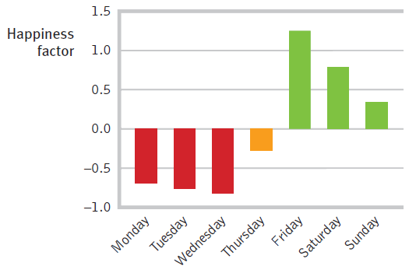
The feel-good, do-good phenomenon is when we are in a good mood we do more for others. Also, doing good things for people feels good!

Happiness has its ups and downs: Levels of happiness (as well as other emotions) can vary over the course of a week or even a day. (We like the weekend, we don’t like Mondays; we like sleep, we don’t like being sleep deprived/tired)

“How far are you up a 10-step ladder toward the best possible life?”
Brighter colour= higher up the “best life ladder”
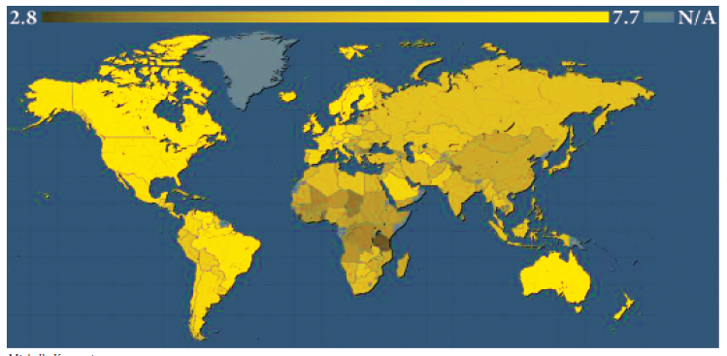
People in Chad and Tanzania are not feeling successful.

Wealth and Well-Being: A Change in Goals
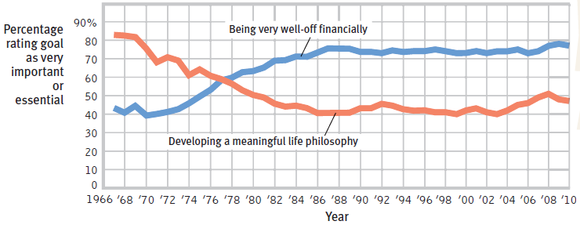
In the late 60’s, students entering college had a primary goal of developing a meaningful life philosophy.

Since 1977, being very well off financially has become more of a primary goal for first year students.

Can Money Buy Happiness?
Money seems to buy happiness when it lifts people out of poverty/being broke.
The average level of income and purchasing “power” has increased in the US.
% of people feeling happy from their purchases has not improved.

Adaptation and Comparison Phenomenon

When we step into the sunlight, it seems bright at first.
Then our sense adapt and we develop a new normal.
If a cloud covers the sun, it may seem dark in comparison.
The adaptation-level phenomenon is when our wealth or other life conditions improve, we are happier compared to our past condition.

However, we will adapt and form our new normal level and most people need another boost to feel the same satisfaction.

Adapting Attitudes Instead of Circumstances

Due to the adaptation-level phenomenon, our satisfaction level is not permanently higher when dealing with income and wealth. (Consistently adjusting expectations).
Contrarily: misfortune, disability and loss don’t result in a permanent decrease in happiness.
Ultimately, humans adapt.

Relative Deprivation

If the average income has risen 10% in your area, and you had a 5% income rise, it’s hard to feel good about it because of relative deprivation –feeling worse off by comparing yourself to people who are doing better.
People satisfied with their lives become less satisfied if the other person gets more: power, recognition and income.
Affect our happiness by choosing the people we compare ourselves to.
We have a tendency to compare ourselves to the more successful.

Correlates of Happiness

There are behaviors that seem to be correlated with happiness.
Unsure if it is the cause or effect of happiness.

Researchers have found that happy people tend to: | However, happiness seems not much related to other factors, such as:
Have high self-esteem | Age
Be optimistic, outgoing, agreeable | Gender (more often depressed, also more often joyful)
Have close friendships or a satisfying marriage | Parenthood (having children or not)
Have work and leisure that engage their skills | Physical attractiveness
Have an active religious faith
Sleep well and exercise

We usually seem to develop a mood set point, a level of happiness to which we keep returning.

Possible Ways to Increase Your Chances at Happiness

- Look beyond financial success for satisfaction.
- Bring your habits in line with your goals; take control of your time.
- Smile and act happy.
- Find work and leisure that engages your skills.
- Exercise, or just move!
- Focus on the needs and wishes of others.
- Work, rest and sleep.
- Notice what goes well, and express gratitude.
- Nurture your spiritual self.
- Make your close relationships a priority.

Health Psychology

Emotions (personality, attitudes, behaviors) and responses to stress have an impact on our overall health.

Health psychology studies these impacts as part of the broader field of behavioral medicine.

Topics of study in health psychology include:

- The phases of stress response and adaptation
- How stress and health are affected by:
- Appraisal of stressors
- Severity of stressors
- Personality types
- Perceived control
- Emotion or problem focus
- Optimism
- Social support
- Exercise
- Relaxation
- Religious faith and participation

Stress: A Focus of Health Psychology

Many people report being affected by stress.

Stress refers to the process of appraising and responding to events which we consider threatening or challenging.

A stressor is an event or condition, which we view as threatening, challenging, or overwhelming.
Ex: poverty, an explosion, psychology test, feeling cold, being in a plane, loud noises, etc…

Appraisal refers to deciding whether to view something as a stressor.

Stress reaction refers to any emotional/physical responses to the stressor.
Ex: rapid heartbeat, elevated cortisol levels, crying.

Clarifying the Components of Stress

Stress is a process in which you participate.
This process includes the stressor (event/condition), cognitive appraisal, bodily response and follow with coping strategies.

The advantage of breaking stress into these components is:
We can see options for altering each factor.
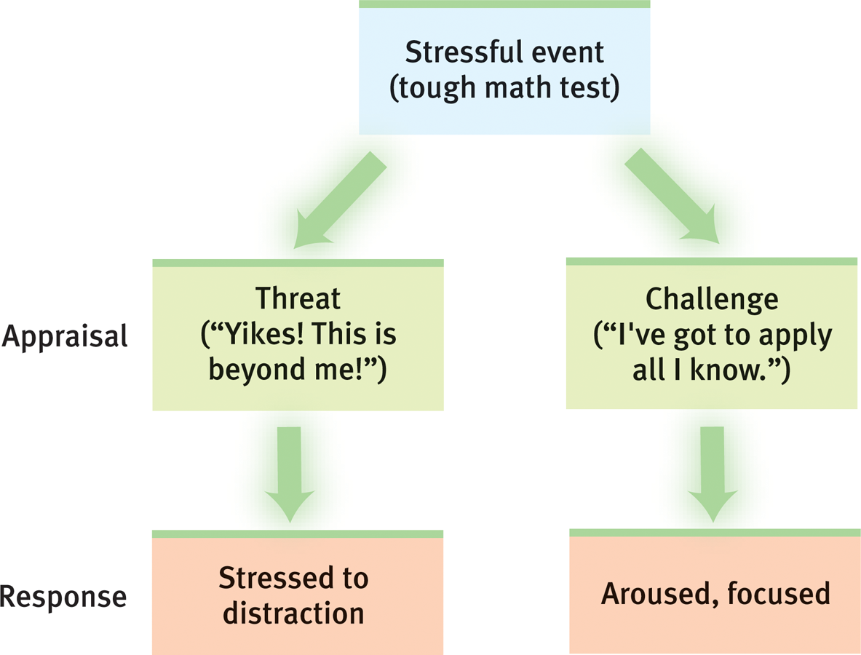
Appraisal: Choosing How to View a Situation

Questions to ask yourself when facing a stressor:
Is this a challenge, and will I tackle it?
Is it overwhelming, and will I give up?

There are inherently and universally stressful conditions; we can often choose our appraisal and our responses.

Beneficial and Harmful Stress Effects

A brief experience of stress can be beneficial:
- Improving immune system response
- Motivating action
- Focusing priorities
- Feeling engaged, energized and satisfied
- Providing challenges that encourage growth, knowledge and self-esteem.

Extreme or prolonged stress causes problems:
- Mental/physical coping systems become overwhelmed and defeated (not strengthened).
- Immune functioning and other health factors decline (due to damage)

Stressors

Stressors refer to the events and conditions that trigger our stress response.
They are perceived and appraised as overwhelmingly challenging, threatening and/or harmful.

There may be a spectrum of levels of intensity and persistence of stressors.

We can also see stressors as falling into one of four categories:
- Catastrophes
- Significant life changes
- Chronic daily hassles
- Low social status/power
*The textbook focuses on the first 3.

Catastrophic Events/Conditions

Examples of catastrophic events –earthquakes, floods, hurricanes, war/combat, wildfires.
Can be a single event or consistent, harmful conditions.

Appraisal is not essential in a catastrophic event. Most people agree that the event is harmful and overwhelming.

Short-term effects of these events include: increased heart attacks on the day of the event.
Long-term effects include depression, nightmares, anxiety and flashbacks.
Bonding: both the trauma and the recovery are shared with others. (Shared=bonding)

Major Life Events/Changes

Even happy life changes (i.e. marriage, college, new job, birth/adoption of a child) can bring increased challenge and stress.

Change itself is often challenging –positive or negative.
New roles, priorities and tasks can put a strain on our coping resources.

The challenge and negative impact on our health increases when:
- Changes are painful, such as death in the family, loss of job or heart attack.
- Changes are in a cluster, and there are too many at once.

Chronic Daily Difficulties

Daily difficulties can be caused by facing too many tasks with too little time and too little
control.

They can also be caused by the lack of social power and freedom:
- Being bullied
- Living in poverty
- Living under oppressive political conditions

The Body’s Stress Response System

Phase 1: “Fight or flight” sympathetic nervous system responds by reducing pain and increasing heart rate.

Core of adrenal glands produce more norepinephrine and epinephrine (adrenaline)
This system (identified by Cannon) gives us energy to act.

Phase 2: The brain sends signals to the outer part of the adrenal glands to produce cortisol and other stress hormones.
These focus us on planning adaptive coping strategies and resisting defeat by the stressor.
Selye identified this extended “resistance phase of the stress response, followed by Phase 3….

Phase 3: Exhaustion
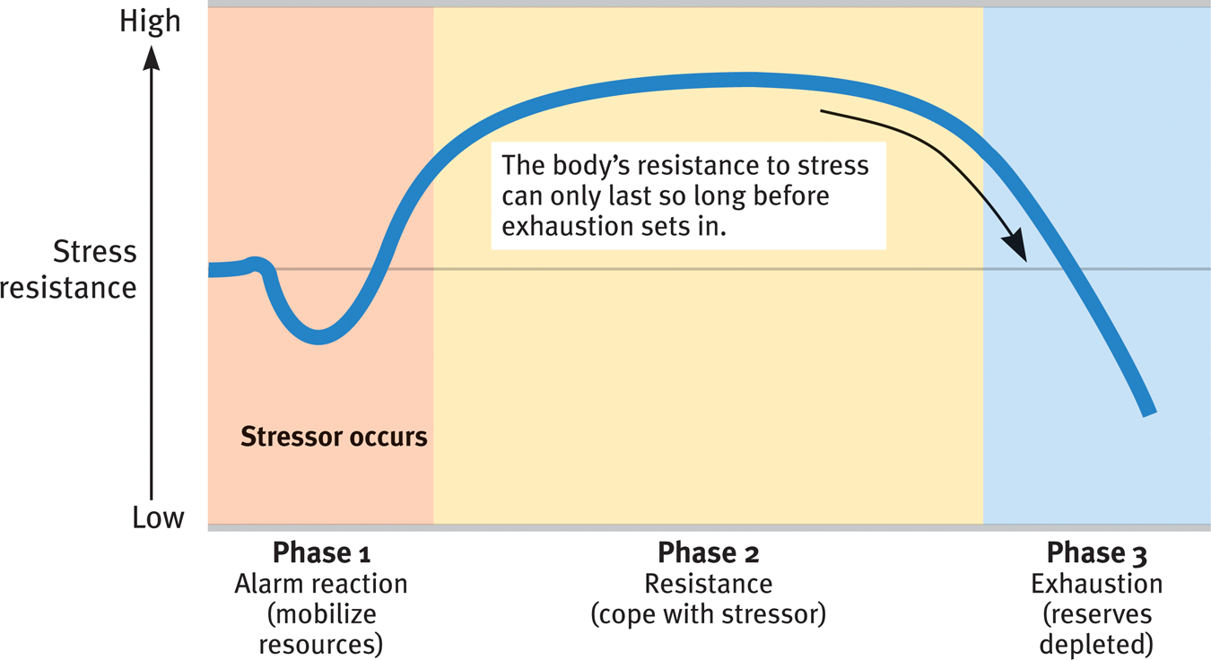
General Adaptation Syndrome (GAS)

Identified by Seyle.
Our stress response system defends, then fatigues.

Effects of Prolonged Stress

Repeated and prolonged stress with too much Phase 3 time leads to physical deterioration and premature aging:
- The production of new neurons declines
- Neural circuits in the brain break down
- DNA telomeres shorten (cells lose ability to divide, cells die, tissue stop regenerating, early aging and death).

Female and Male Stress Response

Women may tend and befriend –nurture themselves and others and bond together.
The bonding hormone oxytocin may play a role in this bonding.
Women show behavioral and neurological signs of being more empathetic under stress.

Men under stress usually socially withdraw and numb themselves with alcohol.
Men are more likely to be aggressive under stress.
Men’s behavior and brains shows less empathy and tuning into others under stress.

Studying the Stress-Illness Relationship

Main question: How does stress increase our risk of disease?

Psycho-neuroimmunology is the study of how interacting psychological, neural, and endocrine processes affect health.

Psychologists don’t use the term psychosomatic –it means an “imagined” illness.
It is now psychophysiological illness – a real illness caused by psychological factors (i.e. stress).

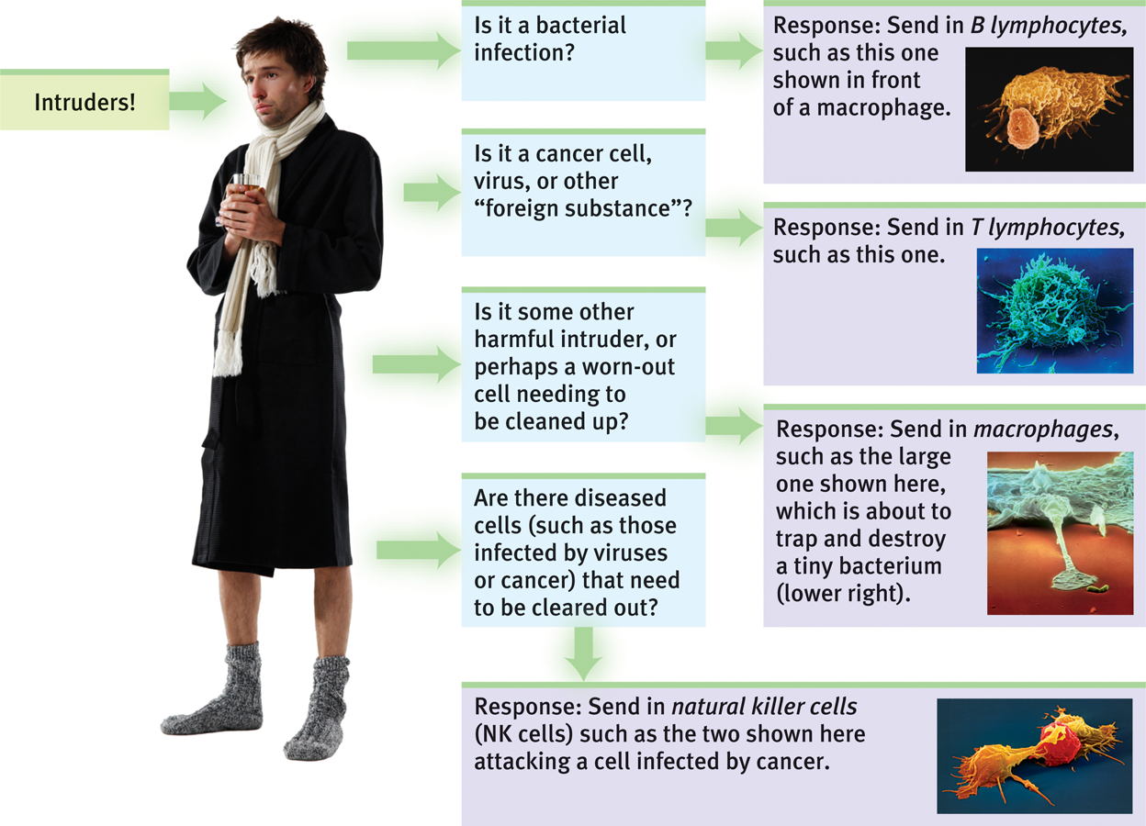
How the immune system works, before stress plays a role.

Stress Increases the Risk of Illness

Pyscho-neuroimmunology in action:
- Psychological factors (i.e. appraisal, thoughts, feelings)
- Neurological factors (i.e. brain signals engaging the stress response system)
- Immunology (i.e. stress hormone exposure which suppresses the immune system)

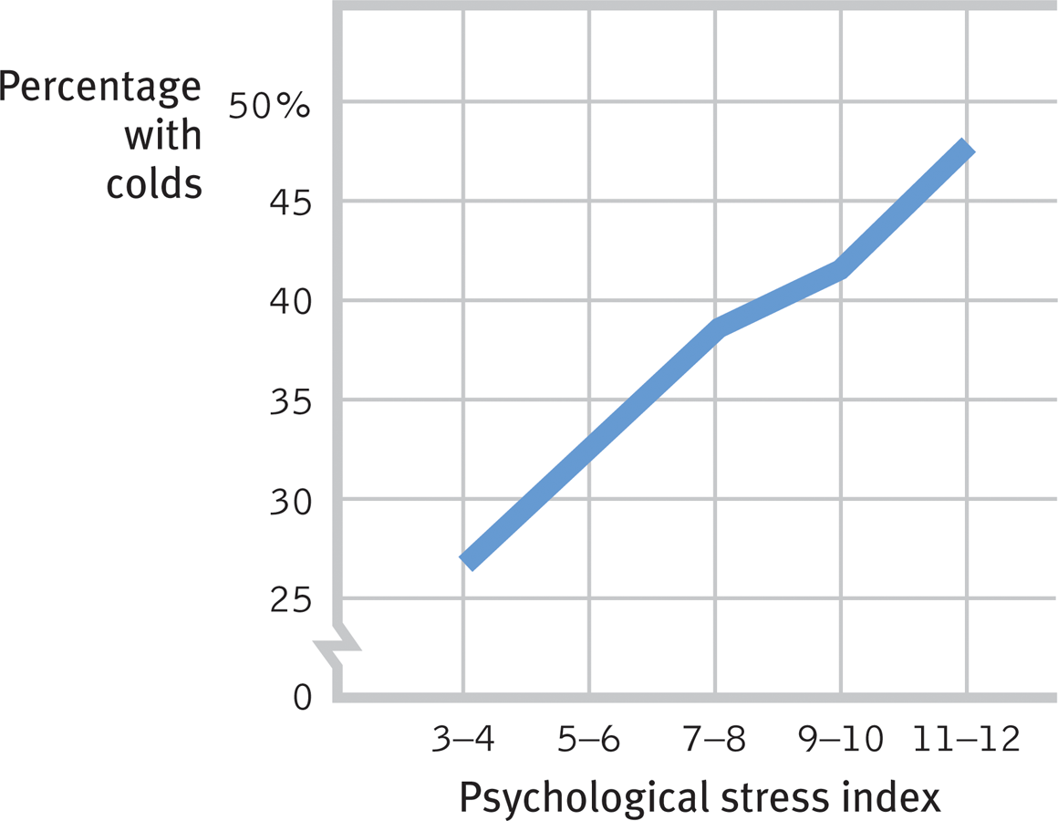
Stressors Appraisal Thoughts Feelings Brain signals Hormonal action Immune suppression Risk of illness.

Ex: The impact of stress on catching a cold.
In a group exposed to germs, those under stress caught the cold.
This stress response/immune response tradeoff may help our bodies focus energy on managing stress.

Stress, AIDS and Cancer

AIDS –Acquired Immune Deficiency Syndrome
Stress response suppresses the immune response.
Exposure to stress worsens the development of AIDS in those exposed to HIV.
Reducing stress slow the progression of AIDS.

Cancer –the stress link is not as clear.
Stress may weaken the body’s defenses against the replication and spread of malignant cells.

*This doesn’t mean that stress causes cancer or AID.

Stress and Heart Disease

In coronary heart/artery disease, the blood vessels that provide oxygen and nutrients to the heart muscle itself becomes clogged, narrowed, and closed.

Factors that contribute to heart disease:

- Biological –genetics (high blood pressure and high cholesterol)
- Behavioral –smoking, inactivity, high-fat diet
- Psychological –chronic stress, personality styles that worsen stress.

Type A Personality – Stress – Heart Disease

People with a type A personality are impatient, verbally aggressive, always pushing
themselves/others to achieve.

People with a type B personality are more relaxed/ go with the flow.
*In a study, heart attacks only hit people with type A traits.

Note: Accomplishing goals is healthy, but compulsion to always work without pleasure is not healthy.

Pessimism and Heart Disease

Pessimism refers to the assumption that negative outcomes will happen, and often facing them by complaining and/or giving up.
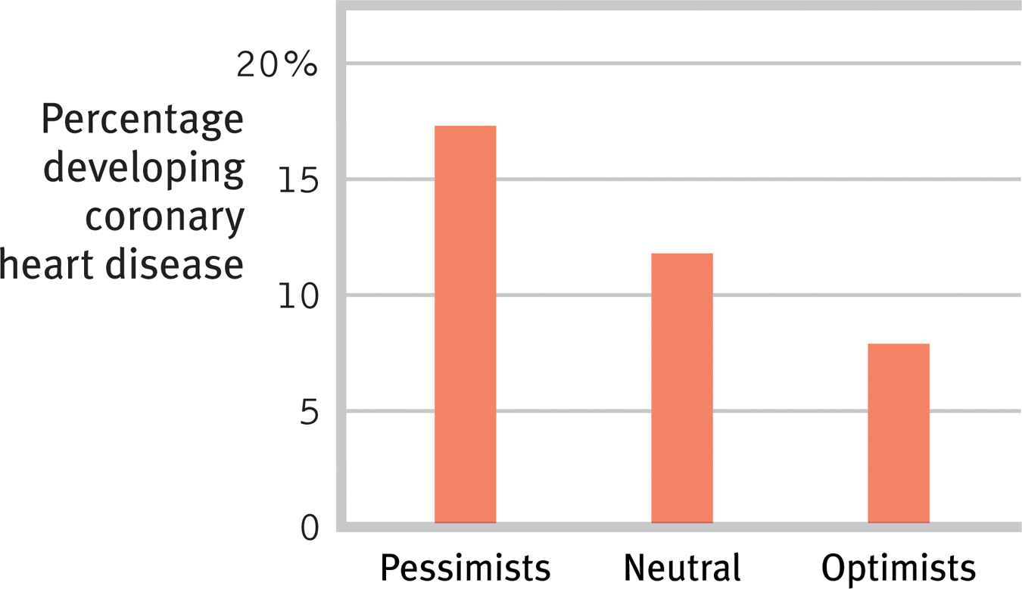
It can be helpful to anticipate possible negative events in a realistic way.
This would help us plan to prevent or cope with them.

Men who are pessimistic are more likely to develop heart disease within 10 years than optimists.

Depression and Heart Disease

Both heart disease and depression are both cause by chronic stress.
Possible intervening variable –excessive inflammation.
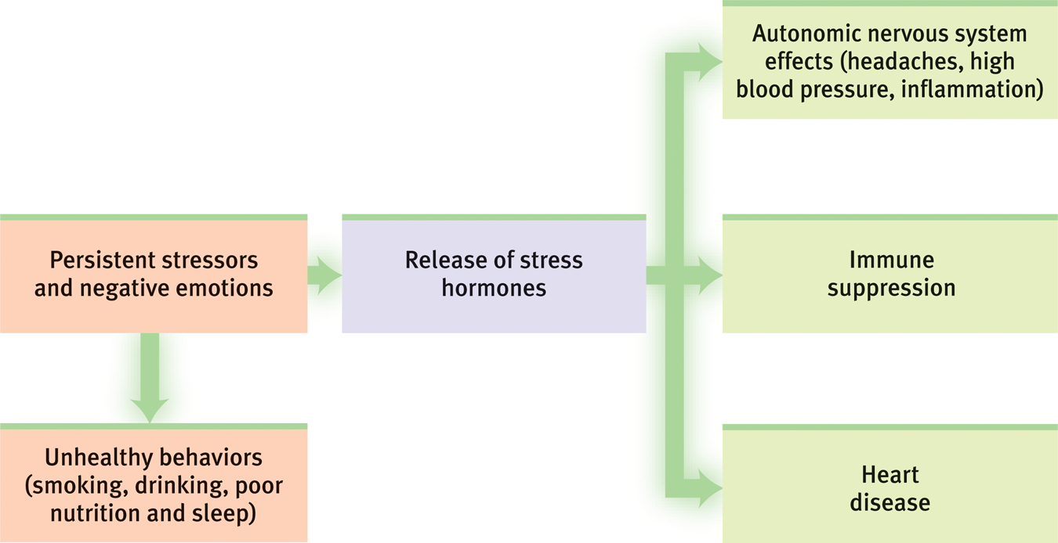
Health Consequences of Chronic Stress
The repeated release of stress hormones.

The stress hormone cortisol helps our bodies respond to brief stress.
Chronically, high cortisol levels damage the body.

Promoting Health

Ways to reduce stress:
- Address the stressors
- Soothe emotions
- Increase of one’s sense of control over stressors.
- Exchange optimism for pessimism
- Get social support (family, friends)

Ways to reduce stress and improve health:
- Aerobic exercise (gym, sports)
- Relaxation and meditation
- Participation in communities of faith
- Alternative medicine

Coping with Stress

Problem-focused coping –reducing the stressors by working out a conflict or tackling a difficult project.
Risk: Magnifying emotional distress (changing something that’s difficult to change)
Emotion-focused coping –reducing the emotional impact of stress by getting support, comfort, and perspectives from others.
Risk: ignoring the problem

Stress factor: Perceived Level of Control

Experiment: The left and middle rats received shocks. The rat on the left was able to turn off the shocks for both rats. Which rat had the worst stress and health problems?
Only the middle, “subordinate” rat had increased ulcers.
It is not the level of shock, but the level of control over the shock, which created stress. 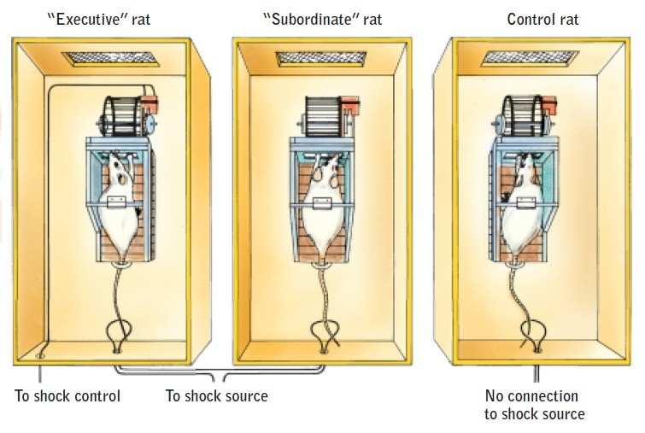

Promoting Health: Social Support

Close relationships is associated with improved helth.
Social support (family, friends, pets) provides calming effect –reduces blood pressure and stress hormones.

Confiding in others will help manage painful feelings.

Aerobic Exercise and Health

Aerobic exercise –a sustained activity that raises heart rate and oxygen consumption.
Triggers certain genes to produce proteins that protect against diseases.
Reduces: heart disease, cognitive decline and dementia, early death.

Aerobic Exercise and Mental Health

Aerobic exercise is correlated with: high confidence, energy, good mood.
Exercising have proven to reduce depression.

Lifestyle Modification

An experimenatal group practiced lifestyle modification –plan to slow down life, renew faith, accept imperfection.
Result: Modifying lifestyle led to reduced heart attacks.

Relaxation and Meditation

Relaxation techniques reduce headaches, high blood pressure, anxiety, insomnia.
Meditation teaches people to create a relaxation response –relax muscles, lower blood pressure, slow breathing and heart rate. Increases brain activity to “up” positive emotions.

Religious Involvement and Health

Religious attendance seems to have positive results, especially in men.
Health may improve because of the lifestyle and emotional factors associated with religious involvement, and not the faith.

PSY1102: Chapter 13 –Personality

Personality is an individual’s characteristic pattern of thoughts, feelings and behaviors.
Prolonging over time and across situations.

Different types of personalities:
- Agreeable/Open
- Naïve
- Contentedly lethargic
- Conscientious
- Neurotically irritable
- Sensitive/Reactive
- Introverted

Nature of Personality

Personality refers to an individual’s unique constellation of consistent behavioural traits.
Concept of personality is used to explain:
- The stability in a person’s behavior over time/with different situations.
This is consistency.
- Behavioral differences among people that react to the same situation.
This is distinctiveness.

Introverts –Go to a party, socializing is “draining”; they go home to collect their thoughts and calm down
Extroverts –Go to a party, socialize and collect their energy; they go home and use that energy and wind down alone.

Psychodynamic/Psychoanalytic Theories

These theories of human personality focus on the inner forces that interact to make us who we are.

Behavior, human emotions and personality develop in a dynamic (interacting/changing) interplay between conscious and unconscious processes –including various motives and inner conflicts.

Types of motives –intimacy, sexual, achievement, power.

Freud’s Path to Developing Psychoanalysis

Sigmund Freud started his career as a physician.

He explored how unexplained physical symptoms could be cause purely by psychological factors.
Ex: loss of feeling in the hand, unexplained blindness, etc.

He realized that many mental processes operate in the unconscious –meaning without our awareness.

Psychoanalysis is Freud’s theory of the structure of human personality and its development.
Also his therapeutic technique is called psychoanalysis.

Techniques of Psychoanalysis

Free association a creative technique that encouraged the patient to say whatever comes to mind. The therapist will verbally trace the flow of thoughts into the past, then into the unconscious.

He suggested meanings for “slips of the tongue”
Ex: “Good morning, beheaded –uh, I mean beloved.” Saying something you either do not mean or do not want to share but something you believe in.

Latent content of dreams.

Freud’s Personality/Mind Iceberg

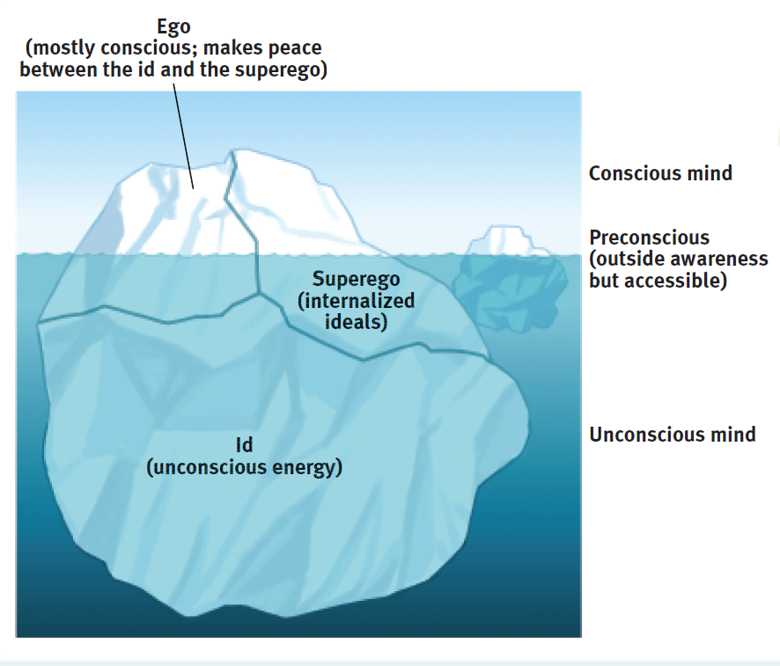
The mind is mostly below the surface of conscious awareness.
Personality develops from the efforts of our ego (rational self) to resolve tensions between our ID (unconscious energy) based on biological drives and the superego (society rules, constraints, ideals)
The unconscious (Freud’s view) –a reservoir of thoughts, wishes, feelings, memories that are hidden from awareness because they feel unacceptable.
Ex: You are shown a picture of a nurse, but do not see the photo long enough to recognize the photo, your unconscious retained the nurse photo and you will subconsciously want to see a doctor. Our unconscious has a constant impact on our every day lives.

Ex: Video of a man talking to a woman.
Superego says “respect your mother and honor your mother” meaning respect the woman and do not give in to the drives/pleasures.

ID says “Go home with her, I want it.” Giving in to the drives/pleasures.
He ultimately gives into his ID. We are, sometimes, a slave to our unconscious drives.

The Developing Personality

1. Start life with a personality made up of the ID.
-Strive to meet basic needs.
-Living by pleasure principle.

2. Ego develops in a toddler –self that has thoughts, judgments and memories.
-Follows a “reality principle”
-Still focuses on ID’s needs.

3. Age 4-5, child develops the superego –a conscience internalized from parents/society.
-Follows the ideals of a “morality principle”

The ego works as the “executive” of this three-part system, to manage bodily needs and wishes while managing it in a socially acceptable way.

Freud’s Theory of Psychosexual Stages

Id is focused on the needs of erogenous zones –sensitive areas of the body.

People sometimes feel shame/bad about these needs and can get fixated at one stage.
They may never resolve how to manage the needs of that specific zone’s needs. 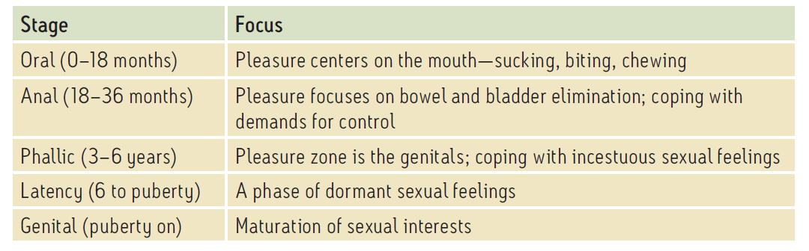

Male Development Issues

Freud believed that as boys in the phallic stage seek genital stimulation, they develop unconscious sexual desires for their mothers.
-This causes hate toward their fathers as a rival.
-They feel guilt and fear punishment by castration.

Freud named these feelings the Oedipus complex.
To resolve this issue: boys will identify with their fathers rather than seeing them as a rival.

Defending Against Anxiety

Freud believes we are anxious about unacceptable wishes and impulses.
We try to avoid/ignore this anxiety with the help of the strategies listed in the chart below:
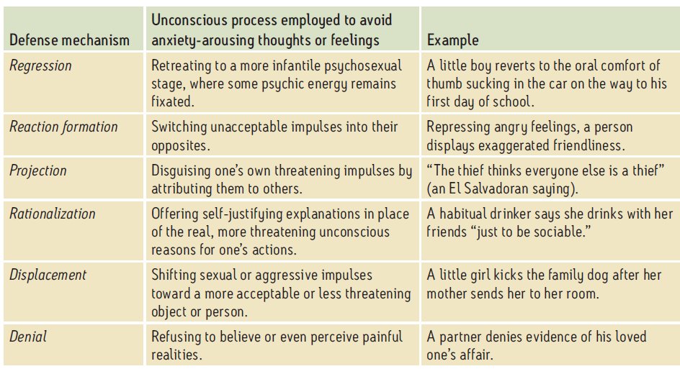

Reaction formation –Unacceptable impulses are switched to their opposite. (Being somewhat of a hypocrite.
Projection –You don’t like something about yourself subconsciously, so you believe others are displaying the attribute that you don’t like.
Ex: You’re a thief, but you think everyone else is a thief.
Rationalization –Needing justification for your actions, even if they are bad actions.
Ex: An alcoholic says he is a “casual drinker”

Denial –Refusing to believe a painful situation or reality.

Which Defense Mechanism Am I?

Examples:
A politician gives anti-gay speeches, then turns out to have homosexual tendencies.
This is reaction formation.

Someone with an anger problem accuses everyone else of being angry/threatening.
This is projection.

Similarity: they both seek to prevent being conscious of unacceptable feelings.
Difference: First one compensates, second one distracts.

Neo-Freudian, Psychodynamic Theorists

Psychodynamic theorists (Adler, Horney, Jung) accepted Freud’s ideas about:
- Unconscious and childhood relationships are important in shaping personality.
- Id/ego/superego structure
- Defense mechanisms in reducing anxiety about uncomfortable ideas.
Psychodynamic theorists differed from Freud in a few ways:
- Adler, Horney –believed anxiety and personality are a function of social tensions in childhood (NOT sexual)
- Jung believed that we have a collective unconscious that contains images from our specie’s experiences. (NOT just personal repressed memories/wishes)

More about the Psychodynamic Theorists

Carl Jung –Highlighted universal themes in the unconscious as a source of creativity and insight.
Found opportunities for personal growth by find meaning in moments of coincidence.

Alfred Adler –Fight against feelings of inferiority as a theme at the core of personality.
(May have been projecting from his own, personal experience)

Karen Horney –Criticized Freudian portrayal of women as weak/subordinate to men.
Highlighted the need to feel secure in relationships.

Assessing the Unconscious: Psychodynamic Personality Assessment

Freud tried to get unconscious themes to be projected into the conscious world through free association and dream analysis.
Projective tests are a structured exposure to a standardized set of ambiguous prompts, which are designed to reveal inner dynamics.

Rorschach test: “What do you see in these inkblots?”
Problem: Results do not link well to traits (low validity) and different rates get different results (low reliability).

Evidence Updated Freud’s Ideas

- Development appears to be lifelong, not set by childhood.
- Infant neural networks are not mature enough to crate life long impacts of childhood trauma.
- Peers have more influence on personality than parents, less than Freud assumed.
- Dreams/Slips of the tongue have many possible origins + less likely to reveal deep unconscious conflicts and wishes.
We may ignore threatening information, but traumatic memories are usually very remembered (not repressed)
- Sexual abuse stories are more likely to be fact, less likely to be wish fulfillment.
- Gender/sexual identity seems to be more a function of genetics than Oedipua conflicts and relationships with parents.

Freud’s Flaws in the Scientific Method

-Unfalsifiability –he developed theories that are hard to prove or disprove.
-Unrepresentative sampling –he didn’t build his theories on broad observation samples. He described humanity based on people with unusual psychological problems.
-Biased observation –he based theories on his patient; may have given him an encouragement to see them as unwell prior to treatment.
-Post Facto explanations (hindsight bias) –rather than predictions, you could be either fixated or repressing in an anxious/calm situation.

The Unconscious as Seen Today: Processing, Perception and Priming: But NOT a Place

Unconscious –a stream, not a reservoir.

The following processes occur unconsciously because of our autonomic nervous system:

- Schemas guide our perceptions
- Right hemisphere makes choices; left hemisphere does not verbalize

Freud’s Legacy

- Freud benefited psychology –gave us ideas about:
- impact on childhood on adulthood
- Irrationality
- Sexuality
- Evil
- Defenses
- Anxiety
- Tension between biological selves versus socialized selves.
- Psychoanalysis is now a specific course in university outside of general psychology.
- Freud gave us specific concepts that we still use:
- Ego
- Projection
- Regression
- Rationalization
- Dream interpretation
- Inferiority “complex”
- Oral fixation
- Sibling rivalry
- Freudian slips
- Terror management theory (thought of death affects attitude/choices)

Humanistic Theories of Personality

Psychologists in the ‘60s rejected:
- The dehumanizing ideas in behaviorism
- The dysfunctional view of people in psychodynamic thought

Maslow and Rogers offered a “Third Force” – The Humanistic Perspective (in psych)
Studied healthy people instead of people with mental health issues.

Humanism –focusing on the conditions that support healthy, personal growth.

Maslow: The Self-Actualizing Person

Maslow’s view: People are motivated to keep moving up the chain of needs. (Advancing beyond basic needs.)

Self –actualization is the top of the chain –fulfilling one’s potential/self-transcendence.
Personality includes:
- Self-aware
- Self-accepting
- Open
- Ethical
- Spontaneous
- Loving/caring
- Beyond social acceptance

Roger’s Person Centered Perspective

Roger believed that people naturally grow, become healthy and move toward the top hierarchy: self-actualization.

The 3 conditions that facilitate growth:

Genuineness –honesty, being direct, no façade.
Acceptance (Unconditional Positive Regard) –acknowledge feelings, problems, no judgement/devaluing.
Empathy –Trying to understand, listen well (not sympathy- heard, not pitied)

Conditional love leads to distort experiences.
This fosters an incongruent self-concept: Then anxiety, and defensiveness produces more incongruence.

Congruence –self-concept meshes well with actual experience.
Incongruence –self-concept does not mesh well with actual experience.

Assessing the Self in Humanistic Psychology: Ideal Self versus Actual Self

Humanistic perspective: Core of personality is the self concept –our sense of our nature/identity.
*People are happiest with a self-concept that matches their ideal self. (Important to ask people to describe themselves and who they want to be)

If the answers to a questionnaire don’t match the ideal self self-acceptance AND self-change are needed.

Critiquing the Humanist Perspective

(1) Humanist response: Self acceptance is not the end. It will allow us to move on from self-defending our needs to loving and caring for others.

(2) Humanist response: Growth-related motives are more important than defense-related motives.
“Freedom from…” (Being free from negativities) VERSUS “Freedom to…” (Moving towards positive future)

Rogers saw evil as a social phenomenon, not an actual trait.

Critiquing the Humanist Perspective

Some say: Pursuit of self-concept/self acceptance/self-actualization all encourages self-centeredness, NOT self-transcendence.

Humanist response: Do not encourage selfishness –positive regard means acceptance not praise.

Trait Theory of Personality

Trait is an enduring quality that makes a person tend to act a certain way.
MBTI traits come in pairs (i.e. thinking versus feeling)

Trait theory of personality states that we are made up of a collection of traits, behavioral predispositions that can be identified/measured that differ person to person.

Allport decided that Freud overvalued unconscious motives/undervalued our observable personality traits.
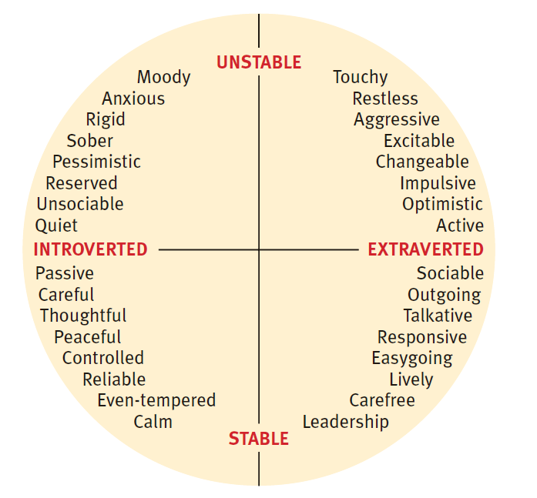
Myers&Briggs wanted to study individual behaviors/statements to see how people’s personalities differ (having different traits).

Myers-Briggs Type Indicator (MBTI) is a questionnaire that categorizes people by traits.

Factor Analysis –identify factors that tend to cluster together.

Hans and Sybil Eysenck found that many personality traits are a function of 2 basic dimensions. (Research supported this theory –variations linked to genetics)

Are Traits Rooted in Biology?

The Brain:

Extraverts –low levels of brain activity (heard to suppress impulses: makes them seek stimulation)

The Body:

Trait of shyness possibly related to high ANS reactivity –easily triggered alarm system.

Genes:

Selective breeding of animals creates lifelong differences in traits (i.e. aggression, sociability, calmness), which suggests genetic roots for these traits.

Assessing Traits: Questionnaires

Personality inventory – Questionnaire assessing many personality traits, by asking which behaviors and responses the person would choose.

Empirically Derived Test –all test items have been selected because they predictably match the qualities being assessed.

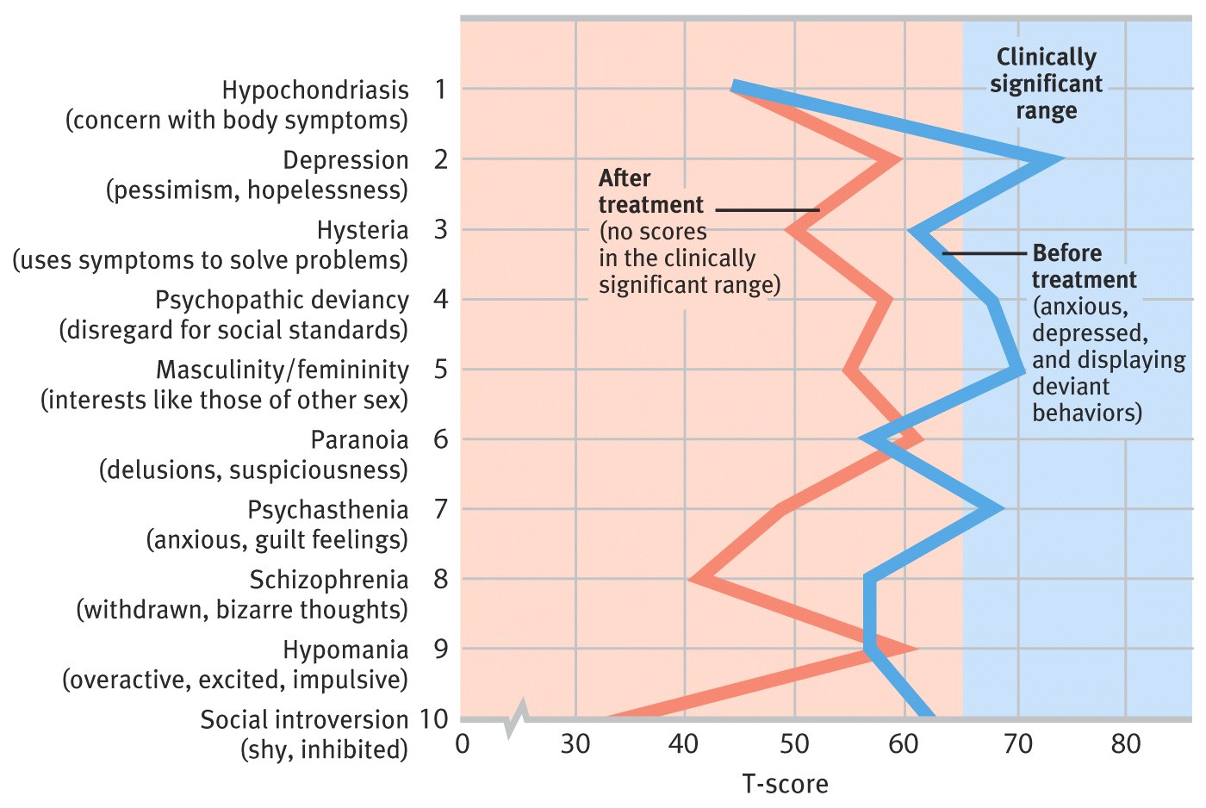
Minnesota Multiphasic Personality Inventory (MMPI) –is designed to identify people with personality difficulties.

True or false questionnaire –items are chosen because they correlated with various traits/emotions/attitudes.
Ex: Depressed people tend to answer “true” to: “Nothing in the paper interests me except the comics.”

Personality as Seen in Palms and Stars

By saying something that is vague and likely to be true of you, then following up on comments that you reinforce by nodding, someone can claim to “see into your soul”. (I.e. a palm reader, readers)

The “Big Five” Personality Factors

Eysencks believed that people varied along two dimensions.
Cross-cultural research+theory supports the expansion from two dimensions into 5 factors:

- Conscientiousness –self-discipline, careful pursuit of delayed goals.
- Agreeableness –helpful, trusting, friendliness.
- Neuroticism –anxiety, insecurity, emotional instability.
- Openness –flexbility, noncomformity, variety
- Extraversion –Drawing energy from others, sociability

Questions about Traits

Stability –One’s mix of traits doesn’t change much over the lifespan.
In adulthood, people become:
- More conscientious and agreeable
- Less extraverted, neurotic/unstable and less open.
Predictive value –Levels of success in work and relationships relates to traits.
Heritability –Genes account for 50% of the variation in most traits.

Change versus Consistency: Shifts with Age

Over the years, we change interests/attitudes/roles/jobs/relationships. We develop skills and build maturity. Do our traits stay stable during this change?
Evidence shows that it takes time for personality to stabilized.
Traits change, but less and less over time. (Change less, become more consistent).

Person-Situation Controversy
Trait theory assumes that we have traits that are a function of personality, not situation.

Evidence proves that some traits are linked to roles and personas we use in different cultures and environments.

Personality Affecting Situation –Not Just a Function of the Situation

Facebook timeline, profile picture, website, music lists, ringtone choice ALL reflect your personality.

They choices may influence how others treat you, which can also affect your personality.

Man’s room reflects his personality.
Contents in the man’s room may shape his personality.

Social-Cognitive Perspective

Bandura believes personality is:
- The result of an interaction that takes place between a person and their social setting
How we think about ourselves and our situations.
Questions raised in this perspective:

- How do we interpret/respond to external events? How do those responses shape us?
- How do our memories/expectations/schemas influence our behavior patterns?
- How do the personality and social environment mutually influence each other?

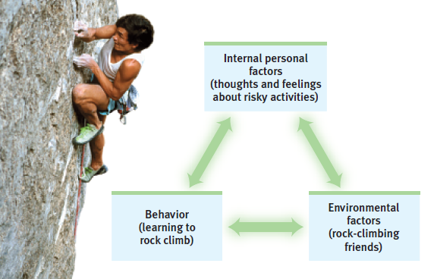
Reciprocal Influences in Becoming
Reciprocal a back and forth influence with no primary cause.

Ex: A tendency to enjoy risky behavior affects your choice of friends.
This in turn may encourage risky activities such as rock climbing. (Could lead to identifying with the activity.)

Reciprocal Determinism
How personality, thoughts, social environment all reinforce/cause each other.

Ex: Why is Jake a happy, smiley person?
He may have started with an “easy” temperament.
He may attract other people –people are more likely to smile around him (reinforces his smile)

He will think of these reasons why he was smiling, even though it may have been a reflection of his happy friends “rubbing” off on him.

Biopsychosocial Approaches to Personality

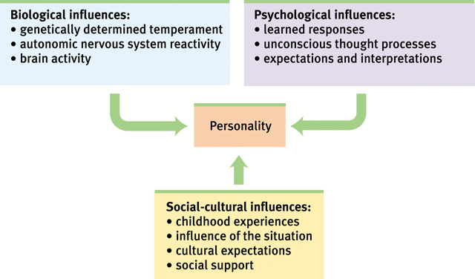
External versus Internal Locus of Control
Locus of control is our perception of where the power over our lives is located.
Internal locus of control –feeling that we are in charge of ourselves/our circumstances.
-Too much: self-blame for bad events.
External locus of control –we picture that a force outside ourselves controls our fate.
-Too much: Lose initiative and motivation and the desire to develop willpower (anxious).

Self-Control –Resource, Skill, Trait

Willpower –the ability to control impulses and delay gratification.

Willpower uses brain energy, which in time is replenished but can be depleted short-term.
Ex: People asked to resist cookies gave up sooner on a tedious task (cannot use brain energy for will power when you are occupied during a tedious task)

With practice, we can improve our self-control.
Individual differences in this trait found in childhood.
Ex: Marshmallow study –kids who resisted the temptation to eat marshmallows later had more success academically and socially.

Learned Helplessness versus Personal Control

Uncontrollable bad events –A dog is given no chance of escape from repeated shocks.
Result: It will give up trying to escape pain, even later on when it has the option to escape.
experiment by Seligman

⬇

Perceived lack of control –Learned Helplessness: declining to help yourself after continuously attempting to self-help have failed.

⬇

Generalized helpless behavior –Personal control: When people are given multiple choices, they succeed/thrive.

Optimism versus Pessimism

We can be optimistic or pessimistic in various ways:

- Prediction –we can expect the best or the worst. We become overconfident or depressed in extreme situations.
- Focus of attention –we can focus on what we have (glass half full-optimism) or what we don’t have (glass half empty-pessimism)
- Attribution of intent –we assume that people meant to hurt us (pessimism) or that they were having a bad day. (optimism)
- Potential for change –We can assume bad thing cannot be changed (pessimism) or have hope (optimism)

Excessive pessimism can leave us depressed and inactive.
Excessive optimism can leave us unprepared and unsafe.
Realism is in between optimism and pessimism –realistic perspective.

A More Positive Psychology

Seligman (created the experiment with shocking dogs) also developed positive psychology –the scientific study of optimal human functioning,” finding ways to help people thrive.

Focus of the theory: build strengths, virtue, emotional well-being, resilience, optimism, sense of meaning.

Three Pillars of Positive Psychology

- Emotions
- Character
- Groups, Culture, Institutions

Evaluating Behavior in Situations: Blindness to One’s Own Faults

Donald Trump prided himself on evaluating executive skills in others.
Assessments based on performance in such simulations predict future job performance better than interviews and questionnaires.

Evaluating the Social-Cognitive Perspective

Social-cognitive perspective on personality helps us focus on the interaction between behaviors, thoughts and social situations.

This focus may distract us from noticing someone’s personal feelings, emotions and inner qualities.

Critics note that traits may be more a function of genetics and upbringing, not just situation.
Ex: Two people with different reactions in the same situation: 2 lottery winners sharing a jackpot; one sobbed, the other slept.

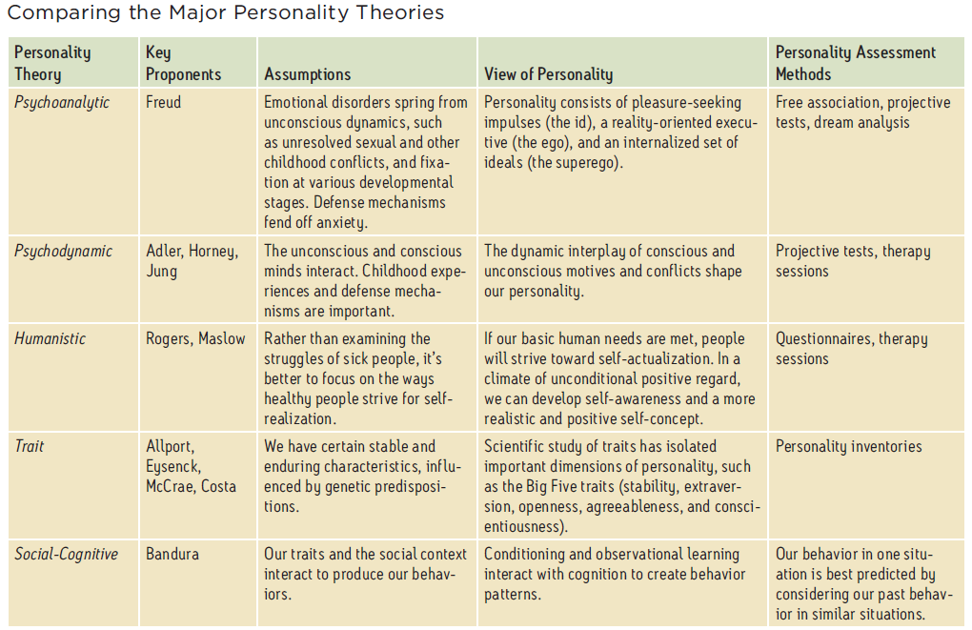

Exploring the Self, Viewing the Self

Researching personality also includes researching the person’s sense of self.
Topics of research:
- Self-talk
- Self-esteem
- Self-awareness
- Self-monitoring
- Self-control

Refined definition of self –the core of personality, the organizer and reservoir of our thoughts, feelings, actions, choices, attitudes and also our feelings about that identity.

Topics for our study of sense of self:

- Spotlight Effect (self-consciousness)
- Self-Esteem (low vs high, benefits and risks)
- Self-Serving Bias
- Narcissism
- Self-disparagement
- Secure self-esteem

Self-Consciousness: The Spotlight Effect

Experiment: Students put on Barry Manilow T-shirts before entering a room with other students.
(Manilow was uncool)
Result: The students thought others would notice the T-shirt, assumed people were looking at them, when this was not the case, they greatly overestimated the extent to which the spotlight was on them.

The spotlight effect –assuming that people are have attention focused on you when they actually may bot be noticing you.

Lesson: People don’t notice our errors, quirks, features, and shirts as much as we think they do.

Self-Esteem
High and low, Good and bad

People with normal to high self-esteem have benefits:
- Increased resistance to conformity pressure.
- Decreased harm from bullying
- Increased resilience and efforts to improve their own mood.

Maybe high self-esteem is actually a result, not a cause of these benefits.

Low self-esteem leads to problems: prejudice and being critical of others.

Self-Serving Bias

We all generally tend to think we are above average.
This bias can help defend our self-esteem.

Self-Focus and Narcissism

Empathy scores and skills are decreasing and being lost.
People don’t bother trying to see things from the perspectives of others (close mindedness).

Narcissim is self-absorption, self-gratification and inflated self worth.
It is on a rise; they see themselves as having a “special place” in the world.
When self-esteem is threatened in a narcissist, it can trigger defensive aggression.
To prevent this, you must reinforce self-esteem and have people state their own values/qualities.

Self-Disparagement/Belittling and Self-Acceptance

Some people have a tendency to belittle themselves: “I’m no good” and “I’m going to fail”.
Sometimes these remarks are a sign of depression or feeling inferior.
The remarks may also:
- Cause pity
- Prepare us for possible bad events
- Help us learn from our mistakes (people are critical of past selves)

Moving from defensive to secure self-esteem requires self-acceptance and realistic expectations.

Chapter 15: Psychological Disorders

Why do we learn about psychological disorders?

- Familiarity with psychological symptoms.
- Knowing someone else with the disorder.
- Hearing about how prevalent and socially devastating some disorders are.
-Can lead to mass murders or suicide.
- Wanting to learn more about mental health and human nature.

Perspectives on Psychological Disorders

Questions to keep in mind:

1. How do we decide when a set of symptoms are severe enough to be called a disorder that needs treatment?

2. Can we define specific disorders clearly enough so that we can know that we’re all referring to the same behavior/mental state?

3. Can we use our diagnostic labels to guide treatment rather than to stigmatize people?

Keep these in mind while: defining, understanding, classifying and labeling psychological disorders. Also thinking critically about ADHD, insanity and responsibility.

Psychological disorders are patterns of thoughts, feelings, or actions that are deviant, distressful and dysfunctional.

Disorder refers to a state of mental/behavioral ill health.
A pattern refers to finding a collection of symptoms that tend to go together; rather than a single symptom.

Distress and dysfunction, symptoms must be severe enough to interfere with one’s daily activities.

Deviant

To deviate means to vary from what typically would happen.
In psychology, a behavior or mental state is considered deviant by a culture when it is different from what would be “normal” in that culture.

A disorder may by a deviation from a specific developmental pathway.

Is ADHD a disorder? A current debate in our society.

Is it deviant? Do some people have a level of inattentiveness, impulsiveness, or restlessness that goes beyond laziness or immaturity?

Is it distressful? Is the person enjoying being energetic? Or are they frustrated that they can’t focus?

Is there dysfunction? Are the symptoms harmless in managing day-to-day tasks and relationship or do they have a negative impact?

The answer to all three questions is, “yes.” For some people, ADHD is a disorder, deviating greatly from the norm, and causing significant distress and dysfunction.
ADHD is over diagnosed in children –misinterpreting that they have ADHD when they are just energetic.

Understanding the Nature of Psychological Disorders

One reason to diagnose a disorder is to make decisions about treating the problem.

To treat a disorder, you must understand the nature/cause of the symptoms.

Based on older understanding of psychological disorders, treatments were –beating, caging restaints, drilling holes in the skull

Pinel’s New Approach

Pinel and others tried to reform brutal treatment by promoting a new understanding of mental disorders.

Pinel proposed that mental disorders were caused by environmental factors: stress and inhumane conditions.
Moral treatment was improving the environment.

The Medical Model

Psychological disorders can be seen as psychpathology –illness of the mind.

Disorders can be diagnosed –a collection of symptoms that tend to go together.

People with disorders can be treated –attended to, given therapy to restore mental health.

This model was created when the discovery that syphilis causes mental symptoms (infection of brain).

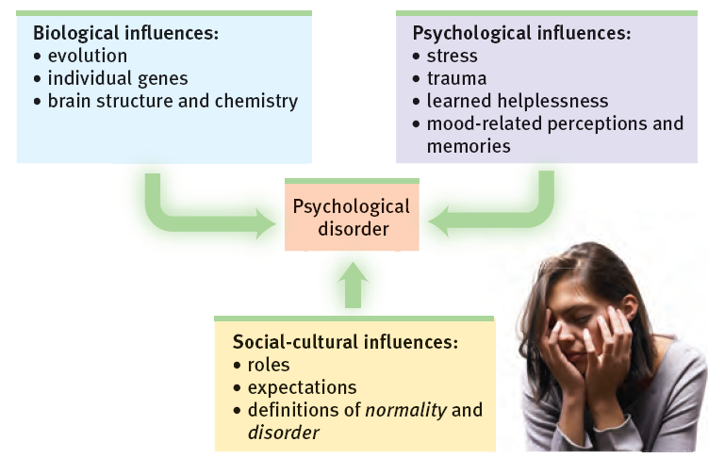

Cultural Influences on Disorders

Culture bound syndromes are disorders that only exist in certain cultures.
They demonstrate how culture can play a role in causing and defining a disorder.
Ex: bulimia (binging -US) Running amok (violent outbursts -Malaysia)

Classifying Psychological Disorders

Why classify mental illnesses?
- Diagnoses create verbal shorthand for referring to a list of symptoms.
- Diagnoses allow to statistically study similar cases –allows for predictions.
- Diagnoses can guide treatment choices.

Diagnostic and Statistical Manual

It’s easier to count cases of autism if we have a clear definition.
DSM is used to justify payment for treatment.
Consistent with diagnoses used by medical doctors worldwide

Five “Axes” of Diagnosis
DSM suggests describing someone with a five part picture:

Axis I:
Is a clinical syndrome present?
- Using specifically defined criteria, clinicians may select none, one, or more syndromes.
Axis II:
Is a personality disorder or mental retardation (intellectual developmental disorder) present?
- Clinicians may or may not also select one of these two conditions.
Axis III:
Is a general medical condition, such as diabetes, arthritis, or hypertension also present?
Axis IV:
Are psychosocial or environmental problems, such as school or housing issues, also present?
Axis V:
What is the global assessment of this person’s functioning?
- Clinicians assign a code from 0-100.

Critiques of Diagnosing with the DSM

- Calls too many people “disordered”.
- Border between disorder and normal seems subjective.
- Decisions about “what is a disorder” seem to include value judgments.
- Diagnostic labels direct how we view the world.

Stigma and Stereotypes

People think a diagnostic labels mean being seen as weak and weird.
With this, psychologists believe we should be cautious when diagnosing/labeling.

These negative views or “stigmas” come from popular cultural views of mental illness, and not from the DSM.
DSM may contain information to correct these inaccurate perceptions of mental illness.

Insanity and Responsibility

Loughner shot many people, including a US representative in 2011.
He had schizophrenia and substance abuse problems combination associated with increased violence.

To what degree should he be held responsible? What is the appropriate consequence?

Anxiety Disorders

- GAD: Generalized anxiety disorder
- Panic disorder
- Phobias
- OCD: Obsessive-compulsive disorder
- PTSD: Post-traumatic stress disorder

GAD: Generalized Anxiety Disorder

Emotional-cognitive symptoms –worrying, anxious feelings/thoughts, “free-floating” anxiety with no actual trigger/attachment.
Anxious anticipation interferes with concentration.

Physical symptoms –trembling, sweating, agitation, sleep disruption (sympathetic ns)

Panic Disorder

A panic attack may include:
- Many minutes of intense dread or terror.
- Chest pains, choking, numbness, etc... (may think it’s a heart attack)
- A feeling of a need to escape.

Panic disorder is repeated and unexpected panic attacks, as well as fear of the next attack. A change in behavior just to avoid panic attacks.

Specific Phobias

A phobia is more than a strong fear/dislike.
It is diagnosed when there is an uncontrollable, irrational intense desire to avoid the object/situation.
Even an image of the object can trigger a reaction –“Get it away from me!!”
Some Fears and Phobias

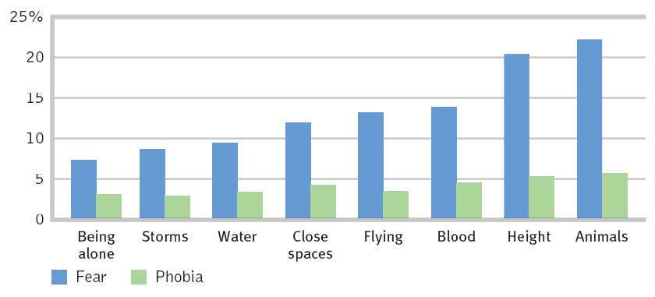
Agoraphobia –avoidance of situations when you feel closed in and unable to escape, resulting in a fear of a panic attack.

Social phobia –intense fear of being watched and judged by others.
I.e. embarrassment, humiliation, public speaking, eating, performing.

Obsessive-Compulsive Disorder (OCD)

Obsessions are intense, unwanted worries, ideas and images that repeatedly pop up in the mind.

Compulsion is a repeatedly strong feeling of “needing” to carry out an action –even if it doesn’t make sense.

Distress: When you are frustrated with not being able to control the behaviors.
Dysfunction: when the time and mental energy spent on thoughts/behaviors interfere with everyday life.

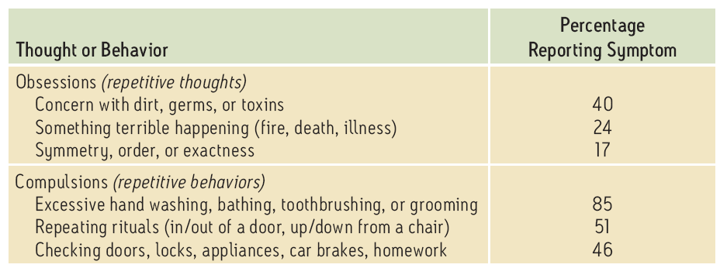

Post-Traumatic Stress Disorder (PTSD)

10-35% of people who experience trauma have 4 weeks to a lifetime of:
- Repeated recalls of those memories
- Nightmares, re-experiencing
- Social withdrawal or avoidance
- Jumpy anxiety, hypervigilance
- Insomnia, sleep problems.

Which People get PTSD?

People with less control in the situation –sense less of a chance to escape/change.
People traumatized more frequently –less chance to recover from stress/harm.
People with brain differences –a sensitive amygdala, attention issues.
People who get re-traumatized –intrusive debriefing.

Resilience/recovery after trauma may include:
- Lingering stress
- Finding self strengths
- Finding connections with others
- Finding hope
- Seeing the trauma as a challenge that can be overcome
- Seeing yourself as a survivor.

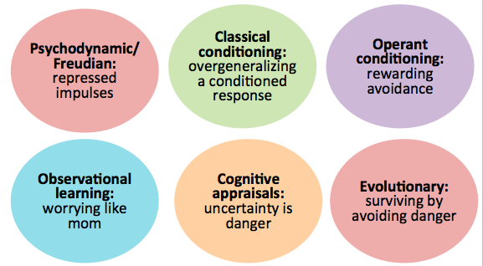
Understanding Anxiety Disorders: Different Perspectives

