Office hours 9:30 to 11am on Monday
Prof Gaynor spencer
Office location MCH F22
Tel ext. 3391
  - Bio Lecture 1

Lecture notes
Week 1
The nervous system
- introduction to human biology and scientific method
- introductions to nervous system
- individual brain cells input region output region
- point of contact b/w brain cells the synapse
- changes in brain connections learning memory
- cocaine how it affects connections in the brain
- links between drug addiction and learning memory

Introduction to biology
1. They require energy and raw materials, living things have ability to create molecules
2. They are made of cells, smallest unit to sustain life
3. maintain homeostasis, ability to maintain constant environment, cellular level and whole organism level
5. respond to external environment, all info going into nervous system, brain chooses what info it wants to focus on.
6. grow and reproduce

Defining features of human (taken together)
- Bipedalism
- Opposable thumbs We have the ability to use the tips of our fingers, we have fine control
- LARGE BRAIN
- Capacity for complex language

Population: group of same species
Community: population of different species, all the different species that might be found there
Ecosystem: organisms and non living matter.
Organs combine into organ systems
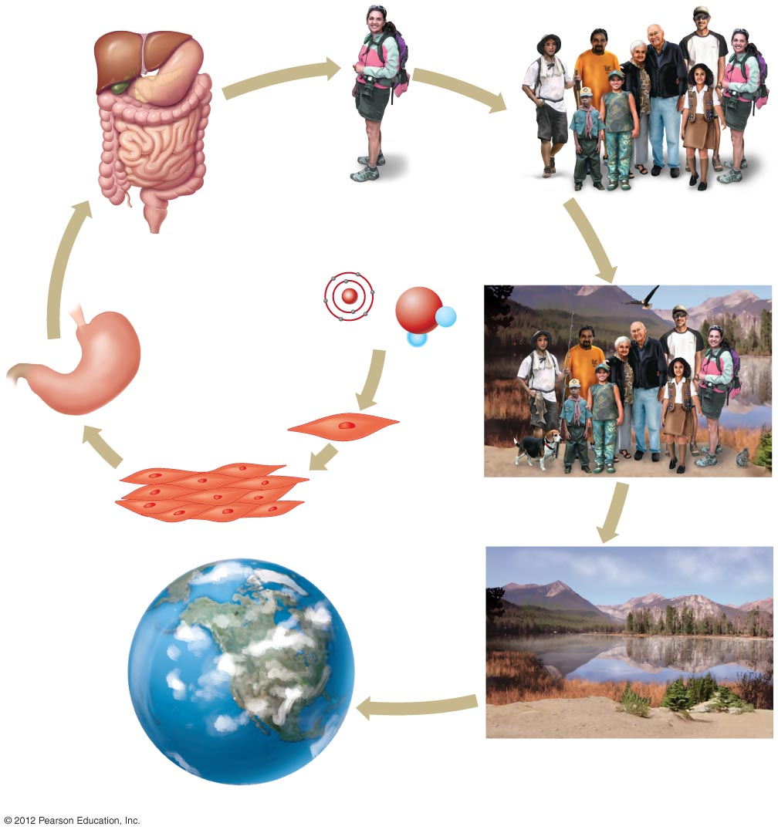
Organ system
Organism
Population
Organ
Atom
Molecule
Community
Biosphere
Tissue
Cell
Ecosystem

Science: is both knowledge and the process used to obtain that knowledge. Relies on observation and experimentation.

The scientific method: a process for testing ideas

- Observe and generalize** from the observations generalizations are then made
- Formulate and hypothesis** general statement, doesn’t allow you to directly test so you need to make testable prediction
- Make testable prediction
- Experiment or observe
- Modify hypothesis and repeated steps if necessary** go back and see if your experiment is the same as your hypothesis

How and experiment might be set up.
- Observe and generalize: two separate studies have shown that Drug X lowers blood pressure in different mammalian species eg, rats/d
- Hypothesis: Drug X would be a safe and effective treatment for high blood pressure (BP) in humans. **Can rarely be proven true, its very difficult.
- Testable Prediction: e.g If Drug X is safe/ effective for treating high BP in humans, then 10mg/day will lower BP in people with high blood pressure within months
- Design and conduct experiment:
-carefully planned
-conducted under controlled conditioned
-controlled variable(BP)
N.B A hypothesis can not be proven true only supported. **Where there is very distinct parameter where its being tested.

How to test this
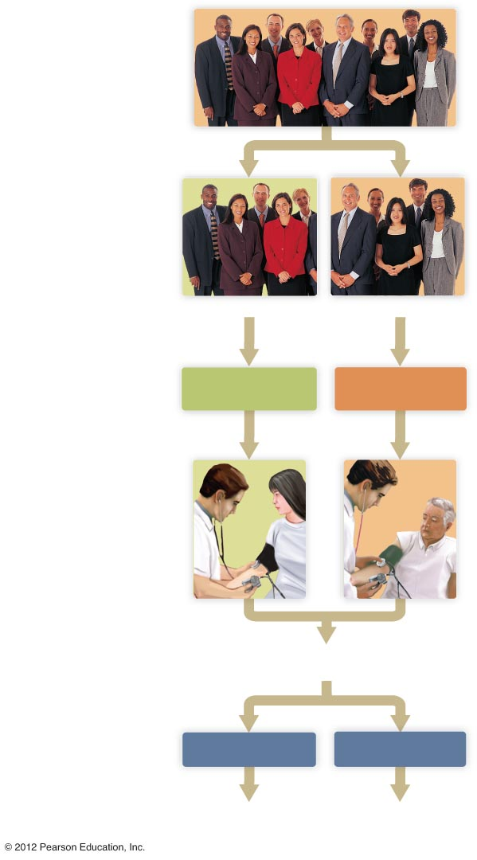
- Get large # of people(group with high BP)
- Randomly divide the subjects into 2 groups (if its not random there could be a bias, things like variables that need to be kept constant, age, gender, weight, diet, it needs to be random for this reason no bias)
Control group:
receives Placebo
Experimental group:
receives treatment
GROUP1
GROUP2
- Treat the groups equally in all ways but one.
- Experiment group gets drug X
YES
NO
Modify hypothesis to fit new findings
Hypothesis received support
Is blood lower in Experimental group?

- Control group accounts for all unknown factors.
- Blind is keeping people in the dark, double blind is keeping the researcher in the dark about the drug too. Double blind gets rid of the bias.
- Observe or make measurements.
- Compare result
Group 1, receives treatment (experimental)
Group 2, receives placebo(control)
is the blood pressure lower in the experimental group?
there could be other things going on that, subconscious, changes in their life to try to bring their blood pressure down. Many factors in the

