SCHEDULES OF REINFORCEMENT AND CHOICE BEHAVIOUR
6.2 a introduction to schedules of reinforcement
-in real life, we only get reinforced some of the time and to a specific schedule
Schedule of reinforcement – plan specifying when reinforcement will follow response
-can depend on number of responses OR passage of time
Continuous reinforcement (CRF) – reinforced with every response

Intermittent reinforcement – only some response are reinforced
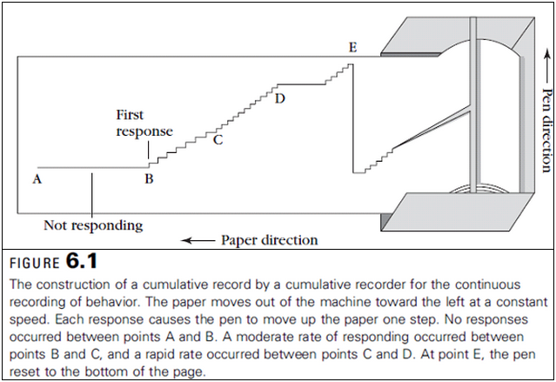
Cumulative recorder:
-look at slope on cumulative recorder
-each schedule of reinforcement causes a specific pattern of responding on cumulative recorder
6.2 b ratio schedules
Ratio schedule – reinforcement depends on number of responses
-2 types:
1. fixed ratio (FR) – same number of responses needed
-FR-1 is technically same as CRF
Post-reinforcement pause – period of no responding after reinforcement
-irrelevant to time taken to eat because length increases with larger FR schedules
Ratio run –rapid responding right before ratio requirement is completed
2. variable ratio (VR) – delivered after an AVERAGE number of responses
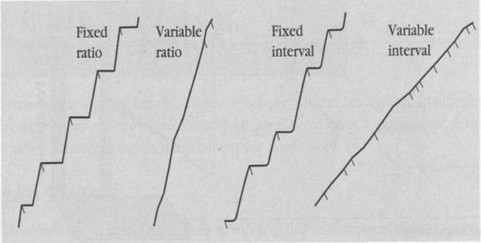
-no predictable pauses – high, steady rate of responding at all times

6.2 c interval schedules – reinforce first response after certain amount of time
Fixed interval (FI) – amount of time between reinforcements is same
FI scallops – pause of reinforcement, and then gradual increase in responding until right before reinforcement
Variable interval (VI) – amount of time between reinforcements varies each time
-steady rate with no predictable pauses
6.2 d comparison of schedules
-fixed schedules both have pauses after reinforcement and high rate of responding right before reinforcement
-variable schedules both have steady rates of responding with no predictable pauses
-ratio schedules both have higher response rates than interval schedules
-2 theories as to why this is true:
1. centres around the interresponse time (IRT) (interval between responses) – short interval time is reinforcing and ratio schedules allow participant to shorten it, this makes long IRTs reinforcing because they’re paired with short IRTS in variable
2. feedback function – no limit on how many they can learn in a fixed time, and faster responding causes more reinforcement
6.3 choice behaviour: concurrent schedule – experiment in which we allow animal to choose between 2 different activities with different reinforcement schedules – see how we choose what we do
6.3 a measures of choice behaviour
-relative rate of responding on each alternative
RR_{L} = B_{L} / (B_{L} + B_{R}) RR_{L} = relative rate of behaviour left choice
RR_{R} = B_{R} / (B_{L} + B_{R}) RR_{R} = relative rate of behaviour right choice
B_{L} = # of behaviours on left alternative
B_{R} = # of behaviour on right alternative
-equal choices made to each side – RR_{L} = RR_{R} = 0.5
-more to left side - RR_{L} > 0.5 and RR_{R} < 0.5
-more to right side - RR_{L} < 0.5 and RR_{R} > 0.5
-relative rate of reinforcement earned on each alternative
rr_{L} = r_{L} / (r_{L} + r_{R}) rr_{L} = relative rate of reinforcement left choice
rr_{R} = r_{R} / (r_{L} + r_{R}) rr_{R} = relative rate of reinforcement right choice
r_{L} = # of reinforcements earned on left alternative
r_{R} = # of reinforcement earned on right alternative
-equal choices made to each side – rr_{L} = rr_{R} = 0.5
-more to left side - rr_{L} > 0.5 and rr_{R} < 0.5
-more to right side - rr_{L} < 0.5 and rr_{R} > 0.5
6.3 b the matching law – proportion of responses on any alternative is equal to rewards earned
-do not put a lot of effort into little reward, or little effort into big reward
B_{L} / (B_{L} + B_{R}) = r_{L} / (r_{L} + r_{R}) OR B_{L} / B_{R} = r_{L} / r_{R}
-both are equal and show matching law
-as predictive as it is, it was designed for interval not ratio schedules, therefore doesn’t work as well with ratio – if given choice between FR-5 and FR-20, it will obviously choose FR-20
i: non-matching – matching does not always occur
-if they are unaware of each alternative’s schedule
Undermatching – responds to alternative less than expected
Overmatching – responds to alternative more than expected
Response bias – develop stronger preference for alternative over time
B_{L}/B_{R} = b(r_{L}/r_{R})S b = response bias
S = sensitivity to schedule
b = 1 = no response bias S = 1 = perfect matching
b > 1 = left is preferred over right S < 1 = undermatching
b < 1 = right is preferred over left S > 1 = overmatching
ii: simple reinforcement schedules
-if matching law is fundamental, it should apply when looking at choosing between instrumental response and other things
B_{X} / (B_{X} + B_{O}) = r_{X} / (r_{X} + r_{O}) B_{X} = doing instrumental response
r_{X} = reinforcement of instrumental response
B_{O} = doing other things
r_{O} = reinforcement of doing other things
(B_{X} + B_{O}) can be simplified to a constant ‘K’ because it represents all possible behaviours
-therefore, B_{X} = kr_{X} / (r_{X} + r_{O})
-shows us to increase B_{X} (instrumental response) we increase r_{X} (reinforcement of instrumental responses) or decrease r_{O} (reinforcement of doing other things)
-shows us to decrease B_{X} (instrumental response) we decrease r_{X} (reinforcement of instrumental responses) or increase r_{O} (reinforcement of doing other things)
iii: mechanisms of the matching law
-all agree when given a choice, animals distribute responses to get most efficient possible reinforcement
Molecular theories: we apply matching theory to moment-by-moment situations to get optimal rewards
Molar theories: we apply matching theory to compilation of all actions (maximize reinforcement of all combined actions)
Melioration theories: combination of both – compromise a little effort from each situation
6.4 complex choices
-reality is different – choices we make puts us on a patch for a while and discontinues alternatives for a while
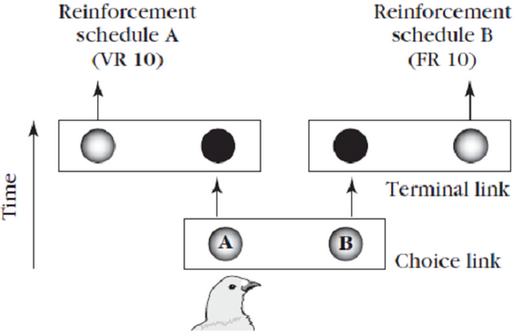
6.4 a concurrent-chain schedules – choose between 2 response alternatives, but with 2 stage or links

-makes initial stage or choice link that doesn’t result in reinforcement, but determines what schedule in second stage, that THEN leads to reinforcement

6.4 b studies of self-control
-showing self-control is abandoning the immediate small reward and choosing the larger delayed reward
-(studies have shown) it is easier to do this if smaller reward is not immediately available
6.4 c value discounting function – shows decrease in reward value as delay increases
V = M / (1 + KD) V = value D = delay
M = magnitude K = speed value decreases as delay increases
-conceptualizes choices between small immediate or large delayed rewards
-value is directly related to magnitude, and inversely related to delay
-K is directly related to someone’s self-control level, being related to other character traits (ie addiction)

