INSTRUMENTAL CONDITIONING: FOUNDATIONS
5.1 introduction
-behaviour is emitted (not elicited) – subject initiates behaviour and it is already part of their repertoire
-consequences of behaviour determine future frequency of behaviour
5.2a Thorndike and the Law of Effect
Thorndike – studies cats in puzzle boxes (early 1900s)
-thought outcome was not part of the association
Law of Effect – if response in presence of a stimulus is followed by a pleasant event, association between S (stimulus) and R (response) will be strengthened – vice versa
5.2 b Tolman
Cognitive maps:
-disagreed with S-R learning (Thorndike), or that animals are learning about behaviours and having those behaviours triggered by stimuli
-saw behaviour as a flexible means to a goal – learn about stimuli in the environment and represent those in memory, such as with a cognitive map
-animals don’t just learn about S-R associations, but they learn about stimuli and places too
Latent learning – learning in absence of reinforcement
-showed reinforcement gives reason to show they know the association, but is not necessary for learning S-R associations themselves (let rats explore maze, knew maze as soon as given reinforcement)
-goes back to learning-performance distinction – cannot just look at behaviour to infer learning has occurred
5.2 c Skinner
-showed how voluntary behaviour is related to payoff – animal has to do behaviour to get reward (Skinner Box)
-showed behaviours occur under certain stimuli
Superstition experiment – pigeons ‘made up’ a set of behaviours they thought led to reinforcement even though no behaviour was necessary
-shows reinforcers are so powerful their effects can be accidental or automatic
-took into great consideration responses immediately before reward – shows animals take into account timing of behaviour via reinforcement very strongly
5.3 modern instrumental conditioning methods
5.3 a 2 types of instrumental conditioning procedures
Discrete-trial procedure – instrumental response is done once per trial, animal is then removed from apparatus (runway or T-maze)
-usually measures latency to reach goal or running speed
Free-operant procedure – does instrumental response repeatedly (lever pressing or key pecking in Skinner box)
-measures response rate to determine likelihood of response over time
Operant response – defined by effect response has on environment
-no matter which body part presses lever, lever pressing is operant response
-doesn’t matter how behaviour is done, matters how behaviour operates on environment
5.3 b shaping
How to shape a behaviour: example training rat to press lever
Magazine training – classic conditioning teaches to pair click of food delivery device with delivery of food
-to shape, reward successive approximations to required response while not rewarding earlier response forms (once that part of behaviour is accomplished, reward further behaviour instead)
Variability in behaviour is necessary for shaping: must have some kind of pre-existing variability in behaviour
-if exact same behaviour is done every time, you cannot reward next behaviours and cannot not reward behaviours in wrong direction
Using shaping to teach new response:
-usually use behaviours already done by animal, then teach it to do those in certain way, place, and/or time to accomplish a specific behaviour
-for new behaviours, use variability in old to teach different variations of behaviour (essentially a new behaviour entirely)
5.4 4 instrumental conditioning procedures
- future response rate depends on:
1. outcome – 2 possible kinds:
Appetitive stimuli – pleasant outcome (food, praise, money, good grades, smiles, etc.)
Aversive stimuli – shock, public humiliation, annoying sounds, extreme temperatures, etc.
2. outcome-response contingency – 2 possible kinds:
Positive contingency – response produces outcome
Negative contingency – response eliminates outcome
-these can combine to give four possible outcomes:
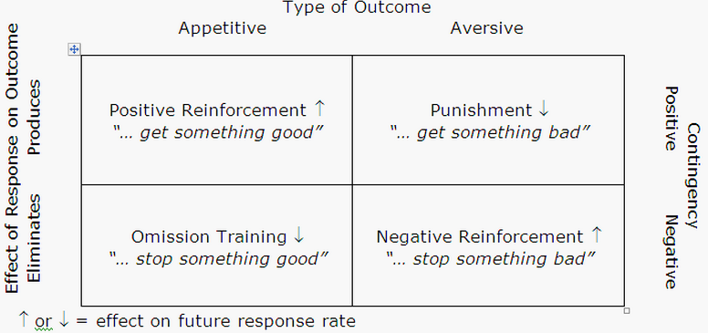
- Positive reinforcement – give something good
- Negative reinforcement – take away something bad
- Punishment – give something bad
- Omission training – take away something good
5.5 fundamental elements of instrumental conditioning
-key players involved in instrumental conditioning:
- response
- outcome (reinforcement or consequence)
- relation between response and outcome (contingency)
5.5 a the instrumental response
i: behavioural variability vs stereotypy
-Thorndike and skinner both saw instrumental behaviour as strengthening of a response
-led to belief instrumental conditioning produces repetitions of same behaviour (stereotypy)
-therefore, rat will come to press lever in less varied way
-variability goes up if you reinforce variability (less stereotypy)
ii: belongingness of instrumental response
-easier to teach an animal an instrumental response if it belongs with the reinforcement from an evolutionary perspective
Instinctive drift – responses animals would normally do in food situation interfere with learning instrumental response for food reinforcement
-shows al responses are NOT equally learnable
-therefore, responses that fit well with situation or reinforcement have a learning advantage
iii: behaviour systems theory
-behaviour system the consequence activates affects whether they will do the desired response
Ex: if a hamster is rewarded with food, depriving them of food will make them do responses relevant to the hunger behaviour system, but frequency of irrelevant behaviours will not increase over many trials
5.5 b the instrumental reinforcer
-there is a lot of evidence showing animals expect something for their responses
i: reinforcer quantity and quality
-increasing quality or quantity increases response rate
-if either are too low, there will be no change in instrumental response
-if too big, could become satiated or reinforcement could become aversive
-bigger the response needed, bigger the reinforcement needed
-longer response period if access to reinforcement is longer
-the more favoured the reinforcer the better the response rate
ii: shifts in reinforcer quantity or quality
-animals expect specific quality or quality of reward – expectation reinforces behaviour in first place
Positive contrast – getting better reward than usual (better than expected)
Negative contrast – getting worse reward than usual (not as good as expectation)
5.5 c the response-reinforcer relation
-2 important relations between instrumental response and the reinforcer:
1. temporal contiguity – time between response and reinforcement
-good delivers reinforcer quickly
2. response-reinforcer contingency – extent the response is necessary and sufficient for reinforcement delivery
-good delivers reinforcement every response and never when it doesn’t
i: effects of temporal contiguity
-learning instrumental response is highly dependent on temporal contiguity – learns much faster and better when time between in small
-confuses animal as to what they’re reinforced for – 2 ways to fix this:
1. use a conditioned reinforcer – stimulus previously associated with reinforcement
2. marking procedure – present non-reinforcing stimuli after response whether it is right or wrong – lets animal know that response holds significance
ii: effects of response-reinforcer contingency
-response-reinforcer contingency is important for instrumental conditioning, but you need both for successful conditioning
-Skinner thought contiguity was most important – did a study with Pigeons, found even when reinforcing any behaviour, learning was accomplished
-this study was then replicated – found behaviours depended on stage of interval:
Terminal behaviours – at end of interval
-did NOT vary across birds because they did a species specific pecking near food – shows accidental reinforcement was not occurring
Interim behaviours – early in interval
-was likely only classical conditioning (birds pecked at time food was about to be administered)
-shows there MUST be both to produce true instrumental conditioning
iii: effects of controllability of reinforcers
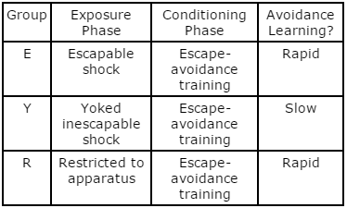
-learned helplessness if participant can’t control the outcome and it is negative
Learned helplessness effect – exposure to uncontrollable shock interferes with subsequent learning
Learned helplessness hypothesis – animals exposed to inescapable shock behave like they’ve learned their behaviour had nothing to do with turning off the shock
-if they previously learned behaviour does not control shock, it becomes harder to teach that they do have control
-there are not only cognitive deficits, but motivational deficits, and emotional deficits (passive to shocks)
Immunization effect – giving escapable shock before inescapable shock stopped development of those deficits
-others hypothesized animals froze in response to shock, learning to be inactive to shock
-doesn’t explain errors in T-maze – should have latency, NOT errors
-others thought exposure to shock makes them feel it less, causing them not to react as potently
-eliminating this effect (physiological manipulation) doesn’t eliminate the effect
-others say inescapable shock changes brain chemistry therefore how they react – need more research
-escapable shock is less harmful because escape itself becomes signal for shock termination

