Question 1:
(a) Why is it so important to control the rate of drying of a ceramic body that has been hydro-plastically formed or slip cast?
(b) Cite three factors that influence the rate of drying, and explain how each affects the rate.
Solution
(a) It is important to control the rate of drying inasmuch as if the rate of drying is too rapid, there will be non-uniform shrinkage between surface and interior regions, such that warping and/or cracking of the ceramic may result. The rate of surface evaporation must be diminished to, at most, the rate of water diffusion toward the surface.
(b) Three factors that affect the rate of drying are temperature, humidity, and rate of air flow. The rate of drying is enhanced by increasing both the temperature and rate of air flow, and by decreasing the humidity of the air. On the other hand, there are three factors that affect the drying shrinkage which may consequently influence the drying rate. The factors are thickness of the body, clay particle size, and the water content. Increasing the water content and the body thickness increase the shrinkage. Decreasing the clay particle size will enhance the body shrinkage.

Question 2:
A three-point bending test is performed on a glass specimen having a rectangular cross section of height d = 5 mm and width b = 10 mm; the distance between support points is 45 mm.
(a) Compute the flexural strength if the load at fracture is 290 N.
(b) The point of maximum deflection Δy occurs at the center of the specimen and is described by

where E is the modulus of elasticity (69 GPa for glass) and I is the cross-sectional moment of inertia. Compute Δy at a load of 266 N.

Solution
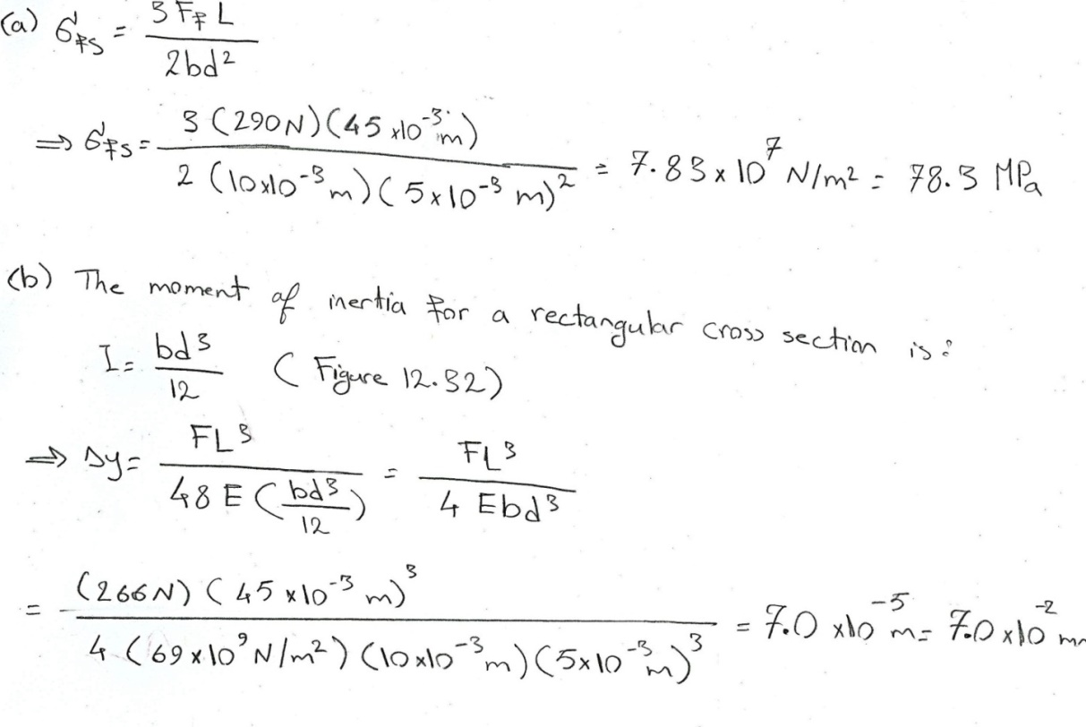
Question 3:
Compute the critical crack tip radius for an Al₂O₃ specimen that experiences tensile fracture at an applied stress of 275 MPa. Assume a critical surface crack length of 2 × 10⁻³ mm and a theoretical fracture strength of E/10, where E is the modulus of elasticity.
Solution:
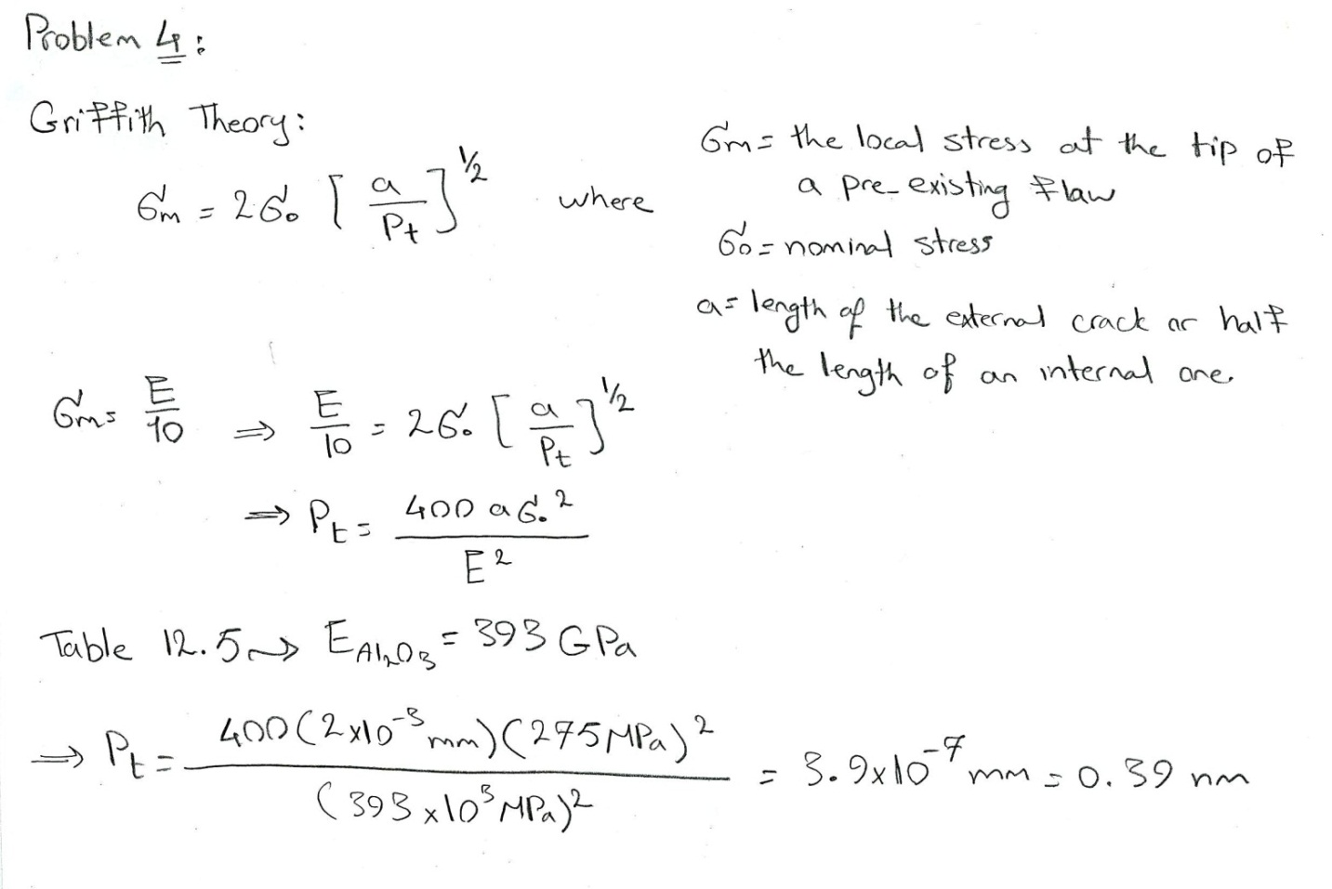
Question 4:
Briefly explain how each of the following influences the tensile or yield strength of a semicrystalline polymer and why:
(a) Molecular weight
(b) Degree of crystallinity
(c) Deformation by drawing
(d) Annealing of an undeformed material

Solution:
(a) The tensile strength of a semicrystalline polymer increases with increasing molecular weight. This effect is explained by increased chain entanglements at higher molecular weights.
(b) Increasing the degree of crystallinity of a semicrystalline polymer leads to an enhancement of the tensile strength. Again, this is due to enhanced interchain bonding and forces; in response to applied stresses, interchain motions are thus inhibited.
(c) Deformation by drawing increases the tensile strength of a semicrystalline polymer. This effect is due to the highly oriented chain structure that is produced by drawing, which gives rise to higher interchain secondary bonding forces.
(d) Annealing an undeformed semicrystalline polymer produces an increase in its tensile strength.

Question 5:
The following table lists molecular weight data for a polytetrafluoroethylene. Compute:
(a) The number-average molecular weight,
(b) The weight-average molecular weight, and
(c) The degree of polymerization.
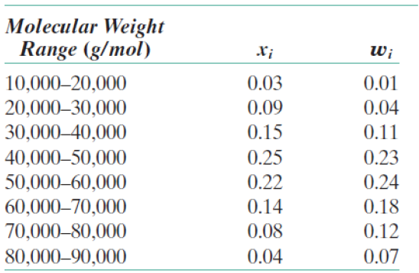
(a) From the tabulated data, we are asked to compute, the number-average molecular weight. This is carried out below.

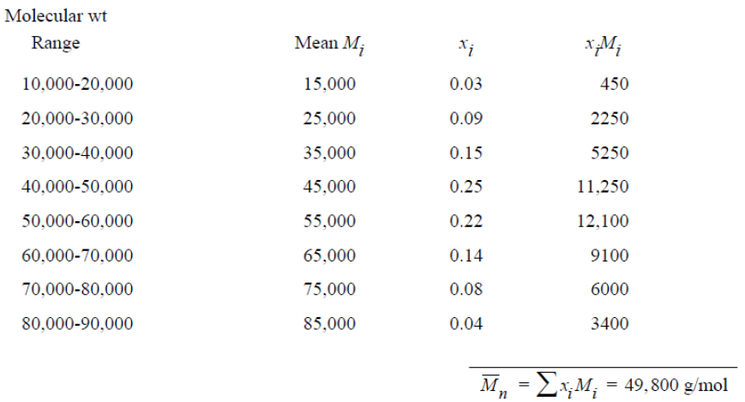

(b) From the tabulated data, we are asked to compute , the weight-average molecular weight.

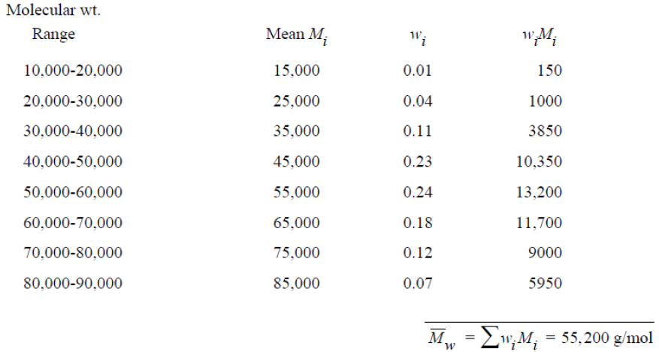

(c) Now we are asked to compute the degree of polymerization, which is possible using Equation 14.6. For polytetrafluoroethylene, the repeat unit molecular weight is just
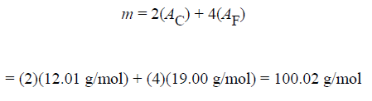
And,

Question 6:
Make a schematic plot showing how the modulus of elasticity of an amorphous polymer depends on the glass transition temperature. Assume that molecular weight is held constant
Solution:
For an amorphous polymer, the elastic modulus may be enhanced by increasing the number of cross-links (while maintaining the molecular weight constant); this will also enhance the glass transition temperature. Thus, the modulus-glass transition temperature behavior would appear as


