Mark 305 Notes

Chapter 1: An Introduction to consumer Behaviour

It’s all about you!

- You are a business student, a friend and a consumer with needs; making choices from competing brands
- Demographics: gender, income, occupation
- Psychographics: lifestyle and personality
- Behavioural: Usage Patterns

What is consumer Behaviour?

Consumer behaviour: the study of the processes involved when individuals or groups select, purchase, use, or dispose of products, services, ideas, or experiences to satisfy needs and desires.

Consumer Behaviour is a Process

- Consumer behaviour is more that just a purchase.
- It involves the issues that influence the consumer before, during, and after the purchase.

Consumer Impact on Marketing Strategy

- Knowing & understanding customers is key for exceptional companies.
- Award winning businesses know their customers as well as they know themselves. They use this knowledge to give buyers:
  - the right product
  - at the right place
  - at the right time
  - for the right price

Segmenting Consumer

Marketing segmentation identifies groups of consumers who are similar to one another in one or more ways and then devises marketing strategies that appeal to one or more groups

Demographics: Statistics that measure observable aspects of a population, such as:
  - Age
  - Gender
  - Family Structure and Life Stage
  - Social Class and Income (education, occupation, income)
  - Ethnicity
  - Geography

Demographics and Canadians

- Average Canadian worked 36.4 hours per week in 2011.
- The average income of a Canadian was $840 per week in 2011
- In 2011 the typical household spent $14,997 on shelter
- Average Canadian television viewing was 20.6 hours per week in 2010

Segmenting Consumers: Lifestyles

- Psychographics:
  - The way we feel about ourselves
  - Our attitudes to things and others around us
  - The things we value
  - The things we do in our spare time
  - how we use our disposable income

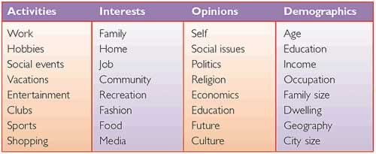

Segmenting Consumers: Behavioural

- Usage Rates
- Price Sensitivity
- Brand Loyalty
- Benefits sought

EX: Royal Caribbean cruise – Alaskan Cruise

Demographic:
- Retired people
- Ages 50-70
- Higher disposable income
- Higher class

Psychographic:
- People who like to travel
- Cruise enthusiast
- Enjoy scenery

Behavioural
- Like the Company (have used them several times before

Relationship Marketing

- Building lifetime relationships between brands and customers…a bond
  - Regular interaction with customers
  - Giving them a reason to maintain a relationship with the company
  - Not just interested in this purchase but future purchases

  - Marketers significantly influence lifestyles and consumption habits: combinations of Integrated Marketing Communications, rewards, and social media create strong loyal

  - Ex: points cards to build relationship

Marketing and Culture

- Popular culture
- Consisting of music, movies, sports, books, celebrities, and other forms of entertainment consumed by the mass market.
  - Both an inspiration and an influence
  - Tweeting
  - Movie heroes, product usage
  - Spokes characters (Pillsbury man)

Consumer generated content
- Consumers themselves voice their opinions about products, brands, and companies on blogs, podcasts, and social networks.
  - Opinions on brands and products
  - Social networking
  - Facebook, youtube

The Meaning of Consumption

- People often buy products not for what they do, but for what they mean
- The roles products play in our lives go well beyond the task they perform
  - Brands…
    - People chose the brand that …convey image/personality
    - …help us to form bonds with others who share similar preferences

Marketing Ethics and Public Policy

- Business Ethics: To conduct business honestly and ethically
- Rules of conduct that guide the marketplace
- Knowing right from wrong
- Various cultures and organizations may conduct themselves differently in certain situations

Ethical Standards of Conduct

- Prescribed code of ethics guidelines:
  - Disclosure of substantial risks with a product
  - Identifying added features that will increase the cost
  - Avoiding false or misleading advertising
  - Avoiding selling or fundraising under the guise of market research

- Think about it: Are you willing pay a bit more for fair trade coffee that helps various cultures?

Do Marketers Manipulate Consumers?

- Do marketers give people what they want or, do they tell people what they should want?

- Are advertising and marketing necessary?
  - Critics suggest we buy things we do not need, just because we can
  - Or are products designed to meet existing needs and promotions simply communicate product availability?

Public Policy and Consumerism

- Consumer welfare is protected at the federal, provincial and municipal levels
- Regulation protects the consumer from unfair business practices
- Consumers depend on governments to regulate and police standards

Consumer Activism and its Impact on Marketing

- Corporate Social Responsibility: voluntarily choose to protect or enhancr their positive social and environmental impacts as they go about their business activities.
- Cause-Related Marketing: Promise donations to charity as purchase incentives (corporate diving: companies giving their own money) ex: toms, pampers
- Green Marketing: they offer products in ways that are less harmful to the environment ex: less plastic
- Social Marketing: refers to using techniques normally employed to sell beer or detergent to encourage positive behavioural such as increased literacy or to discourage drinking ex: projects, awareness, social marketing campain

The Dark Side of Consumer Behaviour

- Addictive Consumption: is a psychological or physiological dependency on products or services
- Compulsive Consumption: repetitive shopping, often excessive done as an antidote to tension, anxiety, depression, or boredom.
- Anti-consumption: involves rebelling against the idea of consumption itself

Privacy

- Huge problem in the modern world, your information is all over the internet, ex: do you agree to the terms and conditions?
  - Use internet to find interests and advertise those interests to individual people
  - Cookies track where you go
  - All these companies have your information

Ex: snapchat, everyone has your information, Internet

Illegal Activities

- In North America a retail theft takes place every 5 seconds
- Shrinkage is the industry term for shoplifting and employee theft
- Fraudulent abuse of exchange policies in retail

The Role of Consumer Research

- Primary Research
  - When the data is collected by the researcher specifically for the research question at hand, this called primary research.

    - Surveys: method of data collection in which the respondent self-reports answers to a set of questions posed by the researcher

    - Focus groups: involve small group session with approx. 6-12 consumer participants

    - Interviews: questions/discussion in direct contact the consumer

    - Observational research: research consumer behaviours are directly observed, in either natural or controlled settings.

    - Qualitative research: (storytelling, role-playing, photos or pictures, diary)

    - Experimental research: used when researcher wants to make cause-effect claims

- Secondary Research
  - When the marketer finds the information needed by going to a pre-existing source of information collected for another purpose. When the researcher uses pre existing data to answer a new research question this is called secondary research.

*The wheel of Consumer Behaviour

Chapter 2: Perception

Sensations

- Immediate response of our sensory receptors…
- …eyes, ears, nose, mouth, fingers… to basic stimuli… such as light, colour, sound, odour, and texture
- Our world is a tapestry of stimulation

Lush: company all about sensation. Strong smell, soaps looking like cheese

Sensory Marketing: companies pay extra attention to the impact of sensation on our product experiences.

Sensory stimuli: Sensory Receptors
- Sights - Eyes
- Sounds - Ears
- Smells - Nose
- Tastes - Mouth
- Textures - Skin

Vision

- Colour, size, styling, brightness provokes emotion or stimulates
- Reaction to colour is both biological and cultural
- Trade dress: colours associated with specific companies
- Colour in packaging design is critical

- Yellow: optimistic, youthful, brightest colour
- Red: Increases heart rate, arousing, stimulate appetite
- Orange: Aggressive
- Black: status symbol, luxury
- Purple: calm, beauty, anti-aging
- Blue: Trust, security ex: BMO
- Green: Wealth, calmness, earthy
- Brown: reliable

Vision and Consumption

- Container size can influence the amount we consume
- Consumers ate 45 percent more popcorn from large as compared to medium popcorn buckets
- Tend to pour over 30 percent more into the shorter, wider glass than a taller glass
- Consumers eat more from smaller packs of candy when multiple small packs are available
- Blue is an unappetizing colour

Smell

- Scents stir emotion or create calm feelings
- Episodic memories of a pie out of the oven or a steaming cup of coffee…feelings of home
- One study found the smell of fresh cinnamon buns induced sexual arousal in males
- Scent marketing: from cars to fragrances

- Video: Scent marketing targets shoppers
  - Coconut in sunglass hut sense of being at the beach
  - Motorcycle and dirt smell
  - Hotel Western smelling like spa anywhere you go

Hearing

- Sound affects behaviour: airline passengers move to their seats faster with an up-tempo playing
- Jingles maintain brand awareness; lively music stimulates
- Harley Davidson’s revving engine has been trademarked
- https://www.youtube.com/watch?v=gjyWP2LfbyQ
- Honda “choir” advertisement
- Repetition in phonetic structure
  - Bebe
  - Jelly Belly
- Muzak uses sound and music to create a mood
  - High tempo = more stimulation
  - Slower tempo= more relaxing
- Muzak in factories can reduce absenteeism
- Certain high pitched sounds only teens can hear, allow ring tones that their parents won’t hear
- Subway stations play classical music to encourage teens to leave

Touch

- Haptic senses: touch is the most basic of senses; we learn this before vision and smell
- Touching affects the product experience
- Waiters who touch patrons get bigger tips
- Touching an item forms a relationship with the product
- Textures are associated with product quality
- We are more likely to buy a product after we touch it
- We are more likely to buy a product when we see someone else touch a product we did
- The longer you hold a product the more likely you are going to buy it

Taste

- Flavour houses develop new concoctions for consumer palates
- Cultural changes determine desirable tastes
- VanillaBoom
- 70% of Canadians like bolder tastes than they did 5-10 years ago
- hot flavours: Hot sauce, lemon, cilantro, chipotle, vanilla

Perception

- Sensations are selected, organized and interpreted

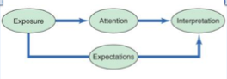

Exposure

- The process by which the consumer comes into contact with the stimulus and has the potential to notice it.
- Initial stage of Perception
- Exposure occurs when a stimulus comes within range of someone’s sensory receptors
- Consumers can focus on the stimulus, or ignore the information

Sensory Thresholds

- Psychophysics: The science that focuses on how the physical environment is integrated with our personal, subjective world

- Absolute Threshold: The minimum amount of stimulation that can be detected on a sensory channel

Differential Threshold and JND

- Differential Threshold: ability of a sensory system to detect changes, or differences between 2 stimuli
- Minimum difference between two stimuli is the JND- Just Noticeable Difference
  - Rule of Thumb: 20% is the minimum for consumers to notice a difference (sales minimum 20% off)
  - Can be different for different stimuli ex: notice difference in some aspects but not in others such as price vs. packaging, price vs. quantity given (ex: bag of chips)

- Weber’s Law: the stronger the initial stimulus the greater the change must be for it to be notices

Subliminal Perception

- Subliminal perception occurs when a stimulus is below the level of a consumer’s awareness
- Rumours of subliminal advertising is rampant-but with little proof
- Subliminal techniques such as an embed (often of sexual nature)
- Subliminal messages in the form of self-help tapes do not appear to be very effective
- Lots of controversy
- Works somewhat with primal needs – hunger, thirst, sex
- Visual subliminal messages only effective method
- Self help tapes are useless

- Evidence shows that it doesn’t really work, there are better ways to get consumers to buy products

Attention

- The extent to which processing activity is devoted to a particular stimulus
- Much competition for our attention:
- Sensory overload—too much to process
- 3,500 ad info pieces daily
- Younger consumers can multi-task: process multiple media
- Marketers need to break through the clutter
  - Perceptual selectivity means that people pay attention only to stimuli to which they are exposed
- Guerrilla Marketing: putting ads in places they are not expected to be

Perceptual Selectivity

- Perceptual filters - based on past experiences of what they decide to process
- Perceptual vigilance – aware of stimuli that relate to their current needs
- Perceptual defence - see what you want to see and ignore what they don’t
want to see
- Adaptation - the degree to which consumers continue to notice a stimulus over time

Adaptation

- Adapt to ads and block them out

consumers adept due to:
  - Intensity: less-intense, habituate easily
  - Duration: relatively long exposure tends to get habituated (longer than 30 seconds)
  - Discrimination: overly simplistic gets habituated
  - Exposure: over exposed (ads seem to many times)
  - Relevance: irrelevant

Stimulus Selection

Stimulus Selection

We are more likely to notice stimuli that differ from others around them:

- Size: the size of the stimuli itself in contrast to the competition (whether in a magazine of billboard)
- Colour: colours are a powerful tool to grab attention
- Position: where on the self? Top bottom? Where is the ad placed? Position of writing and other aspects in the ad ex: putting messages on the front label of alcoholic beverages horizontally.
- Novelty: Communications that use novel(original) stimuli or appear in unexpected places (can be in ad, slogan, product, position)

Interpretation

The process where meaning is assigned to stimuli (two people may see event differently)

    - Consumers assign meaning to stimulus based on a schema, or set of beliefs, to which stimulus is assigned
    - Consumers assign meaning differently and have different schemas.

- Schema 1: Yellow = fresh colour Lemon = fresh scent. Therefore: Use this product for cleaning.
- But some consumers used this SCHEMA instead:
- Schema 2: Yellow = fresh colour Lemon = fresh fruity juice. Therefore: ??

Stimulus Organization

- Gestalt: the whole is greater than the sum of its parts
- Explains how stimuli are organized:
    - Closure: people perceive an incomplete picture as complete
    - Similarity: consumers group together objects that share similar characteristics
    - Figure Ground: one part of the stimulus will dominate the figure, while other parts recede into the background

Positioning strategy: the way the marketer wants to put the brand to be viewed in the eyes of consumers.

Chapter 3: Learning and Memory

The learning Process

Learning: refers to the relatively permanent change in behaviour that is causes by experiences.
    - We can learn vicariously by observing events and that affect others
    - Incidental learning: unintentional acquisition of knowledge

- Products as reminders of life experiences
- Products + memory = brand equity/loyalty
  - Ongoing process

Types of Behavioural Learning Theories

Behavioural learning theories: assume that learning takes place as a result of responses to external events, as opposed to internal though processes.

Classical conditioning: a stimulus that elicits a response is paired with another stimulus that initially does not elicit a response on its own.

Instrumental conditioning (also, operant conditioning): the individual learns to perform behaviours that produce positive outcomes and to avoid those that yield negative outcomes.

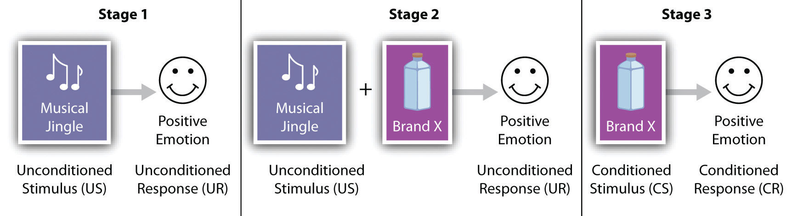
Classical Conditioning

- Classical conditioning is a form of associative learning, in which consumers learn associations between stimuli in a rather simple fashion without more complex processes such as memory or cognition taking place.

Repetition

- Repetition increases learning
- More exposure results in greater brand awareness
- Less exposure can result in decay
- When exposure decreases extinction results, which occurs when the effects of prior conditioning is reduced and eventually disappears
- But too much exposure leads to advertising wear out

Classical Conditioning Continued

Stimulus generalization: Tendency for stimuli similar to a conditioned stimulus (keys jangling resemble bell) to evoke similar, unconditioned responses.

- Family branding: which a variety of products capitalize on the reputation of a company name. Ex: using Google

- Product line extensions: related products are added to an established brand. Ex: Sun-Maid going from raisins to raisin bread

- Licensing: Well known names are rented out. No names take advantage, ex: Motorola

- Look-alike packaging: distinctive packaging designs create strong associations with a particularly popular brand.

- Stimulus discrimination: Occurs when a stimulus similar to a CS is not followed by a UCS. Only buy the brand names. Ex: cheap imitations

  - Think about it: Can you think of some products that have similar packaging? Similar shapes? Similar names?

- Repetition is important, however some modifications are necessary to avoid adaption and advertisement wear out, ex: changing the attractive celebrity, Jenifer Aniston is different situations but same message.

Instrumental Conditioning

Also known as Operant conditioning, occurs as the individual learns to perform behaviours that produce positive outcomes and to avoid behaviours that yield negative behaviours.
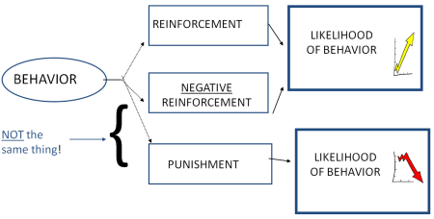

Positive Reinforcement: increase or maintain desired behaviour through the application of a positive stimulus

Negative reinforcement: the removal of a negative stimulus to increase or maintain desired behaviour.

Punishment: the application of a negative stimulus to decrease unwanted behaviour.

Reinforcement schedules

Interval: has to do with time

Ratio: certain number of times/occasions

  - Fixed-interval (seasonal sales): reinforcement occurs only after a fixed (specific period) of time passes.
  - Variable-interval (unknown amount of time): Reinforcement occurs some amount of time that varies around some average – unknown amount of time
  - Fixed-ratio (buy 9 get 1 free): reinforcement occurs after a fixed number of responses
  - Variable-ratio (slot machines, roll up the rim): reinforcement occurs after a certain unknown amount of times.
  - Frequency marketing: reinforces behaviour of regular purchases by giving them prizes with values that increase along with the amount purchased.

Cognitive Learning Theories: Observational Learning

- Cognitive Learning Theory
  - Internal mental processes - we have choice in our actions
  - This perspective views people as problem solvers who actively use information from the world around them to master their environment
  - Used to tweak marketing messages
  - Creativity and insight is stressed.
- Observational Learning
  - We watch others and note reinforcements they receive for behaviours
  - Vicarious learning
  - Socially desirable models/celebrities who use or do not use their products

Observational learning

- We watch others and note reinforcement they receive for behaviours.
- Modelling: Imitating others’ behaviour (celebrities/athletes)
- Much violence is exposed on television
- Children modelled brutal behaviours following a violent demonstration of an adult punching a ‘Bobo Doll’
- Copying celebrities
- Vicarious learning

- Attention: consumer focuses on a models behaviour
- Retention: the consumer retains the behaviour in memory
- Production of processes: consumer has the ability to perform the behaviour
- Motivation: A situation arises wherein the behaviour is useful to the consumer.
- Observational learning: The consumer acquires and performs the behaviour demonstrated earlier by the model.

Negative side: lots of violence is exposed on television
    - Violent video games
    - children experiment

Role of Memory in Learning

- Memory: Acquiring information and storing it over time so that it will be available when needed
- Information-processing approach
Mind = computer and data = input/output

Encoding: information is entered in a way the system will recognize

Storage: this knowledge is integrated with what is already known

Retrieval: the mind accesses the desired information.

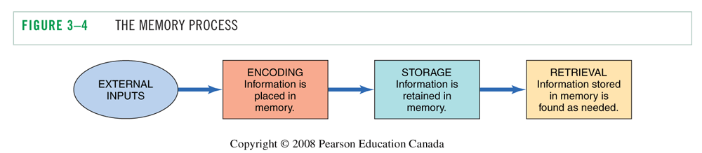
Encoding

- We encode information to help us retain it later
  - Sensory meaning - permits storage of the information we receive from our senses. colors, shapes
  - Semantic meaning - symbolic associations ex: idea that rich people drink Champaign
  - Personal relevance
    - Episodic memories: memories for events that are personally relevant
    - Flashbulb memories: memories that are quite vivid and unique ex: first child
    - Product information conveyed as a narrative
    - Low-involvement products tend to have descriptive, snappy names

Memory Systems

  - Sensory meaning - permits storage of the information we receive from our senses. Colors, shapes

- Short-term Memory: also stores information for a limited period of time, and its capacity is limited, like a computers ram.
  - Chunking: Information is stored by combining small pieces onto larger ones.

- Long-term memory: the system that allows us to retain information for a long period of time.
  - Elaborative rehearsal: this process involves thinking about the meaning of a stimulus and relating it to other information already in memory.

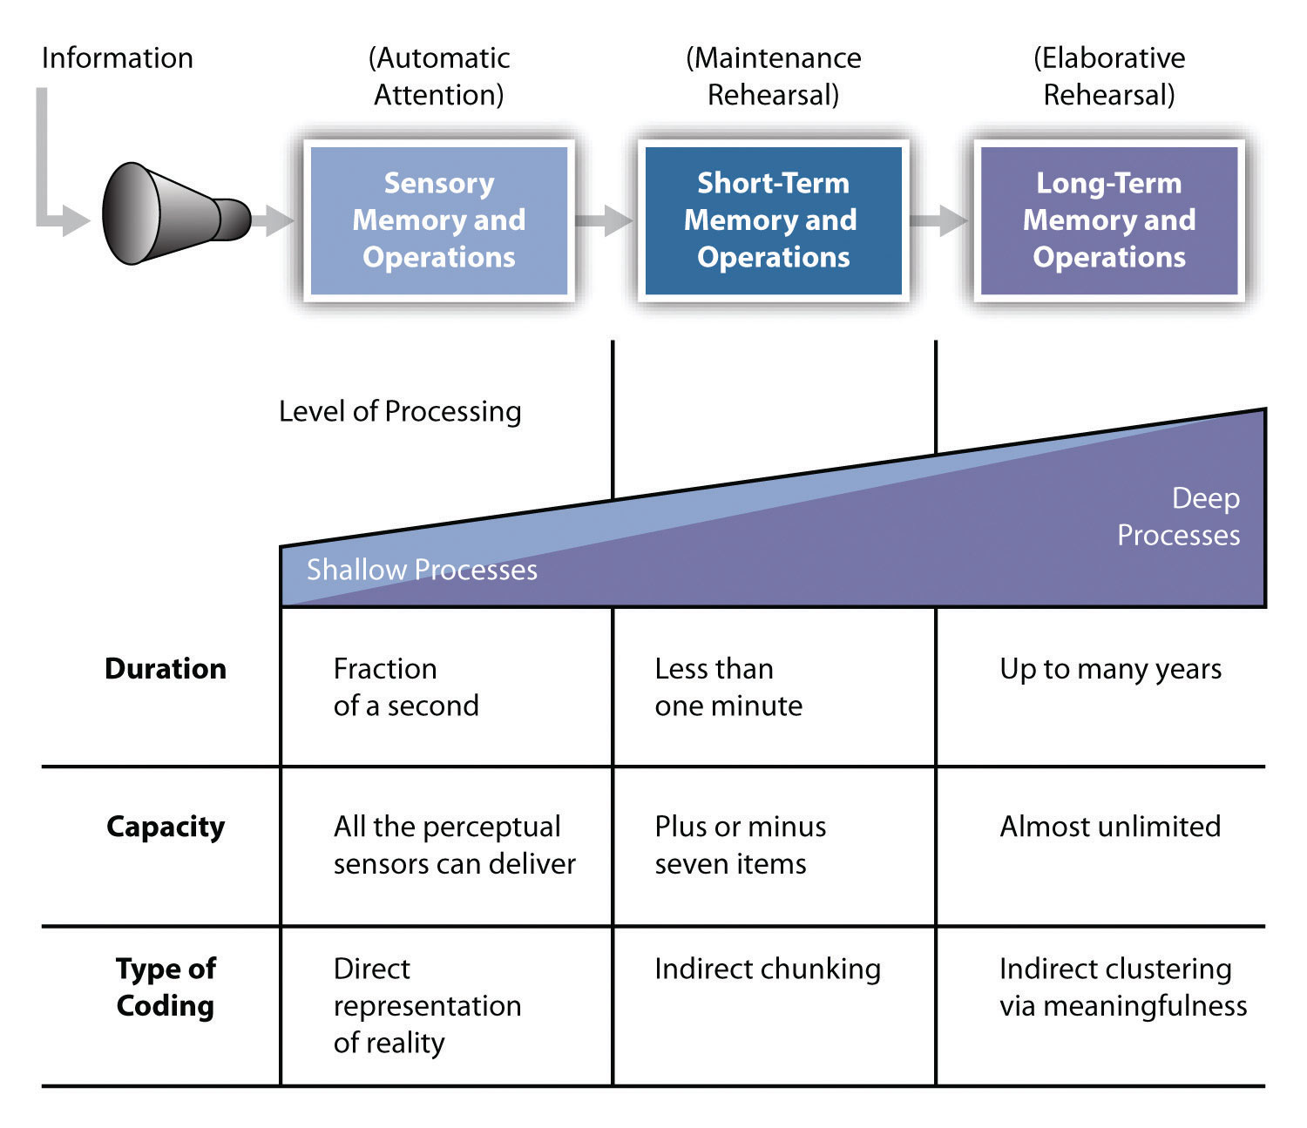

Storing Information in Memory:

Activation modes of memory: Depending on the nature of the processing task, different levels, of processing occur that activate some aspects of memory rather than others.

Associative Networks

    - Associative network model proposes that an incoming piece of related information is stored in an associative network containing many bits of related information organized according to some set of relationships

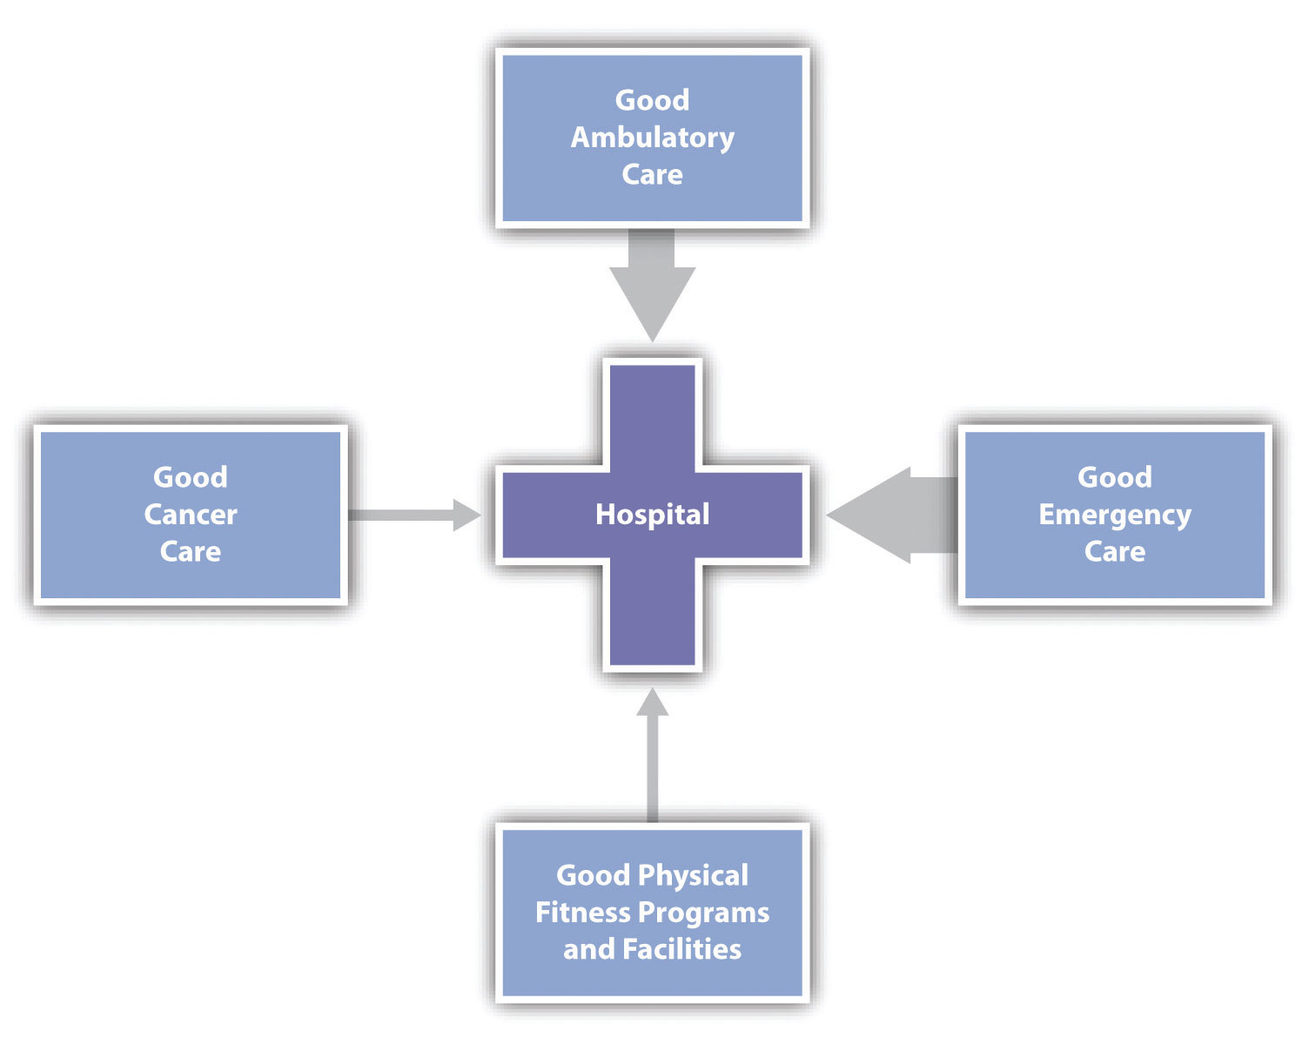

Spreading Activation

- A meaning can be activated indirectly, energy across nodes of varying levels of abstraction.
- Spread activation: allow consumers to shift back and forth between levels of meaning.

Meaning types of associative nodes:

- Brand specific; in terms of claims made for the brans
- Ad-specific: in terms of the medium or content of the as itself
- Brans Identification: in terms of the brand name
- Product category: in terms of how the product works, where it should be used, or experiences with the product.
- Evaluative reactions: in terms of whether “that looks like fun”

Knowledge structure

- Complex spider web filled with pieces of data.
- Information is placed into nodes, which are connected by associative links within these structures.

Levels of knowledge

- Two (or more) connected nodes = proposition (complex meaning)
- Two or more propositions = schema
  - We more readily encode info that is consistent with an existing schema
  - Service scripts – a sequence of procedures that is expected by an individual ex: going to a doctor, pumping gas.

Analogical Learning:

- using comparisons, similarities and analogies to highlight or educate consumers about a new product.

Retrieval for Purchase Decision

- Retrieval is the process of accessing information from long-term memory factors
- Situational factors (distractions)
- Consumer attention; pioeering brand; descriptive brand names
- Viewing environment (continuous activity; commercial order in sequence)
- Post-experience advertising effects
  - Our experiences influences our interpretations
  - Works best with new products
  - Alter product experiences

- Appropriate factors/cues for retrieval
  - Familiarity –familiarity enhances recall
  - Salience and Recall effect (mystery ads) – salience of a brand refers to its prominence or level of activation in memory ex: energizer bunny
  - Visual memory versus verbal memory – a picture is worth a thousand words

Factors influencing Forgetting

- Decay – you don’t use it, you’ll loose it
- Interference
  - Retroactive interference: stimulus-response associations will be forgotten if consumers subsequently learn new responses to the same or similar stimuli.
  - Proactive interference: prior learning can interfere with new learning. Ex: your friend Jennifer Aniston, but now can’t remember another Jennifer’s last name.

Products as Memory Makers

- Furniture, visual art and photos call forth memories of the past
- Autobiographical memories
- Power of nostalgia – bittersweet emotion (men’s first car at 23 years old), referencing the good old days
- Retro brands – updated version of a brans from prior historical period (triggers nostalgia) (go back to that era)
- Nostalgia Index – indicates that people’s tastes in such products as movies and clothing are influenced by what was popular during certain critical periods of their youth.

Measuring Memory for Marketing Stimuli

- Recognition vs. recall
- Recognition is a better measure of memory
- Problems with memory measures
  - Response biases – say what researcher wants to hear
  - Memory lapses – forgetting information, leads to generalization
  - Memory for facts vs. feelings – remember emotions not facts

Chapter 4: Motivation and Values

Motivational Process

- Motivation: Process that leads people to behave as they do
- Also, the forces that drive us to buy/use products
  - Goal: Consumer’s desired end-state
  - Want: Manifestation of consumer need

Motivational Strength

Motivational strength: Degree of willingness to expend energy to reach a goal
- Drive theory: Biological needs that produce unpleasant states of arousal (e.g., hunger)
- Homeostasis: A balanced state
- Expectancy theory: Behaviour is pulled by expectations of achieving desirable outcome
  - Improve situation ex: putting gas in a car
  - Focuses on cognitive factors
  - Affects choice of product
- Needs vs. wants

Types of Needs

Types of needs:
- Biogenic: Biological needs, such as for air, water, food
- Psychogenic: Need for becoming a member of a culture, need for status, power, affiliation
- Utilitarian: Need for tangible attributes of a product, such as miles per gallon in a car or calories in a cheeseburger
- Hedonic: Needs for experiences, excitement, self-confidence, fantasy (experience)

Motivational Conflicts

- Goal valence:
  - Positively valued goal: Approach
  - Negatively valued goal: Avoid
    - Deodorant and mouthwash
- Positive and negative motives often conflict with one another

Types of Motivational Conflict

Two desirable alternatives Cognitive dissonance

Positive & negative aspects of desired product Guilt of desire occurs

Facing a choice with two undesirable alternatives

Approach – Approach conflict

- Person must choose between 2 desirable outcomes
  - Theory of cognitive dissonance: people have a need for consistency in their lives and that a state of tension is created when beliefs or behaviours conflict with one another.
  - Post-decision dissonance: not sure if you made the right decisions
  - Cognitive dissonance reduction: people are motivated to reduce this inconsistency (or dissonance) and this eliminate unpleasant tension
- Ex: Mac vs PC campaign, ad: “its better in the Bahamas”, go home and visit family or all-inclusive resort.
- Golds gym with lots of classes at better times – solves time problem
- Home town Buffet

Approach – Avoid conflict

- Many products we desire have negative consequences attached to then. When we desire a goal but wish to avoid it all at the same time
- Ex: ice cream without the calories, power boat with warrantee
- Rachel ray 30 minute meals
Avoidance – Avoidance conflict

- “Caught between a rock and a hard place” – don’t want either outcomes
- Ex: throwing money into an old car or buying a new one, changing winter tires
- Resolve with financial plans, or buying used
- Closing in on undeclared income

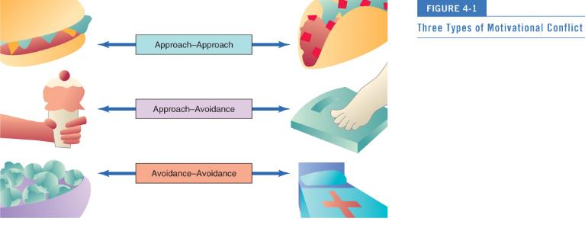

Specific Needs and Buying Behaviour

- Need for achievement: Value personal accomplishment; place a premium on products that signify success
- Need for Affiliation: Need for relevant products and services to alleviate loneliness
  - Sports bar, going to the gym vs. exercising at home
- Need for Power: Control one’s environment. Focus on products that have mastery over surroundings
  - Exclusive restaurants, hotels, vacation, good service
- Need for uniqueness: To assert one’s individual identity.
  - Products that can be customized

Levels of Needs in the Maslow Hierarchy

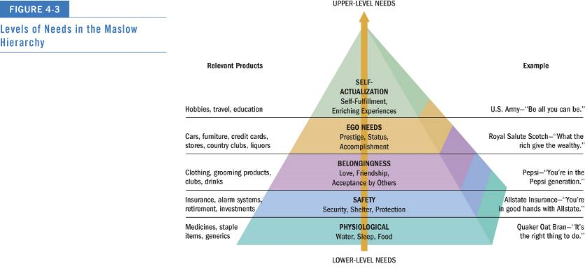

    - Products satisfy different needs
    - Go up and down levels based on satisfaction and dissatisfaction

Consumer Involvement

- We can get pretty attached to products…
- Involvement: Perceived relevance of an object based on one’s needs, values, and interests
  - The motivation to process information
  - Ex: waiting in line for an Iphone

Inertia and Flow State

- Inertia: Consumption at the low end of involvement
  - We make decisions out of habit (lack of motivation)
- Flow state: True involvement with a product
- Flow is an optimal experience characterized by the following
  - Playfulness
  - Being in control
  - Concentration/focused attention
  - Mental enjoyment of activity for its own sake
  - Distorted sense of time
  - Match between challenge at hand and one’s skills

Conceptualizing Involvement

Different levels:
- Advertisement (message)
- The product (object)
- Purchase situation (birthday, Christmas gift)

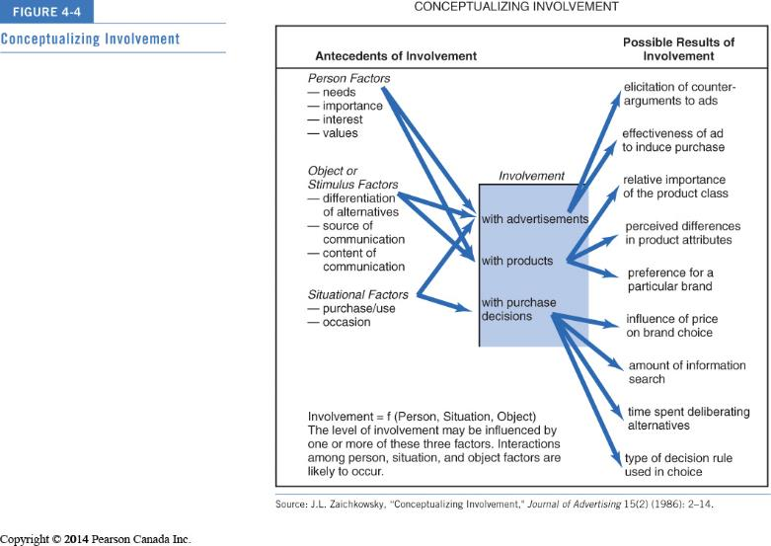

High-Cognitive level/type of involvement:
- Car
- New products
- Media: print, informative based

High-Affective level/type of involvement
- Jewelry
- Motorcycles
- Media: tv, image based

Low-Cognitive level/type of involvement
- Ground beef
- Household cleaners
- Media: 10 sec. IDs, POS reminder

Low-Affective level/type of involvement
- Candy
- Liquor
- Media: POS attention-grabbing

Person Factors

    - Self Concept: product matches self-concept
    - Ex: environmentalist buying earth friendly products

Product Involvement

- Product involvement: Consumer’s level of interest in a product
- Involvement increases with:
- Risk
- Product Differentiation – many choice
- Hedonic value
- Public vs. Private Consumption – increases with public
- money

Purchase Situation Involvement

- Purchase situation involvement: Differences that occur when buying the same object for different contexts.
  - Buying birthday gifts vs. for you
- Factors affecting involvement:
  - Social Pressure
  - Decision Imminence (Timing) – more pressure
  - Decision Irrevocability

Involvement in the message:
    - Flash mob
    - Political leaders kissing

Dimensions of Involvement

The amount of consumer involvement depends on:
- Personal interest in product category
- Risk importance (consequences)
- Probability of bad purchase
- Pleasure value of product category
- Sign value of product category (self-concept relevance)

Strategies to Increase Involvement

- Appeal to hedonistic needs ex: ads with sensory appeal
- Use novel stimuli in commercials ex: unusual cinematography, sudden silence
- Use prominent stimuli in commercials ex: loud music, fast action, larger ads
- Include celebrity endorsers
- Consumer generated content
- Build consumer bonds – maintaining ongoing relationships

Types of Affective Responses

Affect = feelings – refers to the experience of emotionally-laden states, which can range from evaluations, to moods, to emotions

- Evaluations - valenced (i.e., positive or negative) reactions to events and objects that are not accompanied by high levels of arousal.
- Moods - involve temporary positive or negative affective states accompanied by moderate levels of arousal.
- Emotions - tend to be more intense shorter lives, and are often related to a specific triggering event.

How do Marketers Use Affective States?

- Affect as a product benefit
  - Positive moods and emotions are often highlighted as a product benefit
  - Viagra
  - Coke “Open Happiness”
- Negative state relief
  - Helping can relieve negative moods – purchasing and consuming mood-enhancing products
  - Ex: purchasing chocolate, Africa ad to collect money
- Mood congruency
  - Positive moods lead to more positive evaluations – the notion that our judgements are often consistent with our existing moods.

Discrete Emotions – Happiness

- Happiness
  - A mental state of well-being characterized by positive emotions
  - Materialism and happiness
  - Spending money on others vs. the self
  - Experiences make people happier than things
    - memories

- Envy
  - A negative emotion associated with the desire to reduce the gap between oneself and someone who is superior on some dimension
  - Benign vs. malicious envy
  - Benign: other person deserves it (seek to attain what they have
  - Malicious: don’t deserve what the had (avoid those products)

- Guilt
  - An individual’s unpleasant emotional state associated with possible objections to his or her actions, inaction, circumstances, or intentions
  - Guilt appeals – can backfire if too extreme
  - Sense of responsibility
  - In retail contexts – great sales person makes you feel guilty and need to buy

- Embarrassment
  - Driven by a concern for what others are thinking
  - Social concern
  - Unwanted events communicate undesired information about oneself to others
  - Sometimes dependent on product category
  - Ex: shopping for tampons
  - Repeat purchases decrease embarrassment

Chapter 5: The self

Perspectives of Self

- We buy products to highlight/hide aspects of the self
- Eastern and Western cultures see the self as an inner private self and the outer public self.
- In the era of Facebook and Twitter everyone is able to share their thoughts with millions of friends and strangers
- Each of us is a separate, unique individual

Self-Concept

- Self-concept: Beliefs a person holds about his/her own attributes, and how he/she evaluates these qualities
- Attribute dimensions: Content, positivity, intensity, stability over time, and accuracy

Self-Esteem

- Self-esteem: Positivity of a person’s self-concept
- Low self-esteem: Think they will not perform well
- High self-esteem: Think they will be successful and will take risks
- Ads can trigger social comparison
- Attractive models using products
  - Victoria secret vs. dove

Real and Ideal Selves

- Ideal self: Conception of how we would like to be
- Actual self: More realistic appraisal of the qualities we have
- Products can:
  - Help us reach ideal self ex: makeup, alcohol, clothes
  - Be consistent with actual self: injury products

- We are constantly faced with images of the “ideal” person in media
- Each of us has more than one self-concept - one for attractiveness, work ethic, friend etc.
- We engage in impression management - strategically engaging in products and behaviours to impress

Multiple Selves

- Each of us has many selves and roles
- Marketers pitch products needed to facilitate active role identities

Virtual Identity

- People are assuming virtual identities in cyberspace
- Avatars represent visual identity – tricked out versions with exaggerated physical characteristics.
- How do online “selves” affect consumer behaviour?

Looking Glass self

- “Taking the role of the other”
- imagining what others reactions or opinions are if yourself
- Can vary depending on…
  - …Whose perspective we are taking
  - …How accurate our predictions are of their evaluations of us
- Self-fulfilling prophecy

Self-Consciousness

- Can be painfully aware of one-self
- Public self-consciousness: more interested in clothing and tend to be heavier users of cosmetics
- Self-monitoring
  - High vs. low self-monitors
  - High self-monitors are more attuned to how they present themselves in social environments.

Consumption and Self-Concept

- Identity marketing: Consumers alter aspects of their selves to advertise a branded product
- Product consumption = definition of self
- Product as extended self

You are what you Consume

- Meat vs. vegetarian
- Leisure activities (dance vs. golf)
- Type of car

- Social identity as individual consumption behaviours
  - Question: Who am I now?
  - Answer: To some extent, your possessions!
- Inference of personality based on consumption patterns
- Consumers may attach themselves to product to maintain self-concept
- Symbolic self-completion theory: People who have an incomplete self-definition complete identity by acquiring and displaying associated symbols.
  - Ex: new laptop to boost gpa – not confident in the role of being a student

Self/Product Congruence

- Consumers demonstrate their values through their purchase behaviour
- Self-image congruence models: We choose products when attributes matches the self
- Predicts that people who have an incomplete self-definition tend to complete this identity by acquiring and displaying symbols associated with it.
  - Ex: boys might use macho products such as cars or cigarettes
Example: “I’m hardworking, manly

Product Usage = Self-image

The Extended Self

- Extended self: External objects considered a part of us
- Levels of extended self:
- People describe themselves in terms of
  - Individual: personal possessions (cars, clothing)
  - Family: residence and furnishings
  - Community: neighborhood or town where you live
  - Group: social or other groups

Gender differences

- Gender roles vary by culture but are changing
- Many societies still expect traditional roles:
  - Agentic roles: Men are expected to be assertive and have certain skills
  - Communal roles: Women are taught to foster harmonious relationships

Gender Versus Sexual Identity

- Sex-typed traits: characteristics we stereotypically associate with one gender or the other.
- Sex-types products: masculine or feminine attributes

Androgyny

- Androgyny: possession of both masculine and feminine traits
  - Androgynous people function well in social situations
    - Ex: David Beckham (Metrosexual – straight urban male who exhibits strong interests and knowledge regarding product categories such as fashion, home design, gourmet cooking and personal care)
  - Sex-typed people: stereotypically masculine or feminine
  - Females more detail oriented
  - Men consider overall themes

  - Think about it: The “metrosexual” is a big buzzword in marketing, but is it real or just media hype?

Gender Benders

- Gender-bending products: Selling a sex-typed item to the opposite sex
- Rubbermaid introduced grooming tools such as tweezers and clippers for men
- Harley Davidson backed a world record attempt for female motorcycle riders
- Sarah Palin and her hunting adventures could catch on with other women

GLBT Consumers

- Gay, lesbian, bisexual community have lots of purchasing power

- 4% to 8% of U.S. population
- Spend $250–$350 billion a year
- Segments within the GLBT community
  - Super Gays – highly educated and lots of income
  - Habitaters - older
  - Gay Mainstream
  - Party People – young, no money
  - Closeted – traditional, older

Body Image

- Body image: Consumer’s subjective evaluation of his/her physical self
- Body cathexis: person’s feelings about his or her own body
- Strong body cathexis = frequent purchases of “preening” products such as hair conditioner, blow dryers, cologne etc.

Ideals of Beauty

- Exemplar of appearance
- “What is beautiful is good” stereotype – associating good looking with other positive qualities, goes beyond beauty
- Favourable physical features
  - Attractive faces
  - Good health and youth
  - Balance/symmetry
  - Feminine curves/hourglass body shape

Male Ideals of Beauty

- Strongly masculine, muscled body
- Fashion houses are using models who look like “regular guys”
- Men and women “work on the body” from exercise to cosmetic surgery

  - Think about it: Do you believe there is a social stigma attached to cosmetic surgery as a means to improve your self-concept?

Western Ideal

- Skin color and eye shape = status, sophistication, and social desirability
- Less powerful cultures adopt standards of beauty in dominant cultures
- Plastic surgery to obtain big round eyes, tiny waists, large breasts, blond hair, and blue eyes

Ideals of Beauty Over Time

- Specific “looks”/ideals of beauty
  - Early 1800s: delicate/looking ill appearance, 18-inch waistline (use of corsets)
  - 1890s: voluptuous, lusty woman
  - Bad economy: mature features vs. good economy: babyish features
  - 1990s: “waif” look
  - Modern women: high heels, body waxing, eyelifts, liposuction

Chapter 6: Personality and Lifestyles

Personality

- Personality: Person’s unique psychological makeup and how it consistently influences the way a person responds to his/her environment

Freudian Systems

- Strong sexual component – unconscious motives: sex and aggression

Personality = conflict between gratification and responsibility
- Id: pleasure principle (the party animal)
- Superego: our conscience (the conscience)
- Ego: mediates between id and superego (the referee)
- Angel vs. Devil

Freudian Systems (continued)

Marketing Implications
- This ad focuses on the conflict between the id and the superego
- Ads often times use symbolism to motivate product purchases
- Ex united airlines: head – good vs. bad

Freudian Theory

Marketing Implications
- Unconscious motives underlying purchases
- Symbolism in products to compromise id and superego
  - Sports car as sexual gratification for men
  - Phallic symbols – male oriented symbolism, such as cigars – resemble sex organs

Motivational Research

- Based on psychoanalytic (Freudian) interpretation, with a heavy emphasis on unconscious motives.

- Freudian ideas unlock deeper product and advertisement meanings
- Unconscious motives motivates us to buy products
- Consumers and in-depth interviews
- Latent motives for purchases
  - Examples of Dichter’s motives (Table 6.1)
    - Bowling, electric trains, power tools = power
    - Ice cream, beauty products = social acceptance

Ditcher’s Consumption Motives

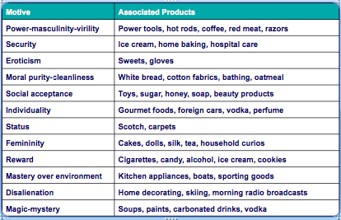

- Criticisms
  - Invalid or works too well
  - Too sexually-based
- Appeal
  - Less expensive than large-scale surveys
  - Powerful hook for promotional strategy
  - Intuitively plausible findings (after the fact)
  - Enhanced validity with other techniques

Neo-Freudian Personality Theory
- Believe that social relationships are fundamental to the formation and development of personality.
- Karen Horney’s three personality groups (CAD)
  - Compliant: move toward others
  - Aggressive: move against others ex: lance Armstrong ad, prefer more male/masculine products
  - Detached: move away from others

Carl Jung Father of Analytical Psychology

- Disciple of Freud
- Established concept of collective unconscious
- Explained the creation of archetypes : universally shared ideas and behaviour patterns, involve themes such as birth, death, the devil, and appear frequently in myths, stories, and dreams
  - Old wise man
  - Earth mother
- Sick personalities: shadow characteristics
- Ex: Oprah: sage, peace, leader – shadow characteristic: hermit: irrelevant

BrandAsset Valuator Archetypes

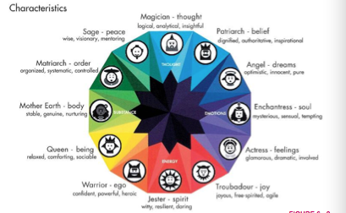

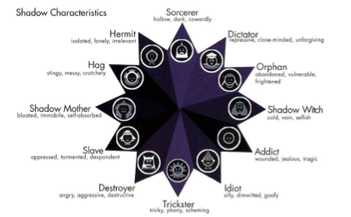

Trait Theory

- Personality traits: Identifiable characteristics that define a person
- Traits relevant to consumer behaviour:
  - Innovativeness
  - Materialism – lifestyle full of possessions
  - Public self-consciousness – more likely to make choices that allow then to present a positive view of the self to other. Monitor our image/behaviour.
  - Need for cognition – can be activated when the consumption situation provides the opportunity for effortful cognition activity - thinking.
  - Need for uniqueness – tend to be more likely to desire unique, counter-normative, or unconventional options when a consumption situation activates it. Benefits sought

Inner and Outer Direction – Trait Theory

Idiocentric: having an individualist orientation

Allocentric: having a group orientation

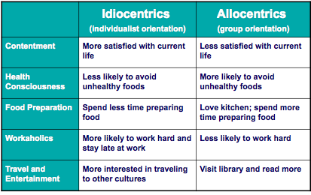
Brand Personality

- Set of traits people attribute to a product as if it were a person
- Brand equity: refers to the extent to which consumers hold strong, favorable, and unique associations with a brand in memory – and the extent to which they are willing to pay more for the branded version of a product than fo a non-branded (generic) version.
- Outsourcing production to focus on brand
- Extensive consumer research goes into brand campaigns

Measurement Construct of B.P

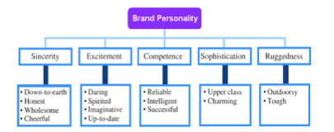

- Distinctive brand personality = brand loyalty
  - Animism (human qualities attributed to products)
    - Level 1: brand = spokespersons and loved ones ex: Mac guy
    - Level 2: anthropomorphized brands – given human characteristics, a cartoon or mythical creation ex: m&m guy

Personality of Positioning

- Brand personality is a statement of brand positioning
- Some brands re-position to gain new interest in their products
  - Ex: McDonalds

Lifestyles

- Consumption patterns reflecting a person’s choices of how one spends time and money
  - Who we are and what we do?
- Lifestyle marketing perspective:
  - WWF Magazine, 4 Wheel & Off Road, Reader’s Digest

Building Blocks of Lifestyles

- Ex: lululemon
- Product usage in desirable social settings
- Consumption style
  - Buy products that go together
  - Gym membership + athletic gear
- Patterns of behaviour:
  - Co-branding strategies: Brands team up with other companies to promote products
  - Product complements: Symbolic meanings of different products relate to one another – ex: corona and lime
  - Consumption constellations: Define, communicate, and perform social roles

Psychographics

- Use of psychological, sociological, and anthropological factors to:
  - Determine market segments
  - Determine their reasons for choosing products
  - Fine-tune offerings to meet needs of different segments
- Consumers can share the same demographics and still be very different!
- Adidas
  - Gearheads, Popgirls, fastidious eclectus

Psychographic Segmentation Uses

- To define target market
- To create new view of market
- To position product
- To better communicate product attributes
- To develop overall strategy
- To market social/political issues

VALS

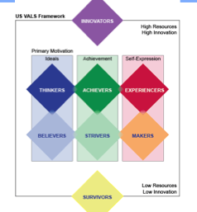
According to SRI, people pursue and acquire products and experiences that provide satisfaction and give shape, substance, and character to their identities

  - Divides people into 8 groups according to both psychological characteristics and resources, which include such factors as income, education, energy levels, and eagerness to buy.

  - Innovators: Successful, sophisticated, take charge people with self esteem, leaders with new ideas problem solving, variety, image is important, value innovative features, image is important as expression of their tastes. Favorite things: a rewarding experience, problem solving, personal challenges, authentic products.

    - Truck

  - Thinkers: Motivated by ideals, satisfied, reflective, and comfortable people who value order, knowledge and responsibility. They tend to be educated practical and value functionality and seek out information in the decision making process. Moderate respect for institutions of authority. Favorite things: informed discussion, finances management, being a smart shopper, proven products

    - Ex: Toyota corolla

- Achievers: Motivated by the desire for achievement, career-oriented and prefer predictability over risk or self-discovery, commitment to career and family, materialism, success, active in the consumer world, image is important, live conventional lives, conservation, favor established, prestige products. Favorite things: Recognition and rewards, peer-group acceptance, material possessions, rules following that lead to success
  - Sports car

- Experiencers: Motivated by self-expression, impulsive and young, and enjoy offbeat or risky experiences. Enjoy being entertained, enthusiastic, sports, and activities. Favorite things are social media, being entertained, being established, and ability to purchase
  - Jeep

- Believers: like thinkers are motivated by ideals, strong principles and favour proven brands – conventional people with concrete beliefs based on tradition, established codes: family, religion, community. They are conservative, value gender roles, family, like stuff that sounds familiar. Favorite things: the familiar, close-knit family, traditional gender roles, religion based life.
  - Minivan, station wagon

- Strivers: like achievers but with fewer resources. They are very concerned about the approval from others – trendy, fun loving, sense of belonging, reduce stress, shopping both social and need purpose. Favorite things: a lottery win, stress relief, a sense of belonging, stability
  - Cube, fiat, used car

- Makers: like experiencers, action-oriented and tends to focus their own self-sufficiency. They express themselves and experience the world by working on it, they will often be found working on their cars, canning their own vegetables, or building their own houses. They are suspicious of new ideas, respectful of the government, and individual rights. Favorite things: Practical contributions, independence, helpfulness to other, contractor-grade power
  - Older sports car, collectors car

- Survivors: Lice narrowly focused lives; they are at the bottom of the ladder. They are most concerned with meeting the needs at the moment. Believe the world is changing too quickly, strong primal motivation, cautious consumers, loyal to favorite brands. Favorite things: a home-brewed cup of coffee, thoughtful gestures, memories, safety and security

Course Reserve article

Frugality - is a unidimensional consumer lifestyle trait characterized by the degree to which consumers are both restrained in acquiring and resourcefully using economic goods and services to achieve long-term goals.

Lifestyle retail brands - like Gap, Benetton, and Laura Ashley. Their retail proposition is augmented with a set of added values that have symbolic meaning for the lifestyles of a specific group.
- Laura Ashley represents "genteel English country lifestyle," while the Gap represents a "classic American, casual lifestyle"
AIO: Attitudes, Interests and Opinions
To measure psychographics (i.e., values, self-concepts, and lifestyles), researchers present a series of statements about possible activities, interests, and opinions (AOI). Respondents indicate their agreement or disagreement with these statements
- Respondents with similar responses are group into AIO/psychographic profiles
12 Tribes:
Adams says Canadian society is no longer homogeneous, but can be divided into 12 "tribes."

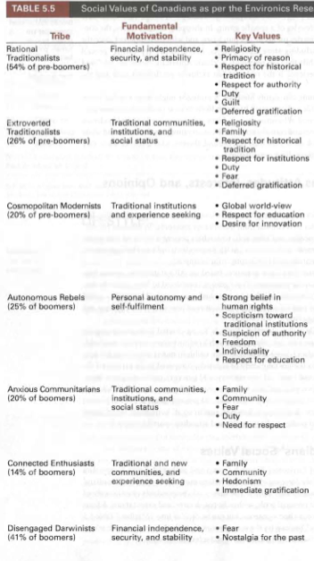

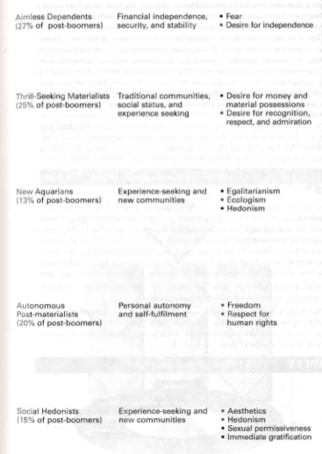

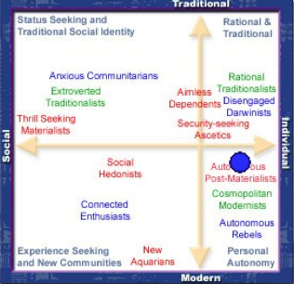

Geodemography

- Consumer expenditures/socioeconomic factors + geographic information
  - “Birds of a feature flock together”
  - Can be reached more economically (by city and postal code)
    - People with similar needs and tastes tend to live near one

Prizm

- 66 clusters of Canadian postal codes
  - Example: “Young Influential,” “Money and Brains,” “Kids and Cul-de-Sacs”
  - Ranked by income, home value, and occupation
- Maximize effectiveness, cost-efficiency, and impact of marketing communications

Values

- A value is a belief that some condition is preferable to its opposite
  - Values are central to what makes a consumer distinct in their consumption and in society
  - Two people can believe in the same behaviour (e.g., vegetarianism), but their underlying belief systems may be quite different (e.g., animal activism versus health concerns).

Core Values

Every culture has a set of values that it imparts to its members.
  - Many values vary by country and culture and change over time
  - Core values define a culture and are taught to us by socialization agents (parents, friends, teachers) through enculturation
  - Differences in values explain why marketing campaigns may be a hit in one country and flop in another
Some Values are universal – health, wisdom etc

Personal Values

- List of values (LOV)
  - Nine dominate consumer values
    - Self-fulfillment
    - Excitement
    - Sense of accomplishment
    - Self-respect
    - Sense of belonging
    - Being well respected
    - Security
    - Fun and enjoyment
Warm relationships with other

Means-End Chain
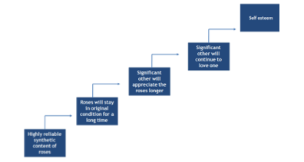

Consumers often buy products not because of their attributes per se but rather because of the ultimate benefits that these attributes provide, in turn leading to the satisfaction of ultimate values. For example, a consumer may not be particularly
The important thing in a means-end chain is to start with an attribute, a concrete characteristic of the product, and then logically progress to a series of consequences (which tend to become progressively more abstract) that end with a value being satisfied. Thus, each chain must start with an attribute and end with a value. An important implication of means-end chains is that it is usually most effective in advertising to focus on higher level items. For example, in the flower example above, an individual giving the flowers to the significant other might better be portrayed than the flowers alone.

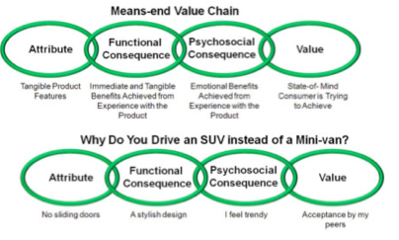
What do all these products do for me? “Means End Chain”

Appendix

Additional Information Resources Trait Theory

Consumer Innovativeness Scale

A “GENERAL” CONSUMER INNOVATIVENESS SCALE
- I would rather stick to a brand I usually buy than try something I am not very sure of.
- When I go to a restaurant, I feel it is safer to order dishes I am familiar with.
- If I like a brand, I rarely switch from it just to try something different.
- I enjoy taking chances in buying unfamiliar brands just to get some variety in my purchase.
- When I see a new brand on the shelf, I am not afraid of giving it a try.

A DOMAIN-SPECIFIC CONSUMER INNOVATIVENESS SCALE
- Compared to my friends, I own few rock albums.
- In general, I am the last in my circle of friends to know the titles of the latest rock albums.
- In general, I am among the first in my circle of friends to buy a new rock album when it appears.
- If I heard that a new rock album was available in the store, I would be interested enough to buy it.
- I will buy a new rock album, even if I haven’t heard it yet.
- I know the names of new rock acts before other people do.

This is an example of a consumer innovation measurement scale that would be used by a researcher. There are many scales that are used to try to understand the consumer’s general or global level of innovativeness. On this scale, the respondent was asked to answer the questions on a scale as to how much they AGREE or DISAGREE with the statement.

Simplified Need for Cognition Scale

- I don’t like to do a lot of thinking
- I try to avoid situations that require thinking in depth about something
- I prefer to do something that challenges my thinking abilities rather than something that requires little thought.
- I prefer complex to simple problem
- Thinking hard and for a long time about something gives me little satisfaction

Sample Items for a Materialism Scale

- Success
  - I admire people who own expensive homes, cars, and clothes.
  - I like to own things that impress people.
  - I don’t place much emphasis on the amount of material objects people own as a sign of success.
- Centrality
  - I usually buy only the things I need
  - I try to keep my life simple, as far as possessions are concerned.
  - I like a lot of luxury in my life.
- Happiness
  - I have all the things I really need to enjoy life.
  - My life would be better if I owned certain things I don’t have
  - It sometimes bothers me quite a bit that I can’t afford to buy all the things I’d like.

Chapter 7: Attitudes

The Power of Attitudes

- Attitude: Lasting, general evaluation of people, objects, advertisements, or issues
  - Attitude object (A_{O})
  - Help to determine a number of preferences and actions
  - More engraved and involve cognition unlike perception

Functional Theory of Attitudes

- Katz: attitudes exist because they serve some function

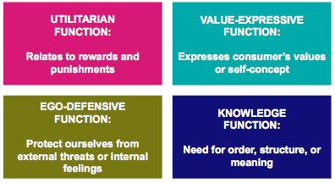

- A product can work in more than one function

ABC Model of Attitudes

Attitude has three components:
- Affect: The way a consumer feels about an attitude object. (Positive/negative)
- Behaviour: Person’s intentions to do something with regard to an attitude object.
- Cognition: Beliefs a consumer has about an attitude object. (Thinking)

Hierarchies of Effects

- Impact/importance of attitude components depends on consumer’s motivation toward attitude object

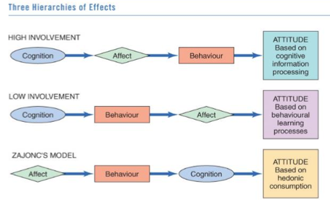

Attitudes Toward the Advertisement

- We form attitudes toward objects other than the product; can influence product selections.
- We often form product attitudes from ads
  - A_{ad}: Attitude toward advertiser + evaluations of ad execution + ad evoked mood + ad arousal effects on consumer + viewing context
- Attitudes are formed through learning – why they last longer and why perception is not learnt

Forming Attitudes

- Classical conditioning - through past associations
- Operant conditioning - through trial and reinforcement
- Cognitive learning – through information processing
  - Modelling
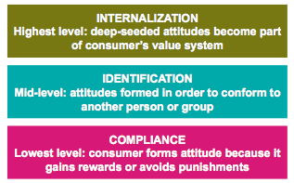
Attitude Commitment

Degree of commitment is related to the level of involvement with attitude object

Internalization: difficult to change

Identification: advertising can depict social consequences of choosing some products.

Compliance: superficial, and likely to change

Consistency Principle

Principle of cognitive consistency:
- Cognitive dissonance is a state of mental conflict, lack of harmony
- We value/seek harmony among thoughts, feelings, and behaviours and they are motivated to maintain uniformity among these elements.
- We will change components to make them consistent
- Cognitive Dissonance – buy when there is dissonance to restore consistency
- Buy things to be consistent

Cognitive & Post Purchase Dissonance

- Theory of cognitive dissonance: when a person is confronted with inconsistencies among his or her own attitudes or behaviour, he or she will take some action to resolve this unpleasant psychological state of “dissonance”
- Dissonance can occur before and after purchase

- Post purchase dissonance can occur in situations where the consumer
has a choice between more than one favorable alternative
  - Dissonance resolution: to commit to the chosen object even more
after purchase
  - Marketers can reaffirm that the consumer made the right choice
    - Testimonials
    - Ex: what cruise to go on? Company offer testimonials to reduce dissonance

Self-Perception Theory

- Provides an alternative explanation of dissonance effects
- We use observations of our own behaviour to determine our attitudes
- Maintain consistency by inferring that we must have a positive attitude toward a product if we freely purchase it
  - Low-involvement hierarchy (after the fact) – buying a product out of habit must have a positive attitude because why would we buy it if we didn’t like it?
  - Foot-in-the-door technique (start with small request)
  - Door-in-the-face technique (start with extreme request, usually refused - guilt)
  - Low-ball technique (ask for small favour, followed by an addition to request that they cant back out of - ballooning)
Social Judgement Theory

- Social judgment theory: We assimilate new information about attitude objects in light of what we already know/feel
  - Initial attitude = frame of reference
  - Latitudes of acceptance and rejection
    - Ideas that fall within a latitude will be favourably received, and those falling outside this zone will not.
    - Reject high-involvement decisions (latitude is smaller)
    - Wider for low-involvement decisions
    - Assimilation effect: messages that fall within the latitude of acceptance tend to be seen as more consistent with our own position than they actually are (ex: designated driver)
    - Contrast effects: messages falling in the latitude of rejection tend to be seen as even farther from our own position than they actually are
    - Brand preference

Balance Theory

- Balance theory: considers relations among elements a consumer might perceive as belonging together
- Involves triad attitude structures:
  - Person
  - Perception of attitude object
  - Perception of other person/object
    - Perception can be positive or negative
    - People alter these perceptions to make relations among them consistent – people desire relations among elements in a triad to be harmonious or balanced.
- Balanced/harmonious triad elements
  - Unit relation, belonging or being a part of the other (couple dating) and sentiment relation, much stronger, two elements are linked (married couple)
- Everything needs to be in balance
- Triad attitude structure

Basking in Reflected Glory

- Consumers often like to publicize their connections with successful people or organizations to enhance their own standing.
- Marketing Applications
  - Marketers use celebrity endorsers of products to create positive associations
  - Budweiser release of a limited edition “Fan Brew” beer for Winnipeg Jets fans.
  - Can backfire if public opinion of celebrity shifts e.g., Michael Phelps, Tiger Woods.
  - Rationalize away the inconsistencies

Attitude Models

- Attitude assessment can be complex
- Product/service may have many attributes
- Attitudes are affected by other factors (approval of others)
- Attitude models help identify influencers of evaluations

Multi-Attribute Attitude Models

- Multi-attribute models: Consumer’s attitudes toward an attitude object depends on beliefs she has about several or many attributes of the object
- Three elements
  - Attributes of A_{O} : features (e.g., college)
    - Example: scholarly reputation, low pricing
  - Beliefs about A_{O:} rate features by Ao – thinking, thoughts on Ao
    - Example: University or College is strong academically
  - Importance weights
    - Example: stresses research over athletics

Strategic Applications of Multi-Attribute Model

Use to get competitive advantage
- Capitalize on relative advantage: Convince consumers that product attributes are important in brand choice
- Strengthen perceived product/attribute linkages: If consumers don’t associate certain attributes with the brand, make the relationship stronger
- Add a new attribute: Focus on unique positive attribute that consumer has not considered
- Influence competitors’ ratings: Decrease the attributes of competitors

Extended Fishbein Model

Theory of reasoned action: Considers other elements of predicting behaviour
- Intentions versus behaviour: measure Behavioural intentions, not just intentions
- Best predictor of behaviour is past behaviour
- Social pressure: Acknowledge the power of other people in purchasing decision
- Subjective norm: What we believe other people think we should do
- Attitude toward buying: Measure attitude toward the act of buying, not just the product

Obstacles to Predicting Behaviour

Fishbein model’s weaknesses include:
- Doesn’t deal with outcomes of behaviour, including those beyond consumer’s control
- Doesn’t consider unintentional behaviour, such as impulsive acts or novelty seeking
- Doesn’t consider that attitudes may not lead to consumption
- Doesn’t consider the time frame between attitude measurement and behaviour
- Doesn’t differentiate between consumer’s direct, personal experience, and indirect experience

Normative Influences

Two types:
- Descriptive norms – norms that convey what others are doing
  - Ex: an ad communicating that 85% of residents are currently recycling.
- Injunctive norms – norms that convey what others think you should do
  - Ex: an ad highlighting that others approve of recycling
- Descriptive norms can be very powerful
  - Cialdini and colleagues reuse of hotel towels research
  - Especially combined with feedback - Opower

Chapter 8: Attitude Change and Interactive Communications

Changing Attitudes through Communication

Persuasion: Effectiveness of marketing communications to change attitudes

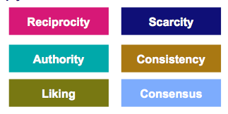
Emphasis on persuasion to change attitudes

What influences people to change their minds or comply?

Reciprocity: people are more likely to give, if they receive something first, there is an obligation to give back leads to likely to say yes (important is how it is given and being the first)
Ex: Waitress gives a mint for better tip

Scarcity: want something more if it is scarce.

Authority: people listen to experts or people with credibility
Ex: uniform

Consistency: people try not to contradict themselves in terms of what they say and do about an issue.

Liking: people say yes to people they like, we like people who:
    - Are similar to us
    - Compliment us

Consensus: look at other people’s behaviour to determine their own behaviour. Point to others to get desired behaviour. Desire to fit in

Tactical Communication Options

- Who will be the source of the message?
- How should the message be constructed?
- What media will transmit message?
- What target market characteristics will influence the ad’s acceptance?

Traditional Communication Model

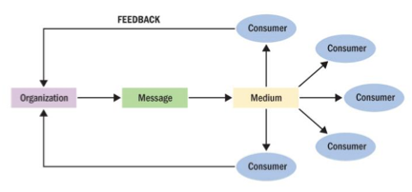
    - One sided communication approach organization consumer
    - Consumers can’t give feedback and are not involved

Interactive Communication

- Consumers have many more choices available and greater control to process messages
- Permission marketing: Marketer may be more successful in persuading consumers who have agreed to let him try
- Social media allows for a more interactive relationship

Updated Communication Model

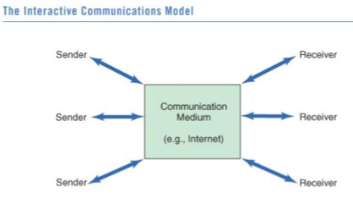

Uses and Gratification

- Uses and gratification theory: consumers are active, goal-directed audience, and draw on mass media to satisfy needs
- Media compete with other sources of entertainment and information
  - Advertising = entertainment, escaping, play, self-affirmation
    - Media play both positive and negative role

Levels of Interactive Responses

- Types of feedback:
  - First-order response: Direct marketing: transaction and sales date
  - Second-order response: Non-transaction, customer feedback
    - Like on a Facebook page
    - Join a mailing list

The Sources

- Individual delivering the message
- Source effects: Same words by different people can have very different meanings
- A “source” often a spokesperson in an ad—may be chosen because s/he is expert, famous, attractive, or similar
- What makes a good source?
  - Source credibility
  - Source attractiveness

Building Creditability

- Building Credibility: Source’s perceived expertise, objectivity, or trustworthiness
  - Consumers’ beliefs that communicator is competent and provides competitor information
  - Credible source is persuasive when consumer has no formed opinion about product
  - Ex: Mike Holmes
  - Credibility = persuasion

Sources Attractiveness

- Physically attractive source leads to attitude change
  - Directs attention to marketing stimuli
  - Beauty = credibility
- Halo Effect. People who rank high on one dimension are assumed to excel at other dimensions. What is beautiful is good
  - Example: good-looking people are thought to be smarter, cooler, happier
Endorsement contract = large profits

Celebrities as Communication Sources

- Celebrities as communications sources
  - Famous faces capture attention and are processed more efficiently by the brain
  - Enhance company image and brand attitudes
- Celebrities embody cultural and product meanings
- Match-up hypothesis: Celebrity’s image and that of product are similar
- When celebrities don’t behave this can create negative associations with the brand
- Celebrity needs clear image to work, Justin Beiber does not have a clear image

The Message

- Most important feature: stressing unique product attribute/benefit
- Message Processing
  - Distraction – loud noises
  - Pace – TV and radio fast pace, need more exposure, print slow pace, need less exposure
  - Product Familiarity – process message better
  - New product: trial programs first

Sending the Message

- Visual versus verbal communication of message
- Visual images: Big emotional impact
- Verbal message: High-involvement situations
  - Factual information
  - More effective when reinforced by a framed picture
  - Require more frequent exposures (due to decay)

Dual Component of Brand Attitudes

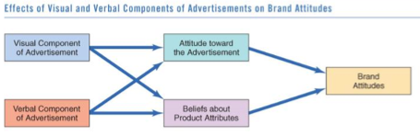

Vividness

- Powerful description/graphics command attention and are strongly embedded in memory
  - Active mental imagery (vs. abstract stimuli)
- Concrete discussion of product attribute

Two-Factor Theory: proposes that two separate psychological processes are operating when a person is repeatedly exposed to an ad.

- Repetition can be a double-edged sword…
  - Mere exposure phenomenon vs. habituation even wear-out
  - Repetition is good, but there is a point of diminishing return (good up to a certain point)

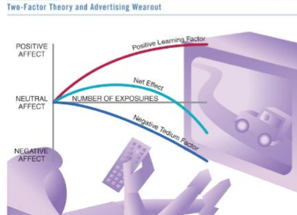

- The positive side of repetition is that it increases familiarity. The negative side is that over time, boredom increases with each exposure, resulting in wear out.

One vs. Two Sided Arguments

- One-sided: Supportive arguments

- Two-sided: Both positive and negative information
  - Refuting an argument: Negative issue is raised, then dismissed
  - Positive attributes should refute presented negative attributes
  - Effective with well-educated and not-yet-loyal audiences
  - Used less
  - More trust
  - Honest
  - Ex: tastes awful but works, we’re #2

Drawing Conclusions

- Should argument draw an explicit conclusion for consumer?
  - Yes…if argument is hard to follow or consumers’ motivation is lacking
  - No…if message is personally relevant

Comparative Advertising

- Comparative advertising: Message compares two + recognizable brands on specific attributes
  - Strategy yields mixed results
  - Confrontational approach can result in source derogation
  - Can seem bias and lead to derogation
- An ad for a new product should not:
  - Merely say it is better than leading brand
  - Compare itself to a superior competitor

Types of message appeal

Emotional Vs. Rational Appeals

- Appeal to the head or to the heart?
- Depends on the nature of the product and the relationship consumers have with it
- Many companies use an emotional strategy when consumers find no differences among brands
  - Especially brands in well-established, mature categories (e.g., cars and greeting cards)
- Recall of ad contents tends to be better for “thinking” ads
  - Conventional ad effectiveness measures may not be effective in assessing emotional ads

Rational appeal

- Highlight important information and facts and communicate functionality with the use of statistics and other facts.
- Rational appeal allows to market to more than one demographic target group at a time

Sex Appeals

- Importance of product fit, do not use sex appeal to market socks
- “Sex sells”
- Nude models generate tension among same-sex consumers
- Erotic ads draw attention, but strong sexual imagery may make consumers less likely to:
  - Buy a product (unless product is related to sex)
  - Recall ad’s content

Humorous Appeals

- Humor varies by culture
- Can be tricky, because what is funny to one person can be offensive to another
- Effective when the brand is clearly identified and the funny material doesn’t swamp the message.
- Humorous ads get attention
  - They’re a source of distraction
  - Work especially well when they violate expectations whilst being relatively benign

Fear Appeals

- Emphasize negative consequences that can occur unless consumer changes behaviour/attitude
- Fear is common in social marketing
- Most effective when:
  - Threat is moderate
  - Solution to problem is presented
  - Source is highly credible
- The strongest threats are not always the most persuasive

Message as Art Form

Advertisers use literacy elements to communicate benefits and meaning
Marketers are thought as storytellers who supply visions of reality similar to those provided by authors, poets, and artists.

- Allegory: Story about an abstract concept personified in a fictional character (Jolly Green Giant)
- Metaphor: Two dissimilar objects in a close relationship (“A is B”)
- Resonance: Play on words with pictures

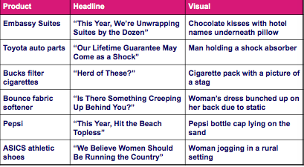

Forms of Story Presentation

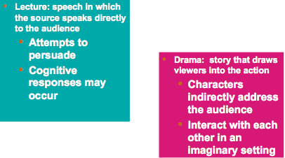

Elaboration Likelihood Model (ELM) of Persuasion

  - ELM: assumes that once consumers receive message, they begin to process it

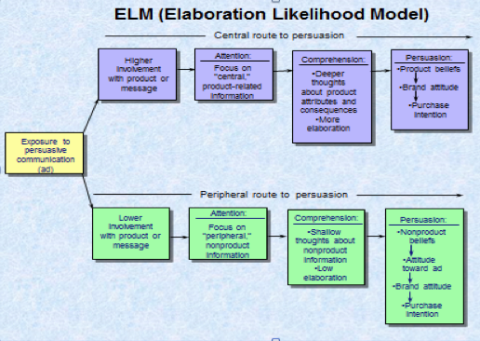

Central route to persuasion:
- For high involvement products, taken when the message is relevant or interesting and he or she will carefully attend to the message content.
- Think actively about the arguments presented and generate cognitive responses.

Peripheral route to persuasion
- For low involvement products, taken when the person is not motivated to think about the arguments presented
- Likely to use other cues in deciding on the suitability of the message (peripheral cues) because the surround the message.
- Importance of stimuli

Support for ELM

- Variables crucial to the ELM:
  - Message-processing involvement
  - Argument strength
  - Source characteristics
- High-involvement consumers are swayed by powerful arguments
- Low-involvement consumers are swayed by source attractiveness
- Steak vs. the sizzle

Chapter 9: Individual Decision Making

Consumers as Problem solvers

- Consumer purchase = response to problem
  - We are interested in a purchase, and go through a series of steps in order accomplish it
  - Can seem automatic or very complicated
  - Complicated by so much consumer choice
- Decision-making process

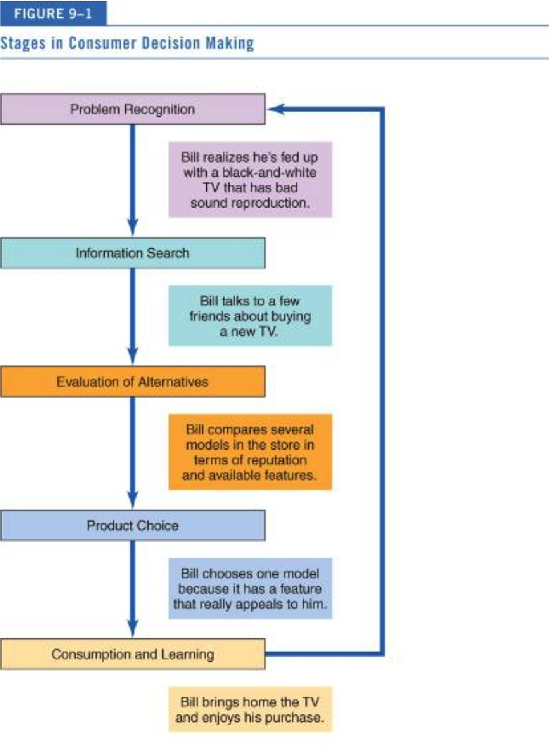

Perspective on Decision-Making

- Rational perspective - consumers:
  - Integrate as much information as possible with what they already know about a product
  - Weigh pluses and minuses of each alternative
  - Arrive at a satisfactory decision

- Other models of decision-making:
  - Purchase momentum: Occurs when consumers buy beyond needs
  - Behavioural influence perspective: Consumers buy based on environmental cues, such as a sale, product placement, and physical surroundings
  - Experiential perspective: stresses gestalt, consumers buy based on totality of product’s appeal

Continuum of Buying Decision Behaviour

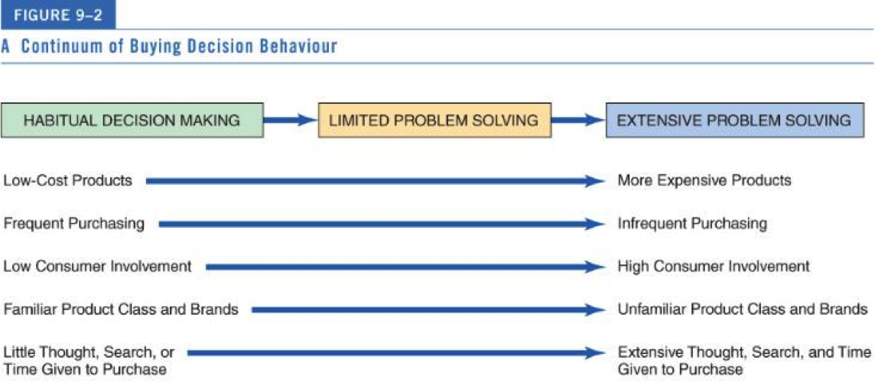

Limited Vs. Extended Problem Solving

Limited Problem Solving:

- Straightforward and simple but with some cognitive processing
- Use decision rules to choose amongst alternatives with cognitive shortcuts

Extended Problem Solving

- Initiated by self-concept motive
- Eventual purchase decision is perceived as a risk / high involvement
- Consumer collects extensive information
  - Internal and external search
- Careful evaluation of brand attributes (one at a time), many criteria used
- Many outlets shopped
- Communication with store personnel often desirable
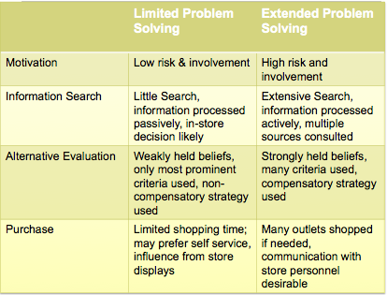

Habitual Decision Making

- Automaticity: Choices made with little/no conscious effort
  - Efficient decisions: minimal time/energy from repetitive behaviour
  - Routine purchases
- Challenge for marketers…
  - Problem when marketers introduce a new way of doing an old task
  - Consumers must be convinced to “unfreeze” their former habit and replace it with new one

Problem Recognition

Occurs when consumer sees difference between current state and ideal state

- Need recognition: actual state moves downward
- Opportunity recognition: Ideal state moves upward

Information Search

- Information search: Process by which consumer surveys the environment for appropriate data to make reasonable decision
- Pre-purchase search: explicitly search the marketplace for specific information after a need has been recognized
- Ongoing search: consumers enjoy hunting for information and keeping track of developments just for the fun of it (browsing) or to use in the future.

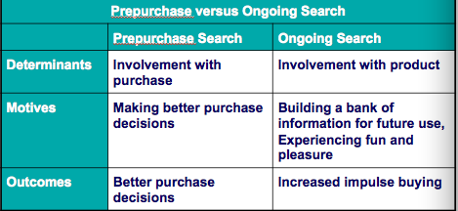

Internal vs. External Search

- Internal search
  - Scanning memory to assemble product alternative information
- External search
  - Obtaining information from ads, retailers, catalogs, friends, family, people-watching, Consumer Reports, etc.

Do Consumers Always Search Rationally?

- External searches are surprisingly low
- Low income shoppers search less
- Satisficing vs. maximizing
  - Maximizing: best possible outcome
  - Satisficing: trying to yield an adequate solution
- Bounded rationality: we rarely have the resources to weigh every possible factor into a decision, therefore we settle for a solution that is good enough
- Personalized product recommendations
- Brand switching: Select familiar brands when decision situation is ambiguous
- Variety seeking: Desire to choose new alternatives over more familiar ones
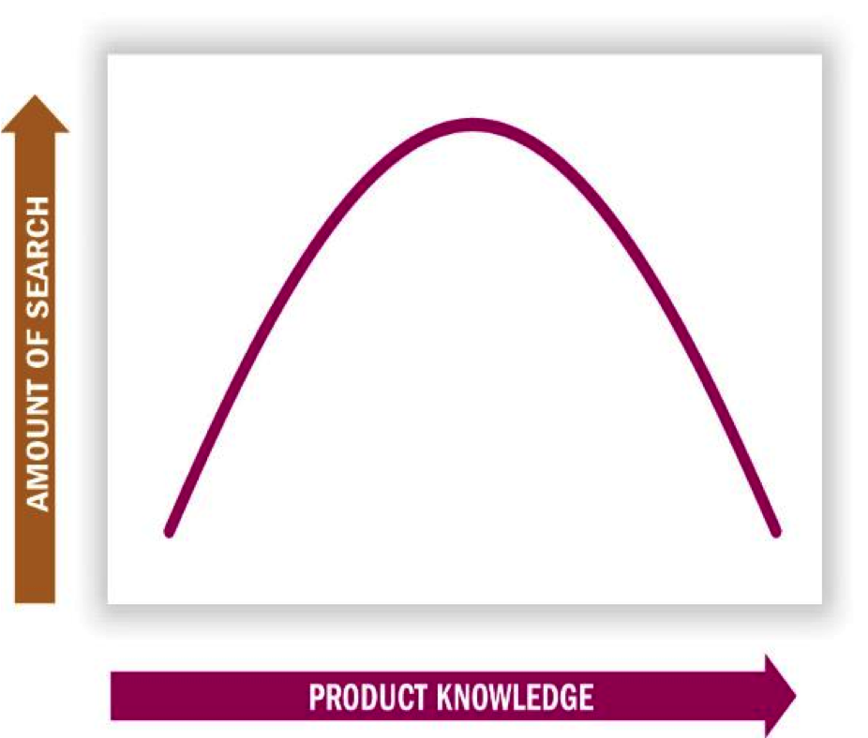

Amount of Information Search and Product Knowledge

Search tends to greatest among those consumers who are moderately knowledgeable about the product.

Consumer’s Prior Expertise

- Moderately knowledgeable consumers tend to search more than product experts and novices
- Experts: Selective search – efforts are more focused and efficient
- Novices: rely on others’ opinions, “nonfunctional” attributes, and “top down” processing

How Much Search Occurs?

- Search activity is greater when…
  - Purchase is important
  - There is a need to learn more about purchase
  - Relevant info is easily obtained/utilized
  - One is younger, is better-educated, and enjoys shopping/fact-finding
  - One is female (compared to male)
  - One places greater value on own style/image

Perceived Risk

- Perceived risk: Belief that product has negative consequences
  - Present when product is expensive, complex, hard-to-understand products
  - Product choice is visible to others (risk of embarrassment for wrong choice)
- Risks can be objective (physical danger) and subjective (social embarrassment)

Five Types of Risk:

- Monetary Risk:
- Those at risk: those with little income
- Products: high ticket items that require substantial expenditures
- Functional Risk:
- Risk consists of alternative means of performing the function or meeting the need
- Those at risk: practical consumers are most sensitive
- Products: use require exclusive commitment and preclude redundancy are most sensitive
- Physical Risk
- Risk consists of physical vigour, health or vitality.
- Those at risk: elderly, frail or ill
- Products: mechanical or electrical goods such as vehicles, drugs, flammables
- Social Risk
- Risk consists of self-esteem and self-confidence
- Those at risk: those who are insecure and uncertain
- Products: socially visible or symbolic goods, such as clothes, jewelry, cars, homes, sport equipment
- Psychological Risk
- Risk consists of affiliation and status
- Those at risk: those lacking self-respect or attractiveness to peers
- Products: expensive personal luxuries that may engender guilt, durables, and services whose use demands self-discipline or sacrifice

Evaluation of Alternatives

- Choosing from the often very many available alternatives
- Extended problem solving
  - Occurs when choice conflicts arouse negative emotions (involving difficult trade-offs)
- Habitual decision
  - Consider few/no brand alternatives
- Evoked set / consideration set
  - Evoke/consideration set: the alternatives actively considered during a consumer’s choice process
  - Inept set: the alternatives that you are aware of but would not consider buying because they aren’t what you are looking for
  - Inert set: those alternatives not coming to mind
  - We usually don’t seriously consider every brand we know about.
  - In fact, we often include only a surprisingly small number of alternatives in our evoked set.
- Marketers must focus on getting their brands in consumers’ evoked set.
  - We often do not give rejected brands a second chance.

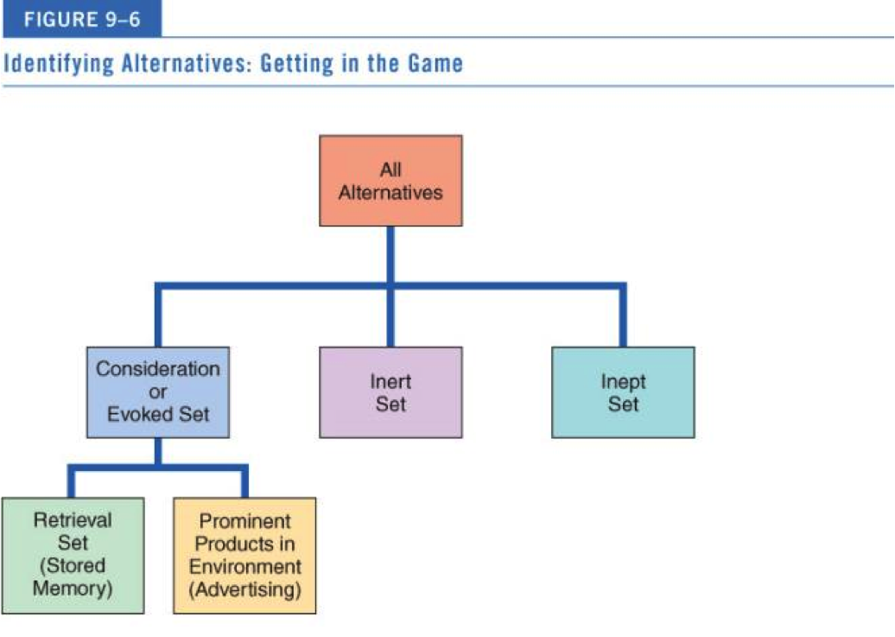

Product Categorization

- We evaluate products in terms of what we already know about a (similar) product
- Evoked-set products usually share similar features
- When faced with a new product, we refer to existing product category knowledge to form new knowledge
- Marketers want to ensure that their products are correctly grouped in knowledge structures

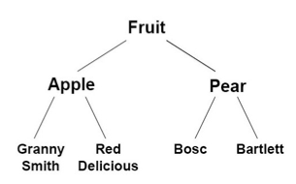
Levels of Categorization

Superordinate: more abstract

Basic Level Category: most useful in classifying products since they have a lot in common but still permit a range of alternatives.

Subordinate: often includes individual brands

Strategic Implications of Product Categorization

Product positioning
- Convincing consumers that product should be considered within a given category
  - Ex: Tropicana + Omega 3, drinking Pepsi for breakfast

Identifying competitors
  - Products/services different on the surface can actually compete for membership of super-ordinate level
  - Ex: bowling and ballet

Selecting Among Alternatives

Exemplar Products: Rhubarb vs. apples
- Exemplar products are more familiar to consumers and more easily recognized and recalled
  - Brands strongly associated with a category “call the shots” by defining evaluative criteria
  - But “moderately unusual” products stimulate more information processing and positive evaluations

Locating Products
- Product categorization can also affect consumer’s expectations of where to find the product.
  - Products that do not fit clearly into categories confuse consumers (e.g., frozen dog food)

Product Choice – How do we decide?

Selecting among alternatives
  - Once we assemble and evaluate relevant options from a category, we must choose among them
  - Decision rules for product choice can be very simple or very complicated
    - Prior experience with (similar) product
    - Present information at time of purchase
    - Beliefs about brands (from advertising)

Evaluative Criteria

- Evaluative criteria: dimensions used to judge merits of competing options
- Procedural Learning: a person undergoes a series of cognitive steps before making a decision
- Determinant attributes: Features we use to differentiate among our choices
  - Criteria on which products differ carry more weight
  - Marketers educate consumers about (or even invent) determinant attributes
    - Pepsi’s freshness date stamps on cans

Heuristics: Mental Shortcuts

- Heuristics: Mental rules-of-thumb that lead to a speedy decision
  - Examples: Higher price = higher quality, buying the same brand your mother bought
- Can lead to bad decisions due to flawed assumptions (especially with unusually named brands)
- Product signal: the aspect of the product that is visible signals some underlying quality

Market Beliefs

- Consumer assumptions about companies, products, and stores that become shortcuts for decisions
- Price-quality relationship: We tend to get what we pay for
- Other common marketing beliefs
  - All brands are basically the same
  - Larger stores offer better prices than smaller stores
  - Credit and return policies are most lenient at large department stores

Country of Origin

- Ethnocentrism: the tendency to prefer products or people of one’s own culture over those from other countries
- Industrialized countries make better products than developing countries
- We strongly associate certain items with specific countries (stereotyping)
- Country-of-origin effects stimulate consumer interest in the product
- Expertise with product minimizes country-of-origin effects

Decision Rules

- Simple decision rules are non-compensatory: a product with a low standing cannot make up for this position by being better than another attribute using Shortcuts via basic standards,

  - Lexicographic rule: the brand that is the best on the most important attribute is selected

  - Elimination-by-aspects rule: brand are evaluated on the most important attribute, however, specific cut offs are imposed for each attribute.

  - Conjunctive rule: cut-offs are established for each attribute, the brand is chosen that meets all cut-offs

  - Disjunctive rule: develops acceptable standards for each attribute usually higher that cut-off points, if the alternative exceeds that standard it is accepted.

- Compensatory:

  - Compensatory rule: gives a product a chance to make up for its shortcomings.

  - Simple additive rule: the consumer merely chooses the alternative with the largest number of positive attributes

  - Weighted additive rule: takes into account the relative importance of positively related attributes. Essentially multiplying brand ratings by importance weights.

Hypothetical Alternatives for a Phone Plan

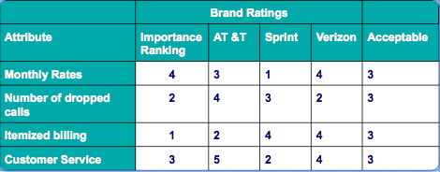

Chapter 10: Buying and Disposing

Issues Related to Purchase and Post purchase Activities

Situational effects on Consumer Behaviour
    - Occasions, birthdays – hallmark

- A consumer’s choices are affected by many personal factors…and the sale doesn’t end at the time of purchase

Relationship marketing: building strong customer service experiences with loyal customers in ways that foster a continued relationship over time.
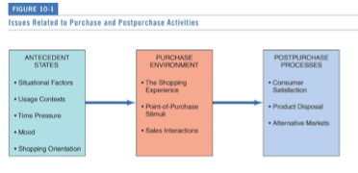

Situational Effects on Consumer Behaviour

- Consumption situation: contextual factors over and above characteristics of the person and the product.

  - Situational effects
  - We tailor our purchases to specific occasions
  - The way we feel at a particular time affects what we buy or do
  - Situational self-image (“Who am I right now?”)
    - Identifying usage situations
- Hallmark

Physical and Social Surroundings

- Temperature
- Smell
- Time – temporal
- People – presence of absence

- Affect a consumer’s motives for product usage and product evaluation
  - Décor, odors, temperature
  - Co-consumers as product attributes
    - Large numbers of people = arousal
    - Interpretation of arousal: density vs. crowding
    - Type of consumer patrons matters
    - Relationships with sales staff

Temporal Factors

Economic time
- Time style: Consumers try to maximize satisfaction by dividing time among tasks
- Time poverty
  - One-third of Canadians feel rushed
  - Marketing high tech innovations allow us to save time
  - Polychronic activity/multitasking – do more than one thing at a time
  - Time poverty

Psychological time: Consumers’ perception of time
- “Time flies when you’re having fun”
- Fluidity of time (subjective experience) – more likely to be in a consuming mood at certain times than other
- Time categories relevant to marketers
- Slow moving short time line, rather than fast long line
- Hotels have mirrors in front of elevators

Flow time:
- Become absorbed in an activity and notice nothing else

Occasion time:
- Special moments when something monumental occurs (ex: giving birth)

Deadline time:
- Any time when you’re working against the clock

Leisure time:
- Downtime

Time to kill:
- When we are waiting for something

  - Good times for ads: occasion, leisure times and time to kill
  - Bad times for ads: flow and deadline times

Queuing Theory

- Queuing theory: mathematical study of waiting lines
  - Waiting for product = good quality
  - Too much waiting = negative feelings
  - Marketers use “tricks” to minimize psychological waiting time
  - Ex: Disney really good at managing lines
    - More rides
    - Play with psychological time
    - Fast pass
    - Distractions
    - Waiting area part of the experience

Antecedent States: If it feels good

Antecedent states: Mood/physiological condition influences what we buy and how we evaluate product
- Pleasure and arousal
- Mood congruency: the notion that, in general, a mood state (positive or negative) biases judgments of products and services in that direction
  - Mood biases judgments of products/services
  - Moods are affected by store design, music, TV programs

Dimensions of Emotional States

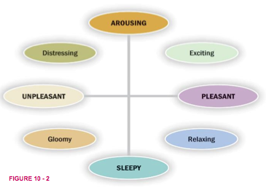

Shopping: Job or Adventure

- Social motives for shopping are important
  - Shopping for utilitarian or hedonic reasons
  - Women “shop to love,” while men “shop to win”
- The reasons we shop are more complex than may appear on the surface!

Reasons for Shopping

Reasons for shopping:
- Vary by product category, store type, and culture
- Hedonic reasons include:
  - Social experiences – social gathering like a country fair
  - Sharing of common interests
  - Interpersonal attraction – natural hangout for teenagers
  - Instant status – some people like being waited on, make them feel important
  - The thrill of the hunt – some people pride themselves on their knowledge of the marketplace

Shopping Orientation

- Economic consumer – rational, goal oriented, priority is maximizing value for you’re your money
- Personalized consumer - form strong attachments to store personnel (they know my name here)
- Ethical consumer – likes to help out the underdog, support local store
- Apathetic consumer – shopping is a chore
- Recreational shopper – views shopping as a fun social activity

E-commerce: Clicks vs. Bricks

- E-commerce reaches customers around the world, but competition increases exponentially
- Benefits: Good customer service, technology value allows for short runs of products, other services, reach more people
  - “See it On” virtual service – allows costumers to virtually try on sunglasses in real time on their iphone
  - pretailing – introducing new products by first selling online, sometimes in limited quantity, before release, realization, or commercial availability

- Limitations: Security/identity theft concerns, actual shopping experience, large delivery/return shipping charges

Retailing as Theater

- Competition for customers is becoming intense as non store alternatives multiply
- Malls gain loyalty by appealing to social motives “more than a store”
- Retail techniques:
  - Landscape themes – images of nature, the earth, animals, ex: bass pro shop
  - Marketscape themes – build on associations with human made places, ex: Las Vegas hotel creating part of an Italian city
  - Cyberspace themes – build on themes of information and communications technology Ex: Ebay
  - Being Space – environment that resembles a commercial living room where consumers can go to relax, hangout, and for entertainment, ex: Starbucks
  - Minipreneurs – offer work-centred being spaces, wifi
- American girl

Store Image

Store image: personality of the store
- Comprises many different factors, store features, coupled with such consumer characteristics as shopping orientation help to predict which shopping outlets people will prefer
- Location + merchandise suitability + knowledge/congeniality of sales staff
- Some factors in overall evaluation of a store:
  - Interior design
  - Types of patrons
  - Return policies
  - Credit availability
- Gestalt plays an important role

Atmospherics

- Conscious designing of space and dimensions to evoke certain effects in buyers
- Colours/lighting, scents, and sounds/music affect time spent in store as well as spending habits
  - Examples:
    - Bright flat lighting = more clothing sales
    - Loud fast music = eat more
    - Slow melancholic music = drink more

In-store Decisions-Making Summary

- Spontaneous shopping consists of:
  - Unplanned buying: Reminded to buy something
  - Impulse buying: Sudden, irresistible urge to buy (Costco, candy, something we want)
- Point-of-purchase (POP) stimuli: Product display or demonstration that draws attention
  - Music store CD sampler, Elizabeth Arden computer and video makeover system
- Salesperson create exchange process
  - Commercial friendships improve sales

Spontaneous Shopping

- Unplanned buying (occurs when a person is unfamiliar with a stores layout and under time pressure, or the reminder to buy something by seeing it on a store shelf) vs. impulse buying (occurs when a person experiences a sudden urge that he or she cannot resist).

  - Wider aisle displays with high profit margins encourage browsing
  - Low margin items in narrower aisles

- Planners (know what products and brands they will buy beforehand) vs. partial planners (know only certain products, but not specific brands) vs. impulse purchasers (no advance planning)

Point of Purchase Stimuli

- POP: Can be an elaborate product display or demonstration, a coupon-dispensing machine, or even someone giving out free samples
  - Pepsi changes pop can design constantly
  - Coors Light sport labels that turn blue when the beer is chilled
  - Unilever sells Axe shower gel in bottles shaped like joysticks
  - Apple store
  - Food samples at costco

The Sales Person

- Exchange theory: Every interaction involves an exchange of value
  - Expertise, likeability, attractiveness
  - Incidental similarity
  - Commercial friendship - service personnel and customer form fairly warm personal relationships
- Dyadic relationship between buyer/seller
  - Identity negotiation – a relationship where some agreements must be reached about the role of each participant.
  - Salespersons’ styles differ – the ability to be adaptable is especially vital when customers and sales people differ in terms of their interaction styles

Has IT Destroyed Customer Service?

- Many times customer service systems fail
- Examples:
  - Call centres use activated response systems that do not satisfy the customer
  - A custom-made guitar was destroyed on an airplane and no compensation offered until the Canadian musician posted a video song on You Tube

Post Purchase Satisfaction

- Post purchase satisfaction or dissatisfaction (CS/D) is determined by attitude about a product after purchase
- Marketers constantly on lookout for sources of consumer dissatisfaction
  - Canadian banks proved that better service commanded a larger share of “wallet” than did others

Expectations and managing them

Expectancy disconfirmation model
- Consumers form beliefs of product quality based on prior performance with the product and/or on communications about the product that imply a certain level of quality
- Marketers should manage expectations
  - Don’t promise what you can’t deliver
  - Expectations determine satisfaction and/or dissatisfaction
  - Underpromising strategies often work well

Managing Quality Expectations

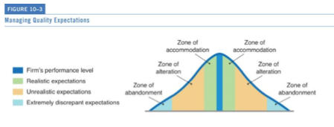
Acting on Dissatisfaction

Three ways consumers can act on dissatisfaction:
- Voice response: Appeal to retailer directly
- Private response: Express dissatisfaction to friends or boycott store
- Third-party response: legal action, going to the news

- More negative word of mouth than positive

The Real Value of Happy Customers

- 78% of customers are willing pay more for products if they experience great customer service
- Good service travels fast via social networking

Temporary Ownership Evolution

Transumers?
- Shred ownership
- Enjoy the benefits of the product when needed, but to not have to worry about:
  - Initial capital cost
  - Maintaining and storing the product
  - Disposal issues
- Car2Go, ZipCar
- Bag, Borrow, Steal

Product Disposal

- Strong product attachment = painful disposal process!
  - Possessions = identity anchors
  - Disposal rituals
- Ease of product disposal is now a key product attribute to consumers
- Disposal options
  - Keep old item
  - Temporarily dispose of it
  - Permanently dispose of it

Consumers’ Disposal Options

- Reasons for product replacement
  - Desire for new features
  - Change in consumer’s environment
  - Change in consumer’s role/self-image
- Public policy implications of product disposition
  - Recycling is a priority in many countries
  - Perceived effort involved in recycling as predictor

Lateral Cycling

- Already purchased products are sold to others or exchanged for still other things
  - Flea markets, garage sales, classified ads, bartering for services, hand-me-downs, etc.

Divestment rituals
- Taking steps to gradually distance themselves from things they treasure so that they can sell them or give them away.
  - Iconic transfer – taking pictures and videos of objects before selling
  - Transition-place – putting items in an out-of-the-way location, such as a garage or attic
  - Ritual cleansing – washing, ironing, or meticulously wrapping the item
- Internet has revolutionized lateral cycling - ebay, kijiji
- Re-stores across Canada (Habitat for Humanity)

Chapter 11: Group Influence and Social Media

Reference Groups

- Reference group: Actual or imaginary individual/group conceived of having significant relevance upon an individual’s evaluations, aspirations, or behaviour
- Influences consumers in three ways:
  - Informational:
    - Individual seeks information about brands from professional/independent group of experts; people who work with product; from friends, family, associated, seal of approval, observation of what experts do or use
    - ex: heather’s choice at chapters, good-housekeeping.com
  - Utilitarian
    - Influence from consumer's own preference; preferences of social circle, family to satisfy expectation others have of her/him
  - Value-expressive
    - Individual feels the brand will enhance image others have of her/him, individual feels those who purchase or use brand possess characteristics she/he wants, individual feels it would be nice to be like person in a,; purchasing product would make individual respected, or what they would like to be

Social media’s impact

- Any external influence that provides social clues
  - Cultural figure
  - Parents
  - A large, formal organization
  - Small and informal groups
    - Exert a more powerful influence on individual consumers

Formal vs. Informal Reference Groups

- Reference group can be large and formal with a standard, recognized structure
  - Regular meetings, charters, and officers
Or
- The reference group can be small and informal, just a group of friends
However
- As a rule, small informal groups can exert powerful influence on individual consumers

Types of Reference Group Influence

- Normative influence
  - Helps to set and enforce fundamental standards of conduct
  - Ex: parents
  - Comparative influence
  - Decisions about specific brands or activities are affected
  - Ex: weight watchers

Brand Communities

- A group of consumers who share a set of social relationships based upon usage or interest in a product
- Typically don’t live near each other
- Organized events
- Emotionally involved with brand welfare (Sam and BMW)
- Brand communities share emotions, moral beliefs, styles of life, and affiliated product
  - Brand loyalty
  - Brandfests enhance brand loyalty (events)
  - Brand missionaries
- Ex: Harley Davidson group

Membership vs. Aspirational Reference Groups

People the consumer actually knows vs. people the consumer doesn’t know but admires
  - Aspirational strategies concentrate on highly visible, widely admired figures (athletes or performers)
    - Idealized figures

  - Membership strategies focus on “ordinary” people whose consumption provides informational social influence
  - Factors include:
    - Propinquity (physical nearness) – as physical distance decreases, opportunities for interaction increases, relationships are more likely to form
    - Mere exposure – like people when we see them more often
    - Group cohesiveness – the degree to which members of a group are attached to each other and value their group membership

Positive vs. Negative Reference Groups

- Reference groups may exert either a positive or negative influence on consumption behaviours
- Dissociative reference groups = motivation to distance oneself from other people/groups
- Marketers show ads with undesirable people using competitor’s product

Antibrand Communities

- Antibrand communities: Coalesce around a celebrity, store, or brand—but in this case they’re united by their disdain for it
- Social Idealists who advocate non-materialistic lifestyles
- Many oppose Walmart, Starbucks, McDonald’s and Hummers
  - Ex: Rachel ray sucks website

When Reference Groups are Important

- Impact of reference groups vary based on whether the product is complex or, a product with little perceived risk (less susceptible)
- Two dimensions of influence:
  - Purchases to be consumed privately or publicly
  - Whether a luxury or a necessity
- Reference groups are most robust for purchases:
  - Luxuries
  - Socially conspicuous products

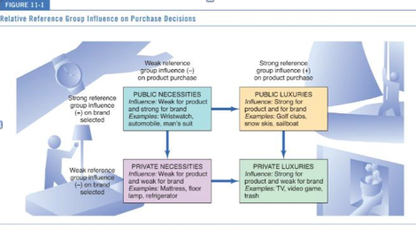

Power of Reference Groups

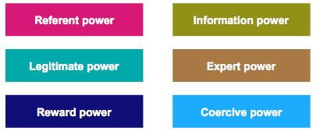
- Social power: capacity to alter the actions of others

- Types of social power:

- Referent power: when a person admires the qualities of an individual or a group, imitating of their behaviour will occur. Ex: family and friends

- Information power: knows more about something that others would like to know. Ability to disseminate information, ex: wish editors that can make of break individual designers or companies

- Legitimate power: power of the uniform. Granted power by social agreement. Ex: doctors, military, nurses, police officers, fireman. Offers security.

- Expert Power: power derived from possessing a specific knowledge or skill. Ex: celebrities, doctors, accountants

- Reward power: person who has the means to provide positive reinforcement, ex: employers

- Coercive power: effective in short run, Authority or power that is dependent on fear, suppression of free will, and/or use of punishment or threat, for its existence.

Conformity

- Conformity refers to a change in beliefs or actions as a reaction to real or imagined group pressure.
- Successful home shopping parties – pressure
- Members develop norms, or informal rules, that govern behaviour

- Factors influencing/increasing conformity:
  - Cultural pressures
  - Fear of deviance
  - Commitment to group
  - Group unanimity, size, expertise – makes it harder to resist demands
  - Susceptibility to interpersonal influence – need to identify with or enhance his/her image in the opinion of the significant others.

Resisting Conformity

- Anti-conformity: Defiance of the group is the actual object of behaviour
- Independence: pride in unique style
- Reactance: Threats of censoring books, television or rock music that people find objectionable actually results in an increase desire for these items

Social Comparison

- Social Comparison Theory
  - We look to others’ behaviour to inform us about reality
  - Occurs as a way to increase stability of one’s self-evaluation (without physical evidence)
    - Tastes in music and art
  - We tend to choose co-oriented peer when performing social comparison

Consumers do it in Groups

- Deindividuation: individual identities become submerged within a group
  - Example: binge drinking at college parties, acting more wildly at a Halloween party
- Social loafing: People don’t devote as much to a task when their contribution is part of a larger group
  - Example: we tend to tip less when eating in groups
- Risky shift: Group members show a greater willingness to consider riskier alternatives following group discussion than if members decide alone
- Decision Polarization: whichever direction the group member were learning toward before discussion – towards risky choice or conservative choice – becomes even more extreme after discussion.

Home shopping parties—such as Tupperware, Avon, Pampered Chef, Amway, or Botox—are designed to put pressure on friends and neighbors to buy merchandise.

Group Decision Making

- Different roles for different members:
  - Initiator – identifies need
  - Gatekeeper – searches and controls information
  - Influencer – uses power to sway the decision
  - Buyer – the purchaser (not necessarily the user)
  - User – the consumer/user of the product

Opinion Leadership

- Opinion leaders: influence others’ attitudes and behaviours
- Hard to identify in such large market
- Valuable because:
  - Technically competent – have expert power
  - Knowledge power – knowledgeable about products, trusted information
  - Socially active, highly interconnected – in community groups and clubs
  - Are similar to consumer in values, beliefs – have referent power
    - Homophilous: degree to which 2 individuals are similar in terms of education, social status, and beliefs, opinion leaders are usually slightly higher on this level.
  - Are often the first to buy
  - Hands-on experience

Reasons to Seek Advice form Opinion Leaders

- Generalize opinion leader versus monomorphic/polymorphic experts
  - Generalized opinion leaders: somebody whose recommendations are sought for all types of purchases (very rare)
  - Monomorphic opinion leaders: experts in limited field
  - Polymorphic: experts in several fields

- Although opinion leaders exist for multiple product categories, expertise tends to overlap across similar categories
  - It is rare to find a generalized opinion leader
- Innovative communicators
- Opinion seekers
  - More likely to talk about products with others and solicit others’ opinions
  - Casual interaction prompted by situation

Types of Opinion Leaders

- Opinion leaders absorb information from mass media and transmits data to opinion receivers
- May or may not purchase the products they recommend
- Innovative communicators – early purchasers (innovators)
  - Socially active
  - Appearance-conscious
  - Involved in music culture
  - Heavy magazine readers
  - Clothing in broader range of styles
  - Intellectual interests were limited
- Two-step flow of model of influence: small group of influencers responsible for dissemination of information that can modify the opinions of large number of people

The Market Maven

Market maven: Actively involved in transmitting marketplace information of all types
- Just into shopping and aware what’s happening in the marketplace
- Overall knowledge of how and where to get products
- Surrogate consumers: Hired to provide input into purchase decisions (compensated for involvement)

Identifying Opinion Leaders

- Many ads intend to reach influencers rather than average consumer
  - Local opinion leaders are harder to find compared to celebrity
  - Companies try to identify influencers in order to create WOM “ripple effect”
    - Ex: fashion panels to provide input on fashion trends
  - Exploratory studies identify characteristics of opinion leaders can be identified and then generalized to the larger market for promotional strategies

The Self-Designating Method

- Most commonly used technique to identify opinion leaders…
  - Simply ask individuals whether they consider themselves to be opinion leaders
  - Method is easy to apply to large group of potential opinion leaders
  - View with skepticism…inflation or unawareness of own importance/influence
- Alternative: key informants identify opinion leaders

Sociometric Methods

- Trace communication patterns among group members
- Systematic map of group interactions
- Most precise method of identifying product-information sources, but is very difficult/expensive to implement
- Network analysis –focuses on communication in social system
  - Better understanding of referral behaviour/network to measure the tie strength among them
  - Bridging function to identify strength of weak ties

Word-of-Mouth Communication

WOM: product information transmitted by individuals to individuals
- Thought to be more reliable than traditional advertising
- Social pressure to conform
- Influences two-thirds of all sales
- We rely upon WOM in later stages of product adoption
  - Powerful when we are unaware of product category
  - Yelp reviews

Negative WOM and Power of Rumors

- We weigh negative WOM more heavily than we do positive comments!
  - Negative WOM is easy to spread, especially online
  - Determined detractors
  - Information/rumor distortion

Buzz Marketing

- Encourage consumers to spread WOM online encouraged by marketers
- Tremor – youth recruited by Proctor and Gamble to act as brand influencers
- Crowd power – non experts
- Wisdom of crowds – creation and marketing by committee
  - Perspective argues that under the right circumstances groups are smarter than the smartest people in them
  - Threadless T-shirts, Doritos commercial

Guerilla Marketing

- Guerilla marketing: Promotional strategies that use unconventional locations and intensive WOM to push products
- Recruits legions of real consumers for street theater

Viral Marketing

  - Viral Marketing: Getting visitors to a Web site to forward information on the site to their friends
  - Friend referrals are a brand you can trust
    - Groupon, Livingsocial

Social Networks

A set of socially relevant nodes connected by one ore more relationship

- Social networks = social graphs
- Nodes = members in a network
- Ties = relationships among nodes
- Flows = exchanges of resources, information or influence among members of the network
- Nodes
  - Have interactions (behaviour based ties)
  - Have flows (exchange information, influence, etc.)
- Media multiplexity – flows are in many directions
- Social object theory – more powerful ties if there is a way to activate relationships among people with object of common interest
- Object sociality – extent objects can be shared in social media

Virtual Communities

- Virtual community of consumption
  - Common love of a product
  - Remain anonymous – through cyberspace only
  - Operation is similar to any community
  - Social media provides the connection

  - Characteristics of Virtual World Communities:
    - Conversation – communication among membvers
    - Presence – effect that people experience when they interact with a computer-mediated environment
    - Collective interest – family, religion, brand, hobbies
    - Democracy – leaders emerge due to reputations they earned
  - Standards of behaviour – flaming (all capitals)
  - Levels of participation – members must participate unlike lurkers (absorb content others post but they don’t contribute their own)

Chapter 12: Income, Social Class and Family

Income Patterns

- Whether a skilled worker or a child of privilege, social class has a huge impact on one’s life
- Status symbols are valued as markers of social class
- Canadian living standards are high and improving
  - Average Canadian income increased from $75,000 in 2009 to $82,000 in 2013
  - World-wide over 2.5 billion people lived on under $2 per day in 2008

Improved standard of living due to:

1. Woman’s Work

- A larger proportion of people of working age are in the labour force
- Mothers with preschool children comprise the fastest growth in the labour market
- Women get high-paying jobs such as doctors, architects, etc.
- Nearly 30 percent of wives make more money than their spouses

2. Yes, It pays to go to School

- Education pays off in the long run
- In 2006 over 50 per cent of Canadians had some post-secondary education
- University graduates earn about 60% more versus other education levels

To Spend or Not to Spend

- Consumer demand = willingness to buy + ability to buy
- Discretionary income: The money available to a household over and above what it requires to have a comfortable standard of living
  - Ex: travel
- Households are spending more now on entertainment and education

Attitudes Toward Money

- How we spend varies based in part on our attitudes toward money
  - Frugality – great pleasure in saving (2 types):
    - Tightwads: spending money is an unpleasant experience
    - Spendthrifts: spend cautiously because the enjoy saving money

Wal-Mart Study on Attitudes Towards Money

- Money has meaning
- Walmart has lots of name brands
- Walmart study identified three distinct groups of consumers:
  - Brand aspirationals: on low incomes but obsessed with names like KitchenAid.
  - Value-price shoppers: who like low prices and cannot afford more.
  - Price-sensitive affluents: wealthier shoppers who love deals.

Consumer Confidence

- Behavioural economics/economic psychology: concerned with “human” side to economic decisions
- Consumer confidence: Extent to which people are optimistic or pessimistic about the future health of the economy
  - Influences how much discretionary money we will pump into the economy
- Overall savings rate is affected by:
  - Pessimism/optimism about personal circumstances – ex: ear of being laid off
  - National and World events – ex: new prime minister
  - Cultural differences in attitudes toward savings

Forecasting Consumer Confidence

- Would you say that you and your family are better or worse off financially than a year ago?
- Will you be better off or worse off a year from now?
- Do you plan to buy a car in the next year?

Social Class Structure

- “Haves” versus “have-nots”
- Social class is determined by a complex set of variables such as income, family background, education and occupation
- Universal pecking order: relative standing in society
- Social class affects access to resources such as education, housing, consumer goods

Picking a Pecking Order

- Chickens develop clearly defined dominance – submission hierarchy where each has a position much like people do
- People are ranked on relative standing in society
- Social stratification
  - Artificial divisions in a society in terms of peoples relative social standing and economic resources
  - Scarce/valuable resources are distributed unequally to status positions
- Achieved versus ascribed status
  - Achieved status: people who earned resources through hard work or diligent study
  - Ascribed status: born into it
    - Status hierarchy: some members are somehow better off than others

Social Mobility

- Social mobility: passage of individuals from one social class to another
  - Horizontal mobility: from one occupation to another in same social class
  - Downward mobility: moving down a social class
  - Upward mobility: moving up on the social standing –higher class have less children, therefore position must be filled by lower status
  - Think about it: What consumption cues do you use to determine social standing? VIDEO

- Inherited
- Social climber
- Working stiff
- Social critic

Class Structure Around the World

- Rise of Chinese middle class
  - Nike’s new brand presence there
- Japan as a status- and brand-conscious society
  - Single, working women spending on luxury goods
- Major retailers/brands are coming to Middle-Eastern countries, where Arab women enjoy shopping with their families/friends
- England’s rigid class structure still exists, but the dominance of its aristocracy is fading but marketers are still targeting chavs’ as a group
- India’s economy is booming, many poor but rich are prefer high-end brands & credit cards
  - Burberry hats in India
    - Luxury brand selling to lower class style

Blurring Social Class

- Many “luxuries” are now affordable to all
- People shop “cheap” in one area to shop “rich” elsewhere
  - Even the wealthy shop at Walmart for basics
- The emerging BRIC economies – Brazil, Russia, India and China
- Growing demand for mass class (hundreds of millions of global consumers who now enjoy a level of purchasing power that enables them to afford high-quality products) products globally
  - Excluding:
    - Big-ticket items
    - Education
    - Housing
    - Luxury cars
  - Including
    - Volkswagen
    - Fiat

Components of Social Class

- Occupational prestige:
  - Some occupations are more respected than others
  - Stable over time and similar across cultures
  - Major component of social class
  - People judge others in regard to occupation
  - This is how people evaluate their “worth”
  - Top ranking: CEO, physician, university professor
  - Lower ranking: shoe shiner, ditch digger, garbage collector

- Income:
  - Wealth is not distributed evenly across classes (top 20% controls 40% of net worth)
  - Income per se is not often a good indicator of social class; it’s the way money is spent and not how much is spent
  - Need income to express tastes
  - How money relates to social class:
  - “Money” and “class” not synonymous
  - Whether social class or income is a better predictor of a consumer’s behaviour depends on the type of product:
    - Social class is better predictor of lower to moderately priced symbolic purchases (cosmetics and liquor)
    - Income is better predictor of major nonstatus/nonsymbolic expenditures (major appliances)
    - Need both social class and income to predict expensive, symbolic products (cars and homes)

- Education: related to both occupation and income

Class Differences in World View

World view: one way to differentiate among social classes

World of working class is intimate and constricted:
- Immediate needs dictate buying behaviour
- Dependence on relatives/local community
- More likely to be conservative/family-oriented
- Maintaining appearance of home/property
- Don’t feel high-status lifestyle is worth effort
  - Affluenza and pressure to maintain family status – well-off consumers seem to be stressed or unhappy despite or even because of their wealth

Attitudes Toward Luxury

Strategic Insights study divided consumers into three groups:
  - Luxury is functional: Logical purchases, not impulsive, products that last and have enduring value
  - Luxury is reward: Younger people…I’ve made it! Desire to be successful motivates these purchases
  - Luxury is indulgence: Smallest group, lavish and self-indulgent, willing to pay a premium for goods that express individuality and make others notice.

Old money vs. new money, rich vs. poor : spend in different ways

- Old money: inherited funds, distinguish themselves in terms od ancestry and lineage rather than wealth
  - McCains, Weston, Killiams
- New money: goes from rags to rich through hard work and a bit of luck
  - Self made millionaires
  - Steve jobs, Bill gates
  - Nouveaux rich: describes consumers who recently achieved their wealth and who don’t have the benefit of years on training to learn how to spend it
    - Status anxiety

Taste Cultures, Codes, and Cultural Capital

Taste culture: Differentiates people in terms of their aesthetic and intellectual preferences
- Distinguishes consumption choices among social classes
- Upper- and upper-middle-class: more likely to visit museums and attend live theatre
- Middle-class: More likely to go camping and fishing
- Some think concept of taste culture is elitist
Codes: the way consumers express and interpret meanings
- Devil wears Prada
- Working girl
- Life insurance ad different for different classes
- Lower: hardworking family man
- Higher: long-term thinking, planning for the future

Online Social Capital

A community is healthier and more desirable when it is able to offer a lot of social capital as an inducement for people to join
  - Online gated communities
    - Selectively allow access to some people who offer a high degree of social capital
    - Dating sites – hotenough.com: weed out unattractive people
  - Pecking order matters online too
    - YouTube
    - Instagram
    - Foursquare
    - Social network sites

Status Symbols

- Keeping up with the Joneses (in Japan the Satos)
- What matters is having more wealth/fame than others – tiered loyalty programs
  - Loyalty programs: airlines award you with special status according to how many miles you fly
- Status-seeking: motivation to have products that let others know that you “made it”
- Products function as a status symbol
- Dropping “cheap” brands
- Conspicuous Consumption – peoples desire to provide prominent, visible evidence of their ability to afford luxury goods

Problems with Measures of Social Class

- It is difficult to measure social class complexities
- Most measures of social class in the past had trouble accounting for two-income families, young singles living alone, or households headed by women
- Increasing anonymity of our society
  - Reputational method is virtually impossible to implement today (can use demographic data and subjective impressions)
- Status crystallization
  - Impact of inconsistency on the self and social behaviour

Households and the Modern Family

Before 1900s: Extended family
1950s: Nuclear family (mother, father, and children)
- Just what is a household?
  - Family household contains at least two people, regardless of their relationship
  - Divorces and separations are accepted in our culture…marital breakups are ever-present theme in books, music, and movies
  - Adult females are staying home with family/children more (especially among best-educated/highest achieving women)

Age of the Family

- Most Canadians under 24 have never been married or living common-law
- 35-64 age group greatest number of marriages and common-law relationships (77%)
- Trend toward giving non-traditional items as wedding gifts (home electronics, computers, experiences)

Family Size

- Depends on educational level, availability of birth control, and religion
- Total fertility in 2006 was 1.6, which is below the replacement rate of 2.1 to sustain Canadian population
- Worldwide, women want smaller families (especially in industrialized countries)
  - Divorce is common
  - Fewer young people to support their elders
  - Some countries want people to have more children

Non-Traditional Households

- Any occupied housing unit is a household
  - 16% lone parent
  - 35% mothers stay at home
  - May be unmarried opposite sex couples, or same-sex couples (POSSLQ)
  - Intentional families: celebrate holidays together
  - Rise of single-person households
  - Singles spend more on rent, alcohol, reading materials, health care, and tobacco/smoking

Who’s Living at Home?

- Sandwich generation: Adults who care for their parents as well as their own children
- Boomerang kids: Adult children who return to live with their parents
  - Spend less on household items and more on entertainment

Family Life Cycle

- Factors that determine how couples spend money:
  - Whether they have children
  - Whether the woman works
- Family life cycle (FLC) concept combines trends in income and family composition with change in demands placed on income
  - As we age, our preferences/needs for products and activities tend to change

Family Life Cycle Approach Models

- Takes into account the family variables to describe changes in priorities and demand for product categories:
  - Age
  - Marital status
  - Presence/absence of children in home
  - Ages of children

Chapter 13: Subcultures

Subcultures, Microcultures, and Consumer Identity

Subculture: a group whose members share beliefs and common experiences that set them apart from others.
- Related to age, ethnic group, region

Microcultures: based on lifestyles or aesthetic preferences
- Ex: martial arts enthusiast, trekkies

- Consumers’ lifestyles are affected by group membership within the society-at-large called subcultures and based on age, race/ethnicity, and place of residence. Within these are:
  - Microcultures:
    - Share a strong identification with an activity or art form
    - Have a unique set of norms, vocabulary, and product insignias

Some consumers identify with subcultures or microcultures that share common characteristics and identities and that influence their consumption decisions. People have many things in common with others because they are about the same age.

Age Subcultures and Consumer Identity

- The era in which you grow up bonds you with millions of others who came of age at a certain period eg the many mature consumers who flocked to the Paul McCartney concert in Halifax in 2009
- Marketers must communicate with an age group in their own language
- Age cohort: a group of consumers of the same approximate age who have similar experiences

Generational Categories

- The Interbellum Generation— People born at the beginning of the twentieth century
- The Silent Generation—People born between the two World Wars
- The War Baby Generation—People born during World War II
- The Baby Boom Generation—People born between 1946–1964
- Generation X—People born between 1965–1985
- Generation Y -People born between 1986–2002
- Generation Z—People born 2003 and later

Nostalgia Scale

- Some consumers are more disposed to be nostalgic than others, regardless of age

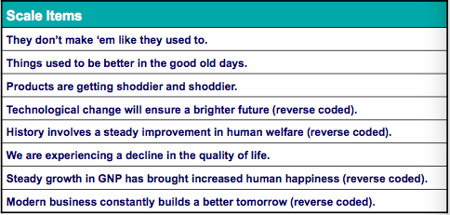

Multi-generational Marketing Strategy

- Using imagery that appeals to more than one generation
- Baby boomers, for example, have a youthful attitude and embrace technology as do the teens and twenties
  - Ex: Ozzy Ozburne and Justin Beiber in the same as
- Youthography points out that the ages of 18-34 are in different cohorts but value personal relationships, media and technology

Ages Apart but Similar Shoppers

Millennials and Boomers

Top Similarities
- Search for products online
- Female Boomers Use Facebook at identical rates (90%)
- Focus on price/value
- Bought more electronics last year
- Retail is prominent place they shopped

Top Differences
- Millennials more optimistic about economy
- Different priorities: travel & apparel vs. necessities and insurance
- Mobile search vs. newspapers/magazines
- WOM vs. sales reps

Generation Y (1986-2002)

- 26.5 percent of the Canadian population
- 20% of Canadians 15-24 belong to a visible minority
- Gen Yers feel they belong to the global community first
- 94% agree that one of the best things about Canada is the way it welcomes different races and cultures

Y are Digital Natives

- Multi-taskers with 500 channels, cell phones, music downloads and laptops
- The THUMB culture – communicates online and by cell phone
- Gen Yers use technology confirms this profile:
  - Texting – 32 minutes a day texting
  - Video – TV, social media, YouTube, internet
  - Online brand WOM – social media sites, clicking online ads
  - Consumer generated content
  - “Connexity”` - high value on being footloose and connected to peeps 24/7
- Schedule Everything
- Assertive with strong views
- Respect authority – falling crime rates, teen pregnancy rates

Big (Wo)Man on Campus

- Advertisers spend millions to influence purchases of college and university students
- Campus food service is a multi-million dollar industry
- Prefer socially responsible brands
- A major target to attain early brand loyalty – loyal to brands that they feel contribute to social issues and the environment
- Hard to reach via conventional media

Teenagers – The Youth Market

- Youth market is massive – hundreds of billions!

Teens are:
- Focused on ‘feel good’ products
- Avidly courted
- Use WOM extensively
- Advertising towards them is huge

Teens, Values, Conflict and Desires

- Product usage is all about:
  - Experimentation
  - Belonging
  - Independence
  - Responsibility and
  - Approval from others – looking for the right way to look and behave
- Friends, activities and clothing are vital

Teen Conflicts

- According to Saatchi & Saatchi teens have four basic conflicts:
  - Autonomy versus belonging – move away from parents but need to attach themselves to a support structure such as peers
  - Rebellions versus conformity – rebel against social standards of appearance and behaviour yet still need others acceptance to fit in
  - Idealism versus pragmatism – view adults as hypocrites and see themselves as sincere
  - Narcissism versus intimacy – obsess with appearance and need to connect with others on a meaningful level

Rules of Engagement

- Rule #1: Don’t talk down
- Rule #2: Don’t try to be what you’re not (b urself) – stay true to brand image
- Rule #3: Entertain them. Make it interactive and keep the sell short
- Rule #4: Show that you know what they’re going through but keep it light

Modern teens are savvy and marketers must tread lightly when talking to them. The message must be authentic and not condescending. These are the four rules for marketers to abide by when engaging teens.

Tweens

- Age 10-14: 2 million
- Between childhood and adolescence
- They have discretionary income from various sources (birthdays, holidays, allowances)
- Aspire to being teens
- 90% have influence over clothing they wear
- Influence another $20 billion of family spending
- Represent $2.9 billion in spending

Ethics, advertising and Children

- Should there be more education for children to understand how advertising works?
  - eg Street Cents, Media Madness publications
- Guidelines Canadian Advertising Foundation in place already
- Other countries also have concerns:
  - Netherlands – TV watersheds and tough codes for sweets
  - Spain & Germany – certain toys banned from advertising
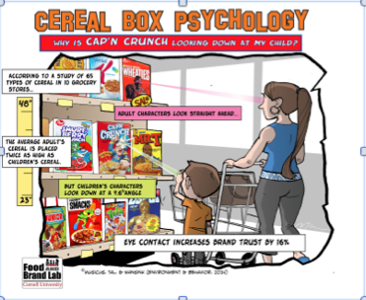
  - France – tight controls on TV for children

Eyes in the Cereal Aisle

- Cereal box Psychology

How Do We Research the Youth Market?
- Research firms specialize in youth markets
- Pizza Hut invites students to lunch with executives
- Companies provide video cameras of a day at school
- Frito-Lay (Doritos) experienced a 22 per cent increase in sales after a social media component tied to the Superbowl
- Teens are consumers in training: can be loyal to products for many years

Generation X

- Sometimes called Baby Busters - 6.5 million
- Includes 3.7 million baby boomers born between 1960 and 1966
- Often overlooked as a small age cohort. However, Gen X members have changed the world creating companies such as Google, YouTube and Amazon

- Entrepreneurial
- Individualistic. `Latch-Key`kids
- Averages 7 career changes in their lives
- Cautious, skeptical, unimpressed with authority, self-reliant
- Want to save the neighbourhood, not the world
- Want what they want now…a lot are deep in debt
- Late to marry…quick to divorce
- Pessimistic
- Usually market to boomers or gen Yers in hopes that gen Xers will fall in one of the groups

The Mature Market

- Redefining age and what growing old means
- Terms for this group and segmentations within the group are changing all the time:
  - Elderly
  - Boomers
  - Zoomers (boomers with zip)
  - Grey Market
  - Seniors

Baby Boomers

- 9.7 million baby boomers in Canada, over 30% of the population
- As teenagers, the Woodstock generation, today ready to retire or already retired
- The boomers found lucrative jobs, getting older and wealthier. The ``ME`` Generation
- The boomers purchased 80% of all healthcare products in 2007, but they also bought 58% of all cars, and are enjoying 55% of vacations
- Changing the meaning of the word `retirement`
- Defined by culture
- Bonus tome when retired

The Grey Market

- Until recently many marketers neglected the grey market
- As this market remains healthy and active, their role has changed rapidly
- Disciplined, self-sacrificing & cautious
- The grey market is now a picture of health and activity
- Marriage for life
- Avid readers (especially newspapers)
- The market grow
- Value saving

Grey Power

- People over 60 are the fastest growing age group
- 700 million seniors - 65 and older
- Will be 2 billion by mid-century
- Seniors are among the brand loyal customers
- Exercise facilities, cruises and tourism, cosmetic surgery, skin treatments, and toys for grandchildren are products of the seniors

Perceived Age: You’re Only as Old as You Feel

- Chronological Age: Actual number of years lived
- Perceived age: How old a person feels is a better yardstick to use
- Marketers are responding to how the seniors feel, not how old they are
- Emphasize product benefits instead of age appropriateness
  - Old generations still crave beauty and vitality
    - Ex: Ellen DeGeneres for cover girl

Marketing to the Mature Market

- Consumer identity renaissance: redefinition process people undergo when they retire – how do they respond – revived or emergent?
  - Revived: revitalization of previous identity
  - Emergent: pursuit of entirely new life projects
- Engage strategies such as affiliation and self-expression for the next chapter of their lives
- The Mature Market like:
  - Information rich positive advertising
  - Well designed user friendly products and packaging that acknowledges physical limitations

- Marketing strategies should link to the following
  - Autonomy: lead active lifestyles and self-sufficient
  - Connectedness: value bonds with friends and family
  - Altruism: give back and leave their mark

Regional Subcultures

Regional segmentation: segmenting the market according to geographic location

- Canadians share national identity but the regions of Canada differ in weather patterns, populations, ethnic mix, food and product preferences, resources and customs
- Four regions: Atlantic Canada, Quebec, Ontario and West
- Marketers need to know preferences and products by names in regional markets
- Loblaw’s in the west are called Real Canadian Superstore but in Atlantic Canada they are called the Atlantic Superstore
- Loblaw’s vs. Provigo
- Different climate causes different needs
- Montrealers drink soft drinks. Other Canadians drink pop
- Regional print media

Ethnic Subcultures in Canada

- Consumers’ lifestyles are affected by group membership within the society-at-large
  - Ethnic subculture = group of people sharing common cultural and/or genetic ties
  - Homogeneous (Japan) vs. heterogeneous (Canada) cultural societies
- How to identify?
  - Language (strong measure of ethnicity) vs. religion (weak measure)
  - Self-identification

Ethnicity and Marketing Strategies

- Marketers cannot ignore the diversity of cultures in society today - these subcultures shape consumption
- Marketing must address cultural differences
  - High-context culture: group members tend to be tightly knit, and infer meanings that go beyond the spoken word. Use of symbol and gestures rather than words
  - Low-context cultures: less tightly knit and are more literal
- Targeting ethnic consumers in two ways:
  - Fostering inclusiveness – putting more visible minorities into mainstream advertising
  - ‘Speaking’ to ethnic groups in their mother tongue

  - Ethnic media as a bridge – blends the familiar with the new
    - Research indicates that minorities prefer an advertising spokesperson from their own group
  - De-ethnicitization of products:
    - Product formerly associated with a specific ethnic group is detached from its roots and marketed to other subcultures
    - Bagels
    - Olive oil
    - Curries

Ethic Groups in Canada

- Currently British and French are largest two ethnic markets
- Ethnic groups are concentrated geographically
- In addition to two Canadian official languages, Chinese, Italian, German and Ukrainian are the most dominant mother tongues

French Canadian

Significant Canadian Subculture
  - Account for 16% of the population
  - Account for 80% of Quebec’s population and 1/3 of New Brunswick’s population
  - 21.5% of Canadians speak French at home
- French Canadians put more emphasis on being well respected and less on intellectual and cultural activities

Chinese Canadians

One of fastest growing minority groups - 25% of minorities
- Increasing influence on companies and product marketing
Characteristics include:
  - Small, Diverse
  - Hardworking
  - Above Average Incomes
  - Education Oriented
  - Varied population experiences

Canadian Aboriginals and South Asians

- Canadians of Aboriginal origin number just over one million
- About 50 per cent of the Aboriginal population is under 25 years of age
- 19 Aboriginal languages in 5 dialects
- 1.3 million South-Asian Canadians in 2006- 25 per cent of visible minorities (similar to Chinese)
- Over half of the South-Asians live in Toronto

The Effect of Immigration on Canadian Diversity

- Statistics Canada estimates the population of Canada in 2011 was just over 33.5 million and is expected to grow to around 42 million by 2031
- In 2006, 6.1 million Canadians (almost 20%) were immigrants
- It is expected that by 2017 when Canada is 150 years old 19 to 23 percent of Canadians will be visible minorities
- Main four: Chinese, East Indians, Filipino, Pakistani
- Concentrated in urban areas – Toronto is the most ethnically diverse city in the world.

Ethnicity is a Moving Target

- Defining/targeting an ethnic group is not always so easy (“melting pot” society)
  - Many identify with two or more races on Census forms
- Ethnic intermarriage has blurred ethnic boundaries
- Mixed marriages create opportunities for marketers
- New products will celebrate multiple heritages

Ethnic Stereotypes

- Many subcultures have powerful stereotypes associated with them
  - Subgroups are assumed to possess certain traits (often erroneously) which can be cast either positively or negatively
    - Scottish stereotype as “thrifty”

Marketers in the past have made vast use of ethnic stereotypes to communicate product attributes in ways that were sometimes crude and unflattering

Chapter 14: Cultural Influences on Consumer Behaviour

Understanding Culture

- Culture is society’s personality
- The accumulation of shared meanings, rituals, norms, and traditions among members
- Culture is the lens through which we view products
- One’s culture determines product priorities and mandates a product’s success/failure

- If your culture were a person, how would you describe its personality traits?
- Now, select another culture you’re familiar with. How would those personality traits differ from your own?

- Products can reflect underlying cultural processes of a particular period:
  - The TV dinner for the United States
  - Cosmetics made of natural materials without animal testing
  - Pastel carrying cases for condoms

Aspects of Culture

- Cultural system function areas:
  - Ecology: the way a system adapts to its habitat
    - Shaped by technology used to obtain and distribute resources
  - Social structure: orderly social life is maintained
    - Domestic and political groups dominant within the culture (nuclear family vs. extended family)
  - Ideology: mental characteristics of a people and the way in which the relate to their environment and social groups (beliefs and relationships)
    - Share worldview and ethos: morals and aesthetic principles

Cultural Values

- Many values are universal, such as family, health, happiness, and wisdom.
- Value: shared belief shaped by individual, social, and cultural forces
- What sets cultures apart are which values are seen as being relatively more important.
  - Identify the core values for each culture
eg. Amercians value freedom, youthfulness and achievement
eg. Japanese will trade some independence for security

- A marketing message that is appealing in one culture may not be as appealing in another culture.
- Medicine differs by culture

Measuring Cross Cultural Values

Power Distance:

- The way members perceive differences in power when they form interpersonal relationships
- Degree to which accept inequality and hierarchy
- Canada is lower, Japan high
- Power distance in marketing

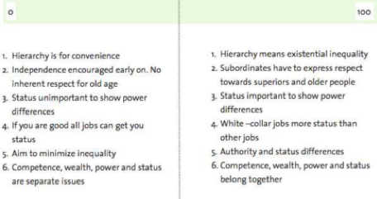

Uncertainty Avoidance:

- Degree to which people feel threatened by ambiguous situations
- Low uncertainty – risk tolerant (Canada)
- Value information on reviews (trip advisor)
- High uncertainty avoidance (trust experts)
- Uncertainty avoidance in marketing

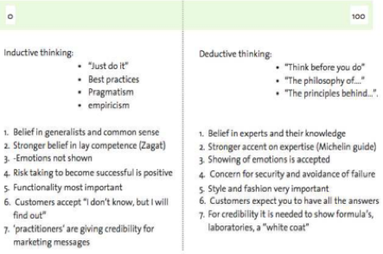

Masculine vs. Feminine:

- Degree to which gender roles are delineated
- Aggressive/competitive vs. caring
- In marketing:

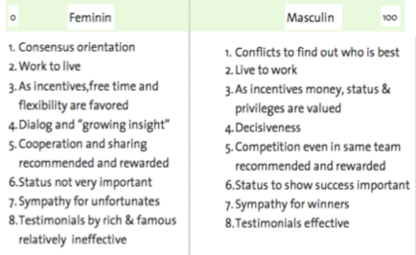

Individualism vs. Collectivism

- Extent to which culture values the welfare of individuals vs. that of the group
- Collectivist culture: people subordinate their personal goals to those of a stable in-group
- Individualist culture: attach more importance to personal goals
- In marketing
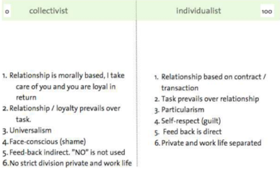

Long Term vs. Short Term:

- A focus on future rewards or values linked to the past and present
- Long-term orientation: tends to foster an orientation towards future rewards such as perseverance and thrift ex: japan
- Short term orientation: values virtues related to the past and present, including respect for tradition and preservation of the “face” ex: Egypt, Africa
- In marketing:
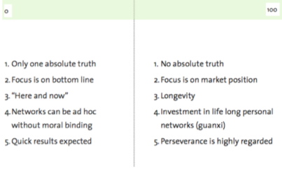

Cultural Norms

Norms: Rules dictating what is right or wrong
- Enacted norms: Explicitly decided on (e.g., green light equals “go”)
- Crescive norms: Less obvious and embedded in a culture and include:
  - Customs: Norms handed down from the past that control basic behavior
    - Ex: division of labour in household
  - Mores: Custom with a strong moral overtone
    - Ex: taboo or forbidden behaviour such as incest or cannibalism
  - Conventions: Norms regarding the conduct of everyday life. Rules deal with the subtleties of consumer behaviour
    - Ex: “correct” way to furnish one’s house
- All three crescive norms combine to define a culturally appropriate behavior

Myths and Rituals

- Every culture develops practices that help make sense of the world
- Cultures’ myths/rituals can seem bizarre
- “Magical” products and interest in occult tend to be popular when members of a society feel overwhelmed and powerless

Myths

Myth: Story containing symbolic elements that represent the shared emotions/ideals of a culture
  - Conflict between opposing forces
  - Outcome is moral guide for people
  - Reduces anxiety
    - Ex: little red riding hood

Marketers create and play upon myths

Functions and Structure of Myths

Myths serve four interrelated functions in a culture

- Metaphysical: helps explain origins of existence

- Cosmological: Emphasize that all components of the universe are part of a single picture

- Sociological: Maintain social order by authorizing a social code to be followed by members of a culture

- Psychological: Provide models for personal conduct

Myths Abound in Popular Culture

- Myths are often found in comic books, movies, holidays, and commercials
- Consumer fairy tales: Disney weddings
- Monomyths: Myth that is common to many cultures often a hero that emerges to win over evil
e.g., Spiderman and Superman
- Myths can be built upon in marketing
e.g., Kokanee beer and Sasquatch

Rituals

- Rituals: Sets of multiple, symbolic behaviours that occur in a fixed sequence and that tend to be repeated periodically
- Many consumer activities are ritualistic:
  - Trips to Starbucks
  - “Pulling” the perfect pint of Guinness
- College campus rituals
  - Tailgating at football games
- Businesses supply ritual artifacts (items needed to perform rituals) to consumers
  - Wedding rice, birthday candles, diplomas, online gift registries
  - Diamond rings for engagement/weddings – De Beers “right hand ring” to add extra purchasing opportunities
- Consumers often employ a ritual script
    - Graduation programs, etiquette books

Grooming Rituals

All consumers have private grooming rituals:
  - Aid transition from private to public self (or back again)
  - Inspires confidence, cleanses body of dirt
  - Before-and-after phenomenon
  - Mystical qualities attributed to grooming products and behaviours
Two types of binary opposition
- Private/public and work/leisure personal rituals
- Beauty rituals reflect transformations from natural state to the social world (put her face on)

Gift-Giving Rituals

- Gift-giving ritual: Consumers procure the perfect object, meticulously remove price tag, carefully wrap it, then deliver it to recipient
- Gift giving is a form of:
  - Economic exchange – giver transfers an item of value to a recipient, who in turn is obligated to reciprocate.
  - Symbolic exchange – the giver is motivated by unselfish factors, such as love or admiration and does not expect anything in return
  - Social expression – exchange oriented
- Every culture prescribes certain occasions and ceremonies for giving gifts
- Business gifts = define/maintain professional relationships, improve employee morale, and result in higher sales
- Birthdays
- Holidays
- Stages of gift-giving ritual
  - Gestation
    - Structural vs. emergent motivational event, motivated by an event to procure a gift
  - Presentation
    - Process of gift exchange
    - The recipient responds to the gift and donor evaluates this response
  - Reformulation
    - Bond between giver and receiver are adjusted (looser or tighter)
    - Reciprocity norm: obliges people to return the gesture of a gift with one of equal value

Self-Gifts

- “One for them, one for me, one for them.”
- Self gifting is a socially acceptable way of rewarding for good deeds, or consoling themselves for negative events
- Canadian Tire gift certificates diminish fear of buying the wrong thing
- Re-gifting: Started with a Seinfeld episode…presenting a gift that you have received and package it up for someone else.

Cultural Differences in Gift-Giving Rituals

- Not all cultures gift the same way
- Japanese gift-giving rituals
  - Symbolic meaning of gift: duty to others in social group
  - Giri: giving is moral imperative
  - Kosai: reciprocal gift-giving obligations to relatives/friends
  - Never open gift in front of the giver

Holiday Rituals

- Holidays are based on a myth with a character at center of story
  - Consumers perform rituals unique to those occasions
- Marketers find ways to encourage gift giving
- Businesses invent new occasions to capitalize on need for cards/ritual artifacts
  - Secretaries’ Day and Grandparents’ Day
- Retailers elevate minor holidays to major ones to provide opportunities

Christmas
- Myths/rituals: Santa’s adventures and mistletoe
- Began as a publicly rowdy celebration
- Santa = champion of materialism
  - Appears in stores and shopping malls
  - Socializes children to expect a reward when they are good (we get what we deserve)
Halloween
- Rituals are unusual…
  - Primarily involves nonfamily members
  - Celebrates evil and death
  - Encourages threats of “tricks” for treats
- Halloween is antifestival: Distorts symbols associated with other holidays
  - Ex: the resurrection of ghosts, symbolism of pumpkin pie to jack-o-lantern
- Second most popular party night for adults

Rites of Passage

- Rites of passage: Special times marked by a change in social status
  - Puberty, death, divorce, dating, bar/bat mitzvah
  - Stages:
  - Separation: detached from his or her group or status
  - Liminality: middle stage, in which the person is between status
  - Aggregation: the person reenters society after the rite of passage is complete
- Practices vary across cultures but are rich in symbolic value
  - Funeral rituals negotiate social identities of deceased through expression of material/symbolic wealth

Sacred and Profane Consumption

- Sacred consumption: Involves objects and events that are set apart from normal activities that are treated with respect or awe
  - Ex: wedding dress

- Profane consumption: Involves consumer objects and events that are ordinary and not special
  - Everyday jeans

Sacred Places

- Sacred places: religious/mystical and country heritage, such as Stonehenge, Mecca, Ground Zero in New York City
- Property of contamination: something sacred happened there, so it assumes sacred qualities
- Some profane (ordinary) places take on sacred qualities: Graumann’s Chinese Theater in Hollywood: celebrities leave their footprints

Sacred People and Events

- Sacred people: We idolize certain people and set them apart from masses
  - Movie stars, rock stars, royalty (Princess Diana)
  - Contagion effect: belief that the individuals immaterial qualities or essence can be transferred to the object through physical contact
- Sacred events: Public events, sports (Olympics), tourism (binary opposition between work and leisure)
  - Souvenirs: Niagara Falls souvenirs, pictorial images, “piece of the rock”

Deserialization

- Deserialization: A sacred item/symbol is removed from its special place or is duplicated in mass quantities (becomes profane)
  - Souvenir reproductions (Statue of Liberty)
- Religion has somewhat become desacralized
  - New Age Crystals moved to mainstream of fashion jewelries (wearing the cross)
  - Christmas as secular, materialistic occasions

Sacralization

- Sacralization: ordinary objects, events, and people take on sacred meaning:
  - Olympic Hockey, Mother Theresa, Elvis Presley
- Objectification: sacred qualities attached to mundane items,
  - Through contamination (objects associated with scared events or people become sacred in their own right) and collections (socialized as soon as the object enters the collection):
  - Beatles memorabilia, Barbie dolls
  - Collecting: systematic acquisition of a particular object or set of objects
  - Hoarding: unsystematic collecting

Language and Symbols

Language barriers across cultures = problems
- Back-translation (translate original language to target language then a different interpreter retranslates a translated ad back into its original language to catch errors) can assist with this and avoid problems such as:
  - “Nothing sucks like an Electrolux”
Symbols – an object/sign the represents something else
- e.g., numbers, gestures, and colours vary across cultures, and can cause problems if not appropriate for the target culture
  - Number 4 in japan is unlucky
  - In china the colour red is associated with joy and fortune

Transferring Product Meanings to Other Cultures

- Innovations know no geographic boundaries
- Costly consequences of ignoring cultural sensitivities
- For examples McDonalds…
  - 1994: reprinting Saudi Arabian flag on disposable packaging
  - 2002: litigation settlement for mislabeling French fries as being vegetarian
  - 2002: cancellation of McAfrika

Two options of approach

Adopt a Standardized Strategy

- Starbucks’ standardized strategy worldwide
  - Critics: Starbucks obliterates local customs
- Etic perspective: Develop one approach for multiple, homogenized markets
  - Economies of scale benefit
  - Fits some products/target groups better than others

Adopt a Localized Strategy

- Disney learned cultural lessons
  - Disneyland Paris, Hong Kong Disneyland
- Emic perspective: Stress on variations across cultures
  - Each country is unique and has a national character
  - Strategies can be tailored to various cultures making product acceptable to local tastes

When Does Global Marketing Work Best?

- Cross-Cultural Analysis: examines degree to which two cultures are different or similar so we can adapt the strategy accordingly
- Consumers in different countries do not always use products the same way
- Significant cultural differences can show up within the same country
- Coca-Cola has been successful in crafting a single, international image because it has linked into those that share a common worldview

Does Global Marketing Work?

- Four major segments consumers in terms of how they evaluate global brands
  - Global citizens 55% - sees size and reach of global company as sign of success, but are concerned with social and environmental responsibilities
  - Global dreamers 23% - see global brands as high quality
  - Antiglobals 13% - avoid transnational brands and companies
  - Global agnostics 9% - evaluate all brands the same no matter origin

Diffusion of Consumer Culture
- The allure of consumer culture has spread throughout the world
  - In a global society, we are quick to borrow from any culture we admire
    - American brands are insinuating themselves into local cultures
    - American TV is shown around the world

Emerging Consumer Cultures in Transitional Economies

- Western “decadence” appears to be infectious in foreign countries
- Globalized consumption ethic
  - Ideal of material lifestyle and well-known brands that symbolize prosperity
  - Rituals/product preferences in different cultures become homogenized (e.g., Christmas in China)
- Attaining consumer goods is not easy for those in transitional economies
  - Loss of confidence/pride in local culture as well as alienation, frustration, increase in stress

