Assignment Four
Applications of Statistical Methods in Business
Professor Phansalker
University of Ottawa, Telfer School of Management

Due: Friday April 10th, 2015

Question 1
- 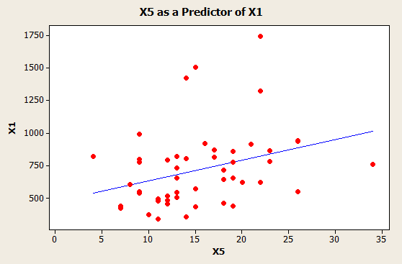
- Step One
H₀: β₁ = 0
H_{a}: β₂ ≠ 0

Step Two
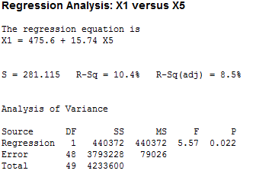
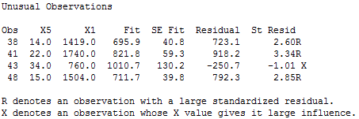
Step Three
T_{stat}= 2.36 (obtained from the Minitab output) T_{crit} =2.0211
Therefore, because the test statistic is greater than the critical test value (2.36>2.0211), we have sufficient evidence to conclude that the percent of 16-19 year olds not in high school and not high school graduates (X5) is only somewhat useful when trying to predict the total overall reported crime rate per 1 million residents (X1). To conclude, we reject the null hypothesis.

- The coefficient found in front of X5 is to represent the increase in the response variable (X1) for every percent that X5 increases: the percent of 16-19 year olds not in high school and not high school graduates.
- 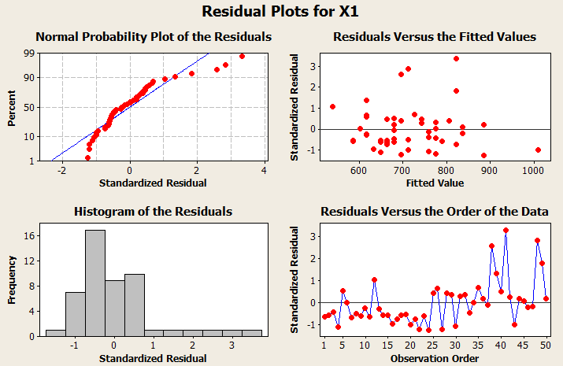

The following are the assumptions and whether or not there is an issue in regards to the above graphs.

When regarding the normal assumption, we look at the residuals versus fitted values data. Using the standardized graph we see that the outliers make up less than 5% of the data and can be overlooked; this assumption is met. Secondly, an equal variance assumption is met because there is a visible pattern among the graphs as the data appears to be spread out evenly and fairly. Thirdly, the linearity assumption is found by looking at the scatterplot above. This assumption is met because the data is even spread for the most part around zero and there is no evidence of a curved pattern. Lastly, the independence assumption appears to be met as nothing in the question says the variables are related.

- From Minitab we see the value of R², which is the coefficient of determination and a measure of how close the data are to the fitted regression line, is equal to 10.4%. From this we can gather that the model explains some (very little though) of the variability of the response data (X1). Also, we can conclude that using X5 as a predictor for X1 is not that great.

Question 2

- Step One
H₀: β₁= β₂ = β₃ = β₄ = β₅ = 0
H_{a}: not all β’s are equal to zero
Step Two
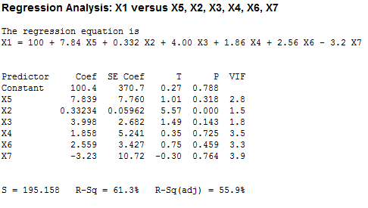
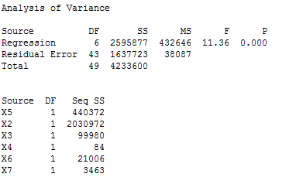
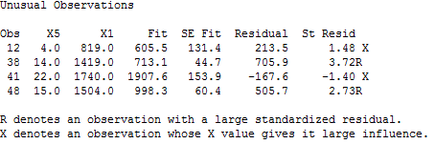
F_{stat} = 11.36 F_{crit} = F_{.05/2} = 2.3185

Step Three
Therefore, because the F_{stat} is greater than F_{crit} (11.36>2.3185) we reject the null hypothesis because we have sufficient evidence to conclude that not all variables are good predictors for X1.

- Step One
H₀: β₁ = 0
H_{a}: β₂ ≠ 0

Step Two
α= 0.05
T_{stat}= 1.01
T_{crit}= T_{.05/2 Df= 48}
=2.011

Step Three

Therefore, because the T_{stat} is less than the T_{crit} (1.01<2.011) we fail to reject the null hypothesis because there is a very weak relationship between X1 and X5. This means that X5 is not a good predictor of X1, which is inconsistent with the answer reached in 1b.

- 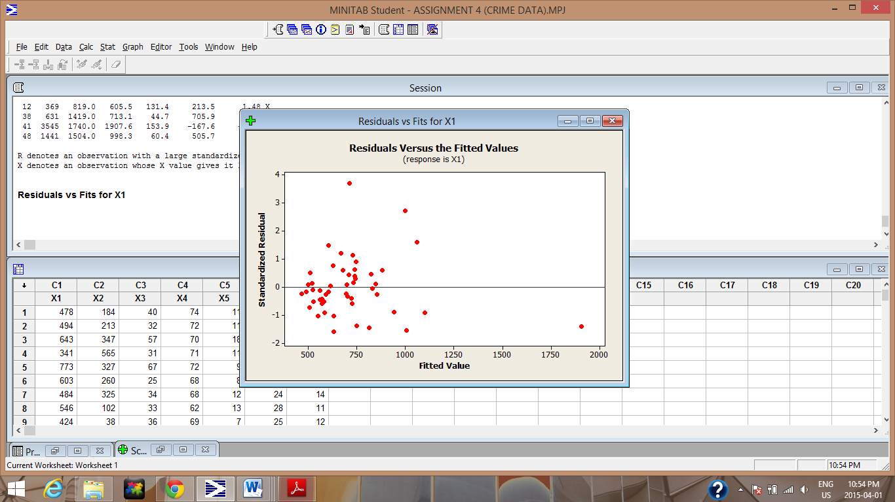

The assumptions and any issues found are as follows:

Firstly, the independence assumption is met because we are not given any information that indicates the variables are related. Secondly, the graph above shows that the linearity assumption is met because the data is fairly even spread around zero and no curved pattern is evident. Thirdly, the normality assumption is met because although there is outliers, this data represents less than 5% of the data and can be overlooked. Lastly, equal variance can be assumed because there is no distinct pattern in the graph and the data appears to be evenly spread.

R denotes an observation with a large standardized residual. Anytime it is above 2.5 or below -2.5, the data is an outlier point. Using the above information observations 38 and 48 have standardized residuals above 2.5; because of this they are outliers.
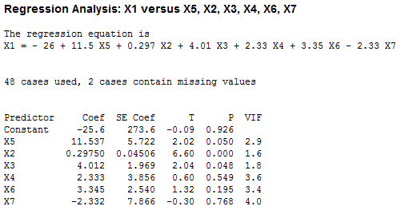
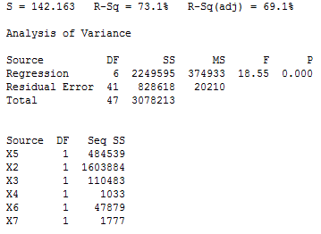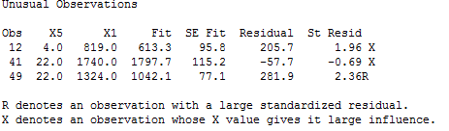

Once observations 38 and 48 were removed and regression was redone R² was adjusted from 55.9% 69.1%.

- 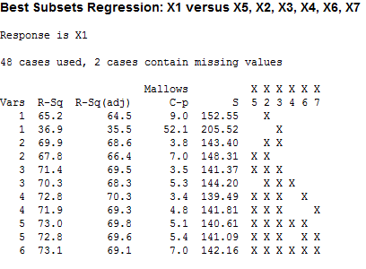
Therefore, the best subset is the second Vars 4, because it has the greatest R²_{adj} value at 70.3, as well as the smallest Mallow Cp value at 3.2 and the smallest S value.

Question 3:

- 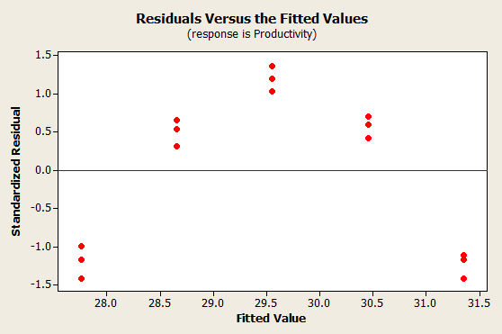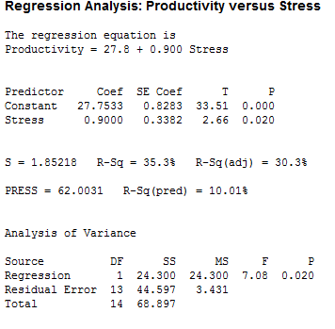

Looking at the graph above, the five groups of three data points each indicates that there is a distinct pattern within the data; for this reason it is reasonable to assume the data is not linear because a curved pattern is evident.
- Given the graph in part a, the stress predictor was transformed using the square function to create a new Stress² predictor. Below is the Residual versus Fitted graph using the new predictor.
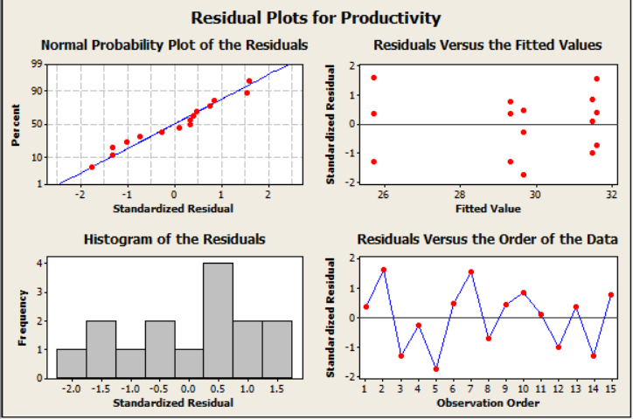

Using the new predictor the assumptions for the regression now seem reasonable. The residual versus fitted graph above shows that the linearity assumption is met because the data is fairly even spread around zero and no curved pattern is evident. Also, the data falls within 2.5 and -2.5 of standardized residual. This means there are no outliers, so the normality assumption is met.
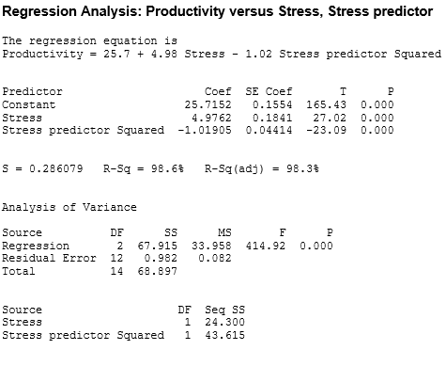
- Step One
H₀: β₁ = β₂ = 0
H_{a}: β₁ = β₂ ≠ 0
Step Two
α= 0.05
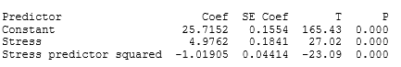
Step Three
0.00<0.05
Since the p-value is less than the level of significance for the stress predictor we reject the null hypothesis. There is sufficient evidence to suggest stress is a strong predictor of levels of productivity.
Also, since the p-value for the stress predictor squared is less than the level of significance we reject the null hypothesis. Therefore, both predictors are significant.

The R²_{adj} using the two predictors is 98.3%, whereas before with only stress as a predictor it was 30.3%. This indicates that both predictors are significant, which confirms the test performed.

- 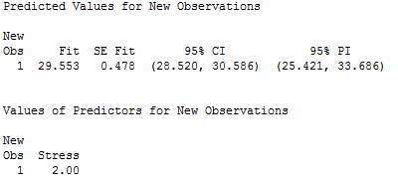

Minitab output has the confidence interval when stress level is 2 as (28.520, 30.586) and the prediction interval as (25.421, 33.686); the fitted value is 29.553 and the standard error of the fit is 0.478.

Calculating CI and PI given Fitted Value and Standard Error of the Fit

CI: (FIT +/- t a/2,n-k-1*SE FIT)
=(29.553+/-2.160*0.478)
=(28.520,30.586)

PI : (FIT +/- ta/2,n-k-1*√MSE +(SE FIT)2)
= (29.553+/-2.160*√3.431+(0.478)2)
=(25.421,33.686)

