Chapter 1: Intro
Marketing: Process by which companies create value for customers and build strong customer relationships to capture value from customers in return.
In other words, it is a managing profitable customer relationship.

The Marketing Process
- Understand the marketplace and customer needs and wants.
- Understanding the needs/wants and demands
- Design a customer driven marketing strategy.
- Segmentation and Differentiation
- Construct a marketing program that delivers superior value
- Create a marketing mix where strategy is Implemented through the use of the 4 P’s
- Price, Promotion, Place, Product
- Build Profitable relationships and create customer delight
- Monitoring customer satisfaction
- Customer will repeat purchase
- Purchase more product
- Exchange of value
- Capture value from customers to create profits and customer equity

The Marketplace and Customer needs
- Needs: Human state of deprivation (Need to Drink)
- Wants: Shaped by culture and personality. (Want a Grande bold)
- Demands: Backed by purchasing power (Purchase before class)
- Market offerings: Combination of products, services, information, or experiences offered to a market to satisfy a need or want.
- Marketing myopia: Focusing only on existing wants and losing sight of underlying consumer needs.
- Exchange: The act of obtaining a desired object from someone by offering something in return.
- Market: are the set of actual and potential buyers of a product
- Marketers search for the most profitable markets
- How can we reach our clients?
- How can clients reach us?
- How can clients reach each other?

Designing a customer-driven marketing strategy
- Marketing management: is the art and science of choosing target markets and building profitable relationships with them.
- It is impossible to serve every client in every way
- Market Segmentation: refers to dividing the markets into segments of customers.
- Target Marketing: Refers to which segments to go after
- Demarketing: Marketing to reduce demand temporarily or permanently. The aim is to reduce or shift the demand. (One-Timer clients)
- Value Proposition: Set of benefits or values a company promises to deliver to customers to satisfy their needs.

Marketing management orientations
- Production Concept: idea that consumers will favor products that are available or highly affordable
- Product concept: the idea that consumers will favor products that offer the most quality, performance, and features
- Selling concept: the idea that consumers will not buy enough of the firm’s products unless it undertakes a large scale selling and promotion effort
- Factory Existing Products Selling and promoting Profits through sales volume
- Marketing concept: the idea that achieving organizational goals depends on knowing the needs and wants of the target markets and delivering the desired satisfactions better than competitors do.
- Market Customer needs Integrated Marketing Profits through customer satisfaction
- Societal Marketing Concept: the idea that a company should make good marketing decisions by considering consumers’ wants, the company’s requirements, consumers’ long-term interests, and society’s long-run interests.
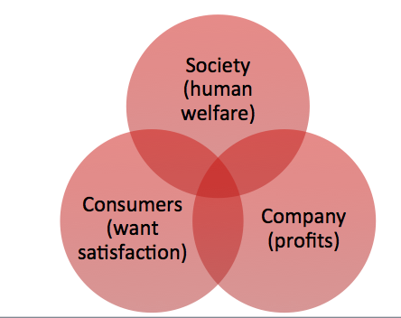

Preparing an Integrated Marketing Plan and Program
- Marketing Mix: 4Ps used to implement is marketing strategy
- Product, Price, Promotion, Place
- Integrated Marketing Program: Is a comprehensive plan that communicates and delivers the intended value to chosen customers

Building Customer Relationships
- Customer Relationship Management (CRM): The overall of building and maintaining profitable customer relationships.
- Deliver superior customer value and satisfaction
- Mange client information.
- Customer-Perceived value: The difference between total customer value and total customer cost
- The customer will always choose the product or service, which he perceives to give him the highest perceived value.
- Customer Satisfaction: The extent to which a product’s perceived performance matches buyer’s satisfaction.
- Perception vs Reality
- Basic relationship vs Full Partnerships (Walmart)

Building Customer Relationships (Contd)
- The changing nature of customer Relationships
- Use Selective relationship management to target fewer, more profitable customers.
- Relating more deeply and interactively by incorporating more interactive TWO WAYS relationships. (Blog, Websites, Online, Communities, and social networks)
- Maintaining good customer relations= Maintaining good partner relations.
- Partner relationship management: Involves working closely with partners in other company departments and outside the company to bring greater value to customer.
- Partner inside the company is every function area interacting with customers.
- Partners outside the company: How marketers connect with their SUPPLIERS, CHANNEL PARTNERS, and COMPETITORS by developing partnerships.
- Supply chain is a channel that stretches from raw materials to components to final products to final buyers.

Capturing Value from Customers
- Customer lifetime value: Is the value of entire stream of purchases that the customer would make over a lifetime of patronage.
- Share of customer: The portion of the customer’s purchasing that a company gets in its product categories.
- Customer equity: The total combined customer lifetime values of all of the customer.
- Better measure of performance then sales and market shares
- Building Customer Equity: Building the right relationships involves treating customers as assets that need to be managed and maximized
- Different types of customers = Different relationship management strategies.

Types of relationship
- Butterflies: Good fit Company/customer. High profit margin
- True Friends: Good fit Company/customer. Highest profit potential
- Strangers: Little fit Company/ Customer.
- Barnacles: Limited fit Company/Customer. Limited Profit potential

New Marketing Landscape
- Digital Age: Advances in computers, telecommunications information, transportation. (Customer research, Advertising tools, 24/7 marketing through the Internet.
- Rapid Globalization: Geographical and cultural distances have shrunk. (Greater market coverage, more competition from foreign competitor)
- Ethics and social responsibility: Marketers takes great responsibility for the impact of their actions.
- Not for profit marketing: Strategic marketing for non-profit organizations. ( Arts, Government, Colleges, Hospital)

Chapter 2: Partnering to build customer relationships

Companywide strategic planning
- Strategic Planning: Process of developing and maintaining a strategic fit Organization’s goal and Capabilities/ Changing marketing opportunities
- Adapting the firm to take advantage of opportunities in its constantly changing environment
- Mission statement: Organizations purpose, what it wants to accomplish in the larger environment. Defines the business in terms of satisfying basic customer needs. Should be meaningful and specific/motivating. Emphasize the company’s strength
- Invisible hand

Company objectives and goals
- Business objectives vs Marketing Objectives
- Build profitable customer relationships vs Increase market share
- Invest in research vs Create local partnerships
- Improve profits vs Increase promotion

Business portfolio
- Business portfolio: Collection of the businesses and products that make up the company
- Best business portfolio: One that best fits the company’s strength and weakness to opportunities in the environment
- Portfolio analysis: Major activity in strategic planning whereby management evaluates the products and businesses that make up the company
- Strategic business unit (SBU): Unit of the company that has a separate mission and objectives. (Company division, product line within a division, single product or brand)

Product type by share
- Star: High growth and high share products. Need heavy investments to finance their rapid growth (Android)
- Question mark: Low share business units in high-growth markets. Requires a lot of cash to hold their share. (Google + in Social media market)
- Cash cow: Low growth, high share businesses, Successful SBU. They need less investment to keep their share. (Google)
- Dogs: Low growth, low share products

Analysing the current business portfolio
- Identify key businesses that make up the company
- Assess the attractiveness of its various SBUS
- Decide how much support each SBU deserves.

Problem with matrix approaches
- Time consuming
- Expensive
- Focus on current businesses, not future planning

Developing Strategies for Growth and Downsizing
- Market Penetration: Growth strategy increasing sales to current market segments w/o changing the product (Supported by ads)
- Market development: growth strategy that identifies and develops new market segments for current products. (Reach out to new segments)
- Product development: Growth strategy that offers new/modified products to existing market segments
- Diversification: Growth strategy through starting up or acquiring businesses outside the company’s current product and markets
- Downsizing: Reduction of the business of portfolio by eliminating products that are not profitable.

Planning Marketing
- Value chain: Series of a department that carry out value-creating activities to design, produce, market, deliver, and support a firm’s products.
- Firm activities depends on coordination
- Value delivery network: made up of the company, suppliers, distributors and customers who partner to improve performance of the entire system.

Marketing Strategy and the Marketing Mix
- Market segmentation: Division of a market into groups of buyers who have distinct needs, characteristics or behaviour. They might require separate product or marketing mix.
- Market segment: group of consumers who respond in a similar way to a given set of marketing effort
- Market targeting: Process of evaluating each market segment’s attractiveness and selecting one or more to enter
- Market positioning: arranging for a product to occupy a clear, distinctive and desirable place relative to competing products in the minds of the target consumer.

Marketing mix
- 4P’s (Product, Price, Place, Promotion)
- 4 C’s (Customer solution, Customer cost, convenience, communication)

SWOT analysis:
- Strengths: Internal capability that help the company reach it’s objective
- Weaknesses: Internal limitation that interfere with a company’s ability to achieve its objective
- Opportunities: External forces that the company could exploit
- Threats: Current and emerging external factors that may challenge the company’s performance

Managing the marketing effort
- Analysis (SWOT)
- Planning (Ex summary, analysis of current situation, objectives, target/positioning, marketing mix, budget, control)
- Implementation (Turn strategies into marketing action)
- Control (Evaluating the results of marketing strategies, take corrective action, goals vs performance)
- ROI: Return on marketing investment. Net return from a marketing investment divided by cost of investment.

Chapter 3: Analyzing the Marketing Environment

Marketing environment
- Includes the actors and forces outside marketing that affect marketing management’s ability to build and maintain successful relationships with customers

Microenvironment
- Includes Strengths and Weaknesses
- Consist of the actors close to the company that affect its ability to serve its customers, the company, suppliers, marketing intermediaries, customer markets, competitors and publics.
- Company: Marketing management takes into account other company groups into account. (Top management, Finance, R/D, Purchasing, Operations, Accounting)
- Suppliers: Provide the resources to produce goods and service. Treated as partners to provide customer value.
- Intermediaries: Help the company to promote, sell and distribute its products to final buyers. (Resellers, physical distribution firms)
- Competitors: Firms must gain strategic advantage by positioning their offerings against competitors.
- Publics: Any groups that has an actual or potential interest in or impact on an organizations ability to achieve its objectives. (Financial publics, media, government)

Macroenvironment
- Includes Opportunities, Threats
- Demography: Study of human populations in terms of size, density, location, age, gender, race, occupation and other stats. Important because it involves people. People =Market. Baby boomers, generation x, millennial (Generational Marketing).

Demography
- Demography: Study of human populations in terms of size, density, location, age, gender, race, occupation and other stats. Important because it involves people.
- People =Market. Baby boomers, generation x, millennial (Generational Marketing).
- More people are: Divorcing, choosing not to marry, choosing to marry later etc…

Economic
- Consists of factors consumer purchasing power and spending patterns.
- Industrial economies are richer markets
- Includes changes in income, cost of living, interest rates and savings and burrowing patterns.
- Engel’s Law
- As income rises:
- The percentage spent on food declines
- The percentage spent on housing remains constant.
- The percentage spent on savings increases

Technological
- Most dramatic force in changing the marketplace
- Create new products and opportunities. (R/D spending is increased)
- Safety of new product always a concern
- Possibility to make products cheaper, quicker and more practical

Political/Social
- Consist of laws, government agencies, and pressure groups that influence or limit various organizations and individual in a given society
- Legislation regulating business
- Socially responsible behaviour: Companies allow the managers to look beyond regulatory system and do the right thing
- Cause-Related marketing: To build a positive image, companies are linking themselves to worthwhile causes.

Cultural
- Cultural environment: Consists of institutions and other forces that affect a society’s basic values, perceptions and behaviours
- Core beliefs and values: Persistent and are passed on from parents to children. Reinforced by schools, churches and government.
- Secondary beliefs and values: More open to change and include people’s view of themselves, others, organization, society, nature and the universe

Views on Responding
- Uncontrollable: React and Adapt to forces in the environment
- Proactive: Aggressive actions to affect forces in the environment
- Reactive: Watching and reacting to forces in the environment

Chapter 5: Marketing Information

Marketing Information and Customer Insights
- Goal of market research: Fresh and deep insights into customer needs and wants
- Difficult to obtain: Not obvious
- Customer’s unsure of their behaviour
- Insights are derived from BETTER information and use of existing information
- Collect customer information Form customer insights Create value for customers
- Goal is to understand the customer to their core and give them exactly what they need, not what they want.
- Marketing Information System: (MIS): Consist of people and procedures for:
- Assessing the information needs
- Developing needed information
- Helping decision makers use the information for customers
- Provides information to the company’s marketing and other managers + External partners

Developing Marketing Information
- Marketers gain information from: Marketing intelligence, Internal databases, Marketing research

Internal databases
- Internal databases: Electronic collections of consumer and market information obtained from data sources WITHIN the company network
- Data are stored in: Accounting system, operations/production, sales reporting system, past research studies
- It is cheap, quick and easy
- May not be in a usable form for the decision to be made
- May be incomplete or inappropriate to a particular situation
- Ex: HBC credit card

Marketing Intelligence
- Systematic collection and analysis of publicly available information about consumers, competitors and developments in the marketplace.
- Ex: Internet buzz, observing customers, lurking at industry trade shows, monitor competitor’s activities, dumpster diving, marketing databases

Marketing Research
- Systematic design, collection, analysis, and reporting of data relevant to a specific marketing situation facing an organization
- Important to know
- Defining the problem and research objectives Developing the research plan for collecting information Implementation of the research plan (Collecting and analyzing the data) Interpreting and reporting the findings

Defining the problem and research objectives
- Defining the problem: managers know what information is needed to make the best decision
- Researchers know how to collect the information
- Exploratory research: Gather preliminary information that will help define the problem and suggest hypothesis.
- Descriptive Research: Describe the market potential for product/ attitudes of customers who buy a product.
- Causal Research: Test hypothesis about cause and effect relationships.

Developing the research plan for collecting information
- Outlines sources of existing data
- Spells out the specific research approaches, contact methods, sampling plans and instrument to gather data.
- Secondary data: Consists of having information that already exists somewhere, having been collected for another purpose.
- Primary data: Consists of information gathered for the special research plan
- Research Approaches: Survey, Ethnographic, Experimental, Observational
- Observational research: Primary data coming from observation of relevant people, actions and situations
- Ethnographic research: Sending trained observers to watch and interact with consumers in their natural environment
- Survey: Most widely used method, best for descriptive information. Surveys are flexible but can gives misleading or pleasing answer.
- Experimental: Best for gathering causal information. Cause and effect relationships.
- Contact methods: Mail, online, Telephone, Personal interviews

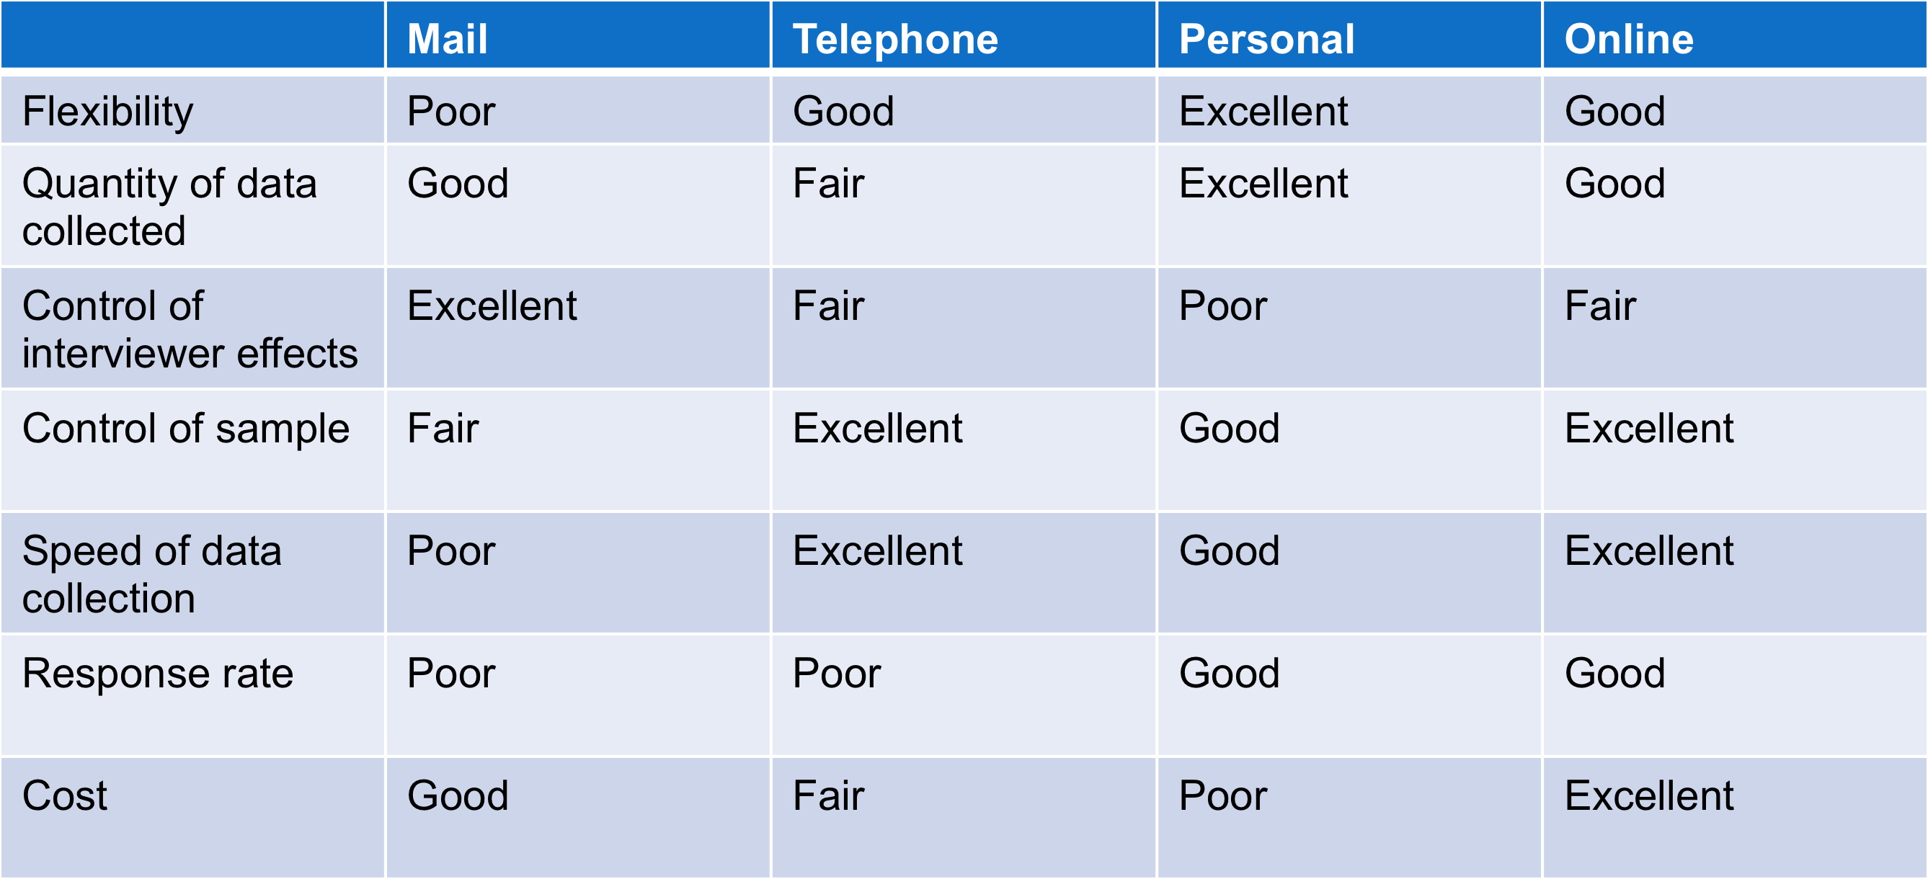

Personal Interview
- Focus group: Six to 10 people with a moderator
- Qualitative research: looking for insights
- Challenges: Expensive, hard to generalize from a small group, honesty

Online
- Advantage: Low cost, speed, higher response rates, good for hard to reach groups.
- Disadvantages: Restricted internet access, Identity can’t be confirmed
- Crowdsourcing: Outsourcing a task traditionally reserved for a producer over to volunteer participants online

Sampling
- Sample: Segment of the population selected for marketing research to represent the population as a whole
- Method: Simple random, Stratified random, Cluster, Convenience, Judgment, Quota.
- Questionnaire (Flexible, administered in person vs Mechanical Instrument (Automatic, Static, for large amount of data)
- Closed-end question (Easier to interpret) vs Open-end questions (Useful in exploratory research)

Implementing the research plan
- Collecting the information
- Processing the information
- Analysing the information
- Interpret Findings
- Draw conclusions
- Report to management

Analyzing and using market information
- CRM: Sophisticated software and analytical tools that integrate customer information from all sources. It analyse it in depth and apply the results to build stronger customer relationships.
- Information distribution: Entering information into databases and making it available in a time useable manner

Other marketing information considerations
- Marketing research in Small Businesses and non-Profit organizations
- Free databases online
- Closer to client base
- Visit the competition
- Informal surveys
- International Market research
- Difficult time finding good secondary data
- Cultural differences in responding
- Limited Access to Internet
- Public policy and Ethics
- Customer privacy
- Misuse of research findings

Chapter 6: Consumer Markets and Consumer Buyer Behavior

Characteristics Affecting Consumer behaviour
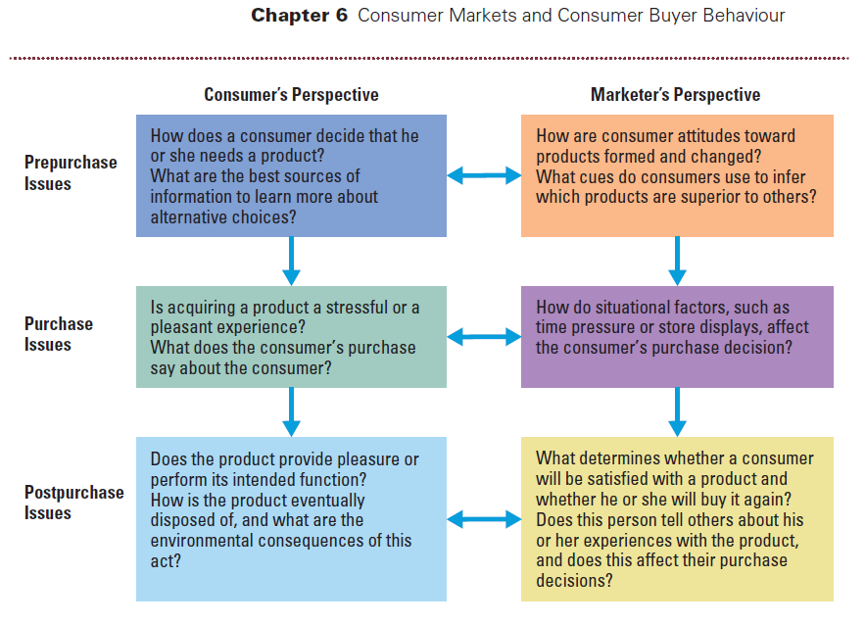
- Consumer buyer behaviour: Refers to the buying behaviour of final consumers / individuals and house holds who buy goods and services for personal consumption
- Consumer Market: All of the personal consumption of final consumers
- Factor influencing consumer behaviour: Cultural Social Personal Psychological Buyer

Cultural
- Social Class
- Culture
- Subculture

Culture
- Culture: Learned values, perceptions, wants and behaviour from family and other important institutions
- Cultural shifts: Help marketers discover new products that would not be want.

Subculture
- Groups of people within a culture with shared value system based on common life experiences and situations. Ex QC vs West Canada
- Founding Nations: Anglophones, Francophone, Aboroginal
- Ethnic Consumers
- Mature consumers: Median is 39.4 years old and represents the largest and wealthiest generation. Less brand loyal than Gen X

Social Classes
- Social classes: Divisions in a society, which share similar values, interest, and behaviours.
- Measured by a combination of occupation, income, education, wealth and other variable

Social
- Groups
- Buzz marketing
- Social Networks
- Family

Groups
- Membership groups
- Groups with direct influence and to which a person belongs
- Ex: Family, friends, organization
- Aspirational Groups
- Groups an individual wishes to belong to.
- Ex: NHL PLAYERS
- Reference Groups
- Groups that form a comparison or reference in forming attitudes or behaviour
- Ex: Labels

Buzz Marketing
- Opinion Leaders: People within a reference groups who exert social influence on others
- Also called: Influentials or leading adopters
- Marketers uses them as brand ambassadors

Social Networks
- Online communities where people socialize or exchange information and opinions.
- Provide hyperdetailed data to marketers
- Include blogs, social networking sites, virtual worlds
- Results are difficult to measure Loss of control

Family
- Most important consumer-buying organization in society.
- Woman influence 85% of all family purchases

Personal
- Economic situation
- Personality and self-concept
- Occupation: Affects the goods and services bought by consumers
- Age and life cycle stages
- Lifestyle

Age and life cycle stages
- Taste and buying behaviour are often age related
- Getting started: 18-35
- Builders: 35-50
- Accumulators: 50-60
- Preservers: Over 60

Economic
- One’s personal spending/saving patterns
- Economic outlook will influence one’s patterns
- Personal Income, Savings, Interest rates

Lifestyle
- Lifestyle: Person’s pattern of living as expressed in his or her psychographics.
- Measure a consumer’s AIOs to capture information about a person’s pattern of acting and interacting in the environment. (Activities, Interest, opinions)
- Consumers don’t buy products they buy the values and lifestyles.

Personality and self-concept
- Personality and self-concept
- Personality refers to the unique psychological characteristics that lead to consistent and lasting responses to the consumer’s environment.
- Brand personality
- Brands also have personalities, and that consumers are likely to choose brands with personalities that match their own
- Ex: Sincerity, Excitement, Competence, Sophistication, Ruggedness,

Psychological
- Motivation
- Perception
- Learning
- Beliefs

Motivation
- Motive: Need that is sufficiently pressing to direct the person to seek satisfaction
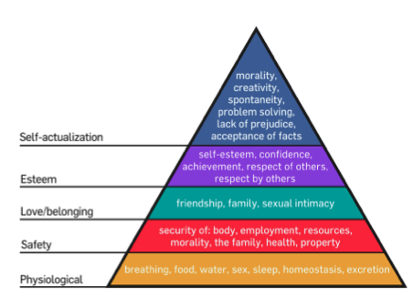
- Motivation research: Refers to qualitative research designed to probe consumer’s hidden subconscious motivations

Perception
- Perception: Process by which people select, organize and interpret information to form a meaningful picture of the world from three perceptual processes.
- Selective attention: Tendency for people to screen out most of the information to which they are exposed.
- Selective distortion: Tendency for people to interpret information in a way that will support what they already believe
- Selective retention: Customers are likely to remember good points made about a brand they favour and forget the good points made about a competing brand.

Learning
- Learning: Change in an individuals behaviour arising from experience and occurs through interplay of
- Drives, Stimuli, Cues, Responses, Reinforcement

Beliefs and Attitudes
- Belief: Descriptive thought that a person has about something based on: Knowledge/ Opinion/ Faith
- Attitudes: describe a person’s relatively consistent evaluations, feelings, and tendencies toward an object or idea. Difficult to change.

Types of buying decision behaviour

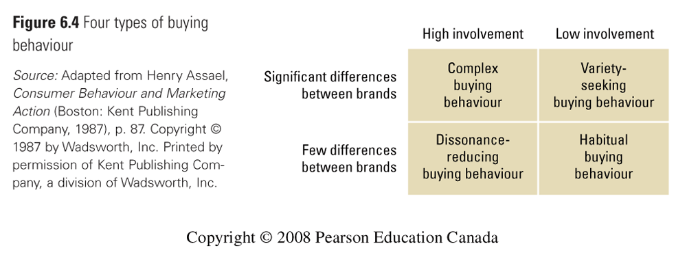

Buyer Decision Making Process
- Need recognition Information search Evaluation of alternatives Purchase decision Post purchase behaviour

Need Recognition
- Occurs when the buyer recognizes a problem or need triggered by Internal Stimuli (Hunger) or External Stimuli (Friend)

Information search
- Personal sources (Family and Friends)
- Commercial Sources (Advertising, Internet)
- Public Sources (Mass media, consumer, organizations)
- Experimental Sources (Handling, examining, using the product)

Alternative Evaluation
- How the consumer processes information to arrive at brand choices
- For marketers: Highlight the features, show the brand position

Purchase decision
- The act by the consumer to buy the most preferred brand
- The purchases decision can be affected by: Attitudes of others, unexpected situational factors

Post-purchase decision
- Customer satisfaction: Key to building profitable relationships with consumers. The larger gam between expectation and performance, the greater the consumer’s dissatisfaction.

Buyer decision process for new products
- Adoption process: Mental process an individual goes through from first learning about an innovation to final regular use
- Awareness Interest Evaluation Trial Adoption
- People differ greatly in their readiness to try new products. In each product area, there are “consumption pioneers” and early adopters.
- Influence of product characteristics on rate of adoption: Relative advantage, Compatibility, Complexity, Divisibility, Communicalbility

