Anthropology 1020E
Biological

Lecture 1 January 5th
What is Biological Anthropology

The study of humans and their closest relatives over space and time
All aspects of human life that are learned and shared from one generation to the next by non-biological means
• technology • language • social roles
• religion • subsistence • economics

The combination of biology, culture and environment (social, physical and political)

Have to be able to make hypothesis that other people can test to create a well supported/developed theory (tested general idea that explains large sets of patterns) Has to be able to be self-corrected.

Anthropology Key themes:
- Comparative
  - Why some groups do things differently than others
- Evolutionary
  - Evolution of primates
- Holistic
  - mutual interactive evolution of human biology and culture

Biological Anthropology
Study of primate biology in the framework of evolution
Research goals:
- human biological variation
- human origins
- human biological evolution
Emphasis on role of culture

Subfields
1. Primatology
- study of non-human primates
2. Paleoanthropology
- study of human evolution using the fossil record
- neanderthals
3. Human Osteology
- study of the human skeleton, past/present
  - bioarchaeology
  - forensic anthropology – investigate remains dug up from the ground.
  - Skeletal anatomy
4. Human Biology/Ecology
- study of biological variations within and between contemporary human populations

Humanistic approach to biology
- human interests and values
- individual’s lived experience
  - Trying to understand what it was like to be someone else at that time in history
- identity, ethnicity, gender roles, beliefs…

Data
- relevant observations that serve as the basis
for study and discussion
- Take data to understand people
- How you decide to collect data proposes a lot of questions or
limits a lot.
- Data needs to be value free
Kinds of data
- cranial capacity – how large is the brain cage
- facial expressions
- isotopes in teeth
- distribution of skeletal lesions
- cortisol levels in hair
- Data do not speak for themselves

Applied anthropology (using data to understand)
  - use of anthropological methods and theories to address practical issues
  - solve ‘real-world’ human problems, often anthropogenic in origin
      - education
      - prevention and treatment
      - technology
      - policy

Medical Anthropolgy
- Health, illness and healing from a cross-cultural perspective. Health research, ex. people who have an extra organ in their body that can cause trouble.
- Beliefs: what makes a person a healthy functioning human? (Health perspective)
- Diversity changes needs and desires
- Some men sell their kidneys to make money to put
a roof over their heads
Jobs in this field:
- World Health Organisation
- Canadian International Development Agency
- Non-governmental organisations
- Public Health
- Health science research
- Healthcare policy
  - disease control campaigns
  - culturally appropriate treatment regimes
e.g. perceptions of HIV/AIDS risk

Ergonomics
- Using knowledge of human variation to design products that optimize human performance, safety and comfort
  - Work areas
  - Military clothing
  - Car and airplane seats

Primate conservation
- >100 of the world’s 300 primate species endangered
- Problems that lead to endangered primates: Habitat destruction, hunting, trade of live animals, and Infectious disease
  - Many primates, especially great apes, susceptible to ‘human’ diseases EX. apes can catch ebola and bring it back to humans.

Forensic Anthropology
- Highest public profile. Help police etc. may be called as a witness to show evidence
- Assist government agencies in identifying otherwise un-identifiable individuals
  - decomposition
  - burial treatment
  - taphonomic factors
  - perimortem and postmortem trauma
  - Help in determining MNI (minimum number of individuals) and sorting commingled remains
- Determine postmortem interval
- Legal knowledge

Lecture 2 Jan 7th
Science as a way of knowing
- Science as a way of knowing
- History of evolutionary thought
- Darwin and natural selection

Anthropology and/of science
- Practice scientific methodology
  - laboratories
  - excavations (dominant)
  - ethnographic fieldwork
- Science as a way of (re)producing knowledge
  - Put people in to groups. Science was used to get certain results
  - e.g. IQ tests, racial typologies

Objectivity and Subjectivity
- The traditional notion of science is that it is ‘objective’ but its difficult to keep opinion out of research. Research needs to be value free
- Humans cannot be totally objective, we try but can’t always be.
difficult to keep out bias, expectation, politics, worldviews
- Science is coloured by ‘subjectivity’
must declare one’s biases up front
be transparent about how have worked to overcome

Old dead white guys of biological anthropology
Western world views vs Nature
Not much view on human origins etc.
- Middle Ages in Europe
  - Fixity of Species – there’s no changing and species were created how they were seen that day
  - Antiquity of Earth – scholars believed world to only be a few thousand years old. Stated by James Ussher (1581-1656) that the world is 4004 B.C. years old, used scientific method of calculating back generations in the bible.
  - Great Chain of Being – organisms were ranked relative to another with humans being at the top of animals living on the plant, giving humans the right to rule over all other organisms.

Carolus Linnaeus
(1707-1778) don’t have to worry about dates
- Binomial nomenclature
  - genus and species names
- 1st taxonomy
  - a system for classifying all living things
- New View
  - seeing connections between organisms

Georges Cuvier
(1769-1832)
People were finding fossils that didn’t look like any of the creatures presently walking on earth.
- Catastrophism
  - shaping of the landscape occurs via periodic catastrophes EX. the great flood in biblical text
  - applied to organisms – could help explain biological diversity, and that environment change can cause biological change in animals to adapt to new surronding
  - multiple creation events
- New View
  - Linked environment to disappearance and appearance of life forms

Jean-Baptiste Lamarck
(1774-1829)
- Argued that the form of species did/could change over time
- Inheritance of Acquired Characteristics
New environment new activities/uses physical changes passed on to offspring
- New View: Linked environmental change to biological change - animals change over time because environment change stimulates animal change
- written about giraffes; biological change when their necks got longer to reach higher food, maybe because of a climate change. Getting closer to natural selection - problem with his idea though: parent can change their look (build muscle, nose job) but their offspring wont come out with this new change

Charles Lyell
(1797-1875)
- Uniformitarianism: geological processes observed in the present are the same as those that occurred in the past
- New View: great antiquity of the earth

Thomas Malthus
(1766-1834)
- Mathematician & economist
- Populations grow exponentially while resources do not (limited resources) EX. not all salmon make it
- New View: competition for survival, not every organism is going to survive and reproduce

Charles Darwin
(1809-1882)
Went on voyage travelling and studying types of birds. Noticed some look related. Built idea of natural selection.
Natural Selection
- Darwin’s finches; found many finches with slightly different beaks son the galapgoes island, found connection between the bird that the beaks helped them adapt to their environment (helping them eat certain foods in their regions)
- more offspring are produced than can survive competition
- individuals within a species vary biologically
- individuals with the most beneficial variations (traits) are more likely to survive and reproduce
- the environment determines whether a trait is beneficial
- Individuals with beneficial traits have greater reproductive success
- Over geological time, beneficial traits accumulate in a population, and a new species may arise

Controversery to biblical text
“light will be thrown on the origin of man and his history”
On the Origin of Species (1859)
- Religious backlash
- Social and political upheaval

Lecture 3 Jan. 12th
Evolution

Evolutionary framework:
Evolutionary theory
  - genes and alleles
  - Mutation
  - Gene flow
  - Genetic drift
  - Natural selection
inheritance
- forces of evolution
- biocultural evolution in humans
- speciation
- Genes
- Alleles
- Genotypes and phenotypes

Natural Selection
- more offspring are produced than can survive competition
- individuals within a species vary biologically
- individuals with the most beneficial variations (traits) are more likely to survive and reproduce
- the (changing) environment determines whether a trait is beneficial
- Individuals with beneficial traits have greater reproductive success
- Over geological time, beneficial traits accumulate in a population, and a new species may appear (speciation)

Inheritance
Pre-1800s
- Blending (mixing 2 paint colours to get one etc.)
Early 1900’s
- Gregor Mendel’s particulate inheritance. Mothers and fathers were contributing something to make their offspring. Everyone has 2 copies and contribute 1 to make offspring, therefore need two people to each give one copy.
1953
- Watson, Crick, Franklin discover structure of DNA.

Deoxyribonucleic Acid (DNA)
- bodies are made up of cells (~1000 billion)
- cells have a nucleus containing the genetic code (DNA)
- Contains information to perform various tasks.
- DNA provides instructions for the development and function of organisms (replication and protein synthesis)
- portions of DNA are called chromosomes
- humans have 46 chromosomes (23 ♀ and 23 ♂)

Genes and Alleles
- genes code for particular traits. EX. gene codes for the colour of the flower, but there are many different colour genes. Alleles determine the specific colour it will be
- genes come in different versions (alleles) that have different effects
- each parent has 2 alleles for a trait (one on each chromosome, at the same locus)
- offspring gets only 1 allele from each parent

Dominant and recessive
Homozygous
- both alleles the same (white, white) genetic instruction is same
Heterozygous
- both alleles different (white, violet) genetic instruction doesn’t match, dominant allele will overpower the other one.
Dominant
- masks effect of other allele (P)
Recessive
- effect masked by other allele (p)
Codominant
- both alleles expressed

Gene to trait
Genotype
- combination of 2 alleles that code for a trait; genetic makeup
Phenotype
- the chemical/physical results of the combination of alleles

ABO Genotypes and Phenotypes
Blood types
3 alleles: A, B, O –only ever going to carry 2
Antigen: molecules found on the surface of cells
6 genotypes, 4 phenotypes
Genotype | Antigens on Red Blood Cells | ABO Blood Type (Phenotype)
AA,AO | A | A
BB, BO | B | B
AB | A and B | AB
OO | None | O

Polygenic Inheritance
- Influenced by alleles at two or more loci with each making a contribution to the phenotype
- Height, shape of the face, skin colour all have genes and multiple alleles making it very complex.
- Many moving parts to figure out phenotype
- Expression influenced by environment
- Continuous variation, no this or that.
- Most of observable variations: skin colour, hair colour, eye colour, shape of face, etc.

Evolution - A change in allele frequency from one generation to the next allele frequencies
- the proportions of alleles in a population
- Where do old alleles go and where do the new ones come from.
- Relative abundance of alleles in a population
population - a community of individuals where mates are usually found

Factors that initiate changes in allele frequencies include those that:
- Produce new variations (of alleles) only possible through mutations
- Redistribute variation through gene flow
- Redistribute variation through genetic drift – bottlenecks of population, put in to a new group of people therefore different gene pool
- Selection of advantageous allele combinations that promote reproductive success (natural selection)

Mutation
- random change in the genetic code (base, chromosome)- not predictable
- something goes wrong and one base gets copied incorrectly
- ultimate source of new genetic variation
- Randomly happens and introduces new info in to th gene pool
- beneficial, deleterious, or neutral

Point Mutation
Hgb A: GGT – CTC – CTT
Hgb S: GGT – CAC – CTT
Substitution of one base
Sickle-shaped red blood cells
sickle-cell anemia – people can die from this.

Gene Flow
- Exchange of genes between populations
- Shuffles alleles around, changing allele frequency
- (mutation introduces new alleles)

Genetic Drift
- Random fluctuations in allele frequencies
- Based on notion of sampling error
- Most dramatic effects with small samples
  - Founder effect (e.g. Hutterites)
  - Bottleneck – frequency of alleles.
  - In a small population a mutation will affect the gene pool and therefore affecting a large portion of popoulation. Can shuffle around alleles

Natural Selection
- Differential survival and reproduction of organisms due to their biological characteristics
- Requires variation in the population
- Phenotype is ‘selected for’
- Status of phenotype depends on environmental niche
Natural Selection in Humans- A simple substitution of one base

EX. Substitution of base can cause a mutation like Sickle-cell anemia
  - Sickle-shaped red blood cells
  - S allele (sickle-cell anemia) carried by up to 20% of people in West and Central Africa
- Where sickle-cell anemia is high so is malaria
- Grow inside a blood cell thrn burst
- Sometimes its an ok thing to have a sickle cell
Malaria:
  - parasite carried by mosquitoes
  - lives in red blood cells
  - Can’t carry pcygen

*Balanced polymorphism – maintenance of 2 or more alleles in a population due to the selective advantage of the heterozygote (e.g. AS)

*Microevolution - small changes occurring within a species
*Macroevolution- changes produced after many generations
  - reconstruct evolutionary relationships?

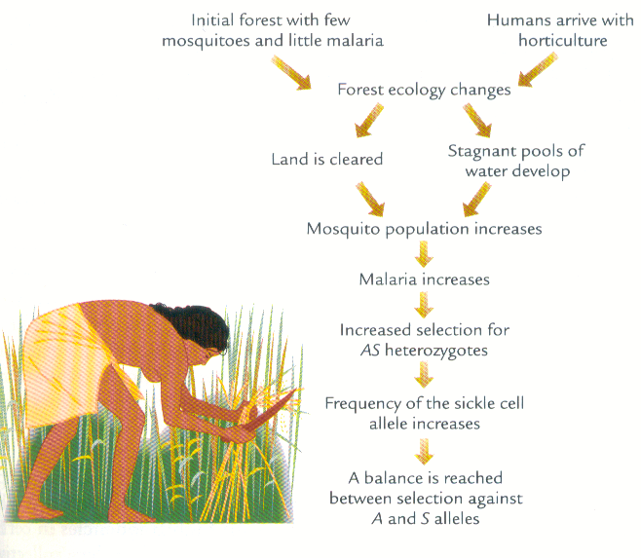

Homology traits
- similarity due to inheritance from a common ancestor
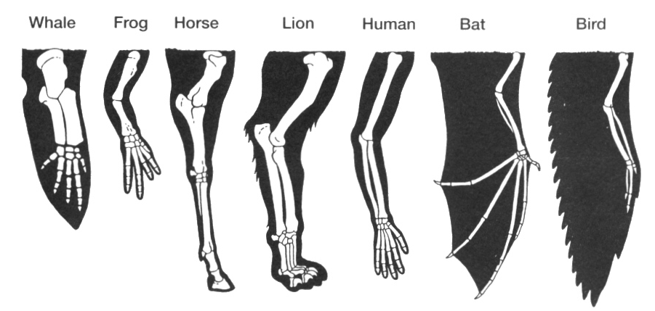

Analogy traits
- similarity of structures due a similar function only
- To figure out organisms are related is to see hwta they share.
- no close shared evolutionary relationship
- EX. bats and butterflies have wings but they are hella different

Ancestral (primitive) Traits
- Compare us to chimpanzees
- traits inherited by a group of organisms from a remote ancestor
- All different primate hands, all are different but still have some similarities (opposble thumb, priminal trait) thumbs al functio nte same
- not diagnostic of particular evolutionary lineages

Derived (modified) traits
- traits that are modified from the ancestral condition
- Derived trait – someonthing only your species has. Use these to look at whats what.
- diagnostic of particular evolutionary lineages
It’s all relative! Depends on the trait and who is compared

Evolution of New Species
Species - a group of interbreeding organisms
Speciation - process by which new species emerge (reproductive isolation and adaptive radiation)
  - How does it happen
- Reproductive isolation (no gene flow)
- Environmental isolation geography/physical barrier
- Adaptive radiation
- rapid expansion and diversification of life forms
- transition of generalised to specialised characteristics
  - environment supports no other species
  - extinction removes other species
  - adaptively generalised, able to survive in new niche

Modes of evolutionary change
Phyletic Gradualism (anagenesis)
  - transformation of a single species over time

Cladogenesis
  - formation of 1 or more new species from another over time

Tempo of evolutionary change
Phyletic Gradualism (Darwin)
  - evolutionary change occurs at a slow, steady rate

Punctuated Equilibrium (Eldredge and Gould)
  - between long periods of stasis, evolutionary change occurs rapidly over short periods of time

Jan 14th Video: Why Sex (Handout in class)

Lecture 5 Jan 19th
Our relatives, non-human Primates - What can they reveal about our humanity?

Primates as Mammals
3 subgroups:
- egg layers (monotremes)
- marsupials
- placental

placental Mammals
- body hair
- long gestation period
- mammary glands
- different types of teeth
- constant body temperature
- increased brain size
- capacity for learning and behavioural flexibility

Primate characteristics: limbs and locomotion
- tendency toward erect posture
- flexible limb structure
- hands and feet with a high degree of prehensility
- opposable thumb
- nails instead of claws
- tactile pads

types of locomotion
Quadrupedal
- all four limbs support the body
Brachiation
- body suspended beneath the hands
- support alternated from one forelimb to the other
Clinging and Leaping
Knuckle-walking
Bipedalism – walking upright

Diet and teeth; comparison between humans and primates
- lack of dietary specialisation (omnivorous)
- generalised dentition
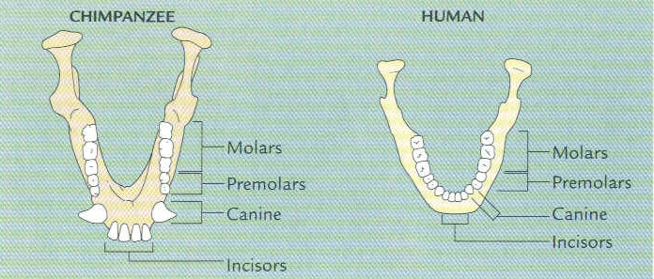
sense and the brain
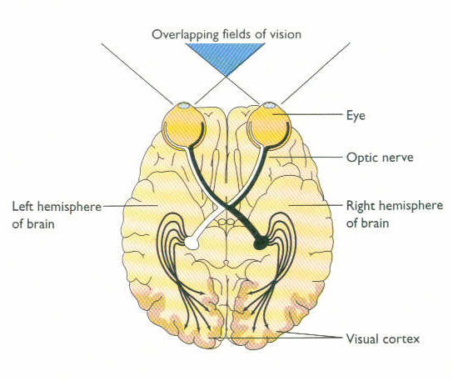
- colour vision
- depth perception
- decreased reliance on smell
- expansion and increased complexity of the brain

Maturation, learning and behaviour
- long gestation
- fewer offspring and delayed maturation
- depend on flexible, learned behaviour
- strong mother-infant bond
- live in social groups
- tendency to diurnal activity patterns

Primate Taxonomy

Prosimians = strephirhines (lemurs and lorises)
Where - Africa and SE Asia
Anatomy
- longer snouts
- wet noses
- no colour vision
- large ears
- 50% are nocturnal
Lemurs
Where - Madagascar
Anatomy
- tooth comb
- grooming claw
- larger olfactory bulb
Behaviour
- female dominance
- scent-marking

Anthropoids = haplorhines
Monkeys, apes and humans
- larger body size (relative to Prosimians)
- larger brain
- reduced reliance on sense of smell
- increased reliance on vision
- bony plate around eye socket
- increased parental care
- more mutual grooming

Monkeys - 85% of all primates
Two groups
- New World monkeys (NWM)
  - ~70 species
  - variety in size, diet and ecological adaptation
  - mostly arboreal
  - Platyrrhines - broad noses with outward facing nostrils
  - prehensile tails
- Old World monkeys (OWM)
      - ~80 species
      - morphological and behavioural diversity
      - most widely distributed of all living primates
      - Catarrhines - narrow noses with downward facing nostrils
      - ischial callosities

Hominoids - Apes (lesser & greater) and Humans
Differ from monkeys in several ways:
- larger body size
- no tail
- more complex behaviour
- more complex brain and cognitive abilities
- longer period of infant development and dependency

Orangutans
Where - Borneo and Sumatra
Anatomy
- long, strong arms
- males have cheek pads
Behaviour
- solitary, mother-child pairs
- build nests
- use tools

Gorillas
- largest of all living primates
- marked sexual dimorphism
  - physical differences between males and females
- almost exclusively vegetarian
- shy and gentle
- live in small groups (1 male, multi-female + offspring)
Chimpanzees/Bonobos
- varied diet, including meat
(PRINTED OUT TO HERE)
- varied locomotion
- communities of up to 50 individuals
Chimpanzees (Pan troglodytes)
- highly excitable, active and noisy
- more aggressive
- male bonding
Bonobos (Pan paniscus)
- darker faces/hair
- smaller/longer limbs
- affiliative behaviour
- male-female bonding
- Tool use!

Lecture 6 Jan. 26th
Hominin ancestors. Who were our earliest bipedal ancestors? Where and when did our species originate?

Bipedal adaption
Bipedalism
- Habitually walking on two legs
- Only primate doing this today is Homo sapiens
Hominin
- Humans (H. sapiens) and our bipedal ancestors

Location of Foramen Magnum

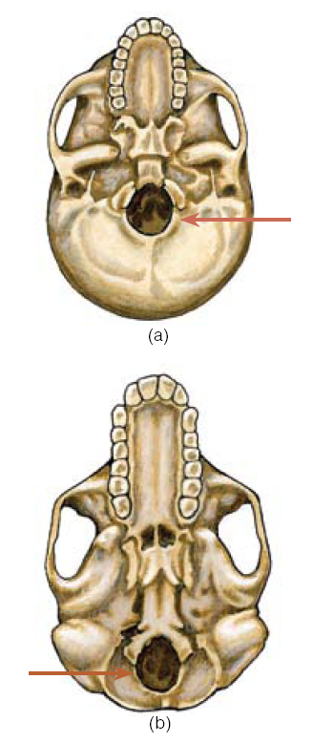

Curvature of the spine
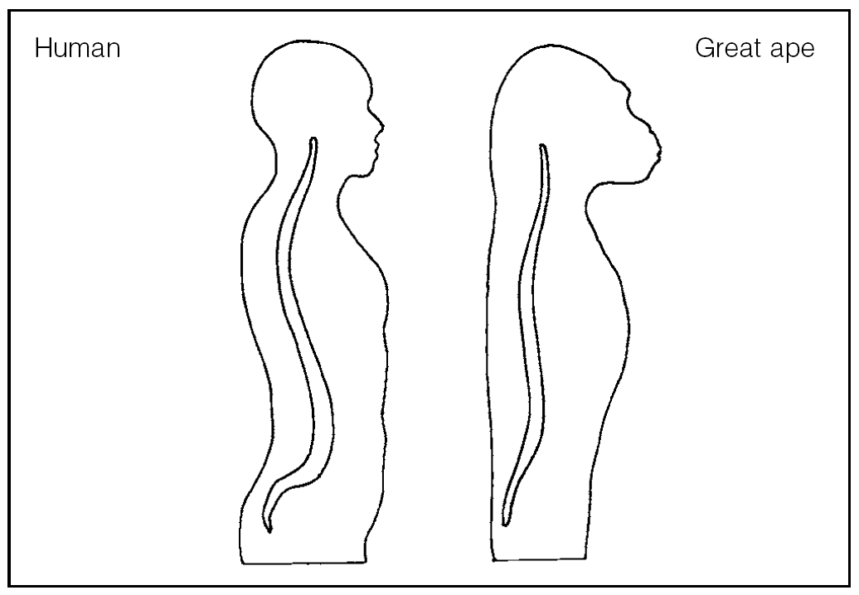
Limb Proportions

Alignment of lower limbs
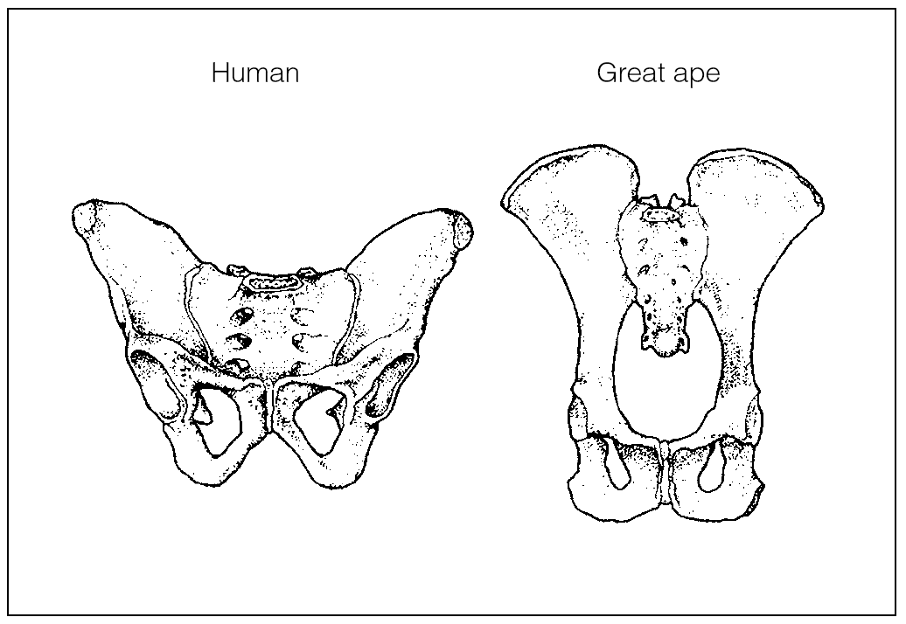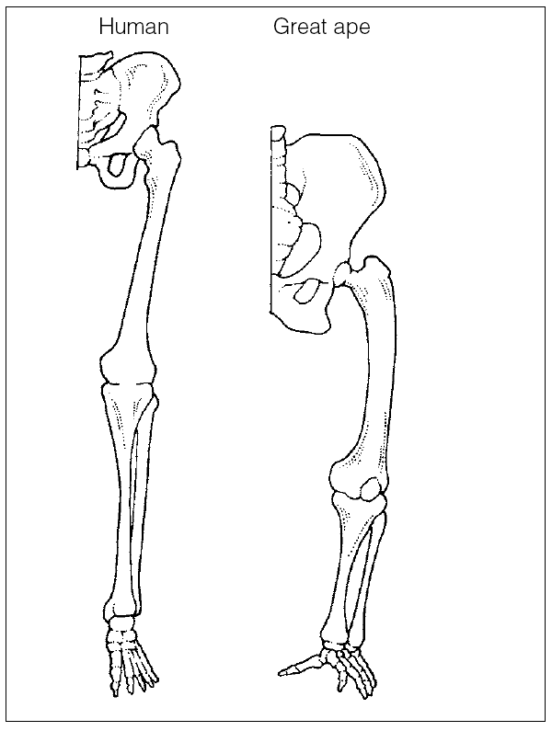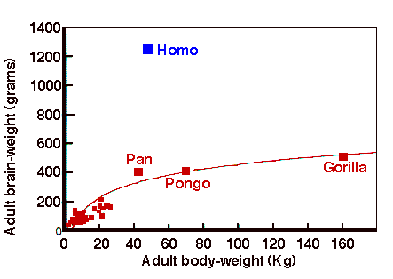

Behavior
- Tools: objects modified or made to serve a particular purpose and humans find multiple purposes
- Art: cave paintings
- Belief: Neandertal burials?
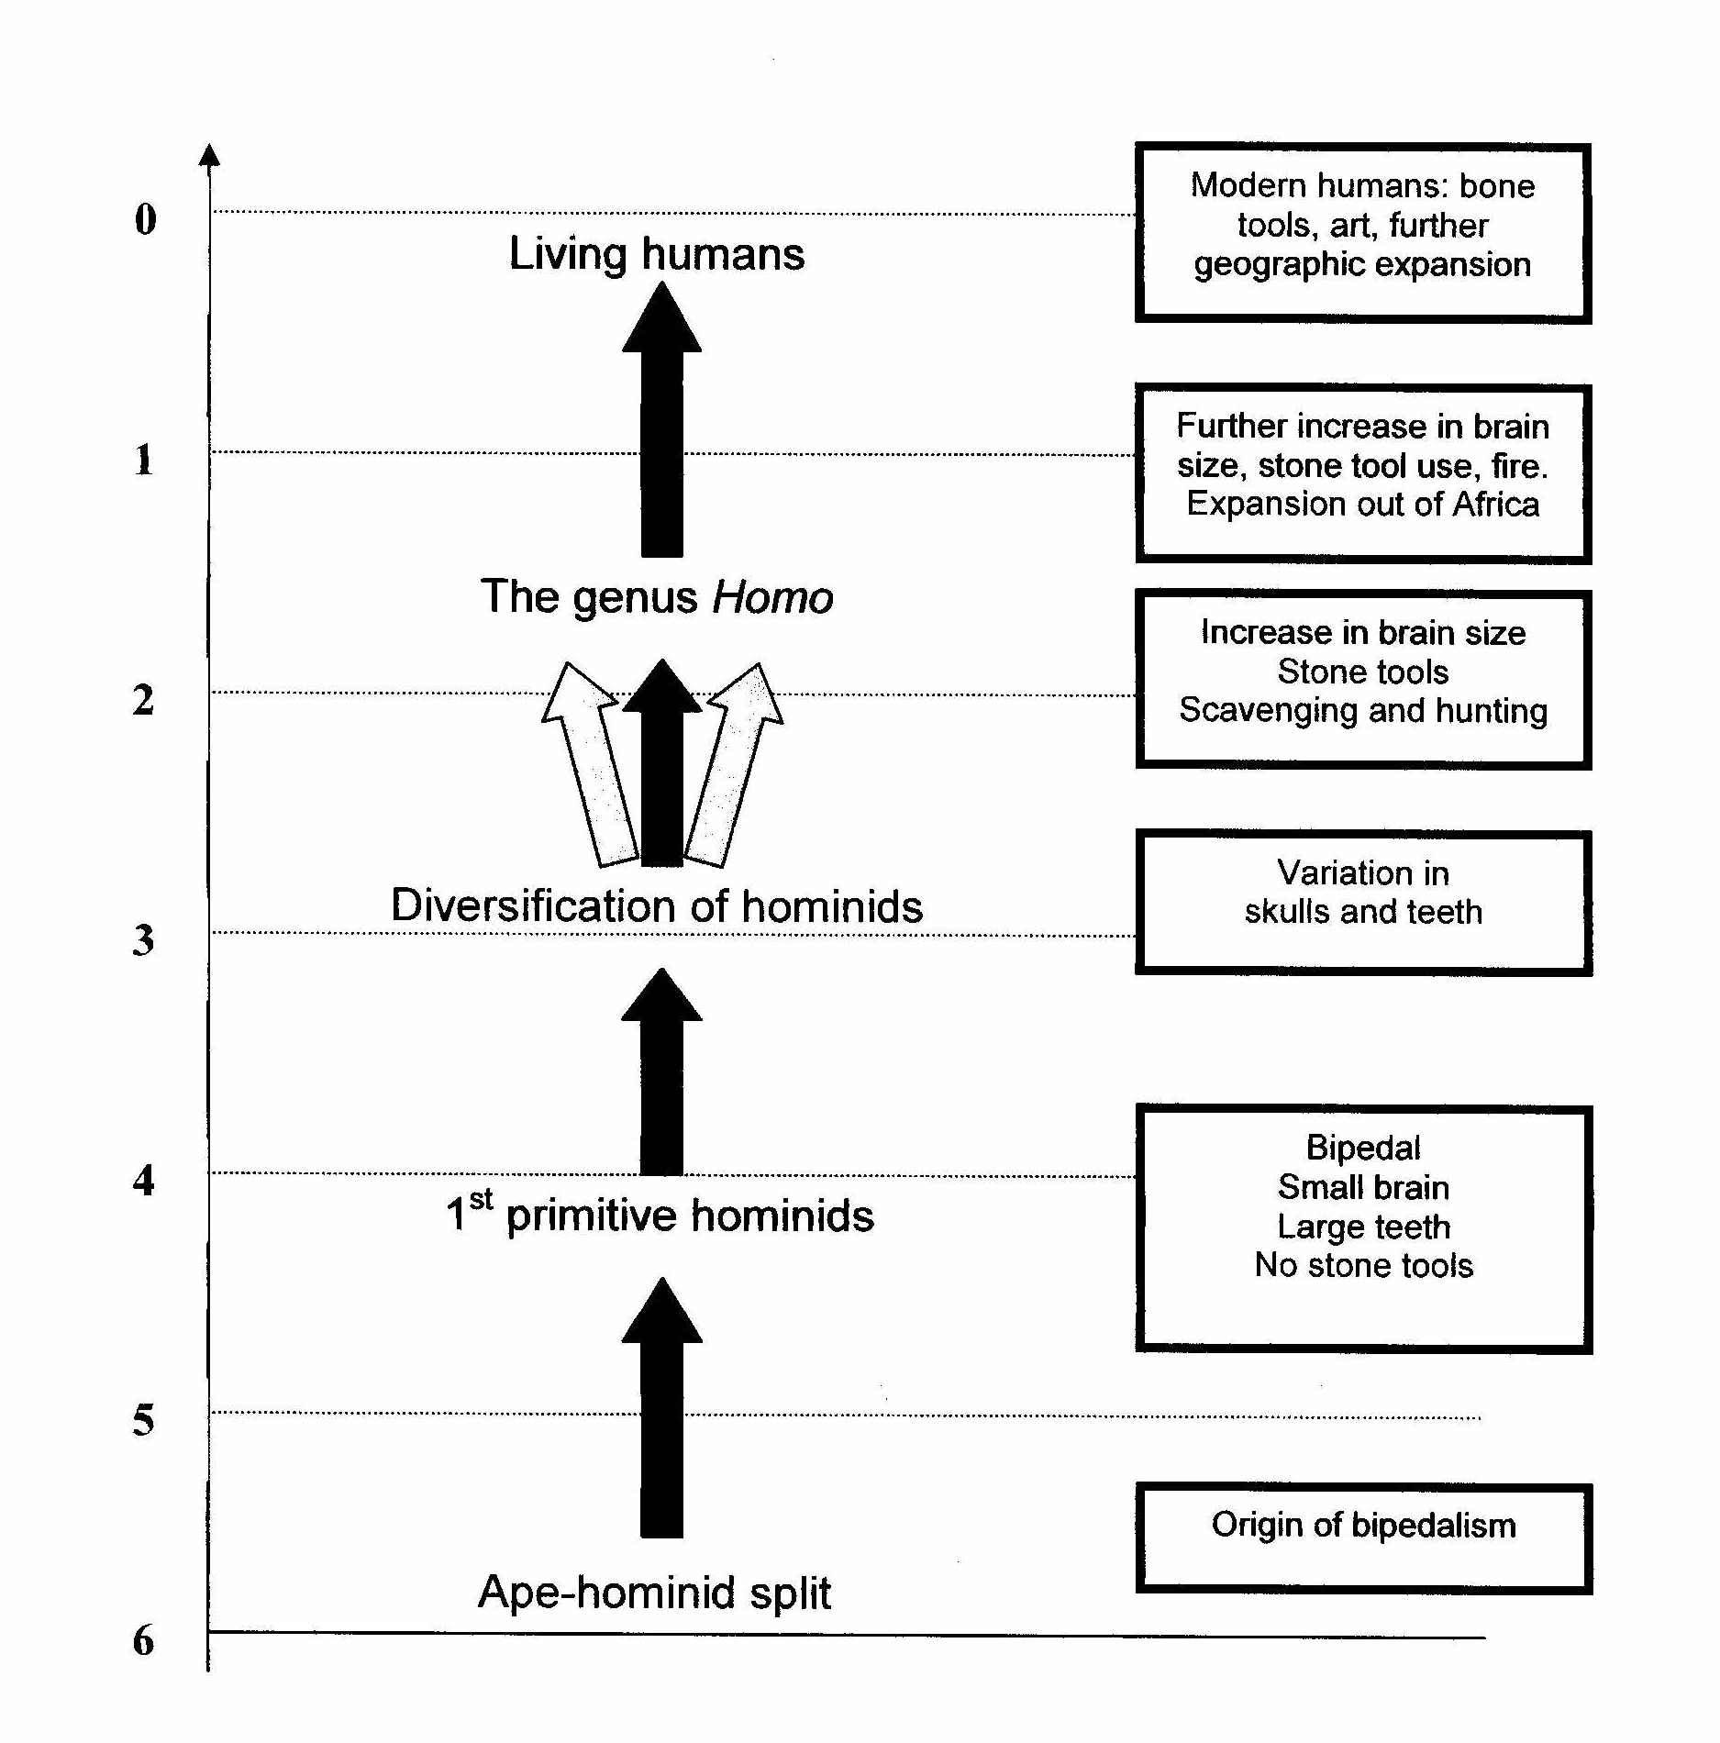
Paleoanthropology
The study of human evolution using the fossil record
- Searching for bipedality
  - foramen magnum
  - femur neck
  - feet
  - fingers
- How know we have a new species?
  - sexual dimorphism
  - regional variation
  - health/nutrition
  - different species

Olduvai Gorge
- 40 Km ravine
- Ethiopia, Kenya, Tanzania
- Part of Great Rift Valley
  - rapid sedimentation
  - faulting
  - volcanic activity

Major Early Hominins
- Transitional (Proto-Hominins)
  - earliest and most primitive
  - 7.0–4.4 mya
- Australopithecines & Paranthropines
  - 2 genera, but many diverse forms
  - 4.2–1.0 mya
- Early Homo
  - first members of our genus
  - 2.4–1.4 mya
Africa only

Proto-Hominin: Ardipithecus Ramidus
Date | Early = 5.8-5.6mya  Late = 4.4 mya
Location | Ethiopia
Discovered | 1992
Evidence | Early = teeth, bits of jaw and postcranial  Late = up to 50 individuals, various parts
Anatomy | - brains 300-350cc (cranial capacity or cm³)  - small canines  - < 4ft  - big toe, foramen magnum, femur (bipedal)
Verdict | - bipedal + some climbing  Possible ancestor of genus Australopithecus

Australopithecines
- 4.2 – 1.2 mya
- Several species
- East, west, south Africa
- Bipedal
- Small brains
- Large teeth
- Paranthropus (derived traits)

“Gracile” and “robust”
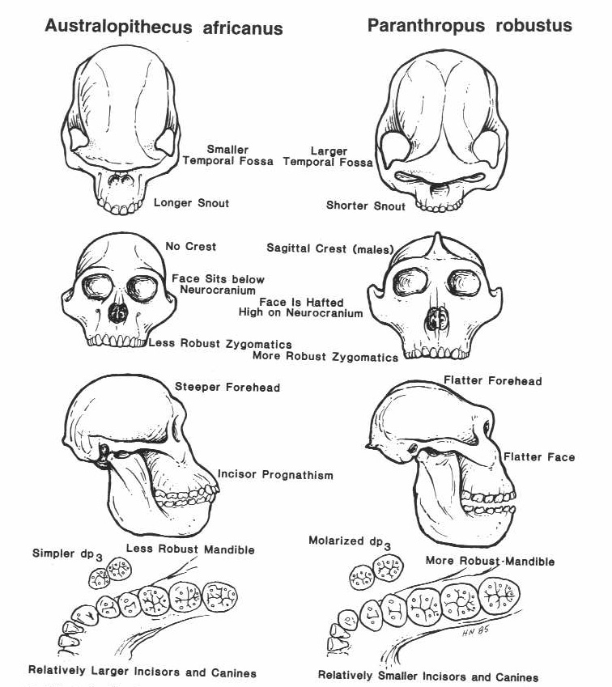
Australopithecus afarensis (gracile type)
Date | ~ 3.6-3.0 mya
Location | Kenya/Tanzania/Ethiopia
Discovered | 1973
Evidence | 65 individuals – cranial and postcranial fragments, teeth
Anatomy | - brain 375-500 cc  - < 4 feet tall  - prognathic face  - large canines  - femur, tibia indicate bipedal
Verdict | Possible ancestor of later australopithecines

“lucy” idk some monkey/ape crap
- 3.2 mya
- Hadar, Ethiopia
- Discovered: Nov 30, 1974 by Donald Johanson
- 40% complete
- 3’3” and 60 Kg

Paranthropus boisei (robust type)
Date | ~ 2.2 - 1 mya
Location | Tanzania, Kenya, Ethiopia in E. Africa
Discovered | 1959
Evidence | Crania, teeth, partial jaws and cranial fragments, postcranial
Anatomy | - small brain (515cc)  - prognathism  - postorbital constriction  - flared zygomatics  - sagittal crest  - very large molars
Verdict | Not ancestral to genus Homo

General characteristics of the genus homo
- larger brains (over 600 cc)
- flatter face
- smaller teeth
- greater reliance on tools (culture)
- use of fire
- moved out of Africa and the Old World

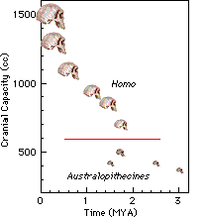
Homo erectus
When: 1.9 mya – 200 kya
Where:
- Africa first
- rapid dispersal to Asia, Middle East, Europe
Anatomy:
- Brain size = 900cc (70% of human size)
- Long legs (> 6 feet)
Other:
  - toolkit more diverse (Acheulian style)
  - 1st to leave Africa
  - 1st to use fire

Early homo: homo habilis
When: 2.4 – 1.4 mya
Where: East Africa
Anatomy: Brain size >600cc
“Handy Man”
- oldest recognized tools
- Oldowan tradition
Ancestral to Homo erectus

Nariokotome boy
WT 15000 from Nariokotome, Kenya
5’ 3” at 8 years of age

Homo erectus diversity
- Homo ergaster = Africa
- Homo erectus = Asia
Neanderthals
- Date: 225 -28kya
- Location:
- Mediterranean, Middle East,
- Western Europe
- Brain size: 1500cc
- Postcranial:
- shorter and stockier than
- modern H. sapiens
- Tools: Mousterian

- Homo erectus/georgicus? = Europe

Archaic H. Sapiens
- Mix of H. erectus and modern H. sapiens traits
  - combination of traits varies regionally
  - found in Africa, Asia and Europe
General changes compared with H. erectus include:
- even larger brains
- smaller molars
- decrease in cranial and post cranial robusticity
- ~800 – 28 kya

Archaic Homo sapiens Anatomy
- low skulls
- sloping foreheads
- face and teeth larger than humans
- no chin
- (some) robust postcranial skeleton
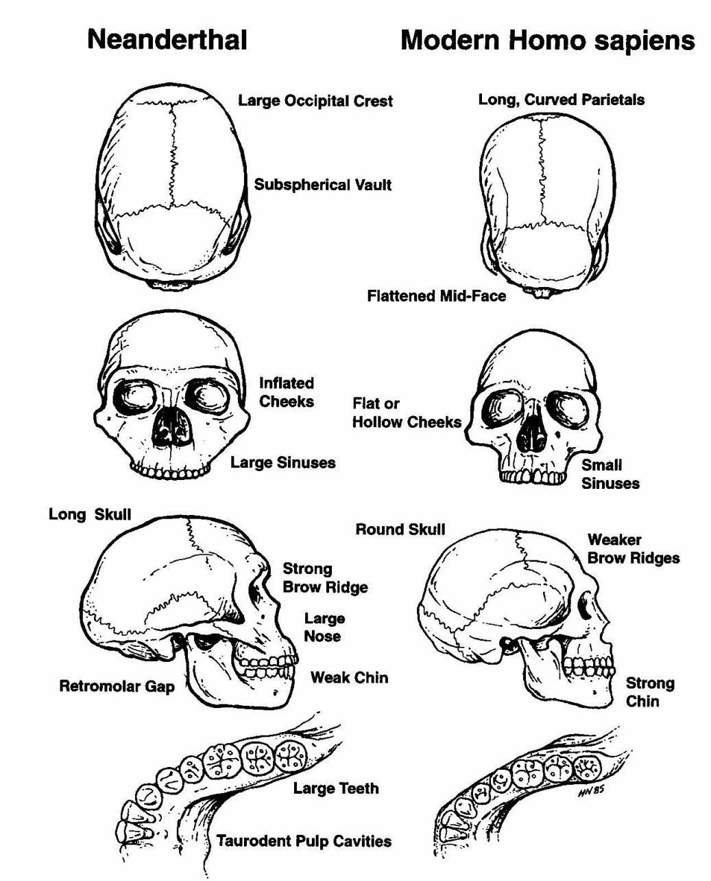
Neanderthal Anatomy
- receding forehead
- no chin
- occipital bun
- large nose + sinuses
- large arched brow ridges
- retromolar gap
Other: lived through several glacial periods – cold adapted anatomy?

Neanderthal culture
- lived in caves and used fire
- evidence of hunting and gathering
Ritual and symbolic thought?
  - Deliberate burial (tools, bones, stone slabs)
  - Flowers in burial
Art and music?
  - “flute”
  - Proto-figurines

Homo Sapiens (aka us)
OR
anatomically modern Homo sapiens (AMHS)
Basic Questions:
- When did AMHS first appear?
- When did AMHS disperse to other areas of the Old World?
- What did they do when they got there?
Anatomically modern homo sapiens
Two opposing theories:
- Replacement hypothesis
- Multiregional hypothesis
Compromise theory:
- Partial Replacement hypothesis

- Date: 160 kya - present
- Location: Worldwide
- Brain size: 1350cc
- Anatomy:
- round cranium
- vertical forehead
- flat face
- small teeth
- chin
- Tools:
- Paleolithic tradition
- space stations, genetic
- engineering, internet

Replacement hypothesis
- Population Replacement Model
OR “Out of Africa” Model
- Archaic to modern H. sapiens transition in Africa only (160kya)
- Spread throughout Africa, Europe, Asia
- Replaced local Archaic H. sapiens populations (including Neandertal)
- No gene flow
Multiregionalhypothesis
- Archaic to Modern H. sapiens transition throughout the Old World
- Different populations changing in different ways
- Gene flow between evolving Archaic and Modern H. sapiens forms prevented speciation (some regional variation is maintained)

Partial replacement hypothesis
- Mostly ‘Out of Africa’/ Primary African Origin
- Archaic to Modern H. sapiens transition in Africa only (160kya)
- Spread throughout Africa, Europe, Asia
- Interbred with local Archaic H. sapiens populations (including Neandertal)
- Gene flow

Homo floresiensis
Where: Ling Bua cave, Flores, Indonesia
When: 95kya to 13 kya
Anatomy:
  - small body (3 ft)
  - small brain (380cc)
Tools: several types, hunting
- descended from H. erectus?
- descended from modern H. sapiens?
- descended from another species?
Little People of Flores

review
- Hominins since ~6-7mya
- Diversity!
- Several genera
  - Ardipithecus
  - Australopithecus
  - Paranthropus
  - Homo
- Several species
  - Ardipithecus ramidus
  - Australopithecus afarensis
  - Paranthropus bosei
  - Homo habilis
  - Homo erectus
  - Homo neandertalensis
  - Homo sapiens
  - Homo floresiensis
Currently only AMHS
  - role of culture

Lecture 7 – Feb.2nd
Where and when did our species originate?
How do we study human biological variation?

Two themes: origins of homo sapiens, and human variation

anatomically modern Homo sapiens (AMHS)
Basic Questions:
- When did AMHS first appear?
- When did AMHS disperse to other areas of the Old World?
- What did they do when they got there?

Anatomically Modern Homo sapiens
Date: 160 kya - present
Location: Worldwide
Brain size: 1350cc
Anatomy:
  - round cranium
  - vertical forehead
  - flat face
  - small teeth
  - chin
Tools:
Paleolithic tradition
space stations, genetic
engineering, internet

origins of homo sapiens
Two opposing theories:
- Replacement hypothesis
- Multiregional hypothesis
Compromise theory:
- Partial Replacement hypothesis

Replacement hypothesis
- Population Replacement Model
OR “Out of Africa” Model
- Archaic to modern H. sapiens transition in Africa only (160kya)
- Spread throughout Africa,
Europe, Asia
- Replaced local Archaic H. sapiens populations (including Neandertal)
- No gene flow

Multiregional hypothesis
- Archaic to Modern H. sapiens transition throughout the Old World
- Different populations changing in different ways
- Gene flow between evolving Archaic and Modern H. sapiens forms prevented speciation (some regional variation is maintained)

Partial replacement hypothesis
- Mostly ‘Out of Africa’/ Primary African Origin
- Archaic to Modern H. sapiens transition in Africa only (160kya)
- Spread throughout Africa, Europe, Asia
- Interbred with local Archaic H. sapiens populations (including Neandertal)
- Gene flow

Who you need to know…
- Hominins since ~6-7mya
- Diversity!
- Several genera
  - Ardipithecus
  - Australopithecus
  - Paranthropus
  - Homo
- Several species
  - Ardipithecus ramidus
  - Australopithecus afarensis
  - Paranthropus bosei
  - Homo habilis
  - Homo erectus
  - Homo neandertalensis
  - Homo sapiens
Currently only AMHS - role of culture

Human Variation and Adaptation

human biological adaptation
Plasticity
- capacity to change physiologically in response to environmental stress
Homeostasis
- a condition of balance in a biological system
  - dynamic steady state

Adaptations to heat
Sweating
- lose heat by evaporative cooling
- can lose too much!
Vasodilation
- capillaries at skin’s surface widen to allow increased blood flow

adaptations to cold
Shivering
- generates body heat
- requires energy
Vasoconstriction
- restriction of capillaries/blood flow at skin’s surface
- more efficient than heating up
- can be too cold
Long-term:
Inuit cycling of vasodilation and vasoconstriction
Adaptation to high altitude
Hypoxia:
Oxygen starvation (>2400 m)
- Short-term adaptation - ↑ red blood cells
  - Long-term adaptation - ↑ lung capacity

Phenotypic variation
Relatively homogenous species
Thousands of genes,
thousands of phenotypic outcomes
Great deal of interest in:
  - hair
  - eyes
  - skin
  - certain phenotypes are
more common in some
populations

Clinal Variation - Cline
- gradual change in the frequency of genotypes and phenotypes from one geographical region to another
e.g. blood types, skin colour

Skin colour: adaptation to solar radiation
Melanin
- absorbs UV radiation
- all have same number of melanocytes
UV rays trigger melanin production
Melanin protects from too much UV
- natural selection for more melanin where there is more sun
- selective advantage of dark skin

Solar radiation and vitamin D
In northern regions there is
less UV radiation
UV stimulates vitamin D production
- Vitamin D deficiency = rickets
- natural selection for less melanin
where there is less risk of UV damage
- selective advantage of light skin

Interpretations of Human Variation
Egyptians classified humans
according to skin colour
- Red - Egyptian
- Yellow - people to the east
- White - people to the north
- Black - Africans from the south

Biological Determinism
- associates physical characteristics with behaviour and capabilities
- argues that some groups naturally superior to other groups
- proven to be inaccurate, but still has its fans

The question of biological races
Race - A group of populations sharing certain biological traits that make
them distinct from other populations
Problems:
- Humans are polytypic
- Human populations difficult to define (clinal variation)
- Also used to refer to non-biological categories
- Assumes linkages between biology and behaviour

Race as Social Construction
- Racial categories are not natural
  - Historical and political context
    - European colonialisation
    - Categories are always shifting
Idea of distinct biological races IS the social construct

The reality of race
- Things believed to be real have real consequences
  - social, economic, political
  - Affects you whether you believe in biological races or not
www.understandingrace.org/lived/video/index.html
“A Girl Like Me”

Sex and Gender

Male and Female Bodies
Sex
- the biological categories and characteristics of males and females
Gender
- the cultural categories and characteristics of men and women
- The roles of males and females vary under different cultural systems
- males and females ≠ men and women

The five sexes
- Female – XX, ovaries
- Male – XY, testes
- Hermaphrodites – testes and ovaries
- Mermaphrodites – testes and ♀genitalia
- Fermaprhodites – ovaries and ♂ genitalia
- Not always simple to define biologically
- Biology does not always determine gender

The Body

Norm and Norma
- Statues of ‘normal’ American bodies in the 1940s
- Based on thousands of measurements of students
- Controversial because did not fit 1940s ideal of female beauty
- Not one person actually matched

Making Bodies
Deliberate body modification:
- Short term – make-up, heels, hair, tanning, body building
- Long term – cosmetic surgery, piercing, tattoos, foot-binding
- often associated with the exotic “Other”

Tight lacing
“Practice of reducing the natural waist by 4 or more inches using a tightly-laced corset.” (Kunzle 1982:216)
physical impacts
- Quickened breathing
- Engorging of genitals
- Restricted movement
- Muscle atrophy
- Displacement of organs

Culture, history and the body
Victorian England
Economics:
- ‘conspicuous consumption’
Class:
- protection of blood lines
Gender:
- women as weak
- women as objects
Biology understood and modified in relation to political, historical, economic forces

Adaptations and Variations
- Heat
- Cold
- Altitude
- UV rays
- Sexes

Lecture 8 – Feb.9th
Sex and Gender
Why take a biocultural approach to human biology?
How do we reconstruct the lives of past peoples?

Male and Female Bodies
Sex
- the biological categories and characteristics of males and females
Gender
- the cultural categories and characteristics of men and women
- The roles of males and females vary under different cultural systems
- males and females ≠ men and women

The five sexes
- Female – XX, ovaries
- Male – XY, testes
- Hermaphrodites – testes and ovaries
- Mermaphrodites – testes and ♀genitalia
- Fermaprhodites – ovaries and ♂ genitalia
- Not always simple to define biologically
- Biology does not always determine gender

Tight-lacing - “Practice of reducing the natural waist by 4 or more inches using a tightly-laced corset.”
Physical impacts
- Quickened breathing
- Engorging of genitals
- Restricted movement
- Muscle atrophy
- Displacement of organs
Culture, History, and the body
Victorian England
Economics:
- ‘conspicuous consumption’
Class:
- protection of blood lines
Gender:
- women as weak
- women as objects
Biology understood and modified in relation to political, historical, economic forces

Reconstructing the lives of past people

Bioarchaeology
- The study of human biological remains in archaeological context
- Human and non-human
  - bones
  - teeth
  - hair
  - coprolites
  - stomach contents
  - calculus
  - plant and other animal remains

Goals - Emphasis on behavioural inferences about populations:
  - social stratification
  - ethnicity
  - division of labour
  - relatedness between groups
  - political transitions
  - warfare, strife among/between groups
  - migration/ethnicity

Archaeology and Humans Remains
- Traditionally not interested in human biological remains
- Skeletons often ignored, covered-up, discarded
  - excavation
  - politics
  - unaware of benefits
“Human bones don’t provide that much
information. After all, we know they’re Indians”

What are we looking at?
- Human?
- Burial?
- How many?
Primarily bone but also:
  - teeth
  - soft tissue
  - hair and nails
- Individuals and populations

Sampling and Preservation
- representative samples of burial populations?
- preservation issues?
  - certain elements more hardy, more often eaten etc
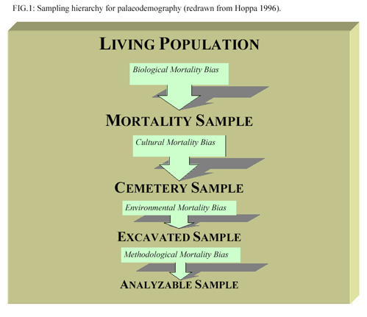

Osteology
- Study of human bone
  - human variation in morphology
  - skeletal biology
  - biomechanics
  - Living organ
  - captures complex interrelationships with cultural and physical environments

Sex Estimation: skull
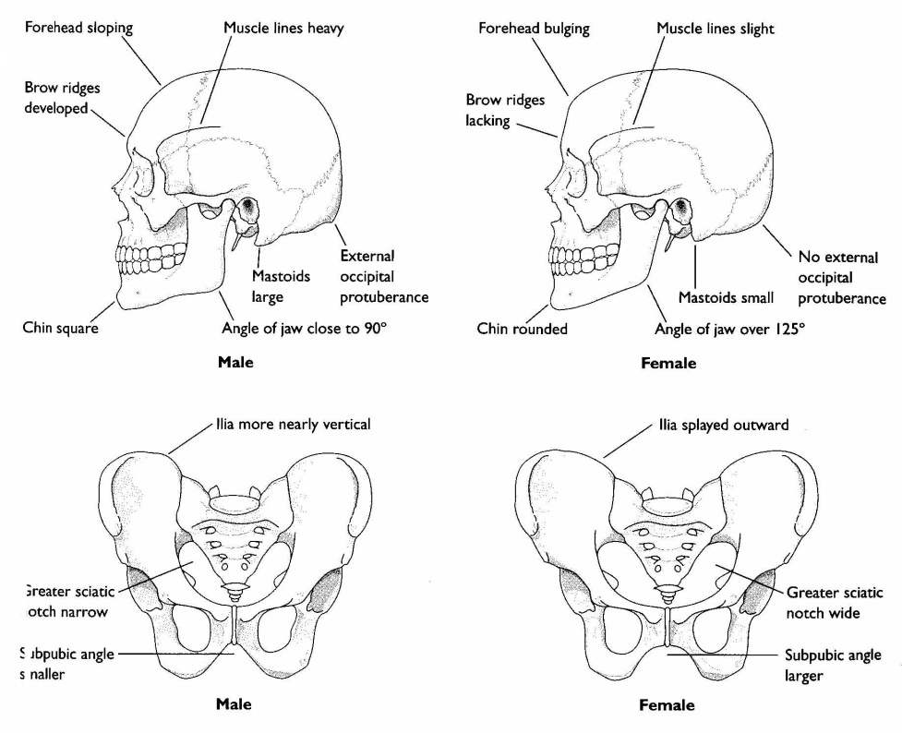

Sex Estimation: Pubic symphysis

Age Estimation: Dental Eruption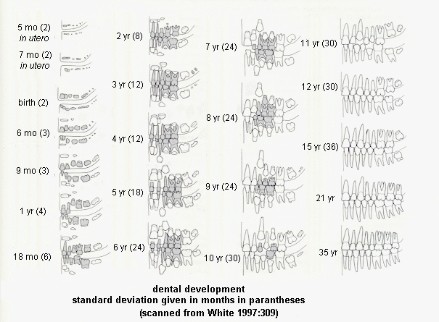

Age Estimation: Sutures
- bones of cranial vault separate at birth
- gradually fuse during a person’s lifetime
- dates of closure are relatively variable
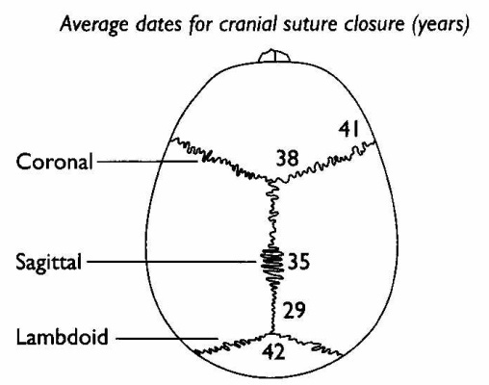

Palaeopathology
Study of how ancient disease, trauma, health and activity affects human bone
Some major kinds of pathology:
- Infectious disease
- Nutritional deficiency
- Dental disease
Can ask questions about:
- trauma and activity
- origins of disease
- influence of impaired health on society
- activity patterns/division of labour

Diease
- Can identify only a few from bony response
- Process of differential diagnosis
  - importance of distribution

Infectious Diease
- Tuberculosis
  - abscesses at hip, knee, spine ankylosis
  - population density
- Leprosy
  - bone resorption
  - fingers, toes, nose
Syphilis
  - multiple forms, venereal most severe
  - ‘sunburst’ lesions on frontal bone
  - OW to NW?

Nutrient Deficiency
Provides insight into:
- access to resources
- food status
- health of the population
  - impaired function
  - workload
Examples:
- Scurvy
- Porotic hyperostosis and cribra orbitalia
Scurvy
- Vitamin C
- New bone (jaws, orbits)
Cribra Orbitalia
Porotic Hyperostosis
- symptoms of iron deficiency anemia
  - meat, parasites
  - impaired function?
  - lesions of the cranial vault (PH) and orbits (CO)

Dental Dieases
- Periodontal disease
  - inflammation of soft tissues

  - transmission to bone
  - resorption, tooth loss
- Caries
  - fermented sugars
  - acids from bacteria demineralize teeth
- Abscess
  - bacteria from teeth to bone
  - pus build-up, sinus

Trauma
Can be evidence of:
- warfare
- accidents
- homicide
- medical intervention
- deliberate modification
For example:
- fractures
- trephination
- tight-lacing

Palaeonutrition
- Study of ancient diets
- Stable isotope ratios – broad categories of foods consumed over time
- Dental wear – types of foods
- Calculus – presence & content
- Pathology – signs of nutritional deficiency

Activity Patterns
Mechanical loading or strain
- enlarged attachment sites for ligaments & tendons
Movement of individuals and populations
- Isotope analysis (e.g. oxygen)

Ethical Considerations
North American history of colonialism
  - grave robbing
  - US government paying for skulls
  - “noble savage” of the past
Native American Graves Protection and Repatriation Act (NAGPRA)

“Bioarchaeology is Anthropology”
- Integrates data, methods, theory from everywhere
- Entirely unique and powerful contribution to knowledge
  - portal to the past
  - biological and behavioural diversity
  - situate contemporary problems
  - holistic biocultural approach

