Covers Chapters 5, 6, 7, and 13.
Chapter 5 - Elasticity and its application
Chapter 6 - Supply, Demand, and Government Policies
Chapter 7 - Consumers, Producers, and the Efficiency of Markets
Chapter 13 – The costs of production

Chapter 5
- Elasticity: measurement of how much buyers and sellers respond to changes in market conditions
  - We can look at in in terms of direction of movement but also in terms of magnitude
  - Elasticity of demand: relationship between demand and price
  - Elasticity of Supply: ……………………………………..Supply and price
- Elasticity of demand:
  - Availability of substitute goods
  - Normal goods, inferior goods, luxury goods
  - Definition of market
  - Time horizon
- In general, in the long run goods become more elastic (exceptions to this)
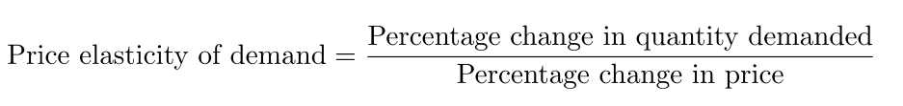
***I believe the order you calculate the difference with is opposite to that of how its written**
By this I mean that if the question says to calculate the elasticity between A and B, then to calculate the percent change in price and quantity you would take the difference (B MINUS A [that’s what I mean by opposite]) in quantity/price and divide it by the total average price/quantity. Ultimately, the formula ends up being (see following image) (also see aplia chapter 5 assignment)
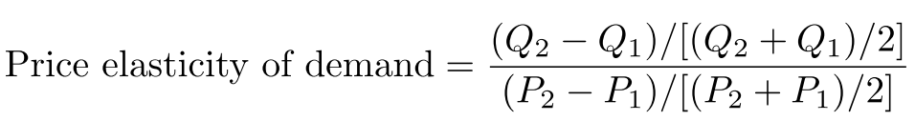
- Definitions of elasticity
  - Inelastic: When elasticity is less than 1
    - Usually very steep or vertical
  - Elastic: ……………………………..greater than 1
    - Slope is nearly flat
  - Unit elastic: …………………….. equal to 1
    - Slope 1/1
- Revenue =Area on supply/demand graph
  - (revenue=length*width if square, =base* height if triangular)
  - How does total revenue change as you move along the supply/demand curves (depends on elasticity)
    - Inelastic: Price and Revenue move in same direction
      - Ex: price increases, revenue increases
    - Elastic: Price and Revenue opposite directions
      - Ex: Price increases, revenue goes down
    - Unit elastic: Revenue remains constant when price changes
- Slope DOES NOT EQUAL elasticity
  - A linear curve may have a constant slope, however different measurements of elasticity will be found between certain points!
- Income elasticity of demand
  - Same as normal formula except instead of price you use income
- Cross-price elasticity of demand
  - Same as normal formula except top is %change in quantity of good 1, and bottom is %change in price of good 2
- Elastic goods change in quantity demanded or supplied substantially with changes in price
- Inelastic goods barely change in quantity demanded or supplied with changes in price
- Supply is usually more elastic in the long run
- When supply is inelastic, an increase in QD will have a greater impact on price than quantity
- When supply is elastic, an increase in QD will have a greater impact on quantity than on price
- Shift vs. Movement:
  - Movement=moves along the curve.
  - Shift= the curve shifts
Chapter 6
- Price ceiling: A legal maximum that a price can be sold at
- Price floor: a legal minimum that a price can be sold for
- Binding vs Not binding
  - Binding means the price ceiling is less than equilibrium price/price floor is greater than equilibrium
  - Non-binding means that the price ceiling is above equilibrium/floor is less than equilibrium
    - Bottom line: Binding will actually impact the market, non-binding will not because markets move towards equilibrium
  - can change between binding and non-binding due to changes in market conditions
- A binding ceiling will result in a shortage of goods supplied vs. demanded
- A binding floor will result in a surplus in goods supplied vs demanded
- In labour markets surplus=unemployment
  - Therefore binding minimum wage increases unemployment
- Tax incidence: the manner the burden of tax is distributed between buyers and sellers
- Tax on buyers shifts demand curve down by value of tax
- Tax on suppliers shifts supply curve up by the value of the tax
- Taxes on buyers and taxes on sellers yield the same market results, buyer pays same price and seller receives same price
  - Only difference is who sends the money to the government
- When supply is more elastic than demand then the tax incidence falls more on consumers
  - Meaning they pay more of the tax
- When demand is more elastic than supply the tax incidence falls more on producers
Chapter 7
- Producer surplus: sale price – cost
- Consumer surplus: Willingness to pay – sale price
- Equilibrium is at a point that maximizes total welfare for buyers and sellers
- Welfare economics: the study of how allocation of resources affects economic well-being
- Willingness to pay: the max a buyer is willing to spend on a good/service
- Consumer surplus: the difference between willingness to pay and what they actually pay
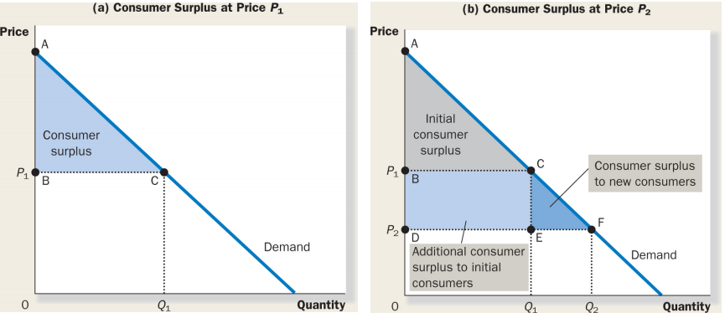
- Decrease in price leads to surplus for initial consumers (rectangle), but also increases number of consumers willing to buy the product. This further increases consumer surplus (triangle).
- Consumer surplus measures the benefit a consumer receives from buying a product
  - Thus it is representative of the well-being in a market
- Policy makers may not respect buyer well-being in certain markets
  - Ex: drug addicts
- Producer surplus:
  - Producer surplus is the difference between price a seller receives for a product and the cost of producing it
  - Producer surplus is a measure of producer well-being
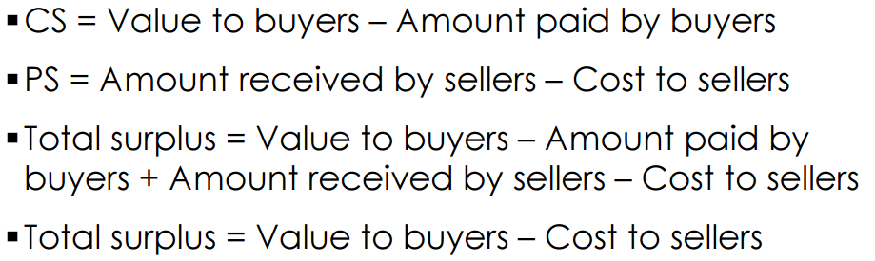
- Total surplus= CS+PS
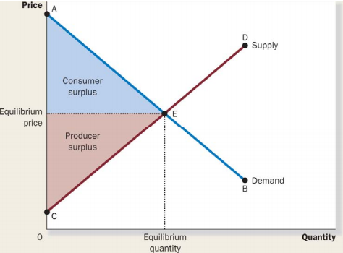
- Things we can learn from this diagram: Is the surplus equitable? Efficient?
- Free markets produce the quantity that brings most well-being to buyers and sellers
  - Thus, Free markets result in most surplus
- Increasing production past equilibrium lowers total surplus (decreases efficiency)
- Increasing price beyond equilibrium would decrease equity
Chapter 13
- Industrial organization: the study of how firms’ decisions regarding prices and quantities change based on market conditions
- Explicit Costs: money must be spent
- Implicit Costs: no actual money is spent
  - Mainly characterized by missed opportunities
    - Ex: investing in a $400k property is an explicit cost of production for a farmer, the implicit cost would be the potential earnings that the $400k investment could have earned through being placed in a savings account
- Economic Profit: Revenue – (implicit + explicit costs)
- Accounting Profit: Revenue – explicit costs
- Production Function: relationship between inputs and outputs (products) in production
  - (Increasing)
  - Quantity on y-axis
  - Input on x-axis
- Total Cost function (increasing)
  - Total cost on y-axis
  - Output on x-axis
- Marginal Product: marginal cost decreases
- Diminishing Marginal Product: marginal cost is increasing
- Fixed Costs: costs that do not vary with number of outputs
- Variable Costs: costs that vary with number of outputs
- Average Total Cost (ATC): The total cost divided by number of output
- Average Fixed Cost (AFC): Fixed Cost divided by number of output
- Average Variable Cost (AVC): Variable Cost divided by number of output
- Marginal Cost: The increase in total cost of increasing output by 1
- Efficient Scale: Quantity of output that minimizes average total cost ATC
- Relationship Between marginal cost and ATC:
  - When MC is less than ATC, ATC is falling
  - When MC is greater than ATC, ATC is rising
    - Therefore MC crosses ATC at ATC’s minimum value
- Properties of cost curves:
  - MC eventually rises with increases in input
  - ATC is U-shaped
  - MC crosses ATC at ATC minimum
- Cost Curves and the Time horizon
- Economies of scale: ATC decreases as input increases (In the long run)
- Diseconomies of scale: ATC increases as input increases (long run)
- Constant returns to scale: ATC remains constant as input increases (long run)
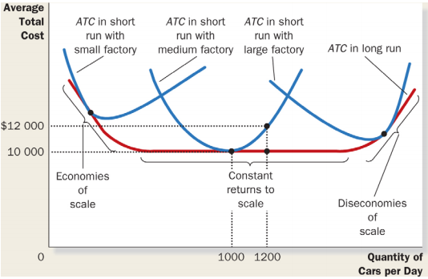
- Decisions may be fixed in short run, then become variable in long run
  - Ex: in short run you may not be able to open new factory due to lack of capital but in long run you may be able to acquire capital and buy new factory

