Discussion

In this laboratory, the nitration of acetanilide using nitric acid and sulphuric acid was observed. The charged electrophile, a nitronium ion, was generated by the donation of a proton from sulphuric acid to nitric acid. Sulphuric acid is a stronger acid than nitric acid, so nitric acid acts as a base. The nitronium ion was then added to one of the pi bonds on the aromatic carbon ring selectively. The focus of the lab performed was to observe regiochemistry and predict whether ortho, meta, or para products were formed. The substituent on the aromatic ring in this lab is an electron-donating group. This means that it will lower the energy of the arenium ion that forms in the reaction as an intermediate. The electron-donating group will stabilize the positive charge on the carbon cation formed from breaking a pi bond. This reduces the amount of energy needed to reach transition states increasing the amount of para and ortho formed.
The meta isomer is the least stable intermediate and therefore is less likely to form which is why it was not seen in any of the TLCs in this reaction, the meta isomer would only form if exposed to large amounts of heat. Although there are similar Rfs for the meta and the para dots as seen in Figure 4. The dots do not line up between the crude product and the meta meaning no meta is formed which corresponds to the theory of the lab. The ortho is more stable than the meta as it has more possible resonance forms, but is still less favourable than para as a result of the steric interactions between the side groups of the benzene ring. As seen in Figure 5 the dots for the crude product and sample do not exactly line up but they are very close, this would lead to the assumption that only para had formed. This is extremely unlikely and a better explanation would be that the ortho dots were spotted slightlty lower on the TLC plate meaning they appear to have risen less. As a result of the likelihood of the ortho forming it can be assumed that the ortho product was formed in this reaction. The para isomer is the most stable and will therefore be more likely to form, this is due to sterics, as in the para isomers the substituents are as far apart as possible. This is why para is the major product appearing in the lab. The para dots on the TLC line up exactly, indicating that para did indeed form and that it was the major isomer formed. This can also be confirmed through the Image J software which gave a percent composition of 41.8:22.3 para: ortho.
In addition to the Image J software the polarity of the compounds also helps identify which were present in the crude product. The para isomer is more polar because it has additive dipoles in its side groups resulting in a large overall polarity. This polarity makes the para dots appear the lowest on the TLC plate. The meta isomer has conflicting dipoles and will therefore be less polar resulting in a spot higher on the plate. The ortho isomer will appear highest on the plate this is attributed to its two side groups interacting. The negative end of the NO₂ molecule will pull the H from the other side group, as a result of the proximity of the atoms, this means that the H bond can’t interact with the TLC plate leading to a higher dot.
Once the TLCs of the isomers were compared, the crude product was added to boiling ethanol this ideally would act to create a product in which there was only the para isomer. Because of the excess heat added at this point it is possible that some meta could have formed as an intermediate, which would explain the additional spot on the TLC plate that appeared after this step.
To isolate for the para isomer, a series of workup steps were performed. The crude solid obtained was subjected to a recrystallization. Ethanol is a polar solvent, and as a result of the added heat, both isomers are dissolvable in the ethanol. Once the solution cools, the para isomer recrystallizes while the ortho isomer remains in the mother liquor. By using suction filtration theoretically only pure para-nitro acetanilide would be left as the final crystal product. This however did not occur as can be seen in the last TLC plate that compares the “pure product” to the crude product. Somewhere the solution picked up contaminants along the way possibly through unclean beakers or the formation of dinitro in addition to the three other isomers. A TLC was performed to compare the pure product to the mother liquor it revealed that the crude product had less spots than the mother liquor meaning it was somewhat purified.

The final product was collected and weighed. The final mass was found to be 0.89g and when compared to the moles of acetanilide gave a percent yield of 66.4%. This is a fair yield though it could have been more precise. Product could have been lost when being removed from the suction filtration apparatus and also some could have been lost at the very beginning of the lab when not all of the acetanilide flakes dissolved into the acids resulting in the lower yield obtained.

Procedure and Observations:
- 1.02g of acetanilide, opaque beige flakes, was placed in a 50mL round bottom flask. A small stir bar was added and the flask was clamped over a magnetic stir plate.
- 3.0mL of sulphuric acid, a clear, aromatic liquid, was added to the reaction flask. This was allowed to stir for 2 minutes.
- The reaction flask was submerged in an ice bath and left to stir for 7 minutes.
- After the 7 minutes had passed the liquid was a yellowish brown translucent colour
- Acetanilide flakes were still present in the solution at this point so it was manually stirred for an additional 5 minutes
- A mixture of 1.3mL sulphuric acid and 0.7mL of nitric acid was combined in an Erlenmeyer flask; the acids were then slowly added to the reaction flask. The mixture turned yellow at first then gradually turned a transparent brown colour.
- A TLC was performed at this time and revealed that the experiment had gone to completion.
- 4 ice cubes were placed into a 125ml Erlenmeyer flask along with approximately 25mL of cold water. The contents of the reaction flask were then added to the beaker. The solution was a bright yellow cloudy colour. The contents were left to stir until the ice had melted.
- The solid that formed was collected via suction filtration.
- The solid obtained was a pale yellow colour and doughy and pliable. The solid was weighed at 2.06g.
- A TLC plate was performed to see if any of the starting material remained in the solid.
- More TLCs of the crude product were performed comparing it against possible isomers that may have formed. All TLCs were formed in 5:5 EtOAc: hexanes.
- The remaining crude product was dissolved in 20 ml of boiling ethanol in a 50mL Erlenmeyer flask containing a stir bar.
- Once dissolved, the flask was removed from heat and allowed to cool undisturbed.
- The crystals that came out of solution were yellow in colour.
- Suction filtration was performed again and the product obtained was again a pale yellow colour, the mother liquor was a translucent yellow, with some flecks in it.
- The final pure solid was weighed at 0.89g

Table 1. Reagent table for the nitration of acetanilide.
Reagent | Amount | Molecular Weight (g/mol) | Density (g/mL) | Moles (mol)
Acetanilide | 1.02 g | 137.170 | 1.22 | 0.00744
Nitric Acid | 0.7 mL | 63.010 | 1.51 | 0.0168
Sulfuric Acid | 4.3 mL | 98.079 | 1.84 | 0.081

Calculations

- Calculation of Rf values.
Rf=$\frac{Distance spot travelled}{Distance solvent travelled}$
Rf= $\frac{1.2}{4.6}$
Rf= 0.26

- Sample calculation of solvent in reagent table
Sulfuric acid
Molecular weight; 98.079g/mol
Amount; 4.3 ml
Density; 1.84g/ml

Mass=volume x density
= 4.3ml x 1.84g/ml
=7.912g

mol= $\frac{mass}{molar mass}$
= $\frac{7.912g}{98.079g/mol}$
=0.081 mol

1 2912.811
2 1925.439

Area=$\frac{Area of Peak 1}{Area Peak 1+Area Peak 2}$x100%

Area= $\frac{2912.811}{2912.811+1925.439}$
Area= 60.2% Para

Therefore Area of 2 = 39.8% Para

Mole percentage; y=7.9391x10⁻³ x² +1.5962x10⁻¹x+3.3788
= 7.9391x10⁻³ (60.2)² +1.5962x10⁻1(60.2)+3.3788
= 41.76 %para

Percent Yield
Acetanilide + Nitric Acid + Sulfuric Acid -> nitroactanilide + byproduct 0.00744mol 0.0168mol 0.081 mol
Acetanilide is the limiting reagent, its moles can therefore be used to compare in order to calculate percent yield.

0.89g of final product obtained.
Molar mass of final product; 180.16g/mol

Therfore; $\frac{0.89g}{180.16g/mol}$= 0.00494mol
Percentage yield = $\frac{moles nitroactenilide}{moles of acetanilide}$x100%
=$\frac{0.00494}{0.00744}$x100
=66.4% yield

Questions

1. The ortho is more polar in respect to para isomer of nitroacetanilide. Silica gel, the medium used on the TLC plates, is also polar. Thus, the ortho isomer will cling onto the silica for longer, meaning it won’t travel far on the TLC. Para, being less polar, is lilely to travel further.

2. The ortho isomer is much more soluble in ethanol. This is why the crude product is dissolved in boiling ethanol. As a result of the added heat, both isomers are dissolvable in the ethanol. Once the solution cools, the para isomer recrystallizes while the ortho isomer remains in liquid. Upon suction filtration, the para isomer can be isolated.

3. This occurs as a result of the higher energy barrier of the second nitration than of the first. Thus, to form a dinitroacetanilide, the rate determining step is the second nitration.

4. The charge distribution in the benzene ring is greatest at para sites to the substituent, thus the para isomer is preferred.

5.
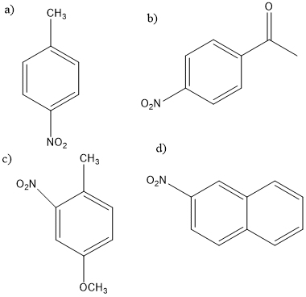

6.

With one pi bond, bromogenation of both carbons is preferrable. However, when benzene, an aromatic compound, is involved, it is preferred to return the molecule to aromacity, Thus, the double bond will be reformed and the bromine ion will pick up the leftover proton.
7.
Benzene + sulfuric acid + nitric acid ---> nitrobenzene + ?
10 mol 137.6 mol 205.7 mol 8.13 mol (experimental)
Thus, Benzene is limiting reagent!
b.

Weight =10 mol _{benzene} x (1mol _{nitrobenzene} /1 mol _{benzene})
Weight =10 mol _{nitrobenzene} x (123g/mol _{nitrobenzene})
Weight =1230g _{nitrobenzene}

Percent Yield= (actual/theoretical) x 100%
Percent Yield= (1000 g/1230g) x 100%
Percent Yield =81.3%
c.
The most probable side product is a dinitrobenzene.
d.
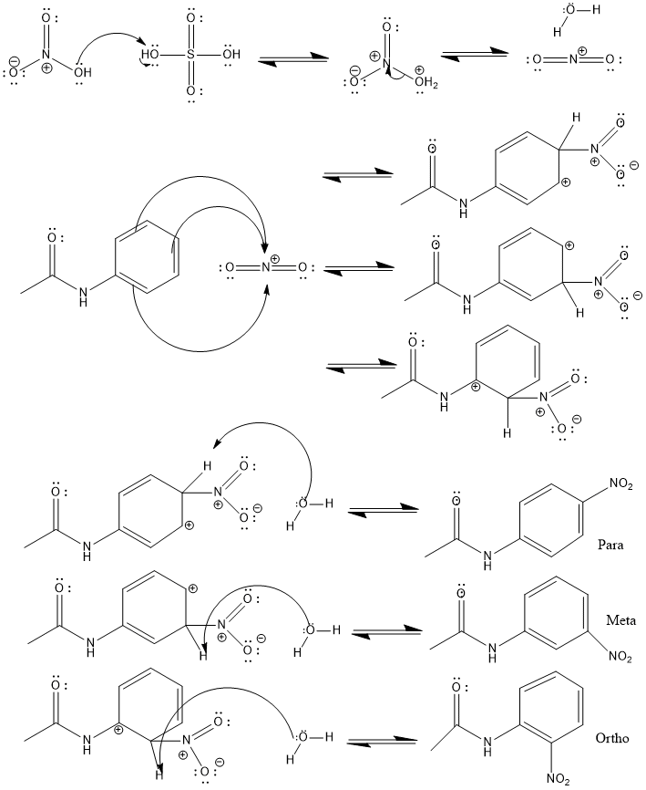
The role of H2SO4 in this reaction is to activate the electrophile, a.k.a. nitric acid.

e.
Weight =10 mol _{benzene} x (1mol _{C6H4N2O4}/1 mol _{benzene})
Weight =10 mol _{C6H4N2O4}x (168.017g/mol _{C6H4N2O4})
Weight =1680.17g _{C6H4N2O4}

Percent Yield= (actual/theoretical) x 100%
Percent Yield= (250 g/1680.17g) x 100%
Percent Yield =14.88%
8.
The regioselectivity of furan is explained in reference to resonance. When 1-nitrofuran is formed, the positive charge is delocalized by three atoms; carbon 3, carbon 5, and the oxygen. The charge is not delocalized as nicely when 2-nitrofuran is formed.

