Chapter 11 – Reporting for Control

Decentralization in Organizations
- A decentralized organization does not confine decision-making authority to a few top executives; rather, decision-making authority is spread throughout the organization.
- Benefits
  - It enables top management to concentrate on strategy, higher-level decision making, and coordinating activities.
  - It acknowledges that lower-level managers have more detailed information about local conditions that enable them to make better operational decisions.
  - It enables lower-level managers to quickly respond to customers.
  - It provides lower-level managers with the decision-making experience they will need when promoted to higher level positions.
  - It often increases motivation, resulting in increased job satisfaction and retention, as well as improved performance.
- Disadvantages
- Lower-level managers may make decisions without fully understanding the “big picture.”
- There may be a lack of coordination among autonomous managers. The balanced scorecard can help reduce this problem by communicating a company’s strategy throughout the organization.
- Lower-level managers may have objectives that differ from those of the entire organization. This problem can be reduced by designing performance evaluation systems that motivate managers to make decisions which are in the best interests of the company.
- It may difficult to effectively spread innovative ideas in a strongly decentralized organization. This problem can be reduced through the effective use of intranet systems, which enable globally dispersed employees to electronically share ideas.

Decentralization and Segment Reporting
- A segment is any part or activity of an organization about which a manager seeks cost, revenue or profit data. A segment can be:
  - An individual store
  - A Sales Territory
  - A Service Centre
- Corporations could segment their business by customer channel or by geographic regions etc.

Assigning Costs to Segments
- There are two keys to building segmented income statements:
  - A contribution format should be used because it separates fixed costs and it enabled the calculation of a contribution margin.
  - Traceable fixed costs should be separated from common fixed costs to enable the calculation of a segment margin.
- Traceable Fixed Costs vs. Common Fixed Costs
  - Traceable costs arise because of the existence of a particular segment and would disappear over time if the segment itself disappeared.
  - Common costs arise because of the overall operation of the company and would not disappear if any particular segment were eliminated.
  - Don’t allocate common costs to segments.

Activity-Based Costing

- Activity-based costing can help identify how costs shared by more than one segment are traceable to individual segments
- Assume that three products, 9-inch, 12-inch, and 18-inch pipe, share 10,000 square feet of warehousing space, which is leased at a price of $4 per square foot.
- If the 9-inch, 12-inch, and 18-inch pipes occupy 1,000, 4,000, and 5,000 square feet, respectively, then ABC can be used to trace the warehousing costs to the three products as shown.

Traceable Costs Can Become Common Costs
- It is important to realize that the traceable fixed costs of one segment may be a common fixed cost of another segment.
- For example, the landing fee paid to land an airplane at an airport is traceable to the particular flight, but it is not traceable to first-class, business-class, and economy-class passengers.

Segment Margin

- The segment margin, which is computed by subtracting the traceable fixed costs of a segment from its contribution margin, is the best gauge of the long-run profitability of a segment.
- Levels of Segmented Statements Example:
  - Webber, Inc. has two divisions: Computer and Television. Here is the segmented contribution income statement.
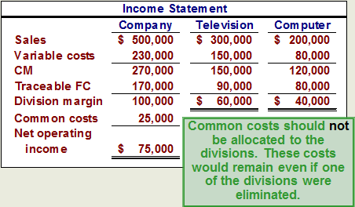

Traceable Costs Can Become Common Costs

- As previously mentioned, fixed costs that are traceable to one segment can become common if the company is divided into smaller segments.
- Continuing with the weber example: the television segment has two product lines: regular and big screen. We know that the regular traceable costs are $45, 000, and the big screen division would trace to $35,000.
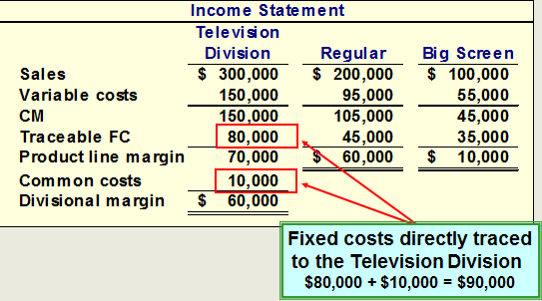

Segment Reporting for Financial Accounting
- International Financial Reporting Standard (IFRS) 8-Operationg Segments required that segmented reports prepared for external users use the same methods and definitions used for internal segmented reports that are prepared to aid in making operating.
- Since the contribution approach to segment reporting does not comply with GAAP, it is likely that some managers will choose to construct their segmented financial statements using the absorption approach to comply with GAAP.
- Hindrances to Proper Cost Assignment
  - Omission of some costs in the assignment process.
  - Assignment to segments of costs that are really common costs of the entire organization.
  - Use of inappropriate methods for allocating costs among segments.
- Omission of Costs
  - Costs assigned to a segment should include all costs attributable to that segment from the company’s entire value chain. (Business functions making up the value chain are R&D, Product Design, Manufacturing, Marketing, Distribution and Customer Service)
- Inappropriate Methods of Allocating Costs Among Segments
  - Many companies do not correctly handle traceable fixed expenses on segmented income statements.
  - First, they may not trace fixed expenses to segments even when it is feasible to do so.
  - Second, they may use inappropriate allocation bases to allocate traceable fixed expenses to segments.
- Arbitrarily Dividing Common Costs and Segments
  - Common costs should not be arbitrarily allocated to segments based on the rationale that “someone has to cover the common costs” for two reasons:
    - This practice may make a profitable business segment appear to be unprofitable.
    - Allocating common fixed costs forces managers to be held accountable for costs they cannot control.

Responsibility centres
- A responsibility centre is broadly defined as any part of an organization whose manager has control over and is accountable for cost, profit, or investment.
- The three primary types of responsibility centres are cost centres, profit centres, and investment centres.
- Organizations categorize responsibility centres into one of these three types based on the manager’s authority to control cost, revenue, and investment funds.
  - Cost Centre: A segment whose manager has control over costs, but not over revenues or investment funds.
  - Profit Centre: A segment whose manager has control over both costs and revenues (but no control over investment funds.)
  - Investment Centre: A segment whose manager has control over costs, revenues, and investments in operating assets.

Return on Investment (ROI) Formula
- ROI= Operating Income/Average Operating Assets
  - Operating Income is income before interest and taxes (EBIT)
  - Avg. Operating Assets are cash, AR, inventory, plant and equipment and other productive assets.

Net Book Value vs. Gross Cost
- Arguments for Using NBV to measure Operating Assets in ROI Calculation:
  - The NBV method is consistent with:
    - how plant and equipment are reported on the balance sheet
    - the calculation of operating income, which includes depreciation as an operating expense.
  - The gross cost method
    - Eliminates both the age of equipment and the method of depreciation as factors in ROI calculations.
    - Does not discourage replacement of old, worn-out equipment.
- Most companies use the net book value of depreciable assets to calculate average operating assets. (Net Book Value = Acquisition cost – Acc. Depreciation)

Understanding ROI
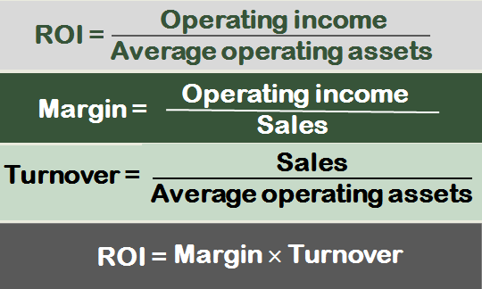
- Increasing ROI
  - There are three ways to increase ROI . . .
    - Increase Sales
    - Reduce Operating Expenses
    - Reduce Operating Assets
- Elements of ROI
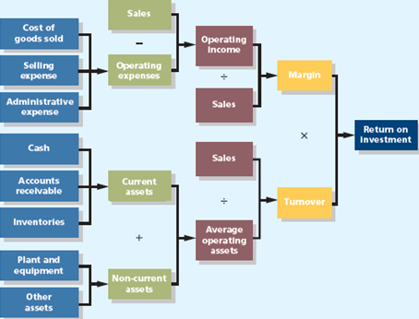
- Criticisms of ROI
  - In the absence of the balanced scorecard, management may not know how to increase ROI.
  - Managers often inherit many committed costs over which they have no control.
  - Managers evaluated on ROI may reject profitable investment opportunities.

Residual Income - Another Measure of Performance
- Operating income above some minimum return on operating assets
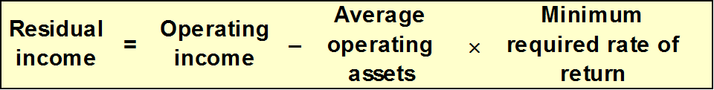
- This computation differs from ROI.
  - ROI measures operating income earned relative to the investment in average operating assets.
  - Residual income measures operating income earned less the minimum required return on average operating assets.
- Motivation and Residual Income
  - Residual income encourages managers to make profitable investments that would be rejected by managers using ROI.
- Divisional Comparisons and Residual Income
  - The residual income approach has one major disadvantage.
  - It cannot be used to compare performance of divisions of different sizes. (Need to look at ROI to understand proportional income)
- Criticisms of Residual Income
  - RI is based on historical accounting data which can lead to inflated amounts for residual income in periods of rising prices (i.e.. values for capital assets).
  - RI does not indicate what earnings should be (need comparison of external benchmark or trends).
  - Calculating RI requires numerous adjustments to GAAP increasing the cost of preparing information.
  - RI does not incorporate important leading non-financial indicators.

The Balanced Scorecard
- Management translates its strategy into performance measures that employees understand and accept.
- From Strategy to Performance Measures
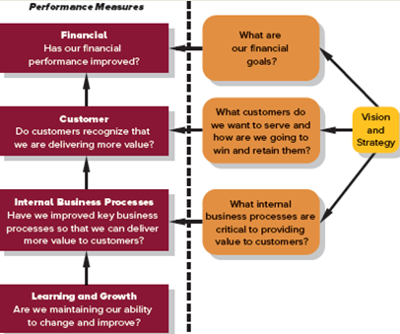
- Non-financial Measures
  - The balanced scorecard relies on non-financial measures in addition to financial measures for two reasons:
    - Financial measures are lag indicators that summarize the results of past actions, Non-financial measures are leading indicators of future financial performance.
    - Top managers are ordinarily responsible for financial performance measures – not lower level managers. Non-financial measures are more likely to be understood and controlled by lower level managers.

- The Balanced Scorecard for Individuals
  - The entire organization should have an overall balanced scorecard and each individual should have a personal balanced scorecard.
  - A personal scorecard should contain measures that can be influenced by the individual being evaluated and that support the measures in the overall balanced scorecard.
- A balanced scorecard should have measures that are linked together on a cause-and-effect basis.
  - If we improve one performance measure then another desired performance measure will improve.
  - The balances scorecard lays out concrete actions to attain desired outcomes.
- Compensation
  - Incentive compensation should be linked to balanced scorecard performance measures.

Transfer Pricing, Quality Costs and Service Department Cost Allocation
- Transfer Pricing - Key Concepts/Definitions
  - A transfer price is the price charged when one segment of a company provides goods or services to another segment of the company.
  - The fundamental objective in setting transfer prices is to motivate managers to act in the best interests of the overall company.
- Three Common Approaches
  - Negotiated Transfer Prices
  - Transfers at the cost to the selling division
  - Transfers at market price
- Negotiated Transfer Prices
  - A negotiated transfer price results from discussions between the selling and buying divisions.
  - Advantages of negotiated transfer prices:
    - They preserve the autonomy of the divisions, which is consistent with the spirit of decentralization.
    - The managers negotiating the transfer price are likely to have much better information about the potential costs and benefits of the transfer than others in the company.
  - Range of acceptable transfer prices:
    - Upper limit is determined by the buying division
    - Lower limit is determined by the selling division
  - Harrison Ltd – An Example
    - Assume the information as shown with respect to Cumberland Beverages and Pizza Place (both companies are owned by Harrison Ltd).
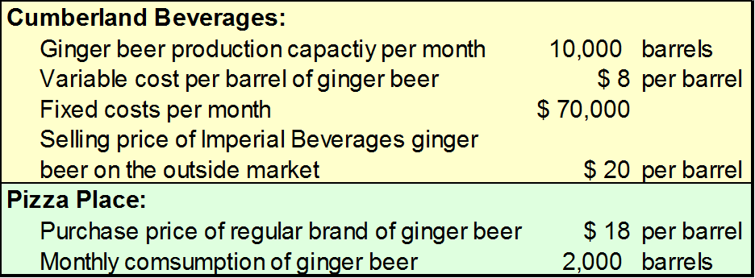
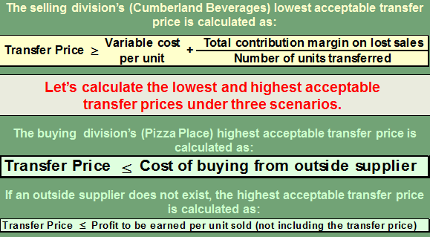
    - If Cumberland Beverages has sufficient idle capacity (3,000 barrels) to satisfy Pizza Place’s demands (2,000 barrels), without sacrificing sales to other customers, then the lowest and highest possible transfer prices are computed as follows:
      - Selling divisions lower possible transfer price: $8 + ($0/2000) = $8
      - Buying division’s highest possible transfer price: Cost from outside supplier is $18.
      - Therefor the acceptable transfer price range is $8-$18.
    - If Cumberland Beverages has no idle capacity (0 barrels) and must sacrifice other customer orders (2,000 barrels) to meet Pizza Place’s demands (2,000 barrels), then the lowest and highest possible transfer prices are computed as follows:
      - Selling divisions lower possible transfer price: $8 + ((($20-$8)x 2,000)/2000) = $20
      - Buying division’s highest possible transfer price: Cost from outside supplier is $18.
      - Therefor there is no range of acceptable transfer prices.
    - If Cumberland Beverages has some idle capacity (1,000 barrels) and must sacrifice other customer orders (1,000 barrels) to meet Pizza Place’s demands (2,000 barrels), then the lowest and highest possible transfer prices are computed as follows:
      - Selling divisions lower possible transfer price: $8 + ((($20-$8)x 1,000)/2000) = $14
      - Buying division’s highest possible transfer price: Cost from outside supplier is $18.
      - Therefor the acceptable range of acceptable transfer prices is $14-$18.
- Evaluation of Negotiated Transfer Prices
  - If a transfer within a company would result in higher overall profits for the company, there is always a range of transfer prices within which both the selling and buying divisions would have higher profits if they agree to the transfer.
  - If managers are pitted against each other rather than against their past performance or reasonable benchmarks, a non-cooperative atmosphere is almost guaranteed.
  - Given the disputes that often accompany the negotiation process, most companies rely on some other means of setting transfer prices.
- Transfers to the Selling Division at Cost
  - Many companies set transfer prices at either the variable cost or full (absorption) cost incurred by the selling division.
  - Drawbacks of this approach include:
    - Using full cost as a transfer price and can lead to suboptimization.
    - The selling division will never show a profit on any internal transfer.
    - Cost-based transfer prices do not provide incentives to control costs.
- Transfers at Market Price
  - A market price (i.e., the price charged for an item on the open market) is often regarded as the best approach to the transfer pricing problem.
    - A market price approach works best when the product or service is sold in its present form to outside customers and the selling division has no idle capacity.
    - A market price approach does not work well when the selling division has idle capacity.
Divisional Autonomy
  - The principles of decentralization suggest that companies should grant managers autonomy to set transfer prices and to decide whether to sell internally or externally, even if this may occasionally result in suboptimal decisions.
  - This way top management allows subordinates to control their own destiny.
International Aspects of Transfer Pricing

- Domestic:
  - Greater divisional autonomy
  - Greater motivation for managers
  - Better performance evaluation
  - Better goal congruence
- International:
  - Less taxes, duties, and tariffs
  - Less foreign exchange risks
  - Better competitive position
  - Better governmental relations

