Chapter 9 –Flexible Budgets

The budgets we just went over are static budgets.
- A static budget is prepared only for the planned or budgeted level of activity.
- These budgets are suitable for planning; however they can be inadequate for control if the actual level of activity during the period differs significantly from the budgeted level.
- Therefore an alternative approach is needed to restore the usefulness of budgets as a control tool.

Flexible Budgets
- May be prepared for any activity level within the relevant range.
- Show costs that should have been incurred at the actual level of activity, enabling “apples to apples” cost comparisons.
- Reveal variances related to cost control.
- Improve performance evaluation.

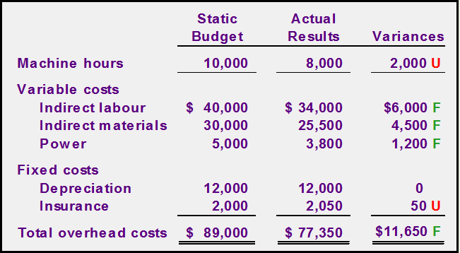
U=Unfavorable variance (unable to achieve the budgeted level of activity, and the costs were higher than expected.)
F= Favorable Variance (When costs are lower than expected)

Since Cost variances are favorable, have we done a good job controlling costs?
- This question can’t be answered using a static budget.
- The relevant question should be…
- “How much of the favourable cost variance is due to lower activity, and how much is due to good cost control?
- To answer the question, we must flex the budget to the actual level of activity.
- To flex a budget we need to know that:
  - Total variable costs change in direct proportion to changes in activity. (expressed as a constant amount per hour)
  - Total fixed costs remain unchanged within the relevant range. (expressed as a total amount)



