Chapter 9 – Budgeting

Basic Framework of Budgeting
- A budget is a detailed quantitative plan for acquiring and using financial and other resources over a specified forthcoming time period.
- The act of preparing a budget is called budgeting.
- The use of budgets to control an organization’s activity is known as budget control.

Planning and Control
- Planning – involves developing objectives and preparing various budgets to achieve these objectives.
- Control – involves the steps taken by management that attempt to ensure the objectives are attained.

Advantages of Budgeting

- Define goal and objectives
- Coordinate activities
- Means of allocating ressources
- Uncover potential bottlenecks
- Think about and plan the future
- Communicate plans

Responsibility Accounting
Managers should be held responsible for those items, and only those items, that the manager can actually control to a significant extent.

Choosing a Budget Period
- The annual operating budget may be divided into quarterly or monthly budgets
- A continuous budget is a 12-month budget that rolls forward one month (or quarer) as the current month (or quarter) is completed.

The Participative Budget
- A budget is prepared with the full cooperation and participation of managers at all levels.
- Advantages
  - Individuals at all levels of the organization are viewed as members of the team whose judgments are valued by top management.
  - Budget estimates prepared by front-line managers are often more accurate than estimates prepared by top managers.
  - Motivation is generally higher when individuals participate in setting their own goals than when the goals are imposed from above.
  - A manager who is not able to meet a budget imposed from above can claim that it was unrealistic. Participative budgets eliminate this excuse.
- Participative (self-imposed) budgets should be reviewed by higher levels of management to prevent “budgetary slack.”
- Most companies do not rely exclusively upon participative budgets in the sense that top managers usually initiate the budget process by issuing broad guidelines in terms of overall profits or sales.

The Budget Committee
- A standing committee responsible for
- overall policy matters relating to the budget
- coordinating the preparation of the budget
- resolving disputes related to the budget
- approving the final budget
Behavioural Factors in Budgeting
The success of budgeting depends upon three important factors:
- Top management must be enthusiastic and committed to the budget process.
- Top management must not use the budget to pressure employees or blame them when something goes wrong.
- Highly achievable budget targets are usually preferred when managers are rewarded based on meeting budget targets.

Zero-Based Budgeting
- A zero-based budget requires managers to justify all budgeted expenditures, not just changes in the budget from the prior year.
- Most managers argue that zero-based budgeting is too time consuming and costly to justify on an annual basis.

Budgeting Example
Royal Company is preparing budgets for the quarter ending June 30.
- Budgeted sales for the next five months are:
April 20,000 units
May 50,000 units
June 30,000 units
July 25,000 units
August 15,000 units.
- The selling price is $10 per unit.

The Sales Budget
The individual months of April, May, and June are summed to obtain the total projected sales in units and dollars for the quarter ended June 30th.
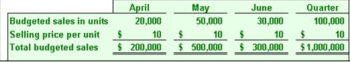

Expected Cash Collections
- All sales are on account.
- Royal’s collection pattern is:
70% collected in the month of sale,
25% collected in the month following sale,
5% uncollectible.
- Sales Amounts on the following table come from the sales budget

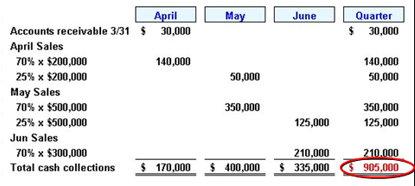
The Production Budget
- Once the sales and expected cash flow budgets are complete, you may move on to the production budget.
- Production must be adequate to meet budgeted sales and provide for sufficient ending inventory.
- The management at Royal Company wants ending inventory to be equal to 20% of the following month’s budgeted sales in units.
- On March 31, 4,000 units were on hand. (April beginning inventory
Let’s prepare the production budget:
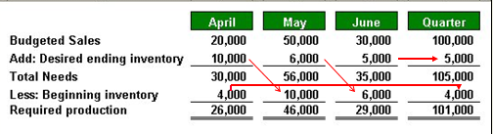
The Direct Materials Budget
- Once the production budget is complete, we must complete the direct materials budget.
- The direct materials budget details the raw materials that must be purchased to fulfill the production budget and to provide for adequate inventories.
- At Royal Company, five pounds of material are required per unit of product.
- Management wants materials on hand at the end of each month equal to 10% of the following month’s production. (desired ending inventory is 10% of the following months production-which comes from the production budget)
- On March 31, 13,000 pounds of material are on hand. Material cost is $0.40 per pound.
Let’s prepare the direct materials budget: 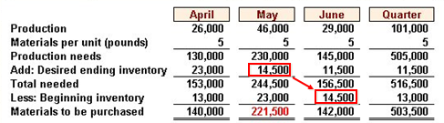
(beginning inventory is from the beginnig of the period, ending is from the end)

Expected Cash Disbursement for Materials
- Royal pays $0.40 per pound for its materials. (materials to be purchased from direct materials budget X .40 to get the purchases $$)
- One-half of a month’s purchases is paid for in the month of purchase; the other half is paid in the following month. (50% of the current month, 50% of the following month)
- The March 31 accounts payable balance is $12,000.
- Let’s calculate expected cash disbursements:

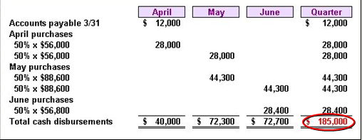
The Direct Labour Budget
- Once the direct materials budget is done, you can complete the direct labour budget
- The direct labour budget is a detailed plan showing labour requirements over some specific time period.
- At Royal, each unit of product requires 0.05 hours (3 minutes) of direct labour. (units come from the production budget)
- The Company has a “no layoff” policy so all employees will be paid for 40 hours of work each week.
- In exchange for the “no layoff” policy, workers agree to a wage rate of $10 per hour regardless of the hours worked (no overtime pay).
- For the next three months, the direct labour workforce will be paid for a minimum of 1,500 hours per month.
- Let’s prepare the direct labour budget.

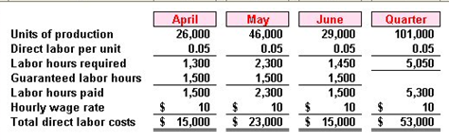
The Manufacturing Overhead Budget
- Once direct labour is complete, you can begin the manufacturing overhead budget
- The manufacturing overhead budget provides a schedule of all costs of production other
than direct materials and direct labour.
- At Royal, manufacturing overhead is applied to units of product on the basis of direct labour hours. (comes from direct labour budget)
- The variable manufacturing overhead rate is $20 per direct labour hour.
- Fixed manufacturing overhead is $50,000 per month and includes $20,000 of noncash costs (primarily depreciation of plant assets).
- Depreciation is a non cash charge
- 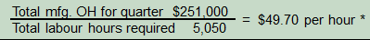
- Let’s prepare the manufacturing overhead budget.

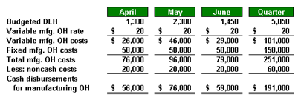

The Ending Finished Goods Inventory Budget
- Once overhead is complete, you can continue with the ending finished goods inventory budget
- All information comes from other budgets

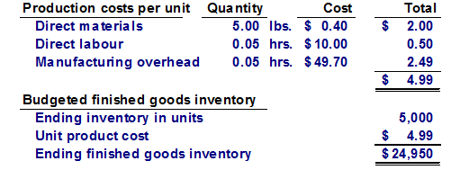

The Selling and Administrative Expense Budget
- Once the finished goods inventory budget is complete, you can move on to the selling and admin
- The selling and administrative expense budget lists the budgeted expenses for areas other than manufacturing.
- At Royal, the selling and administrative expenses budget is divided into variable and fixed components.
- The variable selling and administrative expenses are $0.50 per unit sold.
- Fixed selling and administrative expenses are $70,000 per month.
- The fixed selling and administrative expenses include $10,000 in costs – primarily depreciation – that are not cash outflows of the current month.

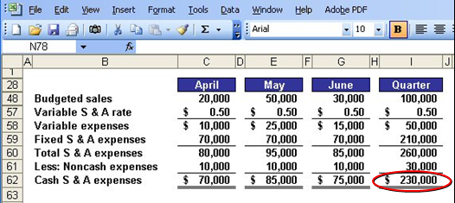

The Cash Budget
- Once the selling and admin budget is complete, you can do the cash budget.
- The cash budget pulls together much of the data developed in the preceding steps and displays it in four major sections: receipts, disbursements, cash excess or deficiency, and financing.
- Format of the Cash Budget
  - The cash budget is divided into four sections:
  - Cash receipts listing all cash inflows excluding borrowing;
  - Cash disbursements listing all payments excluding repayments of principal and interest;
  - Cash excess or deficiency; and
  - The financing section listing all borrowings, repayments and interest.
- Royal:
- Maintains a 16% open line of credit for $75,000
- Maintains a minimum cash balance of $30,000
- Borrows on the first day of the month and repays loans on the last day of the month
- Pays a cash dividend of $49,000 in April
- Purchases $143,700 of equipment in May and $48,300 in June (both purchases paid in cash)
- Has an April 1 cash balance of $40,000
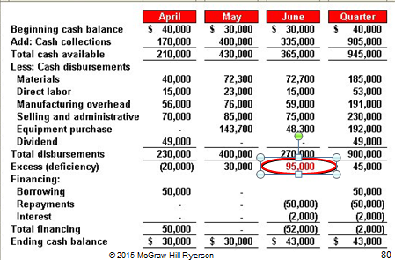

The Budgeted Financial Statements
One the cash budget is complete, you can move on to the financial statements
- The Budgeted Income Statement
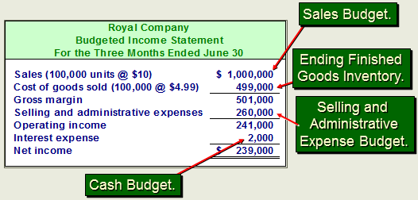

- The Budgeted Balance Sheet
  - Royal reported the following account balances prior to preparing its budgeted financial statements:
  - Land – $50,000
  - Common shares – $200,000
  - Retained earnings – $146,150
  - Equipment – $175,000

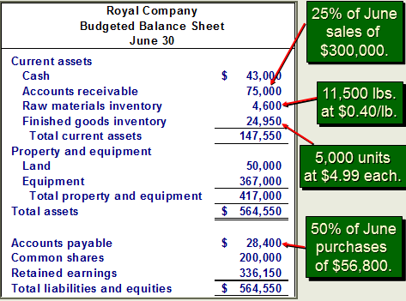
Retained Earnings calculation:


