Chapter 8 – Variable Costing

Overview of Absorption and Variable Costing
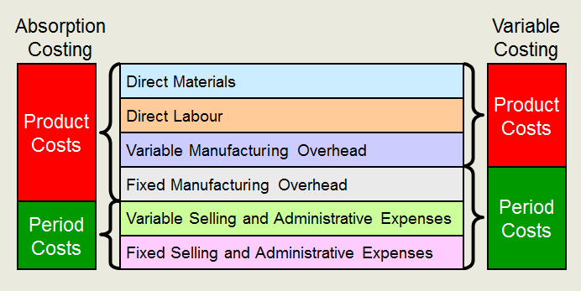

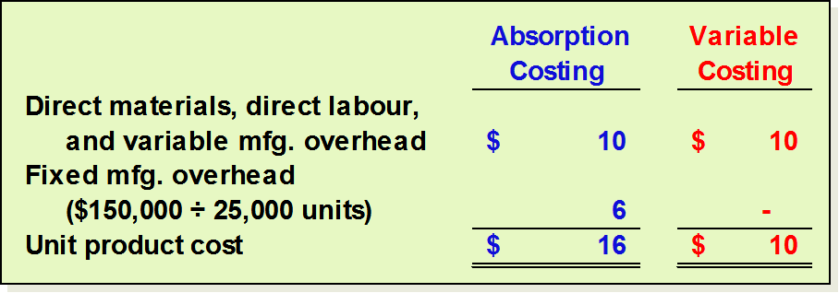
Unit Cost Computations

Harvey Company produces a single product with the following information available:

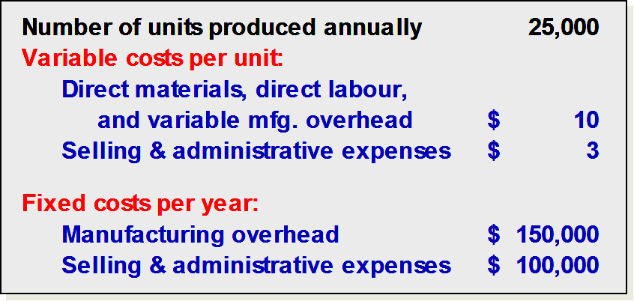

Unit product cost is determined above.
Under absorption costing, selling and administrative expenses are always treated as period expenses and deducted from revenue as incurred.
Income Comparison of Absorption and Variable Costing
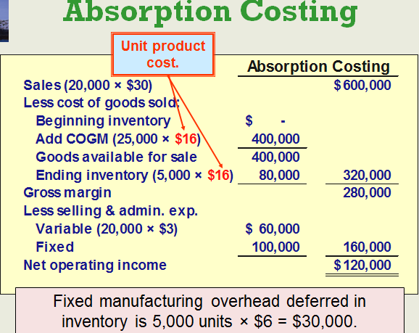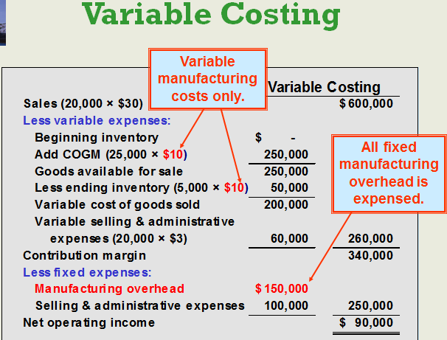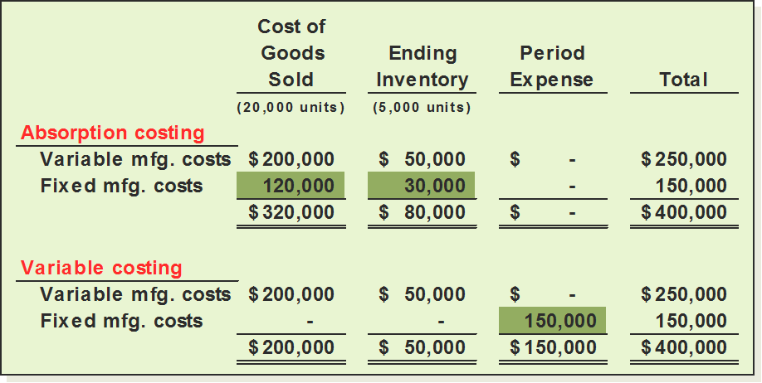 Comparisons of the two methods
We can reconcile the difference between absorption and variable costing by:
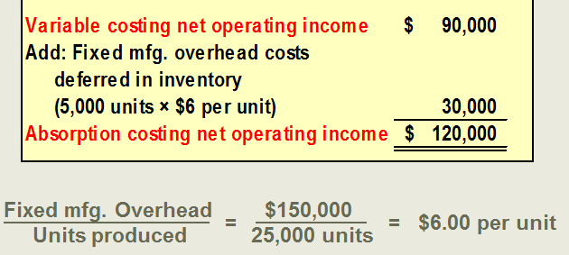

Extended Comparison of Income Data:
Harvey Company Year Two
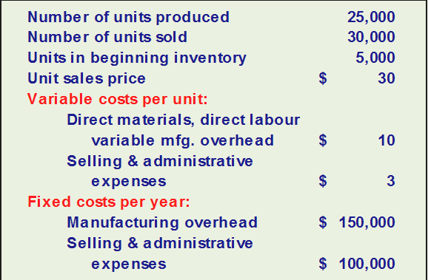

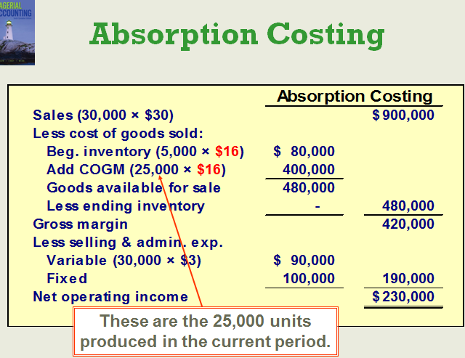

Unit Cost Computations: 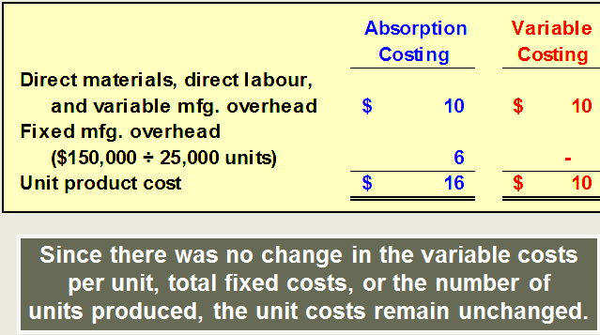

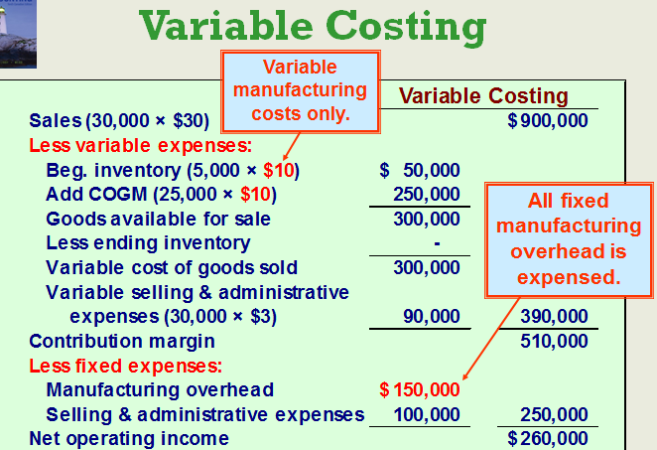

Comparing the Two Methods:
We can reconcile the difference between absorption and variable income as follows:

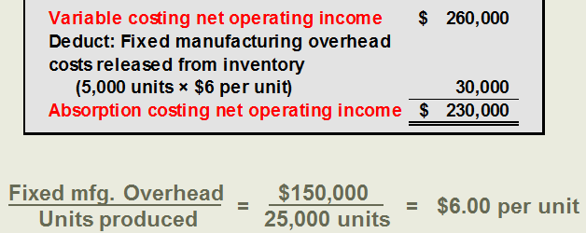
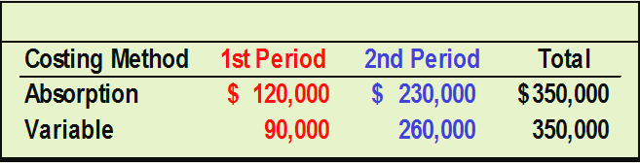

Income Effects:
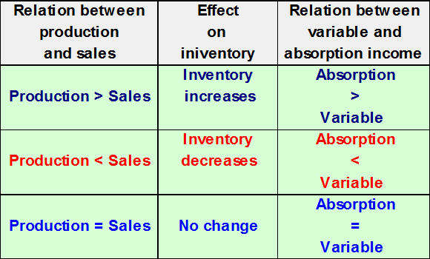

Effect of Changes in Production on Operating Income:
Let’s revise the Harvey Company Example:
- In a previous example, 25,000 units were produced each year, but sales increased from 20,000 units in year one to 30,000 units in year two.
- In this revised example, production will differ each year while sales will remain constant.
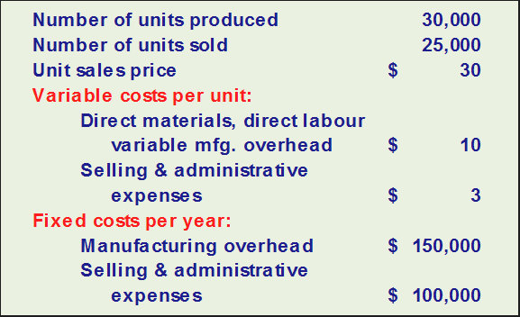
The product cost is determined as follows:
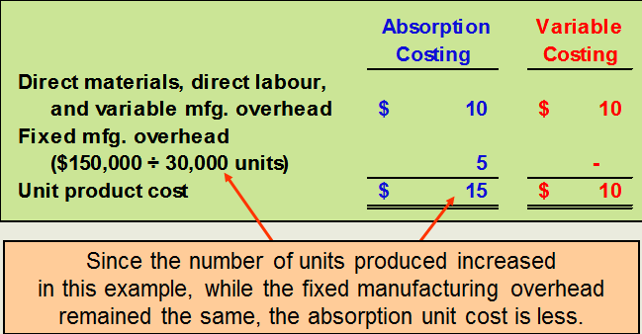

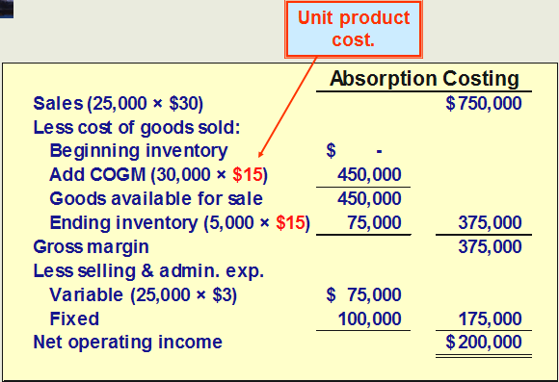
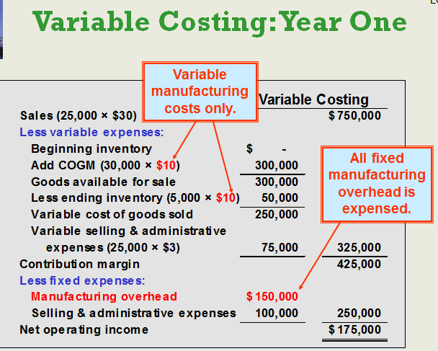
Effect of Changes in Production: Harvey Company Year Two
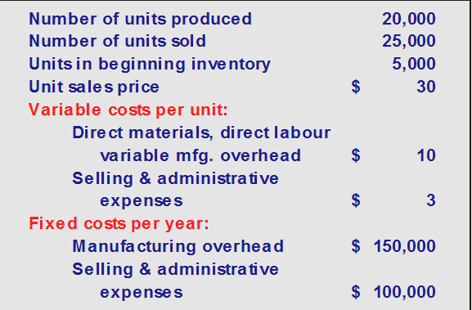
Unit product cost is determined as follows:
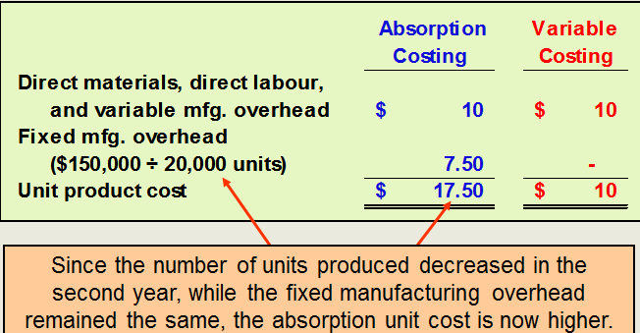

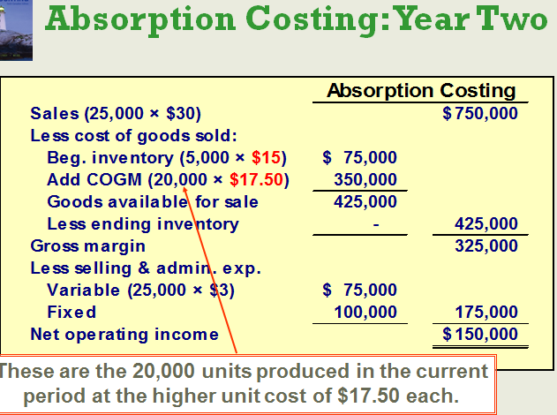
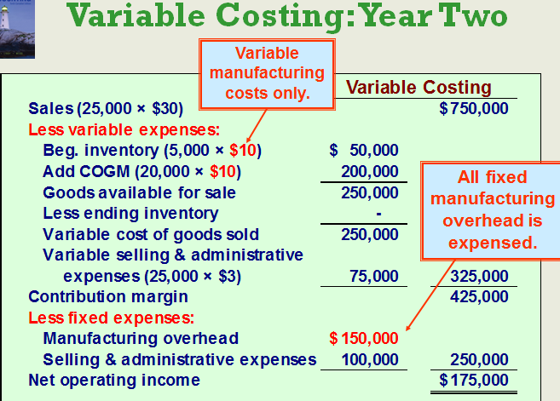

Comparing the Two Methods:
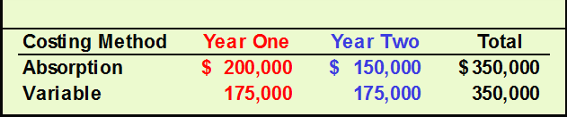

Conclusion:
Net operating income is not affected by changes in production using variable costing.
Net operating income is affected by changes in production using absorption costing even though the number of units sold is the same each year.

Explaining Changes in Operating Income
- Variable costing income is only affected by changes in unit sales. It is not affected by the number of units produced. As a general rule, when sales go up, net operating income goes up, and vice versa.
- Absorption costing income is influenced by changes in unit sales and units of production. Net operating income can be increased simply by producing more units even if those units are not sold.

Choosing A Costing Method: Impact on the Manager
- Opponents of absorption costing argue that shifting fixed manufacturing overhead costs between periods can lead to faulty decisions.
- These opponents argue that variable costing income statements are easier to understand because net operating income is only affected by changes in unit sales. This produces net operating income figures that are more consistent with managers’ expectations.

CVP Analysis, Absorption Costing and Decision Making
- Absorption costing does not support CVP analysis because it essentially treats fixed manufacturing overhead as a variable cost by assigning a per unit amount of the fixed overhead to each unit of production.
- Treating fixed manufacturing overhead as a variable cost can:
- Lead to faulty pricing decisions and keep-or-drop decisions.
  - Produce positive net operating income even when the number of units sold is less than the breakeven point.

External Reporting and Income Taxes
- Absorption costing is required for external reports in the United States and is the predominant method used in Canada. For income tax purposes in Canada, the Canada Revenue Agency permits both variable and absorption costing for determining taxable income.
- Since top executives are usually evaluated based on external reports to shareholders,
they may feel that day to day decisions should be based on absorption cost income.

Advantages of Variable Costing and the Contribution Approach
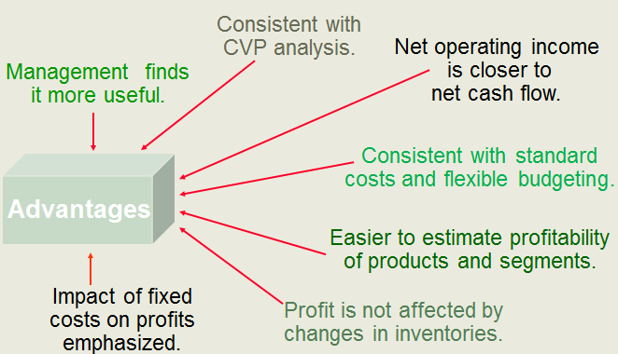

Variable versus Absorption Costing
- Absorption Costing
  - Since top executives are usually evaluated based on external reports to shareholders, they may feel that day to day decisions should be based on absorption cost income.
- Variable Costing
  - Fixed manufacturing costs are capacity costs and will be incurred even if nothing is produced.

