Chapter 5 – Job-Order Costing

Process Costing
- A company produces many units of a single product.
- One unit of product is indistinguishable from other units of product.
- The identical nature of each unit of product enables assigning the same average cost per unit.

Job Order Costing
- Many different products are produced each period.
- Products are manufactured to order.
- The unique nature of each order requires tracing or allocating costs to each job, and maintaining cost records for each job.

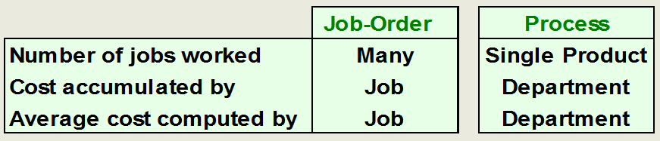
Job Order Costing – An overview
- Charge direct material and direct labour costs to each job as work is performed.
- Manufacturing overhead, including indirect materials and indirect labour, are allocated to all jobs rather than directly traced to each job.
- Job Cost Sheet:
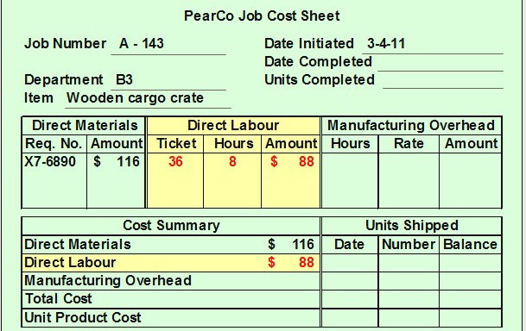
- Overhead: Why use an allocation base?
  - An allocation base, such as direct labour hours, direct labour dollars, or machine hours, is used to assign manufacturing overhead to individual jobs.
  - We use an allocation base because:
    - It is impossible or difficult to trace overhead costs to particular jobs.
    - Manufacturing overhead consists of many different items ranging from the grease used in machines to the production manager’s salary.
    - Many types of manufacturing overhead costs are fixed even though output fluctuates during the period.
    - The timing of payment of manufacturing overhead costs often varies.
  - The predetermined overhead rate (POHR) used to apply overhead to jobs is determined before the period begins.
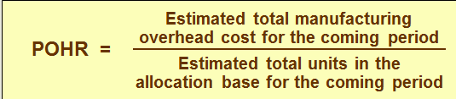
  - Using a predetermined rate makes it possible to estimate total job costs sooner.
  - Actual overhead for the period is not known until the end of the period.
  - Predetermined rate is based on estimates rather than actual result.
  - Predetermined overhead rate is computed before the period begins and used to apply overhead cost to jobs throughout the period.
  - Overhead Applied = POHR X Actual Activity

Computation of the Unit Cost
- The average unit cost should not be interpreted as the costs that would actually be incurred if an additional unit were produced.
- Fixed overhead would not change if another unit were produced, so the incremental cost of another unit may be somewhat less than $118.
- The allocation base used in the POHR should drive the overhead cost
- A cost driver is a factor that causes overhead costs—or, at least, is highly correlated with overhead costs!
- If the base used does not drive the costs then the results will be inaccurate overhead rates and distorted product costs
- A common allocation base is direct labour

Complications of Overhead Application
The difference between the overhead cost applied to Work in Process and the actual overhead costs of a period is referred to as either underapplied or overapplied overhead.
- Underapplied overhead exists when the amount of overhead applied to jobs during the period using the predetermined overhead rate is less than the total amount of overhead actually incurred during the period.
- Overapplied overhead exists when the amount of overhead applied to jobs during the period using the predetermined overhead rate is greater than the total amount of overhead actually incurred during the period.

