Chapter 3 - Cost Behaviour: Analysis and Use of Cost Behaviour Patterns

The Activity Base
Machine hours, units produced, labour hours and miles driven are all a measure of what causes incurrence of a variable cost.
True Variable Cost Example
- A variable cost is a cost whose total dollar amount varies in direct proportion to changes in the activity level. Your total long distance telephone bill is based on how many minutes you talk.
- A variable cost remains constant if expressed on a per unit basis. The cost per minute talked is constant. For example, 10 cents per minute.
- A variable cost in total will increase as the activity increases, the variable rate will remain the same..
Extent of Variable Costs
The proportion of variable costs differs across organizations. For Example:
- A public utility with large investments in equipment will tend to have fewer variable costs.
- A service company will normally have a high proportion of variable costs.
- A merchandising company will usually have a high proportion of variable costs.
- A manufacturing company will often have many variable costs.
Examples of Variable Costs
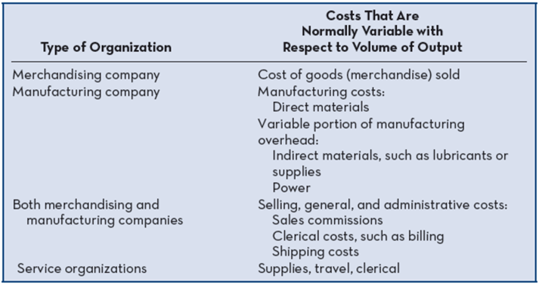
True Variable Cost
Direct materials is a true or proportionately variable cost because the amount used during a period will vary in direct proportion to the level of production activity.
Step-Variable Costs
A resource that is obtainable only in large chunks (such as maintenance workers) and whose costs increase or decrease only in response to fairly wide changes in activity is known as a step-variable cost.
- Small changes in the level of production are not likely to have an effect on the number of maintenance workers employed.
- Only fairly wide changes in the activity level will cause a change in the number of maintenance workers employed.
The Linearity Assumption and the Relevant Range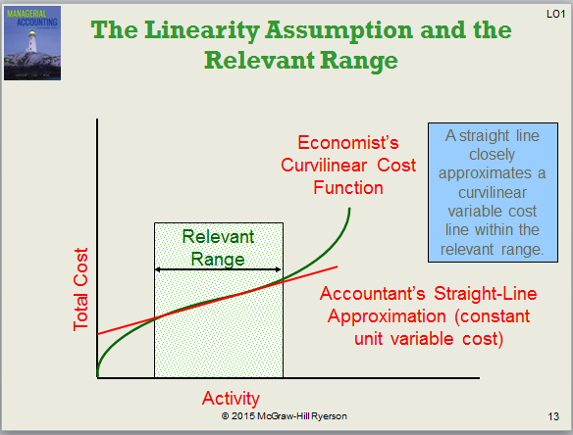
Total Fixed Cost Example
- A fixed cost is a cost whose total dollar amount remains constant as the activity level changes. Your monthly basic telephone bill is probably fixed and does not change when you make more local calls.
- Average fixed costs per unit decrease as the activity level increases. The fixed cost per local call decreases as more local calls are made.
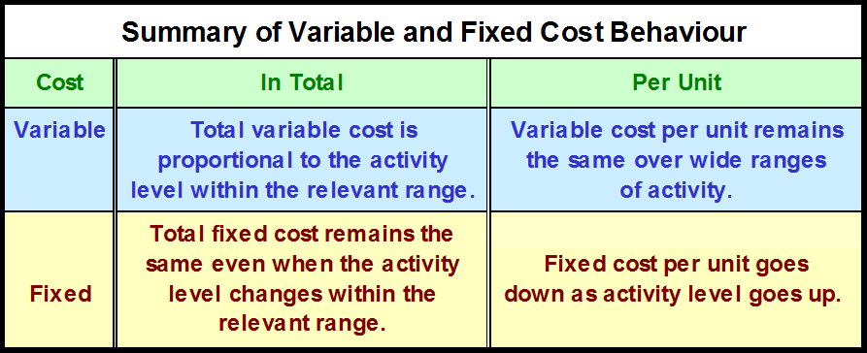
Types of Fixed Costs
- Committed: Long-term, cannot be significantly reduced in the short term.
  - Examples: depreciation on equipment and real estate taxes
- Discretionary: May be altered in the short-term by current managerial decisions
  - Examples: Advertising and research and development
The Trend Toward Fixed Costs
The trend in many industries is toward greater fixed costs relative to variable costs.
- As machines take over many mundane tasks previously performed by humans, “knowledge workers” are demanded for their minds rather than their muscles.
- Knowledge workers tend to be salaried, highly-trained and difficult to replace. The cost o compensate these valued employees is relatively fixed rather than variable.
Fixed Costs and Relevant Range

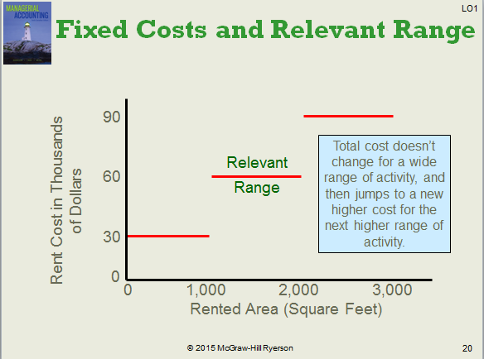
- The relevant range of activity for a fixed cost is the range of activity over which the graph of the cost is flat.
  - Example: Office space is available at a rental rate of $30,000 per year in increments of 1,000 square feet. As the business grows, more space is rented, increasing the total cost.
- How does this type of fixed cost differ from a step-variable cost?
  - Step-variable costs can be adjusted more quickly and the width of the activity steps is much wider for the fixed cost.
Mixed Costs
- A mixed cost has both fixed and variable components. Consider the example of utility cost.

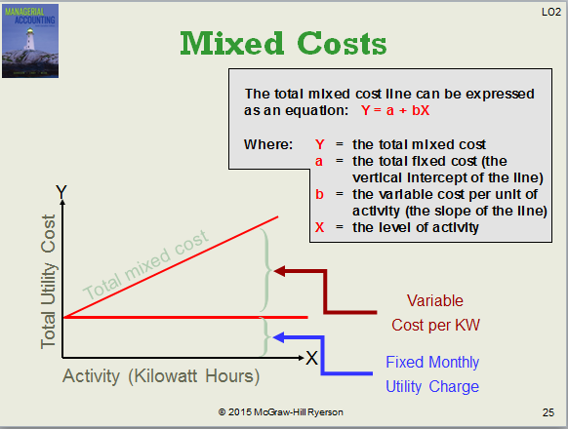
- Example: If your fixed monthly utility charge is $40, your variable cost is $0.03 per kilowatt hour, and your monthly activity level is 2,000 kilowatt hours, what is the amount of your utility bill?
  - Y= a + bX
  - Y= $40 + ($0.03x2000)
  - $100
Analysis of Mixed Costs
- Account Analysis: Each account is classified as either variable or fixed based on the analyst’s knowledge of how the account behaves.
- Engineering Approach: Cost estimates are based on an evaluation of production methods, and material, labour and overhead requirements.
The Scattergram Plot

- Plot the data points on a graph (total cost vs. activity).
- Draw a line through the data points with about an equal numbers of points above and below the line.
- Use one data point to estimate the total level of activity and the total cost.
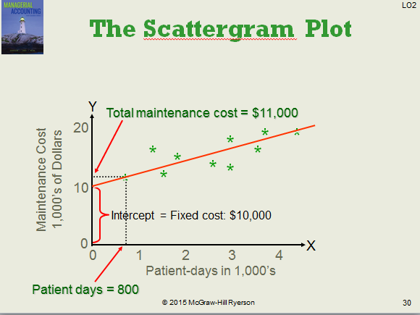
The High-Low Method
Assume the following hours of maintenance work and the total maintenance costs for six months.
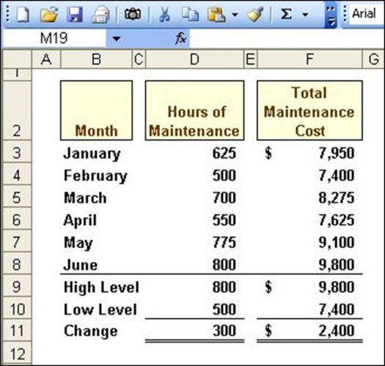
- The Variable cost per hour of maintenance is equal to the change in cost divided by the change in hours.
- $2 400/ 300 = $8/hour
- Total Fixed cost = Total Cost- Total variable cost
- Total fixed Cost = $9800 – ($8/hour x 800 Hours)
- Total Fixed Cost= $9800 -$6400
- Total Fixed Cost = $3400
- The cost Equation: Y = $3400 + $8X

Uses of the Contribution Format
Why a New Income Statement Format?
- Traditional format income statement is organized by function and fixed and variable costs are not distinguished
- Separating costs into fixed and variable elements is often crucial in making decisions
- Contribution format facilitates planning, control, and decision making
- The contribution margin format emphasizes cost behaviour. Contribution margin covers fixed costs and provides for income.
- The contribution income statement format is used as an internal planning and decision making tool. We will use this approach for:
  - Cost-volume-profit analysis (Chapter 4).
  - Budgeting (Chapter 9).
  - Segmented reporting of profit data (Chapter 11).
  - Special decisions such as pricing and make-or-buy analysis (Chapter 12).


