Chapter 12 – Relevant Costs for Decision Making

Identifying Relevant Costs
- A relevant cost is a cost that differs between alternatives.
- An avoidable cost is a cost that can be eliminated, in whole or in part, by choosing one alternative over another.
- Avoidable costs are relevant costs.
- Unavoidable costs are irrelevant costs.
- Two broad categories of costs that are never relevant in any decision are: (irrelevant costs)
  - Sunk costs.
  - Future costs that do not differ between the alternatives

Relevant Cost Analysis: A Two-Step Process
- Eliminate costs and benefits that do not differ between alternatives.
- Use the remaining costs and benefits that differ between alternatives in making the decision. The costs that remain are the differential, or avoidable, costs.

Different Costs for Different Purposes
Costs that are relevant on one decision may not be relevant on the next.

Example: Identifying Relevant Costs
Sarah, a Toronto student, is considering visiting her friend in Windsor. She can drive or take the train. By car, it is 230 kilometers to her friend’s apartment. She is trying to decide which alternative is less expensive and has gathered the following information:

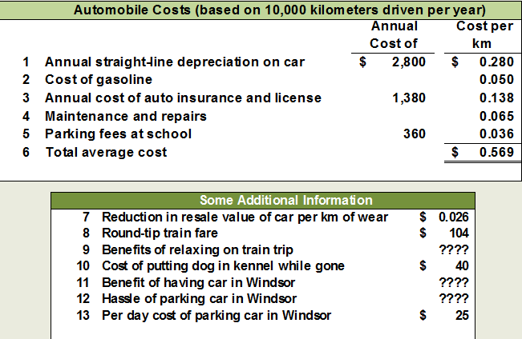
*Depreciation on car = ($18 000 - $4 000 salvage value) / 5 years
*Gasoline cost = $1.60 per gallon/ 32 MPG
*Parking fees = $45 per month * 8 months
- What costs are relevant in Sarah’s decision? (Some of the average costs of $0.569 per kilometer are relevant and others are not.)
  - The cost of the car is skunk (already been incurred and can’t be changed) and is not relevant to the current decision.
  - The annual cost is not relevant. It will remain the same if she drives or takes the train.
  - The cost of gasoline is relevant if she decides to drive. If she takes the train, the cost would not be incurred, so it varies based on the decision.
  - The cost of maintenance and repairs is relevant. In the long-run these costs depend upon miles driven.
  - The monthly school parking fee is not relevant because it must be paid if Sarah drives or takes the train.
  - The decline in resale value due to additional miles is a relevant cost.
  - The round trip train fare is clearly relevant, if she drives it can be avoided.
  - Relaxing on the train is relevant even though it is difficult to assign a dollar value to the benefit.
  - The kennel cost is not relevant because Sarah will incur the cost if she drives or takes the train.
  - The cost of parking is relevant because it can be avoided if she takes the train.
  - The benefits of having a car in Windsor and the problems of finding a parking space are both relevant but are difficult to assign a dollar amount.
  - From a financial standpoint, Sarah would be better off taking the train to visit her friend. Some of the non-financial factor may influence her final decision.
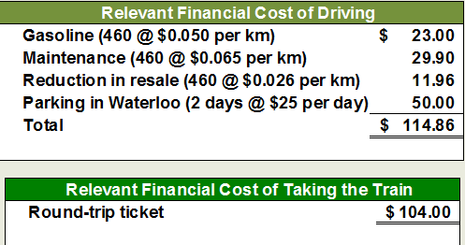
Example: Total and Differential Cost Approaches
The management of a company is considering a new labour saving machine that rents for $3,000 per year. Data about the company’s annual sales and costs with and without the new machine are:

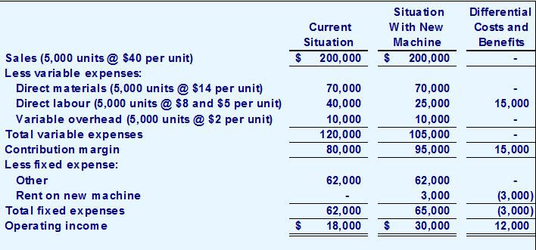
- As you can see, the only costs that differ between the alternatives are the direct labour costs savings and the increase in fixed rental costs.

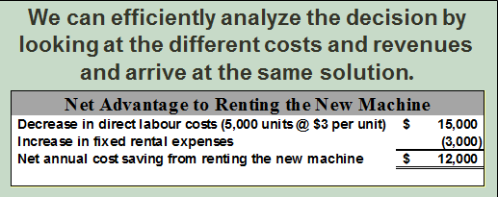
- Using the differential approach is desirable for two reasons:
- Only rarely will enough information be available to prepare detailed income statements for both alternatives.
- Mingling irrelevant costs with relevant costs may cause confusion and distract attention away from the information that is really critical.

Adding/Dropping Segments
- One of the most important decisions managers make is whether to add or drop a business segment, such as a product or a store.
- Let’s see how relevant costs should be used in this type of decision.
- Example: Due to the declining popularity of digital watches, Lovell Company’s digital watch line has not reported a profit for several years. Lovell is considering discontinuing this product line.
- A Contribution Margin Approach
- DECISION RULE: Lovell should drop the digital watch segment only if its profit would increase. This would only happen if the fixed cost savings exceed the lost contribution margin.
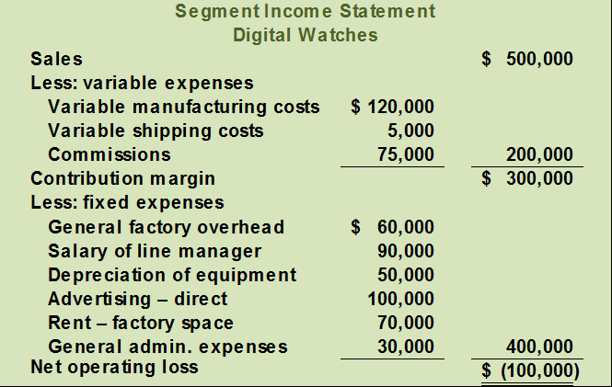

- Investigation has revealed that total fixed general factory overhead and general administrative expenses would not be affected if the digital watch line is dropped. The fixed general factory overhead and general administrative expenses assigned to this product would be reallocated to other product lines.
- The equipment used to manufacture digital watches has no resale value or alternative use.
- Should Lovell retain or drop the digital watch segment?
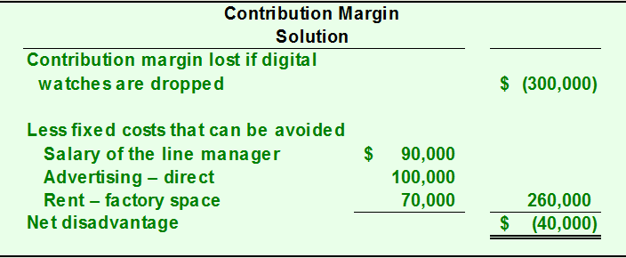
- The Lovell solution can also be obtained by preparing comparative income statements showing results with and without the digital watch segment.

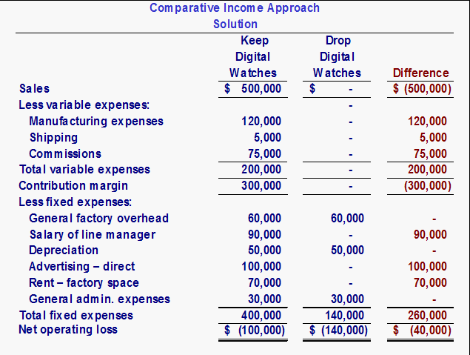
- If the digital watch line is dropped, the company gives up its contribution margin. (300 000)
- On the other hand, the general factory overhead would be the same. So this cost really isn’t relevant. (60 000)
- But we wouldn’t need a manager for the product line anymore. (60 000)
- If the digital watch line is dropped, the net book value of the equipment would be written off. The depreciation that would have been taken will flow through the income statement as a loss instead. (50 000)

- Beware of Allocated Fixed Costs
- Why should we keep the digital watch segment when it’s showing a $100,000 loss?
- The answer lies in the way we allocate common fixed costs to our products.
- Our allocations can make a segment look less profitable than it really is.

The Make or Buy Decision
- When a company is involved in more than one activity in the entire value chain, it is vertically integrated. A decision to carry out one of the activities in the value chain internally, rather than to buy externally from a supplier is called a “make or buy” decision.

- Advantages
  - Smoother flow of parts and materials
  - Better quality control
  - Realize Profits

- Disadvantages
  - Companies may fail to take advantage of suppliers who can create economies of scale advantage by pooling demand from numerous companies.

- Example: Essex Company manufactures part 4A that is used in one of its products.
  - The unit product cost of this part is:
Direct Materials $9
Direct Labour 5
Variable Overhead 1
Dep. Of special equipment 3
Supervisors Salary 2
General Factory Overhead 10
Unit Product Cost $30
- The special equipment used to manufacture part 4A has no resale value.
- The total amount of general factory overhead, which is allocated on the basis of direct labour hours, would be unaffected by this decision.
- The $30 unit product cost is based on 20,000 parts produced each year.
- An outside supplier has offered to provide the 20,000 parts at a cost of $25 per part.
Should we accept the supplier’s offer?

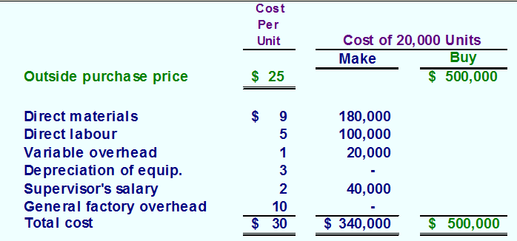
- The special equipment has no resale value and is a sunk cost.
- Not avoidable; irrelevant. If the product is dropped, it will be reallocated to other products.

Opportunity Cost
- An opportunity cost is the benefit that is foregone as a result of pursuing some course of action.
- Opportunity costs are not actual dollar outlays and are not recorded in the formal accounts of an organization.

Special Orders
- A special order is a one-time order that is not considered part of the company’s normal ongoing business.
- When analyzing a special order, only the incremental costs and benefits are relevant.
- Example: Jet, Inc. makes a single product whose normal selling price is $20 per unit.
  - A foreign distributor offers to purchase 3,000 units for $10 per unit.
  - This is a one-time order that would not affect the company’s regular business.
  - Annual capacity is 10,000 units, but Jet, Inc. is currently producing and selling only 5,000 units.

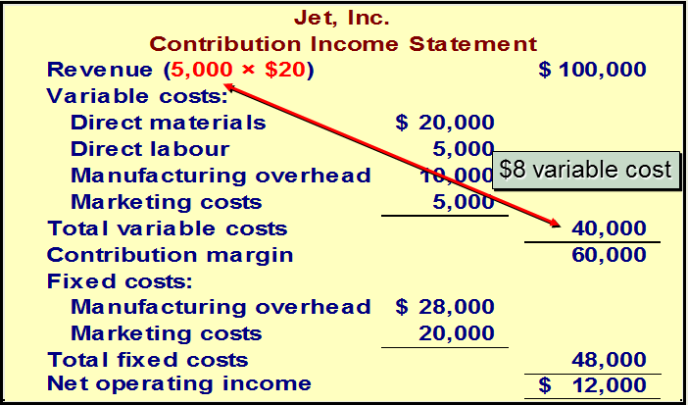

If Jet accepts the special order, the incremental revenue will exceed the incremental costs. In other words, net operating income will increase by $6,000. This suggests that Jet should accept the order. (This answer assumes that the fixed costs are unavoidable and that variable marketing costs must be incurred on the special order.)
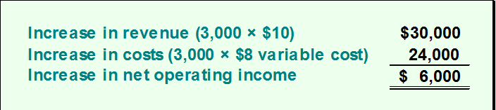
Joint Costs
- In some industries, a number of end products are produced from a single raw material input.
- Two or more products produced from a common input are called joint products.
- The point in the manufacturing process where each joint product can be recognized as a separate product is called the split-off point.

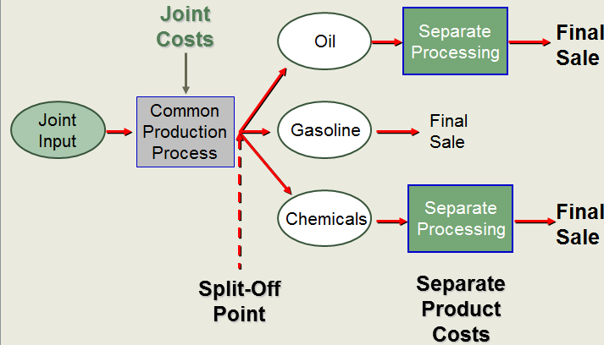
The Pitfalls of Allocation
- Joint costs are often allocated to end products on the basis of the relative sales value of each product or on some other basis.
- Although allocation is needed for some purposes such as balance sheet inventory valuation, allocations of this kind are very dangerous for decision making.

Sell or Process Further
- Joint costs are irrelevant in decisions regarding what to do with a product from the split-off point forward.
- It will always be profitable to continue processing a joint product after the split-off point so long as the incremental revenue exceeds the incremental processing costs incurred after the split-off point.
- Example: Sawmill, Inc. cuts logs from which unfinished lumber and sawdust are the immediate joint products.
- Unfinished lumber is sold “as is” or processed further into finished lumber.
- Sawdust can also be sold “as is” to gardening wholesalers or processed further into “presto-logs.”

- Data about Sawmill’s joint products includes:

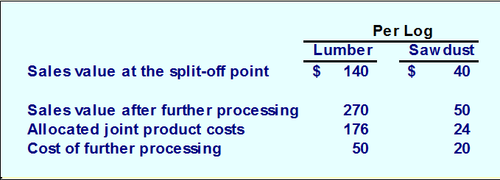
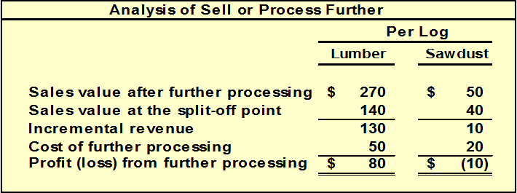
Utilization of a Constrained Resource
- When a limited resource of some type restricts the company’s ability to satisfy demand, the company is said to have a constraint.
- The machine or process that is limiting overall output is called the bottleneck – it is the constraint.
- Contribution Margin in Relation to a Constrained Resource
- When a constraint exists, a company should select a product mix that maximizes the total contribution margin earned since fixed costs usually remain unchanged.
- A company should not necessarily promote those products that have the highest unit contribution margin.
- Rather, it should promote those products that earn the highest contribution margin in relation to the constraining resource.
- Example: Ensign Company produces two products and selected data are shown below:

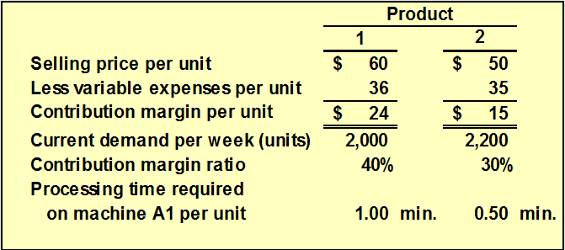

- Machine A1 is the constrained resource and is being used at 100% of its capacity.
- There is excess capacity on all other machines.
- Machine A1 has a capacity of 2,400 minutes per week.
- Should Ensign focus its efforts on Product 1 or Product 2?

- The key is the contribution margin per unit of the constrained resource.
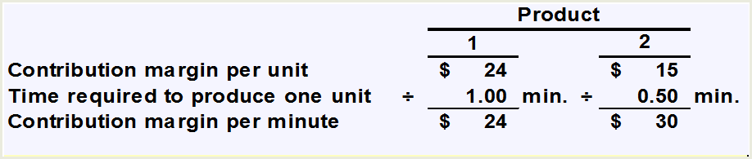

- Product 2 should be emphasized. Provides more valuable use of the constrained resource machine A1, yielding a contribution margin of $30 per minute as opposed to $24 for Product 1.

- If there are no other considerations, the best plan would be to produce to meet current demand for Product 2 and then use remaining capacity to make Product 1.

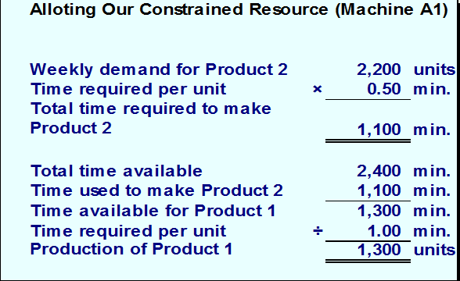
According to the plan, we will produce 2,200 units of Product 2 and 1,300 of Product 1. Our contribution margin looks like this.
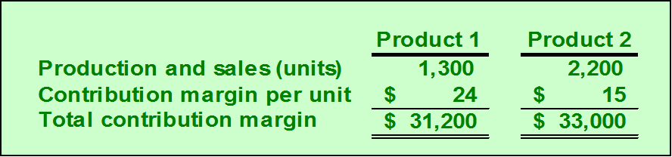

The total contribution margin is $64,200.

