Chapter 4 – Cost-Volume Profit Relationships

Cost-Volume-Profit Relationship Interactions
Cost-volume-profit (CVP) analysis is a powerful tool that managers use to help them understand the interrelationship among cost, volume and profit in an organization by focusing on interactions among the following five elements:
- Prices of products
- Volume or level of activity
- Per unit variable costs
- Total fixed costs
- Mix of Products sold

Basics of Cost-Volume-Profit Analysis
- The contribution income statement is helpful to managers in judging the impact on profits of changes in selling price, cost, or volume. The emphasis is on cost behaviour.
- Contribution Margin (CM) is the amount remaining from sales revenue after variable expenses have been deducted.
- Sales, variable expenses, and contribution margin can also be expressed on a per unit basis.
- The CM ratio is calculated by dividing the total contribution margin by total sales.
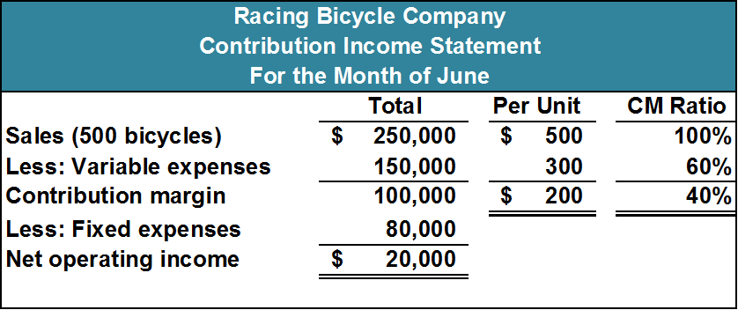

The Contribution Approach
- Each month, Racing must generate at least $80,000 in total CM to break even. (To break even, the contribution margin must cover the fixed costs.)
- If Racing sells 400 units in a month, it will be operating at the break-even point.
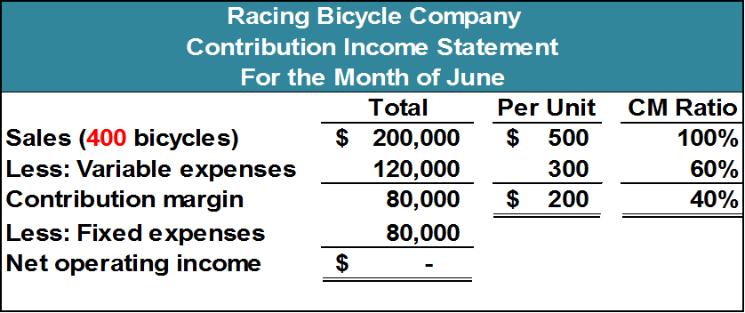
- If Racing sells one more bike (401 bikes), net operating income will increase by $200.
- We do not need to prepare an income statement to estimate profits at a particular sales volume. Simply multiply the number of units sold above break-even by the contribution margin per unit.
- If Racing sells 430 bikes, its net operating income will be $6,000
- 30 bikes above break-even: 30 x 200 = $6,000

CVP Relationships in Graphic Form
The relationship among revenue, cost, profit and volume can be expressed graphically by preparing a CVP graph. Racing developed contribution margin income statements at 300, 400, and 500 units sold. We will use this information to prepare the CVP graph.

- In a CVP graph, unit volume is usually represented on the horizontal (X) axis and dollars on the vertical (Y) axis.
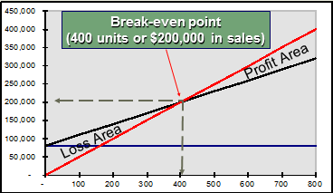

Key Formulas

- CM Ratio= Total CM/Total Slaes
- PER UNIT CM Ratio = Unit CM/Unit Selling Price
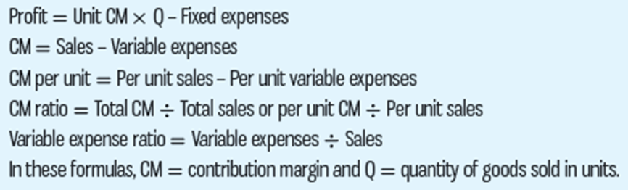
Variable Expense Ratio
Variable expense ratio is the ratio of variable expenses to sales
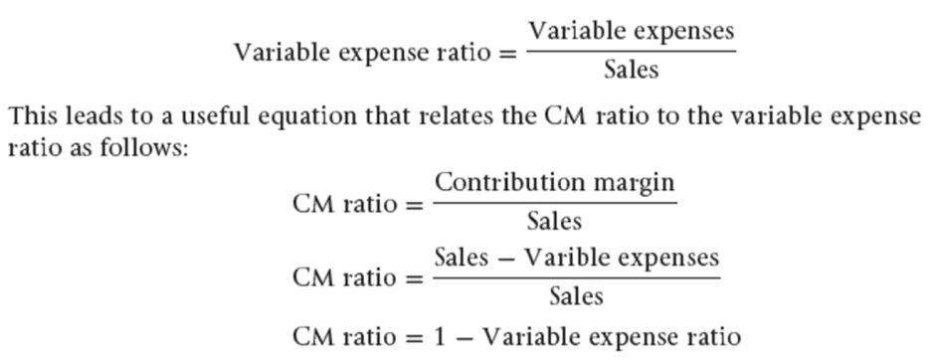

Break-Even Analysis
Break-even analysis can be approached in two ways:
- Equation method
- Profits = (Sales – Variable expenses) – Fixed expenses
- Sales = Variable expenses + Fixed expenses + Profits (At the break-even point profits equal 0)
- Rearrange equation and solve for the unknown or Q (whatever variable costs must be multiplied by in order to reach the breakeven point)
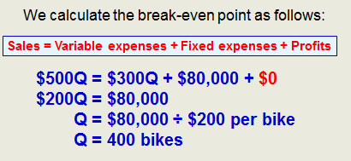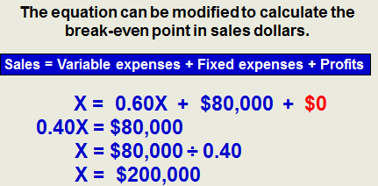

- Formula method
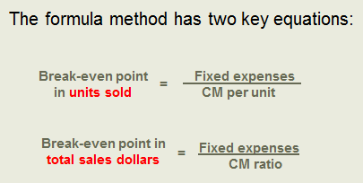

Target Profit Analysis
- The equation and formula methods can be used to determine the sales volume needed to achieve a target profit.
- Suppose Racing Bicycle Company wants to know how many bikes must be sold to earn a profit of $100,000.

- The CVP Equation Method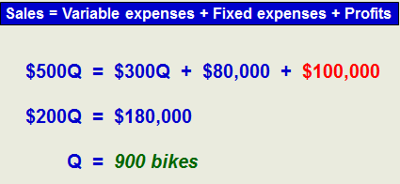
- The Formula Approach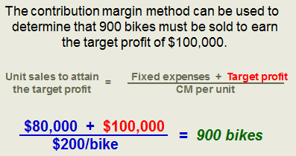

The Margin of Safety
The margin of safety is the excess of budgeted (or actual) sales over the break-even volume of sales.
- Margin of safety = Total sales – Break-even sales
- Let’s look at racing company and determine the margin of safety.
- If we assume that Racing Bicycle Company has actual sales of $250,000, given that we have already determined the break-even sales to be $200,000, the margin of safety is $50,000
- The Margin of Safety can be expressed as 20% of sales. ($50,000 ÷ $250,000)
- The margin of safety can be expressed in terms of the number of units sold. The margin of safety at Racing is $50,000, and each bike sells for $500.
  - Margin of safety in units = $50,000/$500 = 100 bikes

Cost Structure and Profit Stability
- Cost structure refers to the relative proportion of fixed and variable costs in an organization. Managers often have some latitude in determining their organization’s cost structure.
- There are advantages and disadvantages to high fixed cost (or low variable cost) and low fixed cost (or high variable cost) structures.
  - An advantage of a high fixed cost structure is that income will be higher in good years compared to companies with lower proportion of fixed costs.
  - A disadvantage of a high fixed cost structure is that income will be lower in bad years compared to companies with lower proportion of fixed costs.
- Companies with low fixed cost structures enjoy greater stability in income across good and bad years.

Operating Leverage
- A measure of how sensitive net operating income is to percentage changes in sales.
- Degree of Operating Leverage = Contribution margin / Net operating income
- Percent Increase In Profits = Percent increase in sales X degree of operating leverage
Indifference Analysis
- CVP analysis is also useful for aiding decisions about the comparative profitability of alternative products or methods of production. The analysis focuses on cost behaviour in relation to changes in activity level.
- The objective is to find the level of unit sales at which we are indifferent between the two options.
- As a result, we base our decision on expected sales levels.
- At what level of unit sales would we be indifferent between the two alternatives?
- Determine the unit contribution margin (CM) times the number of units (Q) plus total fixed costs of each alternative.
- Setup an equation with each alternative on opposite sides of the equal sign.
- Solve for Q, the indifference point.

The Concept of Sales Mix
- Sales mix is the relative proportion in which a company’s products are sold.
- Different products have different selling prices, cost structures, and contribution margins.
Assumptions of CVP Analysis
- Selling price is constant.
- Costs are linear and can be accurately divided into variable (constant per unit) and fixed (constant in total) elements.
- In multiproduct companies, the sales mix is constant.
- In manufacturing companies, inventories do not change (units produced = units sold).

