Chapter 2: Cost terms, Concepts and Classifications

Classifications of Manufacturing Costs
- Direct Materials
  - Raw materials that become an integral part of the product and that can be conveniently traced directly to it.
  - Ex. A radio installed in an automobile
- Direct Labour
  - Those labour costs that can be easily traced to individual units of product.
  - Ex. Wages paid to the assembly team
- Manufacturing Overhead
  - Manufacturing costs that cannot be easily traced directly to specific units produced.
  - Ex. Wages paid to employees not directly involved in production work (maintenance, janitors, and security guards) and materials used to support the production process (lubricants, and cleaning supplies used in the plant)
Manufacturing costs are often classified as follows:
- Prime Cost
  - Direct materials and direct labour
- Conversion Cost
  - Direct labour and manufacturing overhead
- Overtime Premiums: all factory workers are usually considered to be part of manufacturing overhead. Product specific overtime premiums are part of direct labour.
Non-Manufacturing Costs can be classified as follows:
- Marketing or selling cost
  - Costs necessary to get the order and deliver the product
- Administrative cost
  - All executive, organizational and clerical costs
Product Costs versus Period Costs
- Product costs
  - Direct materials, direct labour, and manufacturing overhead.
  - Inventory items become cost of goods sold items after the sale .
  - Inventory account is places on the balance sheet, whereas the COGS (cost of goods sold) is placed on the income statement.
- Period costs
  - All selling costs and administrative costs.
  - All period costs are expenses, therefor they go on the income statement.
Comparing Merchandising and Manufacturing Activities

- Merchandisers
- Buy finished goods.
- Sell finished goods.
- Manufacturers
- Buy raw materials.
- Produce and sell finished goods.

Items on the Balance Sheet

- Merchandiser
- Current assets
  - Cash
  - Receivables
  - Prepaid Expenses
  - Merchandise Inventory
- Manufacturer
- Current Assets
- Cash
- Receivables
- Prepaid Expenses
- Inventories
    - Raw Materials (Materials waiting to be processed)
    - Work in Process (partially completed products – some material, labour and overhead may be added)
    - Finished Goods (complete products awaiting sale)

Items on The Income Statement
Cost of goods sold for manufacturers differs only slightly from cost of goods sold for merchandisers.
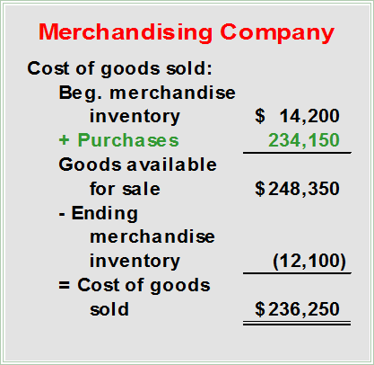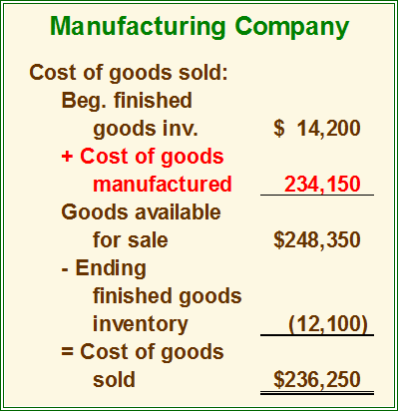
Basic Equation for Inventory Accounts
Beginning Balance + Additions to Inventory = Ending Balance + Withdrawn from Inventory
Schedule of Cost of Goods Manufactured
- Calculates the cost of raw material, direct labour and manufacturing overhead used in production.
- Calculates the manufacturing costs associated with goods that were finished during the period.
Product Cost Flows
- As items are removed from raw materials inventory and are placed into the production process, they are called direct materials.
- Conversion costs are costs incurred to convert the direct material into a finished product.
- All manufacturing costs incurred during the period are added to the beginning balance of work in process.
- Costs associated with the goods that are completed during the period are transferred to finished goods inventory.
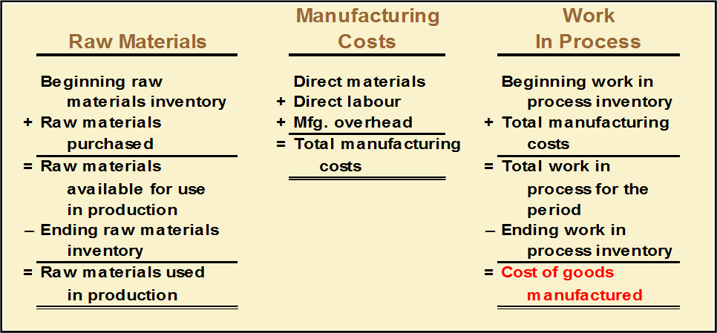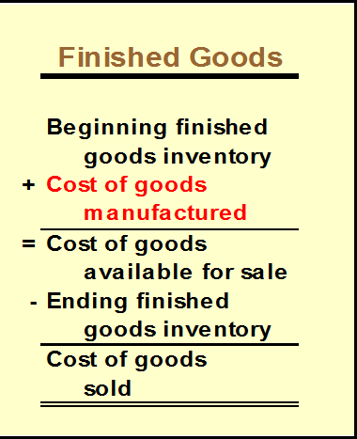

Manufacturing Cost Flows
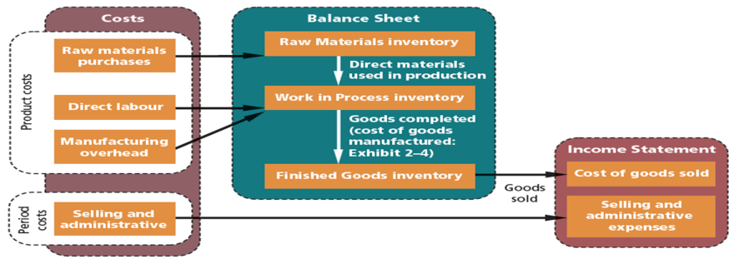
An Example of Manufacturing Cost Flows
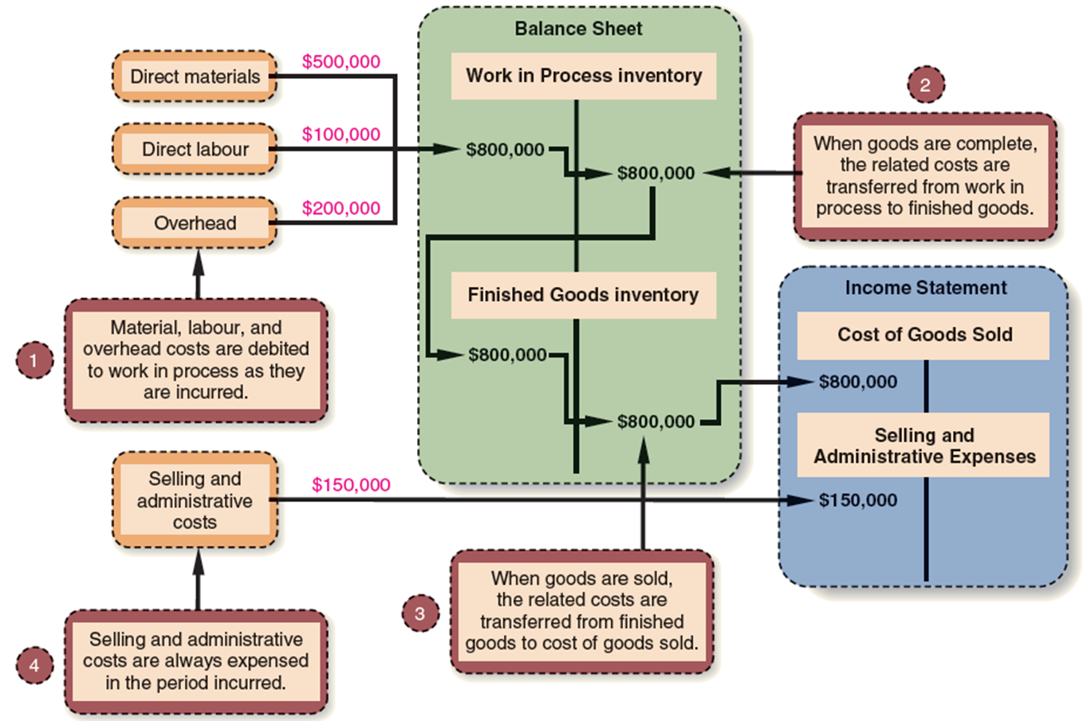
Summary of Cost Classifications
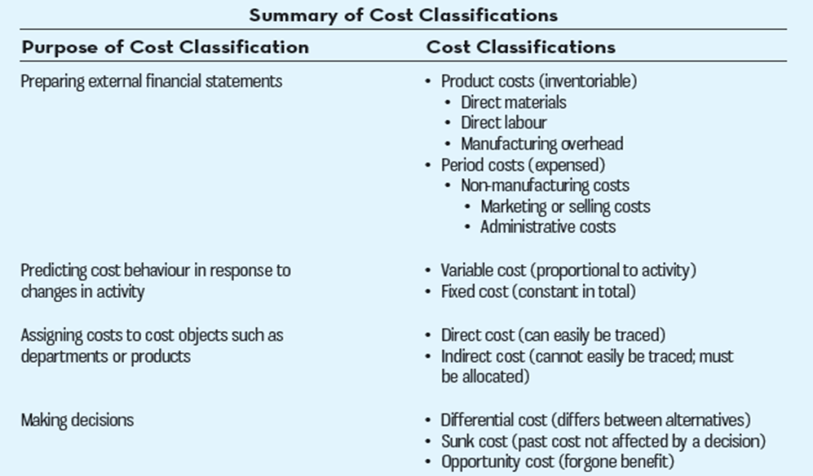
Cost Classifications for Predicting Cost Behaviour
How a cost will react to changes in the level of activity within the relevant range.
- Total variable costs change when activity changes.
- Total fixed costs remain unchanged when activity changes.
Variable Cost
Your total texting bill is based on how many texts you send.
- Variable Cost Per Unit
- The cost per text sent is constant at 5 cents per text message.
The Activity Base (Cost Driver)
A measure of what causes the incurrence of a variable cost

- Units produced
- Machine hours
- Labour hours
- Miles driven

Fixed Cost
Your monthly contract fee for your cell phone is fixed for the number of monthly minutes in your contract. The monthly contract fee does not change based on the number of calls you make.
- Fixed Cost Per Unit
- Within the monthly contract allotment, the average fixed cost per cell phone call made decreases as more calls are made.
Relevant Range
The relevant range is the range of activity within which the assumptions about variable and fixed cost behaviors are valid.
Cost Classifications for Predicting Cost Behaviour
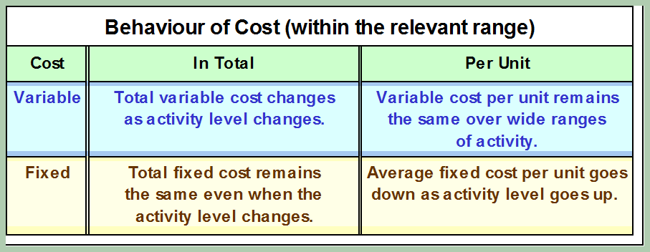
Assigning Costs to Cost Objects
- Direct costs
- Costs that can be easily and conveniently traced to a unit of product or other cost object.
- Examples: direct material and direct labour
- Indirect costs
- Costs that cannot be easily and conveniently traced to a unit of product or other cost object.
- Example: manufacturing overhead
Cost Classifications for Decision Making
- Every decision involves a choice between at least two alternatives.
- Only those costs and benefits that differ between alternatives are relevant in a decision. All other costs and benefits can and should be ignored.
Differential Cost and Revenue
Costs and revenues that differ among alternatives
- Example: You have a job paying $1,500 per month in your hometown. You have a job offer in a neighbouring city that pays $2,000 per month. The commuting cost to the city is $300 per month.
- Differential Revenue is: $2000 - $1500 = $500
- Deferential Cost is: $300
Opportunity Cost
The potential benefit that is given up when one alternative is selected over another.
- Example: If you were not attending college, you could be earning $15,000 per year. Your opportunity cost of attending college for one year is $15,000.
Sunk Costs
Sunk costs have already been incurred and cannot be changed now or in the future. They should be
ignored when making decisions.
- Example: You bought an automobile that cost $10,000 two years ago. The $10,000 cost is sunk because whether you drive it, park it, trade it, or sell it, you cannot change the $10,000 cost.

