Gross anatomy
- External anatomy
  - Mons pubis
    - Fatty layer overlying pubic symphysis
  - Perineum
    - Vaginal and anal area
    - 4 corners are: symphysis, coccyx and 2 ischial tuberosities
  - Labia majora and minora
  - Clitoral hood and clitoris
  - Vestibule
  - Urethral opening
  - 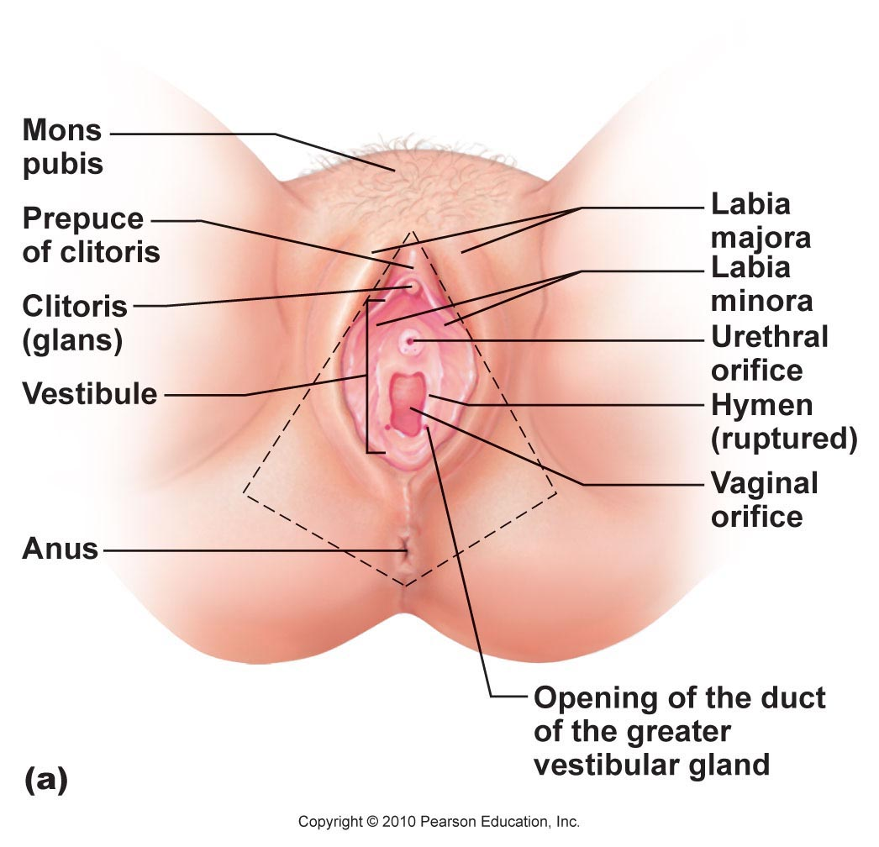
- Internal anatomy
  - Superficial
    - Crus of clitoris
    - Vestibular bulb
    - Body of clitoris
    - Greater vestibular gland
    - Pelvic floor
    - SEE SLIDE 10 FOR DIAGRAM
  - Deep
    - Vagina
    - Cervix
    - Uterus
    - Uterine tubes
    - Ovaries
    - Suspensory ligaments blood and nerve supply

- Ovaries
  - Flank uterus on each side
  - Held in place by ligaments in the fork of the iliac blood vessels in the peritoneal cavity
  - Blood served by ovarian arteries from abdominal aorta
  - Surrounded by a fibrous tunica albuginea and that is covered by germ epithelium
  - Contain ovarian follicles that consist of immature eggs surrounded by cells (follicle cells if one layer present, granulosa cells is more than one present)
  - Contain many classes of follicles
    - Primary
      - Single layer of cells around oocyte
    - Secondary
      - 2 or more layers of cells
    - Late secondary
      - Fluid filled spaces between granulosa cell
    - Tertiary
      - When fluid filled cavities coalesce to form an fluid filled sac called antrum
  - 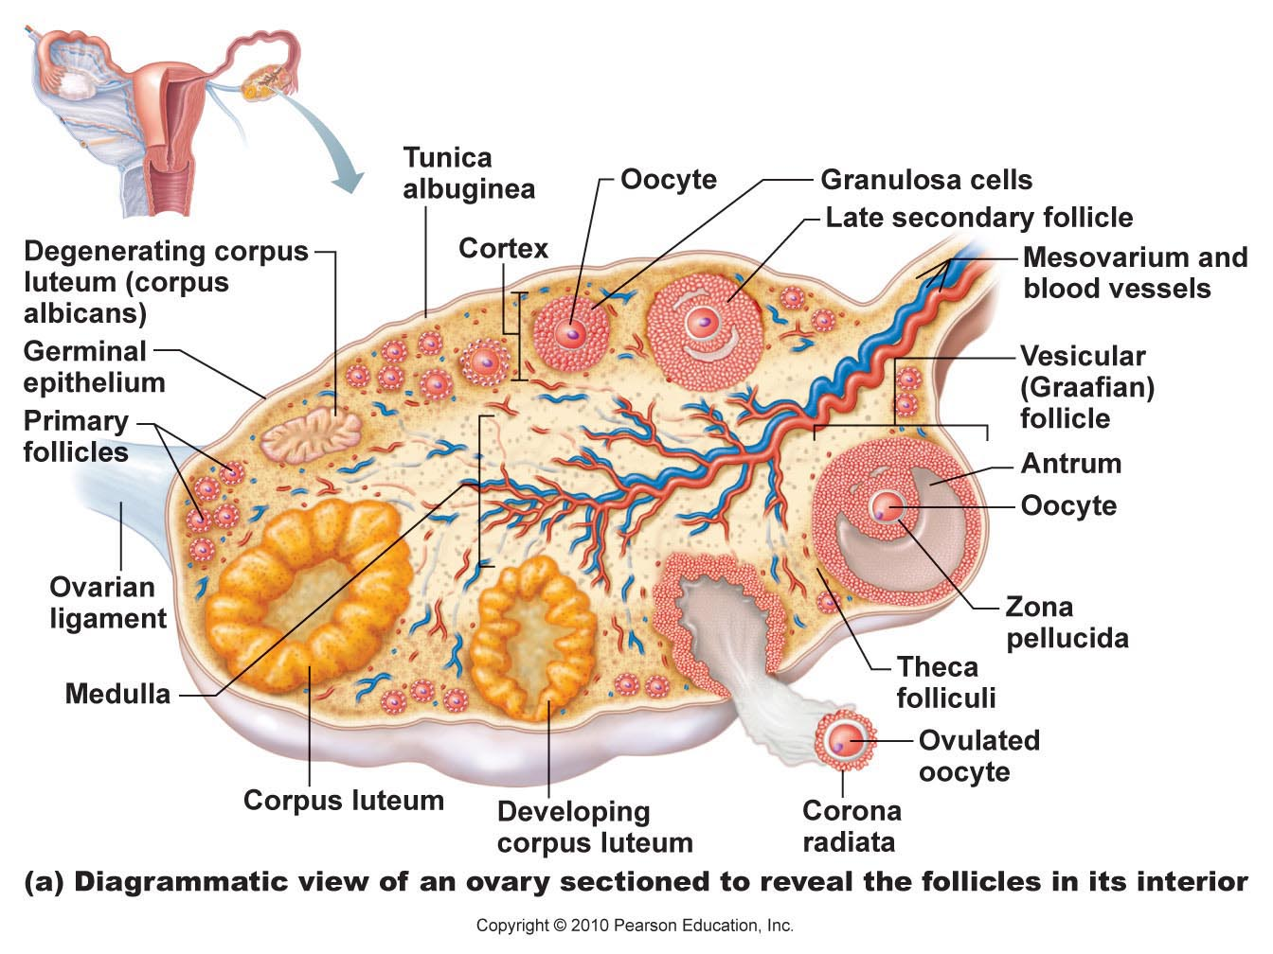
  - After the egg has been ejected, a yellow body called a corpus luteum is formed which eventually degenerates
- Ducts
  - Fallopian tubes
    - Initial part of the female duct system
    - Site of fertilization
    - ~10 cm long and extends into upper portion of uterus via a constricted region called an isthmus
    - Tube expands wider when area is closer to ovaries, called ampulla (site of fertilization, specifically)
    - Part of the tube closest to ovaries is called infundibulum and has finger-like cilia called fimbriae that drape over ovaries
      - Stiffen and sweep during ovulation to propel oocyte into the tube
    - Has smooth muscle and ciliated or non-ciliated portions
      - Peristalsis and cilia sweeping push the egg forward
- Uterus
  - Hollow, thick walled, muscular organ
  - Receives, retains and nourishes a fertilized ovum
  - Smaller in women who have never been pregnant (size of a pear)
  - Fundus is the top rounded region
  - Isthmus is the narrow lower region
  - Cervix is a narrow neck that projects into the uterus
    - Has an internal and external os (os=mouth)
  - Cervical glands secrete mucus that fills cervical canal and external os
    - Could possibly be used to keep out infection and block sperm
      - Becomes less viscous during mid cycle
  - Uterine wall is composed of 3 layers
    - Perimetrium
      - Outermost layer
    - Myometrium
      - Center layer
      - Contains smooth muscle that contract during child birth
    - Endometrium
      - Innermost layer
      - Has an outer stratus functionalis that is shed every 28 days
      - Inner stratus basalis
        - Forms new functionalis
  - Blood supply comes from uterine arteries that branch into the uterine wall
    - Branches form arcuate arteries in myometrium
    - Branch off again to form radial branches
- Vagina
  - Thin walled tube about 4 inches long
  - Urethra is embedded in anterior wall
  - Vagina wall has 3 layers
    - Fibroelastic adventitia
    - Smooth muscle muscularis
    - Inner mucosa marked by transverse ridges called rugae
- Oogenesis
  - Begins before birth
  - Oogonia multiply via mitosis and are set aside in nutrient reserves
  - Primordial follicles then begin to appear and transform oogonia into primary oocytes
  - Primary oocytes then begin meiosis but become arrested in prophase I
  - Remain in state of suspended animation until puberty
  - At beginning of cycle, several primary oocytes are activated by LH surge
  - One is selected to continue meiosis I
    - Oocyte divides to form a small first polar body and a large secondary oocyte
    - First polar body divides to form more polar bodies which then degenerate
    - Secondary oocyte remains locked in metaphase II until it is penetrated by a sperm
    - Upon penetration the secondary oocyte completes meiosis II to form the ovum and a second polar body
- Ovarian Cycle
  - Occurs on a 28 day cycle
  - 3 stages
    - Follicular phase
      - Day 1-14 of the cycle
      - Occurs in steps
        - 1. Primordial follicles become cuboidal cells and turn into a primary follicle
        - 2. Follicular cells proliferate around oocyte forming multiple layers, called secondary follicular cells
        - 3. Secondary follicular cells are called granulosa cells
        - 4. Thin layer of connective tissue, called theca folliculi, form around granulosa cells, produce estrogens. Oocyte secretes glycoprotein substance that forms a thick membrane around it, called the zona pellucida
        - 5. Fluid between granulosa coalesce to form antrum. Continues to fill until oocyte is isolated. Forms corona radiata
        - 6. Oocyte completes meiosis I to form secondary oocyte.
    - Ovulation
      - Occurs when ovary wall ruptures to release secondary oocyte. Oocyte is still surrounded by corona radiata
    - Luteal Phase
      - Ruptured follicle collapses and fills with clotted blood
      - Remaining granulosa cells and thecal cells increase in size to form the corpus luteum that secretes progesterone and some estrogens
      - If pregnancy does not occur, hormone secretion ceases and corpus luteum degenerates into a scar
      - If pregnancy does occur, corpus luteum continues to produce hormones until placenta can take over.
- HPG Axis
  - Induced by Gonadotropin-releasing Hormone (GnRH) produced in the hypothalamus
    - GnRH release can be influenced by leptin
  - Early in life, estrogens inhibit GnRH until puberty when hypothalamus becomes less sensitive (provided adequate leptin levels) and releases GnRH that stimulated anterior pituitary to release FSH and LH in a pulse-like fashion which then act on the ovaries
  - Woman will eventually enter menarche (first menstrual period)
  - Hormone interaction during ovarian cycle
    - 1. GnRH stimulates AP To release FSH and LH
    - 2. FSH acts on granulosa cell and LH on thecal cells, follicles grow and secrete estrogens
    - 3. When enough estrogens are in the blood, negative feedback occurs to hypothalamus. Estrogens also enhance effect of remaining FSH on follicle cells
    - 4. Small rises in estrogen inhibits axis in small concentrations, creates positive feedback in high concentrations
    - 5. Positive feedback creates a LH surge form AP
    - 6. Ovulation occurs
    - 7. LH stimulates corpus luteum to form which releases progesterone and estrogens
    - 8. Progesterone and estrogens cause negative feedback loop.
  - Menstrual Cycle
    - 3 phases
      - Menstrual
        - Shedding of functional layer of endometrium
      - Proliferative
        - Rebuilding of endometrium
      - Secretory
        - Begins immediately after ovulation
    - Enrichment of endometrium with blood vessels and glandular secretions prepared wall to receive and embryo
    - First 2 phases occur before ovulation, correspond to follicular phase of cycle
    - Secretory phase corresponds to luteal phase
  - Estrogens
    - Promote oogenesis and follicle growth
    - Anabolic effects on rep. tract
    - Supports growth spurt at puberty
    - Induction of secondary sex characteristics
    - Metabolic effects
      - Maintains low blood cholesterol and high HDL levels
      - Facilitates calcium uptake
  - Progesterone
    - Helps establish and maintain menstrual cycle
    - Effects of placental progesterone during pregnancy
      - Inhibits uterine motility
      - Prepares breasts for lactation
- Female sexual response
  - When a woman is turned on, her clitoris, vaginal mucosa and breasts engorge with blood
  - Gland secretions lubricate the vestibule
  - During a female orgasm, no ejaculation occurs
    - Muscle tension, increased blood pressure and pulse, rhythmic contractions of the uterus accompanied by extreme pleasure
- Menopause
  - When threshold amount of eggs and hormones are present in a cycle
  - Reserve decreases rapidly after mid 30s
  - Premature ovarian failure is when menopause occurs before 40 years.
- STIs
  - Chlamydia
    - Most common
    - Bacterial therefore easy to diagnose and cure
    - Symptoms include clear discharge, pain and fever
  - Gonorrhea
    - Bacterial, easy to diagnose
    - 50% of males and females are asymptomatic
    - Symptoms include yellowy discharge and pain
  - Syphillis
    - Bacterial and curable
    - 3 stages
      - 1. Within 10-90 days, painless ulcers form and is contagious
      - 2. Within 4-10 weeks, infection is most contagious, symptoms present
      - 3. >1 year, no symptoms, not very infectious, infection deep in system and affects internal organs
  - Herpes
    - Most common sti
    - Viral, no curable but treatable
      - Decrease symptoms and transmission
    - Sores on genitals and mouth, spreads through contact
    - HSV1 =/= HSV2

