Male Reproductive system
- Gross anatomy
  - External
    - Scrotum
      - Hangs outside of body below the penis
        - Sperm cannot be produced in abundance at 37 C
        - Must be cooler than core temp
      - Pulled in towards the body when its cold
        - Wrinkles for low surface area and lower heat loss
      - Hangs away when its hot
        - Increased surface area for heat dissipation
      - Dartos muscle is used for temp regulation
      - Cremaster is used for movement towards/away from body
    - Testes
      - Has an outer layer called tunica vaginalis
      - Deep inner layer called tunica albuginea
        - Divides testes into 250 wedge shaped lobules
          - Each lobule contains 4 seminiferous tubules, sperm factories
        - Seminiferous tubule converges with the tubulus rectus, then to the rete testis to the efferent ductile to the head of the epididymis, to the body of the epididymus, to the tail of the epididymus and finally to the vas deferens
- 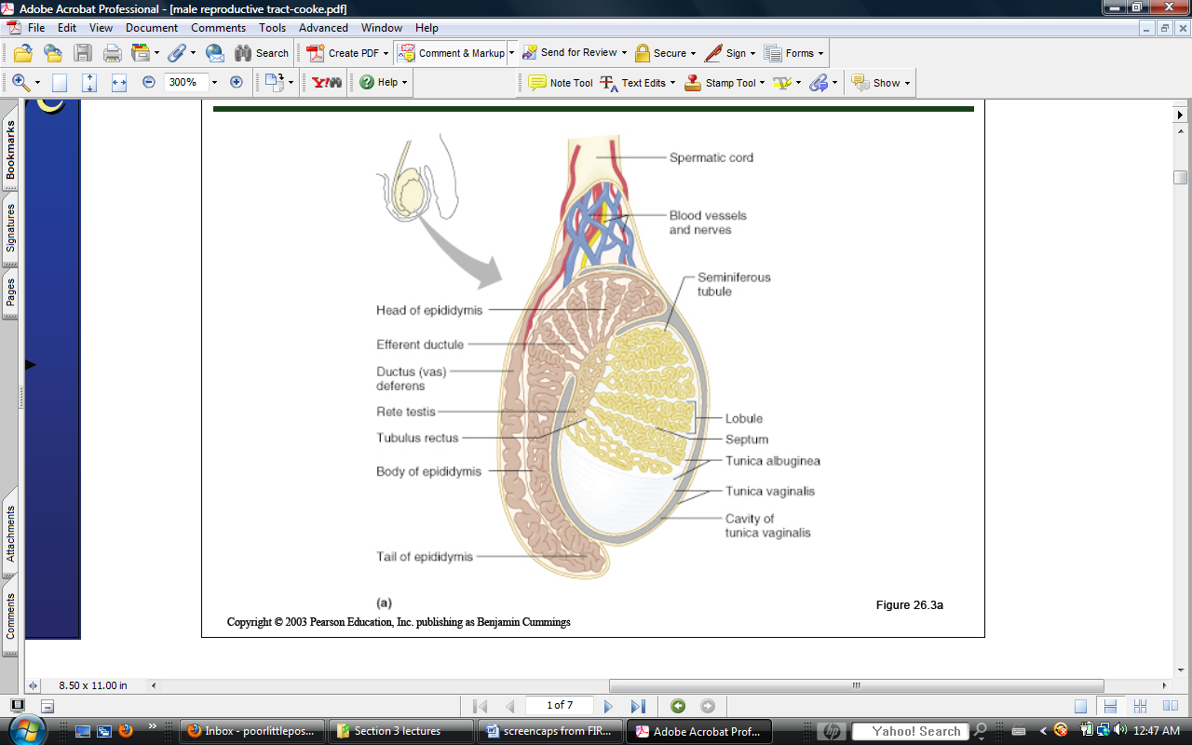
      - Blood is supplied by the testicular arteries
        - Testicular veins drain blood away, arise from a papiniform venous plexus
          - Cool venous blood helps absorb heat from arterial blood, cooling it.
          - Helps maintain homeostatic temperature
  - Internal
    - Vas deferens
      - Long tubule that wraps medially around the ureters and descends along the posterior of the bladder
    - Seminal vescicles
      - Posterior bladder surface
      - Smooth muscle that contracts to empty during ejaculation
      - Contains alkaline, nutrient-rich fluid which also contains coagulants and prostaglandins that enhance sperm motility
        - Prostaglandins decrease cervical mucus viscosity, stimulates uterus to sweep sperm inward and suppresses female immune system
    - Prostate gland
      - Secretes fluid into semen, accounts for 20-30% of semen volume
        - Activates sperm
        - Slightly acidic
        - Sugars and enzymes
        - Prostate-specific antigen
        - Zinc
          - DNA stabilization
      - Empties into prostatic urethra and then to ejaculatory duct
    - Bulbourethral gland
      - Also called Calper’s gland
      - Small pea shaped glands inferior to prostate
      - Secretes fluid when a man is excited
        - Neutralizes traces of acidic urine
        - Lubricates urethra before ejaculation
- Penis
  - Corpus spongiosum is on the ventral side and houses the urethra
  - Corpus cavernosa is on the dorsal side and lateral to the spongiosum on both sides
    - Houses the arteries
  - Crus of penis anchors the proximal end of the penis to the pubic arch via ischiocavernosus muscle
- Semen
  - Sperm account for only 10% of semen, the rest is prostate and seminal fluid
  - Coagulates just after ejaculation, allows sperm to stick to vaginal wall
    - Fibrinolysin breaks up sticky mass and frees sperm
  - Alkaline to protect sperm from acidic urethra and vagina
    - Acidic environments slow down sperm
  - Antibiotics
Spermatogenesis
- Occurs in 2 parts
  - Spermatogenesis
  - Spermeogenesis
- Spermatogonia in the basal lamina divide via mitosis to form type A and Type B cells
  - Type A cells maintain the germ line
  - Type B gets pushed to the lumen to form primary spermatocytes
    - Spermatocytes become sperm
- Primary spermatocytes undergo meiosis I to form 2 haploid secondary spermatocytes
- Secondary spermatocytes undergo meiosis II to form spermatids
- Spermatids then undergo spermiogenesis to form a fully functioning sperm
Sperm Features
- The acrosomal head of the sperm contains hydrolytic enzymes that help it enter the egg
- The sperm midpiece contains an abundance of mitochondria for motility
- The tail propels the sperm forward in a whip-like fashion
Hormone Regulation and Action
- Leydig cells are located outside of the seminiferous tubules and secrete testosterone when stimulated by LH
  - Supports spermatogenesis
  - Supports accessory organs
- Sustentacular/Sertoli cells are the cells that house the events of spermatogenesis/spermogenesis
  - Divided into 2 layers
    - Basal compartment
      - From the basal lamina to their tight junctions
      - House spermatogonia and primary spermatocytes
    - Adluminal compartments
      - From the tight junctions to the lumen
      - Where everything else happens
    - Contain tight junctions that create a blood-testis barrier
      - Prevents immune system from attacking sperm
      - Since sperm are not formed until puberty, the body’s programmed immune system does not recognize them as self
  - Provide nutrients and signals to dividing cells
  - Secrete testicular fluid that act as a transport medium through the lumen
  - Sloughs off excess cytoplasm during spermiogenesis
  - Stimulated by FSH
HPG axis
- Hypothalamus releases GnRH
- GnRH stimulates ant pit to release FSH and LH
- FSH causes sustentacular cells to release androgen binding protein ABP that makes spermatogenic cells receptive to testosterone
- LH stimulates leydig cells to release testosterone which triggers spermatogenesis
- Rising levels of testosterone and inhibin (released from high sperm count) create a negative feedback
Testosterone
- Steroid hormone that remains relatively stable after puberty
- Synthesized from cholesterol and due to its polarity can readily cross plasma membrane
- Must meet with the receptor complex before it can exert its effects
- Actions
  - Gonadal
    - Spermatogenesis
    - Growth/maturation of gonadal and accessory organs
  - Somatic
    - Growth spurts
    - Depening of voice
    - Sweating
    - Hair
  - Metabolic
    - Anabolism
  - CNS
    - Maintenance of libido
    - Aggression
Function and Dysfunction
- Erection – parasympathetic control
- Ejaculation – sympathetic
- Fates of ejaculated sperm
  - Leaks out of vagina (cream pie)
  - Destroyed by acidic environment
  - Fail to make it to the cervix
  - Dispersed in uterine cavity or destroyed by phagocytic leukocytes
  - 100s – a few thousands Reach uterine tubules
- Reproductive capacity is correlated to how much sperm is released
  - 20-60 million required for coitus
  - 1-10 million for Intratuterine insemination
  - 10,000 for in vitro fertilization
  - 1 for intracytoplasmic sperm injection

