Pop Quiz: Lecture 1
- Differentiate between “comparative” or “environmental” approaches to physiology and “biomedical” physiology.
  - Comparative:
    - Focuses on millions of animals that are not humans or mice or rats
    - Considers environment, phylogenetic history, advantages.
  - Biomedical:
    - Focuses on 3 or 4 animals
    - Do not consider the environment

- Camels possess a haemoglobin with very high affinity for O₂. What do comparative and environmental approaches to physiology suggest about this trait?
  - If you look at the current environment, it is a low altitude with higher concentrations of oxygen so it is rather difficult to see why they have this hemoglobin. If you look at their phylogenetic history, they come from high altitude ancestors, in this context, it makes sense for them to have a high affinity hemoglobin.

Learning Objectives: Lecture 2
- List the roles of the circulatory system:
  - The roles of the circulatory system are:
      - Rapid mass transportation of:
        - Respiratory gases
        - Nutrients
        - Waste products
        - Hormones
        - Antibodies
        - Salts/acid-base equivalents
      - Temperature control
      - Production of force
        - Hydrostatic skeleton
        - Wing expansion in insects
        - Renal filtration and excretion in vertebrates
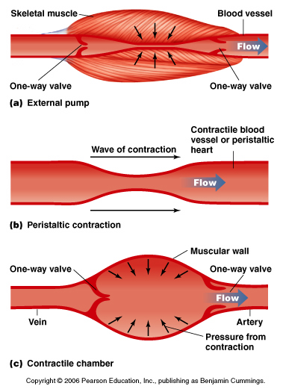
- List the elements of the circulatory system:
  - The elements of the circulatory system are:
    - Pump (usually a heart)
      - Positive vs. negative forces
        - Most work by making a positive pressure
      - Peristaltic pump
        - Contraction determines direction
      - Chamber pump with contractile walls
        - Need a valve system
      - Chamber pump driven by external forces
        - Veins in your legs
    - Vascular system
      - Peripheral circulation
        - Arterial system
          - From heart to tissues
        - Capillaries
          - Blood to tissues
        - Venous system
          - From periphery to heart
    - Circulating fluid

- Contrast and compare open vs. closed circulatory systems:
  - Open (invertebrates)
    - Incomplete system of vessels
    - Low blood pressure and blood flow
    - No capillaries
    - Bathes tissues, then returns to heart
    - Haemolymph pumped by heart empties into sinuses or lacunae to bathe tissues directly
    - High haemolymph volume
    - Limited capacity to alter velocity and distribution of blood flow low max rate of O₂ uptake
    - Only in invertebrates with a low metabolic rate (except insects)
  - Closed (vertebrates, some invertebrates)
    - High blood pressure (resistance provided by vessels) and blood flow
    - Exchange occurs across capillaries
    - Complete loop of blood vessels never leave circulatory system
    - Differential distribution of blood flow
    - Exchange occurs across capillary walls
      - Plasma proteins
      - Requirement for lymphatic system
    - Perfect control
  - How to tell between open and closed:
    - Systemic resistance
      - Higher in closed
      - Lower in open

- Describe the selective pressures driving separation of the circulatory system into systemic and pulmonary circuits:
  - Increased O₂ uptake
    - Shift from water to air breathing
      - Land animals have higher metabolic rates.
        - Large increases in BP and blood flow
    - Shift towards increasing blood pressure and flow
    - Shift towards increasing separation of oxy and deoxy circulation
    - Air breathing-fish:
      - Mixing of oxygenated and deoxygenated blood
    - Lizard:
      - Some degree of separation of O₂ and CO₂ in blood
      - 1 pump for respiratory and circulatory circuits
    - Mammal:
      - Separate the pumps
        - Way more efficient
    - Would push the fluid right out of the lungs if:
      - Fluid pressure > than air pressure

- Describe the circulatory patterns of different vertebrate groups:
  - Fish
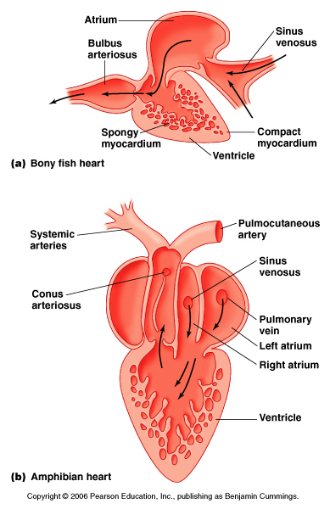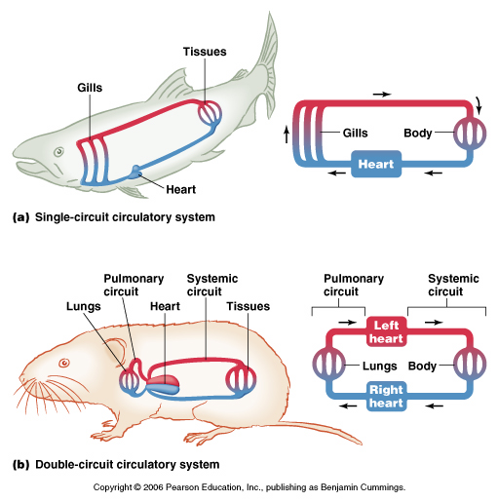
    - 4-chambered heart with chambers
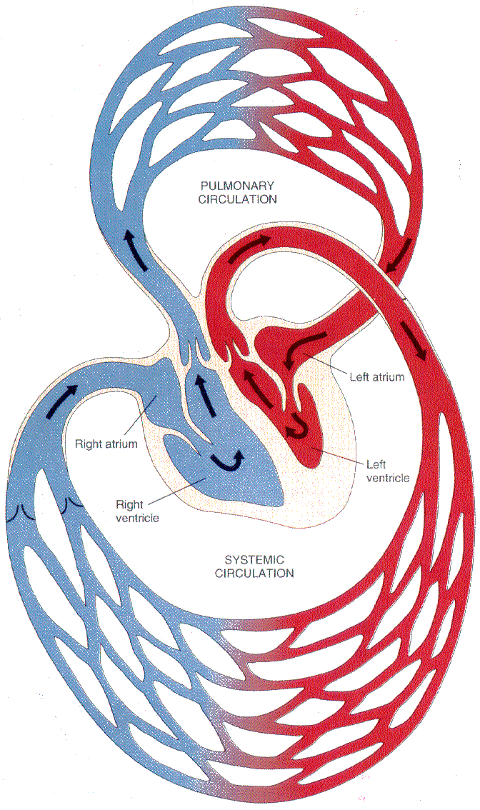
      - Sinus venosus
      - Atrium
      - Ventricle
      - Bulbus or conus arteriosus
    - Heartgillsbody and then back to heart
    - Disadvantage: gills = first step
      - Stronger than lungs due to fluid on both sides
    - Low metabolic rates
    - Restricted to gill pressure

  - Birds/Mammals
    - Lungs cannot withstand high pressure but need high pressure to systemic circulation
    - Separation of systemic and pulmonary circulations
    - Two pairs of heart chambers in parallel
      - Atrium and ventricle
      - Allows different input pressures to separate circuits
      - Requires equal total blood flow through separate circuits
    - Left side = more muscular than right
    - Advantage: two pumps
      - High systemic pressure and low pulmonary pressure
    - Disadvantage
      - Equal rates of blood flow in the two loops

  - Intermittent air-breathers
    - Amphibians and reptiles
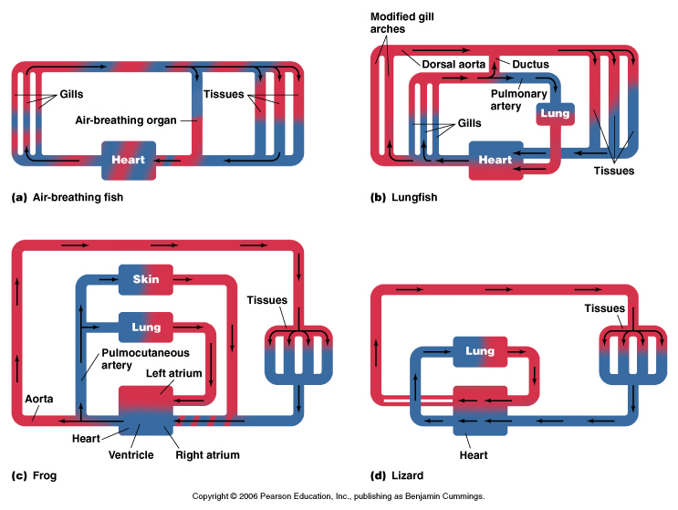
      - Separate atria
      - Variable degree of anatomical division in ventricle
      - Selective distribution of blood flow by mechanisms that are poorly understood
      - Same input pressure to pulmonary and systemic circulations
      - Differential distribution of blood flow to lungs, skin, body can occur
      - Take a few breaths, stops
      - Low metabolic rates
      - Blood flow goes to where it’s needed
      - Advantage:
        - Turn off/on lungs or skin.

    - Lungfish
Pulmonary
Vein

(Posterior;
with lamellae)
      - Partial anatomic separation of conus arteriosus
      - Oxy blood from lungs returned directly to heart and preferentially directed to anterior branchial arches to systemic tissues.
      - Deoxy blood from systemic tissues preferentially directed to posterior branchial arches for oxygenation at gills or lungs.
        - Bypasses lung via ductus if lung not ventilated
      - Air breathing fish with a low metabolic rate
      - Fish heart
      - Gills
        - Anterior lack gas exchange surfaces
        - Posterior: goes to lung and back to heart
      - Ductus, joins pulmonary and systemic circuit
        - Opens and bypass the lungs

- Identify a fish that can drown:
  - Lungfish

Pop Quiz: Lecture 2
- Sketch the circulatory system of a frog. List one pro and one con of this circulatory design.
  - Pro: Low cost
  - Con: Low pressure and low metabolism
- Provide an example of an invertebrate:
  - With an open circulatory system
    - Cephalopods, earthworms
  - With a closed circulatory system
    - Crustaceans
  - That achieves high metabolic rate with an open circulatory system
    - Insects

Learning Objectives: Lecture 3
- Contrast and compare the action potentials of contractile and conducting (pacemaker) cardiac muscle fibres.
  - Contractile cardiac muscle fibres
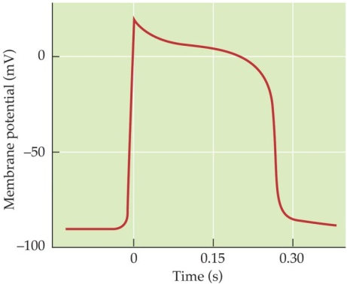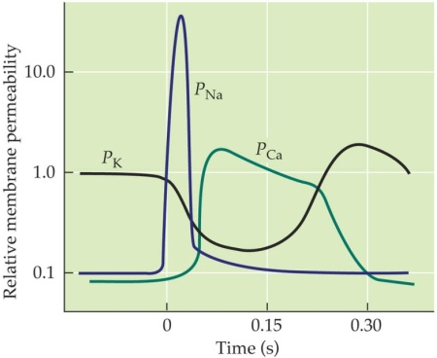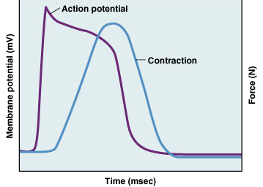
    - Contraction triggered by depolarization
    - AP reflects:
      - VG Na channels open
      - VG Ca channels then open
      - VG K channels close (then open)
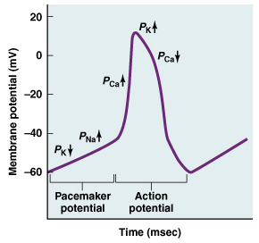
    - Plateau region
      - Involvement of calcium
      - Long refractory period
    - Gap junctions
  - Conducting (pacemaker) cardiac muscle fibres
    - Resting membrane potential is not stable
    - Funny Channel: allow slow Na entry
    - AP triggered when threshold hit
    - T-type – cause depolarization
    - Spontaneously depolarize
    - Once one cell depolarizes, rest will
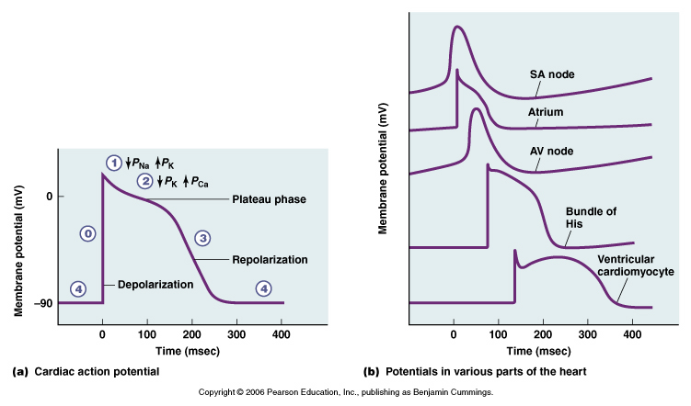
      - Gap junctions

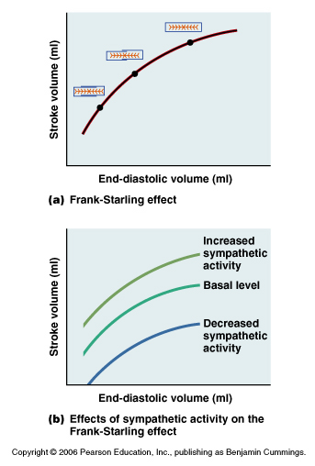
- Describe the inotropic regulation of the heart, distinguishing between mechanical and neural/humoral effects.
  - Mechanical
    - Increase filling more forceful contraction
      - Stroke Volume
    - Frank-Starling relationship
      - SV proportional to diastolic filling
      - Stretch produces more forceful contraction
  - Neural/Humoral
    - Sympathetic ONLY
      - Increase or decrease activity from the basal level of activity

- Describe the pattern of activation of the mammalian heart.
  - SA Node – spontaneous
  - all atrial cells via gap junctions
  - AV Node: rate slows down
    - Allows for ventricular filling
  - Ventricular contraction:
    - Rapid
    - Contracts as a unit
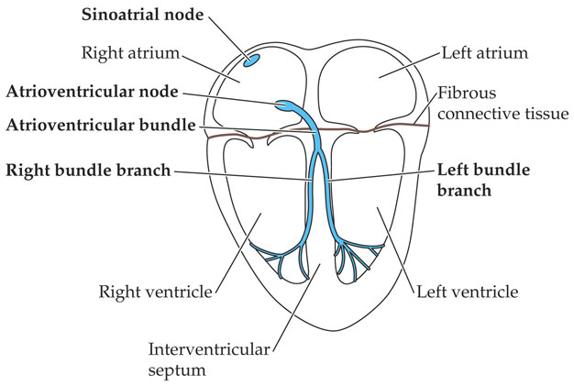
- Describe an ECG and explain its physiological basis.
  - Summation of membrane potential changes across all heart cells
  - P wave
    - Atria depolarizing
  - QRS complex
    - Ventricles depolarizing – as well as atrial depolarize
  - T wave
    - Ventricles repolarizing
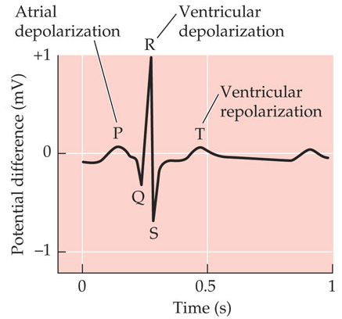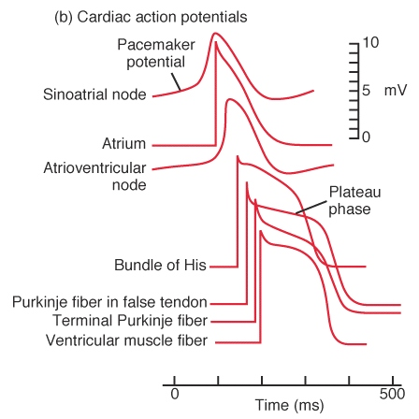
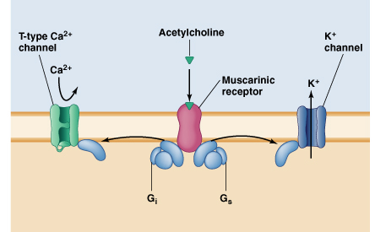
- Discuss the chronotropic regulation of the heart down to the signal transduction pathway level.
  - Parasympathetic
    - Vagus nerve
      - Release of Ach on muscarinic receptors
      - Opens K channels
        - Causes hyperpolarization
    - Negative chronotropic effect
    - Vagal tone – background activity
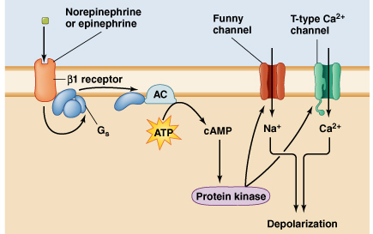
  - Sympathetic
    - NE–––
    - B₁ activates G-protein second messenger GMP
    - Opens T-type Ca ²⁺ and funny channels
    - Effects HR and force of contraction
    - Increase Na and Ca conductance
    - Positive chronotropic effect
  - M₂ and B₁: only change is pacemaker potential. AP stays the same.

- Calculate cardiac output from stroke volume and heart rate.
  - Q = SV x HR

- List and briefly describe the types of blood vessels.
  - Arteries
    - Endothelial cell lining
    - Additional layers of connective tissue (elastic and collagenous fibres) and smooth muscle
  - Capillaries
    - Endothelial cell lining
  - Veins
    - Endothelial cell lining
    - Additional layers of connective tissue (elastic and collagenous fibres) and smooth muscle

- Describe the patterns of blood flow, velocity and pressure across the circulatory system as a whole.

Pop Quiz: Lecture 3
- Name two features that can be used to distinguish the APs of conducting vs. contractile cardiac muscle fibres.
  - Conducting fibre:
    - Funny channels, cause slow depolarization, not stable resting potential.
  - Contractile fibre:
    - Plateau region.

- Sketch the Frank-Starling effect.

- How will administration of atropine (mAChR blocker) affect HR in a resting BIO 3302 student?
  - HR would increase
  - Block mAChR receptor
  - Block Parasympathetic

- HR and SV both double. In the absence of any change in resistance, arterial blood pressure will be increased OR decreased (select one) by what factor?
  - 4x increase in Q if R stays the same
    - P=QR
  - 4x increase in pressure

- The B₁ blocker atenolol may be prescribed to treat hypertension. Why?
  - Atenolol lowers HR and Cardiac output = decrease in BP

Learning Objectives: Lecture 4
- Differentiate different types of blood vessels on the basis of their anatomy and/or function.
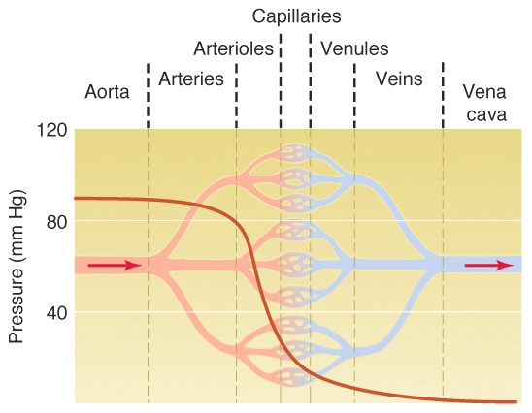
  - Aorta, arteries – Windkessel vessel
    - Structure
      - Large
      - Elastic walls
      - Thick walls
    - Function
      - Blood from pump to periphery, little pressure change
        - Effective distribution to system
      - Pressure
        - maintain BP when heart relaxes
  - Smallest arteries, arterioles – Pre-capillary resistance vessel
    - Structure
      - Small radius
      - Muscular walls
      - Innervated by sympathetic nervous system
      - Walls contain smooth muscle to adjust radius of the vessels
    - Function
      - Pre-capillary resistance vessels
      - Arterial pressure drop across them
      - Ideal BP controls
      - Constriction increase blood pressure
      - Dilation decreases blood pressure
  - Pre-capillary sphincters
    - Structure
      - Smooth muscle
      - Metabolites
    - Function
      - Pinch off blood flow to part of capillary bed
      - Responsive to local tissues
      - Determine capillary exchange area within tissue
  - Capillaries - Capillary
    - Structure
      - Thin walled vessel
      - Endothelial cells, basement membrane
      - Extensive network, high surface area
      - Large surface area
    - Function
      - Low blood flow velocity
      - Gas, nutrient and waste exchange
        - Diffuse across the walls
      - Fluid exchange (balance)
  - Venules and small veins – Capacitance vessels
    - Structure
      - Radius can be adjusted
      - Collecting points surrounded by smooth muscle fibers
    - Function
      - Adjust resistance and hence affects pressure
      - Enables adjustment of pressure across capillary beds
  - Veins
    - Structure
      - Highly distensible
      - Smooth muscle
      - Sympathetic innervation
      - Compliant walls
    - Function
      - Allow for blood donation
      - Venous pressure falls, heart doesn’t fill
      - Influences cardiac output through venous return

- Use the equation $∆P=QR$ to predict the behaviour of the circulatory system.

- Describe the factors affecting R using Poiseuille’s equation.
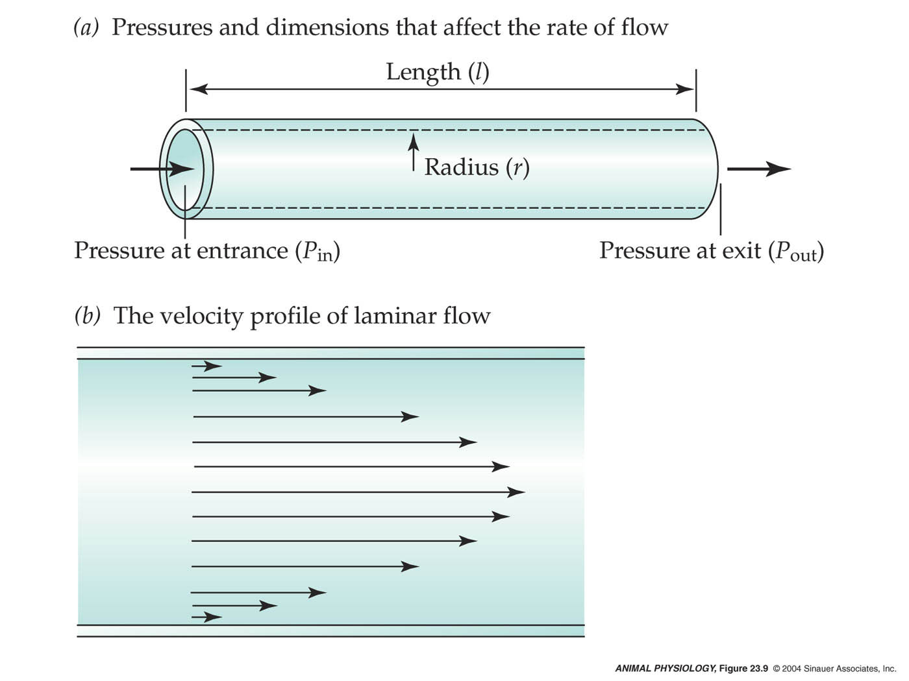
  - Length – increase will increase R
  - Viscosity – increase will increase R
  - Radius – increase will decrease R four fold

- Describe the assumptions of Poiseuille’s equation in the context of a circulatory system.
  - Laminar flow
    - Force required to slide adjacent layers past each other
    - Viscosity = resistance to sliding
    - Turbulent flow = irregular, random, noisy

- Explain the functional significance of the Fahraeus-Lindqvist effect.
  - Fahraeus-Lindqvist effect
    - Rbc’s accumulate in centre of the bloodstream, reducing apparent viscosity for small blood vessels

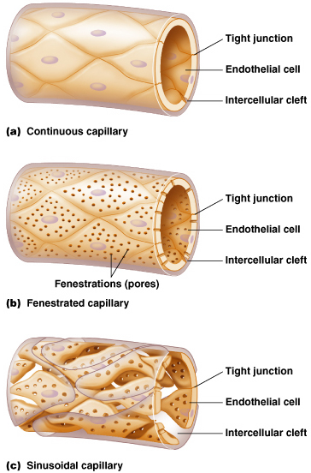
- Relate function to structure for the different types of capillaries.
  - Continuous
    - Tiny gaps
      - For small molecules, water
      - 4nm
  - Fenestrated
    - Holes/pores; more permeable
      - 80-100 nm
  - Sinusoidal
    - Big gaps
    - Large for blood cells and protein

- Explain quantitatively how capillaries function to maintain fluid balance.
  - Convective exchange of fluids to maintain fluid balance
  - Driven by hydrostatic and osmotic pressure gradients
    - Hydrostatic pressure: capillary > interstitial fluid filtration force
    - Colloid osmotic pressure: plasma > interstitial fluid absorption force
      - Plasma proteins (albumin)
    - Net filtration pressure = (BP – P_{IF}) – (OP_{blood} – OP_{IF})
  - Starling-Landis hypothesis
    - Arterial vs. venous end of capillary
    - Net fluid loss and need for lymphatic system
  - Proteins in the blood tend to pull fluid into the blood
  - BP high when entering capillary but low with increasing length
  - Water leaves at arterial end
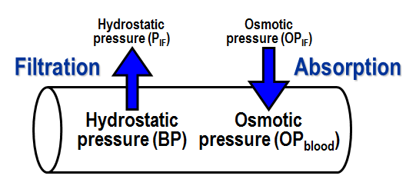
  - Back in at venous end
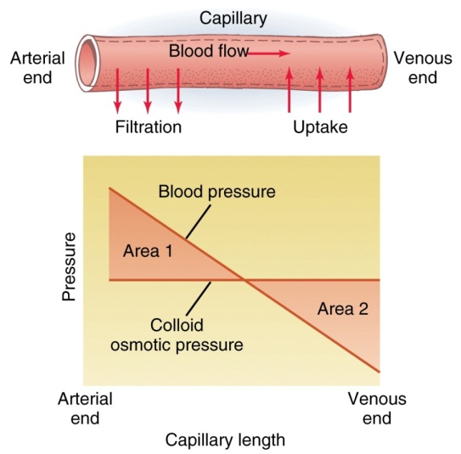

Pop Quiz: Lecture 4
- Assuming that the pressure drop across a blood vessel remains constant, blood flow through the vessel will be increased OR decreased (select one) by a factor of ____ if the radius and length of the vessel are both halved.
  - R = ½ = 16x increase
  - L = ½ = 2x decrease
  - Q = 8x decrease

- What type of capillary would you expect to find in bone marrow? Why?
  - Sinusoidal to let blood cells in and out.

- Make a chart that compares and contrasts Blood vessel by function, type, structural characteristics, and functional significance.
Blood vessel by function | Blood vessel | Structural characteristics | Functional significance
Windkessel vessel | Aorta and largest vessels | Thick elastic walls  Large radius | Maintains pressure  Low resistance  Helps being a conduit
Pre-capillary resistance vessel | Arterioles and smallest arteries | Small radius with smooth muscle | High resistance, slow down blood flow and pressure
Capillary | Capillary | Thin walls  Small radius :high SA  Different sized fenestration | Maximize rate or exchange  Slow blood flow  Nutrient transfer
Capacitance vessels | Veins | Highly distensible  Thin walls with smooth muscle | High volume changes  Little change in pressure

Learning Objectives: Lecture 5
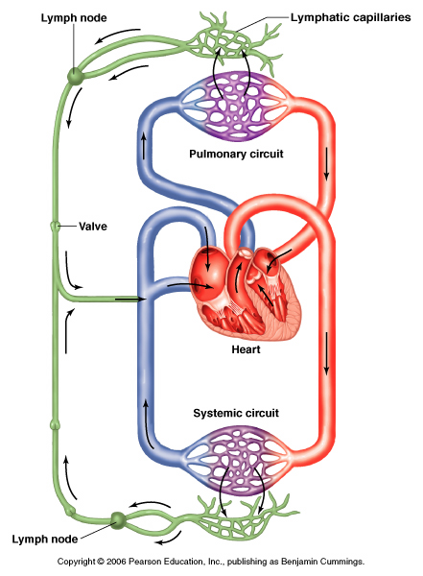
- Explain the structure and function of the lymphatic system
  - Structure
    - Lymph capillaries
      - Highly permeable walls
      - Diffusion
      - Pumped back to circulatory system in large neck veins
  - Function
    - Return plasma proteins to circulation
    - Drain excess fluid

- Distinguish among ischemia, active hyperemia and reactive hyperemia and provide examples of each
  - Ischemia
    - Lack of blood flow
    - Due to blood clot for example
  - Active hyperemia
    - Blood flow higher than normal
    - Higher because of higher activity
    - Due to neurogenic, hormonal, and metabolic function
  - Reactive hyperemia
    - Blood flow higher than normal
    - Follows periods of ischemia
    - Raynaud’s syndrome

- Explain the priority system upon which blood flow distribution to the tissues is based
  - Maintenance of blood flow to brain & heart, and then other tissues.
  - This is important because blood flow to the brain and heart first allows the brain and the heart to have the oxygen and nutrients they need since they are key players in staying alive.

- Discuss local, neural and hormonal mechanisms used to control regional blood flow, noting the level(s) at which each operates
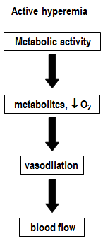
  - Local
    - Arterioles vs. pre-capillary sphincters
    - Heat with increased blood flow
    - Compounds produced by endothelial cells
      - Nitric oxide – vasodilation
    - Inflammatory mediators
      - Histamine – vasodilation
    - Metabolic control
      - Most active tissues vasodilation elevated blood flow (active hyperemia)
      - Independent of nerves or hormones
      - Decrease O, increased CO₂, increased acidity, increased adenosine, increased heat, and increased K.
      - Highly developed in muscle
      - O₂ systemic vs. pulmonary capillaries
        - Decrease in oxygen causes vasodilation in systemic but vasoconstriction in pulmonary
          - Directs blood to oxygenated areas in the lung.
  - Neural
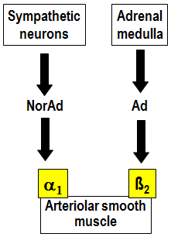
    - Sympathetic nerves
      - Adrenergic fibers release noradrenaline which acts on
        - A₁ adrenergic receptors
        - Vasomotor tone
          - Increase sympathetic stimulation vasoconstriction
            - Reduces blood flow downstream
          - Decrease sympathetic stimulation vasodilation
        - Viscera
        - Brain, heart, lungs/gills lack a-adrenoreceptors
  - Hormonal
    - B₂ – adrenoreceptors
      - Mediates vasodilation
      - Ca pumps activated
      - Remove Ca from muscle resulting in relaxation
    - Vasodilation
    - Skeletal muscle

- Distinguish between chronic and acute mechanisms for controlling blood pressure
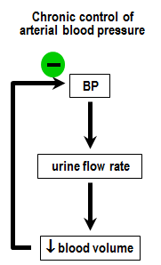
  - Chronic
    - Based on adjustment of blood volume via control of fluid loss in urine
    - Requires hours to days
    - Based on kidneys
  - Acute
    - Based on neural reflex arcs; act in seconds to minutes
    - P=QR
    - Q=SV x HR
      - In mammals HR is adjusted
    - Total peripheral resistance
    - BP regulated by controlling HR and the diameter of arterioles. (QxR)

- Describe the baroreceptor reflex arc
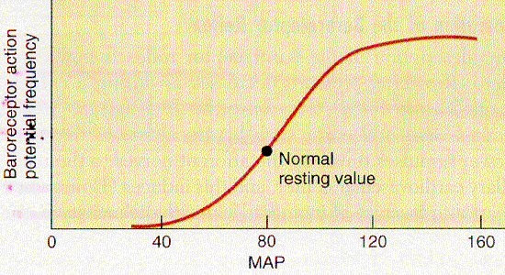
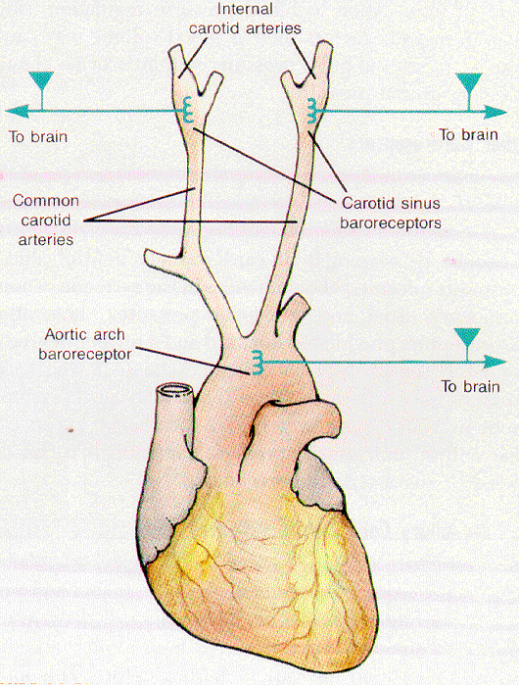
  - Baroreceptors respond to stretch of blood vessel wall
  - Most near brain
  - Carotid baroreceptors are key BP baroreceptors (located in carotid sinus)
  - Works on a negative feedback loop
  - Efferent output via ANS to effector organs

- Predict the responses of the circulatory system to changes in blood pressure
  - Feedback loops
    - Increase blood pressure increase baroreceptor firing integration in CNS response decrease BP
    - Decrease blood pressure decrease baroreceptor firing integration in CNS response increase BP

- Discuss the circulatory responses to exercise and the mechanisms responsible for these responses
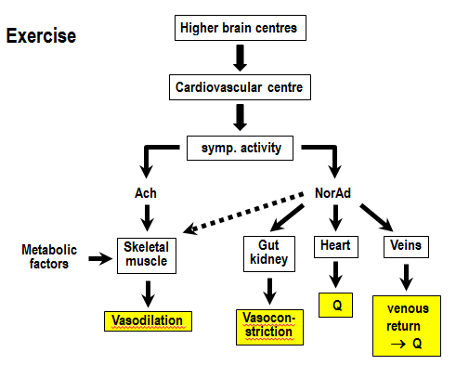
  - Exercise circulatory responses
    - Increase oxygen consumption (5-10x)
    - Increase heat dissipation
    - Increase blood flow (up to 7x)
    - Redistribution of blood flow
    - Only small changes in arterial blood pressure
      - Peripheral resistance decreases during exercise
  - Exercise mechanisms
    - Hyperemia in exercising muscles
      - Sympathetic cholinergic stimulation anticipatory increase in blood flow
      - Active hyperemia in response to local metabolic changes
    - Increased cardiac output
      - Increase sympathetic activity positive inotropic & positive chronotropic effects and venous vasoconstriction (i.e. increases venous return)
      - Increase venous return due to skeletal muscle pump
    - Peripheral vasoconstriction
      - Reduced blood flow to gut, kidney etc. via sympathetic stimulation of a₁ – adrenoreceptors
    - Constant systemic blood pressure:
      - Decrease total peripheral resistance (muscle vasodilation > vasoconstriction elsewhere) but increase cardiac output

Pop Quiz: Lecture 5
- Distinguish between vasomotor tone and vagal tone.
  - Vasomotor tone
    - Sympathetic activity to blood vessels
  - Vagal tone
    - Parasympathetic to heart
  - Both resting/baseline activities

- Distinguish between the Frank-Starling mechanism and the Starling-Landis hypothesis.
  - Frank-Starling
    - Effect of filling volume on heart
  - Starling-Landis
    - Flow across the capillaries
    - Waters driven by hydrostatic pressures

- Distinguish between R and r.
  - R is resistance
  - r is radius

- Distinguish between fluid filtration and absorption in capillaries.
  - Fluid filtration
    - Water moving out of capillary
  - Fluid absorption
    - Water moving into capillary

- Distinguish between the locations of B1, B2 and a1 adrenoreceptors in the circulatory system.
  - B1 = heart
  - B2 = lungs, skeletal muscle (smooth muscle in arterial walls) – dilation
  - A1 = smooth muscle of blood vessel – constriction

- Distinguish between active and reactive hyperaemia.
  - Active hyperemia
    - Increased blood flow due to activity
  - Reactive hyperemia
    - Increased blood flow due to ischemic period

- Distinguish between baroreceptors and adrenoreceptors.
  - Baroreceptor
    - Pressure receptors in carotid
  - Adrenoreceptors
    - Circulating catecholamine receptor

- Distinguish between the roles of arterioles and pre-capillary sphincters in regulating blood flow.
  - Arterioles
    - Higher level; to specific tissues
  - Pre-capillary sphincter:
    - Lower level, to specific cells.

Learning Objectives: Lecture 6
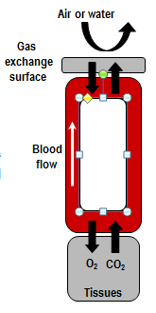
- Describe the steps involved in transferring respiratory gases between tissue and gas exchange site.
  - Ventilation
    - Supplies gas exchange surface with respiratory medium
  - Diffusion of O₂ and CO₂ across the respiratory epithelium
    - Thin layer of cells (0.5 – 15 um)
  - Bulk transport of O₂ and CO₂ by blood between gas exchange surface and tissues
  - Diffusion of O₂ and CO₂ between blood and cells

- Distinguish between diffusion and convection, with examples.
  - Diffusion
    - Movement of molecules from one region to another due to Brownian motion
      - E.g. movement of O₂ and CO₂ between respiratory medium and blood or blood and tissues
      - Fick equation
  - Convection
    - Transport of O₂ and CO₂ due to the bulk movement of the medium
      - E.g. ventilation, gas transport in blood
      - Rely on a carrier
        - Faster transport
        - Maintains partial pressure gradients

- Define capacitance (B), and distinguish between capacitance and solubility (a).
  - Capacitance
    - Total dissolved gases in all parts of the blood
  - Solubility
    - Physically dissolved gases

- Calculate gas concentrations in different types of solutions (e.g. water vs. blood).

- Discuss the impact of physicochemical differences between air and water on the design of gas exchange systems.
  - Need to breathe 30x more water than air for the same amount of oxygen.
  - Flow through system
  - A fish will spend about 10% of energy budget to breath
  - Water is a giant heat sink
  - Lose heat to water
  - Solubility
    - Vwater>>Vair for given MO₂
  - Vertebrate
    - Integument
    - Gills
    - Lungs
  - Common design features
    - Large SA
    - Thin epithelium
    - High permeability
    - Richly vascularised
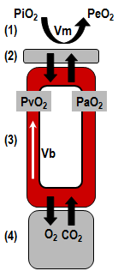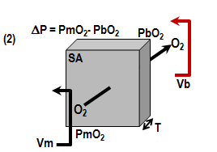

Pop Quiz: Lecture 6
- Which has higher α for O₂ – plasma or fresh water? Why?
  - Solubility falls as salinity increases, therefore water.

- Which has higher α for O₂ – plasma or blood? Why?
  - (physically dissolved) Same solubility.
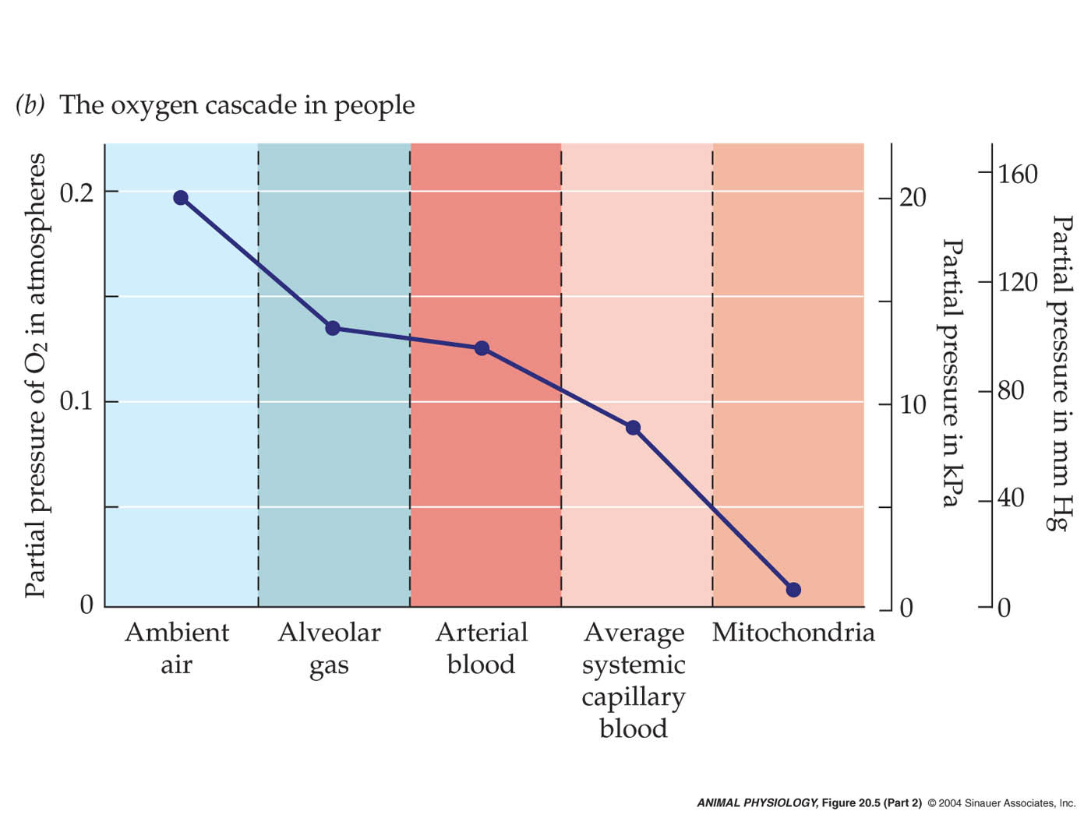
    - Blood has a higher capacitance.

- What is the “oxygen cascade”?

- What are the key characteristics of a good gas exchange surface? Explain your answer using the Fick equation
  - Thin
  - Large surface area
  - Highly vascularized
  - Permeability
  - Fick = partial pressure gradient x permeability coefficient x surface area/ thickness

- In what way does the vertebrate integument fail to meet these criteria?
  - Not permeable, low surface area, can’t maintain a partial pressure, and thick

- Gas exchange systems are usually coupled to circulatory systems. Why?
  - Circulation takes O₂ up and rapidly distributes through the body.
  - It maintains partial pressure gradient.

Learning Objectives – Lecture 7
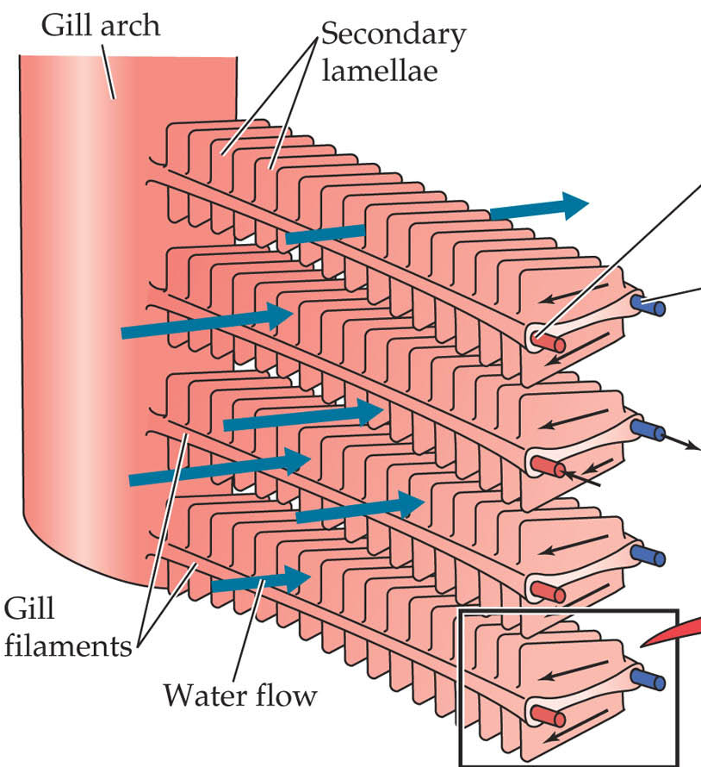
- Discuss the structure of fish gills in relation to their function.
  - Structure
    - Large surface area
    - External or internal gills
    - Evagination of body surface
    - Gills and lungs are highly folded
    - Delicate highly perfuse tissue
    - External may get damaged
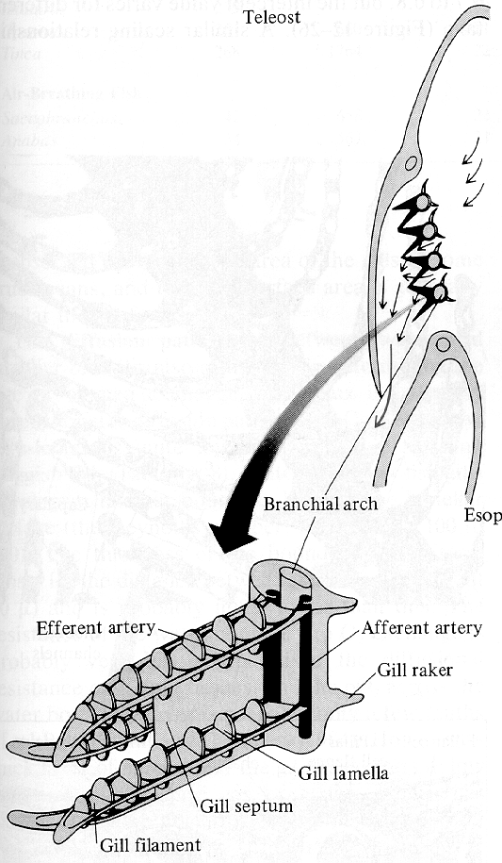
    - Internal = covered by operculum
      - Protects
      - Provides effective way to breathe
    - 4 gill arches and two rows of filaments
      - Holding structures
    - Small lamellae
      - Unit of gas exchange
      - Almost touch each other creating a sieve
      - Maximizes surface area
      - 2 epithelial sheets
      - Vascular space
      - Pillar cells

- Describe how fish gills are ventilated.
  - Open and close mouth & Open and close opercular flap
    - Very coordinated
    - Nearly continuous flow of water across gills
    - Good swimmers will swim with their mouths open
    - Facultated ram ventilation
      - Swimming movements
    - Obligate ram ventilation
      - Must swim to breathe
        - E.g. Tuna
- Model gas exchange across fish gills and use the model to explain the advantage of counter-current flow of blood vs. water.
  - 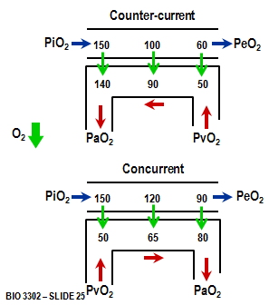
  - Venous blood is equilibrated with the water leaving the gill
  - Incoming blood meets outgoing water
  - Highest PaO₂ approaches PiO₂
  - In concurrent
    - Much less efficient
    - Gradient diminishes
    - Max PaO₂ is a little less than expired PeO₂ is.
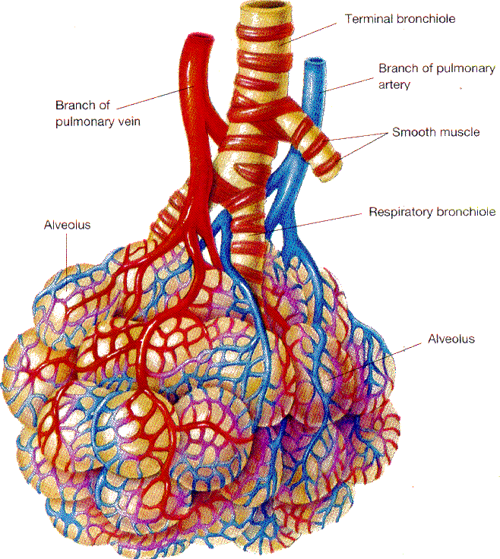
- Describe the structure of mammalian lungs and explain how they are ventilated.
  - Invaginated, internalised gas exchange surfaces
    - Extensive folding
    - Trends among vertebrates
      - Smaller size of air apaces
      - Greater number
      - Increase in total exchange area
    - Structure
      - Alveoli
      - Capillary network
      - High surface area
      - Thin barrier
  - Ventilation
    - Tidal
    - Thoracic cage –ribs and diaphragm move making a negative pressure
    - Pleural space and pleural fluid
      - Acts as a suction to hold lungs
    - Inspiration
      - Expansion of thoracic cage
      - lower diaphragm (contraction) & raise ribs
      - lung volume
      - decrease alveolar pressure
      - draws air into lungs
    - Passive recoil
      - Shrinks lung volume
      - Expels air

- Model gas exchange across the mammalian lung.
  - 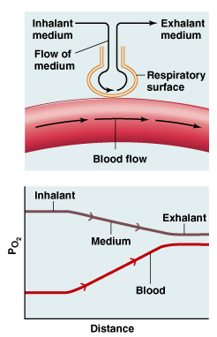
  - Circulated, pool-type gas exchange mechanism
  - Tidal ventilation PaO₂ < PiO₂
    - Anatomical dead space (~150mL)
    - Tidal volume (~500mL)
    - Alveolar ventilation volume (~350mL)
    - Residual volume (~2000mL)
  - Alveolar gas tensions depend on:
    - Alveolar ventilation
    - Rates of gas transfer
  - blood gas levels reflect alveolar gas tensions
  - PaO₂ < PeO₂

- Discuss the limitations of the vertebrate integument vs. fish gills vs. mammalian lungs as gas exchange organs.
  - Integument
    - Limited surface area limits size and/or metabolic rate
    - Vulnerable to abrasion and desiccation
  - Gill
    - Doesn’t work in air
      - Lamellae collapse in air
      - Surface area is highly reduced
  - Lungs
    - Concurrent gas exchange
    - Dead space
    - Non continuous flow of air

- Contrast and compare gas exchange via gills and mammalian lungs.

  - Gills
    - Counter current
      - Expired O2 meets venous blood and continues to get oxygenated as it moves closer to inspired O2. Allows for PaO₂ close to inspired oxygen concentrations
  - Lungs
    - Concurrent
      - Venous blood gets oxygenated by inspired O2, and continues as it moves closer to the expired oxygen. This allows for a PaO2 close to the expired oxygen concentrations.

Pop Quiz – Lecture 7
- The fish gill is an extremely efficient gas exchange organ. Why?
  - Unidirectional water flow
  - Countercurrent blood and water flow
    - Partial pressure O2 maximized

- Name the functional unit of gas exchange for a fish, mammal and bird.
  - Lamellae
  - Alveoli
  - Parabronchi

- Discuss cardiorespiratory limitations on maximum metabolic rate in reptiles.
  - Reptiles can’t move and breathe at the same time
  - Ventricle not perfectly divided, not separated
  - Low pressure blood due to above because lungs need low blood pressure
  - Sac like lungs, lower surface area

- Contrast and compare models of gas exchange for the vertebrate integument and the mammalian lung.
  - Vertebrate integument
    - Thin diffusion barrier
    - PO₂ blood
      - Refreshed if animal moves around
  - Mammalian lung
    - Thin diffusion barrier
    - PO₂ blood
      - Pool is turned over
      - Ventialation

Learning Objectives – Lecture 8
- Describe the structure of avian lungs, contrasting and comparing them with mammalian lungs and fish gills
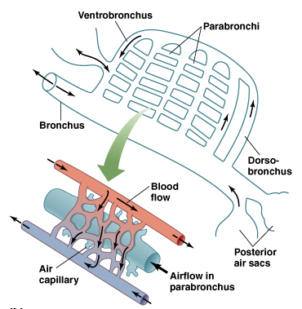
  - Small compact lung associated with thin-walled, non-respiratory air sacs
  - Lung volume ~50% of mammalian lung
  - Air sacs hold ~-80% of respiratory volume
  - Very low diffusion distance (~.1 um)
  - Parabronchi
    - Flow of air rather than tidal
    - Gas exchange organ
  - High metabolic rates
  - High altitude = low O2
  - System of tubes; functional groupings of air sacs
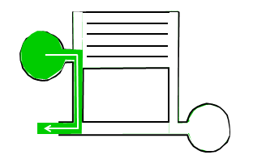
    - Act as bellows
    - Large gas exchange system
    - Cranial or caudal
    - Continuous airflow
  - Ventilation
    - Unidirectional, continuous airflow through parabronchi
    - Air sacs function as bellows
    - Volume changes by movement of sternum and ribs
    - 2 full respiratory cycles required

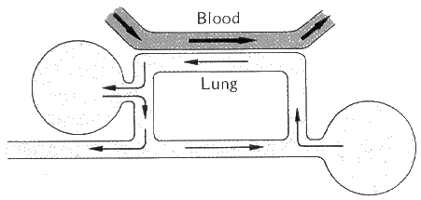
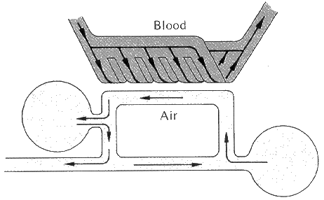
- Model gas exchange across the avian lung
  - Cross-current arrangement: PaO₂ > PeO₂
    - < countercurrent but > concurrent
    - PO₂ starts high then falls
    - Depends where the blood crosses
    - PO₂ of blood depends where it was
    - When blood leaves, blood mixes
    - PO₂ a little higher than expired
  - High altitude tolerance

- Calculate the extraction efficiency (E) for a gas exchange surface

- Correlate trends in E with structural and functional features of gas exchange surfaces
- E = 20-25% for mammals : concurrent flow
- E=40% for birds : cross-current flow
- E = 20-60% for fish : countercurrent flow
- Efficiency = gills > bird lung > mammal lung

Pop Quiz – Lecture 8
- What are the ventilator “innovations” of birds and mammals? Why are these advantageous?
  - Mammals
    - Diaphragm
  - Birds
    - Air sacs
  - Can do more than one thing at once

- What is the extraction efficiency (E) of a fish inhaling air-equilibrated water and exhaling water of PO₂ = 80 Torr?
  - $E=\frac{\left(PiO_{2}-PeO_{2}\right)}{PiO_{2}}×100\%=\frac{160-80}{160}×100\%=50\%$

- What factors make birds more hypoxia-tolerant than mammals?
  - Neurons more tolerant
  - No hypoxic pulmonary vasoconstriction
  - Better capillarity of the muscle
  - Cross-current air/blood flow
  - Continuous unidirectional airflow
  - Thin respiratory membrane
  - Big hearts

- What advantages to vertebrates gain from their possession of RBCs?
  - Pack more respiratory pigment into RBCs without changing viscosity of the blood
  - Control environment in which hemoglobin is found

Learning Objectives – Lecture 9
- Draw and describe an O₂ equilibrium curve, noting the functional significance of its shape
  - Plateau region
    - Large changes in PO₂ have little effect on Hb-O₂ saturation (O₂ content)
    - Margin of safety
    - Little effect of hyperventilation or breathing % O₂
  - Steep region
    - Small changes in PO₂ have a large effect on Hb-O₂ saturation
    - Enables PO₂ gradients for diffusion to be maintained

- Predict the O₂ equilibrium curves of different animals as a function of O₂ availability and demand
  - Left shifted curve
    - Evolved @ high altitudes
  - Co-operativity
    - Once one binds rest bind rapidly
  - Development stage

- Describe how the RBC environment influences the O₂ equilibrium curve of an individual animal, explaining the functional significance of these effects
  - Bohr effect
    - 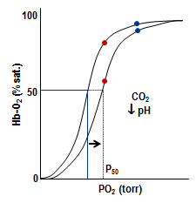
    - CO₂ and/or pH
    - Right shift with increased CO₂ or [H+] (decrease in pH)
    - Left shift with decreased CO₂ or [H+] (increase in pH)
    - Tissues: CO₂ added to blood
      - Right shift
      - Enhance O₂ unloading
    - Lungs/gills: CO₂ lost from blood
      - Left shit
      - Enhanced O₂ loading
  - Temperature
    - 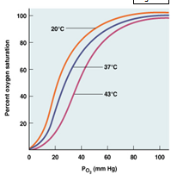
    - Increase in temperature
      - Right shift
    - Decrease in temperature
      - Left shift
    - Significant for O₂ loading and solubility
    - Note interactions between temperature and pH: temp decrease pH

  - Organic phosphates
    - 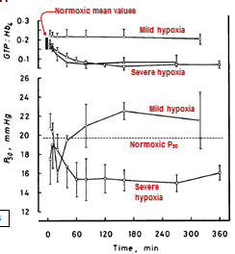
    - Increase in concentration
      - Right shift
    - Mammals have 2,3-DPG
      - Increased at high altitudes
        - Raises p₅₀ value
        - Maintain oxygen unloading
        - Maintain O₂ delivery
    - Birds have IPP
    - Fish and amphibians have ATP and GTP
    - Significant under chronic low O₂ conditions
,
- Draw and describe a CO₂ equilibrium curve, and explain how blood O₂ transport and CO₂ transport are linked
  - 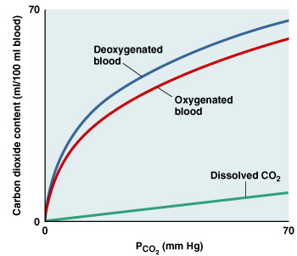
  - 3 forms of CO₂
    - Physically dissolved
    - Carbamino CO₂:
      - Protein-NH₂ + CO₂ H⁺ + protein-NCOO⁻
      - Of variable importance depending on species
    - HCO₃⁻ ions:
      - CO₂ + H₂O H₂CO₃ H⁺ + HCO₃⁻ 2H⁺ + CO₃²⁻
      - At normal blood pH, HCO₃⁻ is the end-product, so CO₂ + H₂O carbonic anhydrase H⁺ + HCO₃
      - Carbonic anhydrase (CA)
        - Zinc metalloenzyme
        - ~15 isoforms known in mammals
        - Much less known about other vertebrates
  - Chloride shift – Chlorine and HCO3 exchange across red blood cell membrane via band 3 protein
  - Haldane effect = deoxy-Hb has a higher affinity for H+ than oxy-Hb
    - O₂ release in tissues allows greater H⁺ binding by Hb for CO₂ loading into blood
    - O₂ binding in gills/lungs provides H⁺ for CO₂ excretion

- Sketch a model of CO₂ loading into blood
  - 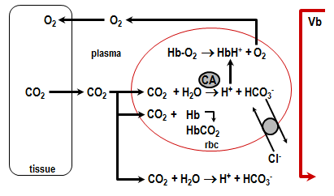
  - Partial pressure from tissue to blood.
  - Reaction in RBC is catalyzed
  - Plasma reaction is slower
  - End product of CO₂ hydration is removed.
  - Anti-porter – facilitated diffusion (chloride)

- Sketch models of CO₂ unloading at the gas exchange surface of different vertebrates
  - 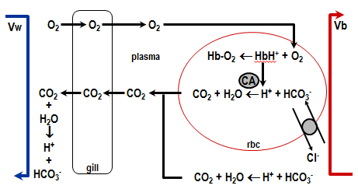
    - Blood to air
  - 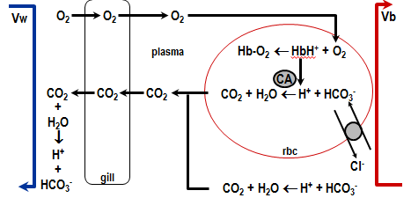
    - Teleost fish – blood to water
  - 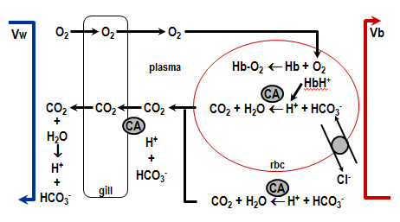
    - Dogfish – CO2 blood to water

Pop Quiz – Lecture 9
- Use a diagram of CO₂ excretion as well as O₂ and CO₂ equilibrium curves to explain how blood O₂ transport and blood CO₂ transport are linked. How does this linkage benefit the transport of each gas?

  - When CO₂ is added in tissues, O₂ has right shift, therefore it is easier to unload O₂.
  - As O₂ binds to hemoglobin, it forces CO₂ out of the blood.
  - Benefits both
  - Increase in H⁺ to tissue = increase loading for CO²
    - Benefit to CO² excretion.

Learning Objectives – Lecture 10
- Explain the significance of ventilator control
  - Two components
    - Generation of rhythmic breathing movements
      - Central pattern generator in medulla sends output to appropriate effector organs
      - Modulation by various inputs
        - Higher brain centres
        - Chemoreceptors
    - Adjustment of breath frequency and size to meet physiological needs
  - 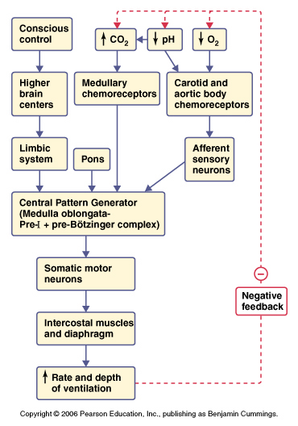

- Explain why ventilation is keyed to O2 in water-breathers but CO₂ in air-breathers
  - Water breathers
    - Ventialation keyed to oxygen because water is oxygen poor
  - Air breathers
    - Ventilation keyed to CO2 because body CO2 levels are higher – convection requirement for oxygen lower

- List the chemosensory mechanisms employed by mammals vs. fish
  - Mammals
    - Brain chemoreceptors are key chemoreceptors that regulate ventilation
    - Central
      - Main determinant of ventilator reponses
      - Located in brainstem
      - Sensitive to H but respond to blood PCO2
        - Decrease pH increase frequency and/or amplitude
        - Respond indirectly to CO2 via H
    - Peripheral
      - Detect CO2 levels
      - Aortic bodies, carotid bodies
        - Close association with baroreceptors
      - Glomus cells – respond to CO2, H, O2
        - More responsive to CO2 and H
      - Ventilation controlled by CO2
  - Fish
    - Ventilation keyed primarily to O2 but CO2 responses present
    - No central chemoreceptors
    - Peripheral
      - Located on gills
        - Neuroepithelial cells
        - Sensitive to blood and/or water
        - Sensitive to O2 and/or CO2 but probably not pH
        - Homologous to carotid and aortic bodies

- List the problems faced by air-breathing animals that adopt a diving lifestyle
  - Absence of ventilation
    - Exercise on restricted oxygen supplies
  - The bends (high pressure)
  - Temperature

- Discuss strategies used by adapted divers to maximize O₂ stores. Explain how these strategies reflect the opportunistic nature of natural selection.
  - Blunted ventilitory sensitivity to CO2
  - Maximize oxygen stores
    - Myoglobin
    - Blood oxygen stores
      - High blood volume
      - High RBC number
      - Selective RBC recruitment
      - Use the oxygen as slowly as possible
      - Hematocrit increases during the dive
      - Spleen contracts releasing blood cells
  - Right shifted oxygen equilibrium curve at tissues
    - Tissue CO2/pH right shifted
    - Don’t use lungs (avoid buoyancy)
  - Meter out available oxygen by decreasing metabolic demand
    - Hypothermia and shivering response diminish
      - Reduce metabolic cost
    - Reduce activity where possible
      - Swim by gliding
      - Cut down on tissues that use oxygen
        - No blood flow to the kidney

- Explain what is meant by the “diving reflex”.
  - Decrease heart rate
  - Combination of decreased heart rate and selective vasoconstriction
  - Triggered by receptors on the face

- Explain the problems associated with diving to depths, and discuss strategies adapted divers used to overcome these problems.
  - Pressure – the bends
    - Blood will become super saturated with gas which is fine at depth.
    - Problem with rapid surfacing
      - Blood doesn’t have time to equilibrated
        - Gas comes into tissue
        - Gas bubble disease
  - Solution
    - Exhale before the dive
    - Minimum amounts of air in the lungs
    - Large tidal volume
    - When descending, the alvieoli collapse, air is pushed into airways which are non-respiratory

Pop Quiz – Lecture 10
- The structure of lungs versus gills reflects the different chemical and/or physical properties of air versus water. This is also true of the mode of ventilation in each case, and how ventilation is regulated. Explain.
 | Lung | Gill
Physical | Exchange surface is thinner | Viscosity of water is > air  Water supports the gill  Water is denser than air
Chemical | Solubility of oxygen in air > water | Solubility of oxygen in water is < air
Mode of Ventilation | Circulated pool exchange  Tidal  Alveoli (sac) | Countercurrent  Unidirectional  Lamella (plate
Ventilation Regulation | Keyed to CO2 | Keyed to O2

Learning Objectives – Lecture 11
- Distinguish between ionic/osmotic regulators and conformers.
  - Ionic regulator
    - Constant ion concentration no matter what environment
  - Ionic conformer
    - Ion concentration matches that of the environment
  - Osmotic regulator
    - Constant body fluid concentration no matter what environment
  - Osmotic conformer
    - Osmotic concentration matches that of the environment
      - May regulate specific ions

- List the routes through which water and salt exchange occur.
  - Water – stored in body fluids and urine
    - Gain
      - Drinking
      - Food
      - Metabolic
      - Transcutaneous
      - Water vapor
    - Loss
      - Feces
      - Urine
      - Evaporation from skin
      - Evaporation through respiration
      - Transcutaneous diffusion
  - Salt – stored in body fluid as ions and skeleton
    - Gain
      - Drinking
      - Food
      - Transcutaneous diffusion/active transport
    - Loss
      - Urine
      - Feces
      - Extrarenal secretion
      - Transcutaneous diffusion

- Distinguish between obligatory and regulated exchanges.
  - Obligatory exchanges
    - Occur as a result of physical factors over which the animal has little or no physiological control
      - Transepithelial gradients
      - Surface to volume ratios
      - Permeability
      - Feeding
      - Temperature, exercise, convection
      - metabolism
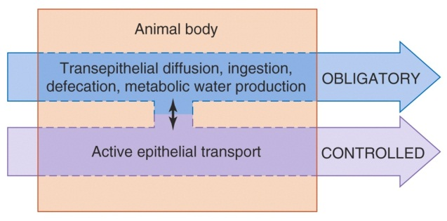
  - Regulated exchanges
    - Physiologically controlled for the maintenance of homeostasis
      - Active epithelial transport
      - Drinking

- Describe the relationship between an aquatic animal and its environment in terms of osmolarity and ionic differences.
  - Euryhaline
    - Tolerate wide range of salinities
  - Stenohaline
    - Tolerate small range of salinities
  - Hyperosmotic
    - Higher osmolarity in the animal than the water
  - Hypo-osmotic
    - Lower osmolarity in the animal than the water
  - Iso-osmotic
    - Same osmolarity in the animal and the water
  - Hyperionic
    - Higher ion concentration in the animal than the water
  - Hypo-ionic
    - Lower ion concentration in the animal than the water
  - Iso-ionic
    - Same ion concentration in the animal and the water

Pop Quiz – Lecture 11
- Where would a stenohaline, hypo-osmotic regulator, be found? Provide an example.
  - Cod. Marine fish only found in the ocean.
  - Flounder
  - Munkfish

- Which of the following must be a hyperosmotic regulator?
  - Lobster, king crab, crayfish
    - Crayfish, found in freshwater

Learning Objectives – Lecture 12
- Describe the osmoregulatory/ionoregulatory challenges of marine animals and their strategies for dealing with these challenges.
  - Ionoregulatory challenge
    - Salt is pouring in
  - Osmoregulatory challenge
    - Water leaves (animal lives in a desert)
  - Strategy #1
    - Drinking salt water
      - Marine fish must drink the sea water to get enough water into their system. This brings an ionoregulatory challenge as well.
  - Strategy #2
    - Rectal gland
      - Produces a very salty fluid

- Contrast and compare the osmoregulatory/ionoregulatory challenges of marine teleost and elasmobranchs.
  - Teleost fish
    - Lose water
    - Gain ions
    - Therefore they:
      - Drink water
      - Divalent ions are eliminated in feces and by kidney
      - NaCl extreted by the gill
        - Via chloride cell
      - Very low volume of isotonic urine produced.
  - Elasmobranch fish
    - Gain ions
    - No osmolarity problems due to urea and TMAO
      - Use rectal gland
        - Producing a very salty fluid
      - These fish get water from their environment
        - Accumulate Urea and TMAO
          - Makes the body fluid iso-osmotic to environment
          - Therefore thy gain water across gills

- Contrast, compare and sketch the ion-transporting cells used for salt secretion vs. salt uptake.
  - Chloride cell/rectal gland
    - 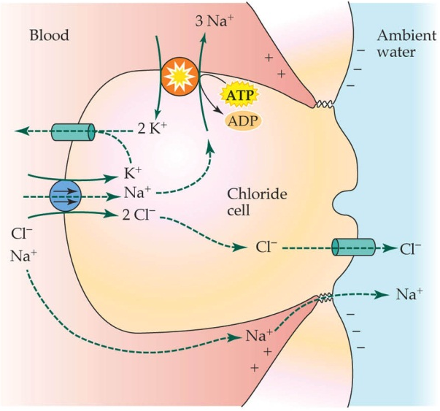
    - Pumps Na out of the cell.
      - Creates a high gradient
        - Exits via paracellular route via diffusion
    - Chloride moves against diffusion
      - Na brings the Cl with it
      - Increases of Cl leave via Cl channel
  - Active NaCl uptake via MR cells
    - 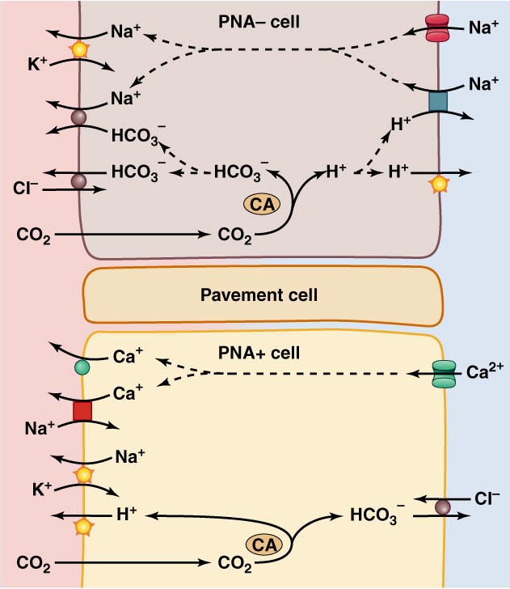
    - Mitochondrion-rich (MR) cells
      - Base-secreting cells for Chloride uptake, and acid-secreting cells for Na uptake
        - Apical proton pump and Na-K pump together produce Na gradient

Pop Quiz – Lecture 12
- Add a euryhaline teleost (e.g. salmon), a marine elasmobranch (e.g. dogfish), and a hagfish to the axes below.
  - Euryhaline Teleost – Salmon
    - Marine
      - Lower salt in body
        - Gain ions
        - Lose water
    - Freshwater
      - Higher salt in body
        - Lose ions
        - Gain water
  - Marine Elasmobranch – Dogfish
    - Marine
      - Lower salt in bodies
        - Gain ions
      - Isosmotic
        - Accumulates urea and TMAO
        - No osmolarity challenge
  - Hagfish
    - Osmoconformer
      - No osmolarity challenge
    - Exclude certain ions
      - Sulfate

- Contrast and compare the iono- and osmo-regulatory challenges faced by these animals.
    - Red – Hagfish, Blue – Dogfish, Green – Salmon.
- What is the osmorespiratory compromise? Provide an example.
  - Conflict of water/ion movements from gill surface area, and oxygen movement.
  - The gill
    - Goldfish
  - Skin
    - Amphibian
  - Eggshell
    - Bird

Learning Objectives – Lecture 13
- Describe the osmoregulatory/ionoregulatory challenges of freshwater animals and their strategies for dealing with these challenges.
  - Osmoregulatory challenges
    - Water influx
  - Ionoregulatory challenges
    - Salt loss
  - Strategy # 1
    - Osmorespiratory compromise
      - Compromise between need for effective gas transfer and need to minimize obligatory exchanges
        - Reduce gill surface area (as much as possible)
      - Avoid drinking
      - High flow of dilute urine
    - Active NaCl uptake at gills
  - Strategy # 2
    - Invertebrates – strategies vary
      - FW crayfish
        - Relatively impermeable
        - Relatively high salts
          - Urine volume is low because permeability is low
          - Active NaCl uptake via the gills
      - FW clam
        - Lower gradients so the gradient is less drastic
          - Minimize water gain
            - Urine volume high because permeability is high – large SA of soft tissues
            - Necessitates very low internal solute concentrations.

- Explain and provide examples of the osmorespiratory compromise.
  - Osmorespiratory compromise
    - Compromise between need for effective gas transfer and need to minimize obligatory exchanges
      - Reduce gill surface area (as much as possible)

- List several strategies terrestrial animals use to minimize water loss.
  - Less permeable integuments
    - Thin layers of lipids
      - Frog rubs lipid rich fluid all over its body
      - Mammals in skin
      - Terrestrial arthropods in epicuticle
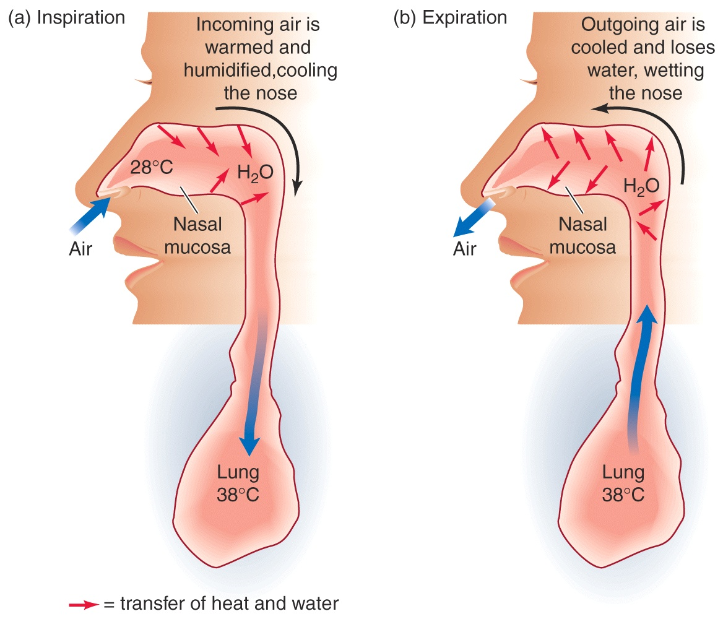
  - Water recovery from exhaled air
    - Temporal counter-current system
      - When you breath in air it is cooler and less humid
        - Picks up heat and water from nasal mucosa
        - Exhaled passes cooled nasal mucosa, condensing the water
          - Longer the nasal passage the better
    - Hygroscopic material in camels
      - When dehydrated develops thick crusty mucous
        - Strips water out of the air
    - Minimize fecal water loss
      - Absorption of fecal water
        - Insects, desert reptiles, rodents
    - Minimize urinary water loss
      - Using ammonia, urea, uric acid
    - Behavioural responses
      - Avoiding desiccating environments
        - Kangaroo rat.

- List several strategies used by terrestrial animals to obtain water from the environment.
  - Drinking
    - Negative feedback system
      - Fluid volume and osmotic pressure monitored
      - Thirst centre in hypothalamus
      - Coupled with hormonal control of urine
    - Extrarenal salt excretion in marine reptiles and birds
      - Similar to chloride cells
    - Hypertonic urine production in mammals and birds
      - Loop of Henle
  - Water absorption across body surfaces
    - Amphibians
      - Pelvic patch
        - Contains many aquaporin channels
      - Controlled by AVT
    - Terrestrial arthropods
      - Absorption of water vapour via rectum or mouth
      - Hygroscopic materials
      - Limiting rh )%) from 45-94.
  - Water gain from food and metabolism
    - Preformed water in food
    - Oxidation of water

Pop Quiz – Lecture 13
- Which will face greater respiratory water loss, a lizard or a mammal? Why?
  - Higher respiratory water loss in a mammal
    - Higher metabolic rate
    - Higher temperature.

- Which will face greater cutaneous water loss, a lizard or a mammal? Why?
  - Higher cutaneous water loss in a lizard
    - More permeable skin

- Urea and uric acid are favoured N end-products of tetrapods but fish use ammonia. Why do tetrapods favour energetically-expensive N end-products? Predict the N end-product of lungfish during aestivation.
  - Cost comes with benefit of less water loss
  - Lungfish
    - Use urea to minimize water loss

- Why do humans become dehydrated by drinking seawater? What animals can drink seawater? Why?
  - Humans use more water to get rid of the salt load than water you take in.
    - Mammals that are able to produce highly concentrated urine
    - Teleost fish with a chloride cell
    - Elasmobranch fish with rectal glands
    - Birds/reptile have secreting glands

Learning Objectives – Lecture 14
- Explain how a small desert rodent can survive and thrive without access to water.
  - A small desert rodent can survive and thrive without access to water by:
    - Eating
      - The seeds it eats absorb water proportional to relative humidity.
    - Minimizing water loss
      - Amount of water lost is proportional to relative humidity

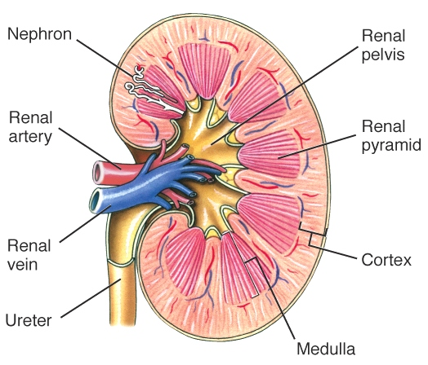
- Describe the gross morphology of the vertebrate kidney.
  - 1% of body weight but 20-25% of cardiac output
  - Layers
    - Cortex
    - Medulla
    - Renal pelvis
  - Functional unit is the nephron
  - Connects to ureters, bladder and finally urethra

- Describe the segments of the nephron and the blood circulation to the nephron.
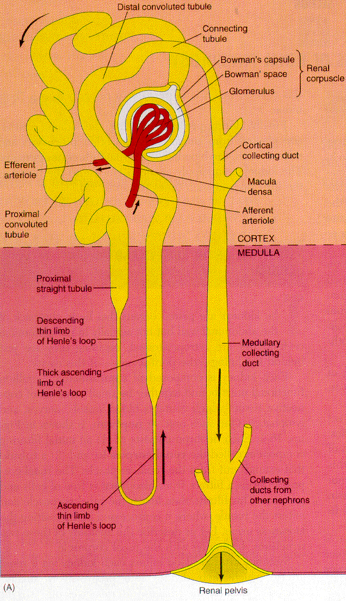
  - Regions
    - Renal corpuscle
      - Bowman’s capsule
        - Enlarged portion of tubule surround glomerulus
        - Filtration o ccurs here
      - Glomerulus
        - Not part of the nephron, part of blood circulation
    - Proximal tubule
      - Reabsorbs some of filtrate ~70%
    - Loop of Henle
      - Hairpin structure (mammals and birds)
      - Concentrating centre
        - Descending limb
        - Ascending limb
    - Distal tubule
      - Fine tuning of urine composition
    - Collecting duct
      - Collects output of several nephrons
    - Afferent arteriole
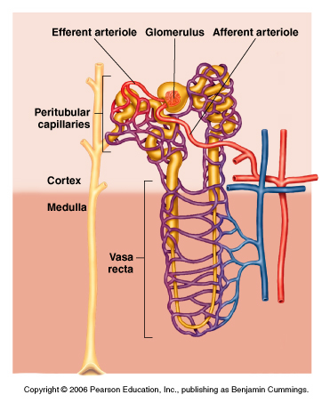
      - Short and large diameter, low resistance
    - Efferent arteriole
      - Narrow and long, leads to capillary bed, high resistance
    - Peritubular capillaries
      - Near renal corpuscle for immediate reabsorption of ions and water
    - Vasa recta
      - At level of loop of Henle in the medulla
        - Absorption

- Use the renal clearance ratio to describe the handling of a solute by the kidney.
  - Renal clearance ratio is the appearcance of solute in urine over the appearance in filtrate
  - RCR = 1 filtration only
  - RCR > 1 = net secretion
  - RCR < 1 = net reabsorption
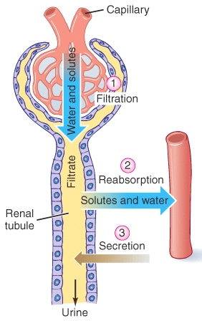
- Explain the three processes involved in urine formation, describing the structural basis of each process.
  - Filtration
    - Molecular size
    - Filtrate = blood plasma – proteins
    - Glomerular filtration rate (GFR)
      - 15-25% of water and solutes are filtered
      - 125 mL/min
    - Structural basis
      - Pressure gradients
        - Can be varied by controlling diameter of afferent arterioles
          - Main mechanism
        - Hydrostatic pressure difference = BP – Pc = ~45mmHg
        - Colloid osmotic pressure difference = ~30mmHg
          - Plasma proteins
      - High BP occurs here
      - More valves than normal arteries
      - Filtrate must be small enough to get through endothelial cell layer, basement membrane, and foot processes of podocyte
        - All relatively permeable
          - Reduce cells and proteins getting through
  - Reabsorption
    - 99% water and salts
    - Active and passive mechanisms
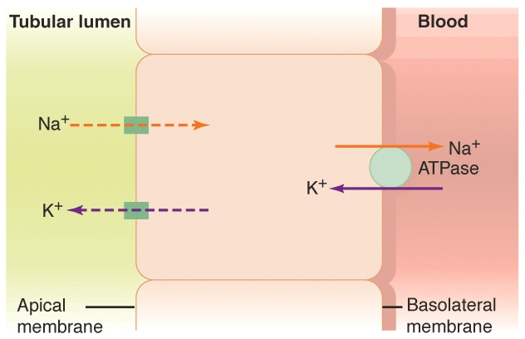
    - All glucose, aa’s reabsorbed
    - 44% urea reabsorbed
    - Brush border increases surface area
    - Lots of mitochondria
  - Secretion
    - Selective
      - K, H, NH3, acids and bases
    - Active transport
      - Require ATP
    - Increases concentration in the urine
    - Distal tubule
    - Source to get rid of foreign molecules
      - Antibiotic s
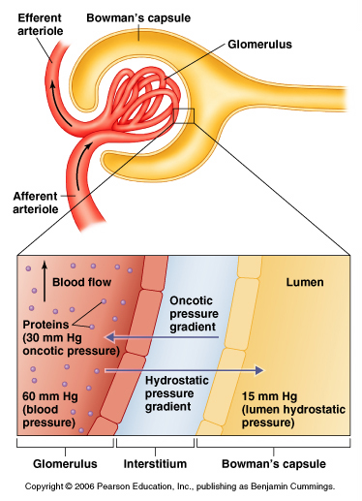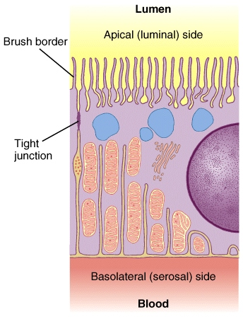

Pop Quiz – Lecture 14
- True or False – the glomerulus is part of the nephron.
  - False, it is part of the blood supply to the nephron.

- True or false – only waste products (e.g. urea), salts and water are filtered at the renal corpuscle.
  - False, all solutes small enough end up in filtrate.

- I have a loop of Henle, whose nephron am I?
  - Mammals, some birds.

- I lack a renal corpuscle, whose nephron am I? How is urine formed by my owner?
  - Fish in a marine environment.
    - Reduces fluid loss in urine.
    - Foremed by secretion at proximal tubule.

- I lack a distal tubule, whose nephron am I?
  - Marine fish
    - It is a diluting segment

- What are the structural features of the renal corpuscle that are related to its function as the site of filtration?
  - Fenestrated capillaries
  - Basement membrane
  - Podocytes of bowmans wall
  - Large diameter afferent arterioles
    - Low resistance to
  - Small diameter efferent arterioles
    - High resistance away

- Which of the following solutes would exhibit the highest renal clearance ratio (RCR): Inulin, Na, urea, glucose, or K?
  - K, it is the only one that is secreted.

- What about the lowest RCR?
  - Glucose, it is the only one completely reabsorbed

Learning Objectives – Lecture 15
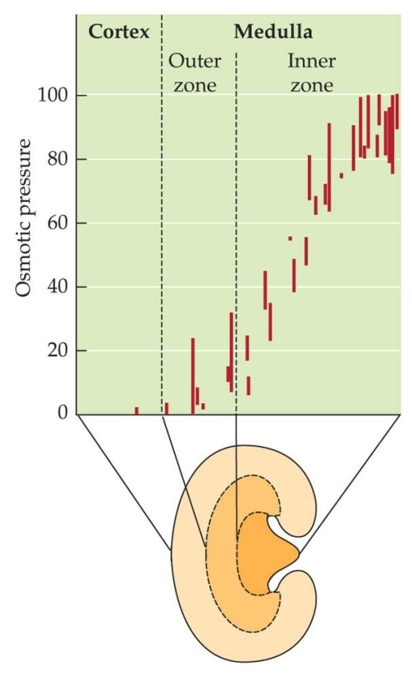
- Describe the concentrating mechanism of the mammalian kidney.
  - The renal concentration mechanism
    - Osmotic removal of water from collecting duct
    - Corticomedullary concentration gradient
      - Increases in [NaCl] and [urea] from cortex t o inner medulla
      - Based on loop of Henle
        - Functional asymmetry in permeability and salt transport
          - Descending loop permeable to water, ascending loop permeable to salt.
        - Anatomical layout
          - Concentration higher near the hairpin, lower near the top of the loop
        - Countercurrent principle
          - Due to hairpin shape of loop
      - As the filtrate moves down the loop of Henle, hypothetically, all concentrations will be the same. In reality, the filtrate is moving, as it moves through the ascending limb, the Na is reabsorbed into the interstitial space, thus requiring the water from the descending loop of Henle to be diffused into the interstitial space to counteract the increased osmolarity of the ISF. Once this occurs, as the filtrate continues to move through the loop, the filtrate at the top become almost iso-osmotic in osmolarity, while the filtrate near the hairpin of the loop become very concentrated with salts.
      - The longer the loop of Henle, the more concentrated the urine gets.

- Explain the diversity among vertebrates in nephron structure and function in terms of environmental adaptation.
  - Loop of Henle
    - Mammals
      - Relative length reflects the environment. (aka the more water in the relative environment, the shorter the length)
    - Birds
      - Only 10-30% of nephrons
      - Have other ways of salt secretion while conserving water
    - Fish, amphibians and reptiles
      - Lacking
  - Glomerulus
    - Freshwater fish
      - Enlarged
        - Need to get rid of lots of water in filtrate
    - Saltwater fish
      - Reduced size
        - Need to reduce water loss in filtrate
    - Aglomerular fish
      - No glomerulus
  - Nephron
    - Freshwater fish
      - Many nephrons
    - Saltwater fish
      - Fewer nephrons
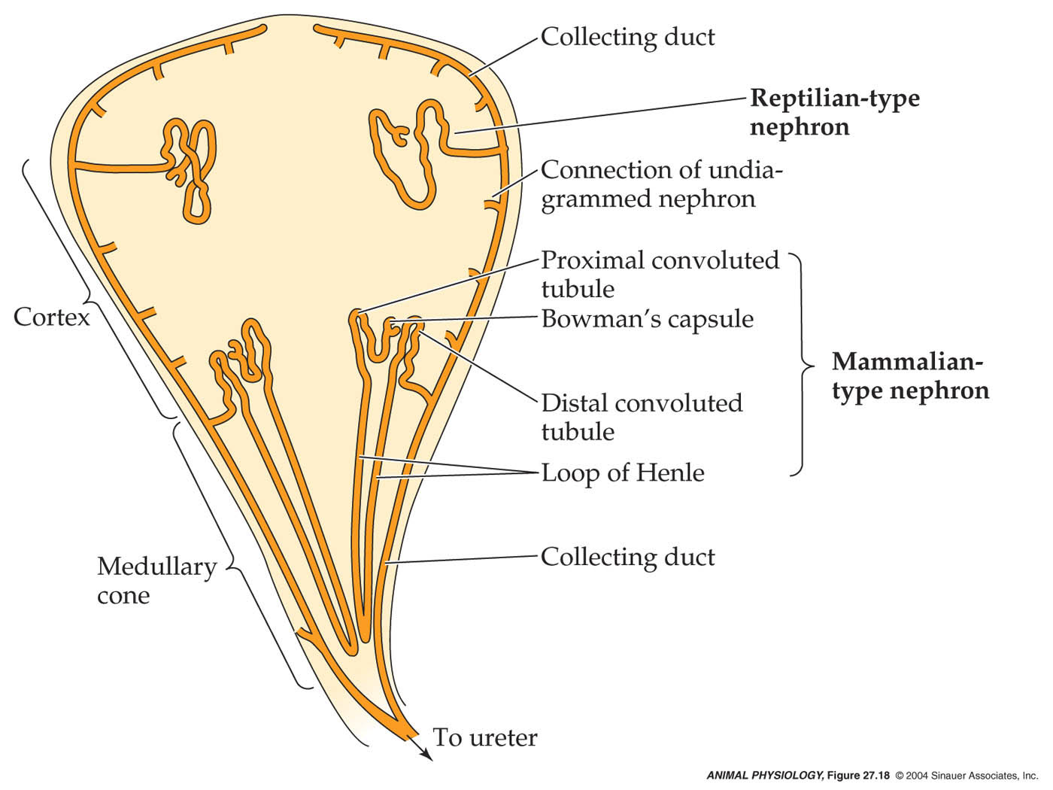
- List the three basic mechanisms through which urine formation (and hence salt and water balance) is regulated.
  - A control of glomerular filtration rate
  - Control of salt reabsorption
    - NaCl represents > 90% osmotic activity of ECF
    - Linkage between salt and water reabsorption
  - Control of water reabsorption

- Explain the intrinsic and extrinsic control of glomerular filtration rate.
  - Intrinsic control
    - Adjust resistance to flow
    - Myogenic mechanism
      - ↑ MAP
      - ↑ afferent arteriolar pressure
        - Stretch of arteriolar smooth muscle
          - ↑ contriction of afferent arteriole, ↑ resistance of afferent arteriole
            - ↓ glomerular capillary pressure, ↓glomerular filtration pressure
              - ↓ GFR = negative feedback
                - ↑ GFR
OR
      - ↑ MAP
      - ↑ afferent arteriolar pressure
        - ↑glomerular capillary pressure
          - ↑ glomerular filtration pressure
            - ↑ GFR
    - Paracrine mechanism
      - ↑ MAP
      - ↑ afferent arteriolar pressure
        - ↑glomerular capillary pressure, ↑ glomerular filtration pressure
          - ↑ GFR
            - ↑ flow at macula densa = chemical signals
              - ↑ Constriction of afferent arteriole, ↑resistance of afferent arteriole
                - ↑ glomerular capillary pressure = negative feedback on Step 2.a) ↑glomerular capillary pressure, ↑ glomerular filtration pressure
  - Extrinsic control
    - Neural control
      - Sympathetic neural control
      - Baroreceptors
    - Hormonal control
      - Angiotensin II
      - ADH (AVP or AVT)

- Describe the renin-angiotensin system and explain how it is used to regulate salt and water balance.
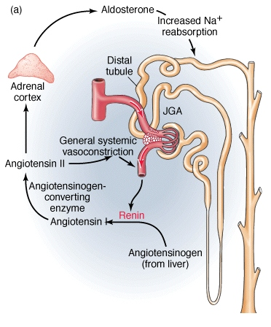
  - This system controls sodium reabsorption
  - Juxtaglomerular cells are stimulated by a decrease in sodium concentration in the flow to the macula densa, and a decrease in BP or volume, and sympathetic stimulation or circulating catecholamines.
  - The response to these cells are renin release
    - Which convert angiotensinogen into angiotensin I, which is then converted into Angiotensin II via ACE in the lungs.
      - Angiotensin II stimulates aldosterone and increases blood pressure.
        - Aldosterone promotes Na reabsorption. Water retention occurs here.
          - Acts on distal tubule of nephron
            - Increases # of Na channels and increases # of Na pumps.

- Explain the role of ADH in the regulation of water balance in vertebrates.
  - ADH secretion is controlled by:
    - Plasma osmolarity
      - Hypothalamic osmoreceptors
    - Blood pressure
      - Via baroreceptor reflex and atrial stretch receptros
  - ADH regulates
    - Collecting duct permeablitiy in mammals (AVP)
    - Distal tubule permeability in FW fish, amphibians (AVT)
      - Insertion of aquaporin 2 into the apical membrane of the pelvic patch and bladder
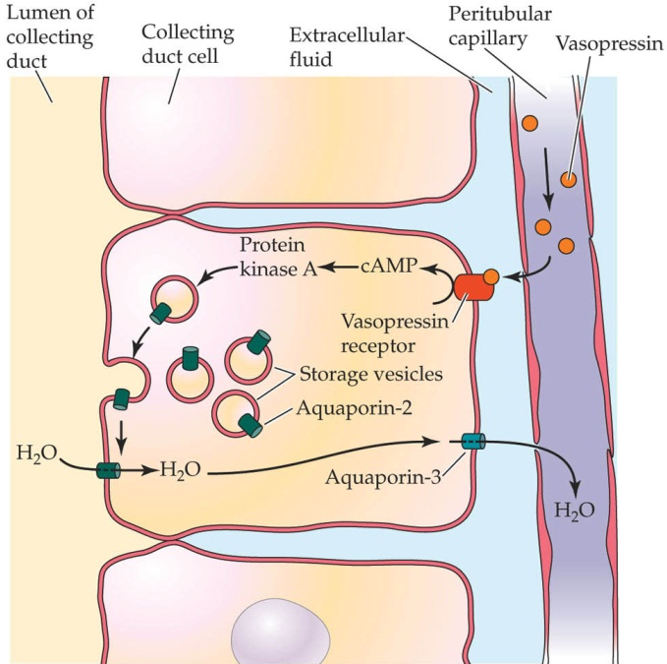
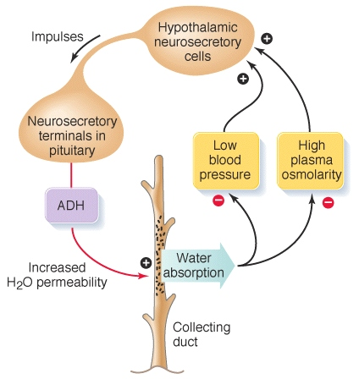
- Describe the cellular actions of aldosterone and ADH.
  - ADH increases water permeability of collecting duct
    - It is a peptide hormone
    - Insertion of AQP 2 in apical membrane
  - ADH binds to receptor
    - Releasing cAMP into cell
      - Activating PKA
        - Inserts AQP 2 into apical membrane

- Explain the role of atrial natriuretic peptide in the regulation of salt and water balance.
  - ANP is involved in control of both salt and water balance
  - Responds to increased plasma volume by increasing salt and water excretion
  - Stretch-sensitive cells in wall of atrium: stretch ↑ ANP
  - ANP increases urinary loss of Na
    - Inhibits release of renin
    - Inhibits secretion of aldosterone
    - Inhibits ADH release
    - Increases GFR
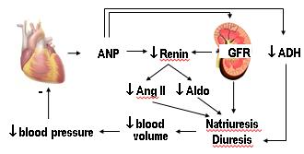

Pop Quiz – Lecture 15
- List the structural features of the loop of Henle that allow it to function as a concentrating mechanism.
  - Permeability to salt and water different between descending and ascending loop of Henle:
    - Descending – permeable to water, no salt transport
    - Ascending – permeable to salt, no water transport
  - Transport protein position in loop of Henle.

- T or F: A decrease in glomerular blood pressure from 55 to 47 mmHg represents myogenic regulation of GFR?
  - False
    - Myogenic regulation = smooth muscle of arteriole
      - Keeps blood pressure constant in glomerular capillaries
      - Not expected to reduce pressure
        - Extrinsic would
          - Reduce glomerular GFR

- T or F: Angiotensin II levels are determined by circulating levels of angiotensinogen.
  - False
    - Angiotensin II regulated by renin levels (released by kidney)

- A frog becomes dehydrated. What is the hormonal response? What responses are triggered by this hormone?
  - ↑ AVT, reduced glomerular filtration, water reabsorption
    - Pelvic patch and bladder permeability increases
      - AQP 2 channels inserted into apical membrane and skin
        - Conserve water
          - ↑ environmental water
          - ↓ water loss

- Blood pressure falls owing to blood loss by haemorrhage. How is this problem corrected?
  - Short term response
    - Baroreceptors and stretch receptors (detect ↓ BP)
      - Carotid and aortic arch sinuses, ↓ firing, ↑ ADH, ↑ sympathetic neuronal activity, ↓ parasympathetic activity
        - Kidney = ↑ renin, ↑ vasoconstriction in afferent arteriole
          - ↑ angiotensin II
          - ↓ GFR
  - Long term response
    - Restore blood volume
      - ↑ Salt reabsorption in distal tubule
      - ↑ water absorption in collecting duct
      - Angiotensin II increases BP, and stimulates aldosterone

Learning Objectives – Lecture 16
- Predict the responses of the renal control systems to challenges to salt and water balance (e.g. dehydration, consumption of salt load).
  - Dehydration
    - ↑ ANP which (↑ BP, ↑ osmolarity)
    - ↓ BP, Stretch receptor firing, increase ADH, promote water reabsorption
    - Low urine flow (high concentrated urine)
    - Detected by macula densa
    - ↓ renin, ↓ aldosterone, ↓ Na reabsorption
  - Overhydration
    - ↑ BP, osmolality of blood falls (diluted)
    - Activate intrinsic mechs, ↑ GFR
    - ↓ vasopressin (AVP)(ADH) inhibited
    - Decrease reabsorption, increase urine flow rate
    - Large volumes of dilute urine

- Describe different kinds of acid-base disturbances and the mechanisms through which they are regulated.
  - Disturbances
    - Alkalosis
      - High HCO3 in blood, low H
      - Alkaline tide, base infusion (metabolic)
      - Hyperventilation (increasing pH)
    - Acidosis
      - High H in blood, low HCO3
      - Acid infusion
      - H release following exercise
    - Respiratory
      - pH change and PCO2 changes.
    - Metabolic
      - pH changes but PCO2 does not.
  - Compensation
    - Respiratory alkalosis
      - Retain CO2
        - Hypoventilate

    - Respiratory acidosis
      - Blow off CO2
        - hyperventilate
    - Metabolic alkalosis
      - Excrete HCO3 and/or accumulate H
        - Urine/gills
    - Metabolic acidosis
      - Accumulate HCO3 and/or excrete H
        - Kidneys

Pop Quiz – Lecture 16
- You drink 2 L of Coca cola. Describe the renal response. How is it achieved?
  - Note: osmolarity of coke is ~493 mOsmol/L (mostly due to sugar!), pH 2.4, 0.1 mg caffeine/mL.
    - Renal response:
      - ↑ blood pH (acid load)
        - Sugar gets taken up (valuable resource)
        - NaCl in plasma (osmolarity of plasma ~300 mOsmol/L)
          - Adding large volume of fluid
            - ↑BV and BP
        - Taking on volume load and acid
          - Increase filtration
          - ADH goes down
          - Produce increased volume of dilute urine and acidic urine

- What is the response of the mammalian kidney to consumption of a base load?
  - Excrete more basic urine.

- Provide an example of how a respiratory alkalosis might occur.
  - High altitude hyperventilation, low altitude as well.

Learning Objectives – Lecture 17
- Explain how and why the compensatory mechanisms used by tetrapods and fish to correct acid-base disturbances differ.
  - They differ in
    - Reliance on respiratory compensation
    - Primary organ for metabolic compensation
  - Tetrapods
    - Alter ventilation
    - Rely on HCO3 adjustment via the kidney
      - During acidosis, HCO3 is retained by enhancing tubular HCO3 reabsorption
      - Reabsorbed by an H mechanism, bound to filtrate, combining to form CO2
      - Kidney, H recycling (cycling over), HCO3 reabsorbed in filtrate.

  - Fish
    - Entirely reliant on metabolic compensation
      - Gill is the workhouse, not the kidney.
        - Acid and base secreting cells
          - Linked, may come at some ionic cost
            - Less chloride taken up
          - Alkilosis compensation
            - ↑ exchange of HCO3-Cl
            - ↓ proton loss
          - Acidosis compensation
            - ↑ proton loss
            - ↓ HCO3 loss
          - Important for kidney to regulate as a secondary filter
    - No respiratory compensation
      - PCO2 very low
      - Fish cannot afford to hyperventilate

- Explain why nitrogen must be excreted.
  - Nitrogen in the body gets converted into ammonia, which is toxic.
  - Amino acids get converted into ammonia
  - Synthesized in the liver and converted into ammonia

- List the three main end-products of nitrogen metabolism, together with the pros and cons of using each one and their modes of synthesis.
  - Ammonia
    - Pro
      - Requires least amount of energy to get rid of
    - Con
      - Requires more water to get rid of.
      - Incredibly toxic
    - Synthesis
      - Nucleic acids N bases C skeleton and NH2 groups ammonia
      - Proteins Amino acids C skeleton and NH2 groups ammonia
  - Urea
    - Pro
      - Requires less water to get rid of.
      - Less toxic
    - Con
      - Requires ATP
    - Synthesis
      - Ornithine urea cycle
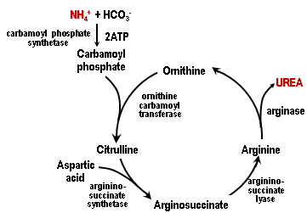

  - Uric acid
    - Pro
      - Requires the least amount of water to get rid of.
    - Con
      - Requires ATP
      - Turns amino acids into purine ring, which is a large molecule and needs transporters. Therefore more energy needed.
    - Synthesis
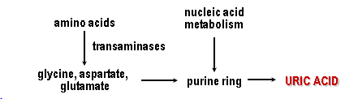
- Explain patterns of nitrogen end-product use in terms of environmental water availability and the environment in which embryonic development occurs.
  - Ammonia
    - Used when environmental water is very abundant
    - Used when larval stage of amphibians live in water
  - Urea
    - Used when environmental water is not as abundant or not available for a while. (Lungfish)
    - Terrestrial animals, also some fishes (lake migadi tilapia)
    - Some fish use urea as an osmolite
    - Some fish use urea as camouflage
  - Uric Acid
    - Embryonic stage is a shelled egg.
      - Exception of crocodiles (secrete ammonia)

- List the animal groups that use each end-product, and explain how the exceptions to these patterns support the previous point.
  - Ammonotelic
    - Fish, invertebrates, crocodiles, larval amphibians
  - Ureotelic
    - Elasmobranchs, terrestrial animals,
  - Uricotelic
    - Birds, reptiles

Pop Quiz – Lecture 17
- What is the main factor determining whether an animal excrets ammonia or urea/uric acid? Provide an example that illustrates this point.
  - The water availability in the environment.
    - Alligators, when small don’t secrete ammonia, they secrete uric acid.
      - when adult they secrete ammonia
    - Tadpoles secrete ammonia (aquatic), frogs secrete urea (semi-terrestrial)
    - Lungfish, in water secrete ammonia, on land secrete urea.

- What is the OUC?
  - Ornithene urea cycle – converting ammonia into urea.
  - Ureotelic animals

- What is an Rh glycoprotein?
  - Transport proteins for ammonia.

- What is a cleidoic egg and why does it matter with respect to N2 excretion?
  - Has a shell, closed environment
    - Cant get rid of N2
    - Use uric acid, low toxicity
    - Birds, reptiles, terrestrial insects
      - Uric acid = N2 end product

- What is the acid-trapping mechanism?
  - Occurs at fish gill
    - Ammonium can’t pass through membranes
    - Ammonia passes through membrane
    - Protonated with protons from hydration of CO2 or proton pump

- What prevents the Lake Magadi tilapia from excreting ammonia?
  - pH of the lake is too high, too buffered, acid trapping mechanism doesn’t work.

- Why is the mangrove killifish unusual?
  - It can survive outside of water for a month at a time. Excretes ammonia gas.

Learning Objectives – Lecture 18
- Describe the thermoregulatory strategies of animals using the terms endothermy vs ectothermy and poikilothermy vs homeothermy.
  - Endothermy
    - Generates enough metabolic heat
  - Ectothermy
    - Does not generate enough metabolic heat
  - Poikilothermy
    - Body temperature follows the environment
  - Homeothermy
    - Stable body temperature

- Distinguish between regional and temporal heterothermy.
  - Regional heterothermy
    - Regulates body temperature in specific parts of body but not the rest of it.
      - E.g. brain and eyes and swimming muscles of fish
  - Temporal heterothermy
    - Regulates body temperature but fluctuates at different times of the day.
      - Body temperature vs. time.

- List (with examples) the types of heat exchange that occur with the environment and the main determinants of the rate of exchange.
  - Radiation
    - Heat derived from energy in radiation
      - UV visible IR
      - Absorption and re-radiation
    - Determinants
      - Medium – water vs. air
        - Air doesn’t absorb radiant heat whereas water does
      - Colour – Light vs. dark
      - Surface area
        - Larger SA the more heat gain (loss).
      - Temperature difference
        - Clear night vs. cloudy night.
          - Cloudy night radiates heat back at you.

  - Conduction
    - Direct transfer of energy
      - Requires contact
      - Heat flux
    - Determinants
      - Material – conductivity
        - Water vs. fat vs. water
        - Aquatic vs. terrestrial animals
        - Thickness
        - Temperature difference
        - Surface area
  - Convection
    - Transfer of heated molecules by a moving fluid
    - Determinants
      - Rate of fluid flow
        - Wind chill factor
        - Boundary layer
      - Conductivity of fluid
      - Surface area
      - Temperature difference
    - Faster than conduction

- Distinguish (with examples) between obligatory and regulated evaporative heat loss.
  - Obligitory
    - Temporal counter-current exchange
    - Reduce heat and water loss by recondsing water vapour
      - Mammals
  - Regulated
    - Only route for heat loss when environmental T > ideal T
      - Role of environmental humidity
    - Environmental water
    - Body water
      - Saliva spreading
      - Panting need to avoid respiratory alkalosis
      - Sweating – salt and water loss
    - Dry environments and SA:V

Pop Quiz – Lecture 18
- Distinguish between thermoregulation and homeothermy.
  - Thermoregulation
    - Attempt to maintain constant temperature
  - Homeothermy
    - Constant body temperature maintained, (could be from environment)
      - Without telling how it is maintained.

- Distinguish between homeothermy and endothermy.
  - Endothermy
    - Metabolic heat as a component of thermoregulation strategy. Generates enough metabolic heat.

- Why is a windy day cooler than a still day?
  - Increasing convective heat loss.

- Why is the danger of over-heating in a hot tub greater than that in a sauna (at the same temperature).
  - Sweat in a sauna
  - Conduction heat gain in water is > than air.

- What sources of heat exchange are relevant to a tadpole? What about a frog?
  - Water temperature, only important heat exchange is conduction
  - When in water, same as tadpole.
    - When on land, radiant heat from sun, conductive with lily pad, convective with air.

Learning Objectives – Lecture 19
- Explain the relationships among metabolic heat production, body temperature (Tb) and environmental temperature for endotherms vs. ectotherms.
  - Endotherms
    - Have high metabolic rates. This allows for endothermy.
      - Generate heat by ramping up metabolism
      - Factors
        - Pulmonary and systemic circulation = low pressure and high pressure systems
        - Diaphragm, air sacs, ventilation mechanisms
        - High surface area alveoli or parabronchi
    - Why only air breathers?
      - Water is an oxygen poor environment
        - Lower metabolism rates
        - Breathing water loses heat to surround water
    - Try to stay in thermoneutral zone to minimize metabolic costs.
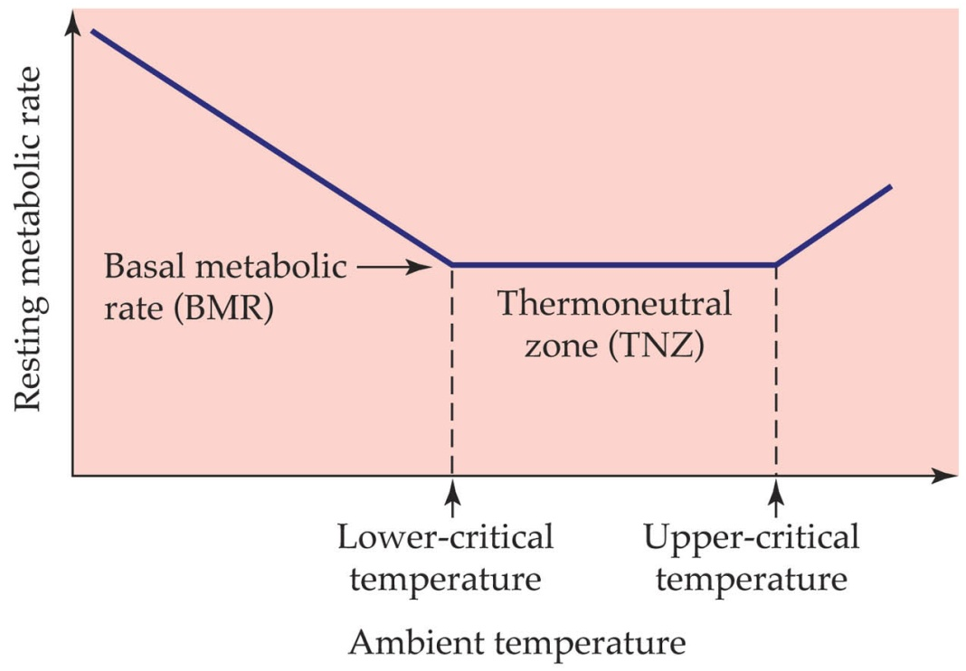
  - Ectotherms
    - Have low metabolic rates. This means they must use ectothermy.
    - As environment temperature rises, body temperature raises, oxygen uptake rises, and metabolic rate rises.
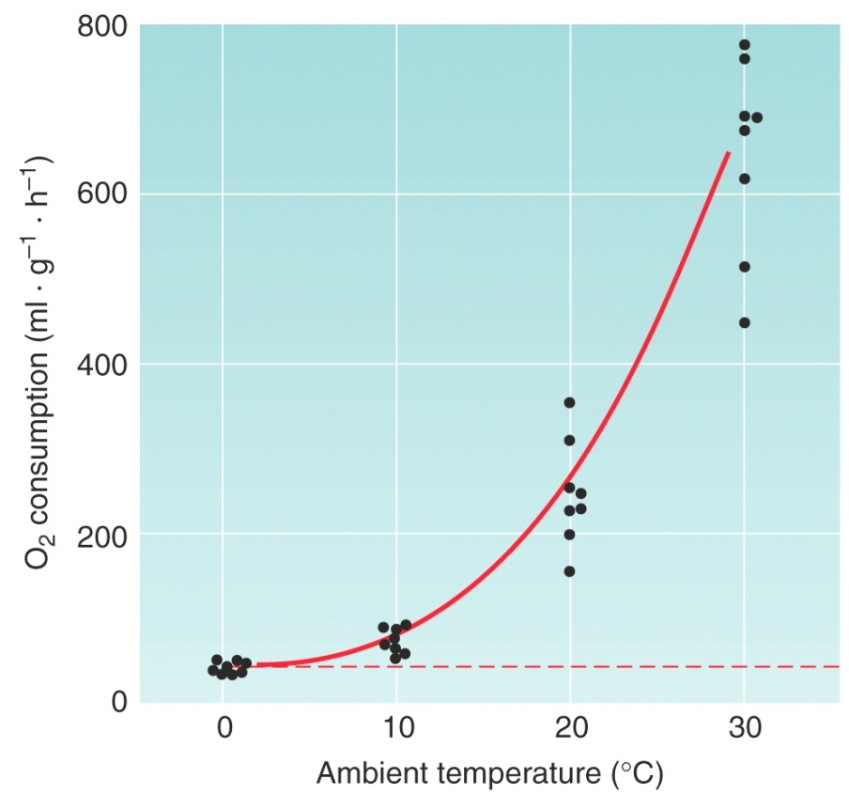
- Sketch examples for animals with different thermal strategies of the negative feedback pathways used in thermoregulation.
  - Endotherms
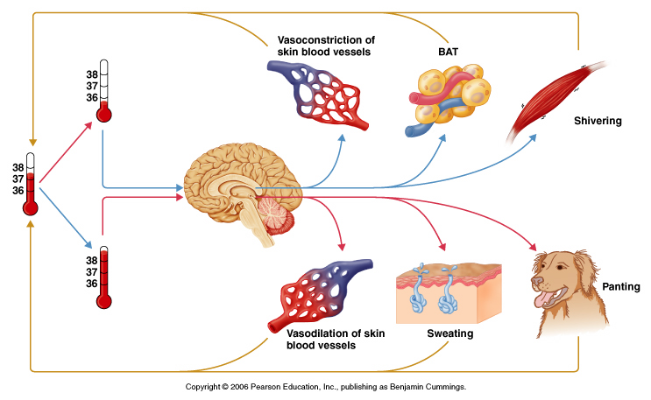
  - Ectotherms
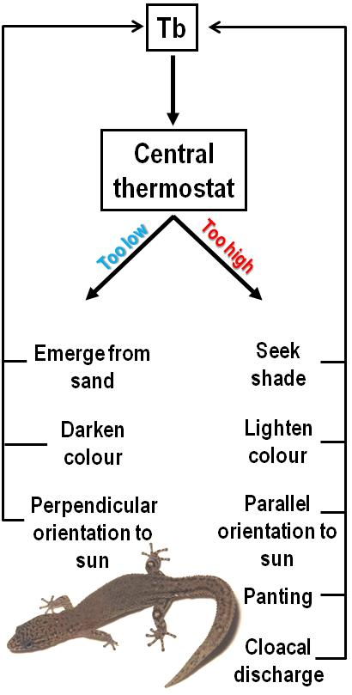
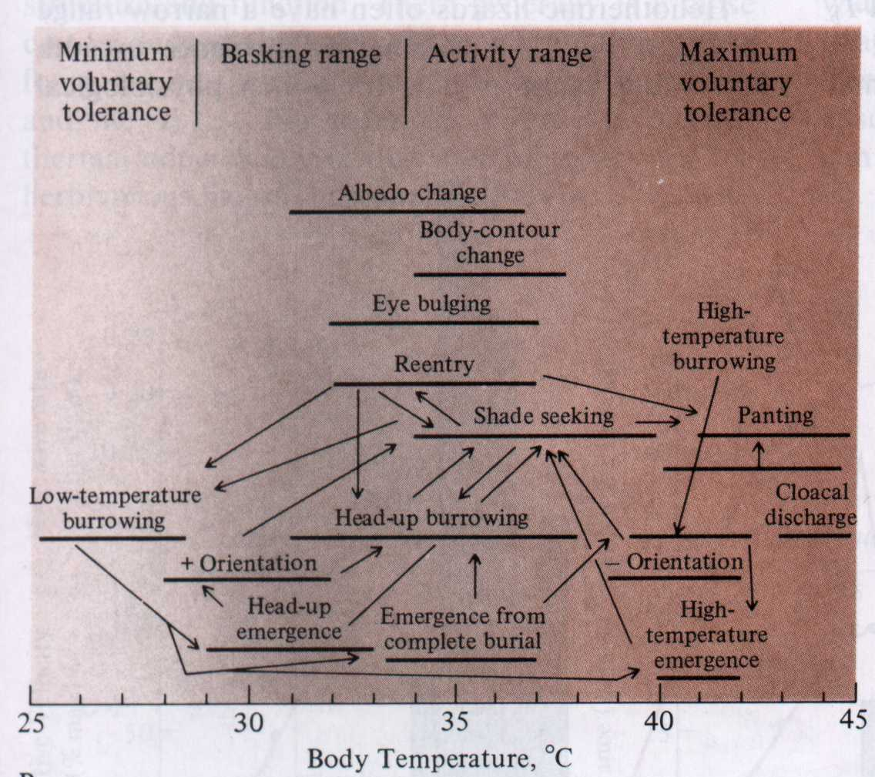
- Explain behavioural thermoregulation and provide examples of what animals use this strategy and how it is used to regulate Tb.
  - Try to find a favourable environment
  - Most of the time Te is < Tb
  - By using behavioural thermoregulation, it can maintain preferred Tb more than just Te can.
  - Many different behaviour. Make use of environment of preferred temperature.

- Describe, with examples, the physiological mechanisms used by ectotherms to regulate heat exchange.
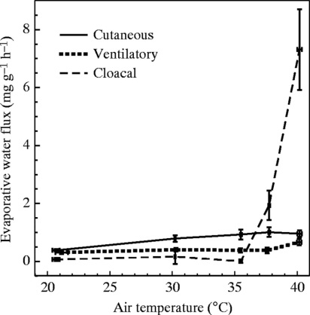
  - Colour changes, for example B.alvarengai will turn black to absorb more heat when it is cold, and turn white to reflect more heat when it is hot.
  - Use of evaporative heat loss
    - Panting
      - Galapagos marine iguana
    - Cloacal evaporative cooling
  - Regulation of convective and/or conductive heat transfer by cardiovascular adjustments in reptiles (lizards)
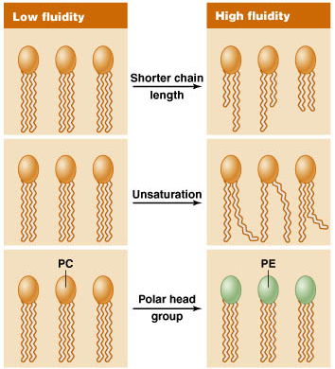
    - Vasodilate in places to lose heat, (belly) casoconstrict on back, lift their belly off the rock, shed heat into their own shadow
    - Stand parallel to the sun
  - Compensatory adjustments of physiological function within idividual (attempt to acclimate to new temperature
    - Blunts impact of temperature changes on physiological function
    - Homeoviscous adaptation
      - Adjustments of membrane composition through phospholipid and/or membrane remodelling to maintain fluidity as temperature changes.
      - Fatty acid chain length, fatty acid saturation, phospholipid classes, cholesterol content.
      - Adjustments of enzyme concentrations

Pop Quiz – Lecture 19
- What is the thermoneutral zone?
  - The thermoneutral zone is the temperature range (environmentally) where endotherms can maintain body temperature with minimal metabolic rate.

- List at least 2 cardiorespiratory adaptations that support endothermy and explain their significance.
  - Must be air breathers
  - Better gas exchange system
  - Separation of systemic and pulmonary circulations
  - Ventilative mechanisms of the gas exchange surface
  - Larger surface area
  - Higher hematocrit
  - Things that increase metabolic rate.

- Where is the ‘thermostat’ in vertebrates? What else is detected here?
  - Hypothalamus
    - Temperature
    - Thirst and hunger (water balance)

- Poikilothermic ectotherms are incapable of thermoregulation. Is this statement true or false? Explain.
  - They do use thermoregulation (behavioural not metabolic)
    - Therefore the statement is false
    - They can change colour
    - Vasoconstriction and vasodilation, minimizing or maximizing heat exchange respectively.
    - Panting
    - Water evaporation from cloaca
    - Depends on thermal environment quality

- Explain the physiological significance of homeoviscous adaptation to a poikilothermic ectotherm.
  - Homeoviscous adaptation
    - Membrane phospholipid changes
    - Maintain constant fluidity
    - Significance?
      - Alter physiology to maintain constant temperature
      - Adjust concentration of enzymes

Learning Objectives – Lecture 20
- Contrast and compare (with examples) strategies for maintaining physiological function as Tb changes (acclimation) vs. strategies for maintaining physiological function at different Tb’s (adaptation).
  - Adaptation = fixed in genome
  - Acclimatization = can change in individual
  - Acclimatization:
    - Freezing solid: ice nucleating compounds/cryoprotectants. Genetic difference.
  - Adaptation
    - Heat shock proteins
      - More enzymes when colder (changes in affinity (genetics), and structure of enzyme)
  - Both
    - Homeoviscous adaptation (adaptation and acclimatization)

Pop Quiz – Lecture 20
- Contrast and compare strategies for acclimatization to seasonal changes in temperature versus adaptation to different temperatures owing to climate (latitude, altitude).
  - Adaptation = fixed in genome
  - Acclimatization = can change in individual
  - Seasonal:
    - Freezing solid: ice nucleating compounds/cryoprotectants. Genetic difference.
    - Heat shock proteins
      - More enzymes when colder (changes in affinity (genetics), and structure of enzyme)
    - Homeoviscous adaptation (adaptation and acclimatization)

- Distinguish between an antifreeze protein and a cryoprotectant.
  - Antifreeze protein
    - Don’t have colligative effect (osmolarity), prevent ice crystals from forming.
  - Cryoprotectant
    - Broader category, colligative (salting the ice on the road) and non-colligative.

- Contrast and compare the roles of behavioural thermoregulation in ectothermic poikilotherms and endothermic homeotherms.
  - Ectothermic poikilotherms
    - Maintain preferred body temperature.
  - Endothermic homeotherms
    - Minimize cost of endothermy by staying in the thermoneutral zone.

Learning Objectives – Lecture 21
- Explain (with examples) how endothermic homeotherms regulate heat exchange in the thermoneutral zone.
  - Adjusting heat loss through
    - Behaviour
      - Postural changes
      - Selection of an appropriate micro-environment
    - Insulation
      - Thicker insulation greater resistance to conductive and convective heat loss/gain
      - Size effects
      - How can insulation be adjusted?
        - Pilomotor or ptilomoter response
        - Heat windows
          - Ears of a rabbit
            - Light fur
            - Sends blood to ears to lose heat
            - Preferential blood flow
        - Seasonally
          - Fur length changes
      - Risks of overheating with exercise.
    - Blood flow
      - Vasomotor responses are used to adjust heat loss
        - Limbs = high surface area:volume
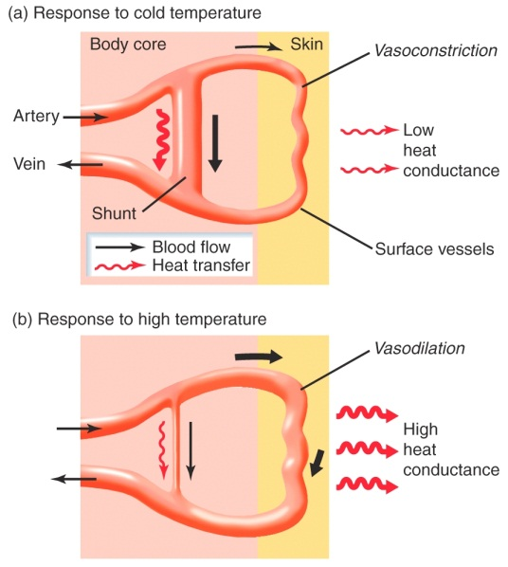
          - Reduce blood flow here to trap heat in the core
          - If cold, then you minimize distance blood travels to minimize heat loss
          - If hot, then you maximize the distance blood travels to maximize heat loss

- Use counter-current heat exchangers as an example of a structure-function relationship.
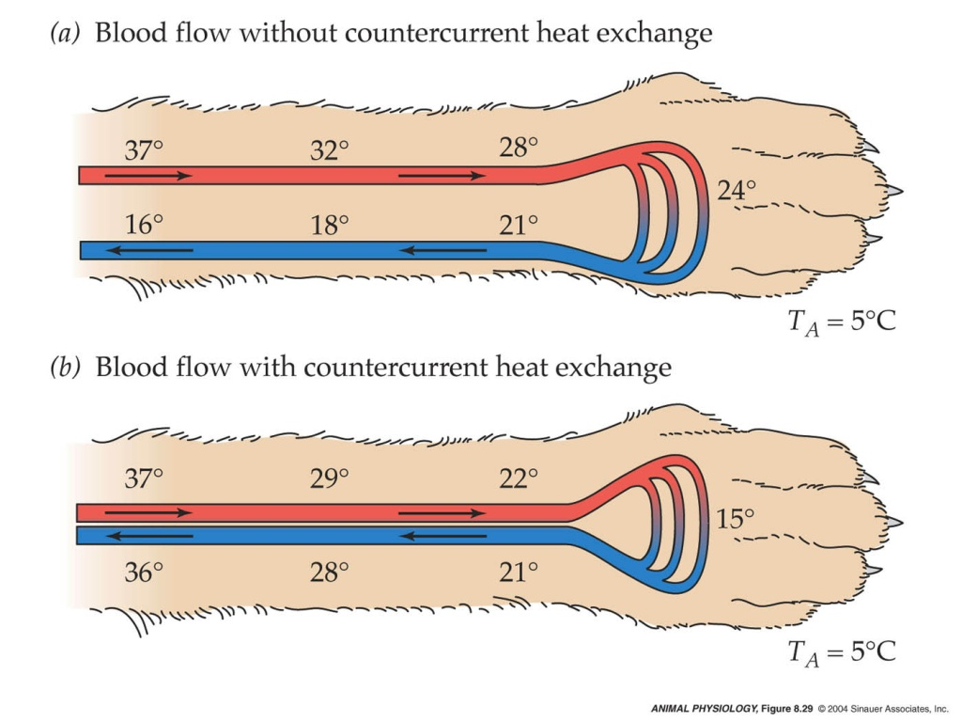
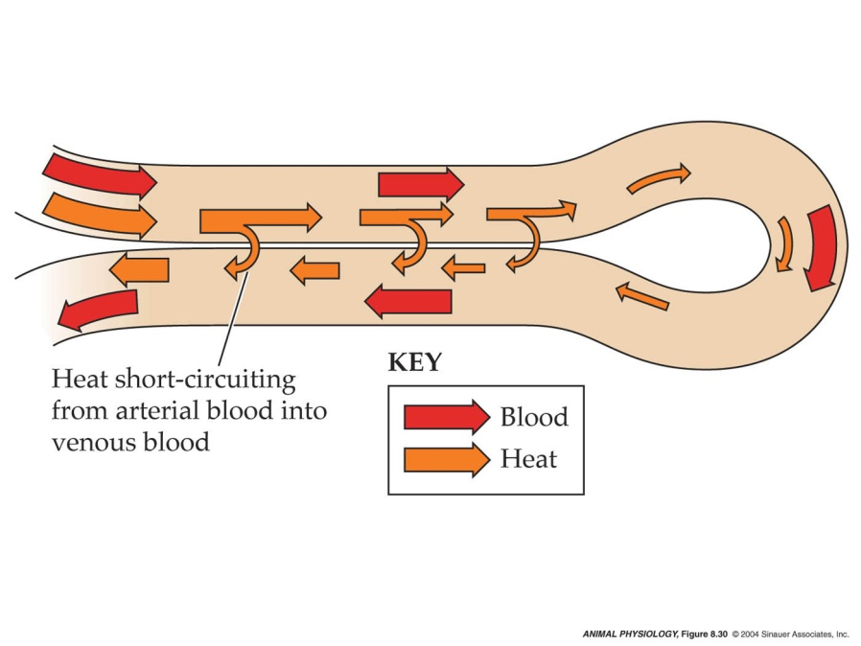
  - Counter-current heat exchanger
    - Reduce heat loss in cold environments without sacrificing blood flow
    - Artery gets surrounded by veins.
      - Heat is trapped by venous blood
      - Heat moves from arterial to venous blood
    - Arterial blood is cooled venous blood is heated
    - Lower temperature difference in extremity = less heat lost (smaller heat gradient)
    - Prevent overheating in warm environments
      - Ungulates
        - Rete mirabile
          - Veins and arteries form counter-current heat exchanger
          - Nasal mucosa
            - Blood is cooled to warm the air
            - Interacts with hot blood at rete mirabile
            - Cools blood to brain to prevent overheating.

- Explain how spatial heterotherms use counter-current heat exchangers.
  - Spatial heterothermy
    - Endothermy and thermoregulation in some areas of the body and no endothermy or thermoregulation in other areas.
  - Insects
    - Heart is in the abdomen.
    - Pumps hemolymph to thorax
      - Cold hemolymph in abdomen.
        - Meets warm hemolymph at abdomen from flight muscles.
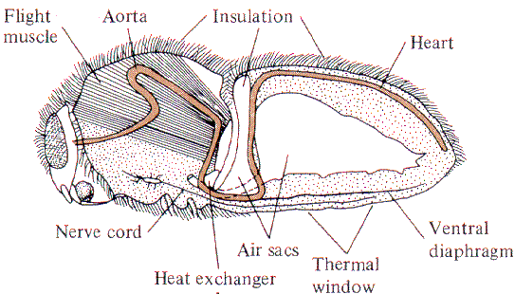
  - Fish
    - Blood around surface of fish go to the red muscle. Blood entering muscles must go through rete mirabile
    - Blood vessels are very close to eachother to act as a counter-current heat exchanger.
      - Heat transferred from venous blood to arterial blood in the rete mirabile.
        - Heat is trapped here.
        - Endothermic water breather.
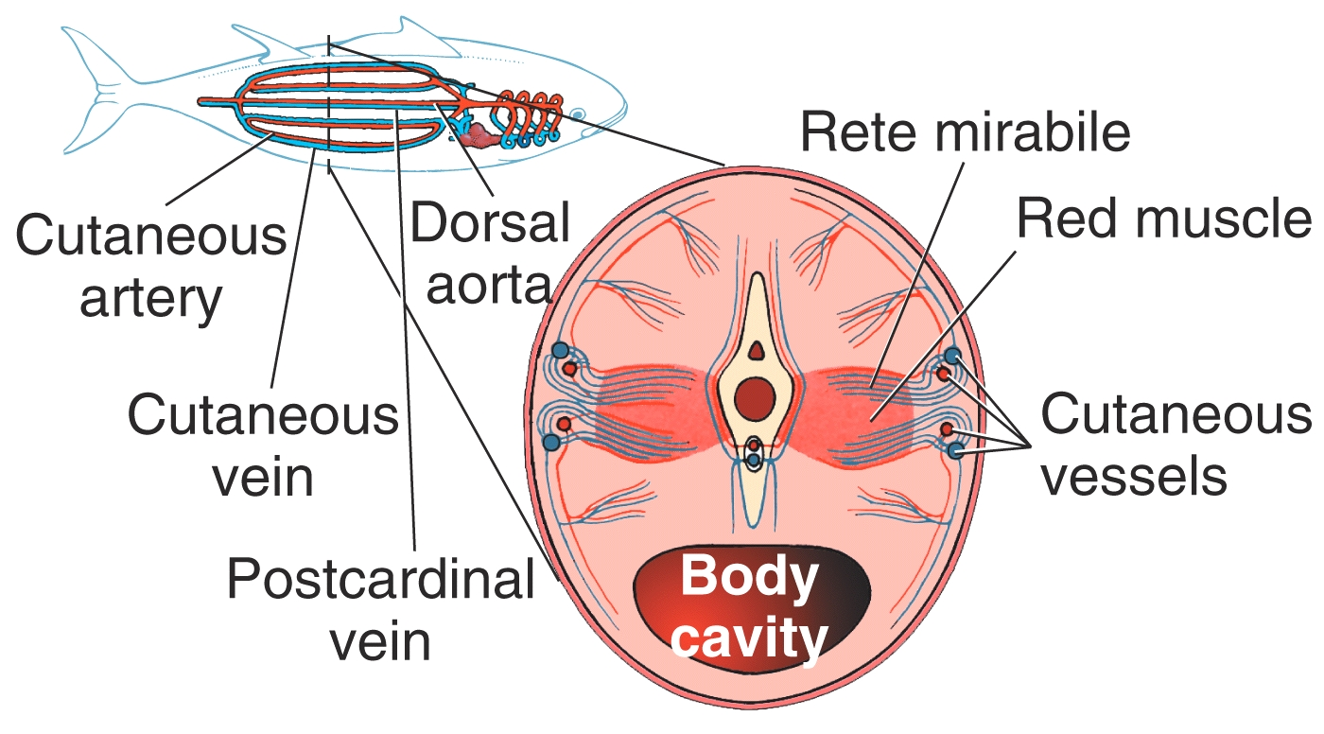
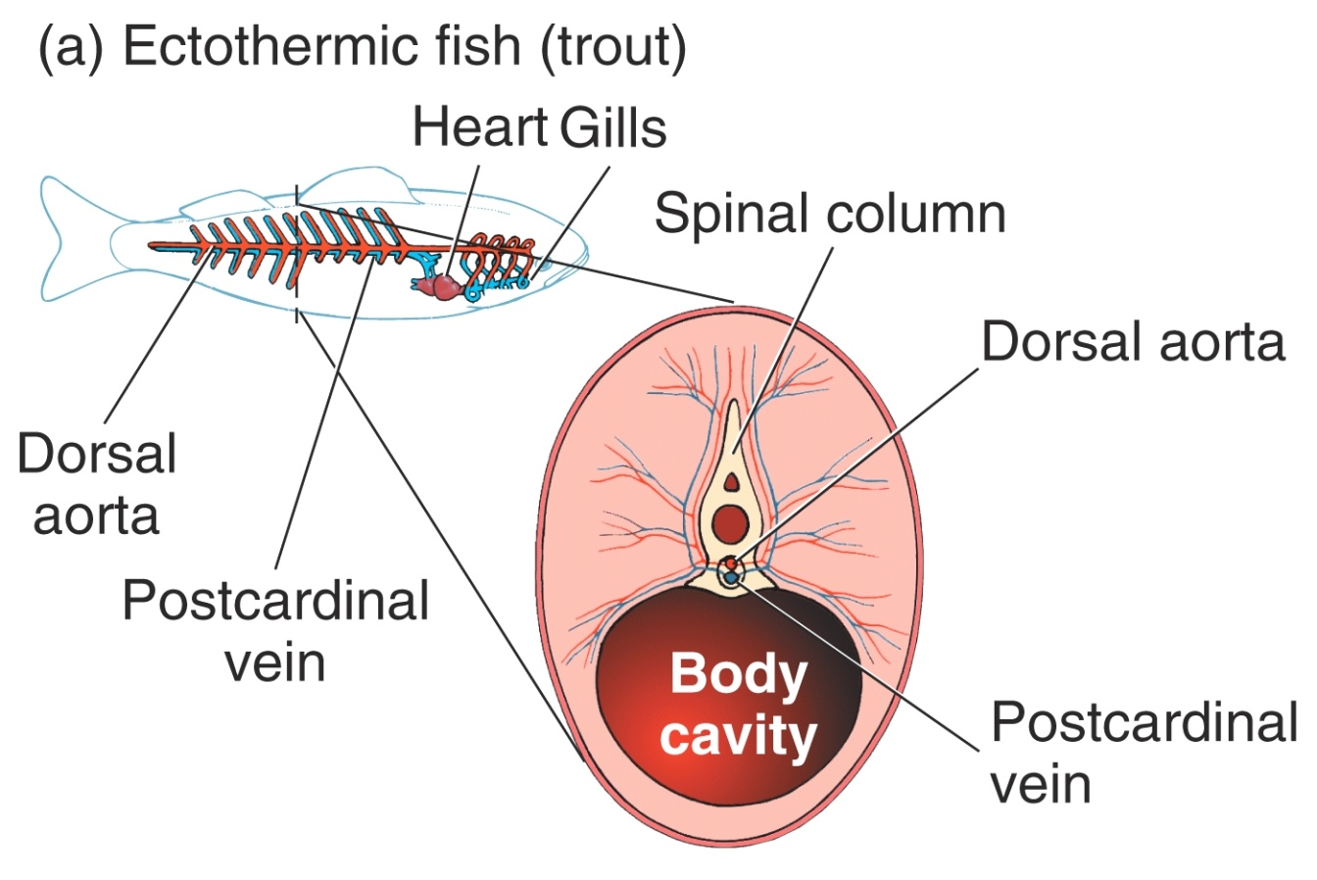

- Contrast and compare shivering vs. non-shivering thermogenesis.
  - Shivering
    - Birds and mammals
    - Similar effect in endothermic insects achieved by activating antagonistic flight muscles simultaneously.
    - Uncoordinated contraction
      - Inefficient = heat production.
      - Antagonistic muscles contract together.
  - Non shivering
    - Doesn’t lead to anything other than heat generation
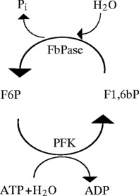
    - Insects
      - Futile carbohydrate cycle
        - F6P F1,6bP
          - Going back and forth between these, adding phosphorus and taking it off.
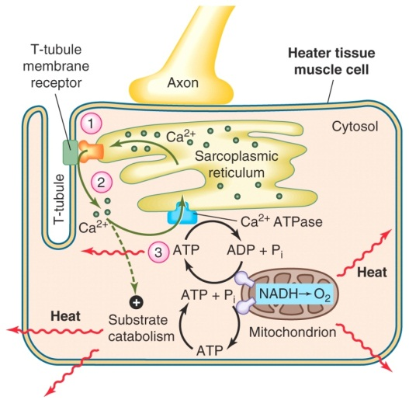
    - Fish
      - ‘Heater muscles’ in fish – futile Calcium cycle
        - Heats the eyes and brain
        - Muscle cells that have no contractile apparatus
        - AP ↑ Calcium pumped back into SR
    - Mammals
      - Brown adipose tissue
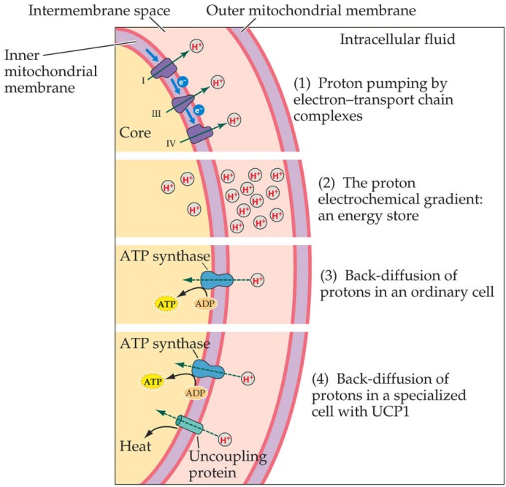
        - Uncoupling of oxidative phosphorylation from electron transport
        - Uncoupling protein 1 (UCP1)
          - Disippates
        - Packed with mitochondria
          - Metabolize fat in a very inefficient way
        - Activated by sympathetic nervous system

- Explain, with examples, the physiological significance of futile metabolic cycles.
  - Examples above
  - The physiological significance of futile metabolic cycles is that the organism can metabolize certain elements of their being in very inefficient ways to produce heat.

Pop Quiz – Lecture 21
- What is a heat window and how is it used?
  - Poorly insulated area on body
    - Short thin fur, fat, or feathers
    - Increases heat loss

- What do fish gills, Arctic fox legs and the loop of Henle have in common?
  - Counter-current exchanger systems

- Explain the principle behind non-shivering thermogenesis, and provide an example of a futile cycle.
  - No mechanical work or change or progression.
    - Energy released as heat.
  - Examples
    - Metabolize fat in a very insufficient way
    - Uncoupling of oxidative phosphorylation from electron transport
    - Fructose 6-phosphate Fructose 1-biphosphate
    - Heater muscle, calcium cycle with no muscle contraction
    - H gradient produced in mitochondria

Learning Objectives – Lecture 22
- Describe, with examples, two strategies endothermic homeotherms use to maintain Tb in hot environments.
  - Seasonally adjust metabolic rate.
    - Winter acclimatized can generate enough heat at cold temperatures
    - Summer acclimatized become hypothermic
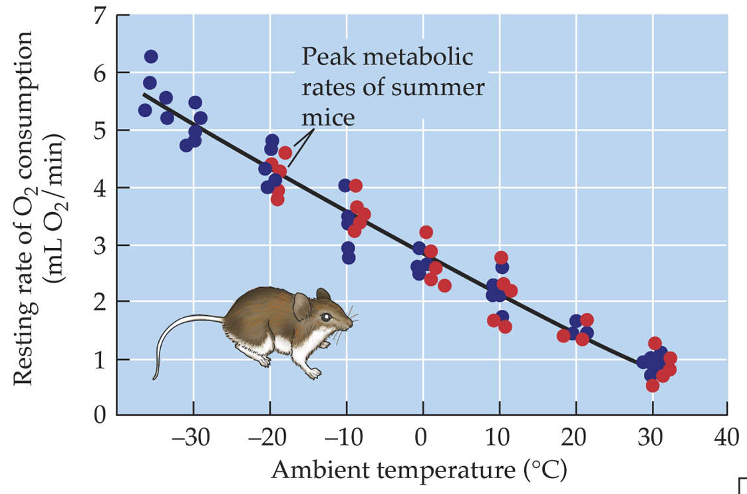
    - More insulation in the winter, longer fur, more fat, etc.
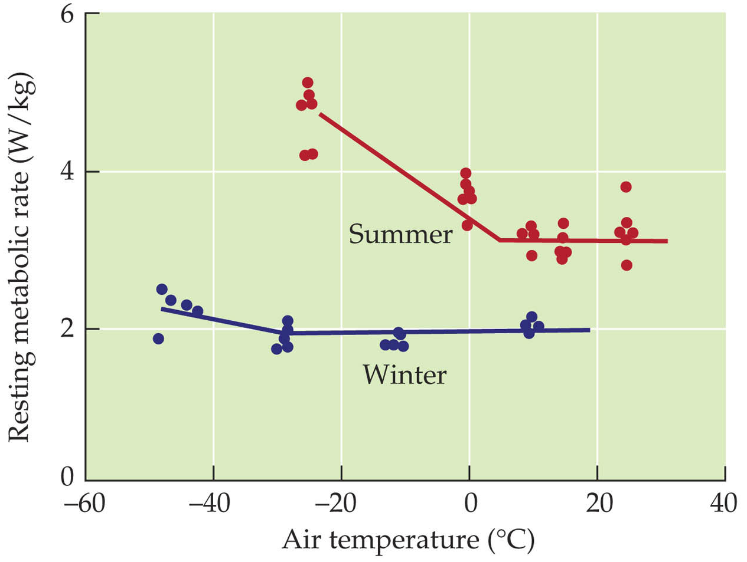
  - Active heat dissipation
    - Active evaporation
      - Saliva spreading, sweating, panting
    - Elevation of body temperature
      - Heat storage
      - Reduces heat gain by minimizing temperature difference
      - Promotes heat loss by increasing temperature difference
    - Use water to evaporate from body.
      - Process of evaporation uses the heat from the body
      - Store heat by elevating temperature
        - Conduction or radiation, without losing body water.
        - Release heat at times when thermal gradient is in their favour.
    - Example:
      - Antelope ground squirrel
        - Raises its body temperature to near critical temperatures
        - Then goes into its burrow to shed the heat. Does this constantly
      - Dromedary camel
        - Sweat
        - Heat storage
          - Saves about 5L of water by doing this
        - Minimises heat gain
          - Surface area:volume ration, radiant heat, small temperature differences, insulation

- Describe, with examples, the special problems and strategies of endothermic homeotherms that are very small, inhabit aquatic environments, or experience extreme temperatures.
  - Small endotherms
    - Problems
      - High rates of heat loss
      - High SA:V ratio
      - Less insulation
      - Greater metabolic costs
    - Strategies
      - Life on the metabolic edge
        - Lower metabolic rate
        - Torper – deliberately lower metabolic rate
          - Body temperature follows
            - Minimize heat loss
            - Reduce cost of endothermy
      - Minimise heat loss temporal heterothermy
  - Aquatic endotherms
    - Problem
      - High rates of heat loss
    - Strategy
      - Large body size
      - BMR – 2x that of similarly sized terrestrial endotherm
        - Turn up the internal furnace
      - Good insulation
        - Large bodied animals, low SALV
          - Rounded rather than leggy.
      - Counter-current mechanisms for heat conservation
        - In limbs
      - Diving hypothermia
      - They can overheat in warm water and land
        - Have heat windows if they need it
  - Endotherms in extreme climates
    - Problems
      - Very low temperatures and/or reduced food/water availability
    - Strategies
      - Temporal heterothermy (relaxed endothermy)
        - Controlled hypothermia
          - Hibernation (winter)
          - Aestivation (summer)
      - Temporary escape from the costs of homeothermy
        - Biochemical downregulation of metabolic rate
        - Reduced water/heat loss


