Review of Chapters 1-4 for Midterm I

Chapter 1 – Managerial Accounting and Business Environment

The functions of Management
Every organization has managers who perform several major activities such as:
- Planning – identify alternatives, select best alternative that furthers organization’s objectives, and develop budget to guide progress toward the selected alternative
  - Formulating long- and short-term plans
- Directing and Motivating – involves managing day-to-day activities to keep the organization running smoothly such as employee work assignment, routine problem solving, conflict resolution, and effective communications
  - Implementing plans
- Controlling – ensures that plans are being followed by getting feedback in the form of performance reports that compare actual results with the budget; essential part of the control function
  - Measuring performance
  - Comparing actual to planned performance
- Decision Making –most basic managerial skill is the ability to make intelligent, data driven decisions, involved throughout all the processes, and involves asking:
    - What should we be selling?
    - Who should we be serving?
    - How should we execute?

Planning and Control Cycle
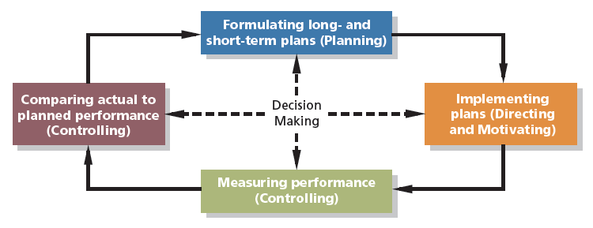
Strategy
- A strategy is a “game plan” that enables a company to attract customers by disguising itself form competitors
- The focal point of a company’s strategy should be its target customers

Customers Value Propositions
Customer Intimacy Strategy understands and responds to individual customer needs (catering to customers’ needs in a better way than competitors do)
Operational Excellence Strategy delivers products and services faster, more conveniently, and at lower prices
Product Leadership Strategy offer higher quality products

Comparison of Financial and Managerial Accounting
 | Financial Accounting | Managerial Accounting
Users | External persons who make financial decisions | Managers who plan for and control an organization
Time focus | Historical perspective | Future emphasis
Verifiability vs. relevance | Emphasis on objectivity and verifiability | Emphasis on relevance
Precision vs. timeliness | Emphasis on precision | Emphasis on timeliness
Subject | Primary focus is on companywide reports | Focus on segment reports
Rules | Must follow GAAP/ASPE/IFRS | Not bound by GAAP/ASPE/IFRS
Requirement | Mandatory for external reports | Not mandatory

Organizational Structure
Decentralization is the delegation of decision-making authority throughout an organization
Corporate Organization Chart
Line and Staff Relationships
Line positions are directly related to achievement of the basic objectives of an organization (example: production supervisors in a manufacturing plant)
Staff positions support and assist line positions (example: cost accountants in the manufacturing plant)
Business Process Management
The Controller is a member of the top management team responsible for:
- Providing timely and relevant data to support planning and control activities
- Preparing financial statements for external users
A business process is a series of steps that are followed in order to carry out some task in a business
Business Functions making up the Value Chain:
- Research and Development
- Product Design
- Manufacturing
- Marketing
- Distribution
- Customer Service
There are 3 approaches to improving business processes:
- Lean Production
- Organizes resources round the flow of business processes
- Only produces units in response to customer orders
- Often called just-in-time (JIT) production
- Number of units produced tends to equal the number of units sold, therefore minimal inventory
- Fewer defects, less waste effort and quicker customer response time
- Enterprise Systems
- A single software system that integrates data across an organization, thereby enabling all employees to have simultaneous access to a common set of data
- All data recorded only one in the company’s database
- The unique data elements contained within a database can be linked together
- Risk Management
- A process used by a company to proactively identify and manage risk
- Once a company identifies its risks, perhaps the most common risk management tactic is to reduce risks by implements specific controls
- Managers need to be able to predict risks and plan for them and control them to reduce business risks

Ethics, Corporate Governance, and Corporate Social Responsibility
- Accountants must maintain a level of competence appropriate to their designation
- Confidentiality is essential because of the importance of information they analyze
- Integrity is maintained by avoiding conflicts of interest with their employers or clients, by communicating the limits of professional competence, and by not accepting favors that would compromise their judgment
- Objectivity must be present in communications, so that recipients can receive both favorable and unfavorable information
Why have Ethical Standards?
- Ethical standards in business are essential for a smooth functioning advanced market economy
- Without ethical standards in business, the economy, and all of us who depend on it for jobs, goods, and services, would suffer
- Abandoning ethical standards in businesses would lead to a lower quality of life with less desirable goods and services at higher prices

Corporate Governance
- The system by which a company is directed and controlled
- The Board of Directors has incentives and monitoring for Top Management to pursue the objectives of Shareholders
- An effective corporate governance system should also protect the interests of the company’s other stakeholders which include:
  - Employees
  - Customers
  - Creditors
  - Suppliers
  - The communities in which the company operates

Corporate Social Responsibility
- CSR is a concept whereby organizations consider the needs of all stakeholders when making decisions
  - Customers
  - Employees
  - Suppliers
  - Communities
  - Shareholders
  - Environmental & human rights advocates
- CSR extends beyond legal compliance to include voluntary actions that satisfy stakeholder expectations

Chapter 2 – Cost Terms, Concepts, and Classifications

Classifications of Manufacturing Costs
The Product Costs
- Direct Materials – Raw materials that become an integral part of the product and that can be conveniently traced directly to it
  - Direct costs, prime costs
- Direct Labor – Those labor costs that can be easily traced to individual units of product
  - Direct costs, prime and conversion costs
- Manufacturing Overhead – Manufacturing cost that cannot be easily traced directly to specific units products
  - Indirect costs, conversion costs
  - Indirect Materials, Indirect Labor, Utilities, Insurance/Rental Payment/Depreciation/etc. on Production Factory, Maintenance and Repairs on Production Equipment, Property Taxes, etc.
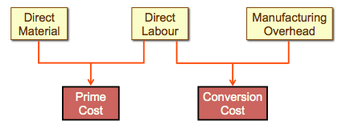
Overtime Premiums
The overtime premiums for all factory workers are usually considered to be part of manufacturing overhead. Product specific overtime premiums are part of direct labor.
If overtime is done for work on all cars, then we cannot tell how much has been produced from that specific overtime, therefore it is considered manufacturing overhead. But if we can trace the labor to one direct car, then it is considered direct labor costs.
Benefits given to direct workers are considered direct labor costs, whereas benefits given to indirect workers are considered indirect labor costs.

Period Costs (non-manufacturing overhead)
Costs that are not directly related with the production of the product
Marketing or Selling Costs costs necessary to get the order and deliver the product
Administrative Costs all executive, organizational, and clerical costs

Product Costs vs. Period Costs
Product costs include direct materials, direct labor, and manufacturing overhead
- Inventory Balance Sheet
- Cost of Goods Sold Income Statement
Period costs include all selling and administrative costs
- Expenses Income Statement

Comparing Merchandising and Manufacturing Activities
Merchandisers - buy finished goods, and sell finished goods
Current Assets:
- Cash
- Receivables
- Prepaid Expenses
- Merchandise Inventory
Income Statement
Cost of goods sold:
Beginning Merchandise Inventory
Add: Purchases
Goods Available for Sale
Less: Ending Merchandise Inventory
Cost of Goods Sold

Manufacturers - buy raw materials and produce and sell finished goods
Current Assets:
- Cash
- Receivables
- Prepaid Expenses
- Inventories
  - Raw Materials materials waiting to be processed
  - Work in Process partially complete products – some material, labor, or overhead has been added
  - Finished Goods completed products awaiting sale
Income Statement
Cost of goods sold:
Beginning Finished Inventory
Add: Cost of Goods Manufactured
Goods Available for Sale
Less: Ending Finished Inventory
Cost of Goods Sold

Schedule of Cost of Goods Manufactured
- Calculated the cost of raw material, direct labor and manufacturing overhead used in production
- Calculates the manufacturing costs associated with goods that were finished during the period
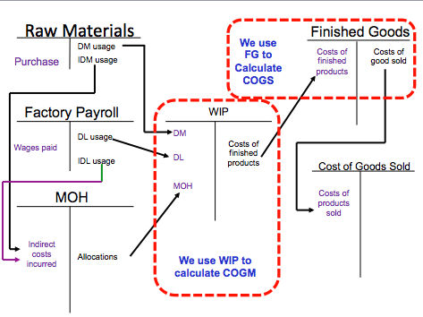
Cost Classifications for Predicting Cost Behavior
How a cost will react to changes in the level of activity within the relevant range
- Total variable costs change when activity changes
- Variable costs per unit remain unchanged when activity changes
- Total fixed costs remain unchanged when activity changes
- Fixed costs per unit decreases exponentially as activity increase

Variable Costs Variable Costs Per Unit
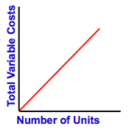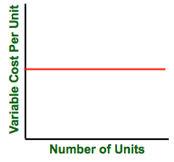

The Activity Base (Cost Driver)
A measure of what causes the incurrence of a variable cost
A factor that causes variations in a cost
- Units produced
- Machine hours
- Miles driven
- Labor hours

Fixed costs Fixed Costs Per Unit
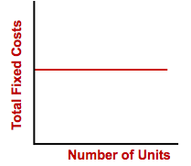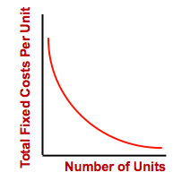
The Relevant Range is the range of activity within which the assumptions about variable and fixed cost behavior are valid
Assigned Costs to Cost Objects
Direct costs – costs that can be easily and conveniently traced to a unit of product or other cost object (examples: direct material and direct labor)
Indirect costs – costs that cannot be easily and conveniently traced to a unit of product or other cost object (example: manufacturing overhead)

Cost Classifications for Decision Making
- Every decision involves a choice between at least two alternatives
- Only those costs and benefits that differ between alternatives are relevant in a decision. All other costs and benefits can and should be ignored

Differential Cost and Revenue
Costs and revenues that differ among alternatives
Example: your job out of the city pays you $2,000 per month and your other job in your hometown pays $1,500 per month, the commuting cost to the far job is $300
The Differential Revenue is: $2,000-$1,5000 = $500
The Differential Cost is: $300

Opportunity Cost: the potential benefit that is given up when one alternative is selected over another
Sunk Costs: have already been incurred and cannot be changed now or in the future. They should be ignored when making decisions

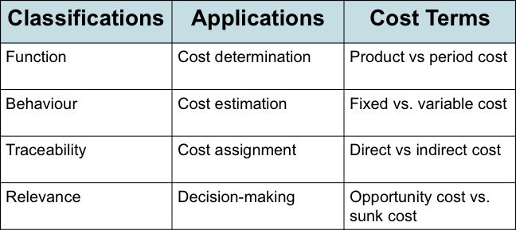

Chapter 3 – Cost Behavior: Analysis and Use
Variable Costs
True Variable Costs Step-Variable Costs
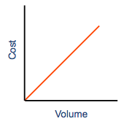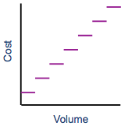
- Direct materials is a true or proportionately variable cost because the amount used during a period will vary in direct proportion to the level of production activity
- A resource that is obtainable only in large chunks (such as maintenance workers) and whose costs increase or decrease only in response to fairly wide changes in activity known as a step-variable cost
  - Small changes in the level of production are not likely to have any effect on the number of maintenance workers employed

The Linearity Assumption and the Relevant Range
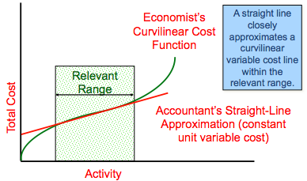

Types of Fixed Costs
Committed: long-term, cannot be significantly reduced in the short term (example: depreciation on equipment and real estate taxes)
- Something that has to be paid for no matter what
Discretionary: may be altered in the short-term by current managerial decisions (examples: advertising and R&D)
- Something a manager chooses to pay for and can change

The Trend Toward Fixed Costs
The trend in many industries is toward greater fixed costs relative to variable costs
Knowledge workers tend to be salaried, highly trained and difficult to replace. The cost to compensate these valued employees is relatively fixed rather than variable.

Fixed Costs and Relevant Range
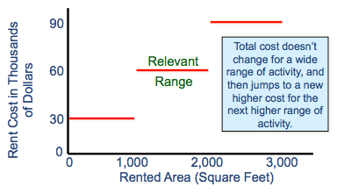

The relevant range of activity for a fixed cost is the range of activity over which the graph of the cost is flat
Example: Office space is available at a rental rate of $30,000 per year in increments of 1,000 square feet.

Difference between Step-Variable Costs and this type of fixed cost: step-variable costs can be adjusted more quickly, and the width of the activity steps is much wider for the fixed costs

Mixed Costs
A mixed cost has both fixed and variable components
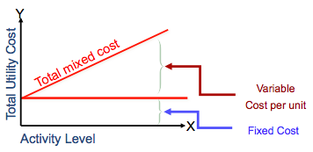
Analysis of Mixed Costs
Account Analysis: Each account is classified as either variable or fixed based on the analyst’s knowledge of how the account behaves
Engineering Approach: Cost estimates are based on an evaluation of production methods, and material, labor and overhead requirements

The Scattergram Plot
A graph that represents total cost vs. activity level within the data points on the graph. Then, draw a line through the data points with about an equal number of points above and below the line. This line will help estimate what the total cost will be at each level of activity.
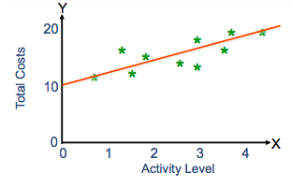
The High-Low Method
Formula = (Greatest cost – lowest cost) / (greater number of units – least number of units) = $variable cost/unit
Total Fixed Cost = Total Cost – Total Variable Cost
= Total Cost – ($variable cost per unit x high level of units)
The Cost Equation for Mixed Costs: Y = Total Fixed Cost + Variable Cost Per Unit(X)
Where X is the number of units, and Y is the total Mixed Cost

The Contribution Format
Why a New I/S Format?
- Traditional format income statement is organized by function and fixed and variable costs are not disguised
- Separating costs into fixed and variable elements is often crucial in making decisions
- Contribution format facilitates planning, control, and decision making
Uses of this Format
- The contribution income statement format is used as an internal planning and decision-making tool. We will use this approach for:
  - Cost-volume-profit analysis
  - Budgeting
  - Segmented reporting of profit data
  - Special decisions such as pricing and make-or-buy analysis
Comparison of the Contribution Format with the Traditional Income Statement
Traditional Approach (costs by function) |  | Contribution Approach (costs by behavior)
Sales | $xxx | Sales | $xxx
Less: COGS | xxx | Less: Variable Costs | xxx
Gross Margin | xxx | Contribution Margin | xxx
Less: Operating Expenses | xxx | Less: Fixed Costs | xxx
Net Operating Income | $xxx | Net Operating Income | $xxx
used primarily for external reporting used primarily by management

Chapter 4 – Cost-Volume-Profit Relationships
Cost-Volume-Profit Relationship Interactions
Cost-Volume-Profit (CVP) analysis is a powerful tool that managers use to help them understand the interrelationship among cost, volume and profit in an organization by focusing on interactions among the following five elements:
- Prices of products
- Volume or level of activity
- Per unit variable costs
- Total fixed costs
- Mix of products sold

Basics of Cost-Volume-Profit Analysis
The contribution I/S is helpful to managers in judging the impact of profits of changes in selling price, cost, or volume. The emphasis is on cost behavior
Contribution Margin (CM) is the amount remaining from sales revenue after variable expenses have been deducted

Formulas:

Profit = Unit CM x Q – Fixed Expenses

CM = Sales – Variable expenses

CM per unit = Per unit sales – Per unit variable expenses

CM Ratio = $\frac{CM per unit}{SP per unit}$ = $\frac{Total CM}{Total Sales }$ = $\frac{Total CM}{(Total Sales)/(Per unit sales)}$

Variable Expense Ratio = $\frac{Variable Expenses}{Sales}$

Q = quantity of goods sold in units, SP = Selling price

CVP Relationships in Graphic Form
The relationship among revenue, cost, profit and volume can be expressed graphically by preparing a CVP graph. In a CVP graph, unit volume is usually represented on the horizontal (X) axis and dollars on the vertical (Y) axis
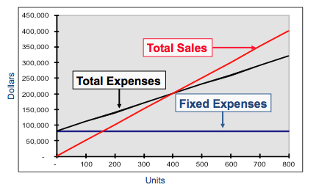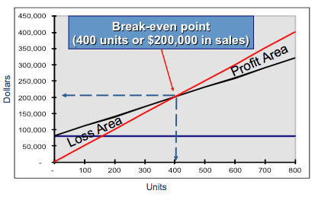

Break-Even Analysis
Can be approached in two ways:
- Equation method
Profits = (Sales – Variable Expenses) – Fixed Expenses
OR
Sales = Variable expenses + Fixed expenses + Profits
(At BEP, profits equal zero)
- Formula method
Break-even point in units sold = $\frac{Fixed Expenses}{CM per unit}$
Break-even point in total sales dollars = $\frac{Fixed Expenses}{CM Ratio}$
Target Profit Analysis
The equation and formula methods can be used to determine the sales volume needed to achieve a target point.

Sales = VC + FC + Profits
OR
Unit Sales to attain the target profit = $\frac{Fixed Expenses + Target Profit}{CM per unit}$

The Margin of Safety
The Margin of Safety is the excess of budgeted (or actual) sales over the break-even volume of sales
Margin of Safety = Total Sales – Breakeven Sales
Can be expressed as a percentage = Margin of Safety/Total Sale = % margin of safety
Margin of Safety in Units = $\frac{Margin of Safety}{Selling Price per unit}$ = margin of safety in # of units
Margin of Safety in Dollars = Total sales – Breakeven sales
Margin of Safety Percentage of sales = $\frac{Margin of Satefy in Dollars}{Sales}$

Cost Structure and Profitability Stability
Cost structure refers to the relative proportion of fixed and variable costs in an organization. Managers often have some latitude in determining their organization’s cost structure.
There are advantages and disadvantages to high fixed cost (or low variable cost) and low fixed cost (or high variable cost) structures
Companies with low fixed cost structures enjoy greater stability in income across good and bad years
Advantage: of a high fixed cost structure is that income will be higher in good years compared to companies with lower proportion of fixed costs
Disadvantage: of a high fixed cost structure is that income will be lower in bad years compared to companies with lower proportion of fixed costs

Operating Leverage
A measure of how sensitive net operating income is to percentage change in sales
DOL = $\frac{CM}{Net Operating Income}$

The Concept of Sales Mix
- Sales mix is the relative proportion in which a company’s product are sold
- Different products have different selling prices, cost structures, and contribution margins

Assumptions of CVP Analysis
- Selling price is constant
- Costs are linear and can be accurately divided into variable (constant per unit) and fixed (constant in total) elements
- In multiproduct companies, the sales mix is constant
- In manufacturing companies, inventories do not change (units produced = units sold)

