40001787

Word Assignment
INTE 290

Stephanie Matej 40001787
15/10/2015

Concordia University

Project Description
Ever get tired of that same old zipper and flap luggage you travel with all the time? Trunkster has the solution with its new smooth silhouette, great construction and intelligent features for both carry on and check in suitcases. Say goodbye to flimsy handles, terrible wheels and fragile zippers. With this modernized luggage we take away the flap and zipper closure to add a sliding door to make it easier to access your belongings.
The luggage also has a handful of useful features that have been carefully picked out. The main goal is to “prioritizes utility and versatility in a minimalist style”. Our features are a zipper less entry, a removable battery and USB charge for the carry-on, a built in digital scale, a control handle, a GPS and many more.

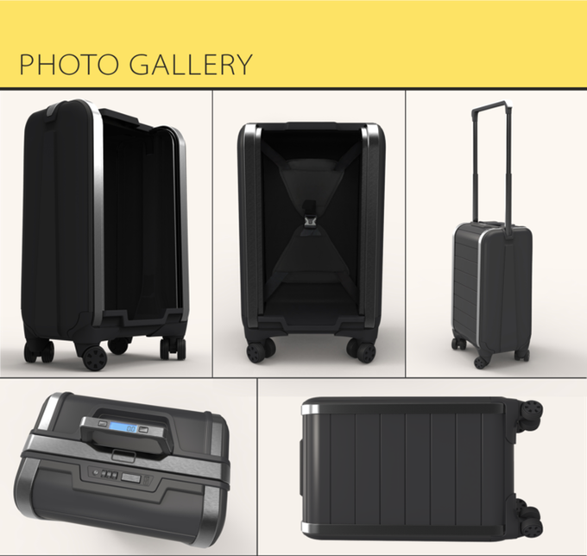
Source: “Trunkster: zipperless luggage with GPS + battery + scale”

Budget
Item | Amount
Travel costs | 11,500$
Office space | 10,580$
Advertising | 2,500$
Materials | 10,000$
Manufacturing | 10,420$
Shipping cost | 5,000$
Total cost of 50,000$

Timeline
Month | Description
2015-2016  November  December  January | Spread the word
2015-2016  November  December  January | Project funding
2016  January  February  March | Design
2016  January  February  March | Engineering
2016  March  April  May | Buying materials
2016  March  April  May | Testing
2016  May  June  July | Production
2016  May  June  July | Quality control
2016  July  August | Delivery

Location of business
T

he location of the main office for Trunkster will be in New York. However the product itself is going to be manufactured in Asia specifically the Taiwan area. Trunkster plans to open offices in the Taiwan/outside Hong Kong. This would help reduce the travel costs while also being able to monitor the production.

We’ve estimated that the relative cost for both offices will be around 10,580$ as shown in our budget.
We would like to ship internationally as well to accommodate all of our clientele around the world. The shipping cost shown in our budget is estimated at 5,000$.
We will be shipping around:
- Asia
- North America
- South America
- Europe
- Australia



Value of the product
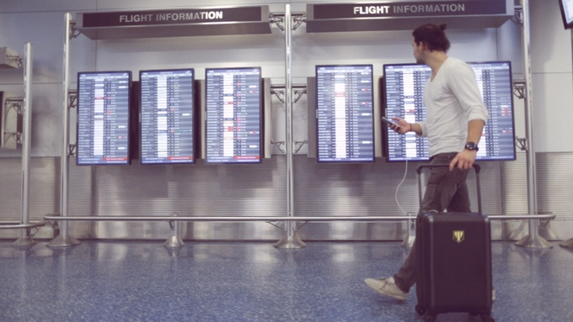

The value of this new product by Trunkster is the simple reason being that it will allow for an easy stress free travel experience. We want to change how you travel by making the process more enjoyable. Avoid those pesky overweight luggage fees; avoid losing your luggage and enjoy joys of travelling without these headaches. What we promise is products that will change the negative idea of planning, packing and flying. We want the process to be something our customers won’t mind given how our product will make things much more efficient.

Bibliography
- “Trunkster: zipperless luggage with GPS + battery + scale” kickstarter.com. 18 Nov. 2014. Web. 10 Oct. 2015.

Source: “Trunkster: zipperless luggage with GPS + battery + scale”
Source: “Trunkster: zipperless luggage with GPS + battery + scale”
Source: “Trunkster: zipperless luggage with GPS + battery + scale”
Source: “Trunkster: zipperless luggage with GPS + battery + scale”

