CVG2141
Engineering Materials

Title Page

Steel and Aluminum Tension
Testing

By:

University of Ottawa
Department of Civil Engineering

Experiment Date:
Report Date:

Instructor:

Group C1

Abstract

Testing three specimens one hot rolled steel, cold rolled steel, and aluminum for their tensile strength using a standardized method of testing called ASTM E8/ASTM E111. The data collected from the standardized method helps examine the mechanical properties of each specimen. The results showed that hot rolled steel is the most ductile and has a mediocre yielding strength with highest modulus of toughness. On the other hand, cold rolled still was found to be more brittle but has a very high yielding point with very low modulus of toughness. Finally, the aluminum was found to be more ductile than cold rolled steel and less ductile than hot rolled steel. It had a moderate modulus of toughness and a yielding point.
Table of Contents
Title Page i
Abstract ii
List of Tables iv
List of Figures v
Objectives 1
Theoretical Background 1
Materials and Equipment 2
Experimental Procedure 3
Analysis of Data 3
Discussion of Results 11
Conclusions and Recommendations 12

List of Tables

Table 1 – Hot rolled steel gauge markers before and after testing measurements 7
Table 2 – Percent of elongation of hot rolled steel specimen between gauge marks after performing ASTM E8 test 7
Table 3 – Cold rolled steel gauge markers before and after testing measurements 8
Table 4 – Percent of elongation of cold rolled steel specimen between gauge markers after performing ASTM E8 test 8
Table 5 – Aluminum gauge markers before and after testing measurements 9
Table 6 – Percent of elongation of aluminum specimen between gauge markers after performing ASTM E8 test 9

List of Figures

Figure 1 - Stress-strain relationship in a ductile material 2
Figure 2 – The stress-strain curve of a hot-rolled steel specimen 4
Figure 3 – The stress-strain curve of a cold-rolled steel specimen 4
Figure 4 – The stress-strain curve of an aluminum specimen 5
Figure 5 - A combination graph of the percentage of elongation (%) vs. gauge markers of hot rolled steel, cold rolled steel, and aluminum 10
Figure 6 - Combined stress-strain curves of hot rolled steel, cold rolled steel, and aluminum 12

Objectives

The objective of this experiment is to perform standard tests ASTM E8 and ASTM E111 on hot rolled steel, cold rolled steel and aluminum specimens. Performing the tests on previously mentioned specimen, gives us results that can be used to determine stress-strain relationships. The stress-strain relationship is then used provide values such as yield strength, tensile strength, modulus of elasticity, modulus of resilience, and modulus of toughness.

Theoretical Background

Every structure that is designed by engineers is subjected to various types of stresses:
$$σ=\frac{P}{A}$$
Where σ is equal to the stress (N/m²), P is the force (N, KN, lb, etc.) and A is the cross sectional area (m², mm², etc.).
Once a load is applied to a material it causes deformation. A material has two types of deformation an elastic and plastic behavior. To measure the deformation of a material, strain is calculated in the following method:
$$ε= \frac{L-L_{0}}{L_{0}}$$
Where ε is strain and has no units, L_{o} is the original longitudinal length of the material being subjected to a tensile force and L is the longitudinal length of the material after being subjected to the tensile force.
In order for an engineer to design a safe and stable structure, using the proper materials to withstand the loads, is the key determining factor. Therefore, in order to evaluate a material for the proper use in a design, the mechanical properties of the material must be determined. The material in question must undergo testing procedures such as ASTM E8/ASTM E111 to reveal its mechanical properties. ASTM E8 is a Standard Testing Method for Tension testing of Metallic Materials and ASTM E111 is a Standard Testing Method for Young’s Modulus, Tangent Modulus, and Chord Modulus. The test requires a specimen from the material in question, usually in the shape of a rod which can be attached to the universal testing machine. By subjecting the material to a tensile force and by recording the deformation by using an extensometer, the recorded data can then be plotted in a stress-strain graph in the following method:

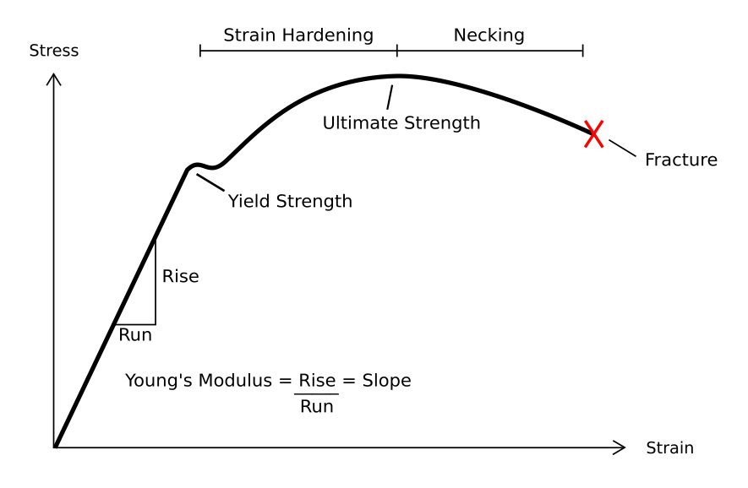
Figure 1 - Stress-strain relationship in a ductile material
Using the graph, the material’s behavior is then better understood. The linear part is the elastic behavior which is a reversible deformation where the material will return to its original form once the stress is removed. Once the stress exceeds the yielding point of the material it changes its behavior to plastic where the material will be permanently deformed. From the graph, the Modulus of Elasticity, or Young’s Modulus, can be calculated by finding the slope of the linear portion of the curve. The Modulus of Resilience can be found by calculating the area under the linear portion of the stress-strain curve. The Modulus of Toughness is the area under the entire curve. In the instance of Figure 1 the material is a ductile material (e.g. steel). However, other material might be more brittle or stiffer and therefore resulting in different graphs and therefore different values.

Materials and Equipment

To complete ASTM E8 procedure the following list is required:
- Hot-rolled steel specimen
- Cold-rolled steel specimen
- Aluminum specimen
- Universal Testing machine
- Micrometer calliper
- Gauge marker
- 50 mm gauge length extensometer

Experimental Procedure

Hot-rolled steel, cold-rolled steel and aluminum specimens were obtained and the width and the depth of each specimen were measured using the micrometer calliper and recorded. Then, the gauge markers were numbered on each specimen from 1-10. Using the micrometer calliper, the distance between the gauge markers were measured and recorded from all three specimens. The hot-rolled steel was then attached to the universal testing machine and the extensometer was attached to the specimen. The test was conducted by the TA and the values were recorded by the computer. After the breaking point was reached the specimen was removed and the gauge markers were measured again and the values were recorded. Finally, at the point where the rupture occurred for each specimen the depth and the width was re-measured and recorded.

Analysis of Data

- Calculating and plotting the stress against the strain for all three specimen:
- Hot-rolled steel specimen cross sectional area:
Thickness before testing: 19.23 mm
Width before testing: 6.58 mm
A₀ = 19.23 mm x 6.58 mm
A₀ = 126.53 mm²
- Stress sample calculation:
$$σ=\frac{P}{A}$$

Using values from the results’ data:
$$σ=\frac{2971.50}{126.53}=23.48 N/{mm}^{2}$$
- Strain sample calculation:
$$ε= \frac{L-L_{0}}{L_{0}}$$
$$ε= \frac{0.0061 mm}{50 mm}=0.000122$$
- After applying the lateral calculations to all three specimens’ data, the stress-strain graphs are plotted as follows:
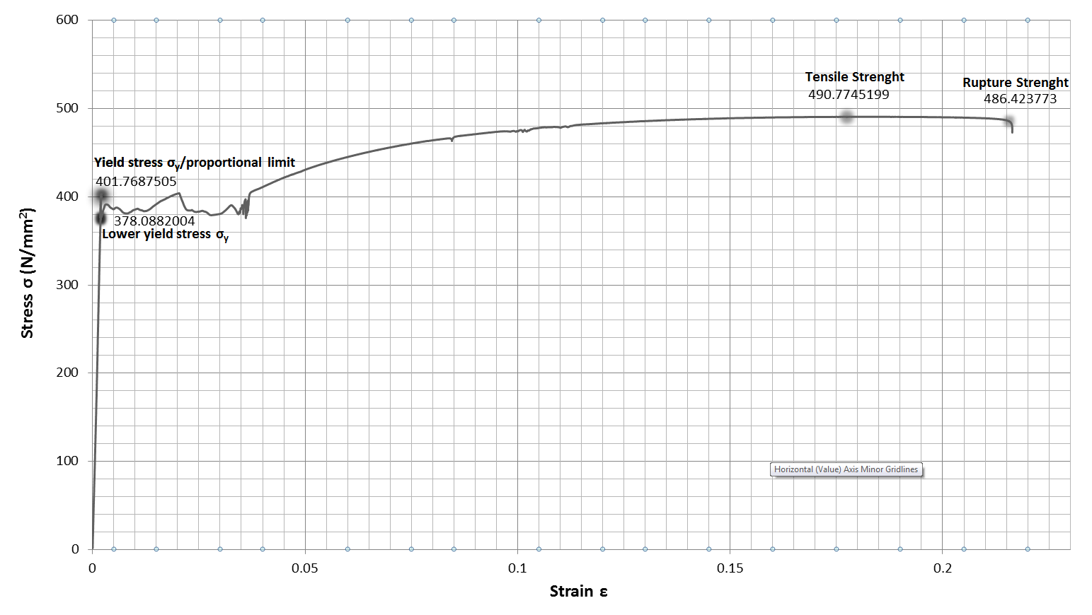
Figure 2 – The stress-strain curve of a hot-rolled steel specimen

Figure 3 – The stress-strain curve of a cold-rolled steel specimen

Figure 4 – The stress-strain curve of an aluminum specimen

- Young’s Modulus:
$$(E)=\frac{Rise}{Run}$$
Hot-rolled steel:
$E= \frac{346.77-115.5141}{0.001724-0.000618}$ = 209092.13 N/mm²
Cold-rolled steel:
$E= \frac{609.7932-216.3153}{0.00301-0.001001}$ = 195857.59 N/mm²
Aluminum:
$E= \frac{272.5146-74.25073}{0.004-0.00109}$ = 68131.91N/mm²

Modulus of resilience:
The modulus of resilience is equal to area under the curve of the elastic region (i.e. before the yield point).
Hot rolled steel:
Yield Point is at (0.0369,401.77)
Area of triangle = $\frac{base ×height}{2}$
Mr = $\frac{0.00199 × 401.77}{2}$ = 0.40 N/mm²
Cold rolled steel:
Mr = $\frac{0.006643 × 869.44}{2}$ = 2.89 N/mm²
Aluminum:
Mr = $\frac{0.006587 × 322.26}{2}$ = 1.06 N/mm²
- The modulus of toughness:
The area under the entire curve must be calculated in order to get the modulus of toughness. Since some of the curves are irregular in shape multiple areas are calculated to approximate the entire area.

Hot rolled steel:
Mt = $390 ×(0.21637-0.00199) + 0.40 + (\frac{\left(0.21647-0.03668\right)×\left(486.42-390\right)}{2})$ = 92.68 N/mm²
Cold rolled steel:
Mt = $2.89+\left(0.015315-0.006643\right)×875$ = 10.48 N/mm²
Aluminum:
Mt = $1.06+\left(0.127836-0.006587\right)×320$ = 39.86 N/mm²
- The recorded measurements between the gauge markers before and after the testing are as follows:
Hot rolled steel
Table 1 – Hot rolled steel gauge markers before and after testing measurements
Between Gauge Marker | Distance Between Gauge Marker Before Testing (mm) | Distance Between Gauge Marker After Testing (mm)
1-2 | 24.65 | 28.84
2-3 | 28.73 | 40.71
3-4 | 24.93 | 33.34
4-5 | 24.84 | 29.85
5-6 | 24.69 | 29.88
6-7 | 24.80 | 29.88
7-8 | 24.98 | 29.95
8-9 | 24.92 | 29.32
9-10 | 24.71 | 28.65
1-10 | 227.25 | 280.42

The percent of elongation is the difference between the after testing measurements and the before testing measurements divided by the original length:

% elongation = $\frac{L_{f} - L_{0}}{L_{0}} ×100$
Sample calculation:
% elongation $=\frac{28.84 mm-24.65 mm}{24.65} ×100=$ 17.00 %
Table 2 – Percent of elongation of hot rolled steel specimen between gauge marks after performing ASTM E8 test
Between Gauge Marker | % elongation
1-2 | 17.00
2-3 | 41.70
3-4 | 33.73
4-5 | 20.17
5-6 | 21.02
6-7 | 20.48
7-8 | 19.90
8-9 | 17.66
9-10 | 15.94
1-10 | 23.40

Cold rolled steel:
Table 3 – Cold rolled steel gauge markers before and after testing measurements
Between Gauge Marker | Distance Between Gauge Marker Before Testing (mm) | Distance Between Gauge Marker After Testing (mm)
1-2 | 24.72 | 24.76
2-3 | 25.16 | 25.00
3-4 | 24.86 | 24.99
4-5 | 25.01 | 24.78
5-6 | 25.15 | 25.32
6-7 | 24.78 | 24.73
7-8 | 25.25 | 29.53
8-9 | 24.93 | 25.07
9-10 | 24.91 | 25.06
1-10 | 224.77 | 229.24

Table 4 – Percent of elongation of cold rolled steel specimen between gauge markers after performing ASTM E8 test
Between Gauge Marker | % elongation
1-2 | 0.16
2-3 | -0.64
3-4 | 0.52
4-5 | -0.92
5-6 | 0.68
6-7 | 0.20
7-8 | 16.95
8-9 | 0.56
9-10 | 0.60
1-10 | 1.99

Aluminum:
Table 5 – Aluminum gauge markers before and after testing measurements
Between Gauge Marker | Distance Between Gauge Marker Before Testing (mm) | Distance Between Gauge Marker After Testing (mm)
1-2 | 24.99 | 26.52
2-3 | 24.81 | 26.57
3-4 | 24.78 | 26.96
4-5 | 25.02 | 26.96
5-6 | 24.83 | 29.91
6-7 | 24.76 | 26.76
7-8 | 25.01 | 26.77
8-9 | 25.02 | 26.76
9-10 | 24.88 | 26.41
1-10 | 224.10 | 243.62

Table 6 – Percent of elongation of aluminum specimen between gauge markers after performing ASTM E8 test
Between Gauge Marker | % elongation
1-2 | 6.12
2-3 | 7.09
3-4 | 8.80
4-5 | 7.75
5-6 | 20.46
6-7 | 8.08
7-8 | 7.04
8-9 | 6.95
9-10 | 6.15
1-10 | 8.71

Figure 5 - A combination graph of the percentage of elongation (%) vs. gauge markers of hot rolled steel, cold rolled steel, and aluminum
- Percent reduction in area where the fracture occurred:
Hot rolled steel:
Thickness before testing: 19.23 mm Thickness after testing: 13.58 mm
Width before testing: 6.58 mm Width after testing: 4.61 mm
Sample calculation:
% reduction in cross section = $\frac{A_{0}- A_{f}}{A_{0}}×100$
A₀ = $19.23 mm ×6.58 mm$ = 126.53 mm²
A_{f} = $13.58 mm ×4.61 mm$ = 62.60 mm²
% reduction in cross section = $\frac{126.53- 62.60}{126.53}×100$ = 50.53%
Cold rolled steel:
Thickness before testing: 19.08 mm Thickness after testing: 16.65 mm
Width before testing: 6.31 mm Width after testing: 4.80 mm
% reduction in cross section = 33.62%

Aluminum:
Thickness before testing: 19.00 mm Thickness after testing: 17.62 mm
Width before testing: 6.48 mm Width after testing: 6.32 mm
% reduction in cross section = 9.55%

Discussion of Results

After the analysis of the data, all the results were combined in one graph to demonstrate the difference between all three specimens (refer to Figure 6 on pg. 12). It was found that the hot rolled steel is the stiffest of all three materials, since it has the highest Modulus of Elasticity (209092.13 N/mm²). The cold rolled steel seconds by a small difference (195857.59 N/mm²) and the lowest stiffness of all three was found to be the aluminum (68131.91N/mm²).
However, when the brittleness was compared it was found that the most brittle specimen was the cold rolled steel, then the aluminum and then the hot rolled steel. The highest yielding point was achieved by the cold rolled steel and it had the value of 869.44 N/mm² which is more than the double of the hot rolled steel which had a value of 401.77 N/mm².The yielding point of the aluminum was found to be the lowest and had a value of 322.26 N/mm². The yielding point of the cold rolled steel was calculated using the offset method. Since, the transformation from the elastic behavior to the plastic behavior was gradual and did not show an upper yielding point and a lower yielding point. However, the hot rolled steel had a clear point of transformation and showed both an upper yielding point and a lower yielding point. This observation occurred to the high ductility of hot rolled steel and the low ductility of cold rolled steel.
When comparing the results of Modulus of Resilience (Mr) it was found that the cold rolled steel had the highest value (2.89 N/mm²). This demonstrates that the cold rolled steel has the highest ability to absorb energy before it reaches its yielding point, which is very clearly demonstrated by the graph in Figure 6. The second highest value of Mr was found to be in aluminum (1.06 N/mm²⁾. And the lowest value was found in the hot rolled steel (0.40 N/mm²).
On the other hand, the Modulus of Toughness (Mt) explains how much energy can be absorbed during both Elastic and Plastic behaviors. The highest value of Mt was found in the hot rolled steel (92.68 N/mm²), aluminum had the second highest value (39.86 N/mm²) and the lowest value of Mt was found in cold rolled steel (10.48 N/mm²). This reports that the hot rolled steel can withstand the highest amount of energy before rupture.
After obtaining the percentage of elongation it was found that it is relative to the ductility of the material. The highest percentage of elongation was found in the hot rolled steel, then in the aluminum and then in the cold rolled steel. The reduction of the cross sectional area did not follow relatively to the ductility of each material. Surprisingly, the aluminum had the lowest reduction percentage in the cross sectional area (9.55%), which is more ductile than the brittle cold rolled steel which had a higher reduction in the cross sectional area (33.62%). The hot rolled steel acted as expected due to its high ductility and had the highest reduction percentage (50.53%). This could have occurred due to a sampling error of the aluminum specimen or due to how the elements of aluminum align with each other.
(no relevant data was found to calculate percentage of error)
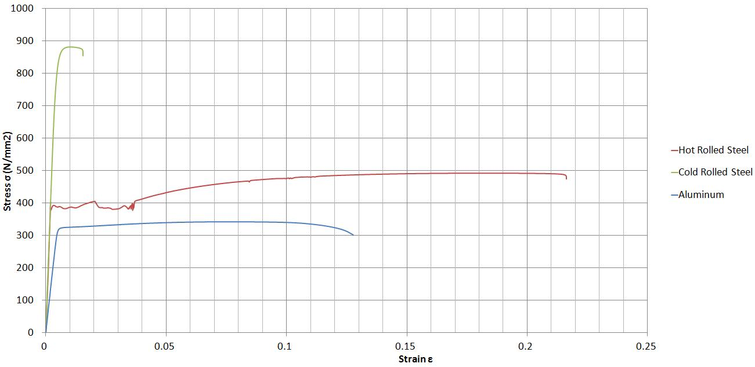
Figure 6 - Combined stress-strain curves of hot rolled steel, cold rolled steel, and aluminum

Conclusions and Recommendations

To conclude, the most recommended application of hot rolled steel is for purposes where ductility and strength is required. Given its relatively high yielding point and its high ductility, it provides both the strength and warning signs in case of a failure, as opposed to the very strong but brittle cold rolled steel. The strength of cold rolled steel is significant and is best used in applications where failure is not fatal or very crucial. The aluminum is a mixture of both, with its low yielding point and low mediocre ductility it is not recommended for structural purposes but for applications where it will not be subjected high stresses.

