Economic Problem Set

Resources Devoted to Clothing | Output OF Clothing | Resources Devoted to Food | Output of Food
100% | 28 | 0% | 0
80 | 25 | 20 | 4
60 | 17 | 40 | 11
40 | 12 | 60 | 15
20 | 7 | 80 | 18
0 | 0 | 100 | 21

Opportunity Cost (OC)  one more unit of food in terms of Clothing | Opportunity Cost (OC)  One more unit of clothing in terms of food (slope going from left to right)
-0.75 | -0.43
-1.14 | -0.60
-1.25 | -0.80
-1.67 | -0.88
-2.33 | -1.3

My formula to get the Opportunity costs were the change in clothing divided by the change in food. (28-25)/(0-4) = -0.75.

-0.43 is the reciprocal of -2.33.

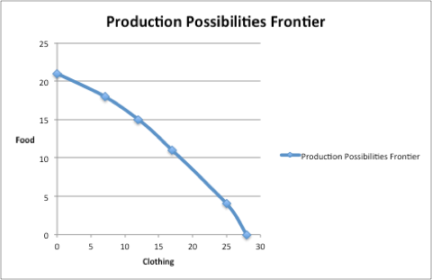

ii. The opportunity cost of food is increasing in absolute value because of the law of absolute value, which gives rise to the concave shape.

iii.If the country is becoming better at producing food, the point on the Y axis of the PPF will move vertically up. This is called a rotational transformation. The production of clothing is unaffected.

iv. If a country is becoming equally better at producing food and clothing, the PPF will equally move outward, (up and to the right), which is called a radial expansion.

b. i.

Resources Devoted to Clothing | Output OF Clothing | Resources Devoted to Food | Output of Food
100% | 25 | 0% | 0
80 | 21 | 20 | 7
60 | 17 | 40 | 12
40 | 13 | 60 | 16
20 | 8 | 80 | 19
0 | 0 | 100 | 22

Combined Output of Clothing | Combined Output of Food
53 | 0
46 | 11
34 | 23
25 | 31
15 | 37
0 | 43

- 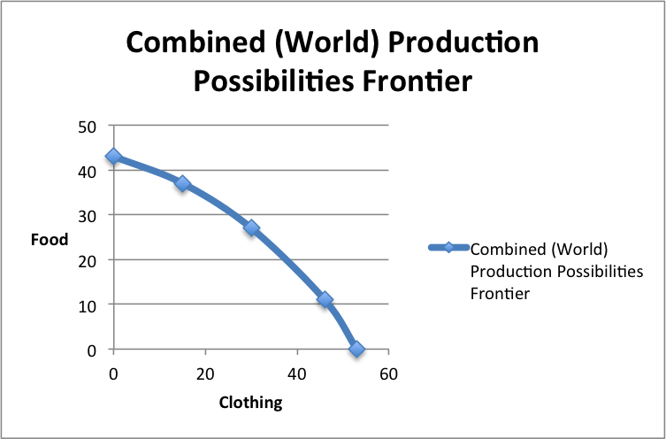

iii. In order to determine the pattern of comparative advantage, one way to do this is as follows. For country B, the series for the opportunity cost of producing one more unit of food in terms of clothing foregone is (0.57, 0.80,1.00,1.67,2.67). For country A, the series for the opportunity cost of producing 1 more unit of food in terms of clothing foregone is (0.75, 1.14, 1.25, 1.67, 2.33). In most cases, this cost is higher in country A. Since country A has to give up more clothing for each additional unit of food, its trade-off rate is less favourable, so it should produce more food when facing this trade-off. It should produce clothing, where it has a comparative advantage. It automatically follows that country B has the comparative advantage in the production of food.

2. Supply and Demand

- Done in Excel.

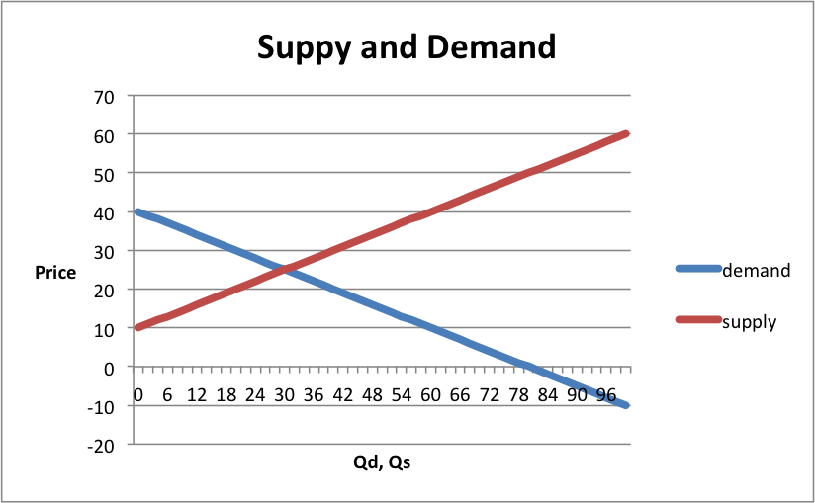

b. The sign of slope for the demand curve is negative because the law of demand says that, other things equal, the quantity demanded of a good falls when the price of the good rises. This is because of the negative relationship between price and quantity demanded. The sign of the slope for the supply curve is positive because the law of supply states that other things equal, the quantity supplied of the good rises when the price of the good rises, this is because of a positive relationship because of quantity supplied and price.

c. The equilibrium price is 25 units ($), as shown, highlighted in the table below.

Price | Quantity Demand | Quantity Supplied
0 | 80 | -20
1 | 78 | -18
2 | 76 | -16
3 | 74 | -14
4 | 72 | -12
5 | 70 | -10
6 | 68 | -8
7 | 66 | -6
8 | 64 | -4
9 | 62 | -2
10 | 60 | 0
11 | 58 | 2
12 | 56 | 4
13 | 54 | 6
14 | 52 | 8
15 | 50 | 10
16 | 48 | 12
17 | 46 | 14
18 | 44 | 16
19 | 42 | 18
20 | 40 | 20
21 | 38 | 22
22 | 36 | 24
23 | 34 | 26
24 | 32 | 28
25 | 30 | 30
26 | 28 | 32
27 | 26 | 34
28 | 24 | 36
29 | 22 | 38
30 | 20 | 40
31 | 18 | 42
32 | 16 | 44
33 | 14 | 46
34 | 12 | 48
35 | 10 | 50
36 | 8 | 52
37 | 6 | 54
38 | 4 | 56
39 | 2 | 58
40 | 0 | 60

d. The reservation price in this case is $40.00.

e.
Q | P demand | P supply
0 | 40 | 10
2 | 39 | 11
4 | 38 | 12
6 | 37 | 13
8 | 36 | 14
10 | 35 | 15
12 | 34 | 16
14 | 33 | 17
16 | 32 | 18
18 | 31 | 19
20 | 30 | 20
22 | 29 | 21
24 | 28 | 22
26 | 27 | 23
28 | 26 | 24
30 | 25 | 25
32 | 24 | 26
34 | 23 | 27
36 | 22 | 28
38 | 21 | 29
40 | 20 | 30
42 | 19 | 31
44 | 18 | 32
46 | 17 | 33
48 | 16 | 34
50 | 15 | 35
52 | 14 | 36
54 | 13 | 37
56 | 12 | 38
58 | 11 | 39
60 | 10 | 40
62 | 9 | 41
64 | 8 | 42
66 | 7 | 43
68 | 6 | 44
70 | 5 | 45
72 | 4 | 46
74 | 3 | 47
76 | 2 | 48
78 | 1 | 49
80 | 0 | 50
82 | -1 | 51
84 | -2 | 52
86 | -3 | 53
88 | -4 | 54
90 | -5 | 55
92 | -6 | 56
94 | -7 | 57
96 | -8 | 58
98 | -9 | 59
100 | -10 | 60

f. The equilibrium point is still $25.00, which is consistent in the chart.

g.
Q | P demand | P supply | D Prime
0 | 40 | 10 | 80
2 | 39 | 11 | 79.5
4 | 38 | 12 | 79
6 | 37 | 13 | 78.5
8 | 36 | 14 | 78
10 | 35 | 15 | 77.5
12 | 34 | 16 | 77
14 | 33 | 17 | 76.5
16 | 32 | 18 | 76
18 | 31 | 19 | 75.5
20 | 30 | 20 | 75
22 | 29 | 21 | 74.5
24 | 28 | 22 | 74
26 | 27 | 23 | 73.5
28 | 26 | 24 | 73
30 | 25 | 25 | 72.5
32 | 24 | 26 | 72
34 | 23 | 27 | 71.5
36 | 22 | 28 | 71
38 | 21 | 29 | 70.5
40 | 20 | 30 | 70
42 | 19 | 31 | 69.5
44 | 18 | 32 | 69
46 | 17 | 33 | 68.5
48 | 16 | 34 | 68
50 | 15 | 35 | 67.5
52 | 14 | 36 | 67
54 | 13 | 37 | 66.5
56 | 12 | 38 | 66
58 | 11 | 39 | 65.5
60 | 10 | 40 | 65
62 | 9 | 41 | 64.5
64 | 8 | 42 | 64
66 | 7 | 43 | 63.5
68 | 6 | 44 | 63
70 | 5 | 45 | 62.5
72 | 4 | 46 | 62
74 | 3 | 47 | 61.5
76 | 2 | 48 | 61
78 | 1 | 49 | 60.5
80 | 0 | 50 | 60
82 | -1 | 51 | 59.5
84 | -2 | 52 | 59
86 | -3 | 53 | 58.5
88 | -4 | 54 | 58
90 | -5 | 55 | 57.5
92 | -6 | 56 | 57
94 | -7 | 57 | 56.5
96 | -8 | 58 | 56
98 | -9 | 59 | 55.5
100 | -10 | 60 | 55

h.
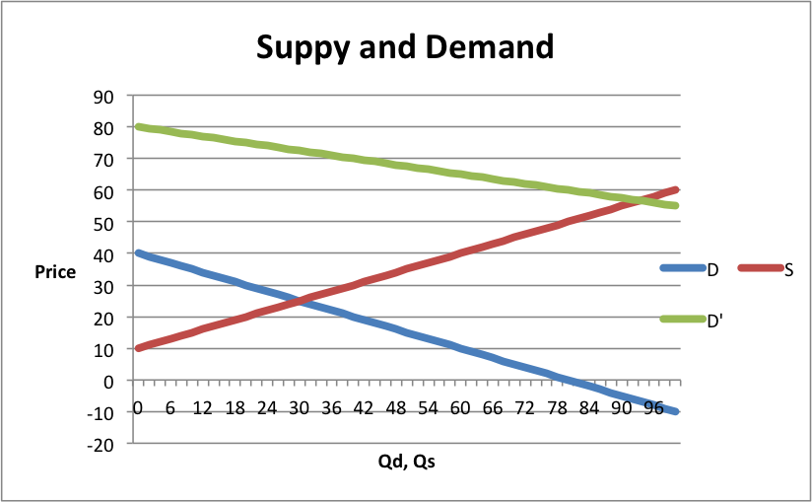

- The new market equilibrium quantity is, which is 92 and the equilibrium price is $57.00 where the point in which the supply curve (S) and the new demand curve (D’) intersect. The shift from D to D’ is an increase because each at quantity, the price that people are willing to pay is higher. 3 factors that could have explained a shift in demand is the increased income, an increase in the price of a substitute good and the decrease in a complimentary good. The new reservation price for curve D’ is $80.00, which is much higher than the original demand curve reservation price of $40.00. The outward shift in the demand curve makes sense because at each quantity, the willingness to pay has increased.

j.
Qd,Qs | D | S | D’ | S’
0 | 40 | 10 | 80 | 35
2 | 39 | 11 | 79.5 | 36
4 | 38 | 12 | 79 | 37
6 | 37 | 13 | 78.5 | 38
8 | 36 | 14 | 78 | 39
10 | 35 | 15 | 77.5 | 40
12 | 34 | 16 | 77 | 41
14 | 33 | 17 | 76.5 | 42
16 | 32 | 18 | 76 | 43
18 | 31 | 19 | 75.5 | 44
20 | 30 | 20 | 75 | 45
22 | 29 | 21 | 74.5 | 46
24 | 28 | 22 | 74 | 47
26 | 27 | 23 | 73.5 | 48
28 | 26 | 24 | 73 | 49
30 | 25 | 25 | 72.5 | 50
32 | 24 | 26 | 72 | 51
34 | 23 | 27 | 71.5 | 52
36 | 22 | 28 | 71 | 53
38 | 21 | 29 | 70.5 | 54
40 | 20 | 30 | 70 | 55
42 | 19 | 31 | 69.5 | 56
44 | 18 | 32 | 69 | 57
46 | 17 | 33 | 68.5 | 58
48 | 16 | 34 | 68 | 59
50 | 15 | 35 | 67.5 | 60
52 | 14 | 36 | 67 | 61
54 | 13 | 37 | 66.5 | 62
56 | 12 | 38 | 66 | 63
58 | 11 | 39 | 65.5 | 64
60 | 10 | 40 | 65 | 65
62 | 9 | 41 | 64.5 | 66
64 | 8 | 42 | 64 | 67
66 | 7 | 43 | 63.5 | 68
68 | 6 | 44 | 63 | 69
70 | 5 | 45 | 62.5 | 70
72 | 4 | 46 | 62 | 71
74 | 3 | 47 | 61.5 | 72
76 | 2 | 48 | 61 | 73
78 | 1 | 49 | 60.5 | 74
80 | 0 | 50 | 60 | 75
82 | -1 | 51 | 59.5 | 76
84 | -2 | 52 | 59 | 77
86 | -3 | 53 | 58.5 | 78
88 | -4 | 54 | 58 | 79
90 | -5 | 55 | 57.5 | 80
92 | -6 | 56 | 57 | 81
94 | -7 | 57 | 56.5 | 82
96 | -8 | 58 | 56 | 83
98 | -9 | 59 | 55.5 | 84
100 | -10 | 60 | 55 | 85

The contraction or decrease in supply because at every given price, the quantity supplied is lower.

k.

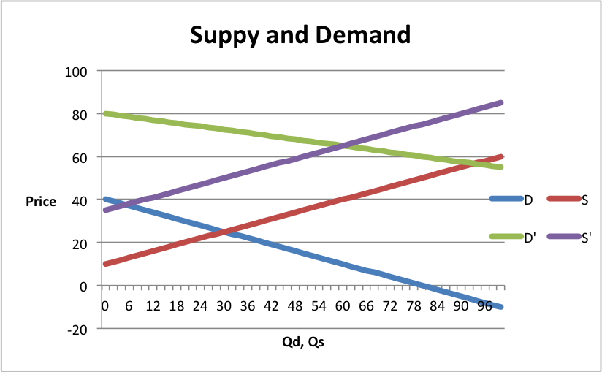

l) The equilibrium price is $65, the new equilibrium quantity is 60.
Higher costs of production, a significant increase in people leaving the market, and less efficient production methods are all factors that explain this shift in supply.

3. Elasticity
i.

Price | Quantity Demanded | Total Revenue
 | (Business Travelers) | (Business Travellers)
225 | 2700 | 607500
300 | 2500 | 750000
375 | 2300 | 862500
450 | 2100 | 945000
525 | 1900 | 997500

Price | Quantity Demanded | Total Revenue
 | (Vacationers) | (Vacationers)
225 | 1500 | 337500
300 | 1200 | 360000
375 | 1100 | 412500
450 | 900 | 405000
525 | 600 | 315000

- a) the price elasticity for business travellers is 0.27.
b) the price elasticity for vacation travellers is 0.78.
Formula: PED= ((Q2-Q1)/((Q2+Q1)/2))/((P2-P1)/((P2+P1)/2))

- The value I obtained is consistent with the direction change of the total revenue. As the price increases, total revenue increases.

- As the price of tickets rises from $450 to $525, the price of elasticity for :

- business travellers: 0.65
- vacation travellers: 2.60

- The tickets that are priced higher are more elastic than those that are priced lower. We would expect the higher priced tickets to be more elastic because they would be considered as more of a luxury good, where as the lower priced tickets would be considered a necessity.

- Vacation travellers may have different elasticity than business travellers because vacation traveling is a luxury good which is more elastic, where as business travel is a necessity which is more inelastic.

