Chapter 1: What Is Organizational Behavior (OB)?
- Understanding, explaining and improving the behaviors of people within an organization.
- Human Resources Management takes the theories and principles studied in OB and explores the “nuts and bolts” application of those principles in organizations.
- Strategic mgmt.: Field of studying the products choices and industry characteristics that effect an organizations profits.
Fredrick Taylor:
- The father of scientific management.
- Scientific Management: Using scientific methods to design optimal and efficient work processes and tasks.

Max Weber:
- The “father” of bureaucracy.
- Bureaucracy: An organizational form that emphasizes the control and coordination of its members through:
- A strict chain of command.
- Formal rules and procedures.
- High specialization.
- Centralized decision making.
Human Relations Movement
- Emerged as management scholars noticed that physiological (needs, attitudes) and social forces within work groups had huge impact on behavior.
- Hawthorne Plant series of studies produced the foundation on which the human reactions movement was built.
- Revealed the importance of norms, leadership, work motivation, job satisfaction and culture.
Most important individual outcomes:
- Job Performance
- Organizational Commitment.

The Individual Mechanisms (Which effect the two most important outcomes):
- Chapter 4: Job Satisfaction
- Chapter 5: Stress
- Chapter 6: Motivation
- Chapter 7: Trust, Justice, and Ethics
- Chapter 8: Learning and Decision Making.
Hyundai’s emphasis on OB, therefore its work teams and training increased the quality of its cars.
Resource Based View:
- What makes resources rare, which are unique to companies.
- This boils down to non-tangible things like wisdom, decision making, culture, etc.
- People are inimitable for 3 reasons:
  - People create history through actions, and history cannot be bought.
  - People make small decisions, like habits. Small decisions accumulate into big results, which cannot be copied.
  - Socially Complex Resources, such as teamwork, leadership, chemistry, culture, cannot be copied like a tangible thing.
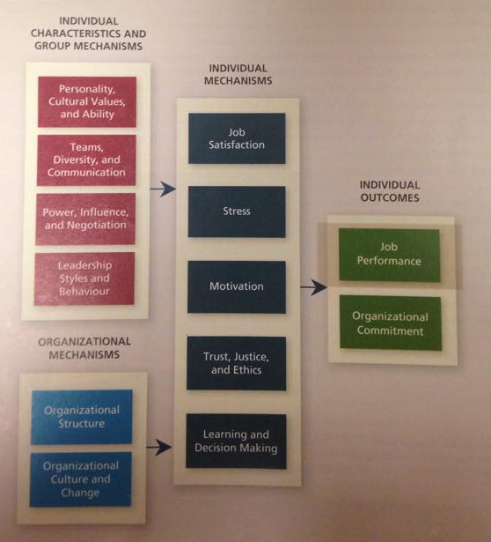
Chapter 2: Job Performance.
Fits into 3 categories:
- Task Performance
- Citizenship Behavior (Positive)
- Counterproductive Behavior (-)
Task Performance
- Duties and tasks employees must perform in order to continue getting paid.
- Routine Task Performance:
Well-known responses, things occur predictably, repetition, so what robotically (flight attend seatbelt demonstration).
- Adaptive Task Performance:
Un-predictable, more spontaneous, new experiences, new learning, non-robotic, etc.
Sometimes employees can switch from routine to adaptive (adapt to an emergency situation for example).
- Creative Task Performance:
The degree to which creativity and responding to situation in novel and useful ways.
Job Analysis Method:
- List of all activities in the job is listed.
- Activities are rated by “Subject Matters Expert”.
- Activities that are rated high are retained and used to define task performance.
Citizenship Behavior:
- When employees do things outside of their job description, “Go the Extra Mile”.
- Interpersonal Citizenship: Aiding other co-workers, so maybe showing the new guy the ropes even if no one told you to.
  - Courtesy: Sharing important information with co-workers.
  - Sportsmanship: Maintaining a positive attitude with co-workers through good and bad times.
- Organizational Citizenship: Providing strength to the actual bigger picture of the organization.
  - Civic Virtue: Helping the company at deeper levels by attending volunteering meetings and function.
  - Boosterism: Is bringing good face to the company, so representing it in a good way.
Counterproductive Behavior:
Employee’s behaviors that intentionally hinder organizational goal accomplishment (bad apples).
Property Deviance: Behaviors that harm the organizations assets and possessions.
- Sabotage: Purposeful destruction of physical equipment, organizational processes, or company products. Laser disc was shut out of business cause of employee’s dirtiness in production lab which sabotage the final product.
- Theft: Stealing company products or equipment from the organizations.

Production Deviance: Intentionally reducing organizational efficiency of work output.
- Wasting Resources (MOST COMMON).
- Political Deviance: Intentionally screwing over other coworkers.
- Incivility: Rude Communication.
- Substance Abuse, Gossiping, Aggression, Harassment.
Outcome of this all:
- On average, people who participate in 1 negative behavior also engage in numerous more.
- There is always an opportunity for counterproductive behavior.
- The prettiest people do the nastiest things. Surprised? The ones who seem to be the “best”, tend to be the ones who get away with the most counterproductive behavior.
Being a good worker means:
- Task Performance
- Citizenship Behavior Maximum
- Virtually No Counterproductive Behavior (Behavior can be contagious)
How organization use job performance:
- Management by Objectives – MBO
  - Based on employee’s evaluation on whether the employee achieves specific performance goals.
  - An employee needs a manager to discuss some mutually agreed upon objectives.
  - They agree on the time period and method for achieving those objectives.
  - Example: A manager could augment production by 35% within 3 months following certain new procedures.
- Behaviorally Anchored Rating Scales (BARS)
  - Use of examples of critical incidents to evaluate an employee’s job performance behaviors directly.
  - 5 = Open-minded; Learns new methods easily
  - 4 = Willing to make changes without much need for persuasion or supervision
  - 3 = Able to make changes with average amount of instruction
  - 2 = Requires persuasion and supervision to make changes
  - 1 = Unwilling to accept changes; does not adjust readily

- 360 Degree Feedback
  - This aims to provide a more balanced version of a rating by gathering ratings from a greater range of people who have experienced this employee first hand, whether they worked with him, if they were costumers, etc.
  - Problems: How much weigh raters have specifically on the overall rating? Who is most correct? What if raters are biased?
  - Best suited for improving or developing talent.
- Forced Ranking:
  - Evaluations that make clear distinctions in job performance.
  - They rank subordinates relative to each other.
  - Rank them based on A team (Top 20%), B team (Vital middle 70%), and C team (Bottom 20%).
  - 20% of fortune 500 companies use forced ranking.
  - Some people think it’s unfair in nature because it forces managers to rate some employees who may be good, in the bad category just to reach a pre-established %.
  - May make employees hypercompetitive.
- Social Networking:
  - Some companies use social networking programs that can provide anonymous information about job performance.
Chapter 3: Organizational Commitment
Talented employees are becoming scarcer, which increases the risk of them leaving for competitors. Turnover can be voluntary or involuntary.
Withdrawal Behavior
- Employee actions that avoid work situations.
- They are subconscious reflections of a loss of interest and commitment.
Affective Commitment
- Emotional attachment to a company, due to “feeling”.
- In simple, you stay because you want to.
- Engage in more boosterism, intrapersonal citizenship and organizational citizenship.
- Strong correlation between affective commitment and citizenship behavior.
  - Erosion Model: suggests that employees with fewer bonds with coworkers are more likely to quit.
  - Social Influence Model: Suggest that employees with direct linkages to co-workers who leave the organization will themselves become more likely to leave.
Continuance Commitment
- Exist when there is a benefit associated with staying and a cost associated with leaving.
- How many investments has an employee made (time, energy, effort, ect.) in the company? The more, the likely that they have higher commitment.
- The correlation between continuance commitment and work outcomes, other than turnover, tends to be characterized as negligible or weak negative.
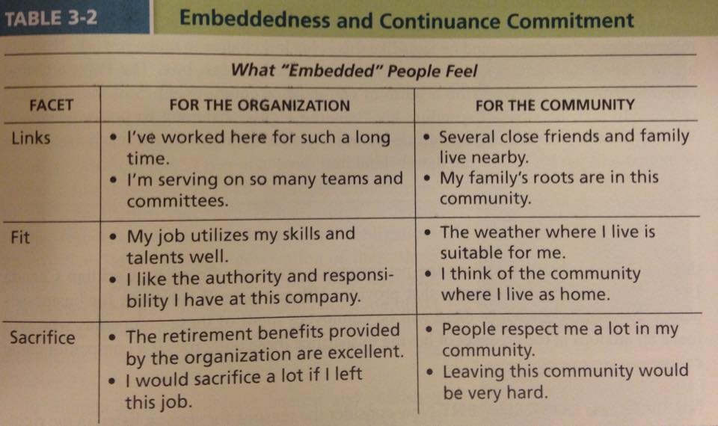
- Embeddedness describes how an employee feels he fits into an organization.

Normative Commitment
Staying with a company because you feel a sense of duty, obligation, as if you owe them to stay.
- Example: Spent 5 years working on a farm due to the employer being 80+ and sick with cancer. It was only moral to stay.
Withdrawal Behavior
- Exit: Reacting to a negative circumstance by showing up to work less and/or leaving the company.
- Voice: Trying to talk the situation out, actively trying to improve.
- Loyalty: A passive response to a negative work event in which one’s interest and effort in work decline.
- Neglect: A passive, destructive response to a negative work event in which one’s interest and effort in work decline. You slow down your work until you mentally “Check out” of the situation.
- Two MAIN FORMS: Psychological (NEGLECT) or Physical (EXIT)

Psychological withdrawal (Neglect):
- Consists of actions that provide a mental escape from the work environment.
- Day Dreaming, Socializing, Looking busy, and Cyber Loafing.
- Moonlighting: A form of psychological withdrawal in which employees use work time and resources to do non-work-related activities.
Physical withdrawal (Exit):
- Consists of actions that provide a physical escape.
- Tardiness, Long Breaks, Missing Meetings, and Absenteeism.
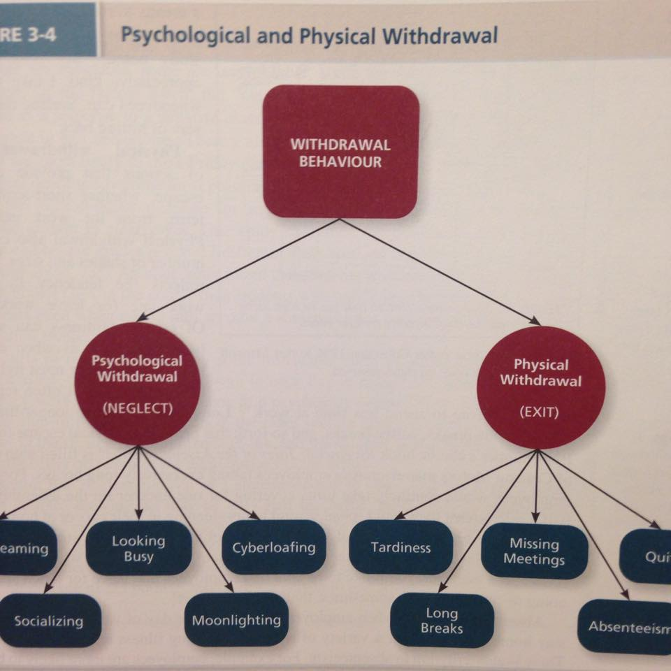

All these behaviors can be looked at in 3 days.
- Independent forms model: Withdrawal behaviors are not related. Someone may randomly cyber loaf, then randomly day dream, etc. Predicts that the various withdrawal behaviors are uncorrelated, so that engaging in one type of withdrawal has little bearing on engaging in other types.
- Compensatory Forms: One behavior means you’re less likely to do another one. Therefore, if you waste a lot of time day dreaming, long breaks is less likely to happen.
- Progression model: A model indicating that the various withdrawal behaviors are positively correlated, so that engaging in one type of withdrawal makes one more likely to engage in other types.
Downsizing
- Bad for the company since it takes 2 years to get back to the performance levels it was before.
- Creates Survivor Syndrome. Which is when an employee survives a downsizing but becomes biter in the process.
Psychological Contracts:
- Employee beliefs about what employees owe the organization and what the organization owes them.
- Transactional Contracts: Psychological contracts that focus on a narrow set of specific monetary obligations. A sense of a monetary value of what the company owes, and what he owes.
- Relational Contract: I owe the company loyalty and they owe me security.
Chapter 4: Job Satisfaction
Meaningfulness of Work
- Feel that what they do matters, and is positively helping at large.
- Formed by three things.
- Variety: When variety is high, every day is different, there are new challenges, lots of room for learning and growth, there is a sense of value and excitement.
- Identity: Employees identify with their work; they say “there I did that!”.
Seeing something from beginning to end.
- Significance: How the work effects the lives of other people, giving back to society at large, etc. if their job was taken away, society would suffer.
Responsibility for outcomes
- Employees feel that they actually matter, that they are key drivers in the company.
- Autonomy: the degree to which job provides freedom, independence, and not as much bossing around. In this, you feel like results are your results.

Knowledge of Results:
- They are aware of how well or poorly they are doing.
- Feedback: Refers to how well the job itself provides feedback on how well employees are doing day to day.

