- The process of economic growth has two essential ingredients.
  - Supply side: Given the available supplies of inputs like labour and capital, and the technology at its disposal, an economy is able to produce a certain volume of outputs, measured by GDP.
This capacity to produce increases from one year to the next as the supplies of inputs grown and technology improves.
  - Demand side: How much of the capacity to produce is actually utilized depends on how many of these goods and services people and businesses want to buy.
- Under the realm of growth policy, policy should create an environment in which the economy can expand its productive capacity rapidly, because that is the ultimate source of higher living standards.
- Under the realm of stabilization policy, policy makers should manage aggregate demand so that it grows in line with the economy’s capacity to produce, avoiding the cycles of boom and bust.
- The ultimate goal of macro policy is achieving rapid but relatively smooth growth with low unemployment and low inflation. Inadequate growth of aggregate demand can lead to high unemployment, while excessive growth of aggregate demand can lead to inflation.

PART 1: THE GOAL OF ECONOMIC GROWTH
- While it seems that the notion that standards of living continue to rise annually is natural, history shows that it is not the case. The living standards barely changed during a period of 16 centuries from the time of the Roman empire to the dawn of the Industrial Revolution. Per-capita incomes in most former Soviet Union and some poorest countries of Africa have also declined.
- Canadians will consume ~2% more goods and services per year. During the 2nd half of the 20th century, the living standards in Canada increased by a factor of 3.
Productivity Growth: From Little Acorns
- Small difference in growth rates make an enormous difference eventually.
- Comparing over a 130 year period, the US growth rate in GDP per capita was 1.9% while Uruguay’s was 1.0%, a small difference of 0.9%. This shows what a huge difference a one percentage point change in the growth rate can make, if sustained for a long time.
- The productivity of a country’s labour force, or labour productivity, is the amount of outpiut a typical worker turns out in an hour of work. If output is measured by GDP, productivity would be measured by GDP divided by total # of hours worked.
- A country’s productivity growth rate determines whether living standards will rise rapidly or slowly, contributing to material well-being, reduction of poverty, increases in leisure time, the ability to finance education, public health, environmental improvement, and the arts.
The Wonder of Compound Interest.
  - Growth rates, like interest rates, compound so for example, 10 years of growth at 3% leaves the economy more than 30% larger, 34.4%. After 20 years, it will be 80.6%. After 50 years, 338% and after a century 1,822%.
  - The arithmetic of grows leads to a “doubling rule.” If something grows at an annual rate of g percent, the amount of time it taks to double is 70/g, so the rule is often called “the Rule of 70.”
Ex. With a 2% growth rate. 70/2 = 35. It takes 35 years to double. With a 3% growth rate, 70/3 = 23.33 years, It takes 23.3 years to double showing why small differences can make a large difference.

The Capacity to Produce: Potential GDP and the Production Function
  - Economists created the concept of potential GDP to measure the economy’s normal capacity to produce goods and services, its real GDP if its labour force were fully employed.
  - Note the word normal in describing capacity. Just as it is possbile to push a factory beyond normal operating rate (ex. Adding a night shift), it is is possible to push an economy beyond its nromal full-employment level by working it very hard. So when we talk about emplying the labour force fully, we do not mean a measured unemployment rate of zero.
  - To eastime potential GDP, (1) count up avaiable input (labour, capital, other productive resources), (2) Assessing the economy’s technology to estimate how much outputs could be produce if inputs were all fully utilized. The more tehcnologically advanced an economy, the more potential outputs given available inputs.
  - A production function helps show the relationshop between inputs and outputs.
  - Either more capital or better technology will shift the production upward and raise potential GDP.

The Growth Rate of Potential GDP
  - Similarly, the growth rate of potential GDP and size of potential GDP depends on a few factors:
    - The growth rate of the labour force (size)
    - The growth rate of the nation’s capital stock (amount of capital)
    - The rate of technical progress
  - Real GDP = hours of work x output per hour = hours of work x labour productivity
  - Growth rate of potential GDP = Growth rate of labour input (hours of work) + growth rate of labour productivity
  - Canada’s Real GDP growth from 2000-2014 was around 2.20% = 1.15% + 1.05%.
  - Actual GDP may be quite different from potential GDP in the short run due to business cucles.
  - Over long periods of time, economists like to assume the growth rate of actual and potential GDP are similar.

ISSUE: Is Faster Growth Always Better?
  - Faster growth of either labour productivity or GDP per person is the route for higher living standards. Faster growth brings more wealth.
  - However, environmentalists worry that the sheet increase in the volume of goods imposes enormous costs on society in the form of pollution, crowding, proliferation of wastes that need disposal, and poisoning our food with dangerous chemicals.
  - Some psychologists and social critics argue that the never-ending drive for more and better goods fails to make make people happier. Surveys show residents of richer countries are no happier than residents of poorer countries. Growth may drive people to work longer hours.
  - An economy that grows too fast may generate inflation which occurs when aggregate demand expands faster than its capacity to produce, so growing faster than growth rate of potential GDP is not desirable long-term.
  - While building more capital is a good way to speed the growth of potential GDP, it imposes a cost, citizens must consume less today – an opportunity cost of faster growth.
  - Despite this, it’s known slower growth makes it difficult to finance programs that improve quality of life – including efforts to protect the environment. 2nd, we cannot order people to stop being inventive and hard-working to prevent further growth. 3rd, slower economic growth seriously hampers efforts to eliminate poverty. Most of Earth’s population live in poverty where more food, clothing, and shelter is desirable over cleaner air and fulfillment in the work place.

PART 2: THE GOAL OF LOW UNEMPLOYMENT
- When the economy grows more slowly than its potential, it fails to generate enough new jobs for its growing labour force, hence the unemployment rate rises. GDP growth faster than the economy’s potential leads to a falling unemployment rate.
- Potential output that is lost forever is the central economic cost of high unemployment.
- Table 2 summarizes the idleness of workers and machines, and the resulting loss of national output during years of low economic activity over the last 2 years.
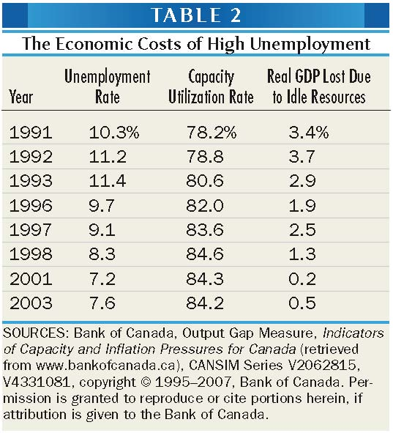
2009 8.4 69.6 2.9
2010Q3 8.0 76.0 1.7
2015Q3 7.0 82.5 1.5

The Human Costs of High Unemployment
- High unemployment is a problem due to forgone income but has been linked to psychological and physical disorders, divorces, suicides, and crime.
- These costs are distributed unevenly across the population. Unemployment is greater for younger workers.
- In good times and bad, workers with a high level of education experience the least unemployment, and those with a lower level of education suffer the most.
- A country’s productivity growth rate determines whether living standards will rise rapidly or slowly, contributing to material well-being, reduction of poverty, increases in leisure time, the ability to finance education, public health, environmental improvement, and the arts.

Counting the Unemployed: The Official Statistics
- Statistics Canada estimates the labour force (L), and classifies each person surveyed as employed (E), unemployed (U), or out of the labour force.
- The Employed
Includes everyone currently at work, including part-time workers. Although some part-timers work less than a full week by choice, others do so only because they cannot find suitable full-time jobs. These are counted as employed although many would consider them “underemployed.”
- The Unemployed
For persons not currently working, the survey 1st determines whether they are temporarily laid off from a job they expect to return. If so, they are counted as unemployed. The remaining workers are asked whether they actively sought work during the previous four weeks. If they did, they are also counted as unemployed.
- Out of the Labour Force
If they failed to look for a job, they are classified as out of the labour force rather than unemployed. While some people don’t want to work, research shows that many unemployed workers give up looking for jobs after awhile. One problem is that these distinctions cannot deal very well with the problem of “hidden” or “disguised
- These distinctions cannot deal very well with the problems of “hidden,” “disguised” unemployment (full-time becoming part-time) or discouraged workers – an unemployed person who gives up looking for work, and is therefore no longer counted as part of the labour force.
- Some argue that exclusion of such people from the unemployment rate underestimates the magnitude of the problem while others argue it overestimates the problem, because the unemployed only need to claim to be looking for jobs.
- As of 2014, the adult population in Canada is 29.0 million (A) with 19.1 million part of the labour force (L), a participation rate of 65.8%. Among those in the labour force, 17.8 million are employed (E) and 1.3 million unemployed (U) leaving an unemployment rate of 6.8%. The employment rate among the adult population is equal to 61.3% = E/A = (E/L)x(L/A).
- The adult population is defined as all persons 15 years of age or older, excluding full-time members of the armed forces, people living on Indian reserves, and inmates of institutions such as prisons and hospitals.
- “The LFS covers the civilian, non-institutionalised population 15 years of age and over. It is conducted nationwide, in both the provinces and the territories. Excluded from the survey's coverage are: persons living on reserves and other Aboriginal settlements in the provinces; full-time members of the Canadian Armed Forces and the institutionalized population. These groups together represent an exclusion of less than 2% of the Canadian population aged 15 and over.”

Types of Unemployment
- While providing jobs for those willing to work is one goal of macro policy, a 0-unemployment rate is not the answer. Unemployment is inevitable in our dynamic highly mobile ecnomy and can be categorized as follows.
- Frictional unemployment
Unemployment that is due to normal turnover in the labour market. It includes households who are moving from one province to another, people who have quit jobs to seek better positions or retool for more attractive occupations, people who are temporarily between jobs due to moving or changing occupations, or are unemployed for similar reasons.
- Structural unemployment
Arises when jobs are eliminated by changes in the economy, such as automation, or permanent changes in the skills demanded, Unlike frictional unemployment, structurally unemployed workers cannot realistically be considered “between jobs” since their skills and experience may be unmarketable in the changing economy. They are faced with prolonged periods of unemployment or the necessity of making major changes in their skills or occupations.
Ex. Maritime workers in fisheries, naval jobs.
- Cyclical unemployment (sometimes called involuntary unemployment)
Arises when the level of economic activity declines, such as a recession. When macroeconomists speak of maintaining “full employment,” they mean limiting unemployment to frictional and structural, which roughly means producing at potential GDP.

How Much Employment is “Full Employment”?
- It was once thought that 4% was a good target, but as the actual unemployment rate increased and this target never came close to being realized, the target was gradually increased.
- Events since the early 1970sm through 2007 have left economists uncertain of the full-employment unemployment rate.

Unemployment insurance: The Invaluable Cushion
Features of the Program
  - Employment insurance is a government program that replaces some of the wages lost by eligible workers who lose their jobs. It reokaces some but not all of the monetary loss by unemployed people.
  - It has gradually been used as a means to provide other social programs that go beyond unemployment, such as maternity and parental leaves.
  - The generosity of the program depends on five parameter tha change through time due depending on politics and government ideologies
  - Maximum Annual Insurable Earnings
Employment benefits are based on earnings of $50,000 – the 2014 maximum annual insurable earnings. Any labour income that is made beyond $50,000 is not liable to the 1.8% payroll tax that employees must pay to finance the EI plan.
  - Amount of Weekly Benefits
Unemployed workers can get at most 55% of weekly insurable earnings. But most EI recipients do not receive this amount, either because they did not earn the maximum weekly insurable amount while working, or because they had already claimed benefits in the past.
  - Qualification Requirements
The program is designed for people who are truly laid-off or who have reached the end of their fixed-term employment without having found another job.
Individuals who quit without just cause or who are fired for misconduct, as well as those who refuse a job offer, are penalized by losing their benefits for a # of weeks.
  - Number of Work Hours Required to Qualify for Benefits
Applicants must have worked a certain number of hours during a 52-week qualifying period. Applications who come from regions where the rate of unemployment is low need many more hours of work (about 20 weeks at 35 hours/week of work) than applications who come from regions where the rate of unemployment is high (about 12 weeks at 35 hours/week of work).
  - Number of Weeks for Payment Receipt
This depends both on the region’s rate of unemployment and on the number of hours of insurable earnings accumulated by the applicant during the 52-week. In regions of low unemployment, recipients may receive benefits for only 14 weeks whereas regions of high unemployment, recipients may receive benefits for 45 weeks.
Implications of the Program
  - The employment insurance program is an automatic stabilizer or an automatic stimulus program that may also help citizens who never become unemployed. By giving money to those who become unemployed, the system helps prop up aggregate demand during recessions.
  - It limits the severity of recessions by providing additional purhcasing power when and where it is most needed.
  - Payroll taxes and unemployment benefit spreads the cost of unemployment over the entire population rather than letting it fall on an unfortunate few but they do not eliminate its basic economic cost, i.e. the lost in potential output.
  - Should the benefits be more generous such as in European countries, or less generous?
  - If the program is too generous, people who lose their jobs and who might have been able to find work may be less eager to look for new jobs or decline offers.
  - 80% of unemployed used to get access to benefits while now, its closer to 40% despite small recent changes.

PART 3: THE GOAL OF LOW INFLATION
Inflation: The Myth and Reality
- During inflation, the belief is people pay higher prices for the same quantity of goods and services as before. So more income is needed to maintain the same standard of living. People’s purchasing power is decreased. However, this is incorrect.
- Figure 6 shows the rates of change of wages and prices since 1946. The difference between the two, shaded in yellow, indicates the rate of growth of real wages. Generally, wages rise faster than prices reflecting the steady advance of labour productivity.
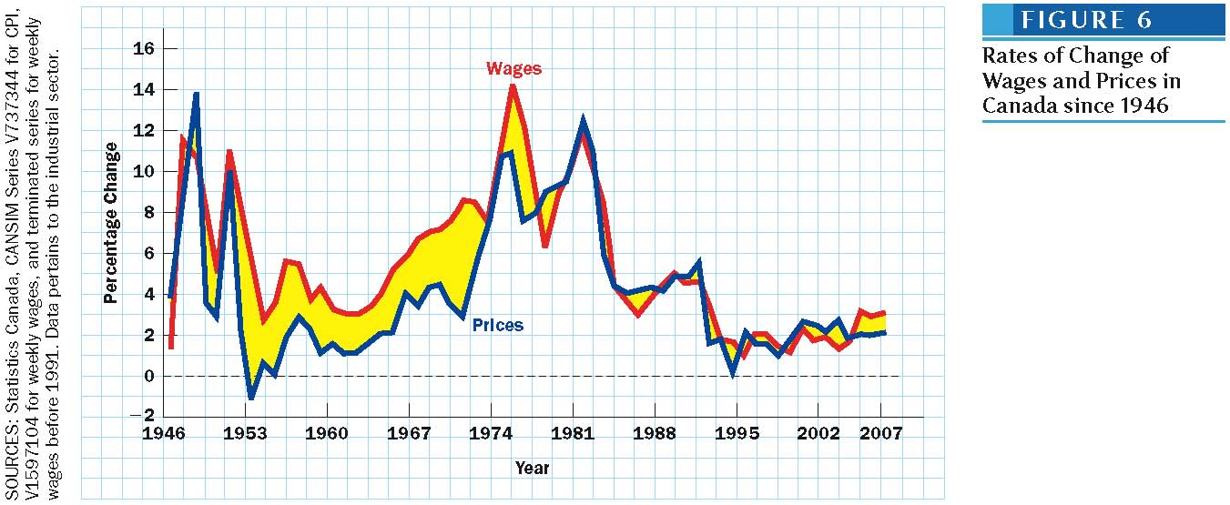
- Wages normally rise rapidly when prices rise rapidly and rise slowly when prices rise slowly but this does not imply causation.
Inflation and Real Wages
  - Wages which are prices for labour services also rise during inflation. The purchasing power of wages, the real wage rate, is not systemicatically eroded by inflation. Sometimes wages rise faster than prices and sometimes its vice versa. In the long run, wages tend to outstrip prices as new capital equipment and innovation increase output per worker.
    - Suppose there was a situation where there as no inflation and wages rose 2%/year because of increasing productivity. If fnlation sets in and prices started to rise by 3%/year, Figure 6 shows that after a small delay, wage increases would go up by 5%/year.
    - 2% would be due to the increased productivity while 3% would be due to compensation for higher prices (inflation) for a total of 5%.
The Importance of Relative Prices
  - There is a differnce between a rise in the general price level and a change in relative prices, which is a rise in one price relative to another.
    - Suppose a situtation where there was pure inflation in which every price rises by 10% so the releative prices do not change.
    - Table 3 gives an example where the price of candy bars rise from $0.50 to $0.55 movie tickets rise from $6.00 to $6.60, and cars rise from $9,000 to $9,900. After inflation it will take 12 candy bars to buy a movie ticket and 1,500 movie tickets to buy a car.
    - However, with real inflation, a 10% general inflation means that the average price rises by 10% - some prices jump 20% while others may remain the same or actually fall.
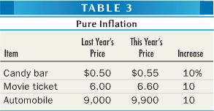
    - Table 4 illsutrates an example where movie prices go up by 25% from $6.00 to $7.50 while the price of candy bars remain the same. Thus, there was an increase in the price of movies relative to candy. It will not cost 15 candy bars to go to the movies instead of 12. The same would result if movie tickets stayed the same but the price of candy bars dropped to $0.40 meaning 15 candy bars would still be needed to go to to the movies.
    - However, because car prices have risen by only 5% from $9,000 to $9,450. It will not cost 1,260 movie tickets rather than 1,500 to buy a car. The same would result if car prices dropped to $7,560 with movie tickets remaining the same. In this case, cars became cheaper relative to movies.
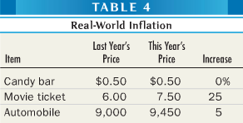
  - Real-world inflations proceed at uneven rates, relative prices are always changing.
  - Inflation is not usually to blame when some goods become more expansive relative to others. Losers often blame inflation for their misfortune, whereas gainers rarely credit inflation for their good luck.*****

How Statisticians Measure Inflation
Index Numbers for Inflation & The Consumer Price Index
- Inflation is generally measured by the change in some index of the general price level.
- An index number expresses the cost of a market basket of goods relative to its cost in some “base” period, which is simply the year used as a basis comparison.
- The Consumer Price Index (CPI), often known as "the cost of living," is the most widely cited index.
- There are many CPIs:
- CPI including all items
- CPI excluding energy
- CPIX Bank of Canada core inflation (excludes most volatile elements)

- Consumer Price Index (CPI) is measured by pricing the items on a list representative of a typical household budget.
- To know which items to and in what amounts, StatsCan conducts a survey of spending habits – the Survey of Household Spending. The same bundle of goods and services is used for four years or more, regardless of whether or not spending habits change.
- This is also called the base-period weight index because the relative importance it attaches to the price change on each item depends on how much money consumers choose to spend on the item in the base period. Canadians are asked at the beginning of 2006 about the amounts they spend on various items during 2005. The share of each class of expenditures is then established.
Ex. Fresh fruit = 0.73%, electricity = 2.46%, gasoline, 4.49%, tuition fee, 1.93%, textbook = 0.38%
During the adjustment of weights in 2005, rentals of video games was added.
- The current index is set at 100 for the year 2002.
Suppose in 2002, $2,000 a month was the amount needed to buy 600 goods and services in the CPI. Then $2,000 would serve as base index of 100.
If in 2007, it costs $2,230 per month to buy the same 600 goods and services, then the CPI in 2007 would be 111.5 [($2,230/$2,000)x100], meaning that the cost of living has increased by 11.5% per month.
- The base-period weight index is year 2005: it is based on the expenditures in 2005, as measured in the 2006 Survey of Household Spending.

- The index number problem refers to when relative prices are changing, there is no such thing as a “perfect price index” that is correct for every consumer. Any statistical index will understate the cost of living for some families and overstate it for others. At best, the index can represent the situation of an “average” family.
  - Table 5 represents the results of a hypothetical survey on spending habits in the base year of 2002 of students which will be used to devise a cost-of-living index, called SPI (Student Price Index)
  - In Table 6, prices of the same three items evaluated in 2002 are shown. Each price has risen ranging from 25% to 50%
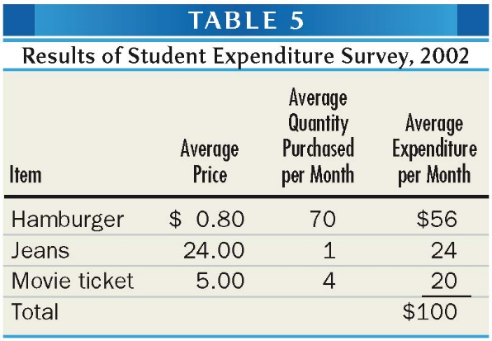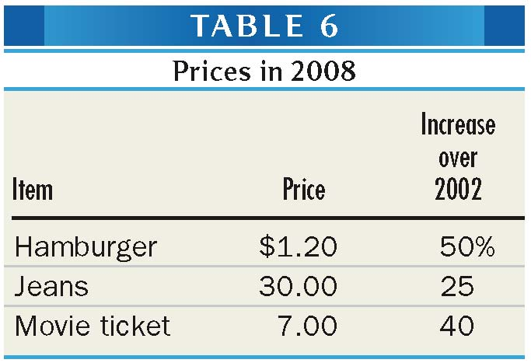
  - To determine how much the SPI has risen, we price the 2002 student budget at 2008 budgets to find that what once cost $100 now cost $142. The SPI thus stands at 142 meaning that the student’s cost of living has increased by 42% over 6 years.
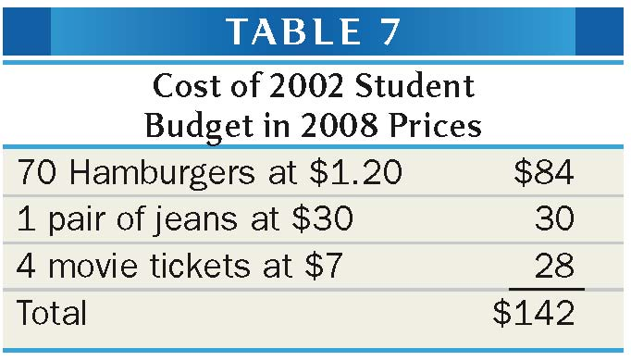
Using a Price Index to “Deflate” monetary Figures
- One of the most common uses of price indexes is in the comparison of monetary figures relating to two different points in time.
- Nominal values can be deflated by the CPI in order to estimate real changes.
- In the above example, suppose the student spent $100 per month in 2002 but $140 per month in 2008.
- The SPI showed that it takes $1.42 in 2008 to buy what $1.00 could buy in 2002. To compare the spending habits in the two years, we must divide the 2008 spending figure by 1.42.
- Real spending/student in 2008 = (nominal spending 2008/SPI of 2008) x 100
- Real spending in 2008 = (140$/142)x100 = $98.59
- Despite the fact that monthly spending by students went up from $100 in 2002 to $140 in 2008, there has been a small decrease in real spending, down to $98.59
- This procedure called deflating is the process of finding the real value of some nominal or monetary magnitude.
Using a Price Index to Measure Inflation
- Three measure of inflation are commonly found:
  - Month-to-month price change: A given month and the preceding month
  - Month-to-month change on annual basis: A given month and the same month of the preceding year
  - Price change over 12 months: The annual average index of a given year and that of the previous year
- The 1st measure is good if you are interested in the latest change, i.e. the month-to-month price change
- The 2nd measure is good if you want to know what happened over the last 12 months
- The 3rd measure is good if you want to compare annual rates or use historical series
What the CPI Is Not
- The CPI is useful for calculating changes in consumer prices.
- However, you cannot use these CPI data to find out whether the price level in Vancouver is any higher than other Canadian cities. To do this, the Inter-City Index of Consumer Price Levels mus be used.
- An example can be seen in the following figure. Since 2002, prices in Winnipeg rose by 24% while it only rose by 19% in Vancouver. However, this does not mean prices in Vancouver are lower than those in Edmonton. It is much more expensive to live in Vancouver (104) than Winnipeg (95). In other words, you would need $104 to buy $100 worth of stuff in Vancouver but only 95$ to buy $100 worth of stuff in Winnipeg.
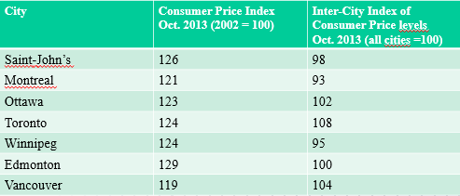
The GDP Deflator
- The price index used to deflate nominal GDP is called the GDP deflator. It is a broad measure of economy-wide inflation; it includes the prices of all goods and services in the economy. It includes the prices of goods (ex. airplanes, computers, etc.) purchased by businesses as well as government services.
- The GDP deflator is somewhat different from the CPI, in that its basket includes all the components of GDP, not just consumer goods. For that reason, it is considered a better measure of overall inflation.
    - It is also more complex to compute the GDP deflator.
  - Real GDP = (Nominal GDP /GDP Deflator) x100
  - Real (constant dollar) GDP is currently in chained (2007) dollars.
  - 2015Q2 Real GDP = ($1981B/112.6)x100 = $1759B

*** Inflation As A Redistributor of Income and Wealth
- Because inflation does not proceed evenly, some people gain from inflation and others lose.
- Those on a fixed income or lend money are often victimized by inflation because their income do not increase and keep pace with rising prices. Those who lend money often get back an amount that are worth less in purchasing power than the amount they originally loaned.
- Inflation usually benefits borrowers at the expense of lender and because both lenders and borrowers are found at every income level, we can conclude that inflation does not systematically steal from the rich to aid the poor or vice versa.
- Inflation redistributes income in an arbitrary way. Society’s income distribution should reflect the interplay of the operation of competitive markets and the purposeful efforts of government to alter that distribution. Inflation interferes with and distorts this process. It robs particular classes of people of purchasing power year after year – people living on private pensions, families who save money and “lend” it to banks, and workers whose wages and salaries do not adjust to higher prices.
Real vs Nominal Interest Rates
- There is a sharp distinction between expected and unexpected inflation
  - Suppose Adam wants to borrow $1,000 from Bob for one year, and both agree, in the absence of inflation, a fair interest rate would be 3% meaning Adam would pay back $1,030 at the end of the year.
  - If both men expect prices to increase by 6%, Bob may reason that the $1,030 one year from now will buy less than $1,000 buys today so realistically Bob would be paying Adam. So Bob may decide to charge him 9% so Adam will pay back $1,090 and with prices 6% higher, this will buy what $1,030 is worth today meaning Bob will get the 3% increase in purchasing power he would have got in the absence of inflation.
  - A contract with a 9% interest rate may then be created, 3% for the increase in purchasing power and 6% for expected inflation. If the expected 6% inflation actually materializes, neither party will be better or worse off by inflation.
- In the example, the 3% increase in purchasing power that the borrower, Adam, pays to the lender, Bob, for the privilege of borrowing is the real rate of interest while the 9% contractual interest written in the loan agreement is the nominal rate of interest which will include an adequate inflation premium, above the real interest rate.
- Nominal interest rate = Real interest rate + Expected inflation rate
- Real interest rate = nominal interest rate – expected inflation rate
- Inflation that is accurately predicted need not redistribute income between borrowers and lenders. If the expected rate of inflation that is embodied in the nominal interest rate matches the actual rate of inflation, no one gains and no one loses.
- However, to the extent that expectations prove incorrect, inflation will still redistribute income. Errors in predicting the rate of inflation are the norm.

Inflation Distorts Measurements
  - Many laws and regulations that were designed for an inflation-free economy malfunction when inflation is high.
Confusing Real and Nominal Interest Rates
  - Many Canadians viewed the 14% one-year mortgange interest rates that banks charged in 1980 as scandalously high while they viewed the 8% mortgage rates of 1992 as a bargain.
  - In truth, with inflation around 2% in 1992 and 10% in 1980 the real interest rate was 6% and 4% in 1992 and 1980 respectively.
  - This means that a household borrowing $100 in 1980 returned $114 at the end of year. If their income went up with inflation, then if they started with an income of $100, they would have a $110 income at the end of the year and after returning money to bank, have lost $4. On the other hand, if the household borrowed $100 in 1992 it returned $108 at the end of year. If their income went up with inflation, then if they started with $100 income, they would have $102 at the end of the year and lost $6.
The Malfunctioning Tax System
  - The tax system simply taxes nominal interst regardless of how much real interest it represents.
  - Similarly, capital gains – the difference between the price at which an investor sells an asset and the price he/she paid for it – are taxed in nominal terms.
    - Between 1983 and 2007, the price level doubled. Consider some stock that was bought in 1982 for $20,000, and sold in 2007 for $35,000. $20,000 of 1982 money could buy $40,000 worth of product s in 2007 money. Since the law levies tax on nominal capital gains, the investor was taxed on the $15,000 of nominal capital gain even though she suffered a real capital loss of $5,000.
- If the tax was 50%, then the investor lost $12,500 [5,000+(15,000x50%]. For her to have broke even with a tax of 50%, her stock would have had to be worth $60,000. With a nominal capital gain of $40,000 and losing $20,000 to taxes, she would have $40,000 in 2007 money which is equivalent to $20,000 in 1982 money, a real gain of $0.
- In this case while her nominal capital gain is $40,000, her actual capital gain before taxes was $20,000. If the tax targeted her real capital gain, she would lose $10,000 and thus would be left with $60,000-$10,000 = $50,000, a nominal gain of $30,000. She would realistically have $25,000 in 1982 dollars and have made a real gain of $5,000.
  - Canadian government only include 50% of capital gain as taxable income.
  - The tax system fails to recognize the distinction between nominal and real capital gains, or between nominal and real interest rates. It levies high, and unintended tax rates on capital income when there is high inflation. Thus the laws that govern our financial system can become counterproductive in an inflationary environment, causing unforeseen problems. Some economists feel that the high tax rates caused by inflation discourage saving, lending, and investing and therefore retard economic growth.
  - The difference between real and nominal interest rates, and the fact that the real rate matters economically whereas the nominal rate is often politically significant, are matters that are matters that are of the utmost importance and yet are understood by very few people including policymakers.
    - In another example, suppose a family deposits $10000 in savings with a nominal interest rate of 25%/year, a real interest rate of 15% since inflation is predicted to be 10%. At the end of the year, they have $12500. If they are taxed 50% on the gains from interest, they are left with $11250. If inflation was 10%, that means they made $250 with interest ($1125 - $1100).
    - On the other hand if the tax would have targeted their real interest rate, they would have ended up with $11750. With inflation, they would have made $750 with interest ($1175-$1100).

Other Costs of Inflation
  - Rapidly changing prices make it risky to enter long-term contracts. Without long-term loans, business investment become impossible and the economy may stagnate.
  - Shoppers may confuse a relative price change with a general price increase (this is more like an allocation problem, so it is more a microeconomic issue.
    - Suppose a corporation wants to borrow $1 million to purchase new equipment and needs the loan for 20 years. With no interest, if inflation average 2% over this period, the $1 million it repays at the end of 20 years will be worth $672,971 to the bank. If inflation averages 5%, it will be worth $376,889 to the bank. The bank has lost money in both cases.
    - If there existed a mansion that the bank wanted to buy at the end of the 20 years and it was initially listed at $1,000,000, at the end of 20 years with 2% inflation, it would be listed at $1,485,947.40. With 5% inflation, it would be listed at $2,653,297.71.
The Costs of Low vs high Inflation
  - Inflation creates fewer social problems if:
  - It is steady and therefore relatively predictable
  - It is low rather than high. High inflation is more damaging because it creates more uncertainty, thus leading people to confuse absolute price changes with relative price changes. Since resource allocation and decisions in market economies ought to be guided by relative prices, which measure relative scarcities, being confused about these relative prices induces agents to take mistaken and inefficient decisions. Higher inflation rates, along with their associated increased variability, generate more errors in the assessment of relative price changes, and thus may lead to slow productivity growth.
  - Steady and low inflation ma allow prices to rise or a long time and a moderate and fairly constant pace, allowing people to adapt.
Low Inflation Does not Necessarily lead to High Inflation
  - Low inflation does not necessarily lead to high inflation. There is neither statistical evidence nor theoretical support for the belief that low inflation inevitable leads to high inflation. To be sure, inflations sometimes speed up. At other times, they slow down.
  - Creeping inflation sometimes accelerate, but it sometimes deccelerates.
  - Runway inflations have occurred only when the government has printed incredible amounts of money, usually to finance wartime expenditures.
  - Several countries have experienced annual inflation rates exceeding 100% (Argentina, Russia)
  - While creeping inflations may have causes, galloping inflations have occurred only under exceptional circumstances (Zimbabwe, Germany 1923).

