- In chapter 8, we learned that aggregate demand has four components: consumer expenditure (C), investment (I), government purchases (G) and net exports (X-IM).
- We also saw that consumer expenditures depend on GDP, more specifically they are a function of disposable income.
- We assume that the price level, rate of interest, and the international value of CDN is constant. We are assuming that the government does not intervene. This will allow us to see how the strength of AD influences GDP and it will give us an initial answer to the question: “can we expect the economy to achieve full employment if the government does not intervene?”
- “A definite ratio, to be called the Multiplier, can be established between income and investment.” – John Maynard Keynes

ISSUE: Why Does the Market Permit Unemployment?
- Market economies have one coordination problem: the periodic bouts of mass unemployment, called recessions and depressions. Widespread unemployment represents a failure to coordinate economic activity in this sense. If the unemployed were hired, they would be able to buy the goods and services that businesses cannot sell. The revenue from sales would allow firms to pay the works. Seems like a straightforward deal offering hob for the unemployed and sales for firms yet workers remain unemployed and firms get stuck with unsold output.

The Meaning of Equilibrium GDP
- Will the economy automatically gravitate towards full employment if left alone? In contrast to past economists, Keynes argued that it would not but his view remains controversial to this day.
- As explained in chapter 8, total production and total income must equal but this is not true of total spending.
- Neither the output nor the price level is in equilibrium when total spending exceeds current production because falling inventories demonstrate to firms that their production and pricing decisions were not quite appropriate.
- Equilibrium level of GDP on the demand side cannot be one at which total spending [C+I+G+(X-IM)] exceeds output because firms will notice that they are depleting their inventory stocks. Firms may first decide to increase production sufficiently to meet the higher demand. Later they may decide to raise prices.
- The equilibrium level of GDP on the demand side cannot be one at which total spending is less than output, because firms will not allow inventories to pile up. They may decide to decrease production or to cut prices to stimulate demand.
- Equilibrium level of GDP on the demand side occurs when total spending equals production. Firms find their inventories remaining at desired levels, so they have no incentive to change output or prices.

The Mechanics of Income Determination
- Table 1 shows how consumer spending (C), depends on GDP (Y) appearing in columns 1 and 6. We assume the other three components of expenditure are fixed regardless of GDP. This relationship is called the expenditure schedule [C+I+G+(X-IM)].
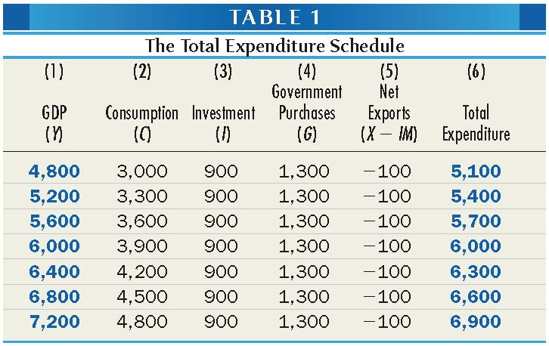
- The expenditure schedule [C+I+G+(X-IM)] can be constructed graphically as shown in figure 2.
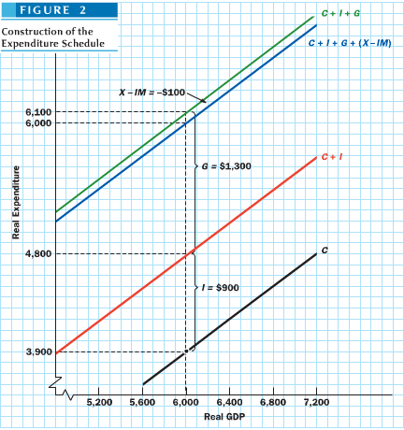
- The black line (C) is the consumption function graphing the numbers given in columns 1 and 2.
- The red line is C+I assuming I is constant. However, usually I is larger when GDP is higher. This added investment as GDP rises is called induced investment and the red line would have a steeper slope.
- The green line is labelled C+I+G adding in government purchases.
- The blue line is labelled C+I+G+(X-IM) adding in net exports. If imports depending on GDP as the previous chapter suggested, see Appendix D to see what happens.

- Table 2 represents the circular flow argument in tabular form.
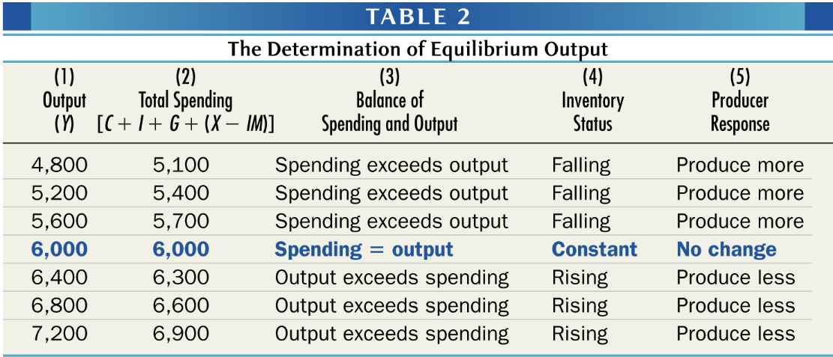
- Figure 3 depicts the same conclusion graphically by adding a 45º line using a 45º line marks all points at which the variable measured on the horizontal axis (GDP in this case) equals the value of the variable measured on the vertical axis (total expenditure in this case). The 45º line therefore displays all the points at which the economy can possibly be in demand-side equilibrium.
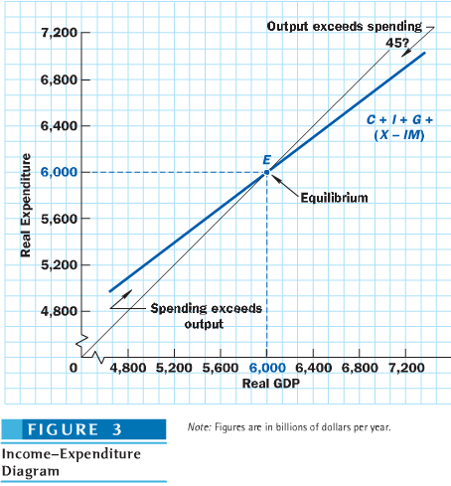
- Whenever production is above the equilibrium level (right of E), market forces will drive output down.
- Whenever production is below equilibrium (left of E), market forces will drive output up.

- Diagrams such as figure 3 are called income-expenditure diagrams or simply 45º line diagrams.

Demand-Side Equilibrium and Full Employment
- As GDP falls above potential GDP, the economy will be plagued by inflation and when equilibrium falls below potential GDP, unemployment and recession will result.
- Equilibrium GDP may not equal full-employment GDP. That is, we may be in an unemployment equilibrium.
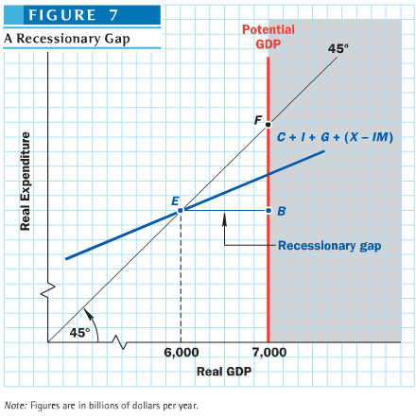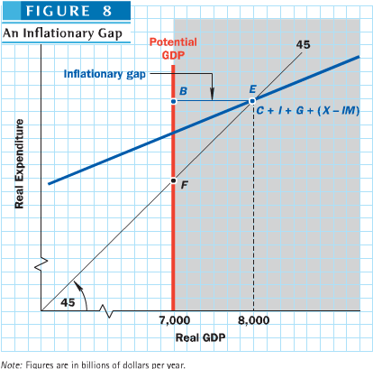

- Figure 7 illustrates a situation where equilibrium falls short of full employment, leaving some resources unemployed. A vertical line has been drawn at the level of potential GDP, a number that depends on the kinds of aggregate supply considerations discussed in chapter 7. Such a situation characterized the Canadian economy during most of the 1990s.
- An equilibrium below potential GDP can arise when consumers or investors are unwilling to spend at normal rates, when government spending is low, or when foreign demand is weak depressing the total expenditure curve. Not enough output is demanded to keep the labour force at work. The amount of difference between the equilibrium level of output demanded (GDP) and the full-employment level of output that can be demanded (potential GDP) is called the recessionary gap shown by the horizontal distance from point E to point B.
- Figure 8 illustrates a situation where equilibrium exceeds full employment, a situation believed to characterize the Canadian economy in 2000 and between 2004 and 2007. Such a case can arise when consumer or investment spending is unusually buoyant, when foreign demand is particularly strong, or when the government spends too much.
- The amount by which the quantity of GDP exceeds potential GDP is called the inflationary gap shown by the horizontal distance from E to point B.

The Coordination of Saving and Investment
- Figure 9 shows a circular flow diagram that ignore exports, imports, and the government. In this version income can leak out of the flow only at point 1, where consumers save some of their income. Lost spending can be replaced only at point 2, where investments enter the flow.
- If firms produce exactly the full-employment level of GDP at point 3, full employment income will be maintained ONLY if the spending by investors at point 2 exactly balances the saving done by consumers.
- The economy will reach an equilibrium at full employment on the demand side only if the amount that consumers wish to save out of their full-employment incomes happens to equal the amount that investors want to invest. If these two magnitudes are unequal, full employment will not be an equilibrium.
- The answer to the question posed at the beginning is, the market will permit unemployment when total spending is too low to employ the entire labour force.
- If saving exceeds investment at full employment, total demands received by firms will fall short of total output because the added investment spending will not be enough to replace the leakage to saving. With demand inadequate to support production at full employment, actual production will fall below potential production at full employment resulting in a recessionary gap.
- If investment exceeds savings at full-employment, total demand will exceed potential GDP and production will rise above the full-employment level resulting in an inflationary gap.
- The people who invest are not the same as the people who save. In a modern capitalist economy, investing is done by one group of individuals (primarily corporate executives and home buyers) whereas saving is done by another group (households, businesses as retained earnings – the firms that gather the retained earnings may not be those that decide or want to invest).
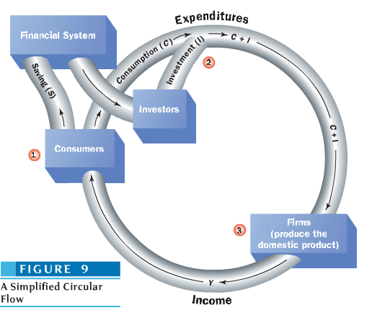
- If both high unemployment and high inflation arise from coordinate failures, might the government be able to do something about this problem. Keynes suggested it could using monetary and fiscal policy.

Changes on the Demand Side: Multiplier Analysis
- We learned how demand-side equilibrium depends on the consumption function and the amounts spent on investment, government purchases, and net exports but none of these are constant in reality.
- A remarkable result called the multiplier says that a change in spending will bring about an even larger change in equilibrium GDP on the demand side.
The Magic of the Multiplier
- Since investment is subject to abrupt swings, it often causes business fluctuations nationally and internationally. If firms suddenly decided to spend more on vestment goods, it would have a multiplied effect on GDP.
- The multiplier is defined as the ratio of the change in equilibrium GDP (Y) to the original change in spending that caused GDP to change. When we deal with the multiplier for investment (I), the formula is:
Multiplier = Change in Y/Change in I
- This effect can be seen in Table 3 which is similar to Table 1 except in this case, firms want to invest $200 billion more than previously for a total of $1,100 billion. Equilibrium between total expenditure and Production (Y) now occurs at $6,800 billion.
- Figure 10 shows this change graphically. The black line marked C+I₀+G+(X-IM) is derived from the total expenditure column of table 1 while the blue line marked C+I₀+G+(X-IM) is derived from the total expenditure column of table 3.
- The upward shift in the expenditure line has caused the equilibrium to move outward from $6,000 billion to $6,800 billion, a difference of $800 billion.
- The multiplier in this case is thus equal to 4.
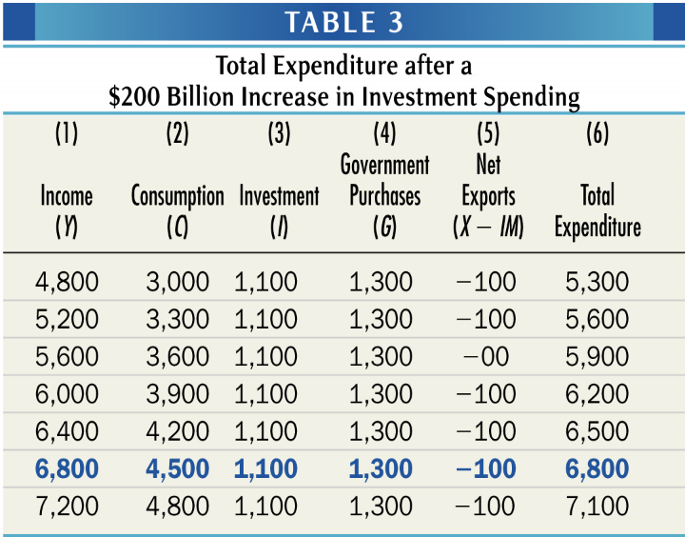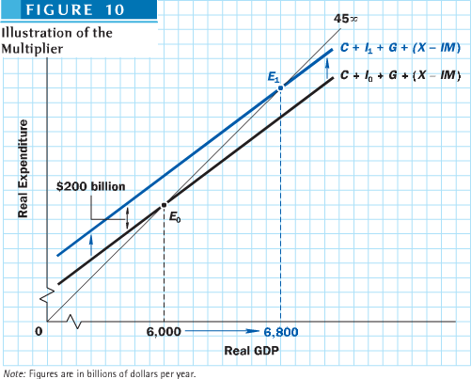
Demystifying the Multiplier: How it Works
- It works because one person’s spending is another person’s income. Increased spending thus leads to increased income.
- An example illustrated in Table 4 can show how this works.
  - Suppose Microhard, a major corporation, decides to spend $1 million on a new office building. $1 million expenditure goes to construction workers and owners of construction companies as wages and profits. The $1 million becomes their income.
  - The construction firm’s owners and workers will not keep all of their $1 million in the bank. They will spend most of it. If they are “typical” consumers their spending will be $1 million times the MPC. In our example, MPC is 0.75, so assume they spend $750,000 and save the rest. This $750,000 is a net addition to the nation’s demand for goods and services just as Microhard’s original $1 million expenditure was.
  - At this point the $1 million investment has pushed GDP up by $1.75 million.
  - Shopkeepers receive the $750,000 spent by construction workers and spend 75% of their new income accounting for $562,500 (0.75x$750,000) in additional consumer spending in the “third round.” This goes on and on, at each stage in the spending chain, people spend 75% of the additional income they receive.
  - It eventually ends with GDP a total of $4 million higher than it was before Microhard built the original $1million office building. The multiplier is 4.
  - We can see that after 10 rounds of spending, the $1 million investment has led to $3.77 million. After 20 rounds, the toal increase in GDP is over $3.98 million.
  - We see that it hits $3 million rather quickly. If each income recipient in the chain waited 2 months before spending their new income, the multiplier will reach 3 in about 10 months.
  - Figure 11 provides a graphical representation of the numbers in column 3 of table 4.
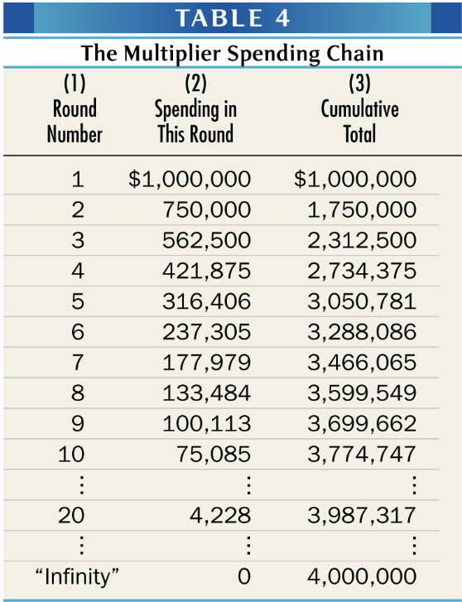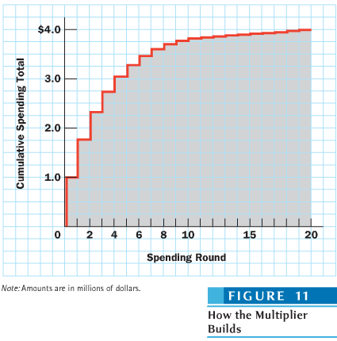
Algebraic Statement of the Multiplier
- It is an infinite geometric series where each subsequent number is a fixed fraction of the previous one. The fraction is called the common ratio which in this case is the MPC.
- The sum of an infinite geometric progression is equal to 1/(1-R).
- Thus the oversimplified Multiplier formula is:
- Multiplier = 1/(1-MPC)
- It is called oversimplified because it ignores many factors that are important in the real world. The current MPC has been estimated to be about 0.9 implying the multiplier is 10.
- In fact the actual multiplier for the Canadian economy < 2. Why?
- Factors that reduce the size of the multiplier (leakages that are additional to those of personal saving)
  - International trade – in particular, the fact that a country’s imports depend on its GDP dealt with in Appendix D
  - Inflation (price increases) – a complication seen in chapter 10.
  - Income taxation – a point seen in chapter 11
  - Retained earnings of corporations (corporate saving)

The Multiplier is a General Concept
- Any increase in spending can kick off a multiplier chain.
- When the process is initiated by an upsurge in consumer spending, we must distinguish between two types of change in consumer spending:
  - Induced increase in consumption
When C rises because income rises, consumers move outward along a fixed consumption function
  - Autonomous increase in consumption
When C rises because the entire consumption function shifts upward. As discussed in Chapter 8, could be due to several events such as a change in the value of the stock market.
- An autonomous change in consumer spending (caused by something other than an increase in income) shifts the consumption function and has a multiplier effect, just the same as a change in Investment does.
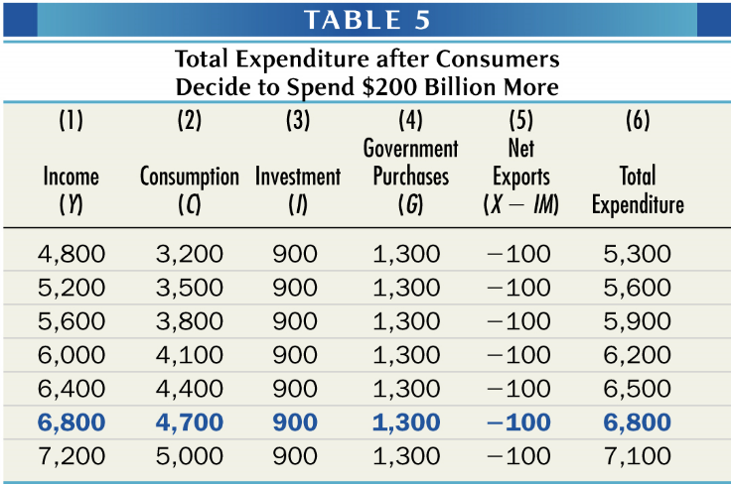
- We see that a $200 billion increase in C rather than in I produces a similar effect.
- The multiplier for autonomous changes in consumer spending, is also 4.
- It does not matter who injects an additional dollar of spending into the economy, businesses or consumers, 75% of it will be respent if the MPC is 0.75

- The idea that changes in G have multiplier effects on GDP will play a central role in the discussion of government stabilization policy that begins in Part 3, thus it should be noted here that a change in G has the same multiplier effect as a change in I or a change in autonomous C.
- This is why you want to increase G during an economic recession. It will boost GDP.
- Applying the multiplier effect to net exports shows that booms and recessions can be transmitted across national borders. The GDPs of the major economies are linked by trade. A boom in one country tends to raise its imports and push up exports and GDP in other countries. Similarly, a recession in one country tends to pull down GDP in other countries.

The Paradox of Thrift
A Reduction in Autonomous Consumer Spending
- What happens if there is an autonomous decrease in consumption? If consumers decide to spend $200b less? Initially, saving rises by $200b. But the economy is then in disequilibrium.
- Given a multiplier of 4, equilibrium income should fall by $800billion. By comparing Table 1 and Table 5 we can see Table 1 with a $200billion lower autonomous consumption (C), has a lower equilibrium GDP of $6,000billion, a $800billion decrease from Table 5.
- Seen from another angle, households decided to increase their savings by $200billion but by doing so caused the GDP to reach a new equilibrium that was $800 billion.
- Under the assumption that taxes are constant, disposable income has also gone down by $800 billion. Since all the tables use the assumption MPC is 0.75 that means consumer expenditures have fallen by $600billion while savings has decreased by $200billion. In the end, saving is no larger than it was before households decided to increase their savings.
The Saving and Investment Approach
- What happens if there is a change in the propensity to consume?
- Consider a simple example where there are no taxes and no net exports (G=T=X=IM=0). Under those conditions, Y = C + I.
- Because there is no tax, gross domestic income and disposable income is the same so that gross domestic income is also the sum of consumption and saving. Calling S the saving of our households:
Y= C + S C + S = C + I and hence in equilibrium S = I.
- As long as there is no change in the level of investment I decided by firms, the level of saving at the new equilibrium level of output can be no different than it was at the initial equilibrium of output. Thus, households can try to save but in the aggregate, the saving of the community in equilibrium can be no different than the given level of investment. Thus if households attempt to consume less or save more on their current income than the given level of investment, spending will exceed output and income, so that the inventories of firms will rise, inducing the firms to reduce production. This will happen until output, and hence income, is so much reduced that household saving is once more equal to the given level of investment.
A Reduction in Marginal Propensity to Consume
- So far we have assumed the MPC remains the same. The MPC being the slope of the expenditure schedule in our income-multiplier diagram also remained constant.
- Suppose that a huge thrift campaign is launched on the basis that individuals become wealthier when they save than when they spend. The advertising in favour of household saving is not much different than every year in February when financial institutions run ads to promote the purchase of RRSPs. Each consumer reduces his or her MPC so that the aggregate MPC falls and hence the aggregate MPS rises. An example is illustrated in Table 6.
  - Initially at equilibrium, output is at $6,000 where the MPC is 0.75 and the MPS is 0.25
  - (MPC + MPS) must always add to equal 1. What you don’t spend you save.
  - As a result of the campaign, the MPC is now 0.625 and the MPS is 0.375. Spending is now only $5,250 and the economy is no longer in equilibrium. Eventually, the new equilibrium at $4,000 is reached.
  - Assuming autonomous consumption is $500 billion. With investment spending at $1,000 billion, the overall autonomous expenditures = $1,500 billion.
  - With an MPC of 0.75 and income at $6,000 billion, induced consumption is (0.75x$6,000) $4,500 billion and overall consumption is ($500+$4,500) $5,000billion. Total spending is thus $5,000 billion (consumption) and $1,000 billion (investment) making $6,000billion.
  - Equilibrium income is the amount of autonomous expenditures times the multiplier ($1,500x 4). With a new MPC of 0.625, the multiplier is 1/(1-0.625) = 8/3 or 2.666 implying a new equilibrium level of income equal to $4,000 billion.
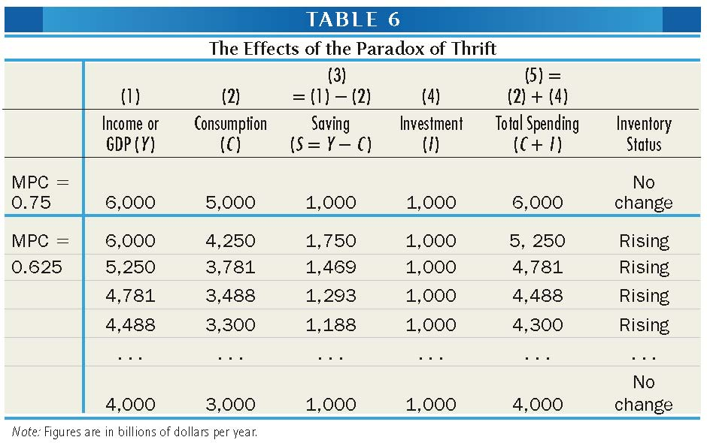
  - As can be seen in figure 12 which is the example illustrated graphically, with a lower MPC, the slope of the consumption function and therefore the expenditure schedule is flatter. The new schedule cross the 45º line at the $4,000 billion. As producers adapt to the lower expenditures by reducing production by producing the amounts that correspond to the total expenditures of the previous round, income falls gradually until it reaches equilibrium.
  - Savings which was $1,750 at the beginning of the thrift campaign is now back at $1,000 billion and has led to a recession. Real output and real income have fallen by $2,000 billion.
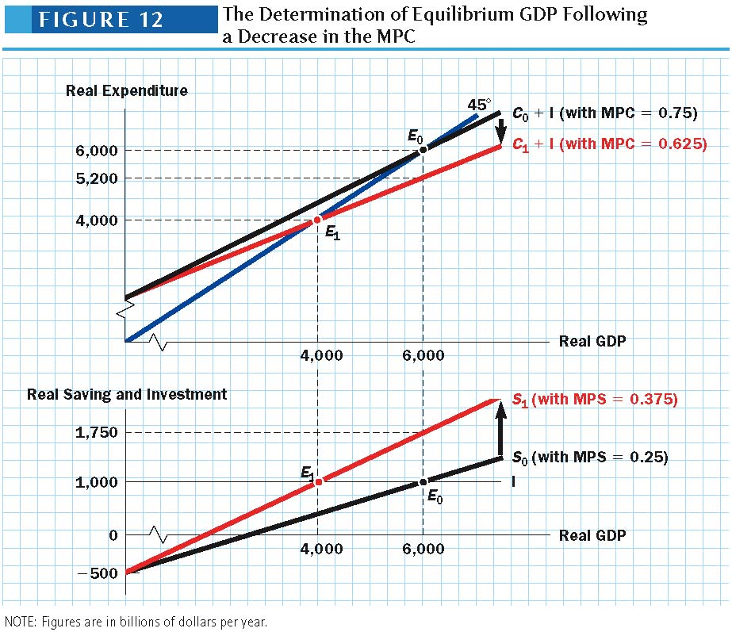
- We have observed this during the subprime financial crisis.
- The fact that the efforts of all individuals to increase saving proves to be unsuccessful, leading only to a fall in GDP and lower equilibrium income, and no increase in overall saving when GDP is back to its equilibrium level, is called the paradox of thrift.
- In equilibrium, the macro causality goes from investment to saving; that is, investment determines saving. It is higher levels of investment that will induce greater community saving and hence lead to the accumulation of greater wealth for the entire community.
- Attempts to reduce consumption, either through a reduction in autonomous consumption demand or through a reduction in the propensity to consume, will lead to a reduction in the equilibrium level of income.

*The paradox of thrift and the banana parable*
- If the thrift campaign could be accompanied by a small simultaneous increase in investment expenditures, none of this would happen.
- In chapter 8, it was argued investment would increase in business confidence solidified. But if sales are falling and stock of inventories are rising, unplanned, this will not convince entrepreneurs to increase the pace of investment in fixed capital and capacity.
- What if prices were not constant and they fell as real sales declined? The issue is whether we take into account the debt affect – the fact that wealth is often the counterpart of the debt of someone else.
- Keynes’ banana parable calls for the saving of all households to be accumulated as deposits in bank accounts with all of the deposits being lent out to the firms to make up for their losses.
- Imagine a community, initially in a state of equilibrium, which produces only bananas. A thrift campaign is started where people save more and consume less, the rate of investment in plantations stay the same. The price of bananas fall by the amount of the increased saving. Virtue is rewarded. People get the same amount of bananas as before for less money, and they have “saved” as well. But the producers of bananas have now made an unexpected loss, since they have been forced to sell their bananas below cost price. They can’t store them because they will rot. The increased saving has not increased the aggregate wealth of the community. It has transferred part of it from producers to the consumers of bananas so nothing has happened to reduce their excess saving.
- In the next phase, the banana makers try to produce themselves by reducing their wage bills, which means letting go of workers. This will cause the income of the community to be reduced by just as much as the aggregate costs of production.
- The entrepreneurs will continue to makes losses as long as the community continues to save more than it invests and the output of bananas continues to decline until either all production stops and the population starves, or the thrift campaign is called off or peters out as a result of growing poverty.
- The fact that you don’t spend means that some businesses has to accept a lower price for what he sells you and is poorer by the exact amount you are richer. Without knowing it, you as a shareholder in a banana plantation are that much poorer as well. With producers of consumption goods making a loss, why would anyone think it worthwhile investing in new facilities for these goods?

- In table 2, we saw that inventories (a stock) fall when spending exceeds output, and that inventories rise when output exceeds spending.
- In the appendix of chapter 8, we emphasized, from a national accounting point of view, gross domestic output is always the same, measured from a value-added point of view from the expenditure side, or from the income side. So how can spending exceed output, while at the same time, domestic output is equal to domestic expenditures?
- This is because national accountants use a definition of investment, and hence of total expenditures, that is slightly different form the one used in macroeconomics.
- In the models for this chapter, investment expenditures includes only fixed business investment, i.e. investment in fixed capital (machines, factories, houses). This is what we call I in our model out of equilibrium.
- By contrast, national accountants include in investment expenditures both fixed business investment and business investment in inventories, the sum of which we call I_{na}.
- Business investment in inventories represents the value of the change in inventories. Increases in inventories due to unsold goods constitute an investment in inventories (a flow). Similarly, when spending exceeds output, inventory stocks will diminish and there will be a negative investment in inventories.
- Any discrepancy between output and spending will lead to the creation of investment in inventories (either +ve of –ve) which will equate domestic production with domestic expenditures, as verified by national accounts.
  - This is shown in Table 7, starting with out-of-equilibirum values taken form table 1. With fixed capital investment of $900 billion and total spending equaling $5,100 and exceeding output of $4,800. This means the firms will have to deplete their inventories to meet demand, up to a –ve value of $300 billion.
  - Since business investment according to the definition of national accounts is the sum of fixed investment and investment in inventories, it is now equal to only $600 billion. This will make GNP, expenditure-based, exactly equal to the value added of what has been produced during the year.
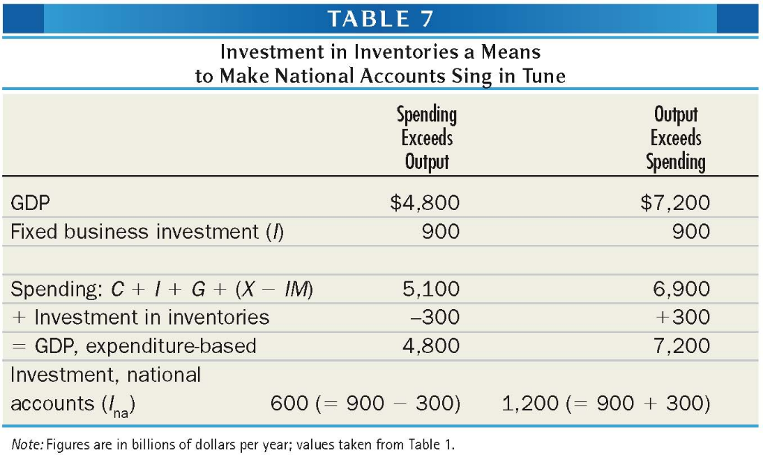
- Changes in inventories also allow us to explain how savings and investment are always equal to each other from the point of view of the national accounts, while the equality of investment and saving is an equilibrium condition in macroeconomics.
- This can be seen in the case of our model with no government and international trade where saving is defined in the national accounts as identical to household saving. If saving is any different from fixed capital investment, as defined by macroeconomics, investment in inventories will make up the difference. This can be seen in table 8 which is based off table 6.
  - Saving which stood at only $1,000 billion before the change in MPC, moved up to $1,750. From the national accounting viewpoint, investment also moved up to $1,750 billion but $750 billion came from increases in inventories, i.e. $750 billion worth of goods that were produced but not sold.
  - Eventually, through changes in the level of output, overall saving diminished gradually, until it became equal to the given level of fixed capital investment by firms, $1,000 as shown in the last row.
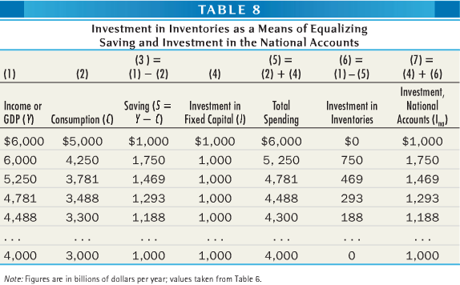

Aggregate Demand Curve
- Chapter 5 introduce aggregate demand and aggregate supply curves relating aggregating quantities demand and supplied to the price level. For figure 3 to be an aggregate demand curve, it must bring in price level.
- As noted in chapter 8, households own a great deal of money-fixed assets whose real value declines when the price level rises. The money in your bank account is a prime example. If prices rise, it will buy less. Because of that fact, consumer’s real wealth declines whenever the price level rises affecting their spending, otherwise called the wealth effect described in chapter 8. We also know that a higher price level reduces household debt but this affect is assumed to be weaker.
- Recall that consumer spending is dependent on real wealth not real income. The consumption function is a relationship between real consumer income and real consumer spending. Thus, any decline in real income, moves the economy leftward along a fixed consumption function. A decline in real wealth will shift the entire consumption function downward meaning people spend less for any given level of real income.
- A higher price level leads to lower real wealth and therefore to less spending at any given level of real income. Higher price level leads to a lower consumption function and vice versa.
- In terms of the 45º line diagram a rise in the price level pulls down the consumption function and the total expenditure schedule. A fall in the price level will raise the consumption function and total expenditure schedule.
- A rise in price level and lower consumption function means equilibrium GDP falls. A fall in price level and higher consumption function means equilibrium GDP should rise.
- Therefore, ↑ price level ⇒ ↓ total expenditures and ↓ equilibrium GDP
- Therefore, ↑ price level ⇒ ↓ equilibrium level of real aggregate quantity demanded

The Multiplier and the Aggregate Demand Curve
- Remember that any income-expenditure diagram is drawn for a specific price level.
- The oversimplified multiplier formula thus give the increase in real GDP demanded that would occur if the price level were fixed, meaning graphically that it measures the horizontal shift of the economy’s aggregate demand curve.
  - This can be seen in figure 13 which supposes that the price level in figure 3 is P=100. The top panel repeats figure 10 and shows how an increase in investment from $900 billion to $1,100 billion would lead to an increase in the total expenditure schedule and an increase in equilibrium GDP from $6,000 to $6,800 billion.
  - The bottom panel shows two downward-sloping aggregate demand curve. The first labelled D0D0 depicts the situation when investment is $900 billion. Point E0 on this curve indicates that at the given price level of P=100, the equilibrium quantity of GDP demanded is $6,000 billion, corresponding exactly to the point E0 on the top panel.
  - The second Ad curve D1D1 depicts the situation after investment has risen to $1,100 billion. Point E1 on this curve indicates that the equilibrium quantity of GDP demanded when 100 has risen to $6,800 billion again corresponding to the same point on the top panel.
  - The horizontal distance between the two AD curves is exactly equal to increase in real GDP shown in the income-expenditure diagram.
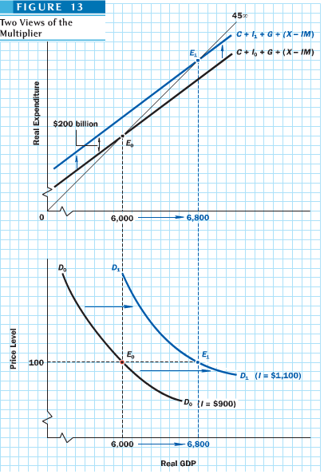
- Thus, autonomous increase in spending leads to a horizontal shift of the AD curve by an amount given by the oversimplified multiplier formula. Everything we have learned about the multiplier applies to shifts of the economy’s AD curve.
- If businesses decide to increase their investment spending, if the consumption function shifts upward, or if the government or foreigners decide to buy more goods, then the AD curve moves horizontally to the right. If any of these variables move downward instead, the AD curve shifts horizontally to the left.
- The economy’s AD cannot remain still, autonomous changes in one or another of the four components will cause it to move around. To understand the consequences of such shifts of AD, we must consider aggregate supply which will be done in the next chapter.

- In the general case with government and foreign sectors, investment must still be equal to saving, but saving will now need to be defined as something more than household saving.
- Recall in chapter 8 that disposable income (DI) is equal to GDP minus taxes net of transfers.

DI = Y – T

- In an open economy where residents may receive investment income from abroad, this is not quite exact. Disposable income will really depend on gross national income (GDP) which includes both (GDP) and net foreign income (NFY)

DI = GNP – T = (Y + NFY) – T

- Disposable income can be either spent or save

DI= C + S

- Thus joining the two definitions.

Y + NFY= C + S + T

- Combining this with the definition of equilibrium GDP we get,

Y= C + I + G + (X-IM)
C + I + G + (X – M) + NFY= C + S + T

- Subtracting C from both sides and keeping only I on the left hand side.

I = [S + (T – G)] + (IM – X – NFY)

- The sum of the three terms on the right side is overall saving in the general case. The sum must equal investment. The three components of overall saving are private saving (S), government saving (T-G), and saving from abroad (IM-X-NFY).
- The sum of first two terms is often called national saving. The last term is also called nonresident saving and is the current account deficit of the balance of payments as will be seen in Chapter 18.
- With no government and foreign trade, we are back simply I = S. This is also verified in the case where both the government budget (G=T0 and the current account (X+NFY) are balanced.

I = private saving + government saving + saving from abroad
I = national saving + saving from abroad

