- “Men are disposed, as a rule and on the average, to increase their consumption as their income increases, but not by as much as the increase in their income.” – John Maynard Keynes
- While Chapter 7 focused on the determinants of potential GDP, this chapter will focus on the factors determining actual GDP – how much of that potential is used. This chapter will focus on the demand side of macro in contrast to the supply side of Chapter 7. Chapter 5 suggested that aggregate demand (AD) holds the key to the economy’s condition in the short run.
- When AD is great, the economy booms. When AD is weak, the economy stagnates.

ISSUE: Demand Management and the Ornery Consumer
- The government can shift the AD curve directly by altering its own spending, spending more when private demand is weak or less when private demand is great.
- Alternatively, it can do so indirectly by using taxes and other policies to influence private spending decisions since consumer expenditures make up ~60% of the GDP.
- An example is when the long boom of the 1990s ended suddenly and economic growth in the US slowed. The Canadian government with Paul Martin as finance minister sped up grants to tax reductions which meant a 20% average reduction in tax and about 2% of household disposable income. The US also passed a multiyear tax cut. Any reduction in tax leaves consumers with more spending money.
- While growth slowed down in Canada in 2001, there was no recession. However, the US experienced –ve growth and a recession afterwards. It seems Americans understood the tax cut to be temporary and ended saving their share of the tax cuts rather than spending to boost the economy.
- Permanent cuts in income taxes cause greater increases in consumer spending than do temporary cuts of equal magnitude.
- In Canada, the tax cuts were advertised as a five-year plan involving $100 billion in tax reductions. In the US, although the tax cuts provided by the Bush administration were also of a permanent kind, the American taxpayers understood the tax cuts as temporary.
Components of Aggregate Spending
- Firms in a market economy produce goods only if they think they can sell them.
- Aggregate demand is the total amount that all consumers, business firms, government agencies, and foreigners wish to spend on Canadian final goods and services. AD is a schedule, not a fixed number that depends on a variety of factors – ex. Consumer incomes, government policies, events in foreign countries.
- To understand AD well, it can broken down into four major components that is a component of GDP from the expenditure side:
- Consumer expenditure/consumption (C)
The total value of all consumer goods and services demanding.
- Investment spending (I)
The total amount that firms spend on factories, machinery, software, and the like, + the amount that families spend on new houses.
Most people speak of investing in the stock market or in a bank account but that is merely swapping one form of financial asset (ex. Money) for another form (ex. Share of a stock). These are called placements by Fren economists.
When economists speak of investment they mean the purchase of some new, physical asset such a drill press, a computer, a house. It is only these kinds of investments that constitute direct addition to the demand for newly produced goods.
- Government purchase (G)
Represent 20% of overall expenditures in Canada.
Include paper, computers, airplanes, ships, and labour bought by all levels of government.
- Net exports (X-IM)
Canadian exports minus Canadian imports.
The reasoning is part of the demand for Canadian goods and services originate internationally.
GDP wants to measure spending on Canadian imports which is why we minus imports.
- We will still need to assess GDP form the income side and to define a more restrictive concept of income, disposable income (DI) tells us how much consumers actually have to spend or to save.
- Microeconomics applies to the decisions of some large units. For example, the annual sales of General Electric and General Motors exceed the total production of many nations. The micro-macro distinction is not based solely on size.
The main distinction is whereas microeconomics focuses on the decisions of individual

The Circular Flow of Spending, Production, and Income
- Figure 1 is a circular flow diagram which depicts a large tube in which an imaginary fluid circulates in a clockwise direction. At several points, some of the fluid leaks out or additional fluid is injected into the tube.
- At point 1 are the consumers. Disposable income (DI) flows into their pockets while two things flow out, consumption (C), which stays in the circular flow and saving (S), which leaks out. This outflow shows that consumers normally spend less than they earn and save the balance. The leakage flows into the financial system via banks, mutual funds, etc.
- The upper loop of the circular flow represents expenditures, and as we move clockwise to point 2, we encounter the first injection, investment spending (I) that comes from investors – a group that includes both business firms and home buyers. As the circular flow moves past 2, it is bigger than before. Total spending has increased from C to C + I.
- At point 3, another injection occurs where the government adds its demand for goods and services (G) to those of consumers and investors (C + I). AD is now (C + I + G).
- The next leakage and injection occurs at point 4 where import spending leaks out and export spending is injected into the flow. The net effect may either be –ve or +ve depending on net export. By this time, AD is now C + I + G + (X-IM).
- Aggregate demand now ends up at the business firms located at point 5. Responding to demand, firms produce domestic product. The domestic product may end up being equal to AD but it can also be larger or smaller than AD. As the circular flow emerges from the firms, it is renamed gross domestic product, income-based or simply, gross domestic income. This is because domestic income and domestic product be equal. When a firm produces and sells $100 worth of output, it pays most of the proceeds to labour and rent. These payments represent income to some individuals. The rest goes to the firm’s owners as profits. Thus, when add up all the wages, interest, payroll taxes, indirect taxes, and profits in the economy to obtain domestic income, we arrive at the value of output, i.e. domestic product.
- The lower loops shows domestic income leaving firms and heading to consumers but the flow takes detours along the way. At 6, the government does two things, (1) siphons off a portion of the domestic income in the form of taxes. (2) it adds back government transfer payments, such as Employment Insurance and social welfare benefits, which government agencies give to individuals as outright grants rather than as payments for goods and services rendered.
- At 7, there is a further flow away from consumers made up of two components: amortization funds and undistributed corporate profits. The sum of these two components is the gross profits of corporations that is not distributed to households, called the gross retained earnings, i.e. the gross saving of corporations that go to investors. The firms will use these funds to invest in new capital and its operations.
- In summary, we obtain
Disposable income (DI) = GDP – Taxes + Transfer Payments
= GDP – (Taxes – Transfers)
= Y – T
Where Y represents GDP and T represents taxes net of transfers or simply net taxes.

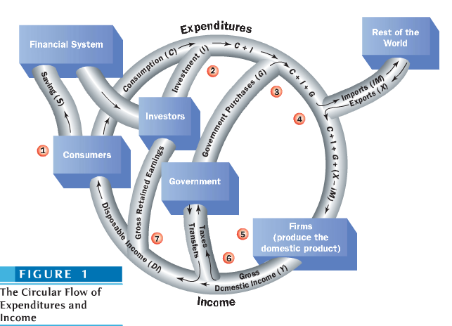
Consumer Spending and Income: The Important Relationship
- Figure 2 depicts the historical paths of C and DI for Canada since 1961. It suggests consumption will rise whenever disposable income rises and fall whenever income falls. However, policymakers need to know how much one variable will change when the other changes by a given amount.
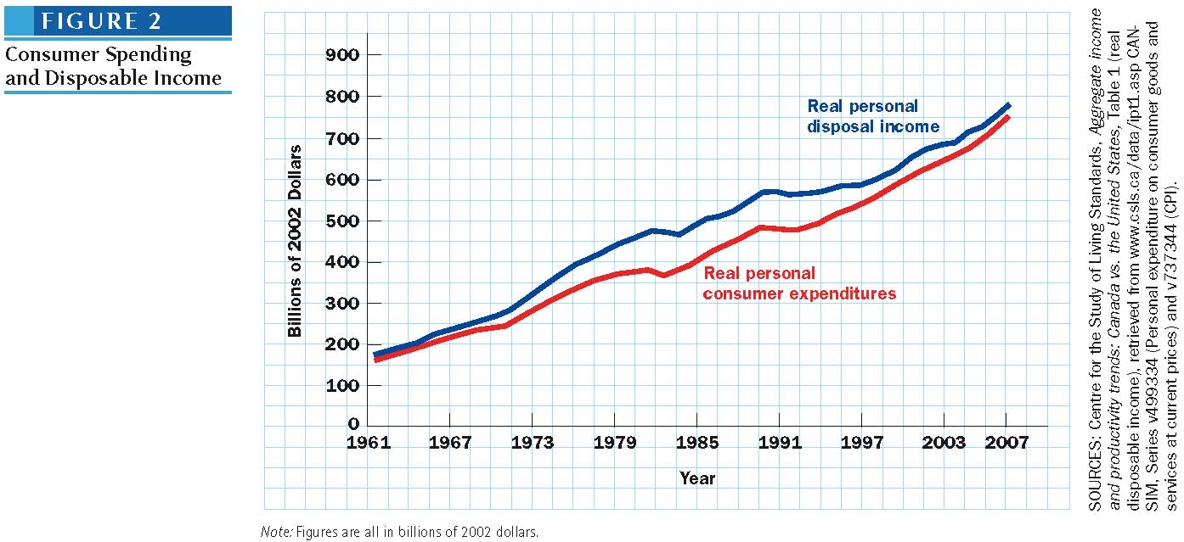
- Figure 3 represents the same data in Figure 2, but in a way designed to answer the “how much” question. Such pictures are called scatter diagrams and are useful in predicting how one variable will change in response to another. Each dot in the diagram represents the data on C and DI corresponding to a particular year.
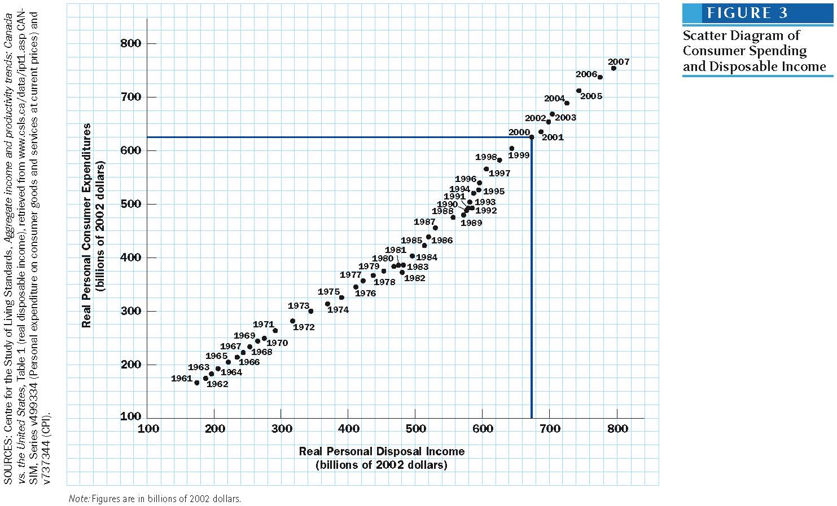

- To predict the changes to one variable when another is changed, a slope can be drawn on Figure 3, shown on Figure 4.
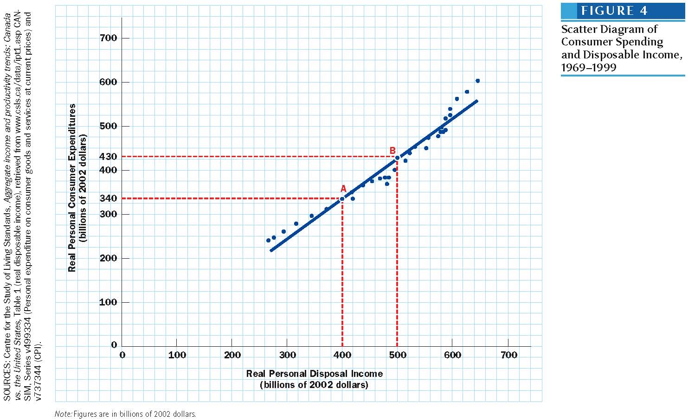

The Consumption Function and the Marginal Propensity to Consume
- The close relationship between consumer spending, C, and disposable income, DI is called the consumption function whose slope is relatively constant. This can be inferred due to the fact that the straight line comes close to touching every point.
- This slope is called the marginal propensity to consume, or MPC, and it tells us how much more consumers will spend if disposable income rises by $1 and is given by the following equation:
MPC = Δ consumption ÷ Δ disposable income
- To estimate the initial effect of a tax cut on consumer spending, the MPC must first be estimated and then multiply the amount of the tax cut by the estimated MPC. Because the true MPC is never known with certainty, the prediction is always subject to some margin of error.

Factors That Shift the Consumption Function
- Recall in chapter 4, the distinction between a movement along a demand curve and a shift of the curve. A demand curve depicts the relationship between quantity demanded and one of its many determinants – price. Hence, a change in price causes a movement along the demand curve but a change in any other factor that influences demand causes a shift of the entire demand curve.
- Similarly, factors other than disposable income influence consumer spending. A change in disposable income leads to a movement along the consumption function. A change in other determinants can shift the entire consumption function.
- This is why while the straight line comes close to many points on the consumption function, it never matches them exactly. This is due to the influence of the “other determinants” which include:
- Wealth
- Wealth and income are different things. Households can finance spending by cashing in some wealth they have previously accumulated.
Ex. A wealthy retiree with a huge bank balance may earn little current income when interest rates are low. A high-flying investment banker who spends every penny of the high income he/she earns will not accumulate much wealth.
With two recent university graduates, each of whom earns $40,000, if one has $100,000 in the bank and the other has 0, the former will spend more.
- A stock market boom adds to wealth and raises the consumption function. This is what happened in the 1990s when the stock market soared and Canadians went on a spending spree. A collapse of stock prices in 2000-20002 shifted the consumption function down.
- The Price Level
- People hold wealth in forms that are fixed in money terms, such as a bank account. The purchasing power of such money-fixed assets declines whenever the price level rises. Whenever we observe inflation in product prices, Canada consumers hold about $1,000 billion worth of deposits and currency, so that each 1% rise in the price level reduces the purchasing power of consumer wealth by $10 billion, a sum worth a bit more than 0.6% of GDP.
- In reverse, Canadians also have money-fixed liabilities – essentially consumer credit and mortgage debts – that amounts to ~$1,000 billion. Any time the price level rises by 1%, their real liabilities fall by 1%. Thus, a 1% rise in the price level increases the purchasing power of Canadians by about $10 billion.
- Which effect is stronger? Referring back to Figure 2, saving rates were rather high at a time when inflation rates were high as well, from mid 1970s through 1980s. It seems the –ve wealth effect seems stronger than the +ve debt effect meaning that Canadian households will save more and reduce spending with high inflation.
- The Real Interest Rate
- A higher real rate of interest rewards savings. Therefore, many people believe that higher real interest rates encourage saving and discourage spending. Surprisingly, stats show that interest rates have little effect on aggregate consumption in most countries.
- Future Income Expectations
To make predictions about strength of the Canadian economy, the Conference Board of Canada – a major forecasting agency – uses a consumer confidence index, based on the likelihood of respondents to make major purchases in the near future. Other forecasters use questions relating to respondents’ assessment of their personal financial situation and that of the entire economy.

The Extreme Variability of Investment
- Investment spending is the most volatile of all spending components meaning it swings from high to low levels with astonishing speed, capable of causing major instability of aggregate demand.
- Factors influencing business investment discussed in chapter 7 included interest rates, tax provisions, technical change, the strength of the economy. But one important factor not discussed much was business confidence which depends on expectations about the future.
- There are few goods ideas on how to measure or even control business confidence so economists usually focus on more objective determinants of investment such as rates of capacity utilization or profit rates, and even influence – factors such as interest rate and tax rates.
- In the current crisis, investment spending has dropped considerably in 2009 (from 315B$ to 254B$, a 20% drop), once everyone was aware of the crisis and could change investment decisions.

The Determinants of Net Exports
National Incomes
- When consumers and firms spend more on consumption and investment, some of the new spending goes towards the purchase of foreign goods.
- Hence, our imports rise when our GDP rises and fall when our GDP falls.
- Our exports are relatively insensitive to our own GDP, but are directly related to the GDPs of our trading partners.
- Our exports rise when our prices fall and vice-versa; our imports rise when prices fall in the economies of our trading partners.
Relative Prices and Exchange Rats
- A rise in the prices of a country’s goods will lead to a reduction in that country’s net exports.
- A decline in the prices of a country’s goods will raise that country’s net exports.
- Similarly, price increases abroad raise the home country’s net exports, whereas price decreases abroad decrease the home country’s net exports.

How Predictable is Aggregate Demand
- While the consumption function seems like a simple tool, it can be difficult to predict consumer spending due to changes in consumer confidence levels and their perception of things.
- Swings in investment spending are difficult to predict since they are closely tied to business confidence and expectations.
- Developments abroad affect net exports, especially the health of the US economy.
- Government purchases (G) are impacted by changing politics and security events (9/11, Afghanistan).

- The system of measurement devised for collecting and expressing macroeconomic data is called national income accounting. The development of this system of accounts ranks as a great achievement in applied economics. Without this system of accounts, the practical value of Keynesian analysis would be severely limited.
- For the remainder of the appendix, we will deal with what StatsCan calls the national income and expenditure accounts.
- There are three other components to the Canadian national accounts:
1) input-output accounts that measure productive activity according to both the commodities produced and the industries that produce them, as well as the use of such commodities in the production process of an industry.
2) financial and wealth accounts that measure the financial flows from and into each sector of the economy, along with the balance sheet (the stocks of financial and tangible assets, as well as their liabilities). This is useful to measure the placements of economic agents by contrast with their physical investments
3) balance of payments accounts which track the commercial and financial transactions of Canadians in relation to the rest of the world

Defining GDP: Exceptions to the Rules
- GDP: the sum of the money values of all final goods and services produced during a specified period of time, usually one year. This is GDP at market prices.
- Unlike private products, the “outputs” of government are not sold. Government outputs are thus, valued at the cost of the inputs needed to produce them.
- Goods that firms add to their inventories count in the GDP even though they do not pass through markets. Inventories are treated as though they were bought by the firms that produced them at their product cost, even though these purchases do not really take place.
- Investment goods are defined as the final products demanded by the firms that buy them (machines, buildings, factories).
- National income accountants have devised 3 ways to measure the GDP.
GDP as the Sum of Final Goods and Services
- GDP is the sum of all final demands of all consumers, business firms, government, and foreigners in one year.
- GDP = C + I_{na} + G + (X-IM).
- I_{na} stands for gross private domestic investment where private indicates that government investment is not included in I_{na} and is a part of G instead. Domestic means that machinery sold by Canadian firms to foreign companies are included in exports X rather than in investment.
- I_{na} is made up of two major components:
1) Fixed business investment – subdivided into residential structures (the construction of houses and apartment buildings) and non-residential investment, i.e. investment in commercial and industrial structures (plants and buildings) and investment in machinery and equipment (including software and computers)
2) Business investment in inventories – the value of the change in business inventories – the goods that have been produced but not yet sold and that firms are presumed to have bought themselves. This ensures that domestic product and domestic expenditure are equal to each other in the national accounts.
- Investment includes only newly produce capital goods, such as machinery, factories, and new homes. It does not include exchange of existing assets.
- Government purchases, G, represents the volume of current goods and services purchased by all levels of government. Thus, all government payments to its employees are counted as G, as are al of its purchases of goods.
- The federal government spends most of its money, not on purchase of goods and services, but on transfer payments.
- This distinction means that G represents the part of the national product that the government uses up for its own purposes – to pay for the armed forces, bureaucrats, paper and ink- whereas transfer payments shuffle purchasing power from one group of citizens to another not using up any real economic resources.
- Because transfer payments merely give someone the capability to spend on C, it is logical to exclude transfers from G, including in C only the portion of transfer payments that consumers spend. If we included transfers in G we would be double counting since it would also be included in C.
Table 3: GDP in 2015 Q2 from the Expenditure Side (billions of current $)
Item | Nominal Amount ($) | Share of GDP (%)
Personal consumption expenditures (C) | 1131 | 57.0
Fixed Business Investment | 388 | 19.6
Business Investment in Inventories | +8 | 0.4
Government current expenditures and investment (G) | 503 | 25.4
Net Exports (X-IM) | -49 | -2.4
Exports (X) | 612
Imports (IM) | 661
Gross Domestic Product (Y) | 1981 | 100.0
  - Note: I_{na} in this case is equal to 396 [388+(+8)]
GDP as the Sum of All Factor Payments
- GDP can be measured by adding up all incomes in the economy, also known as GDP income-based, GDI.
- For every firm in economy, there is an accounting identity that says:
Revenue from sales = Wages paid + Interest paid + Indirect taxes paid + Profits earned + Purchases your firm made from other firms
- Profits are what is left over after the firm has made all other payments. This reflects the definition of profits: sales revenue less call costs.
- Since we apply this accounting identity to all firms in the economy Total purchases from other firms are what we call intermediate goods so we can subtract the latter from both sides:
GDP = wages + interest paid + indirect taxes paid + profits.
- On the right, we have the sum of all factor incomes: payments to labour, land, and capital. On the left we have total sales minus sales of intermediate goods.

Table 4: GDP income-based (GDI_ in 2015 Q2 (billions of current $) using new terminology of StatsCan
Item | Nominal Amount ($)
Compensation of employees (labour income) | 1016
Gross operating surplus (interest and profit income, all corporations) | 528
Gross mixed income (unincorporated businesses) | 234
Taxes less subsidies on production and products (sales) | 203
Gross domestic product (at market prices) | 1981
  - Labour income includes wages, salaries, and supplementary labour income – employees’ and employers’ contribution to Employment Insurance, pension plans, Workers’ Compensation, Medicare, dental plans, disability insurance, etc.
  - Profit income (corporate profits, government enterprise profits)
  - Gross mixed income – includes rents, independent business operators such as farmers, and self-employed professionals who income is partly labour income and partly profit income
  - Taxes on production and products
    - On production: property tax, capital tax, payroll tax
    - On products and imports: GST, HST, provincial tax, sales tax, fuel tax, excise tax on tobacco and alcohol, import duties and taxes
GDP as the Sum of Values Added
- If all intermediate goods were included in GDP, we would wind up counting certain goods and services multiple times giving an exaggerated impression of the actual level of economic activity.
- The value added by a firm is its revenue from selling a product minus the amount paid for goods and services purchased from other firms. If a firm buys inputs from some other firms, does something to them, and sells the resulting product for a higher price than it paid for the inputs, the firm has “added value” to the product.
- GDP = sum of values added to goods in all firms
- Looking back at the previous equation, sales revenue minus purchases from other firms is precisely the firm’s added value.
Value added = wages + interest + indirect taxes + profits
- While this method avoids double-counting Intermediate goods are often difficult to distinguish from final goods. Paint bought by a painter is an intermediate goods while paint bought by a do-it-yourselfer is a final good.
- By measuring the GDP as the sum of values added, we don’t need such distinctions since every purchase of a new good or service counts, but we do not count the enter selling price, only the portion that represents value added.
  - This idea is illustrated in Table 5. A farmer who grows soybeans sell them to a mill for $3/bushel. This transaction is not included in GDP since the miller does not purchase the soybeans for her own use. The miller grinds up the soybeans and sells the resulting bag of soy meal to a factory that produces soy sauce for $4. The grounds beans are also an intermediate product. The factory turns the beans into soy sauce, which it sells to a restaurant for $8. This is still counted as an intermediate good. The restaurant sells the sauce to customers as part of the meals. At this point, the $10 worth of soy sauce becomes part of a final product and counts in GDP. If we had counted up the other amounts, we would have ended up with $25.
  - Neither the miller, factory owner, nor restaurant owner values the product for its own sake. Only the customer who eat the final product have increased their material well-being.
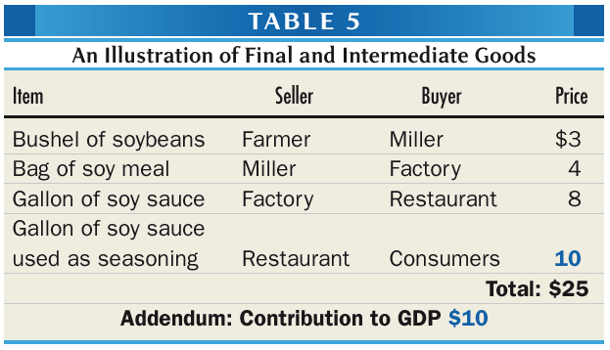
- Another idea is to count only part of each transaction. At each step we county only the contribution to the value of the ultimate final product excluding the values of items produced at other steps.
- Ignoring minor items such as fertilizer that the farmer purchases from others, the $3 selling price of the bushel of soybeans is new output produced by the farmer, the whole $3 value is added. The miller grinds the soybeans and sells them for $4 adding ($4-$3) $1 to the value of the beans. The factory turns the soy meal into soy sauce and sells it for $8 adding ($8-$4) $4 more to the value. When the restaurant sells it to hungry customers for $10, a further ($10-$8) $2 of value is added. The total value added by all four firms is $10, exactly the same as the restaurant’s selling price.
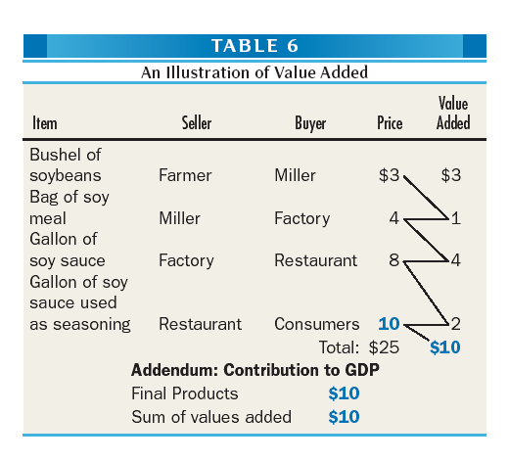
Additional Measures of the Income of the Nation
GDP vs GNP
- Income recipients could be foreigners, either foreigners working for companies located in Canada or foreign owners of companies operating in Canada. Similarly, there are Canadians working abroad and contribute to the GPD of foreign countries (although Canadian diplomets abroad are considered as part of the Canadian domestic activity, and there are Canadians who hold securities issued by companies or governments located abroad.
- Gross national product (GNP) is the sum of the money values of all final goods and services produced by the factors of production owned by the nationals of a country, during a specific period of time, usually a year.
- If Quebec were to secede from the rest of Canada, the salaries of Quebec residents still working in Ottawa would be part of GPD but not GNP of Canada.
- Starting with GDP, to get net foreign income (NFY) one adds the income received from abroad and subtracts the income paid to non-residents (essentially investment income)
Table 7: GDP vs GNP in 2009 (in billions of current $)
Gross Domestic Product (GDP) | 1,981
+ Net Foreign Income (NFY) | -36
= Gross National Product (GNP) | 1,945
- The United Nations System of National Accounts used GNP until switching over to GDP in 1968. Europe in 1970, Canada in 1986, USA in 1991.
- For Canada, it does not make much of a difference now, but for some countries (LDCs), it does.
- For instance, in 2010, in Ireland, GDP = 210B$ while GNP = 150B$
Net Domestic Product
- By adding taxes on factors of production (such as taxes on employment, ownership of land, business structures, and equipment) we arrive at net domestic products at basic prices. This aggregate takes into account all of the factor payments, plus taxes, including payroll taxes, that are associated with labour, land, and capital.
- By also adding sales taxes, provincial sales taxes, and various excise taxes we obtain net domestic product at market prices or NDP.
- The depreciation component of GDP represents the output that needed to repair and replace worn-out factories and machines that is not available for anybody to consume.
- However, depreciation is difficult to measure which is why GDP is thought to be more accurate.
- GDP is calculated first without any adjustment from the figures that are provided by businesses, while NDP is calculated later, on the basis of an estimate of the capital consumption allowance.
- Amortization, or capital consumption allowance, now called consumption of fixed capital, is the value of the portion of the nation’s capital equipment that is used up within the year (that needs to be replaced). It tells us how much output is needed just to maintain the economy’s capital stock,
GDP 2015Q2 $1 981B
Minus Consumption of fixed capital -338
Equals Net Domestic Product 2015Q2 = 1 643
Disposable Income
- Disposable income is crucial when dealing with concepts such as the MPC. Earlier in the chapter, it was claimed that DI was equal to GDP – net taxes/taxes net of transfers
- A more precise definition of disposable income is shown using Table 8.
- 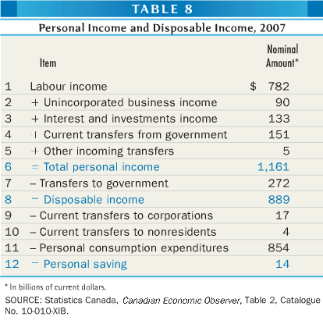
- In Canada, individuals and unincorporated businesses of individuals are amalgamate din a single sector, representing households.
- To get total person income, we add income interest and all investment income (Row 3) – which now includes the profits of corporations paid out as dividends as well as interest payments on government debts, both from Canada and abroad – as well as government transfers to individuals (Row 4) which include the Child tax Benefit, Employment Insurance, welfare, the Canada Pension Plan, Old Age Security Benefits, scholarships, and research grants.
- Other incoming transfers (row 5) such as charitable donations, and pensions paid by foreign governments to Canadians.
- Subtract form personal income, all transfer to governments (Row 7) which include income taxes, and all taxes that were included in supplementary labour income and hence in labour income, such as payroll taxes tied to contributions to Employment Insurance, Worker’s Compensation, and the Pension Plans.
- Disposable income (Row 8) can then be split among payments on consumer debt (Row 9), remittances to foreign countries (Row 10, mainly religious and charitable organizations), and person consumption expenditures (Row 11, the same items that appeared at the top of Table 3 as C).
- Personal saving, or household saving is what is left over.
- The discrepancy between GDP and disposable income (which is ~1/2 of GDP) is due to all taxes that were included in GDP. Other large adjustment items include capital consumption allowances, the undistributed profits of corporate firms (their retained earnings), and income taxes (both personal and corporate).
- In 2007, the corporate retained earnings was ~$107 billion or 7.0% of GDP, and the capital consumption was $122 billion, so that corporate gross retained earnings – the gross profits that firms keep for themselves to invest in new machinery and replace used up capital – were $229 billion or 15% of GDP.

