Biology 1M03 Midterm 1 – Study Notes
- Louis Pasteur’s Experiment
  - Sterilization, evaporation, put in cells
  - Bottle neck – cells came in – presence of cells
  - Swan neck – cells stuck in bottle neck – no cells present (spontaneous generation fails)

- Evolution
  - Common ancestry
  - Descent with modification (change through time)

- Natural selection – heritable variation that influences fitness
  - Change in allele/genotype frequency over time
  - Influence reproductive output

- Artificial selection
  - Domestication – express desirable traits by humans
    - Dogs, tomatoes, cow milk, wild plant into vegetables
  - Indirect – destroy habitats for resources

- Giraffes – long necks
  - Food Competition Hypothesis – long necks to reach high trees
  - Sexual Selection Hypothesis – long necks to fight other males (competition
- Chili peppers – why they’re spicy
  - Direct dispersal hypothesis – capsaicin
    - Thrashers that cause germination consume; prevent seed eats (mice) to eat

- Tree of life – diagram depicting relationships among species
  - Species compared using rRNA sequence
  - Last universal common ancestor – common in all organisms (first node)
  - Phylogenetic tree idea
    - Ancestor has trait and descendents lose traits
    - Ancestor doesn’t have trait and descendent gains trait
- Principle of parsimony – use simplest example to explain data

- Convergent speciation – hybridization (liger), gene transfer, sexual reproduction, endosymbiosis
  - Tasmanian devils with mouth cancer – fights with dogs, gain modified genome (transformation)

- Prezygotic Barriers – barriers that prevent mating (before zygote)
- Post Zygotic Barriers – barriers that prevent offspring to reproduce (sterile offspring)
- Lamarck – characteristics (even acquired by parents) were passed on to filial (mice tails)
- Darwin – descent with modification (common ancestry + change through time)
  - Not progressive, occurs at different times
  - Altruism – benefit to others for one self’s cost (random)

- Evidence for Change through Time
  - Fossils, Extinction – trilobite fossils, hominid footprints, prehistoric turds (sloth)
    - Now species are different, these don’t exist
    - Goes against “special creation” (bible)
  - Speciation – which species mated
    - Domestication – dogs (hybridized) – some species can’t breed with others
      - Habitat – feeding morphology
      - Reproductive isolation (incipient species) – species becoming unique
    - Polyploidization – genome duplication (fusion of two organisms)
      - Produce new species
  - Transitional Forms – intermediate structures
  - Vestigial traits – reduced, incomplete structures; bear similarity to functioning ones
    - Thick hair loss – apes
    - Coccyx – tails
    - Pelvic spurs of python – lizard
  - Geographic Continuity – similar fossils; share common ancestor in different regions
    - Darwin’s finches, South America/Africa

- Evidence Species are Related
  - Homology – similarity between species having common ancestor
    - Genetic homology – similarity in DNA sequences (human, chimp, fruitfly)
      - eyeless, Aniridia gene influences location of eyes
    - Developmental homology – similarity in embryonic traits
      - Gill pouch (fish ancestors)
    - Structural homology – position of similar bones

- Darwin’s Postulate on Natural Selection
  - Individuals in population vary in traits
  - Some traits are heritable, passed on to offspring
  - In each generation, not all individual produce same amount of offspring, not all survive
  - Individuals with certain heritable traits favoured for reproduction/survival
  - Natural selection determines which trait is favourable

- Examples of Natural Selection
  - Industrial melanism – development of black pigment/skin (camouflage in habitats)
  - Antibiotic resistance – Mycobacterium tuberculosis
    - Mutation of rpoB gene (RNA polymerase)
      - Allows transcription (rifampin), before antibiotic didn’t let it
  - Darwin’s Finches – body size, beak form corresponds to food available in habitat
    - Drought changed vegetation/food available
    - Different seed sizes (hard seed, big beak)
    - Determinant: bmp4 gene (done through in situ hybridization)
      - Quantity of expressed gene controls expression
      - Candidate gene study – identifying genes responsible by testing expression
  - Agouti Gene, Lab Mice
    - No expression – dark coat; over expression – light coat
      - Variation of colour in nature (certain level of expression at habitats)
      - Speciation of many coloured mice

- Natural selection is not progressive, goal directed; naturally done
  - Kin selection – fights against natural selection

- Constraints – limitations on natural selection
  - Genetic constraints – no optimization of a trait
    - Genetic correlation – selection on one trait causes selection on another
      - Doesn’t optimize traits that would be most efficient in habitat
    - Molecular variation – available alleles to create certain traits constrains
      - different traits outside molecular scope could optimize fitness
  - Historical constraints – present traits determine limitations for potential traits in future
  - Formal constraints – evolution works within laws of physics
  - Time/variation constraints – evolution limited by time (lifespan) + mutations (variation)

- Fitness Trade-Offs – compromise between traits, how they’re adapted in environment
  - Balance traits – optimal fitness/survival during counteracting selection
    - Brain size + pelvis size – offspring head size

- Hardy-Weinberg principle – null hypothesis predicts genotype frequencies from phenotype
  - Factors, none of:
    - Natural selection – adaptation
    - Genetic drift – random changes (fluctuations in allele frequencies)
    - Gene flow – migration
    - Mutation – introduction of new alleles
    - Biased mating – selecting mates (characteristics) – inbreeding, sexual selection
- Claims
  - Frequencies of two alleles are A² + 2AB + B²
  - Allele frequencies do not change over time; changes cause equilibrium
- Model to generate predictions + consistency with null hypothesis
  - No factor on evolution is being observed on particular allele

- MN blood types – common in Inuit populations (equilibrium)
  - Codes for protein found on surface of red blood cell; mostly heterozygous (MN)
- Human Leukocyte Antigen (HLA gene) – chromosome 6
  - Binds to antigen, so cell can be recognized by immune system
  - Co-dominant – heterozygous – strongest fitness advantage (variety of HLA proteins)
    - Recognize more bacteria
  - Non-random mating – selection based on individuals with different HLA genotype
    - Females preferred males with different HLA allele (non-contraceptive)
    - Females preferred males with same HLA allele (contraceptive)
  - Higher fitness – different alleles as husband – easier birth
    - Same alleles – more spontaneous abortions (lower fitness)
    - More heterozygous, increased fitness (natural selection)

- Patterns of Natural selection
  - Heterozygote advantage – heterozygous individual have higher fitness than homozygous
    - HLA gene
    - sickle cell anemia – heterozygous mutation (partial sickle cell phenotype)
      - higher fitness, prevalence in areas of malaria (die less)
  - Directional Selection – normal distribution of trait shifts towards one direction
  - Stabilizing selection – reduces variation in trait
  - Disruptive selection – increases variation in trait
    - Leads to diversity (speciation) – castes of ants
  - Frequency dependent selection
    - Negative – fitness highest in rare phenotypes
      - So rare, unknown/dangerous to other species
    - Positive – highest in common phenotypes (dangerous phenotypes)
      - Poisonous frogs – common colour for poison

- Genetic drift – random change in allele frequencies
  - Fixation of alleles – all individuals end up with completely different alleles
    - Population size – small size, faster fixation
    - Speed of fixation – how fast generation of offspring is produced

  - Exctinction of alleles – individuals lose an allele (all homozygous)
    - Faster outcome in small populations – extinction: Javan Rhino
  - Founder Effect – large population disperses to area with small number of individuals
    - Darwin’s finches colonizes island; ratio of alleles changes from original population (first new migration)
  - Bottleneck effect – loss of number of individuals (natural disaster), causing changed allele frequencies
    - Causes loss extinction of certain alleles
    - Population size (# affected) and time (length of event)

- Gene flow – migration of individuals, causing change in allele frequencies
  - Reduce genetic differences between populations (old and new)
    - Lupines colonization of St. Helen’s – founder effect (grow from volcanic ash/dirt)
  - Gene flow in human DNA
    - mtDNA – passed on by females
    - autosomal DNA – equally passed on
    - X – chromosomes – 2/3 times by females
  - African + American mating – no biased mate pairing – all European equal contribution
    - Biased mating – Male European + Female African
      - Y >> Autosomes >> X >> mtDNA

- Nonrandom mating
  - Inbreeding (self-fertilization) – increases homozygosity; reduces heterozygosity
    - Heterozygotes produce heterozygotes half the time; ratio lowers after each gen.
    - Allele frequencies stay the same; genotype frequencies changes
  - Inbreeding depression – increase homozygosity, decrease fitness
    - Allele frequency stays the same
      - Lowers beneficial heterozygous, increases low fitness homozygous
- Sexual selection – individuals within population differ in ability to attract mate
  - Favours individuals with heritable traits; enhance ability to find mate
  - Fundamental asymmetry of sex – females invest more in offspring than males (anisogamy)
    - Sperm is cheap compared to eggs
    - Males generally compete for females
  - Factors – sexual dimorphism
    - Honest Advertising (physical characteristics) – reflects traits of offspring
(high fitness)
      - Colour of beak – male has healthy diet
      - Bones in penis (baculum) – strong physique
    - Resources provided by males
      - Sexual cannibalism – nutritious benefits to take of progeny
        - Polyandry (prevent monopolization; doesn’t scare others away)
        - Rejection mechanism – doesn’t like males
- Male-Male Competition – establish territories (areas defended, used)
  - Female – low reproductive success (few males for mating)
  - Male – 90% of males don’t mate; a handful mate
    - Selection of strongest traits
- Innate Preferences – females attracted to certain heritable traits, not connected with fitness
  - Feelings, spiders – vibrations, furry arms
  - Males that exploit the biases female impose will have higher reproductive success
- Sexual dimorphism – resultant traits of non-random mating
Speciation:
- Genetically isolated – populations experience lack of gene flow – become isolated
  - Divergence – natural selection, genetic drift, mutation, biased mating
  - Distinct species – reproductively isolated from each other, distinct morphological characteristics, independent branches on phylogenetic trees
  - Genetic isolation
    - Different geographical regions
    - Different habitats, same area, different resources
    - Population is polyloid, cannot breed with others (polyploidization)
Physical separation
- Allopatric speciation – speciation of populations in different places (Darwin’s finches)
  - Dispersal – population moves to a new habitat, colonizes, forms new population
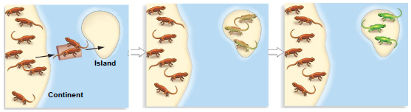
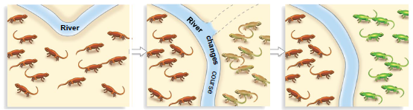
  - Vicariance – physical barriers isolates groups + speciation

  - Dispersal – barrier is older than speciation time
  - Vicariance – time of barrier – same age as speciation event (causes barrier)
    - Glaciers – separated organisms on Pangaea
    - Continents broke off – separated fauna; different organisms on different continents (emu, kiwi, ostrich, elephant bird rhea)
    - Rhinophrynidae + pipidae (plate tectonics, similar characteristics)
- Sympatric speciation – speciation of populations in same area (different habitats)
  - Feed on different food (soapberry bug + beak length – different diet)
    - Disruptive selection

- Polyploidization
  - Autopolyploids – spontaneous genome duplication in a species
    - Maidenhair ferms – diploid, tetradiploid populations
      - Combination of diploid 1 + diploid 2 –> tetraploid 1/2 (same species)
  - Allopolyploids – genome duplication in association with hybridization of two different species
    - Combination of diploid 1 + diploid 2 –> tetraploid 1/2 (different species)
      - Fertilization of two polyploids (2n + 2n 4n)
      - Error/mutation -> causes 4n to become 8n; “haploid”4n
        - Mutation = new species
    - Reproductive isolation + allopolyploids
      - Diploid + tetraploid = triploid (dysfunctional)

- Interaction between diverged species
  - Reinforcement of divergence – pre/post-zygotic isolation
    - Hybrid offspring have lower fitness (postzygotic isolation) – natural selection
  - Hybrid zone development – region for areas of available hybridization
    - Dependent on which parent species breed and hybrid fitness
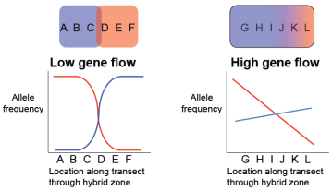
    - Blending transition
    - Hybrid zones can move
    - Hybrid zones can speciate – hybridization
  - Speciation by hybridization
  - Fusion (convergence) – stabilizing speciation
    - Gene flow reduces differences between population
  - One population goes extinct

- Approaches to Identifying Species
  - Biological species concept – assigns individuals to same species – actually/potentially interbreed
    - Different species – don’t interbreed (no gene flow between two populations)
    - Prezygotic isolation – individuals of different species prevented from mating
      - Penis sizes (mechanical)
    - Postzygotic isolation – populations mate; offspring unfertile/don’t survive
  - Morphological species concept – species distinguished by morphological features
    - Features arise if lineages do not have gene flow (independent on population)
    - Described features are subjective by person describing
  - Phylogenetic species concept – species defined as smallest monophyletic group on ree that compares populations
    - Monophyletic group (clade) – most common ancestor and everything above

- Problems with concepts
  - BSC – asexual organisms producing hybrids
  - MSC – subjectivity; what level of morphological divergence represents species-level to population level differences
  - PSC – overdiagnosis

- Phylogeny – evolutionary history of a group
- Phylogenetic tree – shows ancestor-descendant relationships of species
- Monophyletic group/clade – set of individuals that contains all descendents of their most recent common ancestor
  - Tools used to study history of life

- adaptive radiation – diversification coupled with adaptation (Cambrian Explosion)
  - species exploit new ecological opportunities (resources habitat) – colonization

- phylogeny of mammals – common: lactation, hair, sweat glands
  - monotremes – lay eggs (platypus)
  - marsupials – nipples, no placenta
  - placentals –nipples, placenta

- estimating phylogenies
  - phenetic (distance matrix) – statistics; data >> distance matrix >> phylogeny
    - overall similarity among taxa
  - cladistic (maximum parsimony) – minimize number of changes on tree from
observed data
    - data >> place trait on evolution >> fewest number of changes (synapomorphies)
      - similarities/differences in DNA base pairs
  - maximum likelihood
  - Bayesian

- Homology – traits are similar due to shared ancestry
  - Structural homology – bones are similar in related organisms
  - Homeobox (Hox) genes regulate differentiation in adult/embryo
    - Similar DNA sequence (common ancestors), genomic organization, expression pattern, function
- Homoplasy – traits are similar not due to shared ancestry (environmental)
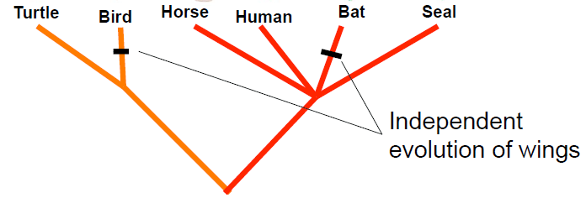
  - Convergent evolution – occurs geographically (placental/marsupials – (Tasm.) + wolf)

- Whale Evolution: Whippo Hypothesis
  - Artiodactyls – mammals that have hooves, even number of toes
+ astralagus (ankle bone)
  - Parsimony hypothesis rejected (whales aren’t outgroup)
  - Whales + hippos have close relationship (DNA evidence)
    - Share several SINE genes, absent in other artiodactyls groups
(gene present at locus) – synapomorphies (clade)
    - Gain + loss phylogenetic tree is less parsimonious but true
    - Transitional states – whales closely related; little chance for homoplasy

- Cryptic species – not easily distinguished by morphology
  - Animal/plant parts not easily identified, parts of the world not known
  - DNA barcoding – classification of diversity based on a variable gene
    - Cytochrome oxidase I (CO1) – animals
    - Internal transcribed spacer 2 (ITS2) (subunit of rRNA gene) – plants
  - Criticism
    - Oversimplification – may not distinguish recently diverged species,
identify hybrids, draw away from traditional taxonomy (not the dogma)
  - Inventory biodiversity – automate/expedite species identification

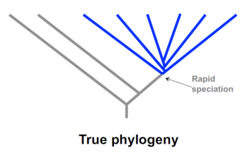
- Adaptive radiations – rapid diversification + ecological diversification
  - Morphological innovation + ecological opportunity (trigger)
  - High diversity, specialization
    - Single ancestor into array of species
  - Criteria for adaptive radiation:
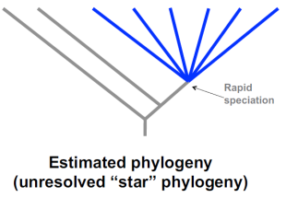
    - Common ancestry
    - Phenotype-environment correlation
    - Trait utility
    - Rapid speciation
  - Hawaiian honeycreepers, silverswords – rapid speciation (habitats)
  - Cichlid fish – great adaptive radiation
    - 3000 species; Tanganyika, Malawi (lake)
    - Variation in social behaviour, size, morphology
    - Jaw evolution – exploit niches of food collecting/processing
      - Oral, pharyngeal jaw development

- Ecological Innovation – availability of habitat
  - Anolis lizards (sympatric) – independent colonization (different morphology) produced same variation after adaptive radiation – trunk, twig, crown, ground
    - Hispaniola and Jamaica
  - Platymantis (Phillipines) + Limnocetes (Sulawesi)
    - Lay eggs on land + guard; similar reproduction pattern (synapomorphy)
    - Adaptively radiated at different parts of the world
- Morphological Innovation – new characteristics, traits for environment

- Mass extinction – periods of great biodiversity loss
  - Sudden random, extraordinary
- Background rate of extinction – level of extinction not during mass extinction
  - Environmental change, disease, competition
- Death of Dinosaurs – meteorite striking earth 65 mya – 60-80% of multicellular life
  - Mammals survived

- Sixth Mass Extinction – progressive decline in last 30 000 years (Human colonization)
  - Ancient extinction – dieoff of huge megafauna; died at colonization
  - Historical extinction – in the past, dodos
  - Mass extinction – cichlid fish, largest extinction event
  - Island fauna extinction – new predators on island (snakes attack grounded birds)
  - Extinction of abundant fauna – hunted (passenger pigeon)
  - Disease related extinction – kyndrick fungus killed species of frogs
  - Biological phenomena – extinction of bison – stopped migration of bison; affects other organisms

- Adaptive radiation on islands
  - Dispersal + adaptation cause speciation (big to small)
  - Further dispersion repeats on other islands
- Cichlid fish extinction
  - Predation by the nile perch (huge sizes)
    - Algae population increases (no cichlid fish predator)
      - Decreases oxygen in water; other fish go extinct
      - Perch population decreased

- Limitations of fossil record – provides minimum ages of group (as old as oldest fossil of group)
  - Habitat bias – where it lived, died – marshy = more likely
  - Taxonomic bias – hard body parts = more fossils
  - Temporal bias – discovered in recent time (date)
  - Abundance bias – high number of fossils, more likely to find fossil

Timeline of Life
- Precambrian Supereon – unicellular; absent oxygen
  - Hadean Eon – water on earth
  - Archaean Eon – origin of life
  - Protezoic Eon – first eukaryotic fossils; photosynthetic eukaryotes
    - First bilaterally symmetric animals (trilobites)

- Cambrian explosion – huge increase in biodiversity
  - New lineages, synapomorphies
    - Doushantuo microfossils of sponges, cyanobacteria, multicellular algae
    - Ediacaran faunas – sponges in Australia, jellyfish,
comb jellies – cilia powered, hermaphrodites
    - Burgess Shale faunas – every major animal group; arthropods (spiders), chordates
      - Increase in size, complexity, diversification
  - Protostomes – spiral cleavage – pore becomes mouth at gastrulation
  - Deuterostome – radial cleavage – pore becomes anus
  - Tardigrades – 8 legs, found everywhere (water bears) – less than 1mm
    - Tolerates extremes

- Cambrian Supereon
  - Phanerozoic Eon – fungi, flora, fauna
    - Paleozoic Era – ends with mass extinction; wiped almost all of multicellular life
      - Comb jellies, arthropods, vertebrates
      - First land plants, bony fish, tetrapods (amphibilians), reptiles
      - 3 mass extinctions
    - Mesozoic Era – age of repitiles (Triassic, Jurassic, Cretaceous)
      - First dinosaurs, mammals, birds
      - 3 mass extinctions – death of dinosaurs
    - Cenozoic Era – age of mammals
      - First primates, apes, Homo sapiens

- Stromatolites – ancient evidence of planet’s life
  - Extreme environments, structures forming shallow water – biofilms of microorganisms trap sediment
- Planes of symmetry
  - Asymmetry
  - Radial symmetry (multiple planes)
  - Bilateral symmetry (posterior, anterior)

- Molecular clocks
  - DNA sequence comparisons estimate timing of evolutionary divergence
    - Provide information on relative divergence times of two comparisons
(humans, chimps)
    - Has to be calibrated
      - Geologically
      - Ancient DNA (known age)
      - Fossil record – misleading

- Evolutionary development
  - Modularity – series of biological events that modulates adult form
    - Formed by series of biological events independent of one another
      - Limbs of centipede, fingers, ribs (development)
  - Mutation in Antennapedia – expressed in thoracic segment (governs leg development)
    - Expressed in cells that normally give rise to antennae, doesn’t affect other development unaffected
  - Hox genes – occur in groups along a chromosome, samer order along chromosome
    - Temporal spatial (quantitative colinearity) – property of Hox genes
    - Hox genes – transcription factors – control expression of other genes
      - Defining each section of body
        - Bithorax mutation in fruitflies
    - Gene expression
      - On/off switch – promoters snakes, no limbs
      - Gradient – certain level of expression
- Human complexity – not significant
  - Conserved genes expressed in different ways – determine major differences (mechanism)
  - Genetic toolkit – similar sets of genes used in different ways to orchestrate a many morphologies
    - Differences in how toolkit is utilized, determines variation

- Embryonic axes
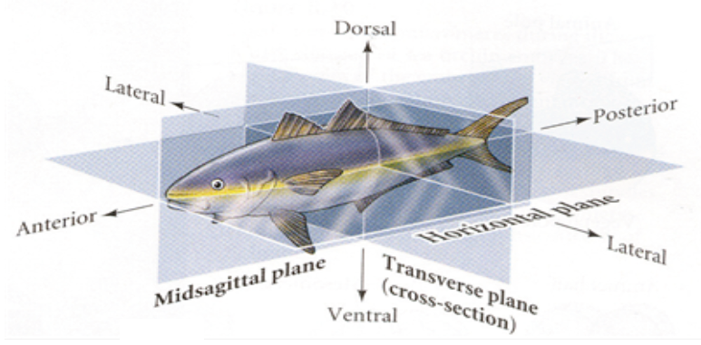

- Humans have 39 Hox genes – 4 clusters
  - Roles with CNS, axial skeleton, gastrointestinal tracts, limbs, etc.
  - Mutation in hox genes – lethal
    - Polydactyly, synpolydactyly (defects)
    - Truncation mutations, development of fingers, toes and uterus

- Hox genes proportional to evolutionary development, increasing diversity, lineages
  - New genes-new bodies hypothesis
- Duplication of hox genes
  - More potential fates >> other functions
  - Retain both copies >> higher expression
  - Neofunctionalization >> one copy diverges, takes on another function
  - Subfunctionalization >>part of duplicated function but degrades copies
    - In order to recover full ancestral function
    - Needing both of them – degrades in both areas
- Morphological diversification – changes in gene number of hox genes

