ISSUE: Was It the Conservatives’ Fault?
- The worst defeat by a major Canadian federal party occurred in 1993, when the Conservatives, who had been in power for nine years by winning two elections un a row under the leadership of Brian Mulroney, decided to call an election six months after the appointment of Kim Campbell as the new Conservative PM.
- The election resulted in the Conservatives losing 167 MPs, salvaging only 2 out of 303 seat in the entire country to Jean Chrétien and the Liberals.
- Mulroney and the Conservatives were highly unpopular. Mulroney had implemented a free trade agreement with the US after his 1988 election and in 1991, introduced the Goods and Services Tax (GST), both of which the Liberal promised to do away with.
- In addition, federal public finances were saddles with a large budget deficit, and Canada’s rate of unemployment had risen to as high as 12% a few months before the election. Kim Campbell’s statement on the campaign trail, was that unemployment was too complex to be discussed during the campaign. Voters thought she was wrong because the economic policies pursued by the federal government can influence the number of jobs created or destroyed by the economy, so they are obviously relevant to an election campaign.

Drawing a Line Between Macroeconomics and Microeconomics
- In microeconomics, the spotlight is on how individual decision-making units behave. How do they decide which actions are in their own best interests? How are these millions of decisions coordinated by the market mechanism and with what consequence?
- Microeconomics applies to the decisions of some large units. For example, the annual sales of General Electric and General Motors exceed the total production of many nations. The micro-macro distinction is not based solely on size.
- The main distinction is whereas microeconomics focuses on the decisions of individual units, no matter how large, macroeconomics focuses on the behaviour or entire economies, no matter how small.
- Macroeconomics study the overall price level, unemployment rate, and other things that are called economic aggregates.
Aggregation and Macroeconomics
  - An “economic aggregate” is an abstraction that people use to describe some salient example of economic life.
  - Among the most important of these abstract notions is the concept of domestic product, which represents the total production of a nation’s economy.
  - The process by which real objects (ex. Baseballs, software, movie tickets) are combined into an abstraction called total domestic product is aggregation, and is one of the foundations of macroeconomics.
  - Ex. Suppose imaginary nation Agraria produces nothing but foodstuffs to sell to consumers. Rather than deal separate with the many markets of hotdogs, pizzas, hamburgers, macroeconomists group them all into a single abstract “market for output.” When macroecomists announce that output in Agraria grew 10%, they are referring to the total production/output of food of Agraria in general.
The Foundations of Aggregation
  - The case for aggregation rests on two foundations:
1) Although the composition of demand and supply in the various markets may be terrible important for some purposes (such as how relative prices are determine and the diets people enjoy), it may be of little consequence for the economy-wide issues of growth, inflation, and unemployment – the issues that concern macroeconomists.
2) During economic fluctuations, markets tend to move up or down together. When the demand in the economy rises, there is more demand for potatoes AND tomatoes, more demand for artichokes AND pickles, more demand for ravioli AND hot dogs.
The Line of Demarcation Revisited
  - The two principles for aggregation allow us to draw a different kind of dividing line between micro and macroeconomics:
In macroeconomics, we typically assume that most details of resource allocation are relatively unimportant to the study of the overall rates of inflation and unemployment. In microeconomics, we general ignore inflation, unemployment, and growth, focusing instead on how individual markets allocate resources and distribute income.
  - As a metaphor, a macroeconomist analyzes the size of the proverbial economic “pie” paying scant attention to what is inside or how it gets divided among the dinner guests. A microeconomics assume that the pies is of the right size and shape, and frets over its ingredients and who gets to eat it.

Supply and Demand in Macroeconomics
A Quick Review
  - The following figures show a downward-sloping demand curve, labelled DD, and an upward-sloping supply curve, labelled SS.
  - Suppose something happens to shift the demand curve outward, such as an increase in consumer incomes. Figure 1b shows the shift as a rightward movement of the demand curve from D₀D₀ to D₁D₁. Equilibrium shifts form point E to point A, so both price and output rise.
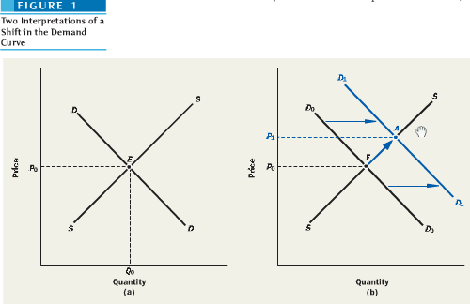
Moving to Macroeconomic Aggregates
  - To move to macroeconomic, we reinterpret Figure 1 as representing the market for an abstract object called domestic product.
  - The way economists actually measure this aggregate output in an economy will be discussed later and in Chapter 8.
  - Think of the price measured on the vertical axis as another abstraction – the overall price index, or “cost of living.” Then the curve DD in Figure 1(a) is called an aggregate demand curve, and the curve SS is called an aggregate supply curve.
Inflation
  - Figure 1(b) depicts the problem of inflation.
  - The outward shift of the AD curve, whatever it was caused by, pushes the price level up. If AD keeps shifting out month after month, the economy is likely to suffer from inflation – meaning a sustained increase in the general price level.
Recession and Unemployment
  - The 2nd principal issue of macroeconomics, recession, and unemployment can be illustrated on a supply-demand diagram, this time by shifting the demand curve in the opposite direction. Figure 2 repeats the supply and demand curve of Figure 1a and depicts a leftward shift of the AD curve from D₀D₀ to D₂D₂. Equilibrium now moves from point E to point B so the domestic product (total output) declines.
  - This is what is meant by a recession – a period of time during which production falls and people lose jobs.
- During a recession, the inflation rate tends to decrease, rising at a lower % than the typical 2% in Canada

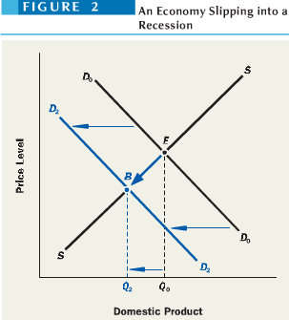
Economic Growth
  - Figure 3 illustrates a 3rd principal issue of macroeconomics: the process of economic growth. Here the original aggregate demand and supply curves are D₀D₀ to S₀S₀, which intersect at point E. When both curves shift to the right over time, moving to are D₁D₁ to S₁S₁, the new intersection point is C, and the blue arrow running from point E to C show the economy’s growth path. Over this period of time, domestic product grows from are Q₀ to Q₁.
  - This is what is meant by a recession – a period of time during which production falls and people lose jobs.
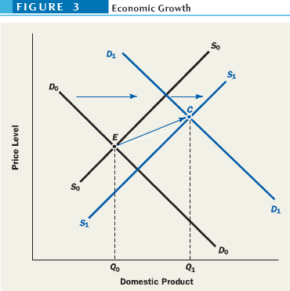
Gross Domestic Product
- Of the various ways to measure an economy’s total output, the most popular choice is the gross domestic product, or GDP. It is the sum of the money values of all final goods and services produced in the domestic economy within the year.
Money as the Measuring Rod: Real vs Nominal GDP
  - To combine all the goods and services, economists convert every god and service into money terms, and then add up all of the money.
  - The market price of each good or service is used as an indicator of its value to society for a simple reason: someone is willing to pay that much money for it.
  - What prices should be used in valuing different outputs?
  - One way is to value each good and service at the price it was actually sold. Taking this approach, the resulting measure is called nominal GDP, or GDP in current dollars.
  - One drawback of this method is nominal GDP rises when prices rise, even if there is no increase in actual production.
  - For this reason, government statisticians have devised alternative measures that correct for inflation by valuing goods and services produced in different years at the same set of price. The result is real GDP or GDP in constant dollars, also known as GDP corrected for inflation.
  - Any discussion following of the nation’s output, will be concerned with real GDP.
  - A recession is thus, a period in which real GDP declines. For example, during Canada’s last recession, nominal GDP rose from $677 to $693 billion, but real GDP fell from $770 billion to $751 billion during the same period. A recession occurs when real GDP declines for two or more consecutive quarters.
What Gets Counted in GDP?
  - The GDP for a particular years includes only goods and services produced within the year. Sales of items produced in previous years are explicitly excluded.
  - Only final goods and services count in the GDP.
  - Parts that are bought with the sole purpose of being used in the further production of goods to be sold are considered intermediate goods which are excluded from the GDP. IF this were not the case, the same output would be counted several times.
  - The adjective domestic in the definition of GDP denotes production within the geographic boundaries of Canada. Canadians working abroad, and offices and factories of Canadian companies in foreign countries are excluded in the GDP of Canada. The activity of foreigners and foreign companies that produce goods and services in Canada count in our GDP.
  - For the most part, only goods and services that pass through organized markets count in the GDP. This excludes illegal activities such as cigarette sales from smuggle merchandise, garage sales, housework, do-it-yourself repairs, and leisure time. These activities result in currently produced goods or services, but they lack the important measuring rod – a market price.
  - According to one estimate, Canada’s GDP might be 42% higher if unpaid housework were valued at market prices and counted in GDP.
Limitations of the GDP: What GDP Is Not
  - GDP is not a measure of the nation’s economic well-being and can’t do so for several reasons:
  - Only Market Activity is Included in GDP:
- International GDP comparisons are vastly misleading when two countries differ greatly in the fraction of economic activity that each conducts in organized markets.
- The fraction difference between two countries means we are not comparing the same economic activities.
- Many things counted in one nation’s GDP is not counted in another because they do not pass through markets.
- GDP takes not account of the underground economy – including not just criminal activities, but also of legitimate business that is conducted in cash or barter to escape the tax collector.
- These activities for around 3-4% of the GDP in Canada, higher in the US and elsewhere.
  - GDP Places No Value on Leisure:
- As a country becomes richer and more productive, its citizens tend to take more and more leisure time.
- A standard workweek fell from ~64 hours/week in 1901 to 44 hours/week in 1950. However, it’s stalled at around 37.5 hours/week nowadays.
  - “Bads” as Well as “Goods” Gets Counted in GDP
- Natural disasters that may lead to Canadians being worse off by destroying trees and damaging physical infrastructure. Yet these disasters raise the GDP due to money spent on cleanup, disaster relief, as well as replanting trees and repairing infrastructure.
- Mobilization for a war fought on some other nation’s soil normally causes a country’s GDP to rise rapidly. But men and women serving in the military could be producing civilian output instead.
  - Ecological Costs are Not Netted Out of the GDP
- Many productive activities of a modern industrial economy have undesirable effects on the environment. However, none of these ecological costs are deducted from the GDP in an effort to give us a truer measure of the net increase in economic welfare that our economy produces.
  - Efforts at new measures of well-being (UN Human Development Index, p. 100: GDP, life expectancy, years of schooling
- Happiness is weakly related to money: mental health, physical health, low stress, (un)employment, belonging

The Economy on a Roller Coaster
Growth, but with Fluctuations
  - Nominal GDP in 2007 was 37x that in 1961.
  - However, the purchasing power of each 2007 dollar was less than 1/7 of each 1961 dollar. Corrected for inflation, the real GDP was only 5x greater.
  - Another reason for growth of GDP is population growth. A nation becomes richer only if its GDP grows faster than its population. By dividing real GDP by the size of the population we obtain real GDP per capita which results say that the real output per person in 2005 was roughly 2.7x as much as in 1961.
  - Canadian economic history displays a les regular pattern – one of alternating period of rapid and slow growth that are called macroeconomic fluctuation, or business cycles.
  - In some periods, real GDP actually declined. Such recessions, and their attendant problem of rising unemployment, have been a persistent feature of Canadian economic performance.
Inflation and Deflation
  - The history of inflation shows there was more periods of inflation than deflation. Although the price level has risen more than 18x since 1914. This upward trend is rather recent. Prior to World War II, inflation and deflation showed no tendency for one to be more common than the other.
  - Although both real GDP, which measures the economy’s output, and the price level have grown a great deal over the past 140 years, neither has grown smoothly.
Canadian Recession Often Induced by US Recessions
  - Canadian economic activity is heavily dependent on the economic health of its largest trading partner - the US.
  - With Canada’s GDP being 1/10 of the US GDP, the following table shows the durations and dates of each of the economic recessions that have occurred since 1926.
  - It’s shown that several Canadian and American recessions occurred almost simultaneously, with the American recession usually preceding the Canadian one.
  - In some cases, Canada’s recessions were home grown while it managed to avoid a recession while the US did not as in 2001.
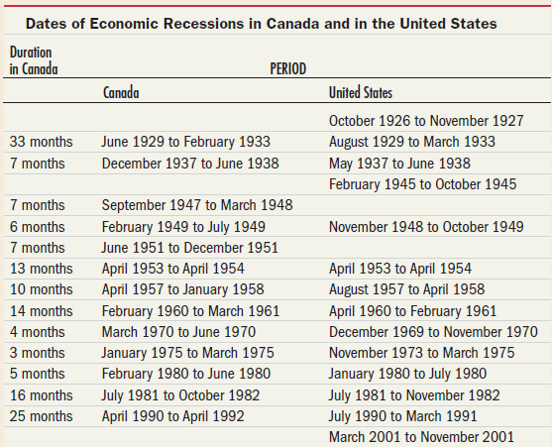
8 months October 2008 to May 2009 December 2007 to June 2009
5 months? January 2015 to May 2015

The Great Depression
  - In the above figure, notice the Great Depression of the 1930s. The decline in economic activity between 1929-1933 was the most severe in Canada’s history and the rapid deflation was almost as severe as the post-1873 and post-World War I deflations.
  - The October 1929 Great Crash of stock markets in Toronto, Montreal, New York, and other financial centres of the world caused tremendous hardship on Canadian industrial workers, many who lost their jobs, and western farmers, who faced a severe collapse of international grain prices.
  - Human Consequences
- The production of goods and services dropped 30%, business investment dried up almost entirely falling 80%, household consumption fell by ~20%, and exports fell by 30%.
- Unemployment rate rose from < 3% in 1929 to 20% to 1933.
- The thoughts of soup lines, homeless beggars on street corners, closed factories, and relief camps where the unemployed could eke out a meagre living follow.
- The Great Depression was centred in the US, but affected almost all countries. It changed the histories of many nations. In Germany, it facilitated the ascendancy of Nazism. In the US, it led and enabled Franklin D. Roosevelt to engineer and push through a host of political and economic reforms based on increased government intervention, commonly referred to as the “New Deal.” This pressure Canadian authorities to adopt a number of similar measures.
- The newly elected Bennett Conservative government authorized, through the Department of National Defence, the creation of a Canada-wide system of work comps for many of the hundreds of thousands of unemployed transients who were threatening public order in the cities. Through the Employment Service of Canada, unemployed men would be provided with bunkhouse facilities, three meals daily, medical care, and 20 cents/day for their labour. These men would work 44 hours/week in rural relief camps to clear brush and build basic infrastructure such as roads, bridges, and public buildings.
- The harsh working conditions at these outputs made them an ideal place for trade union activity, especially since 20 cents/day was about 1/10 of the average industrial wage at the time. In one incident in 1935, 1,600 relief workers in BC boarded freight cars and travelled eastward from the Pacific coast to take their grievances to the government in Ottawa what became known as the famous “On-to-Ottawa Trek.”
- Bennett’s excessively negative reactions to the “trekkers” led to riots in Regina and led to the Conservatives’ defeat. With the Liberal slogan “King or Chaos” Mackenzie’s King Liberals came back to power in 1935, set up a federally run unemployment insurance program in 1940.
  - A Revolution in Economic Thought
- The depression led to a much-needed revolution in economic thinking.
- Until the 1930s, the prevailing economic theory held that a capitalist economy occasionally misbehaved but had a natural tendency to cure recessions or inflations by itself. The rollercoaster bounced but did not run off the tracks.
- The stubbornness of the Great Depression led John Maynard Keynes, to write The General Theory of Employment, Interest, and Money that rejected the idea that the economy naturally gravitated toward smooth growth and high levels of employment, asserting that if pessimism led business and consumers to curtail their spending, the economy might be condemned to years of stagnation.
- Before that, Keynes was known for his book The Economic Consequences of the Peace (1919), his huge Treatise on Money (1930), and his involvement in politics.
- He was also part of the Bloomsbury group, a group of intellectuals, artists, writers, that introduced Sigmund Freud to England, and one of which was Virginia Woolf.
- Keynes was suggesting that a shock, such as the Great Crash of the stock markets, could affect the overall behaviour of investors and firms and lead to an inward shift in demand across many sectors. As employment and incomes fall, household demand for goods and services will continue to decline.
- When generalized across all sectors of the economy, the consequence will be declining domestic product and deflation.
- Keynes concluded by showing that government actions – the things we now call monetary and fiscal policy – might prod the economy out of a depressed state.
- These lessons show how governments can manage their economies so that recessions will not turn into depression and depressions will not last as long as the Great Depression.
From World War II to 1973
- The Great Depression ended when Canada entered WWII in 1939. Unlike during the Depression, government spending almost immediately rose to extraordinarily high levels and gave a big boost to overall demand in the economy.
- Fiscal policy was suddenly being used in a big way, thanks to such important ministers as C.D. Howe who mobilized the Canadian economy for the war effort. The economy boomed and unemployment rate fell to as low as 1.4% by 1944.
- Such spending spurts should lead to inflation but much of the potential inflation during WWII was contained by price controls. Between 1941 and 1945, the Wartime Prices and Trade Board imposed a general ceiling on prices, wages, and rents. With prices held below the levels at which quantity supplied equalled quantity demanded, shortage of consumer goods were common. Sugar and gasoline were rationed.
- When controls were slowly lifted post-war, price shot up as a result of pent-up demand.
- A period of strong growth marred by a few recessions post-war gave way to the fabulous 1060s, a period of unprecedented and noninflationary growth that was credited to the success of the economic policies that Keynes had prescribed in the 1930s.
- As the economy reached high employment levels with unemployment rates at 3.6% in 1966, and without wartime price controls, Canada witnessed a creeping inflation that many analysts attributed to the Vietnam War.
- The high employment accompanied by increasing war expenditures, was putting upward pressure on wages and prices in the US, with strong spillover effects on all international trading partners.
  - Despite a short and mild recession in 1970, inflation continued during the early Trudeau years at levels higher than had been seen since the Korean War. Inflation worsened dramatically in 1973, mainly because of an explosion in food prices caused by poor harvests around the world.
The Great Stagflation, 1973-1984
  - In 1973, things started becoming worse for all oil-importing countries including Canada, which both import and exports oil.
  - A war between Isreali and Arab nations precipitated a quadrupling of oil prices by the Organization of Petroleum Exporting Countries (OPEC). At the same time, continuing poor harvest around the world pushed food prices higher. Prices of other raw materials rose. This is called an adverse supply shock.
  - As shown in figure 7, an inward shift in supply arising from higher energy costs that affected all sectors of the economy pushed up the inflation rate to double digit levels. At the same time, the Canadian economy slipped into a short recession at the beginning of 1975, and unemployment rose.
  - With bot inflation and unemployment, the press coined a new term – stagflation – to refer to the simultaneous occurrence of economic stagnation and rapid inflation.
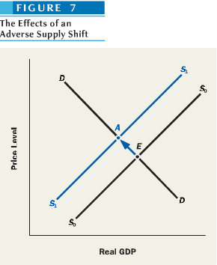
  - Policy makers in Canada were concerned with fighting inflation, even at the cost of significantly lower growth and higher unemployment. The government implemented two policy measures in 1975 to bring down the inflation rate:
1) One was a restrictive monetary policy of what the Bank of Canada termed “monetary gradualism” – a policy of high interest rates – the effect of which was a slowdown in overall spending in the economy, restraining demand.
2) The other was a policy of wage and price controls administered by the Anti-Inflation Board between 1975 and 1978 that would further restrain the growth of costs, thus impacting inflation on the supply side
  - This led to a lower overall growth rate of the economy, but a problem arose in 1979 by a second OPEC oil price shock causing stagflation to come roaring back as inflation reached ever higher double-digit levels.
  - Following the lead of the Federal Reserve in the US, the Bank of Canada brought interest rates to levels as high as 21% that it provoked the 1981-1982 “Great Recession.” Inflation came down at the cost of double-digit mass unemployment not seen since the Great Depressions.
The Mulroney Years, 1984-1993
  - The 1981-1982 recession coincided with the end of the Trudeau era. When John Turner replaced Pierre Trudeau at the helm of the Liberal Party and became prime minister in 1984, the economy was hurting from the mass unemployment caused by restrictive monetary policy.
  - The low growth in the economy (government expenditure rose as government revenues fell), and the high interest rate of policy of the Bank of Canada (which raised the servicing cost of government debt) destabilized the public finances to such an extent that all levels of governments were confronted with ever-increasing budget deficits.
  - This led to the election of Mulroney’s Conservatives. During his 1st term, the Canadian ecnomy followed a moderate growth path. By the time of the adoption of the Canada-US Free Trade Agreement in 1989, the economy was showing signs of accelerating disinflation that coincided with another spike in oil prices before the Persian Gulf War.
  - As newly appointed governor of the Bank of Canada, and with a strong commitment to price stability, John Crow sought to rein in inflation with doses of high interest rate such as his predecessor, Gerald Bouey had done in 1981.
  - The outcome was similar with a deep recession between 1990 and 1992, which was then followed by a jobless recovery.
  - In addition, despite the attempts of the Conservatives to cut public spending and introducing the GST in 1991, government budget deficits and debt exploded.
  - By the time Kim Campbell became leader of the Progressive Conservative Party and called an election in 1993, the Conservative disappeared from the political scene for over a decade until their merger with former Canadian Alliance and the creation of the new Conservative Party of Canada in December 2003.
  - A war between Isreali and Arab nations precipitated a quadrupling of oil prices by the Organization of Petroleum Exporting Countries (OPEC). At the same time, continuing poor harvest around the world pushed food prices higher. Prices of other raw materials rose. This is called an adverse supply shock.
The Chrétien and Martin Era, 1993-2006: Deficit Reduction and the “New Economy”
  - Jean Chrétien had run on a platform to eliminate the GST and the previous free trade agreement.
However, the increasing budget deficit allowed the Liberal government to refocus its agenda on eliminating the deficit. With Paul Martin as federal minister of Finance, the anti-ddeficit strategy rested on two pillars:
1) Restrictive fiscal policy - major cuts in federal spending, particular the significant cutting and reengineering of federal transfers to the provinces to support programs such as health care and social assistance
2) Expansionary monetary policy – a low interest rate policy made possibly by the sharp decline in the inflation rate that resulted from the deep and prolonged 1990-1992 recession
  - The outcome of these changes was that by the mid-1990s, federal finances when from the chronic deficits of the previous era to ever-increasing budget surpluses.
  - The government did get a lot of assistance from the booming American economy during the Clinton administration. AS the stock market soared (notably in the high-tech sectors) business investment perked up in the US, and with the help of the North American Free Trade Agreement (NAFTA), Canadian exports grew to record levels as a share of GDP, with their prime destination being the US.
  - This resulted in high overall growth and a steady decline in Canada’s unemployment rate through the later half of the 1990s, both of which occurred in the context of a low inflation environment.
  - The “New Economy” – a product of globalization and computerization – that somehow performed better than the economy of the past was only somewhat real. On one hand, advances in computer and info tech seemed to lead to faster growth in the 2nd half of the 1990s.However, this growth was associated with a particular alignment of several factors: a major spurt in productivity arising from the high-tech sectors pushed overall supply significantly outward without any growth in labour costs that would have offset it by shifting the supply curve upward.
  - Hence, as demand grew, supply was growing almost as rapidly, thereby guaranteeing a low inflation environment brought about by favourable shifts in supply.
  - By the latter half of 2000, this rapid growth had petered out in the US with the collapse of the “dot-com” bubble, and the American economy went through a short recession in 2001. Despite the difficulties faced by our high-tech sector, the Canadian economy was less severely hit.
The Harper Years, 2006-: Domestic Tax Cuts and Global Finance
  - When the Conservatives came to power in January 2006 as a minority government, they inherited an economy that was experiencing solid growth. Consume spending in the housing sector continued to expand rapidly. During three consecutive federal budgets between 2006 and 2008, the Conservatives cut taxes significantly – the GST, as well as corporate and personal income taxes.
  - The effect was further stimulation of consumer spending and a lowering of Canada’s unemployment rate.
  - Mirroring the US, this growth in household spending was accompanied by an expansion in mortgage debt, which peaked when the US mortgage market collapsed in 2007-2008.
  - The Conservative tax cuts kicked in just around the time when the Canadian economy faced a slump in export demand, thereby somewhat domestic spending.
  - A war between Isreali and Arab nations precipitated a quadrupling of oil prices by the Organization of Petroleum Exporting Countries (OPEC). At the same time, continuing poor harvest around the world pushed food prices higher. Prices of other raw materials rose. This is called an adverse supply shock.

The Problem of Macroeconomic Stabilization: A Sneak Preview
- To provide a preliminary analysis of stabilization policy, the name given to government programs designed to shorten recessions and counteract inflation, we can use the basic tools of aggregate supply and demand analysis.
- When aggregate demand fluctuations are the source of economic instability, the government can limit both recessions and inflations, by pushing the aggregate demand ahead when it would otherwise lag, and restraining it when it would otherwise grow too quickly.
Combating Unemployment
  - Recessions and unemployment are often caused by insufficient aggregate demand. When such situations occur, fiscal or monetary policies that successfully augment demand can be effective ways to increase output and reduce unemployment. But they could also raise prices.
  - Suppose that, in the absence of government intervention, the economy would reach an equilibrium point E as shown in Figure 9. If the output corresponding to point E is too low, leaving many workers unemployed, the government can reduce unemployment by increasing aggregate demand as so far reviewed by: spending more or reducing taxes (“fiscal policy”), or allowing the Bank of Canada to lower interest rates (“monetary policy”).
  - Any of these actions would shift the demand curve outward to D₁D₁, causing equilibrium to move to point A.
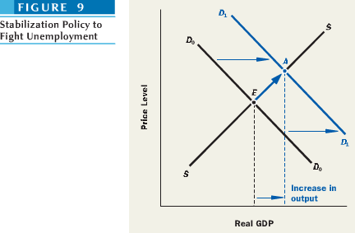
Combating Inflation
  - The opposite type of demand management is called for when inflation is the main macroeconomic problem. Inflation is frequently caused by aggregate demand racing ahead too fast. When this is the case, fiscal or monetary policies that reduce aggregate demand can be effective anti-inflationary devices. But such policies also decrease real GDP and raise unemployment.
  - Suppose the price level corresponding to point E is considered “too high,” meaning that the price level would be rising too rapidly if the economy were to move to point E. A government program that reduces demand from to D₀D₀ to D₂D₂, for example, a reduction in government spending can keep prices down and thereby reduce inflation.
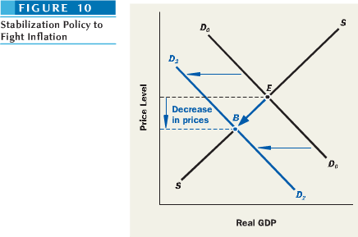
Does it Really Work?
  - Although controversy over this point continues, many economists attribute this shift in the economy’s behavior to lessons the government has learned about managing the economy.
  - When looking at pre-war data (before 1940), you see pronounced business fluctuations and inflation was rare with an unmanaged economy. The government did little about both economic boom and recessions.
  - When examining post-war data, the business fluctuations have been much less severe, but inflation has been a common occurrence.

