Student Name: Bhavika

Student Number: 8228982

Partner’s Name and Student #: Emily Roth, 8208575

Demonstrator's Name: Sora Jalipour

PLEASE NOTE: If ANY of the above information is UNCLEAR or not provided, your grade will NOT be recorded!!

Lab Day (circle): Tues aft Tues night Wed Thurs aft Thurs night Fri

Lab Week (circle): 1 2

Laboratory Report Cover Page

Experiment 2.

Enthalpy of Various Reactions

Checklist:
- Raw Data Sheet written in pen, signed by TA and attached
- 8 curves [2 for metal; 2 for acid 1; 2 for acid 2; 2 for salt] attached
- Completed formal report typed and attached
Student’s Initials :BP

Introduction:

In this experiment, a calorimeter was used to determined the specific and approximate molar mass of a metal, the enthalpy of neutralization of strong acids and bases. Also, it was used to determine the enthalpy of solution of an unknown salt. A calorimeter is used to determine temperature under constant heat and pressure. Even though, heat was loss during this experiment, it was assumed no heat was lost. The calorimeter used in this experiment was an coffee cup calorimeter, made of layers of foam.

Enthalpy of the amount of heat content used or released in a system at constant pressure, it is usually expressed as the change in enthalpy. Enthalpy (H) is the sum of the internal energy, when a process occurs at a constant pressure; the heat is either released or absorbed and it is equal to the change in the enthalpy. Enthalpy is a state function and it calculated throughout the lab report. For the enthalpy of neutralization, q_{n}, is the total heat energy of neutralization. Once the amount of heat is released in the reaction is known, the enthalpy of the reaction per substance can be solved. The state of dissolution of a salt is dependent on lattice energy, energy required to vaporize one mole of salt. Also, it is dependent on the hydration energy, the energy released when one mole of gaseous ion. Either of these two factors can make the reaction either exothermic, when energy is released to the surrounding or, endothermic, when energy is absorbed by the system. The first two parts of this experiment as observed were, exothermic but, the last part is endothermic. Hess’ Law is used to determine the enthalpy of more complex reactions, Hess’ Law is not used during this lab.

Thermal energy is measured through calculating the specific heat capacity, which is the amount of energy required to heat one gram of a substance by one degree. The specific heat of metal which did not react with water was determined by heating up the metal, then transferring it into cold water. The temperature change gives a measure of heat capacity to the water. This idea of heat capacity is fundamental throughout the experiment but, especially in Part 1.

Procedure:

As described in the lab manual (Experiment 2, “…But a Hot Temper Leaps O’er a Cold Decree” Enthalpy of Various Reactions)

Data/Observations Results

Enthalpy of Copper

Data | Trial 1 | Trial 2
Element | Copper | Copper
Mass (g) | 10.004 | 9.2837
Volume of H₂O (mL) | 20.0 | 20.5
Mass of Empty Cup (g) | 1.9332 | 1.9519g
Mass of H₂O & Cup (g) | 21.8576 | 22.1140
Mass of H₂O (g) | 19.9244 | 20.1621
Initial Temperature of H₂O (˚C) | 23.7 | 24.2
Final Temperature of H₂O (˚C) | 26.6 | 26.9
∆_{water}T (˚C) | 2.9 | 2.7
Q_{water} (J) | 2.4 x 10² | 2.3 x 10²
∆_{copper} (˚C) | -73.4 | -73.1
C_{copper} (J/g˚C) | 0.329 | 0.342
MM_{copper} (g/mol) | 76 | 73
% error of c (%) | 14.5 | 11.2
% error of MM (%) | -19.465 | -14.477

Observations: exothermic

Trial 1 |  | Trial 2
Water in Calorimeter |  | Water in Calorimeter
Time (s) | Temperature (˚C) | Time (s) | Temperature (˚C)
0 | 23.7 | 0 | 24.2
30 | 23.7 | 30 | 24.1
60 | 23.6 | 60 | 24.0
90 | 23.6 | 90 | 24.0
120 | 23.6 | 120 | 23.0
150 | 23.8 | 150 | 23.9
180 | 23.6 | 180 | 24.0
210 | 23.7 | 210 | 24.0
240 | 23.6 | 240 | 24.0
270 | 23.7 | 270 | 24.1
300 | 23.6 | 300 | 24.0
330 | 23.8 | 330 | 27.0
360 | 23.8 | 360 | 27.0
390 | 23.7 | 390 | 27.0
420 | 23.7 | 420 | 27.0
450 | 23.8 | 450 | 27.0
480 | 23.7 | 480 | 26.9
510 | 23.7 | 510 | 26.9
540 | 23.7 | 540 | 27.0
570 | 23.6 | 570 | 26.9
600 | 23.8 | 600 | 27.0

Enthalpy of Neutralization

HCL& NaOH

Data | Trial 1 | Trail 2
V_{NaOH} (mL) | 40 | 40
V_{HCl} | 40 | 40
T_{i} (˚C) | 23.0 | 22.8
T_{f} (˚C) | 29.8 | 30.3
Mass of solution with cup (g) | 78.05 | 79.12
∆T (˚C) | 6.8 | 7.5
V_{total} (mL) | 80 | 80
m_{finalSolution} (g) | 80 | 80
q (J) | -2.3 x 10³ | -2.5 x 10³
mol of HCl (mol) | 0.04 | 0.04
mol of NaOH (Limiting Reagent) (mol) | 0.044 | 0.044
mol of H₂O (mol) | 0.04 | 0.04
∆_{n}H˚ HCl (J/mol) | -5.8 x 10⁴ | -6.3 x10⁴
% error (%) | 6.8 | 9.8

Observations: Exothermic
Trial 1 |  | Trial 2
HCl & NaOH in Calorimeter |  | HCl & NaOH in Calorimeter
Time (s) | Temperature (˚C) | Time (s) | Temperature (˚C)
0 | 23.0 | 0 | 22.8
30 | 23.1 | 30 | 23.1
60 | 23.1 | 60 | 22.9
90 | 23.1 | 90 | 23.0
120 | 23.0 | 120 | 22.9
150 | 23.0 | 150 | 22.9
180 | 23.1 | 180 | 23.0
210 | 23.1 | 210 | 22.9
240 | 23.1 | 240 | 23.0
270 | 23.1 | 270 | 23.0
300 | 23.1 | 300 | 23.0
330 | 23.0 | 330 | 27.0
360 | 23.0 | 360 | 30.4
390 | 23.1 | 390 | 30.6
420 | 23.8 | 420 | 30.3
450 | 29.9 | 450 | 30.4
480 | 29.8 | 480 | 30.4
510 | 29.8 | 510 | 30.2
540 | 29.9 | 540 | 30.3
570 | 29.8 | 570 | 30.3
600 | 29.8 | 600 | 30.3

HNO₃ & NaOH

Data | Trial 1 | Trail 2
V_{NaOH} (mL) | 40 | 40
V_{HNO3} | 40 | 40
T_{i} (˚C) | 23.4 | 23.5
T_{f} (˚C) | 29.9 | 30.2
Mass of solution with cup (g) | 77.30 | 70.96
∆T (˚C) | 6.5 | 6.7
V_{total} (mL) | 80 | 80
m_{finalSolution} (g) | 80 | 80
q (J) | -2.2 x 10³ | -2.2 x 10³
mol of HNO₃(mol) | 0.04 | 0.04
mol of NaOH (Limiting Reagent) (mol) | 0.044 | 0.044
mol of H₂O (mol) | 0.04 | 0.04
∆_{n}H˚ HCl (J/mol) | -5.8 x 10⁴ | -5.5 x10⁴
% error (%) | 3.8 | 3.7

Observations: Exothermic. Lower temperature compared to HCl. Pressumed because of the change of acid.

Trial 1 |  | Trial 2
HNO₃ & NaOH in Calorimeter |  | HNO₃ & NaOH in Calorimeter
Time (s) | Temperature (˚C) | Time (s) | Temperature (˚C)
0 | 23.4 | 0 | 23.5
30 | 23.4 | 30 | 23.2
60 | 23.4 | 60 | 22.3
90 | 23.5 | 90 | 23.2
120 | 23.4 | 120 | 23.3
150 | 23.6 | 150 | 23.3
180 | 23.5 | 180 | 23.2
210 | 23.6 | 210 | 23.3
240 | 23.5 | 240 | 23.4
270 | 23.3 | 270 | 23.3
300 | 30.5 | 300 | 23.3
330 | 30.1 | 330 | 30.4
360 | 30.1 | 360 | 30.3
390 | 30.0 | 390 | 30.3
420 | 30.0 | 420 | 30.4
450 | 30.0 | 450 | 30.2
480 | 29.9 | 480 | 30.2
510 | 29.0 | 510 | 30.2
540 | 29.8 | 540 | 30.2
570 | 29.9 | 570 | 30.2
600 | 29.9 | 600 | 30.1

Enthalpy of Dissolution of a Salt

Data | Trial 1 | Trail 2
Unknown Salt | B | B
Mass of Salt (g) | 2.4483 | 3.6450
T_{i} (˚C) | 23.8 | 24.1
T_{f} (˚C) | 20.7 | 20.5
Initial Mass of water with cup (g) | 22.0785 | 21.7396
Final Mass of water with cup (g) | 24.4768 | 24.3135
∆T (˚C) | -3.1 | -3.6
q (J) | 2.6 x 10² | 3.3 x 10²
mol of salt(mol) | 0.0147 | 0.0159
∆_{n}H˚ HCl (J/mol) | 1.8 x 10⁴ | 2.1 x10⁴
% error (%) | 11.3 | 13.2

Observations: Endothermic

Trial 1 |  | Trial 2
Salt B & H₂O in Calorimeter |  | Salt B & H₂O in Calorimeter
Time (s) | Temperature (˚C) | Time (s) | Temperature (˚C)
0 | 23.8 | 0 | 24.1
30 | 23.8 | 30 | 23.8
60 | 23.8 | 60 | 22.8
90 | 23.6 | 90 | 23.8
120 | 23.7 | 120 | 23.9
150 | 23.6 | 150 | 23.9
180 | 23.7 | 180 | 24.1
210 | 23.6 | 210 | 23.9
240 | 23.8 | 240 | 23.9
270 | 23.6 | 270 | 23.9
300 | 30.7 | 300 | 24.0
330 | 20.2 | 330 | 20.0
360 | 20.3 | 360 | 20.1
390 | 20.4 | 390 | 20.0
420 | 20.4 | 420 | 20.1
450 | 20.5 | 450 | 20.2
480 | 20.4 | 480 | 20.3
510 | 20.6 | 510 | 20.3
540 | 20.7 | 540 | 20.4
570 | 20.7 | 570 | 20.4
600 | 20.7 | 600 | 20.5

Calculations: (All Calculations are for Trial 1)

Part 1:Enthalpy of a Metal

- Trail 1
∆T = T_{F} - T_{I}
∆T= 26.6˚C – 23.7˚C
∆T= 2.9˚C

- Q=mc∆T
m= m_{cupwithwater} - m_{emptycup}
m=21.8576g – 1.9332g
m=19.9238g

Q=(19.9238g)(4.184J/g˚C)(2.9˚C)
Q=241.75 J

- ∆T = T_{F} - T_{I}
∆T= 26.6˚C - 100˚C
∆T= -73.4˚C

- –q_{cu} =q_{water}
-c=Q_{water}/m∆T
-c=241.75J/(10.004g)( -73.4˚C)
c=0.329227982J/g˚C
c=0.329 J/g˚C

- c_{cu} x M_{cu} ≈25 J/mol˚C
M_{cu} = 25 J/mol˚C / 0.329 J/g˚C
M_{cu} = 76 g/mol

- % error of c = (accepted value – experimental value)/accepted value
% error of c = ((0.385 – 0.329)/0.385) J/g˚C x 100
% error of c = 14.5 %

% error of M = (accepted value – experimental value)/accepted value
% error of M = ((63.546 – 75.935)/63.546) g/mol x 100
% error of M = -19.469 %

- The mass of metal contributed to different to different values for for q and molar mass but, it did not alter the calculations tremendously. Different values of mass represent different values for q but, for the molar mass, the value of mass should not have made a difference.

Part 2: Enthalpy of Neutralization (all Trial 1)

- ∆T = T_{F} - T_{I}
∆T= 29.8˚C – 23.0˚C
∆T= 6.8˚C

- ∆V= V_{NaoH} + V_{HCL}
∆V = 40 mL + 40 mL
∆V = 80mL

- D=m/v
m=DxV
m=(80mL)(1.0g/mL)
m=80 g

Measured mass = m_{solution} - m_{emptycup}
m=78.05g – 1.9332g
m=76.12 g

The difference between the measured mass compared to the calculated mass is only a matter of 3.88g The more accurate mass would have to be the measured quantity because the values are not experimental. The difference in masses would alter the data, different values of q would be present.

- Q=-mc∆T
Q=(80g)(4.184J/g˚C)(6.8˚C)
Q=-2.3 x 10³ J

- NaOH(aq) + HCl(aq) NaOH(aq) + H₂O (l)

?mol NaOH = 40 mL/1000mL x 1.0 mol/L
? mol NaOH = 0.04 mol

?mol HCL = 40 mL/1000mL x 1.1 mol/L
? mol NaOH = 0.044 mol

The limiting reagent is NaOH.

- ? mol H₂O = 0.04 mol NaOH x (1 mol H₂O/1 mol NaOH)
? mol H₂O = 0.04 mol H₂O

- ∆_{n}H˚ = q_{n}/n_{x}
∆_{n}H˚ = -2.3 x 10³ J/0.04 mol H₂O
∆_{n}H˚= -5.8 X10⁴ J/mol

- ∆_{n}H˚ = q_{n}/n_{x}
∆_{n}H˚ = -2.2 x 10³ J/0.04 mol H₂O
∆_{n}H˚= -5.5 X10⁴ J/mol

HCL : -5.8 X10⁴ J/mol vs. HNO₃ : -5.5 X10⁴ J/mol

- % error of ∆_{n}H˚of HCl = (accepted value – experimental value)/accepted value
% error of ∆_{n}H˚of HCl = ((-5.79 x 10⁴+ 5.8 x 10⁴)/ -5.79 x 10⁴) J/g˚C x 100
% error of ∆_{n}H˚of HCl = 6.8%

% error of ∆_{n}H˚of HNO₃ = (accepted value – experimental value)/accepted value
% error of ∆_{n}H˚of HNO₃ = ((-5.71 x 10⁴+ 5.5 x 10⁴)/ -5.71 x 10⁴) J/g˚C x 100
% error of ∆_{n}H˚of HNO₃ = 3.8%

- The values of each acids between two trials do vary, but are quite similar, this is because of the volume being exactly the same for all four trials. If the volume of the acids or the bases were different, then the moles would have been different, resulting in different values of data. The enthalpies vary do to difference in temperature and mass. The two trials were expected to be different because of different masses and temperature.

Part 3: Enthalpy of Dissolution of a Salt

- ∆T = T_{F} - T_{I}
∆T= 20.7˚C – 23.8˚C
∆T= -3.1˚C

- Q=mc∆T
m=m_{water&calorimeter}+m_{salt}-m_{calorimeter}
m=22.4483+2.4483-1.9332g
m=22.96g

Q=(22.96g)(3.662J/g˚C)(-3.1˚C)
Q=-2.6 x 10² J

- ? mol salt B = 2.4483g/166.0g/mol
? mol salt B = 0.0147 mol

∆_{s}H˚ = -q_{s}/n_{salt}
∆_{s}H˚ = -(-2.6 x 10² J) /0.0147 mol
∆_{s}H˚=1.8 x 10⁴ J/mol

- % error of ∆_{n}H˚of HCl = (accepted value – experimental value)/accepted value
% error of ∆_{n}H˚of HCl = (2.03 x 10⁴ x 10⁴+ 1.8 x 10⁴)/2.03 x 10⁴J/g˚C x 100
% error of ∆_{n}H˚of HCl = 11.3%

- The mass of the salt did affect the results because it affect the number moles per gram of salt.

Discussion

Throughout the experiment, the calorimeter was used to find molar mass of copper, the enthalpy of neutralization of Hydrochloric acid and Nitric acid and finally, the enthalpy of the unknown salt B. The Calorimeter allowed the heat produced by both reactants and products to remain in one isolated area. Due to the equal amounts of heat created, during the experiments equations were able to be set to equal one another to solve for unknown value. This method was used in part 1 of the experiment where q_{water} = -q_{copper.} The value of q_{water} was given.

When comparing the trials for the first part of the experiment, It was found that heat capacity and also the Molar masses were similar in both trials, no major errors were conducted, and this is observed in the calculations. There was no significant difference in both trials, the variations in the values were dependent on the mass of the metal used, as the mass of metal is used to calculate the value of q, and the molar mass.
In the second part of the experiment, when comparing the two trials between HCl and NaOH, the values are once similar but, when comparing the values between HCl and HNO_{3,} there’s a difference. The percent error between the two acids is much greater. The same amount of mole of water is present for both acids, because of the same amount of volumes used for the acids, but it resulted in different enthalpies because of the different values of q, due to the difference in temperatures.

In the third experiment, the enthalpy of dissolution was calculated, and the values for both trial one and trial 2 were similar. The values of moles were calculated to be different because of the different values of mass used in both trials. The percent errors were relative similar to one another in both trials.

In this experiment, there were no major errors present, there still would be minor errors present. For instance, the mass values could not have been correct, and since the propagation of errors were not calculated. Also, calorimeter was not a closed isolated system, we just presumed it was, to make the calculation much easier.

Conclusion

For the first part, the number of moles calculated for 76mol and 73 for both trials. The percent error for each trial were, -19.465% and -14.477%. For the HCl the enthaplies were, -5.8 x 10⁴ and -5.5 x 10⁴ J/mol and the percent error is,6.8% and 9.8%. For the HNO₃, the enthalpies, -5.8 x 10⁴ and -5.5 x 10⁴ J/mol and percent error was 3.8% and 3.7%. For the third part, the enthalpies were, 1.8 x 10⁴ and 2.1 x 10⁴ J/mol and percent errors are 11.3% and 13.2%.

Graphs:

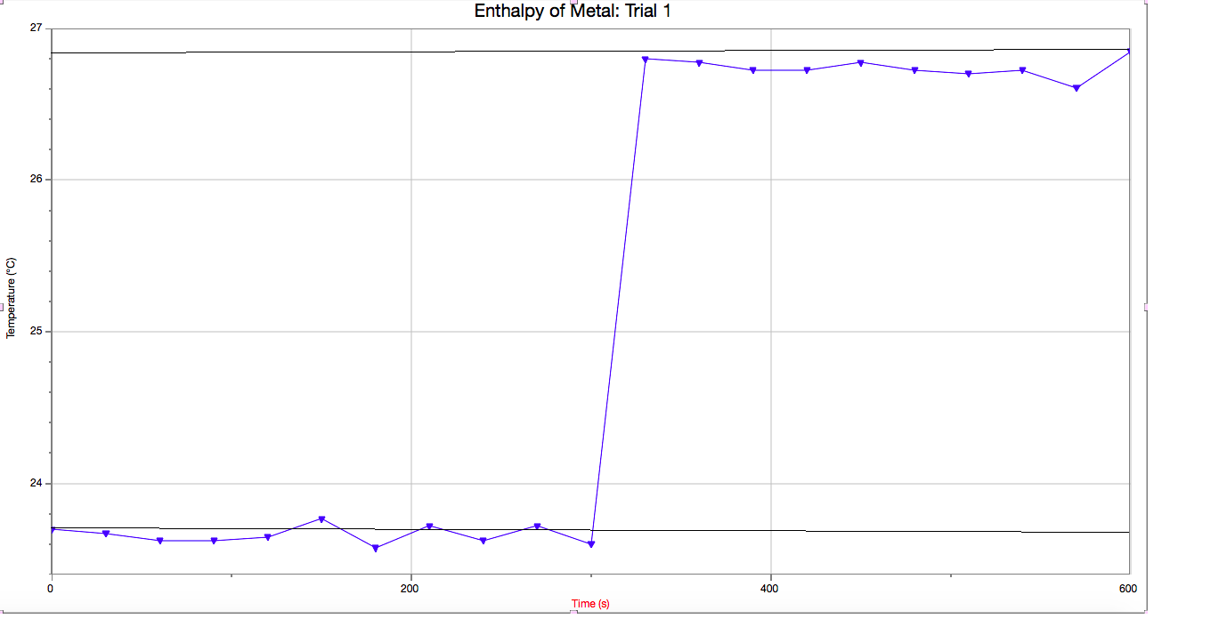

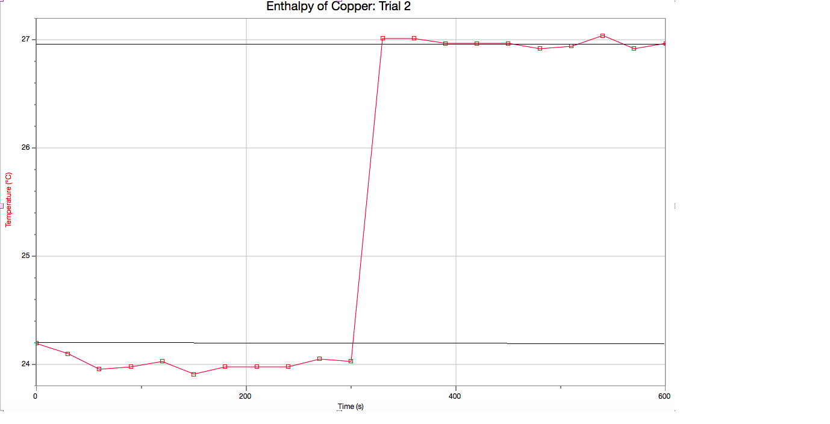

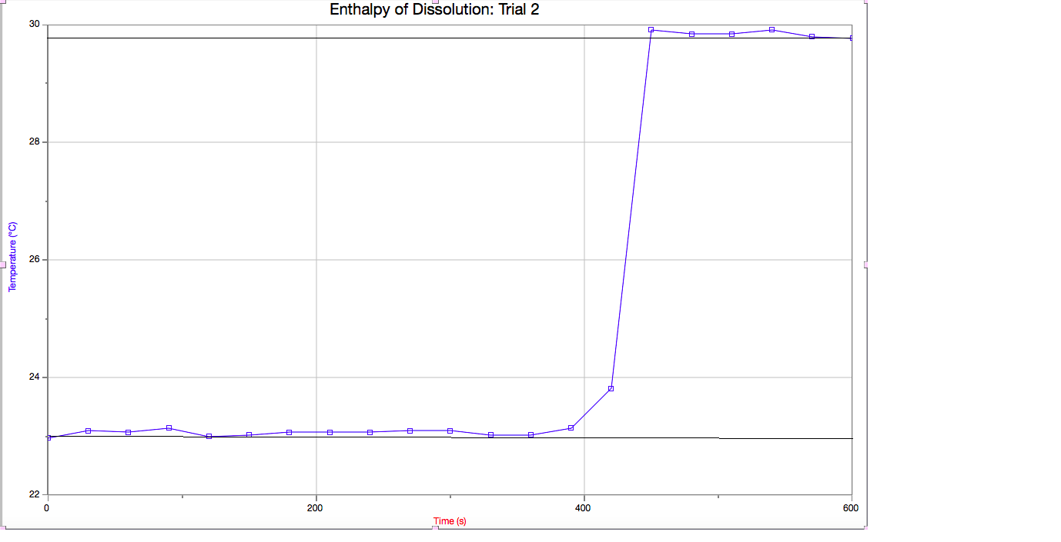

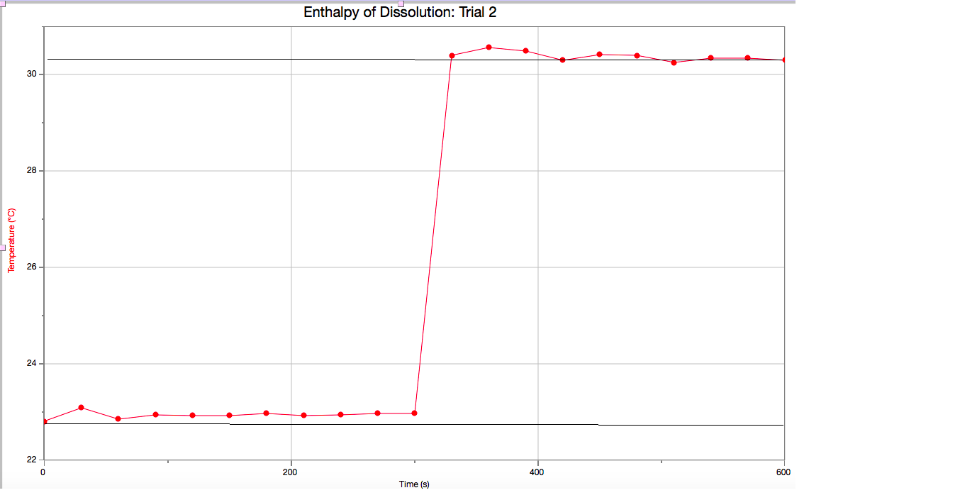

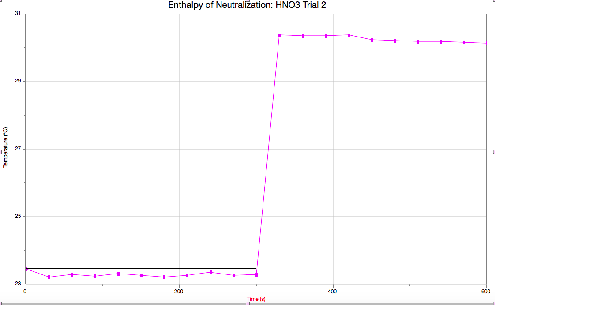

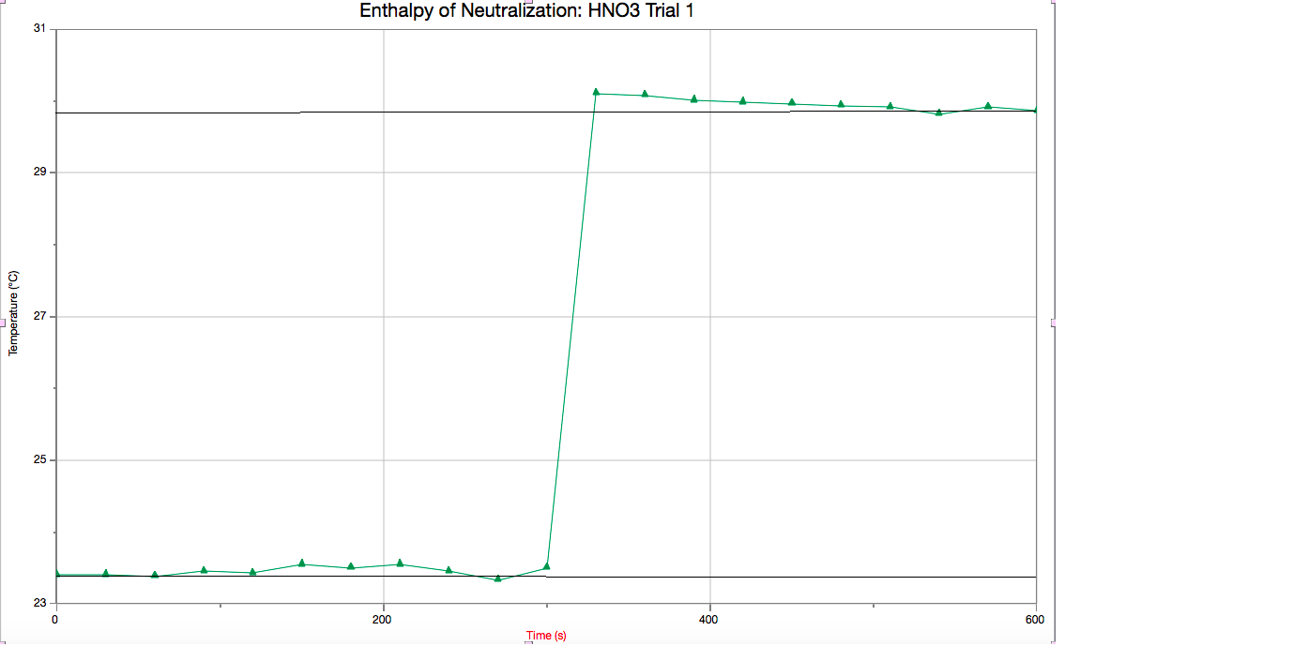

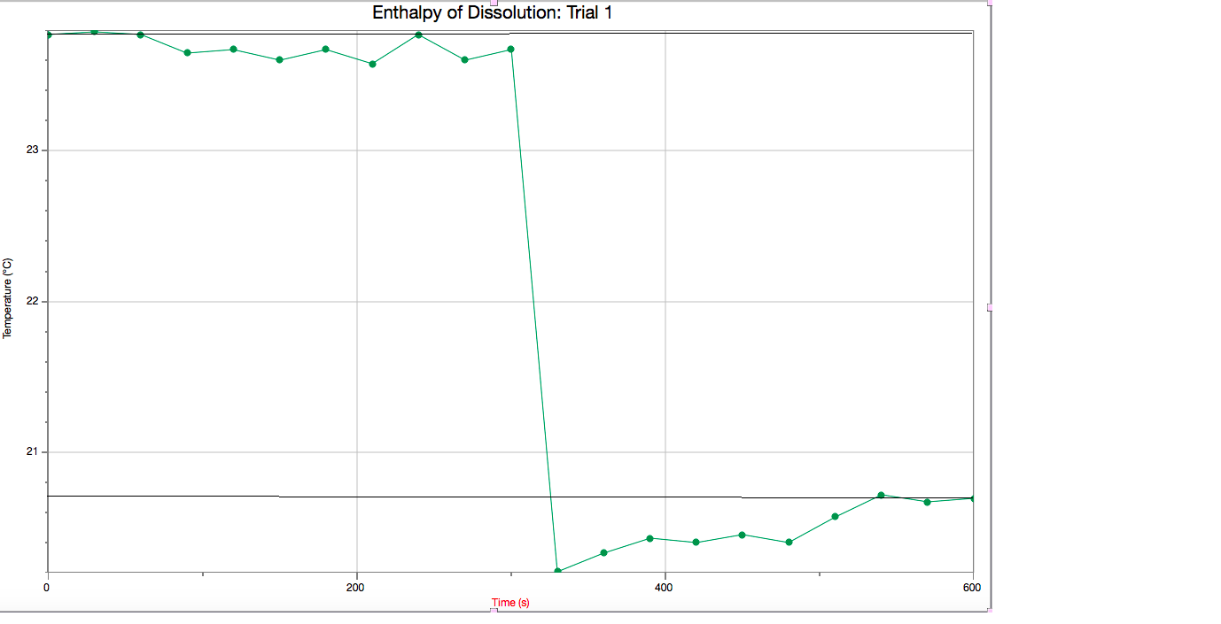

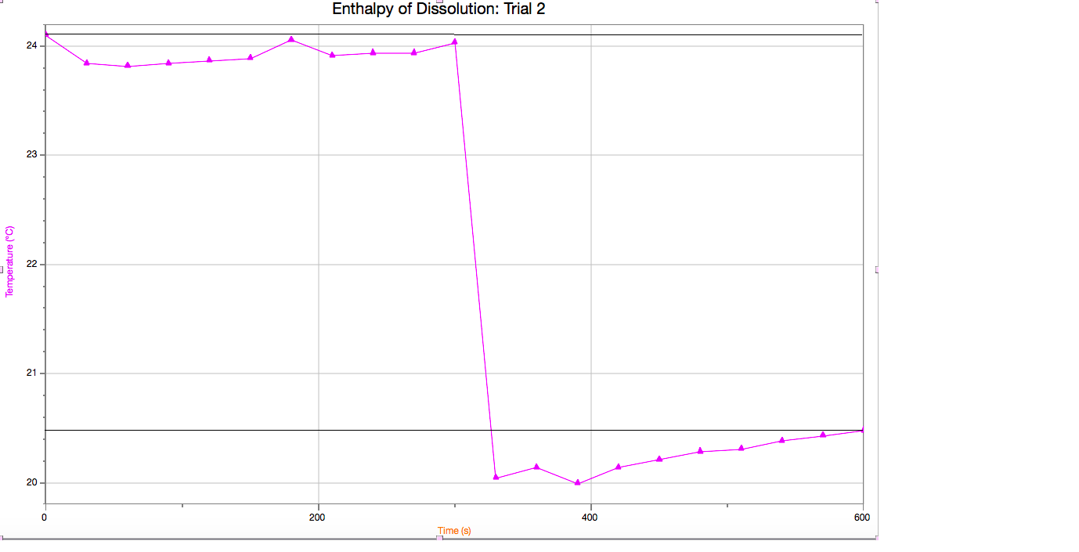

Raw Data

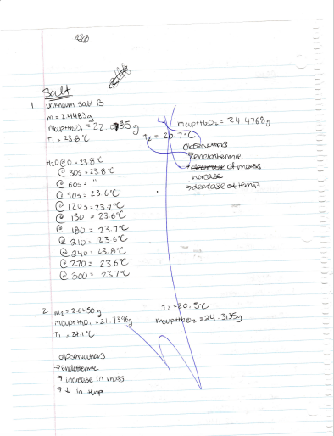

References

Experiment 2, “…But a Hot Temper Leaps O’er a Cold Decree” Enthalpy of Various Reactions

http://www.mindspring.com/~drwolfe/WWWolfe_dat_enthalpies.htm Enthalpies of Solution

http://chemwiki.ucdavis.edu/Physical_Chemistry/Thermodynamics/State_Functions/Enthalpy Enthalpy

