e
eSports Academy
2015
eSports just as important as real sports
Andy Le-Lam


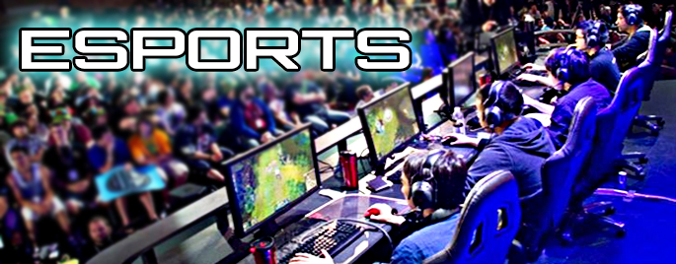
Word Assignment
Inte290
Section 1: Brief History on eSports 1-5
Table of Contents
Section 2: Goal of eSports Academy 6-9
Section 3: When, Where, and How Much? 10-16
Section 4: Conclusion 17-18

¹eSports is a term that is short for electronic sports. ²It serves as an alternative for sports; it gives gamers an opportunity to compete against others like them from around the world. ³There are already many eSports companies out there in the world right now, who host tournaments that allow players to earn money. ⁴Below is a chart illustrating winnings distributed a few esports teams for winning their respective “world championships”. ⁵Every pro gaming team earns a suitable amount of salary from the company they play for as well as payments they receive from their team owner and managers and sponsors of their teams.

Goal: ⁶The goal of the eSports Academy is to open up a school dedicated to training individuals who are interested in the field of gaming. ⁷Focusing on how they can turn this hobby into a plausible career option. ⁸Earning at least a minimum salary for participating in certain game leagues, they also has a chance to win the big finals prize pool. ⁹The goal is to give these individuals a chance to enjoy their opportunity, earn a suitable amount of money, and even earn some glory and pride from winning such vast tournaments.

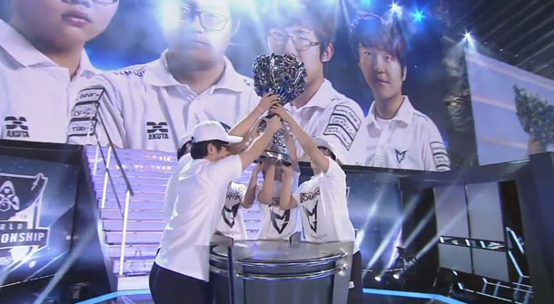
Figure 1: Depicted is an image of League of Legends season 4 winners

When: ¹⁰The School can be opened up as soon as a location is acquired, it isn’t necessary to build a school from the ground up, can rent out building and start finding applicants as soon as possible.

Where: ¹¹Any building that can house up to a suitable amount of interested individuals, of approximately 30+. ¹²For example a wing of a school can be rented out to us, and we can start from there. ¹³Or even an office building can be used as a suitable location.
How Much: ¹⁴The cost for starting up this school would have to be paying the monthly rent of 400$ for a classroom, and for this project we would require at least 2-3 classrooms, therefore 1200$/month. ¹⁵An office space would be the better alternative because it offers us decent space for a cheaper amount of 400$ for a room of 30 people, but a classroom offers a more homey feeling. ¹⁶Also included in the budget we must pay for gaming gear and high end computers say 30 times a gaming setup would cost 30,000$ of a onetime payment.




Figure 2 this figure shows how an average esport career can go.

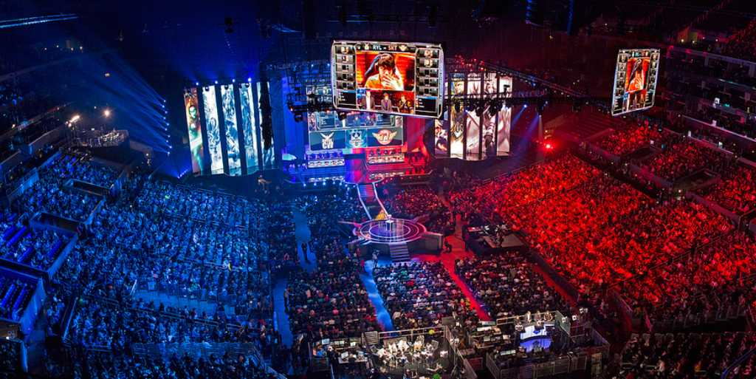
Conclusion: ¹⁷All in all I believe that opening a school dedicated to teaching and improving individuals on playing video games, it does sound farfetched but we live in the 21st century and anything is possible. ¹⁸This is a viable option for those who really enjoy video games, and now they can earn a living off of it.
Figure 3 shows the league of legends world champions ships in the staples centre

"The International 2015." - Liquipedia Dota 2 Wiki. Web. 14 Oct. 2015 . [ Dota 2 ]

"Community Blog: ESports - Blog by MissyMee283 - IGN." IGN. Web. 14 Oct. 2015 [Esports Image]

"Clavier Gamer Tt ESport Poseidon - GamerStuff.fr." GamerStuff.fr. 8 Aug. 2013. Web. 14 Oct. 2015. [ Mechanical Keyboard Image]

"The World Championships 2015." - Liquipedia Counter-Strike Wiki. Web. 14 Oct. 2015. [Counter –Strike]

"Team Samsung White Wins The 2014 League Of Legends World Championship." Www.GameInformer.com. Web. 14 Oct. 2015. [Champions Image]

Please consider this project proposal, as it can become a very successful business idea.

