- Nothing important ! just class introduction!

- Sociological perspectives (Wednesday)

- Conflicts
  - Relation characterized by conflict
  - Look for power: who dominates whom
  - Coercion (imposed values)
  - Change in revolution
  - Main tendency : struggle for advantage
  - Critique : ignores cooperative social behavior
- Structural Functionalism:
  - Relations characterized by interdependence
  - Looks for functions( good effects for society as a whole )
  - Cohesion ( shared values )
  - Change in evolutionary and equilibrium
  - Critique : static, conservative , ignored power
- Symbolic interaction
  - Relations characterized by role taking and negotiation Look for symbolic meaning, perception and expectations negotiation(negotiated values ) trust and shared meanings change in inherent, on going process. Main tendency : society is created in interpersonal interactions
  - Critiques: emphasizes subjective meaning

- Three main theorists
  - Deviance
    - Durkheim(is found normal in society )
      - Theory of anomie: Normlessness “ chaos “. The interesting fact about him was his BF committed suicide. That brought him to idea to research on this theory. He compare Belgium and France. France have more suicide rate than Belgium.
      - Environment society includes of social condition you live in.
      - His concerns were
        - Division of labour
        - Population: Belgium was smaller country than France.
        - Religion: both have same religion
        - Suicide: he was brain storming on suicide.

      - Rural environment was divided as following. (Belgium)
        - Low division of labor
        - One religion
        - Low population density
        - Shared belief and values
        - High social cohesion
        - Low level of anomie
        - Low crime
      - Urban environment: (France)
        - High division of labour
        - Many religions
        - High population density
        - No shared beliefs and values
        - Low social cohesion
        - High level of anomie
        - High crime and Suicide
      - Why Durkheim is important ?
        - In the study of deviance he accounts for the concept of social control and anomie.
          - Informal / formal(legal system)
        - Informal social control is exerted by neighbors in the country
        - Shared beliefs and values also prevents people from committing crime.
        - Anomie means the breakdown of beliefs and values resulting eventually in crime.
      - What is function of deviance? Crime, poverty and the family?

  - Marx (conflict theory)
    - Two classes in society
    - Bourgeoisies
    - Proletariat
    - Bourgeoisie controls the mean of production: the economy.
    - Proletariat are the workers , Exploited for their labour.

Alienation and revolution:
      - the workers are paid only very small wage, the produce a lot more value for the employer. The difference is know as Surplus value (profit)
      - Workers feel alienated from the end product, with no connection and no pride in their labors. Constant exploitation
      - The workers revolt.
    - How is power maintain by the bourgeoisie?
      - Substructure=economy
      - The substructure is controlled by the superstructure.
      - Superstructure= government, legal system, education and religion (religion is the opium of the people) for e.g. Martin Luther king
      - Noam Chomsky: His idea was media. Because it is one of the superstructure. He is modern day conflict theorist.
      - Manufacturing consent: how you manufacture consent in People mind through media. who control media they control mind.
    - Why is Marx Important?
      - He help us to understand how some group have more power than others.
      - Power to:
        - Label others as deviant and criminal;
        - Avoid being caught for deviant behavior themselves.
        - Judge and sentence others as of the legal system.
        - Enact laws to create deviant.

    - Talcott parson(1950) Structural functionism
      - How does the family funcution?
        - system of interrelated parts.
        - Whole system is dependent on each other. Father and mother are functional parts of the system.
        - Dysfunctional family means every part is not playing its role properly.
        - Fathers plays instrumental role that os adaptation- develops ways to handle +adjust to circumstances that lead to change major decisions making – moves . set goals for the family . provides means to achieve the goal. Rewards .
        - Mother – plays the emotional role . integration, finds ways to maintain harmony within family. Keep every body happy. Pattern maintenance and and tension management. Each family must find ways transmitting establishing patterns. Manages tension within family .
        - Mass media change the idea and encourage the family system.
        - !960 feminism -

  - Weber ( early 1900) FRIDAY
    - Build on Marx
    - Four social classes
    - Workers, blue collar, Pretty bourgeoisies rich
    - Status group: Shared life style
    - Shared area of residence, same schools, same universities , same churches, same clubs, same areas of countries residence.
    - Parties or voluntary association : people joining together as a group are more powerful.
    - How is power maintained ?
    - Through: status groups and parties.
      - Why do people allow this ?
        - Weber’s question?
        - Due to 3 types of authority
        - Charismatic(Hitler, kennedy, Gandhi )
        - Legal ( apartheid in south Africa )
        - Traditional ( the Queen of Canada)
      - What is weber’s implication for deviance?
        - Similar to Marx
        - Weber helps us understand how some groups have more power than others
        - Power label others as deviant or criminal
        - Power to judge an sentence others
        - Power to enact laws to create deviants.

- Wednesday: ( women prospective)
- Comte
- Marx weber
- Durkheim
- Talcott parsons

Feminist Perspective( 4 main strokes)
  - Liberal feminism ( 1960s and before)
    - Very white movement. Middle and upper class. Hetro sexual.
  - Marxist Feminism(70s and 80s)
    - Proletarian ( female) , bourgeoisie (male) and inequality of the family. Exploitation of women. Pay less than men.

  - Socialist Feminism( 70s and 80s)
    - Intersexion
      - Gender
      - Sexuality
      - Class
      - Ethnicity
    - Discrimination against women-
      - more involvement in child care by men
      - Equal pay
      - Work force
      - Reproduction rights- right of having women abortion without consulting the partner. Right of having child of any gender- adoption rights- lesbian rights
      - Free to be you and me
  - Radical Feminism (80s)
    - Patriarchy- Oppressions of women in a mane dominated society.
    - Family = centre of oppression
    - Nuclear family – no extended family! People living away from grandparents. Not atomic family ! in nuclear family tasks are divided among the family.
    - Abolition of relations with men- communes
    - Extra-uterine reproduction
      - Free women up
    - More of a university –feminism philosophical approach

- Mary Wollstonecraft( Education) 1792
- Women’s place – gender relations
- Hariet Martineau
- Suffragette movement ( Vote movement )

- Research process:
  - Is sociology a science?
  - Is there a scientific method?
  - Process?
    - Deductive process( starting with theories)
    - Inductive process ( starting with observations)
    - Define a problem
    - Literature review ( last 5 years)
    - Hypothesis ( variables)
    - Design research ( unit of analysis)
    - Data collection
      - Type of research?
        - Questionnaires Surveys
        - Interviews
          - Get sample
            - Random sampling- everyone has to have equal chance of being selected.
            - Snowball sample- picks up size as you go along.
    - Analysis
    - Conclusion
  - Objective/subjective:
    - Objective- close ended questions – yes/no
    - Subjective- open ended questions - how is weather?

    - Missing two lectures

FRIDAY :

Identity – sey : sense of self (culture)

Nature Vs nurture
  - Also can be called essentialism
  - Biology – Capacity to learn
  - Human contact is needed to survive

4 theories of socialization:
  - Learning theory
  - Cognitive development theory
  - Identification ( psychodynamic theory )
  - Symbolic interactionism
- Learning theory :
  - Child learns through observations, rewards , punishments and imitations
  - Girl vs boys – how girls and boys each learn their roles

Cognitive development theory :
  - Piaget , Kohlberg
  - 6 stages of development – basically child learn to reason, remember and believe ( child centered )
- Identification (psychoanalytic ) theory :
  - Frued
    - Id, ego and super ego
- Symbolic interactionism
  - Mead, cooley
  - Stress in sociology

Different types of socialization

1)complex process

How we learn to become ourselves

2)interaction

3)Primary socialization:
  - family, siblings, extended family
  - Language, culture , standard and roles

4)adult socialization:
  - University learning
  - Job learning
  - Learning a new culture
  - Geographical changes
  - Marital breakdown
  - Social mobility
  - Physical handicap
- 5) anticipatory socialization:
  - Learning a role in advance
- 6) resocialization:
  - Replacing old habits
  - I.e AA, wife abuser , self help groups

Model of the social self:

(Mead 1863 – 1931)

- Non verbal communication
- 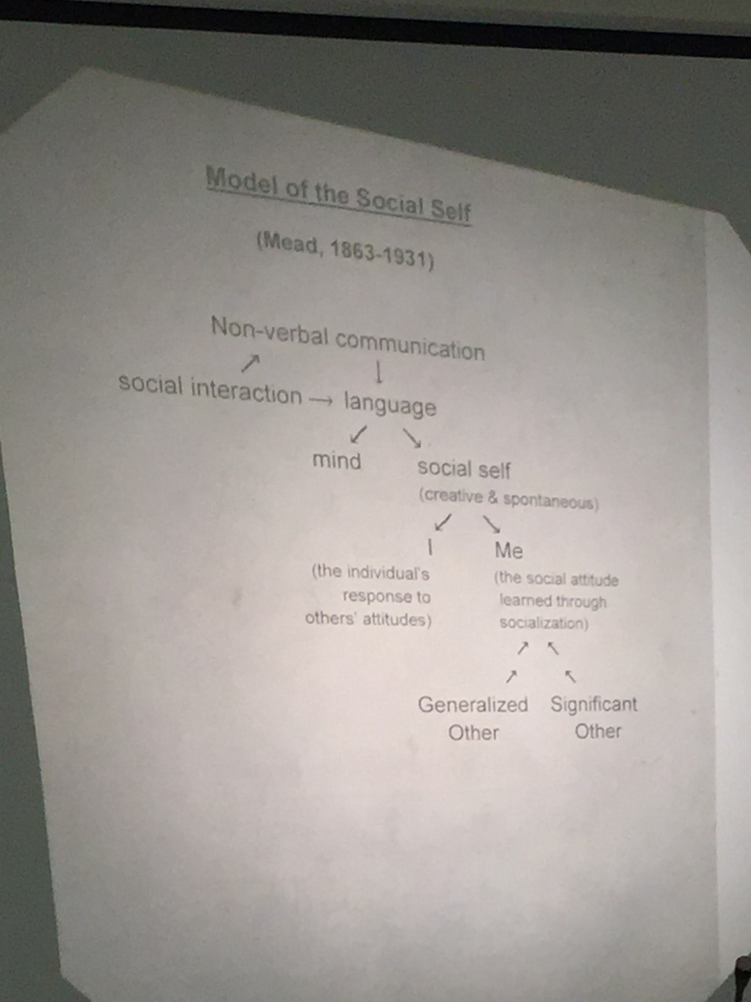

- cooley 1864 -1929:

- 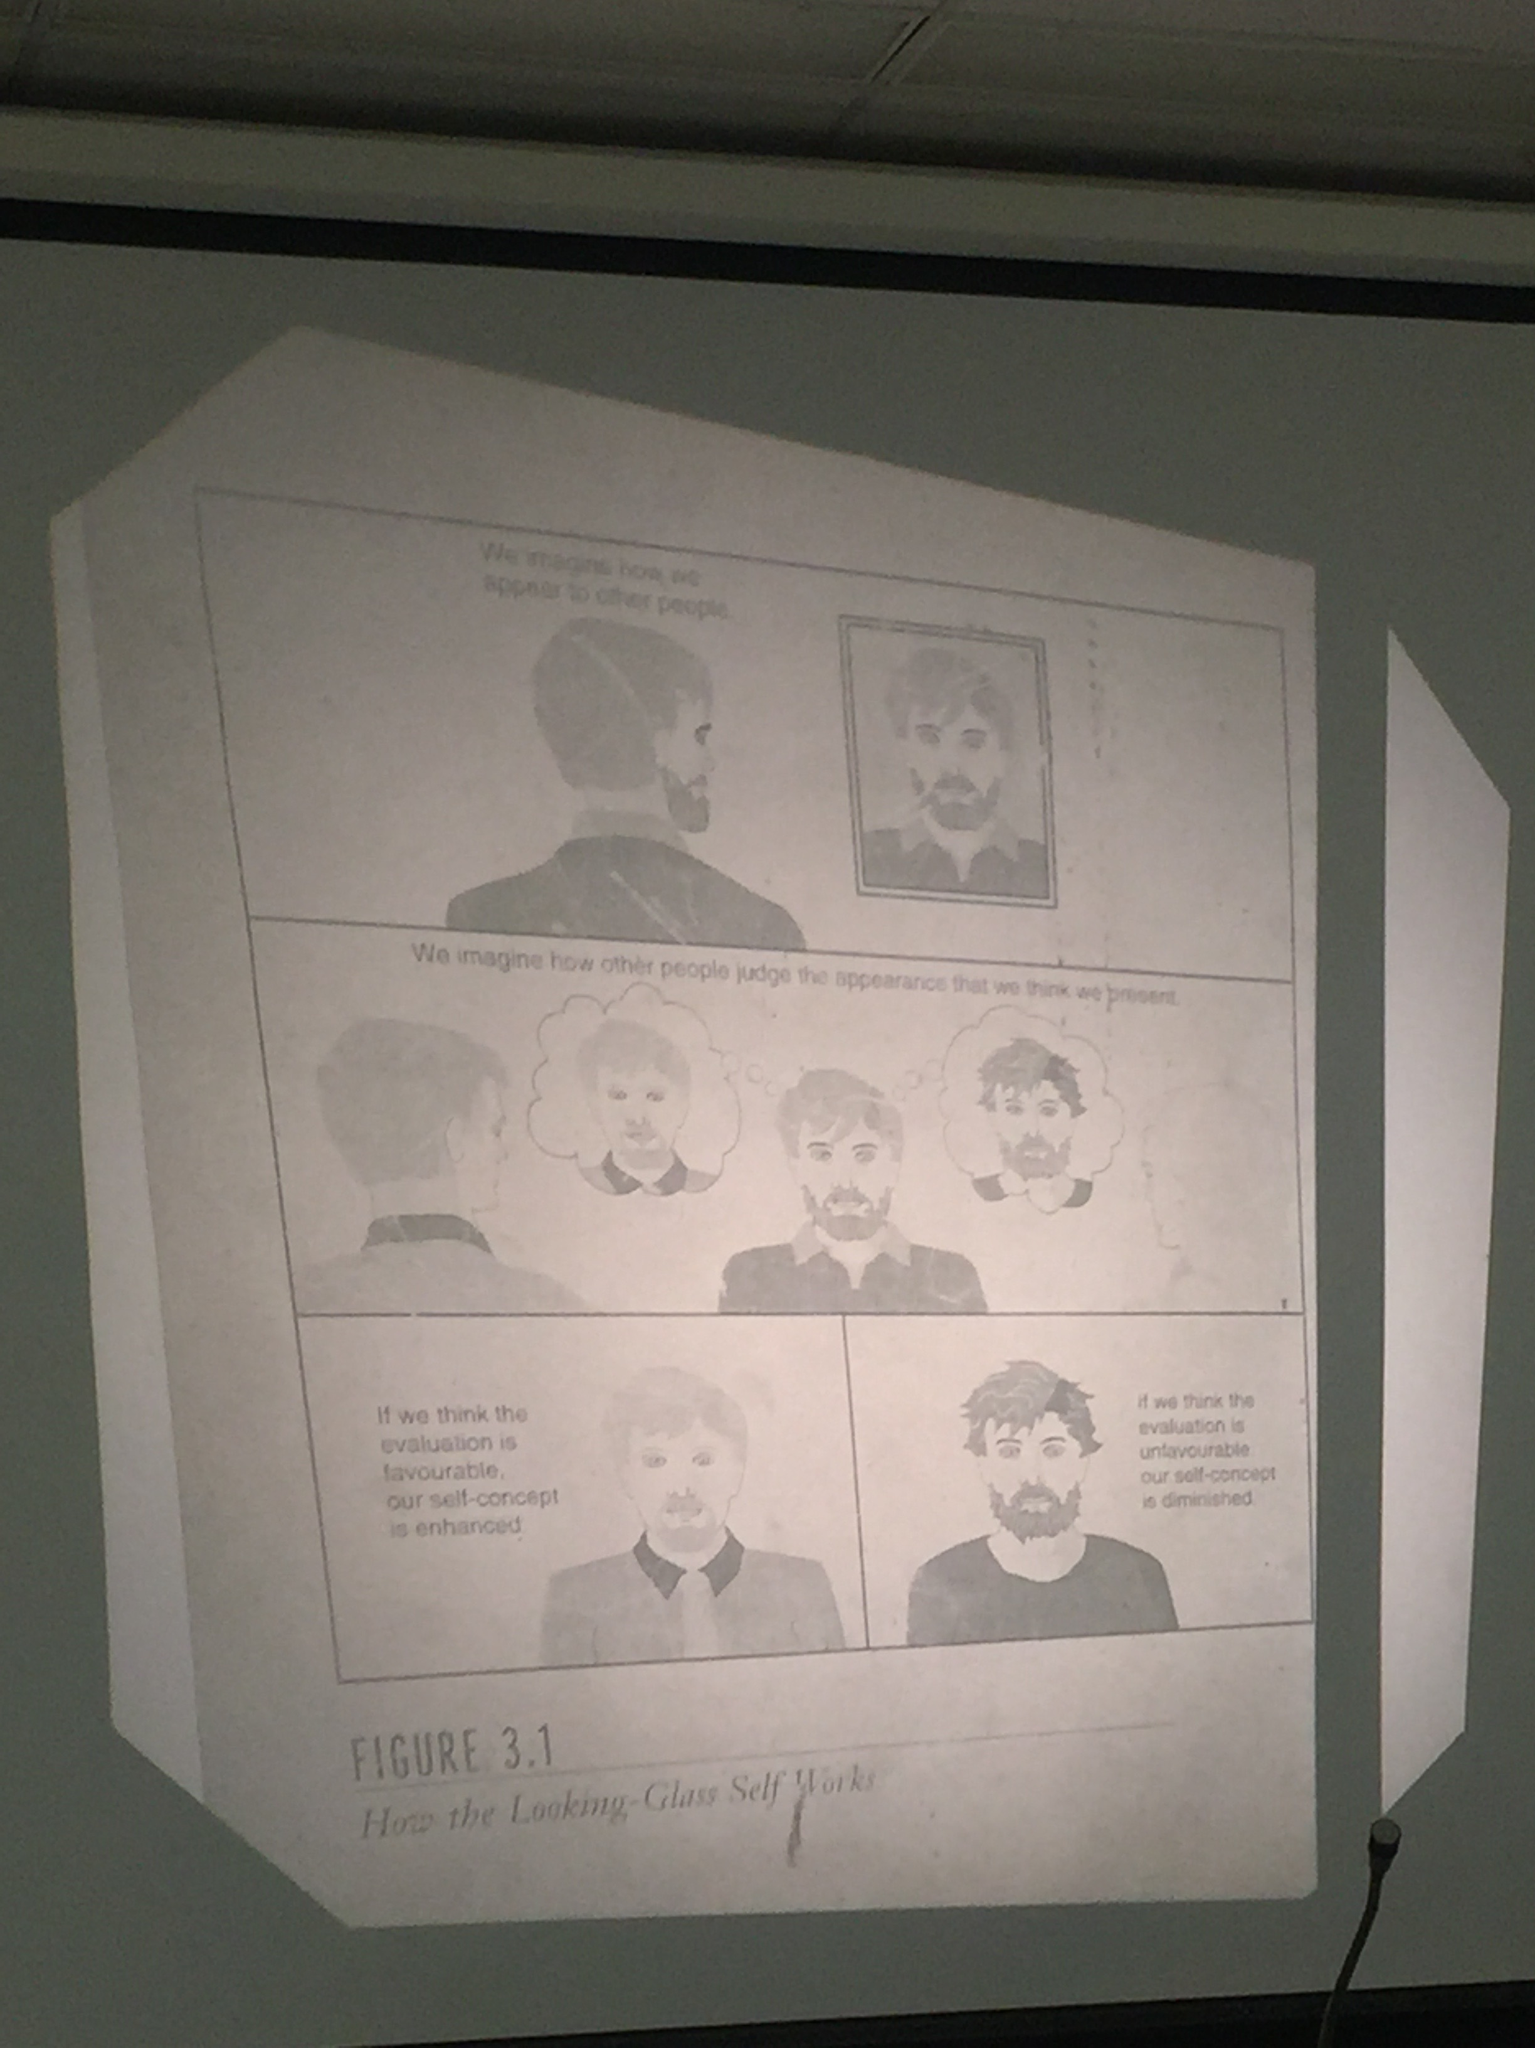
- How the looking glass self works

- Missing three lectures

MCQ sheet missing

30 MCQ questions in mid term

One and 15 mins

Wednesday Video

Secrets of the wild child ! Genie

Movie was about young girl discover by social services.

Issue of socialization :

People who were interested in her was psychologists and linguistics.

Noam Chomsky:

Deep structure:

An idea that individuals are born the ability to speak. Language ability is innate.

Word order “ I have a cookie”
  - Critical period hypothesis
    - A period in which you learn language. If you miss the period afterward you cant learn the language. If you miss it you cant make for lost time
    - Mentally retarded intellectual challenged

Feelings
  - Hot and cold feelings
- She made yearly progress for each year were teaching her. She made an argument she is not mentally challenge. She was late in learning.

- Nature vs nurture !

Reasoning, remembering and believing ( Piager)

Cognitive development

Modeling imitating

Frued ID, ego and super ego : \

Symbolic interaction : (Mead and cooley ): Development of me and I

- Two lectures missing
- Deviance continuing

