Lab 1: Logic Gates

ITI1100 D – Digital Systems
Winter 2015
School of Software Engineering and Computer Science
University of Ottawa

Course Coordinator: Dr. Ahmed Karmouch
Teaching Assistants: Heli Dimuth Amarasinghe
Arulprakasam Ravinthiran

Group #12
Tommy Moore -
Charmarke Aboubker – 7154287

Experiment Date: February 3rd, 2015
Submission Date: February 10th, 2015
Objectives
- The main objective for this laboratory was to be able to construct combinational logic circuits relying only on a schematic:
- This includes having to experimentally determine the functional operation of a combinational logic circuit
- Having to identify common logic functions produced by various circuit configurations by the resulting truth table
- Having to connect various gates to create logic function
- And to push even further by testing out more complex combinational logic circuit
- Once achieved, we analyze all the data gathered from our combinational logic circuits and predict how they are going to work.
Equipment and Components
- QUARTUS II Student Edition Software (9.0)
- Altera UP-1 circuit board. More specifically the MAX EPM7128SLC84-7 CPLD, its LEDs and pins.
- AC Adapter, minimum output: 9VDC, 250 mA
- Wire strippers
- #22 solid-core wires
- Anti-static straps
Circuit Diagrams
Part 1 - Combinational Logic Circuits Construction
Simple OR Logic Circuit
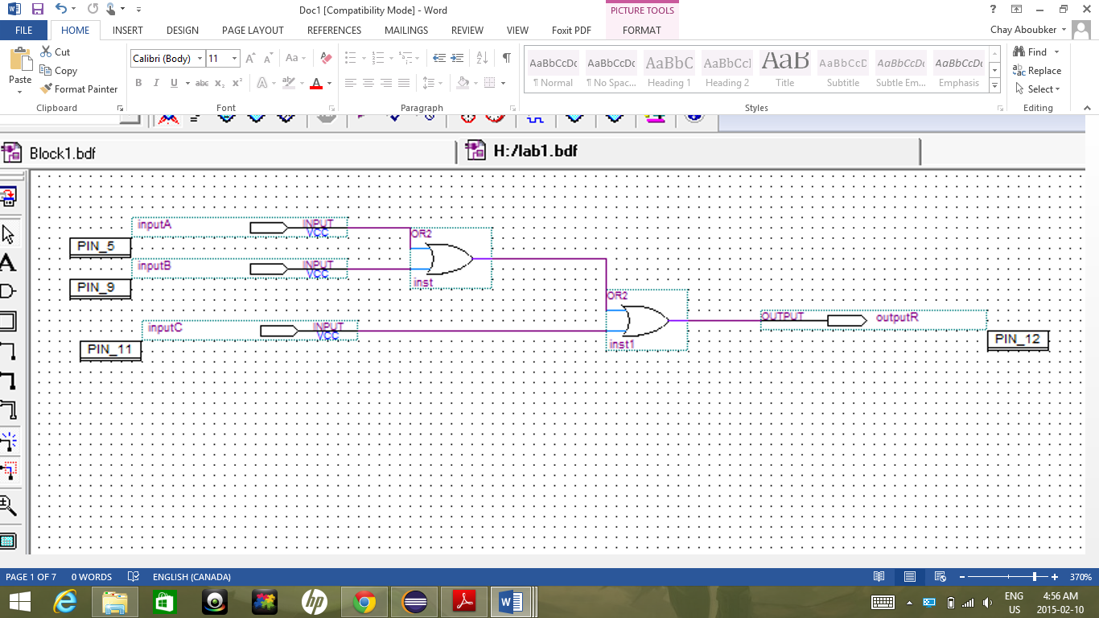
Figure 1: (Screenshot of Simple OR Logic circuit – Figure 6.1.1 in Lab manual)
Part II - Combinational Logic Circuits Analysis
4 NAND Combinational logic circuit
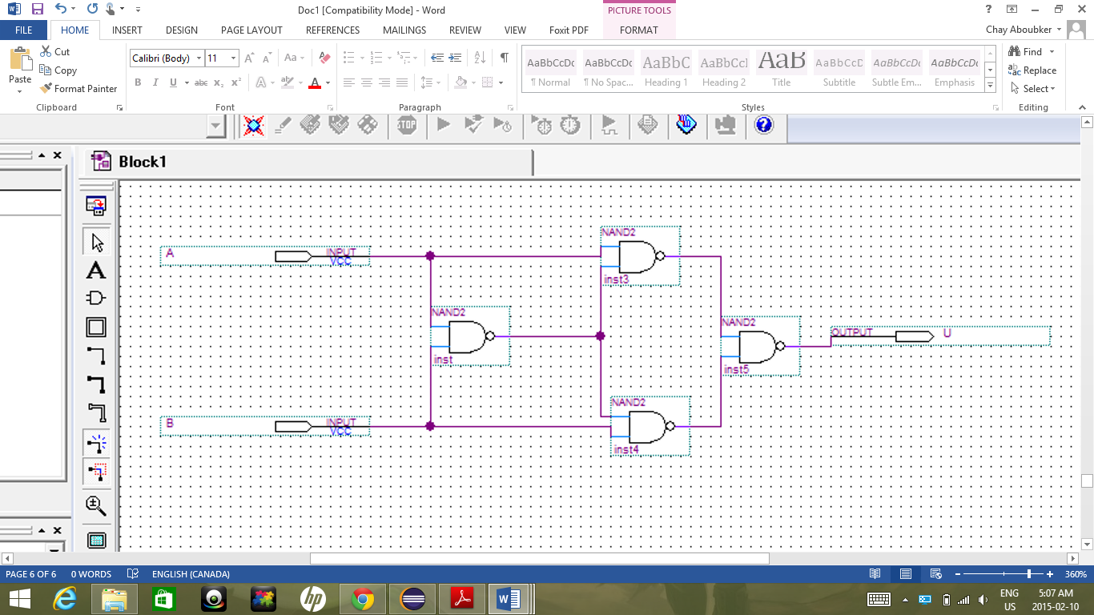
Figure 2: (Screenshot of 4 NAND Combinational logic circuit – Figure 6.1.5 in Lab manual)
Complex logic circuit with 5 gates
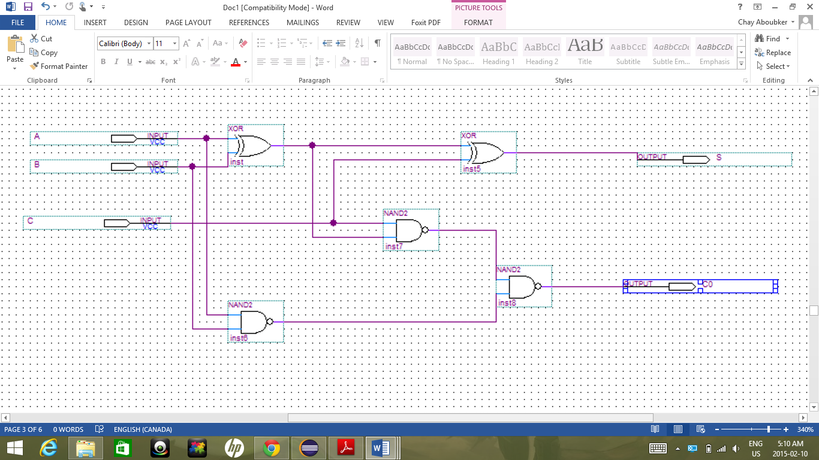
Figure 3: (Screenshot of Complex logic circuit with 5 gates – Figure 6.1.8 in Lab manual)
Experimental Data
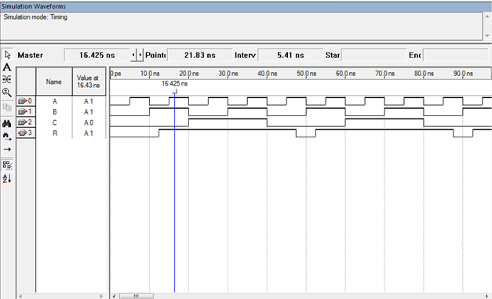
Figure 1: (Simulation output of circuit 6.1.1)
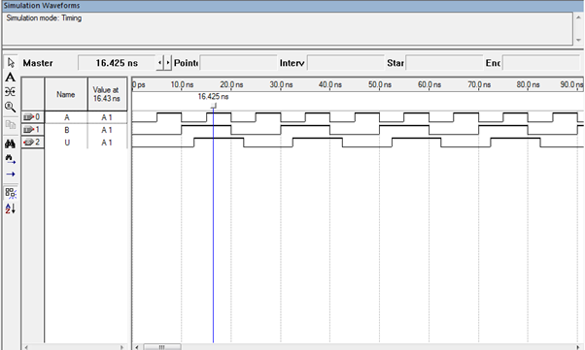
Figure 2: (Simulation output of circuit 6.1.5)
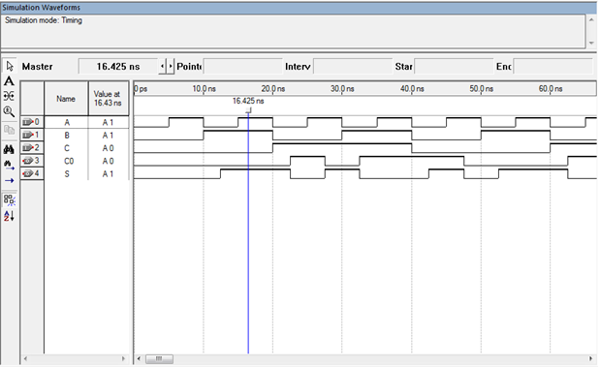
Figure 3: (Simulation output of circuit 6.1.8)

Comparison of Theoretical and Experimental Data

A | B | C | R
0 | 0 | 0 | 0
1 | 1 | 0 | 1
0 | 0 | 0 | 1
1 | 1 | 0 | 1
0 | 0 | 1 | 1
1 | 1 | 1 | 1
0 | 0 | 1 | 1
1 | 1 | 1 | 1
Table 1. Circuit 6.1.1, Theoretical
NOTE: input rows adjusted to better align with experimental

A | B | C | R
0 | 0 | 0 | 0
1 | 1 | 0 | 0
0 | 0 | 0 | 1
1 | 1 | 0 | 1
0 | 0 | 1 | 1
1 | 1 | 1 | 1
0 | 0 | 1 | 1
1 | 1 | 1 | 1
Table 2. Circuit 6.1.1, Experimental

A | B | U
0 | 0 | 0
0 | 1 | 1
1 | 0 | 1
1 | 1 | 0
Table 3. Circuit 6.1.5, Theoretical
A | B | U
0 | 0 | 0
0 | 1 | 1
1 | 0 | 0
1 | 1 | 1
Table 4. Circuit 6.1.5, Experimental

A | B | C | S | C_{O} |  | A | B | C | S | C_{O}
0 | 0 | 0 | 0 | 0 |  | 0 | 0 | 0 | 0 | 0
0 | 0 | 1 | 1 | 0 |  | 0 | 0 | 1 | 0 | 1
0 | 1 | 0 | 1 | 0 |  | 0 | 1 | 0 | 1 | 0
0 | 1 | 1 | 0 | 1 |  | 0 | 1 | 1 | 0 | 1
1 | 0 | 0 | 1 | 0 |  | 1 | 0 | 0 | 0 | 0
1 | 0 | 1 | 0 | 1 |  | 1 | 0 | 1 | 1 | 0
1 | 1 | 0 | 0 | 1 |  | 1 | 1 | 0 | 1 | 0
1 | 1 | 1 | 1 | 1 |  | 1 | 1 | 1 | 0 | 1
Table 5. Circuit 6.1.8, Theoretical |  |  |  |  |  | Table 6. Circuit 6.1.8, Experimental

Experimental data obtained from simulation waveform diagrams. All of the experimental results from these simulation waveform diagrams have differences from the theoretical truth tables.
Discussions & Conclusions
Throughout this experiment, it has been possible to recreate 3 different circuits using their schematics. The team has also learned about different logic functions with differing configurations which reflect in the truth tables that we’ve enumerated. A varying amount of gates have been used in each circuit, and a higher degree of complexity has been achieved with figure 6.1.8. Simulation and programming were successful. However, referring to the comparison of the experimental data gathered versus the theoretical data, it can be observed that there is a slight difference in the truth tables.
In circuit 6.1.1, output of A=1 and B=1 should give an R=1. In circuit 6.1.5, output of A=1, B=0 should give U=1 not 0, and output of A=1, B=1 should give U=0. In circuit 6.1.8, all but two rows are different from the theoretical truth trees. These errors may be due to delay in the waveform diagram, If the experimental data were obtained from testing the Altera card, these error may not have occurred.

