PS 101 Chapter 1: The Evolution of Psychology

Pages 1-2: Intro to Psych

What is Psychology?
-how our physical, mental states and external environment affects our thoughts, feelings and behaviors
-psychology is practical; it is also a way of thinking

Abnormal Psychology: a branch of psychology that studies unusual patterns of behavior, emotion and thought, which may or may not be understood as a mental disorder
Truisms: a statement that is obviously true and says nothing new or interesting.

Page 3: From Speculation to Science: How Psychology Developed

Philosophy, Physiology, and Psychology
-the term “psychology” comes from two Greek words, psyche, meaning the soul, and logos, referring to the study of a subject
-in the early 18th century, psychology was known as “the study of the mind”

Page 4: A New Science is Born – The Contributions of Wundt and Hall

Wilhelm Wundt
-was a German professor that campaigned to make psychology an independent discipline rather than a stepchild of philosophy or physiology
-he is wildly characterized as the founder of psychology
-psychology became the scientific study of conscious experience, focusing on mind and mental processes
-the birth of psychology is dated 1879

G. Stanley Hall
-he studied briefly with Wundt
-in 1883 he was responsible for the birth of American psychology
-in 1892 he established the American Psychological Association (APA)

Page 5,6: The Battle of the ‘Schools” Begins – Structuralism vs. Functionalism

Structuralism
-based on the notion that the task of psychology is to analyse consciousness into its basic elements and investigate how these elements are related
-structuralists wanted to identify and examine the fundamental components of conscious experience (sensation, feelings, and images)
-laboratory investigations

Introspection
-the careful, systematic self observation of one’s own conscious experience
-trained subjects were exposed to auditory tones, optical illusions and visual stimuli and analyzed what they experienced

Functionalism
-based on the belief that psychology should investigate the function or purpose of consciousness, rather than its structure
-how people adapt to their behavior to demands of the real world around them
-chief force was William James and he contended that psychology should investigate the functions rather than the structure of consciousness

Natural Selection
-heritable characteristics that provide a survival or reproductive advantage are more likely than alternative characteristics to be passed on to subsequent generations and thus come to be “selected” over time
*Darwin’s evolutionary theory

-structuralists naturally gravitated to the lab, functionalists were more interested in how people adapt their behavior to the demands of the real world around them

Page 7-8: Watson Alters Psychology’s Course as Behaviorism Makes Its Debut

Behaviourism
-a theoretical orientation based on the premise that scientific psychology should study only observable behavior
-Watson suggested psychologists abandon the study of consciousness altogether and focus exclusively on behaviors that they could observe directly because he believes power of the scientific method rested on the ideas of verifiability

Behavior
-refers to any overt (observable) response or activity by an organism
-psychologists can study anything people do or say, but they could not study scientifically the thoughts, wishes, and feelings that may accompany these observable behaviors
-Watson argued that an individual is made by the environment (nurture) rather than by genetic inheritance (nature)

Stimulus
-is any detectable input from the environment
-behaviorists eventually came to view psychology’s mission as an attempt to relate overt behaviors (responses) to observable events in the environment (stimuli)
-stimuli can range from light and sound waves to such complex inputs as words on a page, advertisements on TV, or sarcastic remarks made by a friend

-behaviorism’s stimulus response approach contributed to the rise o animal research in psychology
-having deleted consciousness from their scope of concern, behaviorists no longer needed to study human subjects, but focused on animal research subjects

Overt: done or shown openly; plainly or readily apparent, not secret or hidden

Page 9: Freud Brings the Unconscious into the Picture

Unconscious
-contains thoughts, memories, and desires that are well below the surface of conscious awareness but that nonetheless exert great influence on behavior
-Freud based his concept of the unconscious on a variety of organizations like how he noticed that seemingly meaningless slips of the tongue often appeared to reveal a person’s true feelings
-his patient’s dreams often seemed to express important feelings they were unaware of

Psychoanalytic Theory
-attempts to explain personality, motivation, and mental disorders by focusing on unconscious determinants of behavior
-belief that behavior is dominated by primitive, sexual urges

Sigmund Freud
-explored the unconscious through his patients and self reflection
-people are fully aware of the forces affecting their behavior
-known for controversial theory: behavior is influenced by people’s sexual urges

Page 10: Skinner Questions Free Will as Behaviorism Flourishes

B.F. Skinner
-developed a system called radical behaviorism (derived as a median between behaviorism and neo-behaviorism)
-seen as most important contributor to schools of psychology
-he argued that psychology could understand and predict positive outcomes and they tend to not repeat responses that lead to neutral or negative outcomes
-according to Skinner, people are controlled by the environment, not by themselves, therefore free will is an illusion

Page 11-12: The Humanists Revolt

Behaviorism
-the study of simple animal behavior
-people are not masters of their own destinies

Humanism
-theoretical orientation that emphasizes the unique qualities of humans, especially their freedom and their potential for personal growth

Humanists
-take an optimistic view of human nature
- Carl Rogers and Abraham Maslow argued that human behavior is governed primarily by each individual’s sense of self, or “self-concept” which animals presumably lack
-people have a basic need to continue to evolve as human beings and to fulfill their potentials
-argued many psychological disturbances are the result of thwarting these uniquely human needs

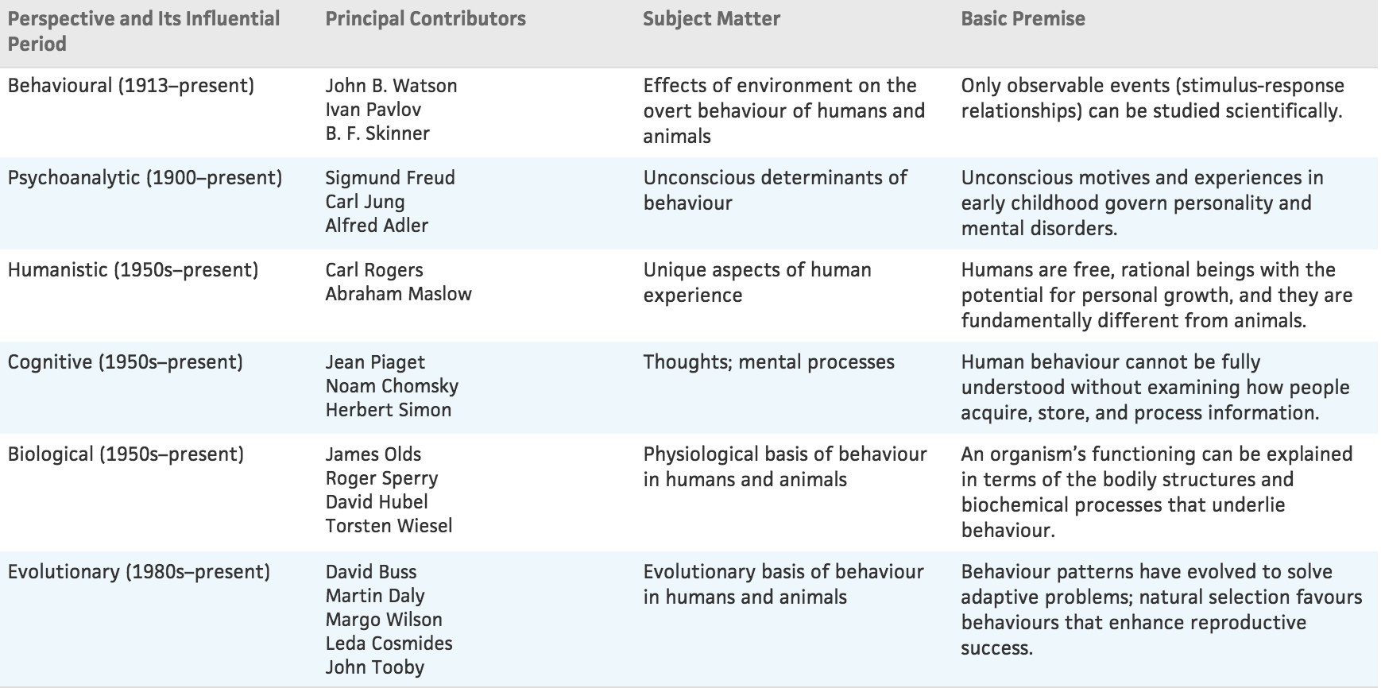

Page 15: Psychology Comes of Age as a Profession

Applied Psychology
-the branch of psychology concerned with everyday, practical problems

Clinical Psychology
-the branch of psychology concerned with the diagnosis and treatment of psychological problems and disorders

Page 16: Psychology Returns to Its Roots – Renewed Interest in Cognition and Physiology

Cognition
-renewed interest in consciousness (“cognition”) and physiological bases of behavior
-cognition refers to the mental process involved in acquiring knowledge, thinking or conscious experience
-a cognitive perspective is how people’s manipulations of mental images surely influence how they behave
-Hebb suggested that repeated stimulations lead to the development of cell assemblies
-these cell assemblies resemble cognitive units that together or in concert with the other cell assemblies facilitate behavior

Page 18: Psychology Broadens Its Horizons – Increased Interest in Cultural Diversity

Cross-cultural Research
-research has been conducted in the United States by middle and upper class white psychologists who used mostly middle and upper class white males as subjects
-cross-cultural research is costly, difficult, and time consuming
-psychologists worry that cultural comparisons may inadvertently foster stereotypes of various cultural groups

Ethnocentrism
-the tendency to view one’s own group as superior to others and as the standard for judging the worth of foreign ways

First Generation: born outside Canada
Second Generation: born in Canada with at least one parent born outside of Canada
Third Generation: born in Canada

New interest in culture appears attribute to two recent trends…
-advances in communication, travel, and increased global interdependence, bring more and more North Americans and Europeans into contact with people from non-Western cultures
-the ethnic makeup of the Western world has become an increasingly diverse multicultural mosaic

What they want to learn…
-test the generality of earlier findings and to catalogue both differences and similarities among cultural groups
-increase knowledge of how culture is transmitted through socialization practices and how cultural colours one’s view of the world
-how people cope with cultural change and find ways to reduce misunderstandings and conflicts in intercultural interactions

Page 20: Psychology Adapts – The Emergence of Evolutionary Psychology

-evolutionary psychology examines behavioral processes in terms of their adaptive value for members of a species over the course of many generations
-natural selection favours behaviors that enhance organisms’ reproductive success – that is, passing on genes to the next generation

Page 21: Psychology moves in a Positive Direction – The Positive Psychology Movement

Positive Psychology
-Martin Seligman is from the University of Pennsylvania and is the founder of the positive psychology movement
-positive psychology uses theory and research to better understand the positive, adaptive, creative, and fulfilling aspects of human existence
-positive subjective experiences are positive emotions, such as happiness or love
-positive individual traits are personal strengths or virtues
-positive institutions and communities focus on how society can foster civil discourse, strong families, healthy work environments, and supportive neighbourhood communities

Page 21: Psychology Today – Vigorous and Diversified

-psychology is the science that studies behavior and the physiological and cognitive processes that underlie it, and it is the profession that applies the accumulated knowledge of this science to practical problems

7 Major Research Areas in Psychology
- Developmental Psychology: development across the life span
- Social Psychology: interpersonal behavior and the role of social forces in governing behavior
- Experimental Psychology: sensation, perception, learning, conducting, motivation, and emotion
- Physiological Psychology: influence of genetic factors on behavior, role of the brain, nervous system, endocrine system, and bodily chemicals in the regulation of behavior
- Cognitive Psychology: memory, reasoning, information processing, language, problem solving, decision making, and creativity
- Personality: describing and understanding individual’s consistency in behavior, factors that shape personality with personality assessments
- Psychometrics: measurement of behavior and capacities, design of tests to assess personality, intelligence, and a wide range of abilities, development of new techniques for statistical analysis

4 Professional Identified Areas of Specialization in Psychology

- Clinical Psychology: evaluation, diagnosis, and treatment of individuals with psychological disorders (less severe behavioral and emotion problems)
- Counselling Psychology: work with people struggling with everyday problems of moderate severity
- Educational and School Psychology: tasks in the world of business
- Industrial and Organizational Psychology: tasks in the world of business

-psychologists and psychiatrists have different training and educational requirements, as well as they have a different approach to treatment
-psychiatry is a branch of medicine concerned with the diagnosis and treatment of psychological problems and disorders
-clinical psychology takes a non-medical approach to such problems

Page 27: Putting It in Perspective – Seven Key Themes

-learn about both behavior and the scientific discipline that investigates it
-two sets:
1. Statements highlighting crucial aspects of psychology as a way of thinking and as a field of study
2. Broad generalizations about psychology’s subject matter: a) behavior b) cognitive/ physiological processes that underlie it

Themes Related to Psychology
Theme 1: Psychology is Empirical
-empiricism is the premise that knowledge should be acquired through observations
-conclusions that are based on direct observation rather than reasoning, speculation, traditional beliefs, or common sense

Theme 2: Psychology is Theoretically Diverse
-psychologists seek to explain and understand what they observe, so they must construct a theory
-a theory is a system of interrelated ideas used to explain a set of observations (linking unrelated observations to try and explain them)
-no single theory can adequately explain everything that is known about behavior
-oversimplification to expect that one view has to be right while all others are wrong

Theme 3: Psychology Evolves in a Sociohistorical Context
-trends, issues, and values in society influence psychology’s evolution
-psychology affects trends, issues, and values in society
-psychology develops in a Sociohistorical context
-society and psychology influence each other in complex ways

Themes Related to Psychology’s Subject Matter
Theme 4: Behavior is Determined by Multiple Causes
-behavior is exceedingly complex, and most aspects of behavior are determined by multiple causes
-psychologists find that behavior is governed by a complex network of interacting factors, an idea referred to as the multifactorial causation of behavior

Theme 5: Behavior is Shaped by Cultural Heritage
-culture refers to the widely shared customs, beliefs, values, norms, institutions, and other products of a community that are transmitted socially across generations
-since a cultural background is widely shared, members feel little need to discuss it with other and then often take it for granted

Theme 6: Heredity and Environment Jointly Influence Behavior
-nature vs. nurture (heredity vs. environment)
-Watson: personality and ability to develop almost exclusively on an individual’s environment
-Galton: personality and ability depend almost entirely on genetic influence
-heredity and environment are both important

Theme 7: People’s Experience of the World is Highly Subjective
-people sometimes see what they want to see
-people sometimes see what they expect to see
-psychologists strive to make their observations as objective as possible

