EBusiness /Ecommerce Quiz Review
Week 1:
- Difference between eBusiness and Ecommerce
Ecommerce – process of buying, selling, trading products/services or information via a computer.
Ebusiness – Broader definition of Ecommerce that includes not just the buying but also servicing customers, collaborating with business partners, and conducting electronic transfers within an organization.

- Difference between pure or partial Ecommerce
Pure eCommerce concerns business whose transactions are largely carried out on the Internet.
"Partial E-Commerce on the other hand concerns business in which a large part of the transaction takes place in the off-line real world. Amazon, for instance, will sell you books online, but these must be stored in large warehouses and physically delivered through the post."

- What is EDI (electronic data interchange technology)
- the computer-to-computer exchange of business documents in a standard electronic format between business partners.

- Transactions types and Transaction Models
-
- Revenue Models
- Sales- selling things
- Transaction Fees- commission based on service
- Subscription Fees- customers pay fixed amount to belong
- Advertising Fees- fees for placing banners/advertising on site
- Affiliate Fees- receive commissions for referrals
- Licensing Fees – annual fees for services/app’s

- Business Models
- Online Direct Marketing- selling product/services online
- Electronic Tendering Systems -usually large volume corporate sales through tendering/bidding systems.
- Electronic marketplaces and exchanges- stock market, or commodity exchanges.
- Viral Marketing- people using social networks to spread the word about products/services through word of mouth advertising.
- Group purchasing- discount quantity purchasing.

- Managerial Challenges and Issues
- How will social commerce impact businesses?
- Should we explore Web 2.0 collaboration?
- How to deal with ethical and etiquette issues?
- What are the ethical issues that may be involved in deploying social commerce?
- Do we need to sponsor a social network?
- How should we deal with social commerce risks?
- Should we have an in-house social network? How do we get the employees to use it?
- Is it wise for a small business to be on Facebook?
- What shall I do now?

- Stages in target marketing strategy development

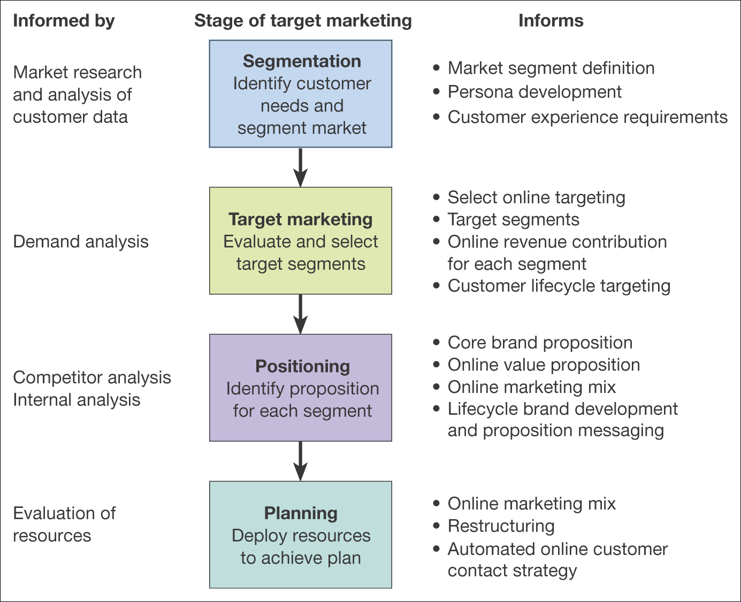
- Strategic Planning Process
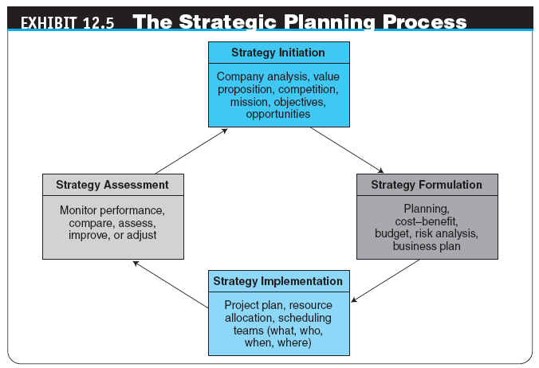

- Framework for eMarketing and Planning
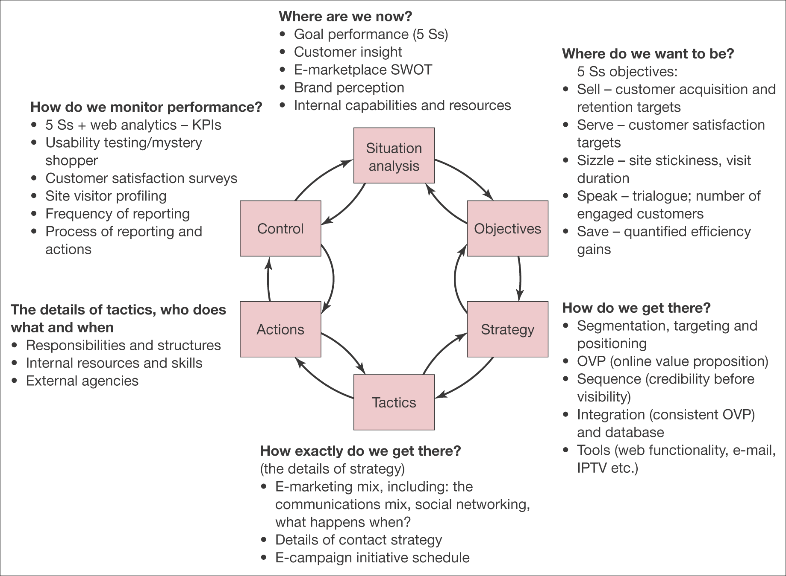
- Difference between BPR and BPM
-business process reengineering (BPR)
A methodology for conducting a comprehensive redesign of an enterprise’s processes
- business process management (BPM)
Method for business restructuring that combines workflow systems and redesign methods; covers three process categories—people-to-people, systems-to-systems, and systems-to-people interactions

- Difference between strategy and eStrategy?
strategy
A broad-based formula for how a business is going to accomplish its mission, what its goals should be, and what plans and policies will be needed to carry out those goals
e-commerce strategy (e-strategy)
The formulation and execution of a vision of how a new or existing company intends to do business electronically

- What is keystroking logging
-is the action of recording (or logging) the keys struck on a keyboard, typically in a covert manner so that the person using the keyboard is unaware that their actions are being monitored.
- 3 types of exchanges (public, private, and consortia)
The 3 types : (exchange currency)
Private (B2C or B2B - owned and operated by a single company) or a Virtual (second life)
Public (B2B) and consortia (usually owned by a 3rd party or group of investors – also known as exchanges)
Consortia – group of investors

- What is cyber crimes
"Computer crime can broadly be defined as criminal activity involving an information technology infrastructure, including illegal access (unauthorized access), illegal interception (by technical means of non-public transmissions of computer data to, from or within a computer system), data interference (unauthorized damaging, deletion, deterioration, alteration or suppression of computer data), systems interference (interfering with the functioning of a computer system by inputting, transmitting, damaging, deleting, deteriorating, altering or suppressing computer data), misuse of devices, forgery (ID theft), and electronic fraud."

- What is AI
-Artificial Intelligence (AI) is usually defined as the science of making computers do things that require intelligence when done by humans. AI has had some success in limited, or simplified, domains.

- What are hackers
-a person who uses computers to gain unauthorized access to data.

- What is malware
-software that is intended to damage or disable computers and computer systems.

- Denial of service
A DDoS is an attempt by criminals to render a website inoperable. I

- What is encryption and decryption
-Encryption is the most effective way to achieve data security. To read an encrypted file, you must have access to a secret key or password that enables you to decrypt it. Unencrypted data is called plain text ;encrypted data is referred to as cipher text.

- Decryption is the process of converting encrypted data back into its original form, so it can be understood.

- What is RFID
Radio-frequency identification (RFID) is the wireless use of electromagnetic fields to transfer data, for the purposes of automatically identifying and tracking tags attached to objects. The tags contain electronically stored information.

- Differences between Web versions (web 2.0, web 3.0 etc)
-Web 1.0 refers to the first stage in the World Wide Web, which was entirely made up of Web pages connected by hyperlinks. Although the exact definition of Web 1.0 is a source of debate, it is generally believed to refer to the Web when it was a set of static websites that were not yet providing interactive content.
- Web 2.0 is the term given to describe a second generation of the World Wide Web that is focused on the ability for people to collaborate and share information online. Web 2.0 basically refers to the transition from static HTML Web pages to a more dynamic Web that is more organized and is based on serving Web applications to users.
-web 3.0 is a third phase in the evolution of the World Wide Web, based on the idea that the Internet 'understands' the pieces of information it stores and is able to make logical connections between them

- What is HTML
-HTML (Hypertext Markup Language) is the set of markup symbols or codes inserted in a file intended for display on a World Wide Web browser page. The markup tells the Web browser how to display a Web page's words and images for the user.
- What is location based
- Location-based services (LBS) are a general class of computer program-level services that use location data to control features.
- What is Wifi
Wi-Fi is a wireless networking technology that allows computers and other devices to communicate over a wireless signal.
- What is crowdsourcing
-Obtaining information from the general public about current events, products and retail establishments. For example, if a natural disaster strikes an area, locals can capture and upload images before a professional news crew arrives. In addition, rather than hire a professional poll taker, using a Web site or blog to ask for public opinion may be the fastest way to generate comments and suggestions. See user-generated content.

- Differences between social web and locational web services
- The social web is a set of social relations that link people through the World Wide Web. The Social web encompasses how websites and software are designed and developed in order to support and fostersocial interaction.
- A location-based service (LBS) is a software application for a IP-capable mobile device that requires knowledge about where the mobile device is located. Location-based services can be query-based and provide the end user with useful information such as "Where is the nearest ATM?" or they can be push-based and deliver coupons or other marketing information to customers who are in a specific geographical area.

